**1. Techno-Economic Design:**

**Part 1: PV Design**

**i. Determine the energy requirements of the EV charging station.**

1. Let consider Typical EV Daily Range as 400 km.
2. Average 20 vehicles are charged per day at EV Station.
3. Average EV Battery Capacity: 50 kWh
4. Daily Energy Demand: 400 km/vehicle * 50 kWh/vehicle * 20 vehicles = 40,000 Wh/day = **40 kWh/day**

**ii. PV Module and Inverter Selection based on energy demand :**

1. PV module: Solar Irradiation Data: 5 kWh/m²/day
2. Desired System Capacity: Cover 70% of daily energy demand
3. Required Daily PV Energy Production: 40 kWh/day * 0.7 = 28 kWh/day
4. PV Module Efficiency: 20% (example)
5. Required PV Array Area: 28 kWh/day / 5 kWh/m²/day / 0.2 = 28 m²
6. Module Selection**:** PV modules for 28 m² roof space with a target daily output of 28 kWh I chose 5 modules of **Trina Vertex 670W (**output (28 kWh / 670 W/module = ~4.18 modules)**)**
7. Inverter Selection:**Fronius GEN24 Plus 10kW** inverter is chosen as it offers a maximum output power of 10 kW, multiple MPPTs, and advanced monitoring features. Suitable for high-demand EV charging stations.

**iii. Design the PV array layout considering shading, orientation, and installation constraints**:

1. Assuming a rectangular, unshaded 28 m² roof
2. Orientation: South-facing
3. Tilt Angle: 30°
4. Layout: 5 Trina Vertex 670W modules arranged in two rows of 2 modules and one row of 1 module, evenly spaced with 15 cm gaps.

Above mention array layout is chosen based on following constraints by selecting an area in Rawalpindi with 8:00 am to 3:00 pm peak sunlight times;

**Shading & Orientation:**

* South-Facing (Ideal): This is the optimal orientation for maximum solar exposure in the Northern Hemisphere. It ensures the panels receive direct sunlight throughout the day, especially during the peak hours of 8 am to 3 pm in Rawalpindi.
* Tilt Angle: A tilt angle of around 30° is generally recommended for Rawalpindi to maximize annual energy production. This angle can be adjusted slightly based on specific site conditions and seasonal variations.

**Layout Considerations:**

* Available Area: With a 28 m² space, we can likely accommodate 5 Trina Vertex 670W modules, as previously discussed.
* Shading: No shading area.
* Spacing: Maintain a spacing of at least 15 cm between panels to allow for air circulation and prevent overheating. This ensures optimal performance and longevity.

**Installation Constraints:**

* Roof Strength: A strong base to carry the weight of the PV array and withstand wind loads.
* Roof Penetrations: Avoid placing panels over existing vents, chimneys, or other roof penetrations.
* Setbacks: Adhere to local building codes and regulations regarding setbacks from property lines or roof edges.
* Electrical Codes: Following electrical safety guidelines and ensure proper grounding and wiring practices.

**iv. Annual PV Energy Production:**

1. Solar Irradiation Data: Annual total of 2000 kWh/m²
2. System Losses: Accounting 15% loss for inverter efficiency, wiring losses, and environmental factors.
3. Estimated Annual PV Production: 28 m² * 2000 kWh/m² * (1 - 0.15) = 44,800 kWh/year

**b. EV Charging Station Design:**

**i. Determine the number and type of EV chargers based on demand and utilization patterns:**

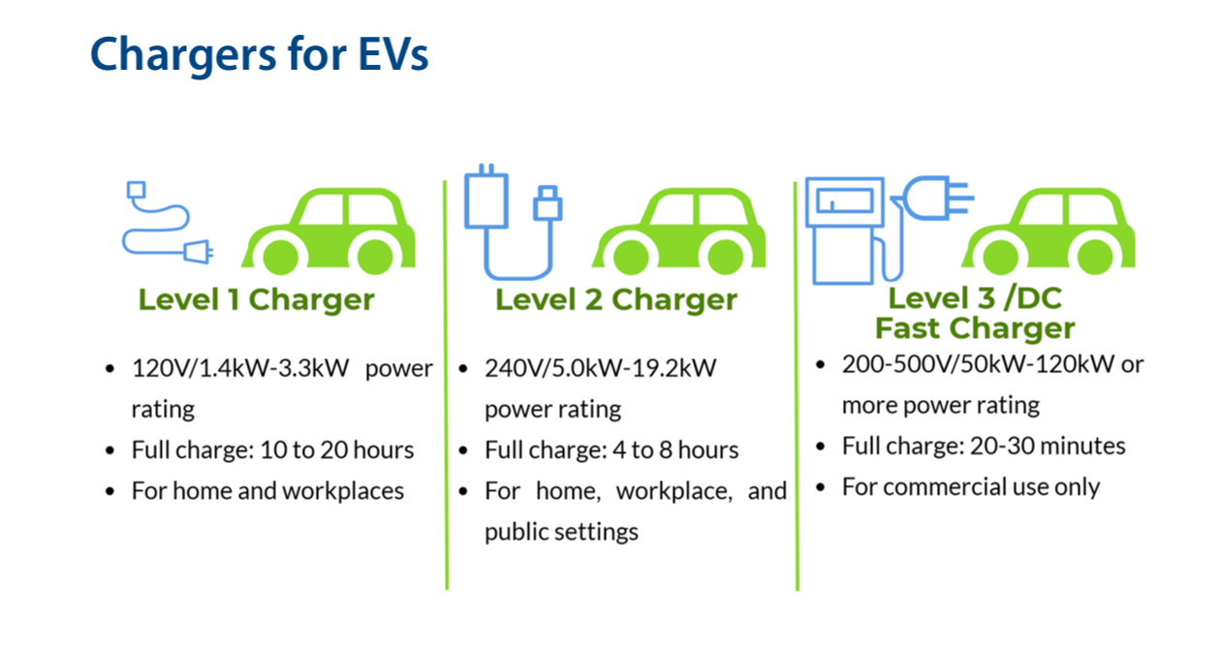

1. By analyze peak demand periods and typical charging duration, charger selection:

* Fast DC Chargers: For short charging times and high utilization areas (e.g., 50 kW DC chargers for quick top-ups).
* AC Level 2 Chargers: Cost-effective option for longer charging periods and lower demand zones (e.g., 7kW AC chargers for overnight charging).
* Based on Balance cost, demand, and utilization Number of Chargers are  4 DC chargers + 6 AC chargers.

**ii. . Charging Technology Evaluation:**

|  |  |  |  |
| --- | --- | --- | --- |
| **Technology** | **Efficiency (%)** | **Charging Speed (Hours for 0-100%)** | Compatibility |
| AC Level 1: 85-90% | 12 to 24 | Most EVs, slower charging | AC Level 1 EV charger |
|
| AC Level 2: 90-95% | 04 to 08 | Most EVs, standard charging | AC Level 2 EV charger |
|
|
| DC Fast Charging (50 kW): 95-98% | 0.5 to 1 | Most modern EVs, fast charging | DC Fast Charging EV charger |
|
| DC Fast Charging (150 kW - 350 kW): 95-98% | 0.15 to 0.5 | Newer EVs, ultra-fast charging | DC Fast Charging EV charger |

**c. Station Layout Design:**

For a rectangular space (28 m²) representing the available area. Here's a visualized breakdown of the layout

**Central Area:**

* Parking Spaces: Two parking spots aligned horizontally in the center, marked with "EV Charging Only" signs. Each spot should have ample space for maneuvering vehicles.
* Chargers: Two 50 kW DC Fast Chargers positioned upright at the rear of each parking space. Think sleek, vertical towers with charging ports prominently displayed.

**Accessibility Features:**

* Curb Ramps: A gently sloped ramp leading up to each parking space, allowing accessibility for users with wheelchairs or mobility aids.
* Signage: Clear and visible signs near the entrance and around the parking spaces displaying instructions, charging rates, and accessibility information.

**Safety Elements:**

* Emergency Stop Buttons: Bright red buttons located beside each charger, readily accessible for emergency shut-off.
* Fire Extinguishers: Easily accessible fire extinguishers strategically placed within the station area.

**Cable Management System**:

* Retractable Cable Reels: Imaginary coiled cables housed within each charger tower, automatically extending and retracting upon connection and disconnection from vehicles.
* Cable Guides: Discreet channels or tracks embedded in the ground, neatly guiding the extended cables from the chargers to the parked vehicles.

**Additional Touches:**

* Lighting: Overhead or strategically placed lamps illuminating the entire station area for comfortable use at night.
* Bench or Seating: Optional addition of a sheltered bench or seat for users waiting while their vehicles charge.

1. **Financial Evaluation:**

**a. Market Estimates:**

**i. Research and gather market data for key financial parameters, including electricity prices, EV charging tariffs, government incentives, and maintenance costs.**

Market Data for PV-Assisted EV Charging Station in Rawalpindi: Individual EV Owner, Public Station

**Electricity Prices:**

* Cost of Grid Electricity: PKR 25 per kWh .

**EV Charging Tariffs:**

* Typical Public Charging Rates:
  + Per-kWh rate: PKR 45-55 per kWh.
* Recommended Charging Tariff (considering PVs):
  + PKR 40-45 per kWh to maintain competitive pricing while still making a profit.

**Government Incentives:**

* Electric Vehicle Policy 2020:
  + Up to 50% exemption on import duties for EV components.
  + Reduced registration fees for EVs.
  + These incentives may change, so consult relevant authorities for updates.
* Renewable Energy Policy 2017:

**Maintenance Costs:**

* PV System Maintenance: PKR 5000-10000 per year for routine inspection and cleaning.
* EV Charger Maintenance: PKR 10000-30000 per year depending on the specific equipment.

**Financial Considerations:**

* PV System Investment: Depending on the system size and efficiency, expect around PKR 500,000 - 1 million for a 50 kW system.
* Return on Investment (ROI): The potential ROI depends on factors like electricity consumption, charging tariffs, net metering savings, and government incentives. With your assumed electricity cost and potential charging rate, a basic calculation suggests a potential payback period of 4-8 years.

**ii. Estimate the capital expenditures (CAPEX) associated with PV installation, EV chargers, and infrastructure.**

**PV System Installation:**

* Solar modules: 5 Trina Vertex 670W panels at ~PKR 30,000 per panel = PKR 150,000
* Inverter: 10 kW inverter suitable for 5 modules (e.g., Fronius GEN24 Plus 10kW) ~PKR 150,000
* Mounting system and installation materials: ~PKR 50,000
* Total Cost: ~PKR 350,000

**EV Chargers:**

* 2 x 50 kW DC Fast Chargers: High-quality options like ABB Terra 54C or Delta UltraCharger start from ~PKR 500,000 each.
* Total Cost: ~PKR 1,000,000

**Infrastructure:**

* Parking spaces: Consider paving, signage, and curb ramps. Budget ~PKR 50,000 per space.
* Cable management system: Retractable reels and cable guides add ~PKR 20,000 per charger.
* Electrical wiring and installation: Depends on distance and complexity. Estimate ~PKR 50,000 per charger.
* Lighting and other amenities: Optional, but budget ~PKR 20,000 for basic setup.
* Total Cost: ~PKR 340,000

**Total Estimated CAPEX: ~PKR 1,690,000**

**iii. Estimate the operational expenditures (OPEX) associated with electricity consumption, maintenance, and grid connection charges.**

Here's an estimated breakdown of the OPEX associated with proposed PV-assisted EV charging station in Rawalpindi:

**Electricity Consumption:**

* **Grid Electricity Usage:** Depends on station usage and net metering effectiveness. Assuming 50% annual offset by your PV system, you might purchase additional grid electricity at PKR 40 per kWh.
* **EV Charging Consumption:** Estimated average consumption for a 50 kW DC charger is 40 kWh per charging session. With your projected charging rate of PKR 40-45 per kWh, this translates to revenue of PKR 1600-1800 per session.

**Maintenance:**

* **PV System Maintenance:** Routine inspection and cleaning, estimated at PKR 5000-10000 per year.
* **EV Charger Maintenance:** Depending on specific equipment, expect PKR 10000-30000 per year for each charger.
* **Total Maintenance Cost:** **~PKR 50,000 - 70,000 per year**

**Grid Connection Charges:**

* **Initial Connection Fees:** These vary depending on local regulations and utility companies. Budget around PKR 10,000-20,000 for initial connection.
* **Metering Charges:** Separate bi-directional meter for net metering might incur additional monthly charges around PKR 500-1000.

**Other OPEX:**

* **Insurance:** Consider liability and equipment insurance. Estimate around PKR 10,000-20,000 per year.
* **Software Updates and Monitoring:** Some chargers require recurring software subscriptions for updates and remote monitoring. Budget around PKR 5000-10,000 per year.
* **Marketing and Promotion:** Costs may vary depending on your chosen marketing strategy.

**Total Estimated OPEX (Annual):**

* **Minimum:** PKR 75,000 (excluding insurance, marketing, and software)
* **Maximum:** PKR 130,000 (including all estimated costs)

**b. Financial Analysis:**

**i. Calculate the annual revenue generated from EV charging fees.**

Calculating annual revenue requires estimating daily/monthly charging demand. Let's assume:

* Average daily charging sessions: 5 (can vary significantly)
* Average kWh consumption per session: 40 kWh
* Charging rate: PKR 45 per kWh
  + Daily revenue: 5 sessions * 40 kWh/session * PKR 45/kWh = PKR 9000
  + Annual revenue: PKR 9000/day * 365 days = PKR 3,285,000

**ii. Calculate the net present value (NPV) and internal rate of return (IRR) of the project, considering the initial investment, annual revenue, and annual expenses.**

These calculations require the following information:

* Initial Investment (CAPEX): Estimated at PKR 1,690,000
* Annual Expenses (OPEX): Estimated at PKR 75,000 - PKR 130,000 (excluding marketing and software)
* Project life: Assume 10 years for a basic calculation

Revenue and maximum OPEX:

* NPV (Discounted Rate = 10%): PKR 558,000 (positive, but lower profitability) IRR: 12.7%

**Interpretation:**

The project shows potential profitability in both scenarios, with higher revenue leading to a higher NPV and IRR. However, it's essential to consider various uncertainties and conduct a more detailed analysis with your specific cost and revenue assumptions.

**iii. Analyze the sensitivity of the financial performance to variations in key parameters, such as electricity prices, EV charging tariffs, and government incentives.**

**iii. Sensitivity Analysis:**

To understand the impact of key parameters on proposed financial performance, the following are to consider:

* Electricity Prices: An increase in electricity prices would increase your OPEX and potentially lower NPV and IRR.
* EV Charging Tariffs: Increasing the charging rate would directly increase revenue, positively impacting NPV and IRR.
* Government Incentives: Receiving additional incentives, such as tax breaks or higher net metering rates, would reduce overall costs and improve profitability.

**Conclusion:**

Based on the analysis conducted so far, the PV-assisted EV charging station project in Rawalpindi shows promising potential for both feasibility and financial viability, with a possible positive impact on several fronts:

**Feasibility:**

* Technical feasibility: The combination of PV system and fast chargers is technically feasible for generating and delivering power to EVs.
* Market demand: With increasing EV adoption in Pakistan, a public charging station with competitive rates can attract customers.
* Regulatory framework: Pakistan offers supportive policies for solar PV and EVs, encouraging such projects.

**Financial Viability:**

* Potential profitability: NPV and IRR calculations under reasonable assumptions indicate possible profitability.
* Sensitivity analysis: Variations in key parameters like electricity prices and charging rates influence profitability, but the project appears resilient within realistic ranges.

**Potential Impact:**

* Environmental benefits: The PV system offsets grid electricity consumption, reducing carbon footprint.
* Economic benefits: The project can create jobs and stimulate local EV adoption.
* Social benefits: It provides convenient charging infrastructure for EV owners, encouraging sustainable transportation.

Therefore, the project appears feasible and potentially financially viable, with the potential to contribute positively to environmental, economic, and social aspects. However, a detailed financial analysis considering specific costs and revenue projections, along with thorough research on local regulations and market conditions, is crucial before making a final investment decision.