Assignment #2. Advanced CSS (Flexbox & Grid)
Report
Name: Farzana Khashi
Group: 2510
GitHub repository: farzanakhashi1-lang/web-dev-assignment2
In this assignment I built three pages with one shared external stylesheet: a Mondrian-style composition (CSS Grid), a small library of interface components (Flexbox), and one piece of markup shown in three different layouts (Grid + Flexbox). No Bootstrap, no JavaScript and no media queries were used.

Task 1. Geometric composition (CSS Grid)
Goal. Recreate Piet Mondrian’s composition with a single CSS Grid (6 columns × 6 rows), without absolute positioning, floats or fixed sizes.
Result
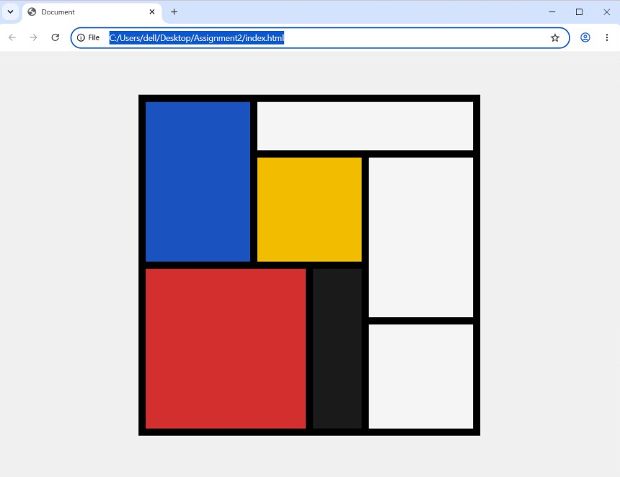
Figure 1 – Mondrian composition built with CSS Grid
How I solved it
First I studied the drawing and worked out how many columns and rows each block covers. Then I made one 6 × 6 grid with repeat(6, 1fr). The container has a black background and a 12px gap, so the thick black lines are simply the gaps between the cells, not borders or margins of the blocks. Every coloured block is placed inside the grid with grid-column and grid-row spans. Because the tracks are made of fr units, the whole composition scales with the window.
Key CSS
.mondrian {
display: grid;
grid-template-columns: repeat(6, 1fr);
grid-template-rows: repeat(6, 1fr);
gap: 12px;
background: #000;
}
.blue { grid-column: 1 / 3; grid-row: 1 / 4; }
.yellow { grid-column: 3 / 5; grid-row: 2 / 4; }
.red { grid-column: 1 / 4; grid-row: 4 / 7; }

Task 2. Component library (Flexbox)
Goal. Build interface components with Flexbox only, in one stylesheet with shared colours, spacing and fonts, and without media queries.

Component 1. Navigation bar
Figure 2 – Navigation bar with logo, links and buttons
How I solved it. The bar is a flex row (display: flex) with justify-content: space-between. The logo and the links stay on the left, and the Log In / Sign Up buttons are pushed to the right edge, so they stay there however long the links become.
.navbar {
display: flex; justify-content: space-between;
align-items: center;
}

Component 2. Row of cards
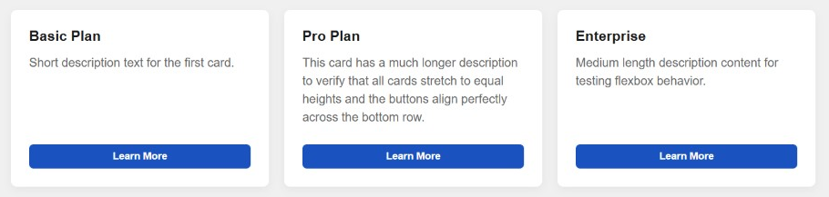
Figure 3 – Equal-height cards with buttons on one line
How I solved it. I put three cards into a flex container. Each card is a flex column, and the description text has flex-grow: 1, so it takes all the free space inside the card. The cards stretch to the same height without any fixed height, and all the Learn More buttons sit on one line at the bottom, even though the descriptions have different lengths.
.cards { display: flex; gap: 16px; }
.card { flex: 1; display: flex; flex-direction: column; }
.card p { flex-grow: 1; }

Component 3. Pagination bar
Figure 4 – Pagination bar with page numbers and result count
How I solved it. The page buttons (« 1 2 3 ») and the result count “Showing 1 to 10 of 50 results” are placed in a flex row with justify-content: space-between. The buttons stay on the left, and the count is pushed to the right edge of the container.
.pagination {
display: flex; justify-content: space-between;
align-items: center; flex-wrap: wrap;
}

Task 3. Three layouts, one markup (Grid and Flexbox)
Goal. Show the same list of products in three ways – a grid of cards, a compact list and a magazine front page – by changing only one class on the container. The HTML stays untouched. The items have titles and descriptions of different length, and there are no media queries.

Layout 1. Grid of cards (layout-grid)
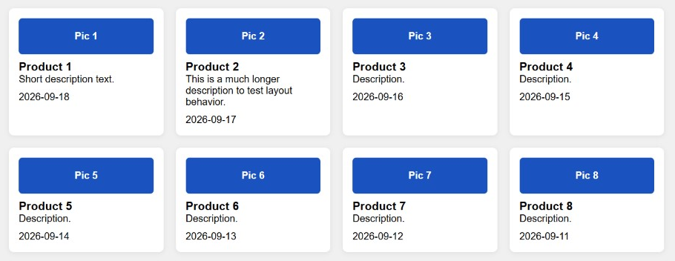
Figure 5 – Grid mode
How I solved it. The container is a CSS Grid with repeat(auto-fit, minmax(220px, 1fr)). The browser puts as many 220px-minimum columns as fit in the window, so the number of columns follows the window width by itself.
.layout-grid {
display: grid;
grid-template-columns: repeat(auto-fit, minmax(220px, 1fr));
gap: 16px;
}

Tool that does the work: CSS Grid with auto-fit and minmax.

Layout 2. Compact list (layout-list)
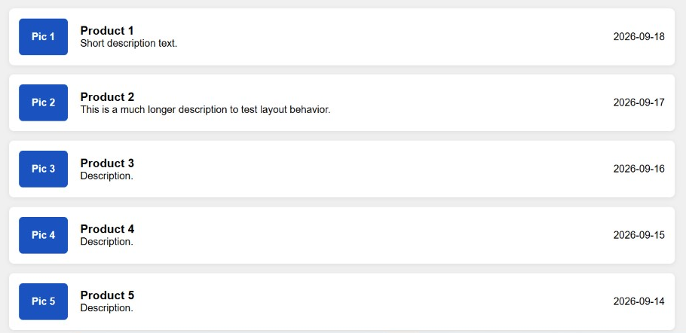
Figure 6 – List mode
How I solved it. I only changed the container class to layout-list. Now every item is a row: the item becomes a flex container (display: flex) that puts the picture on the left, the title and text beside it, and the date at the right edge.
.layout-list .item {
display: flex;
align-items: center;
}

Tool that does the work: Flexbox inside each item builds the row.

Layout 3. Magazine front page (layout-magazine)
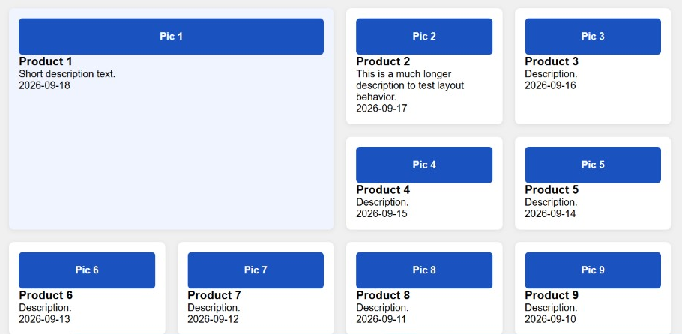
Figure 7 – Magazine mode with a featured lead item
How I solved it. I changed the container class to layout-magazine. The container is a CSS Grid, and the first product card gets grid-column: span 2 and grid-row: span 2, so it becomes a large hero element while the other items fill the grid around it.
.layout-magazine .item:first-child {
grid-column: span 2;
grid-row: span 2;
}

Tool that does the work: CSS Grid with spanning of columns and rows.

Conclusion
In this assignment I learned how to choose between the two layout tools on purpose:
- CSS Grid is for two-dimensional layouts, where rows and columns work together – the Mondrian composition and the grid and magazine views of the products.
- Flexbox is for one-dimensional components – the navigation bar, the cards, the pagination bar and the rows of the list view.
I also learned that the black lines in Task 1 can come from the grid gap alone, that flex-grow keeps cards equally tall without fixed heights, and that repeat(auto-fit, minmax()) gives a responsive layout without media queries. Finally, the three layouts of Task 3 showed me how one HTML markup can look completely different by changing a single class. The layouts do not depend on hacks, fixed sizes or positioning.
GitHub repository
farzanakhashi1-lang/web-dev-assignment2

