Farzaneh Fakhr

- Test whether the test_score table can be changed to BCNF.

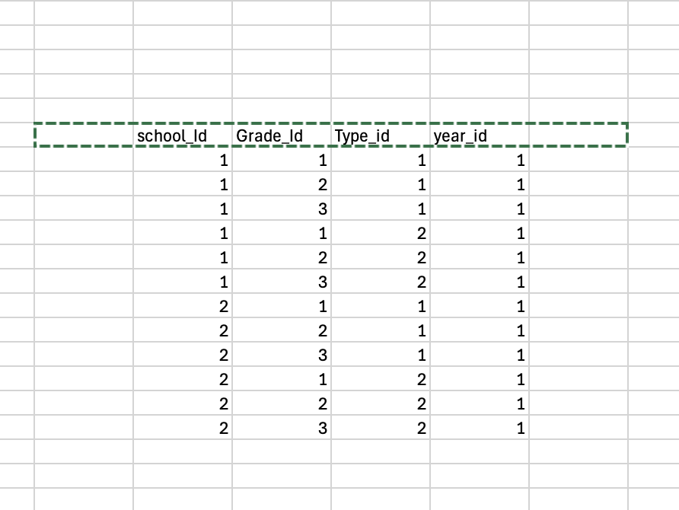

We have an anomaly involving Grade_Id, Type_Id, and Year_Id, so we can move them to a new table called Grade_Table.

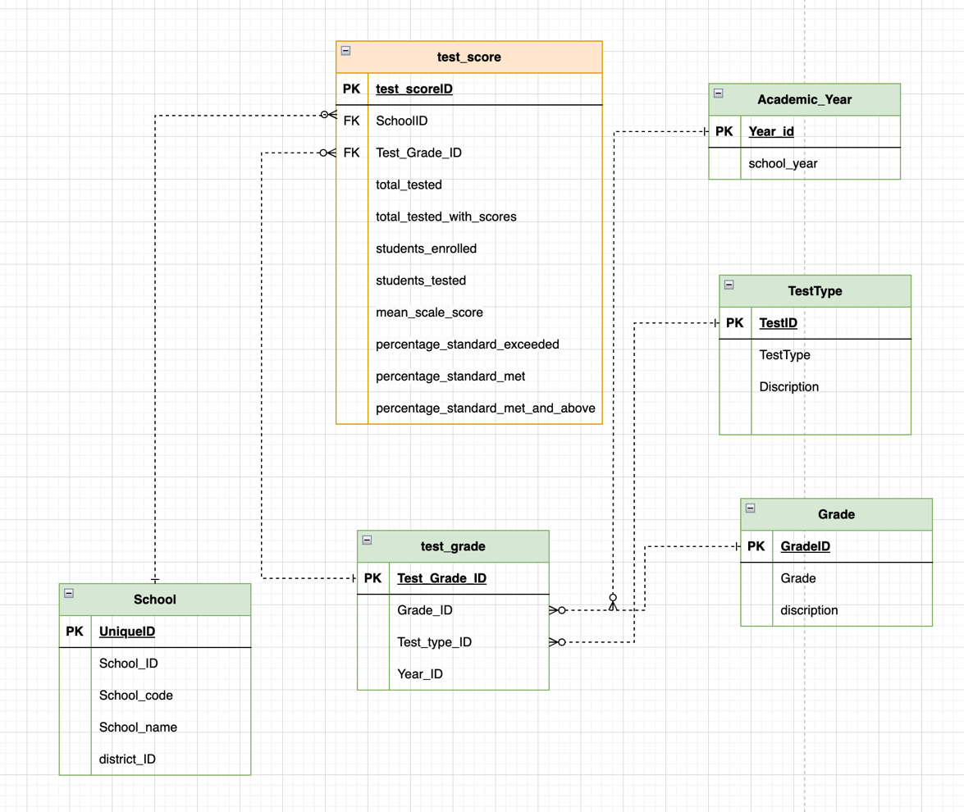

- Test the store procedure for school_dim , SCD type 2

Before the update:

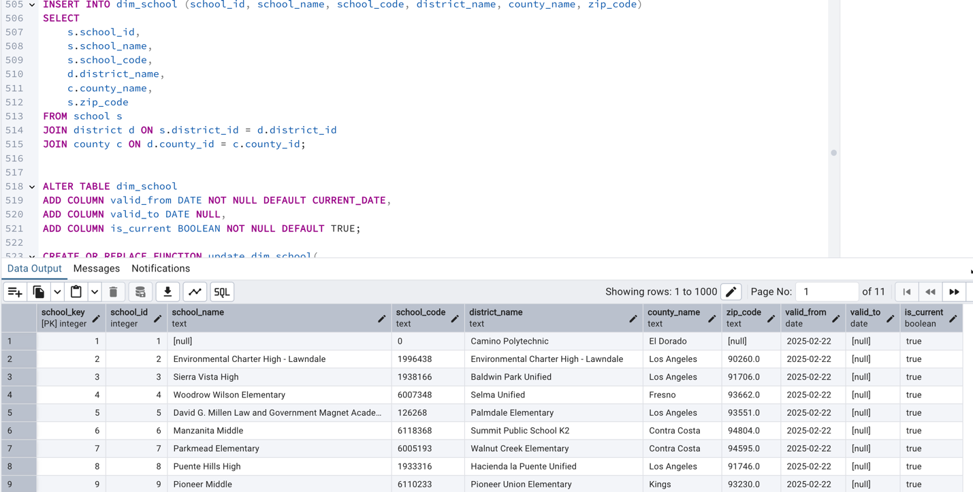

After update:
