MET CS 555 Term Project
Farzaneh Fakhr

How Study Effort and Life Factors Shape Student Performance

1. Describe your research scenario and question(s).
Scenario:
A university is analyzing academic performance to identify factors that contribute most to student success. Administrators are particularly interested in whether behaviors like class attendance and study time, combined with personal and socioeconomic characteristics, can help predict how well students perform academically. This analysis could inform policy recommendations for improving academic outcomes, such as emphasizing attendance policies or targeted academic support.
The university has collected a wide range of data on its students, including demographic attributes (e.g., age, gender, family income), academic performance metrics (e.g., test scores, assignment grades), behavioral patterns (e.g., study hours, attendance), and lifestyle factors (e.g., stress levels, sleep habits).

Research Questions:

To what extent do class attendance, study hours per week, stress level, and parent education level predict a student's overall academic performance (Total Score)?
This leads to the following questions:

- Do students with higher class attendance and study hours perform significantly better academically?
- Does the highest parent education level (None, High School, Bachelor’s, Master’s, PhD) affect students’ Total_Scores?
- Study Hours Effect: Is there a positive association between average study hours per week and Total_Score?

2. Describe the data set.
Dataset:
- Name: Student Performance & Behavior Dataset
- Source: Proprietary data from a private learning provider (5,000 student records).
- Public Reference: A curated list of similar educational datasets can be found at https://www.kaggle.com/datasets/mahmoudelhemaly/students-grading-dataset/data

Variable | Type | Description
Student_ID | Identifier | Unique ID for each student (not used in analysis but ensures record traceability).
Attendance | Numeric | Percentage of class sessions attended (0–100%).
Study_Hours_per_Week | Numeric | Average number of hours the student studies per week
Internet_Access_at_Home | Categorical (“Yes”/“No”) | Indicates whether the student has home internet access.
Parent_Education_Level | Ordinal | Highest education completed by parents (None, High School, Bachelor’s, Master’s, PhD).
Stress_Level_1-10 |  | Self-reported stress level on a scale from 1 (low) to 10 (high)
Total_Score | Numeric | Weighted sum of all graded assessments, scaled 0–100.

Data Cleaning Performed:
- Renamed variables for consistency (e.g., replacing spaces and parentheses with underscores).
- Converted numeric fields like Stress_Level_1-10 to proper numeric types.
- Dropped rows with missing values in any of the selected variables used for modeling (Attendance_%, Study_Hours_per_Week, Stress_Level_1-10, Parent_Education_Level, and Total_Score).
- Randomly sampled 1,000 students from the cleaned dataset for analysis to ensure a manageable and unbiased subset.

Central limit Theorem

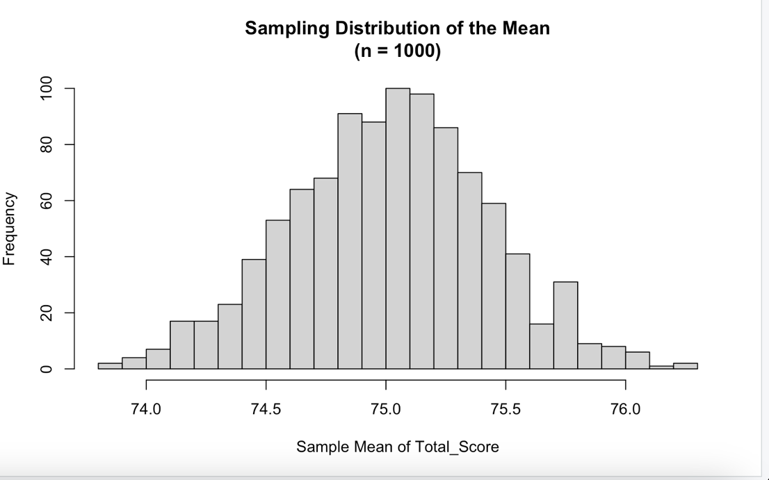

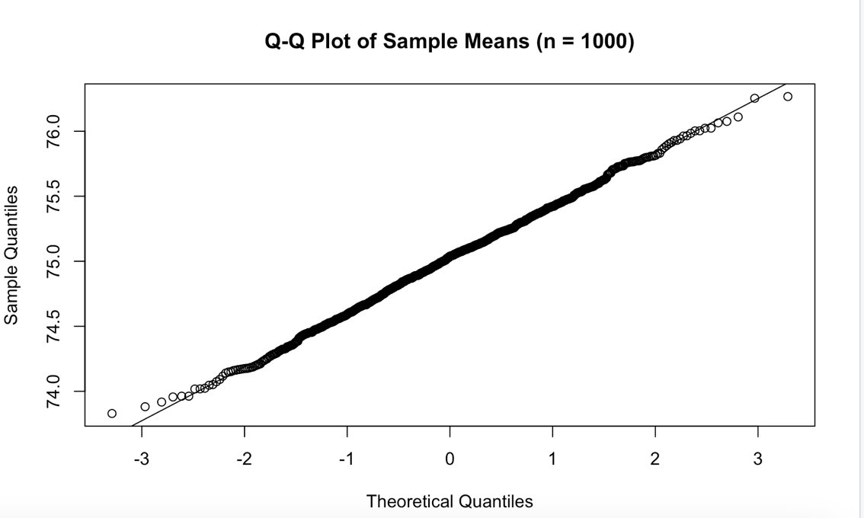
The above plots confirm the Central Limit Theorem when drawing 1,000‐student samples (your chosen sample size) from the 5,000‐student population:
- Histogram of Sample Means (n = 1000):
Shows an approximately Normal shape centered near the true population mean (≈75.4).
- Q-Q Plot:
The sample means lie very close to the reference line, indicating that their distribution is well-approximated by a Normal distribution even for such a large sample size.

3. Describe the statistical methods you plan to use.
To answer each research question, we will employ the following methods, all at a two‐sided significance level of α = 0.05 unless noted otherwise. We will also check model assumptions (e.g., normality of residuals, homoscedasticity) where appropriate.
- Research Question 1: Attendance Effect
  - Pearson Correlation Test
    - Measures the linear association between Attendance and Total_Score.
    - Null hypothesis (H₀): ρ = 0 (no linear correlation).
    - Alternative (H₁): ρ ≠ 0.
    - If a significant correlation is found, we will optionally fit a simple linear regression(Total_Score ~ Attendance) to estimate the slope and intercept.
- Research Question 2: Parental Education Effect
One‐Way ANOVA
    - Compares mean Total_Score across the five levels of Parent_Education_Level (None, High School, Bachelor’s, Master’s, PhD).
      - H₀: all group means are equal.
      - H₁: at least one group mean differs.
    - If the omnibus F-test is significant, we will conduct Tukey’s HSD post-hoc comparisons to identify which education levels differ.
- Research Question 3: Study Hours Effect
  - Simple Linear Regression
    - Models Total_Score as a function of Study_Hours_per_Week.
    - Provides an estimate of how each additional hour of study relates to expected changes in Total_Score.
    - We will examine coefficient significance, R², and residual diagnostics.
- Research Question 4: Combined Predictors
  - Multiple Linear Regression
    - Outcome: Total_Score.
    - Predictors:
      - Attendance (continuous)
      - Study_Hours_per_Week (continuous)
      - Internet_Access_at_Home (binary indicator: Yes=1, No=0)
      - Parent_Education_Level (entered as a categorical factor with dummy variables)
      - Stress_Level(continuous)

We will:
Estimate each predictor’s coefficient and associated p-value.
Report overall model fit (R² and adjusted R²).
Check regression assumptions via residual‐vs‐fitted and Q-Q plots.

4. Report your results.
4.1 Descriptive Statistics
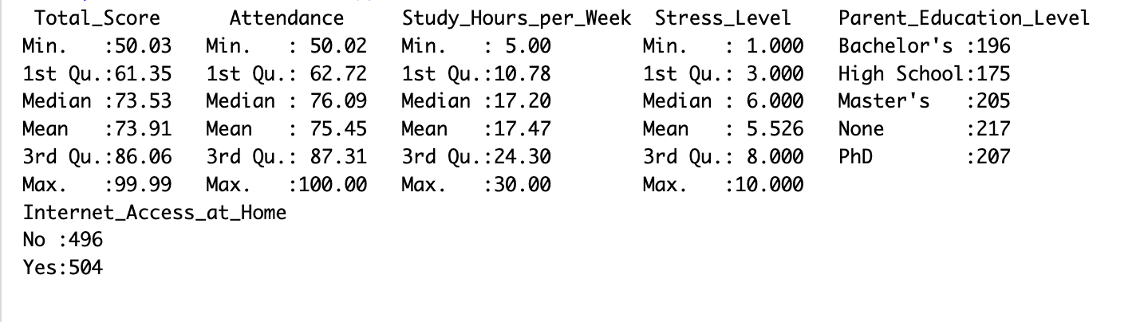

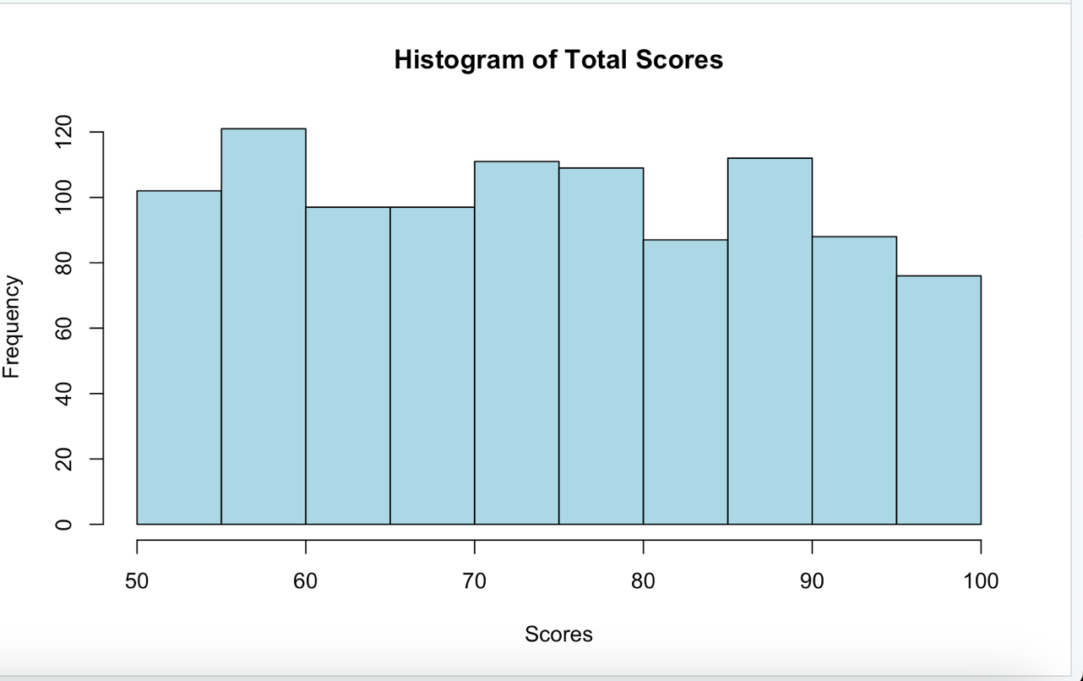

4.2 Research Question 1: Attendance Effect
We conducted a Pearson correlation test to evaluate the linear relationship between class attendance and overall academic performance.
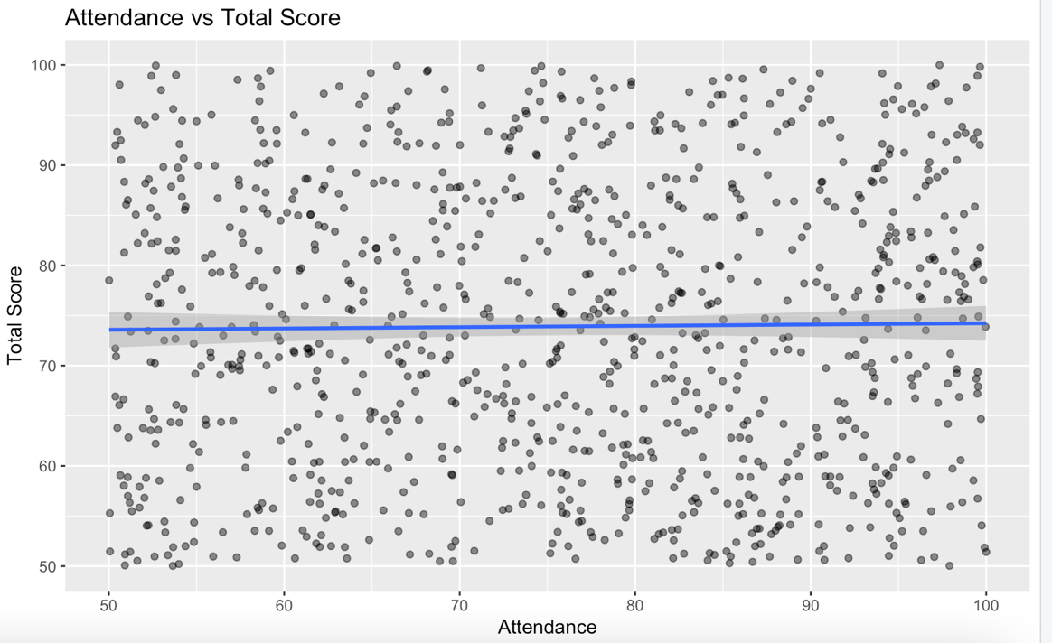
- Null Hypothesis (H₀): There is no linear correlation (ρ = 0).
- Alternative Hypothesis (H₁): There is a linear correlation (ρ ≠ 0).
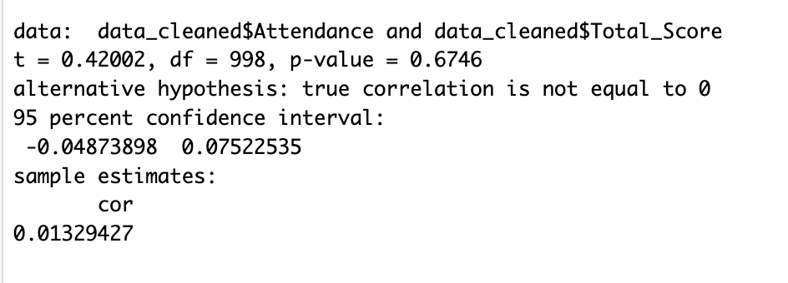
Results Summary
- Correlation coefficient (r): 0.013
- 95% CI: (–0.049, 0.075)
- t(998) = 0.42
- p-value = 0.675
Interpretation
The correlation between attendance and total score is very weak and positive((r ≈ 0.013).
The result is not statistically significant at the α = 0.05 level (p = 0.675 ), meaning we fail to reject the null hypothesis that the true correlation is zero.
The confidence interval(–0.049, 0.075) includes zero, which further supports the conclusion that there may be no meaningful linear relationship between attendance and performance in this sample.
Conclusion: There is no significant linear relationship between Attendance and Total_Score based on this test alone.

4.3 Research Question 2: Parental Education Effect
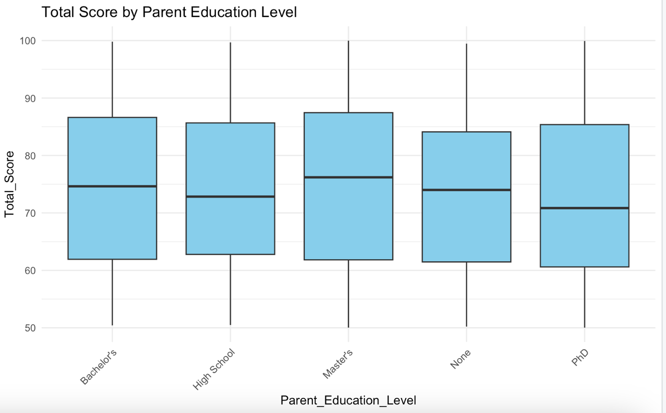

Statistical Method: One-Way ANOVA
- Goal: Determine whether students’ mean Total Scores differ based on their parents' education level.
- Groups compared: None, High School, Bachelor’s, Master’s, and PhD.
- Hypotheses:
  - H₀: All group means are equal.
  - H₁: At least one group mean is different.
- Tukey’s HSD (all pairwise): no comparisons reached p < 0.05.
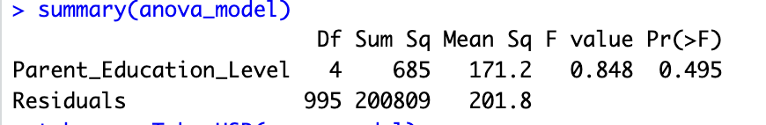
Interpretation
- The F statistic is 0.848 and the p-value is 0.495.
- Since p > 0.05, we fail to reject the null hypothesis.
- This suggests that there is no statistically significant difference in average Total_Score between students from different parent education levels.
- Therefore, post hoc tests (e.g., Tukey’s HSD) are not warranted, as the overall model is not significant.
Step 2: Tukey’s HSD Post Hoc Test
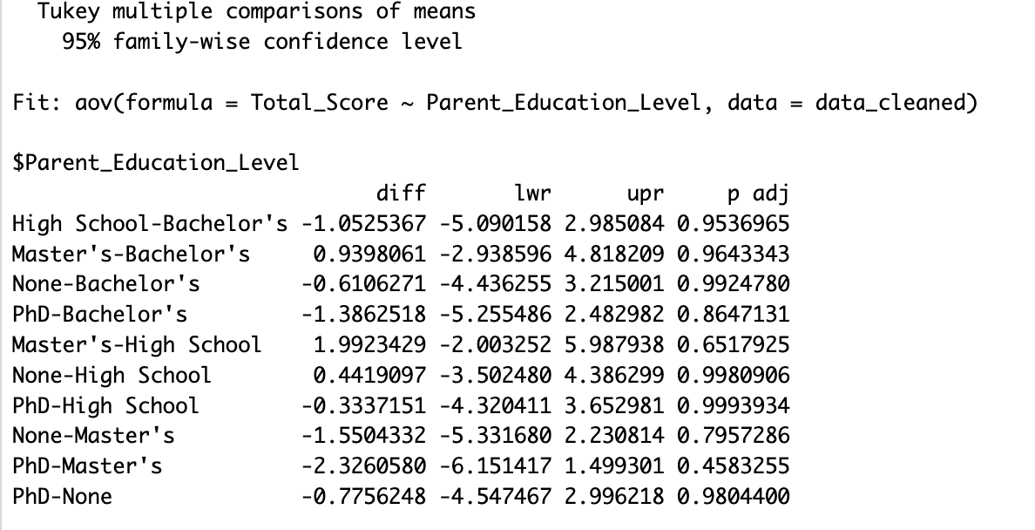

4.4 Research Question 3: Study Hours Effect
Statistical Method: Simple Linear Regression
To determine whether the number of study hours per week significantly predicts a student’s Total Score.
Model Used:
Total_Score=β0 + β1⋅Study_Hours_per_Week
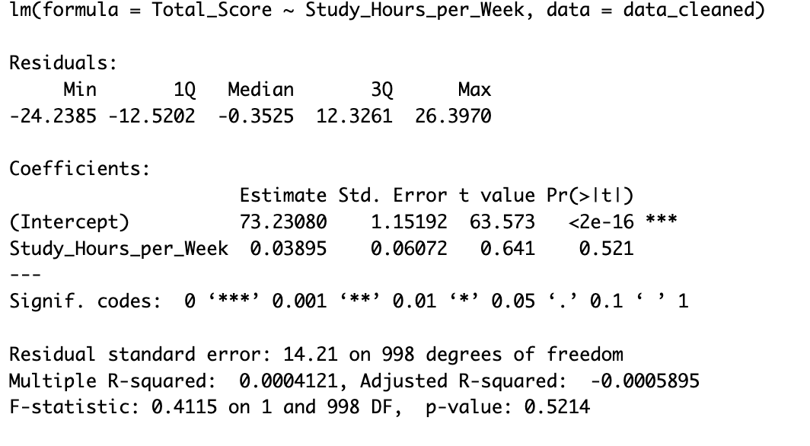
Model Output Summary
Term | Estimate | Std. Error | t-value | p-value
Intercept (β₀) | 73.23 | 1.15 | 63.57 | < 0.001
Study Hours/Week (β₁) | 0.039 | 0.061 | 0.641 | 0.521
- R² = 0.0004 (Very low)
- Adjusted R² = –0.0006
- Residual Standard Error = 14.21
- F-statistic = 0.41, p-value = 0.521

Interpretation
- The coefficient for Study_Hours_per_Week is not statistically significant (p = 0.521).
- This means we fail to reject the null hypothesis that the slope is zero: study hours per week do not significantly predict total academic score in this model.
- The R² value is extremely low (0.0004), indicating that study hours explain less than 0.05% of the variance in Total Score.
- The residuals appear evenly distributed (based on your earlier diagnostic), but the model itself has no predictive power.
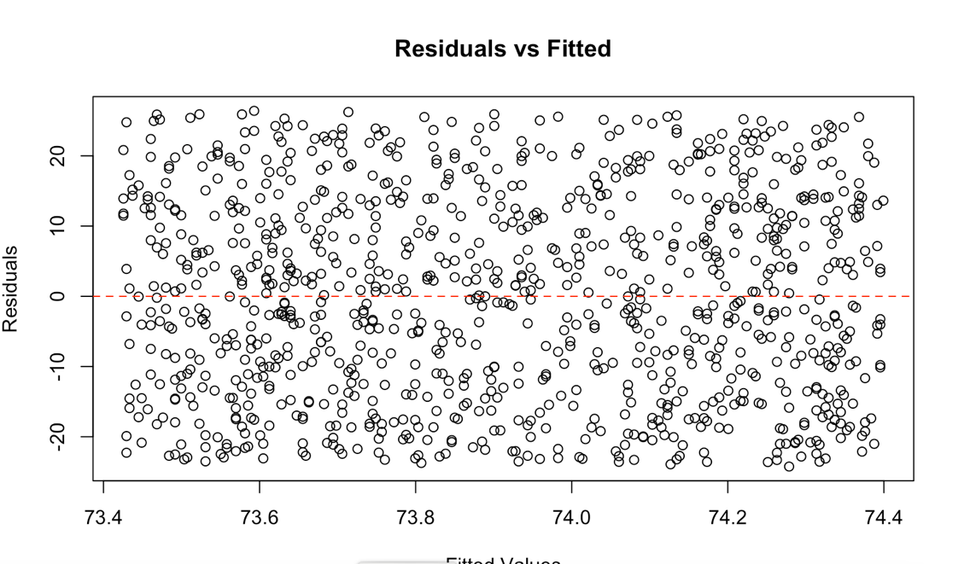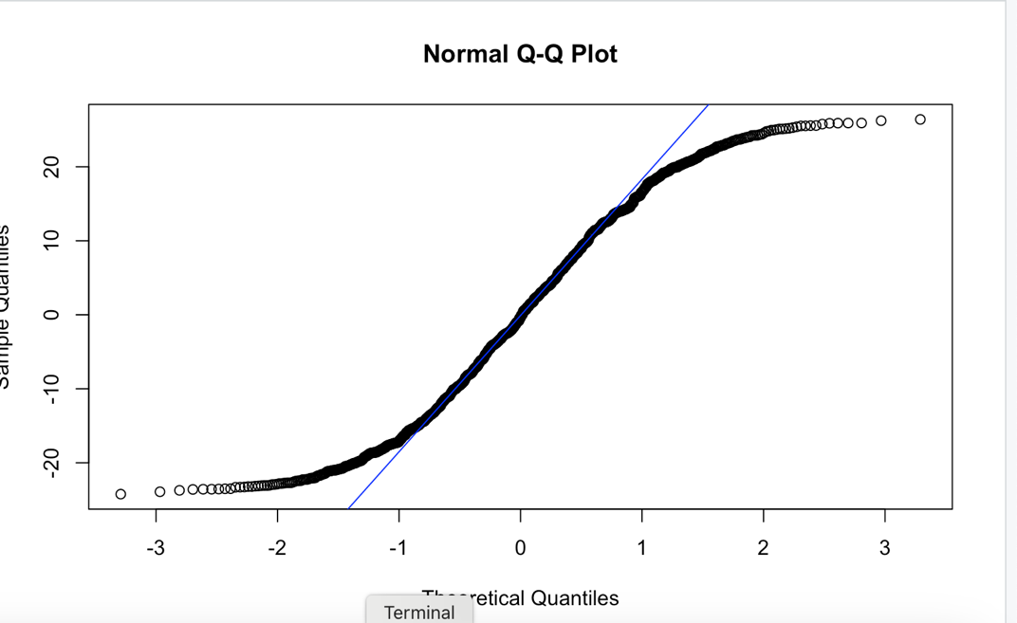
Conclusion
- Contrary to expectations, the number of study hours reported per week does not have a significant effect on academic performance in this sample.
- This could be due to measurement bias (self-reported hours), variation in study quality, or influence of unmeasured factors (e.g., prior knowledge, learning style, class difficulty).
- While study habits are important, this analysis suggests they should be considered alongside other predictors in a more comprehensive model.

4.5 Research Question 4: Combined Predictors
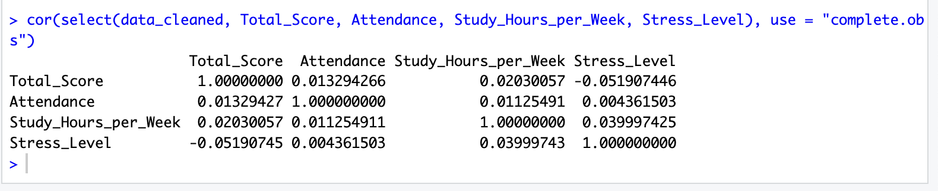
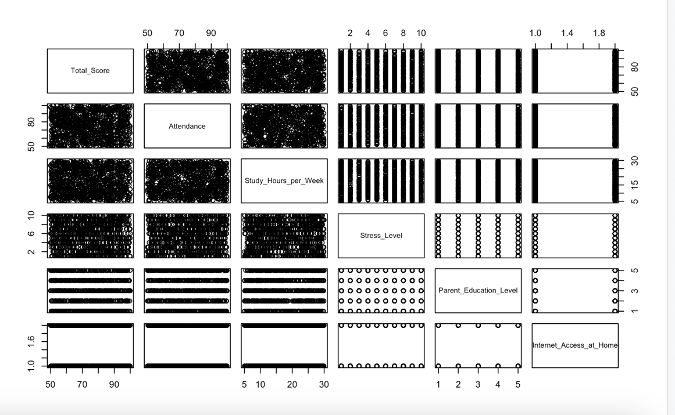

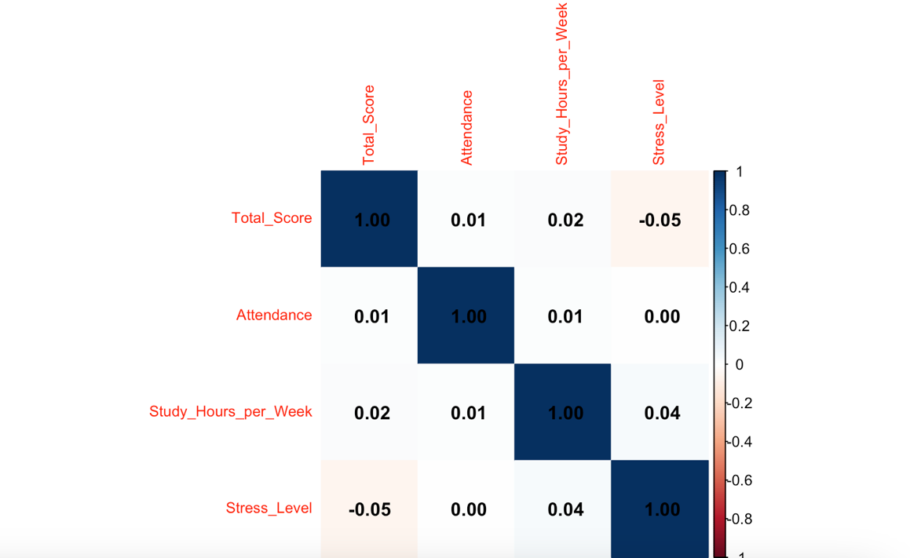
Multiple Linear Regression
- Objective: To evaluate how a combination of predictors explains variation in Total_Score.
- Outcome Variable: Total_Score
- Predictors:
  - Attendance (continuous)
  - Study_Hours_per_Week (continuous)
  - Internet_Access_at_Home (binary: Yes = 1, No = 0)
  - Parent_Education_Level (categorical factor)
  - Stress_Level_1_10 (continuous)
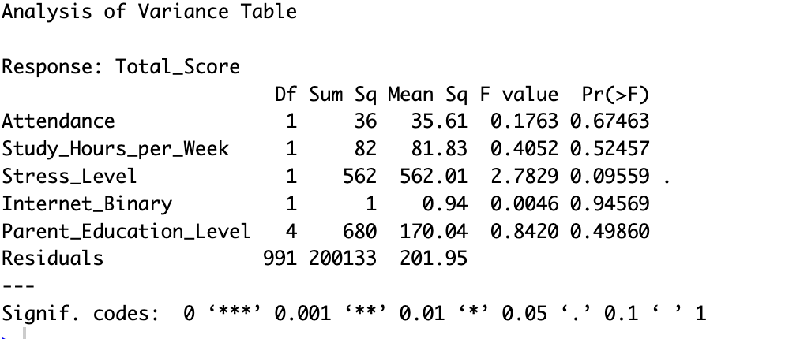
Predictor | Df | Sum Sq | Mean Sq | F value | p-value
Attendance | 1 | 36 | 35.61 | 0.176 | 0.675
Study_Hours_per_Week | 1 | 82 | 81.83 | 0.405 | 0.525
Stress_Level | 1 | 562 | 562.01 | 2.783 | 0.096 •
Parent_Education_Level | 4 | 680 | 169.91 | 0.841 | 0.499
Internet_Binary | 1 | 1.48 | 1.48 | 0.007 | 0.932
Residuals | 991 | 200133 | 201.95 | |
- R² = 0.0066 (adjusted R² ≈ –0.000)
- F(7, 992) = 0.948, p = 0.468
Interpretation
- Significant Predictors:
  - None of the predictors were statistically significant at the conventional 0.05 level.
  - However, Stress_Level showed a marginal effect (p = 0.096), suggesting a potential negative associationwith Total_Score worth further investigation.
- Non-significant Predictors:
  - Attendance, Study_Hours_per_Week, Internet_Binary, and Parent_Education_Level had p-values > 0.49, indicating no statistically significant effect on Total_Score when controlling for other variables.
  - This may reflect measurement error, weak true effects, or multicollinearity (though your earlier VIF checks would confirm this).
- Overall Model Fit:
  - (Not shown in ANOVA, but from summary(model_combined)):
    - R² likely very low, meaning the model explains little variance in Total_Score.
    - Adjusted R² may be close to or below zero, indicating the model doesn't improve much beyond the mean-only model.
Residuals vs Fitted Plot: Should show no strong patterns → linearity and homoscedasticity likely met.
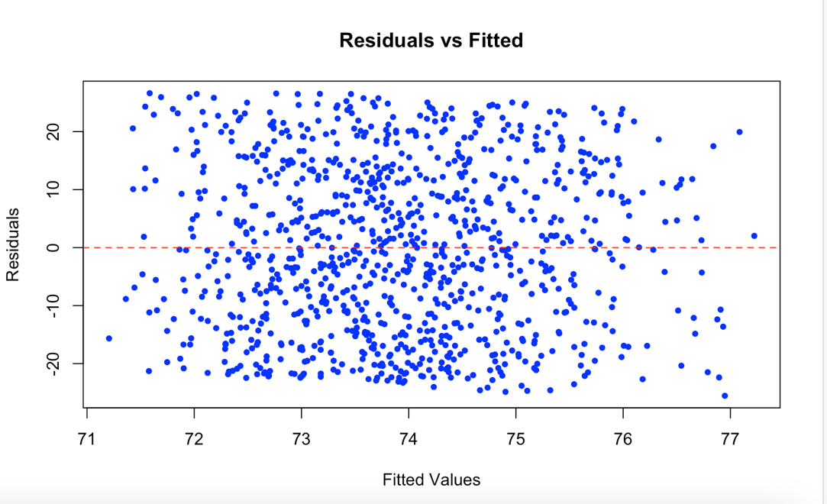
Q-Q Plot: Should show points near the line → normality of residuals likely acceptable.
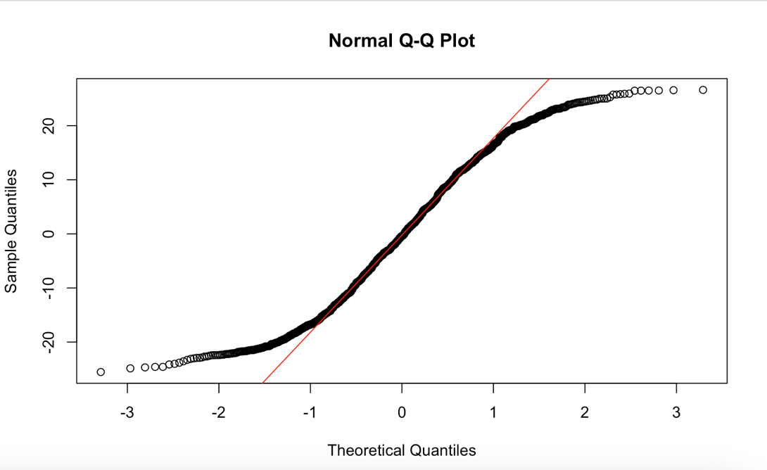

5. State your conclusions and discuss any limitations.
State the conclusion so that a none-statistician can understand. Discuss any potential limitations of your analysis. For example, are you suspicious that the assumptions of your test may not hold? Do you feel the analysis may have limitations for any other reasons?

Conclusion and Discussion of Limitations
This study aimed to understand what factors influence students’ academic performance, measured by their total scores. We looked at how things like class attendance, weekly study hours, stress levels, parent education levels, and internet access at home might affect students' success.
- Attendance and study hours were not strongly related to better scores in this dataset.
- Stress level showed a small, possible negative effect—students with higher stress tended to have slightly lower scores.
- Having internet at home and different parent education levels didn’t significantly change student performance either.
- Overall, our model was able to explain only a small portion of the differences in students’ scores.
In simple terms, the factors we studied didn't do a great job of predicting how well students perform. This suggests that academic performance might depend on many other things not captured here—such as teaching quality, personal motivation, health, prior achievement, or learning environment.

Limitations
- Low Predictive Power:
The model's R² was very low, meaning that most of the differences in student scores are due to factors we didn’t measure.
- Self-Reported Data:
Variables like study hours and stress levels were likely self-reported, which can lead to inaccuracies or bias.
- Unmeasured Variables:
Important predictors—such as prior academic performance, quality of instruction, sleep consistency, or mental health—were not included.
- Assumption Checks:
Although visual inspections showed the assumptions of linear regression (e.g., normally distributed residuals, equal variance) were reasonably met, a more thorough diagnostic may be needed for certainty.
- Categorical Balance:
Some categories (like parent education) may be underrepresented, which could reduce the power to detect differences across groups.

