1. Npm run create user_views
2. 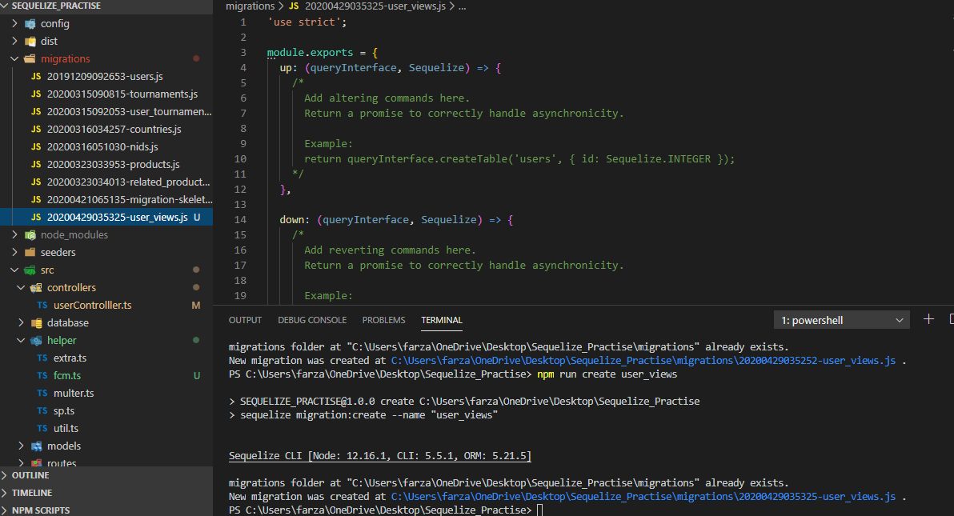
3. 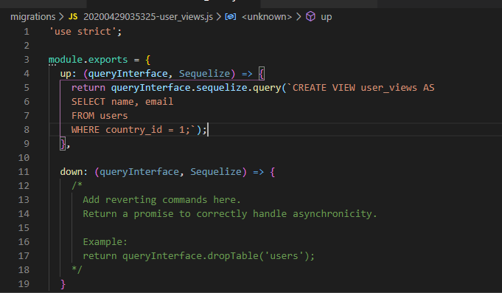
4. For Single Migration:

npx sequelize-cli db:migrate --from 20200421065135-migration-skeleton.js --to 20200429035325-user_views.js