DEPARTMENT OF COMPUTER SCIENCE
Total Marks:
2.5
Obtained Marks:
Database Systems
Lab Task #2

Submitted To: Ms. Bushra shafi

Student Name: Muhammad Jawad

Registration Number: 2412334

Example 1: University Database
A university has several faculties. Each faculty offers multiple programs. Students enroll in
programs, and each student must have an academic advisor who is a faculty member. Some
students may be enrolled in multiple courses at once. The university tracks the grades of each student in each course.
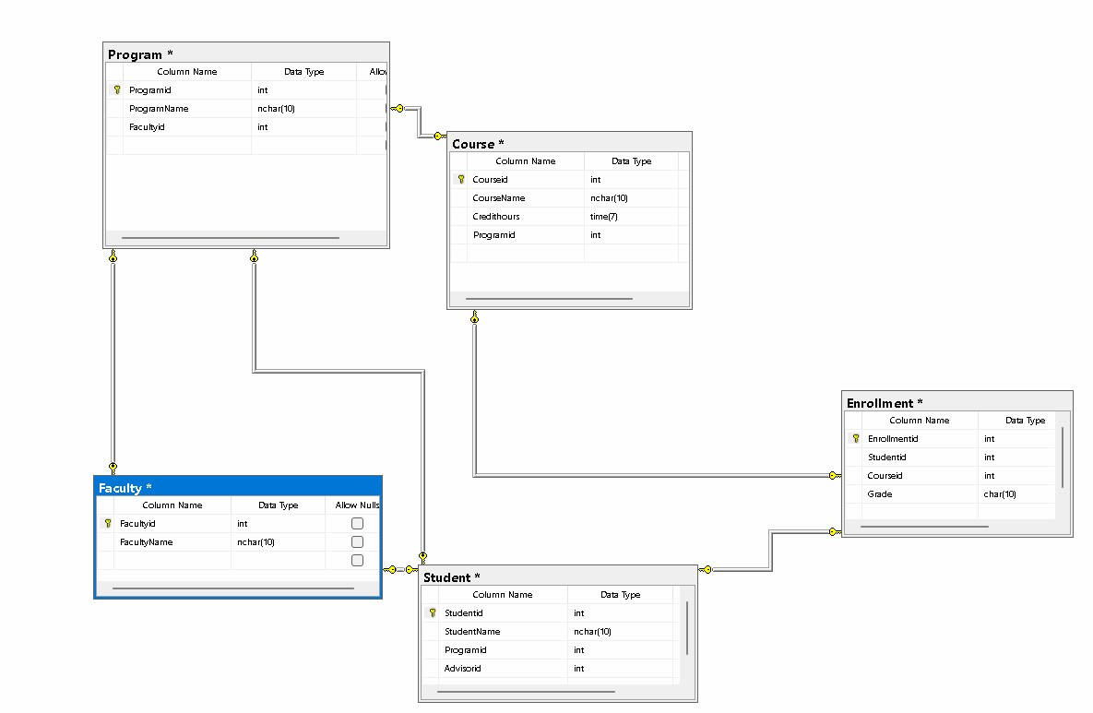
Example 2: Airline Reservation System
An airline operates flights. Each flight has a plane, a pilot, and several crew members.
Passengers can book seats on flights. Each booking has a booking ID, date, and seat number.
A passenger may book multiple flights, and a flight may have many.
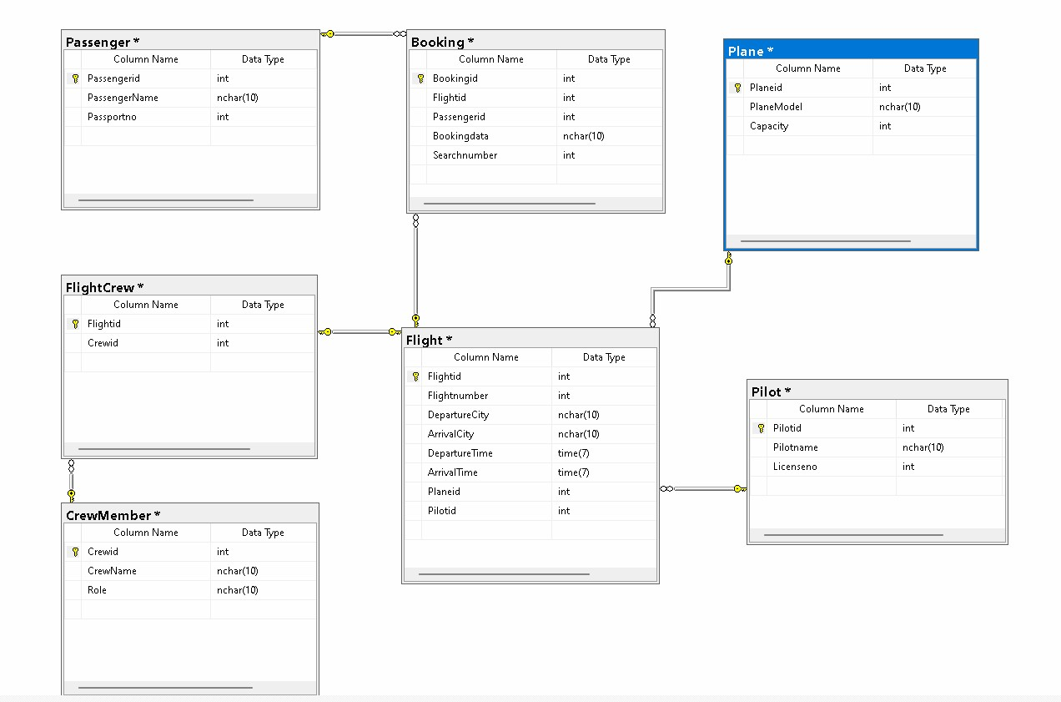
Example 3: Hospital Management System
A hospital employs doctors, nurses, and administrative staff. Doctors treat patients, and
treatments involve prescriptions. Each prescription includes multiple medicines with dosage
instructions. A patient may be admitted to a ward, and each ward is
supervised by a nurse.
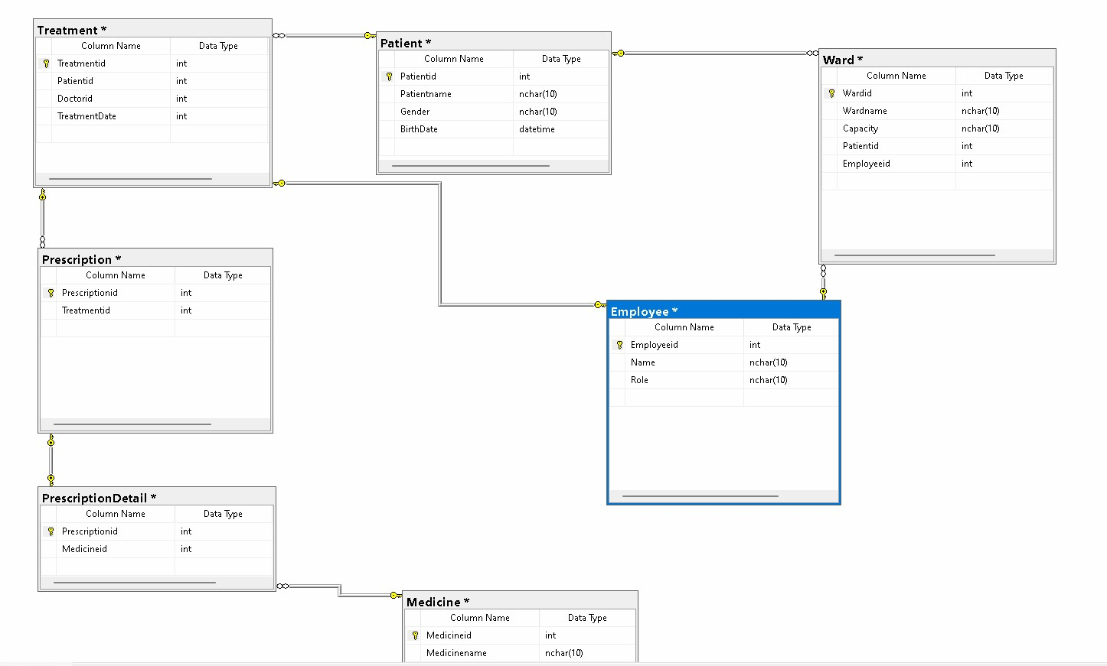
Example 4: E-commerce Database
An online store sells products. Products belong to categories and are supplied by suppliers.
Customers place orders that can contain multiple products. Orders have shipping details and
payment transactions. Customers may also provide product reviews, which include rating and comments.
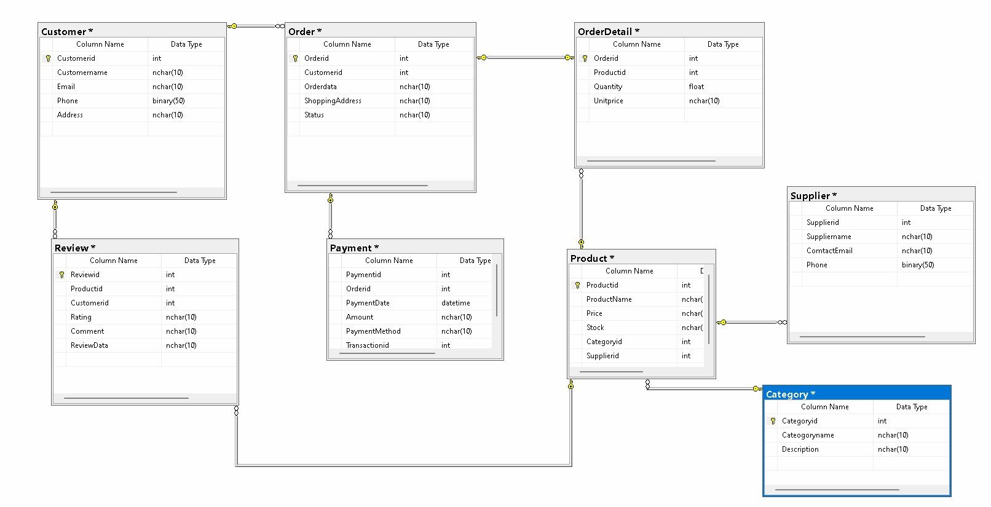
Example 5: Banking System
A bank has customers who own accounts. Accounts can be savings or current. Customers can
perform multiple transactions (deposit, withdraw, transfer). Each
transaction is linked to one
account but may involve another account (in case of transfer). The bank
tracks loan
information, where customers can take loans linked to their accounts.
