Product dependence and monitoring network uncertainty constrain water storage attribution across Thailand
Farzeen Khan
Water Engineering and Management, Asian Institute of Technology, Thailand

Abstract
Separating water-storage decline into climatic and human components requires more than a high prediction score. This study assessed terrestrial and groundwater storage anomalies (TWSA and GWSA) across Thailand's 22 principal basins using documented CSR RL06.3 mascons, a full-compartment groundwater balance, paired naturalized and historical-human WaterGAP simulations and 5,484 observed aggregates from 511 wells. The analysis combined seasonal Sen and Mann–Kendall methods with common-support product comparisons, climate-memory ablations, independent-precipitation forcing tests, additive trend uncertainty and station-panel resampling. National CSR-based TWSA declined by 7.51 mm/year through September 2024 and GWSA by 6.84 mm/year through September 2023. The contrasting COST-G/G3P chain retained a national negative direction but showed weak basin-ranking agreement: Spearman coefficients were 0.138 for TWSA and 0.027 for GWSA. Climate memory raised national held-out anomaly NSE from 0.283 to 0.890 for TWSA and from 0.039 to 0.723 for GWSA relative to current-weather Ridge models. Replacing native precipitation with CHIRPS reduced anomaly skill, exposing forcing dependence. The exact residual decomposition retained both the modeled direct-human perturbation and observation–historical-model discrepancy. The discrepancy-magnitude diagnostics were 0.938 and 0.991; these are descriptive indices, not causal human fractions. Longest-overlap residual–head correlations were 0.127 and 0.037, with broad station-bootstrap intervals. A strict balanced 2013–2022 panel gave groundwater correlation close to zero over eight usable storage years. The study demonstrates robust broad decline alongside unstable local rankings and unresolved human attribution. Its proposed contribution is an auditable credibility assessment linking processed gravity support, climate reconstruction and observation-network uncertainty, released with reproducible code and decision-support outputs.
Keywords: GRACE; groundwater; climate reconstruction; GLDAS; attribution; basin validation

1 Introduction
Satellite gravimetry can identify broad water-storage change, but identifying its causes requires additional assumptions about storage compartments, natural variability and human intervention. A groundwater anomaly obtained by subtracting non-groundwater storage from GRACE is already a combined observational–model estimate. Its trend can therefore depend on the processed gravity product, the land-surface representation and the spatial support of the subtraction. A statistically significant local decline is not, by itself, a measured pumping signal.
Thailand illustrates the resulting inference problem. Earlier studies have examined storage dynamics and extremes in the Chao Phraya system and have compared derived groundwater storage with in situ observations (Abhishek et al., 2021; Sharma et al., 2025). Water-budget research also identifies the value of multisource information in this setting (Abhishek et al., 2022). These contributions establish that storage separation and groundwater comparison are not new to Thailand. The outstanding question addressed here is how robust the attribution remains when the processed product, climatic information and monitored well population are examined together across a national basin framework.
A further ambiguity arises when machine learning is trained directly on observed storage and its prediction is named a climate-only baseline. The observed target can already contain management effects, and some candidate predictors, including actual evapotranspiration and soil moisture, can respond to irrigation. A fitted relationship may be useful for reconstruction without identifying an unmodified climatic counterfactual. A documented naturalized hydrological experiment provides a more explicit baseline, although its regional accuracy must still be evaluated (Müller Schmied et al., 2024).
Groundwater observations do not automatically resolve that ambiguity. Wells measure local head rather than regional water mass. Available records can mix aquifers and aggregation intervals, and the set of monitored stations can change. A positive correlation with a total-storage residual may reflect groundwater behaviour, shared climatic forcing, a common trend or network composition. A strong association for one chosen panel is therefore less informative than a comparison that preserves common time support and tests how the observation network affects it.
We develop an attribution-credibility assessment combining three linked experiments. First, documented CSR RL06.3 storage is compared with a contrasting COST-G/G3P chain on common support, while native mascon mapping exposes shared basin representation. Second, naturalized-model reconstruction is tested through controlled climate-memory ablations and frozen-model precipitation replacement. Third, the paired hydrological residual is assessed against observed heads using station resampling and common-period balanced panels. The accounting identity and learning algorithms are established tools; the contribution is the controlled integration and the empirical evidence it reveals.
The analysis addresses all 22 principal basins and national context. It asks whether broad decline and basin ordering are equally robust, whether climate memory adds information beyond seasonality, and whether groundwater agreement supports an interpretation of the residual as human depletion. The expected output is an evidence-qualified assessment rather than a predetermined human fraction. Reproducible tables and an interactive delivery system make both supporting and limiting evidence available for review.

2 Materials and methods

2.1 Study domain and documented inputs
We use the supplied Office of the National Water Resources principal-basin geometry and polygon–grid intersection weights. Separately coded island features are grouped with their parent basin. The 22-basin framework distinguishes the principal basin labelled Chao Phraya from upstream basins such as Ping, Wang, Yom and Nan; it is therefore not identical to every greater-Chao-Phraya domain in earlier literature. National intersection-area support is approximately 515,230 km².
The primary gravity input is the CSR RL06.3 all-corrections record, downloaded with the provider land mask and native-mascon mapping. Source checksums and a nominal-month audit are retained. Units are converted from centimetres to millimetres; source time attributes are decoded explicitly. Special solutions centred in late October 2011 and April 2015 are assigned to nominal November 2011 and May 2015, respectively, following the established special-month convention. No mission-gap interpolation, additional empirical smoothing or gain factor is applied (Save et al., 2016; CSR, 2026; Sutterley et al., 2026).
The principal TWSA period is April 2002–September 2024, containing 237 observed solutions. Surface-water coverage limits the full-balance GWSA record to September 2023 and 225 observed months. COST-G/G3P v1.12 and the original unidentified export are sensitivity records. Their satellite information is not independent of CSR, and the unidentified export is not treated as an additional identified solution. GLDAS Noah supplies soil, canopy and snow storage; G3P supplies surface water and related structural alternatives (Rodell et al., 2004; Güntner et al., 2024).
WaterGAP 2.2e naturalized and historical-human runs share GSWP3–ERA5 forcing and extend through 2023. Ten regional variable/scenario subsets are retained. Monthly identities from their synthetic 360-day calendar are mapped to month-start labels without daily interpolation. Meteorological rates are expressed as mean millimetres per day rather than converted to physical monthly totals using an assumed synthetic-month length. The supporting 2003–2024 cube contains CHIRPS precipitation, GLEAM and MODIS ET, surface and root-zone moisture and land-surface temperature (Funk et al., 2015; Martens et al., 2017; Gruber et al., 2019).
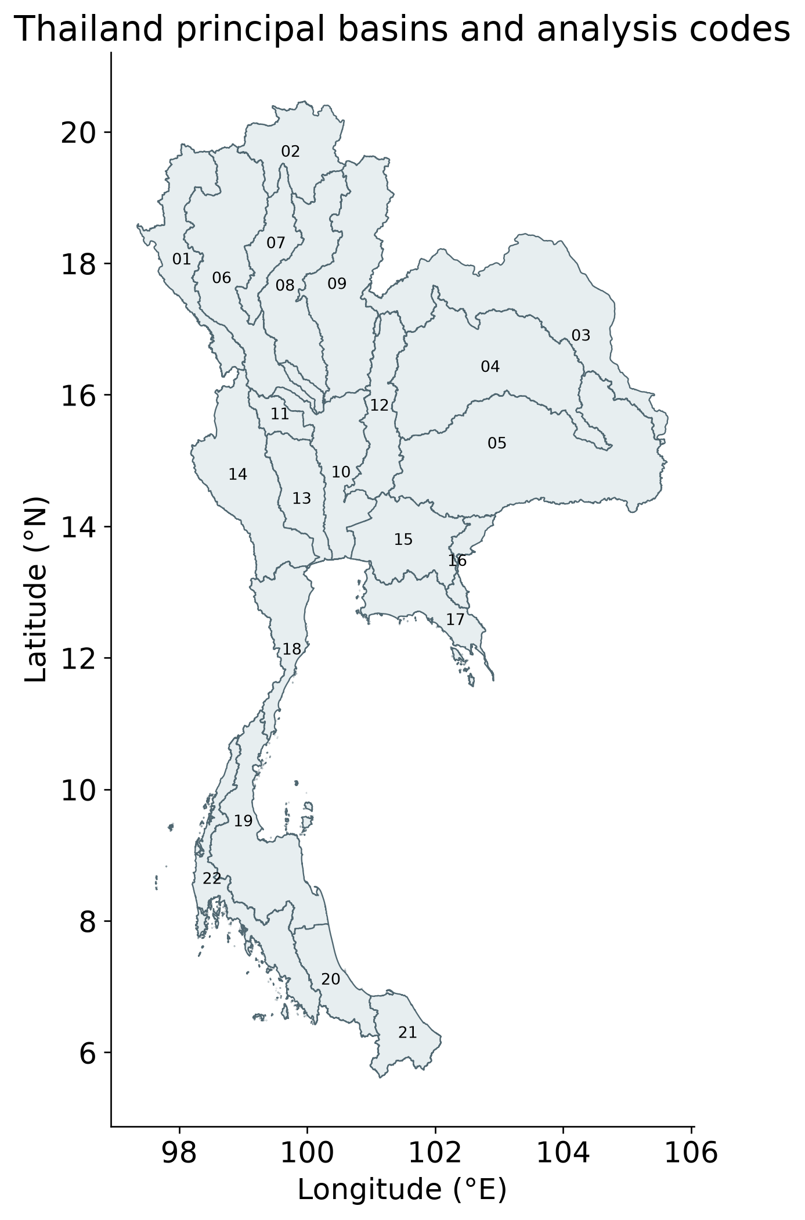
Figure 1 Thai principal basin framework; all temporal atlases retain the 22 basin codes.

2.2 Storage balance and spatial-support controls
Basin means use polygon–grid intersection areas and the fraction of valid basin area for each month. A minimum 50 percent area threshold is required. Coarse component and model cells are assigned to aligned quarter-degree locations using nearest-parent replication, which creates no new independent spatial information. The groundwater calculation uses a common valid-cell mask and a common 2004–2009 observed reference for every compartment.
The full balance subtracts soil-moisture, surface-water, canopy and snow anomalies from the matching TWSA reference. Both grid-level and regional identities are verified. A filtered root-zone soil alternative changes the soil representation while retaining the CSR baseline. The native G3P groundwater product provides a full-chain comparison; because gravity processing and compartment definitions differ, its disagreement cannot be assigned to a single source of error. Compartment compatibility remains structural uncertainty rather than a corrected quantity (Sharifi et al., 2025).
Processed products are compared on identical valid cells and months and rebased to a common valid reference. Seasonal Sen slopes and their basin ranks are compared separately. Native weights are aggregated by CSR mascon identifier; inverse weight concentration and pairwise shared weight describe mapped spatial support. These diagnostics are not counts of independent information or estimates of gravity-error covariance. We follow the provider's restriction to basin time-series interpretation and retain a small-basin caution for every principal basin (Longuevergne et al., 2010; CSR, 2026).
$GWSA = TWSA − SMSA − SWSA − CWSA − SWEA$

2.3 Trend estimation and conditional inference
Seasonal Sen slopes are the median of same-calendar-month pairwise rates using actual elapsed years. Original and seasonal Mann–Kendall tests are retained, with Benjamini–Hochberg adjustment within each 22-basin storage family. Missing dates are not compressed or filled. Primary slope intervals use 300 calendar-year residual-block resamples and describe uncertainty within the selected processed record rather than complete product uncertainty (Sen, 1968; Hirsch et al., 1982; Hirsch and Slack, 1984; Benjamini and Hochberg, 1995).
Fixed early, later, pre-gap and post-gap windows assess period dependence. Short-window slopes are descriptive, not acceleration estimates or forecasts. Cross-product Spearman coefficients describe rank stability; their p-values are not interpreted as independent spatial replication because basin information overlaps. Direction agreement and magnitude differences are reported alongside ranking.
For additive attribution we fit OLS with a time trend and calendar-month fixed effects on identical observed dates for all components. A shared-sign calendar-block wild regression bootstrap produces 999 conditional slope replicates for block lengths of one, two and three years. Original missingness and the component identities are retained. The resulting percentile intervals are unstudentized conditional assessments; they do not propagate all gravity, forcing and structural uncertainties or provide a complete small-sample inferential guarantee (Cameron et al., 2008).

2.4 Climate memory and independent forcing stress tests
The principal climate emulators reconstruct naturalized WaterGAP storage from precipitation, potential evapotranspiration, causal weather lags, exponentially weighted memories and seasonal harmonics. Warm-up uses 1981–1990, training 1991–2009, validation 2010–2015 and testing 2016–2023. Tuning and transformations use chronological training folds. Ridge, ElasticNet, splines and Random Forest form the original candidate ensemble; validation fixes member selection and weights before testing (Hoerl and Kennard, 1970; Breiman, 2001; Zou and Hastie, 2005; Roberts et al., 2017).
Controlled Ridge ablations compare five prespecified feature groups: season only, current weather with seasonality, lagged weather, lagged weather plus memory, and weather memory without seasonal harmonics. Precipitation and potential-ET lags are 0, 1, 2, 3, 6 and 12 months; memory scales are 1, 3, 6, 12 and 24 months. Test metrics include raw monthly scores and anomaly NSE after subtracting a training-derived climatology. They verify a parent model, not independent storage observations (Gupta et al., 2009; Knoben et al., 2019).
A frozen full Ridge model is then driven with unadjusted CHIRPS precipitation and with a training-only calendar-month mean adjustment. CHIRPS totals are divided by actual calendar-month days to match the mean-rate convention. The target remains the native-forced naturalized simulation, so this is a covariate-shift experiment rather than a ranking of rainfall accuracy. Memory error reduction is assessed with 999 circular paired two-year resamples of the eight test years.
A complementary observed-response test selects precipitation accumulations of 1, 3, 6 or 12 months and lags of 0–6 months in 2003–2015. Development-only seasonal and linear-trend references are retained when evaluating 2016–2023. The selected relationship is frozen before the later-period correlation is calculated. Whole-year precipitation permutations and basin FDR provide a conditional screen. These empirical delays are not interpreted as unique recharge or aquifer residence times.

2.5 Paired model attribution and discrepancy
Let O denote observed storage, C the naturalized model and A the paired historical-human model. We calculate the modeled direct-human perturbation H=A−C, the observed residual R=O−C and discrepancy E=O−A. Every term shares the valid observed footprint and common reference. The monthly and fitted-trend identities are checked exactly. Sen component slopes remain separate because medians are not additive.
The descriptive magnitude diagnostic D=|βE|/(|βH|+|βE|) measures whether the discrepancy trend is large relative to the represented human perturbation. It is not a causal human fraction, a proportion of observed decline or an allocation of independent error variances. Shared bootstrap multipliers provide conditional intervals while preserving the trend identities.
H is a change in the human perturbation represented by the model relative to the anomaly reference; it is not cumulative depletion before GRACE. E may include unrepresented human intervention as well as model, forcing, observation and compartment errors. Neither the full residual nor the full discrepancy is assigned a unique physical cause. This makes the conditions for a human-depletion interpretation explicit instead of hiding them in a residual label.
$R = O − C = (A − C) + (O − A) = H + E$

2.6 Groundwater evidence and network uncertainty
The GROW extraction retains 5,484 actual aggregates from 511 Thai wells: 5,259 annual aggregates from 506 wells and 225 monthly aggregates from five wells. Provider flags and aggregation intervals are preserved; gap-filled groundwater values are excluded. Signed head is negative depth below ground. Descriptive well-standardized indices are combined by coordinate-station median before equal-weight regional averaging. No specific yield or storativity is invented, because aquifer construction and storage coefficients are insufficiently documented (Bäthge et al., 2026).
Annual head comparisons use annual storage means with at least eight observed months and exclude incomplete endpoint years. Raw agreement is supplemented by climate-controlled, detrended and consecutive-observed-year-change associations; nonconsecutive years are not treated as annual differences. A 499-replicate coordinate-station bootstrap resamples complete station trajectories and quantifies network sensitivity conditional on the observed years. It is not a temporal or causal correlation interval.
Five conditions are retained: longest overlap with flags, exclusion of flagged observations, a wider-history panel eligible under an eight-of-ten-year rule, all available wells restricted to 2013–2022, and a strict ten-of-ten-year panel on that same window. The last two conditions were added as an explicitly exploratory network extension. Their common observed storage years distinguish a time-window change from a panel-composition change. A separate well-trend screen requires at least eight annual observations and an eight-year span, then groups colocated trajectories for direction summaries.

2.7 Independent reservoir-component evidence
An exploratory extension adds MSEA-Res reservoir storage (Mahto et al., 2025; dataset DOI 10.5281/zenodo.14844580), independently derived from Landsat water area and hypsometry. Outlet coordinates are assigned to principal-basin polygons. A fixed panel contains only reservoirs commissioned before 2004. Monthly summed storage is retained only when all panel members are represented, converted from km³ to basin-equivalent mm and referenced to available 2004–2009 months. No new filling is applied. Level 1 uses screened scene estimates with gaps; Level 2 uses the provider spline-interpolated, smoothed product and requires at least 20 daily records per month.
Correlations use actual common months. Calendar-month effects and linear trend are removed on that same matched support; 499 calendar-year cluster resamples give conditional intervals. Adjustment for naturalized storage is descriptive. This user-requested extension was added after the groundwater analyses; no emulator was retuned using reservoir agreement. Reservoir changes respond to weather and management, so this checks a component rather than directly validating human-only TWS or GWS.

2.8 Spatial and temporal evaluation figures
The figure revision presents all 22 basin records, retaining mission gaps and unavailable validation. Spatial observed trends use seasonal Sen slopes and seasonal Mann–Kendall basin FDR; additive climate/residual maps use calendar-month fixed-effect OLS slopes. The frozen ensemble is evaluated against its naturalized parent on 2016–2023 data using raw and training-climatology-anomaly NSE and RMSE, with separate annual diagnostic scores. No test-year refitting is introduced.
Groundwater maps report raw and detrended correlation with annual support; matched temporal panels retain actual year gaps. Eight-calendar-year rolling head correlations require six observed pairs and are descriptive because windows overlap. Reservoir maps retain screened scene estimates independently from provider interpolation. No head-to-water-storage coefficient, missing observation or human-only validation target is invented.

3 Results

3.1 Broad decline persists but basin ranking is product dependent
National CSR TWSA declines at −7.51 mm/year over the full record, with a conditional 95 percent interval of −9.79 to −5.68. Primary GWSA declines at −6.84 mm/year, with an interval of −8.77 to −5.11. All 22 principal basins have negative primary slope estimates, although their magnitudes differ greatly and all remain below the provider's approximate small-basin caution area.
On the common 223-month source support, national TWSA slopes are −7.67 mm/year for CSR and −2.56 mm/year for COST-G/G3P; corresponding groundwater slopes are −6.88 and −3.45 mm/year. Basin rank agreement is weak, with Spearman coefficients 0.138 and 0.027. The legacy export closely resembles CSR numerically but cannot be counted as independent identified replication. The national sign is therefore more stable than a local severity ordering.
The filtered-soil CSR groundwater alternative declines at −7.86 mm/year nationally, retaining the sign but changing the magnitude by about 1.02 mm/year. This and the full-chain comparison demonstrate distinct structural sensitivities. Native mapping identifies 68 touched mascons nationally and an inverse weight-concentration count near 50.1, while individual basins have smaller, uneven support. These are representation diagnostics rather than independent sample sizes.
Table 1 National full-record primary seasonal Sen slopes
Storage | Months | Slope mm/year | 95% interval
TWSA | 237 | −7.51 | −9.79 to −5.68
GWSA | 225 | −6.84 | −8.77 to −5.11
Spatial GRACE storage trends and Mann Kendall evidence
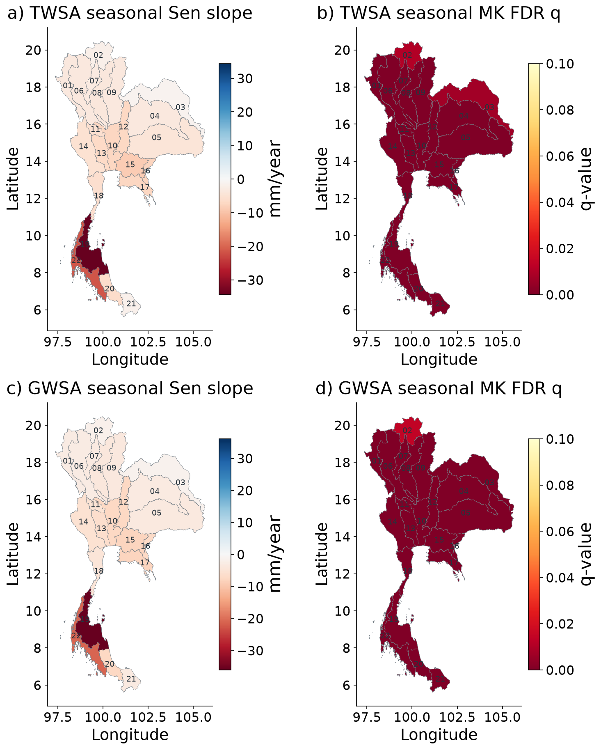
Figure 2 Basin-average CSR TWSA and compartment-derived GWSA; seasonal Sen slopes and basin FDR q. q colours saturate at 0.10. Seasonal MK does not correct serial dependence; slope intervals are supplied in the numerical tables. All basins retain the CSR small-support caution.
Observed storage time series for all 22 basins
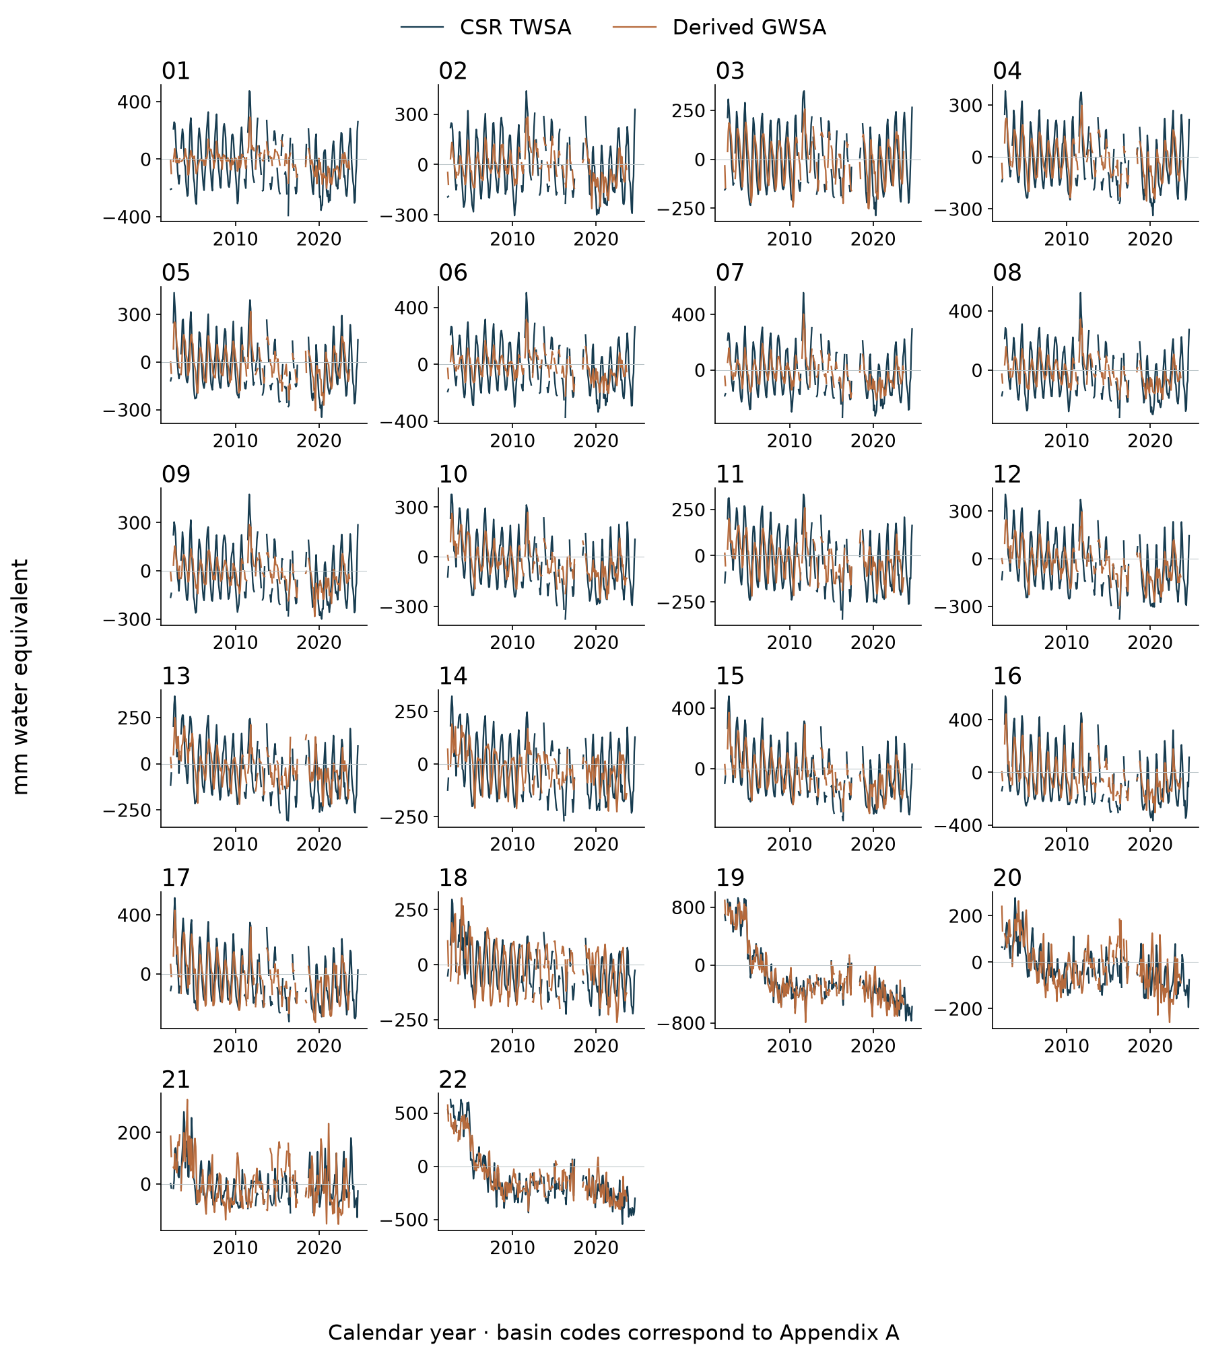
Figure 3 Monthly CSR TWSA and full-compartment GWSA, in mm. Mission gaps remain missing and GWSA ends in September 2023. Basin codes identify every subplot; full names are in Appendix A.
Product dependent basin ranking
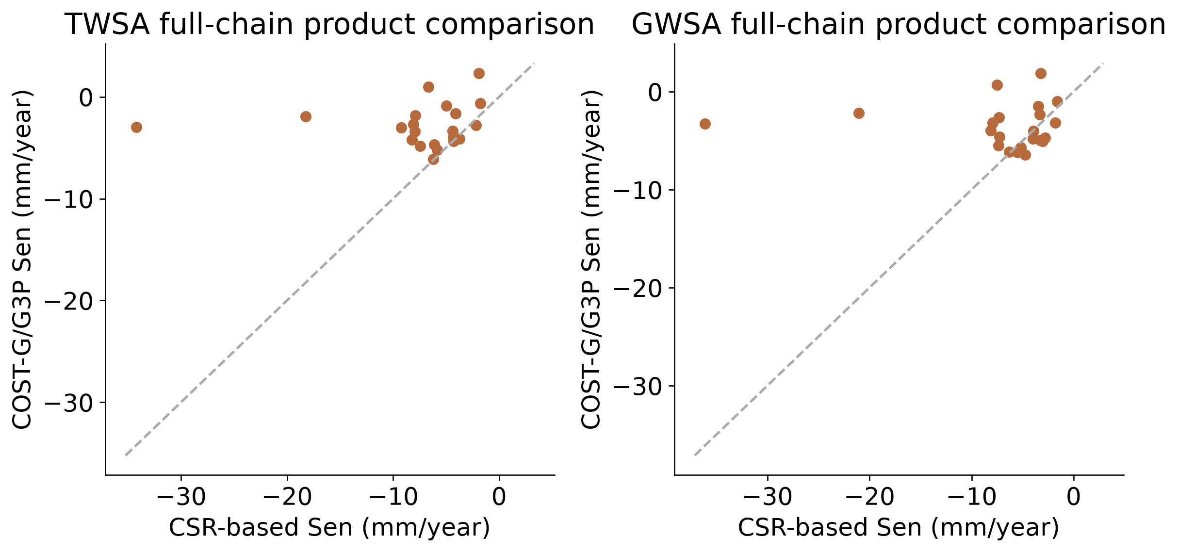
Figure 4 Common-support CSR and COST-G/G3P comparisons; groundwater chains also differ in compartment processing.

3.2 Climate memory adds transferable information within the parent model
Current-weather Ridge models give national held-out anomaly NSE of 0.283 for TWSA and 0.039 for GWSA. Adding lagged weather and memory raises those values to 0.890 and 0.723. Basin-median anomaly NSE rises from approximately 0.201 to 0.844 for TWSA and from −0.044 to 0.680 for GWSA. Seasonal-only models remain weak for anomalies, confirming that strong recurring seasonality is not the main explanation for the memory-model improvement.
The previously selected multi-family ensembles also reconstruct the native parent target strongly, with national raw monthly NSE near 0.981 and 0.961. These scores have a different evaluation target from the CSR model–observation comparison. They do not establish that the naturalized simulation or its groundwater trend is correct. The matched land-compartment GLDAS comparison remains a cross-model benchmark rather than a groundwater observation.
Frozen-model replacement with unadjusted CHIRPS reduces national anomaly NSE to 0.688 for TWSA and 0.562 for GWSA. Training-only monthly mean adjustment gives approximately 0.675 and 0.579 and does not restore native-forcing performance. The useful result is sensitivity to the forcing–target relationship; a lower score against a native-forced target is not evidence that CHIRPS is a poorer rainfall observation.
The observed rainfall–storage test provides complementary evidence. A twelve-month accumulation is selected nationally with a one-month TWSA delay and two-month GWSA delay. Held-out correlations are 0.680 and 0.606, with 79 and 76 paired months and year-permutation p-values of 0.001 and 0.004. The association supports a hydroclimatic role in observed anomalies but does not uniquely identify a climate-only groundwater process.
The separately retained matched-compartment GLDAS benchmark compares naturalized WaterGAP soil, canopy and snow with GLDAS Noah over 261 months: national r=0.969, NSE=0.738 and RMSE=52.49 mm. This is a cross-model land-storage comparison, not validation of full TWS, GWS or human depletion. It excludes groundwater and surface water, shares climatic influences and uses a product that also contributes to GWS subtraction.
In 2022, national annual anomaly NSE is 0.243 for TWSA and -1.067 for GWSA. Pooled verification therefore masks important year-specific behaviour; an annual negative score is retained rather than hidden by the strong full-test seasonal score.
Spatial naturalized storage and climate reconstruction
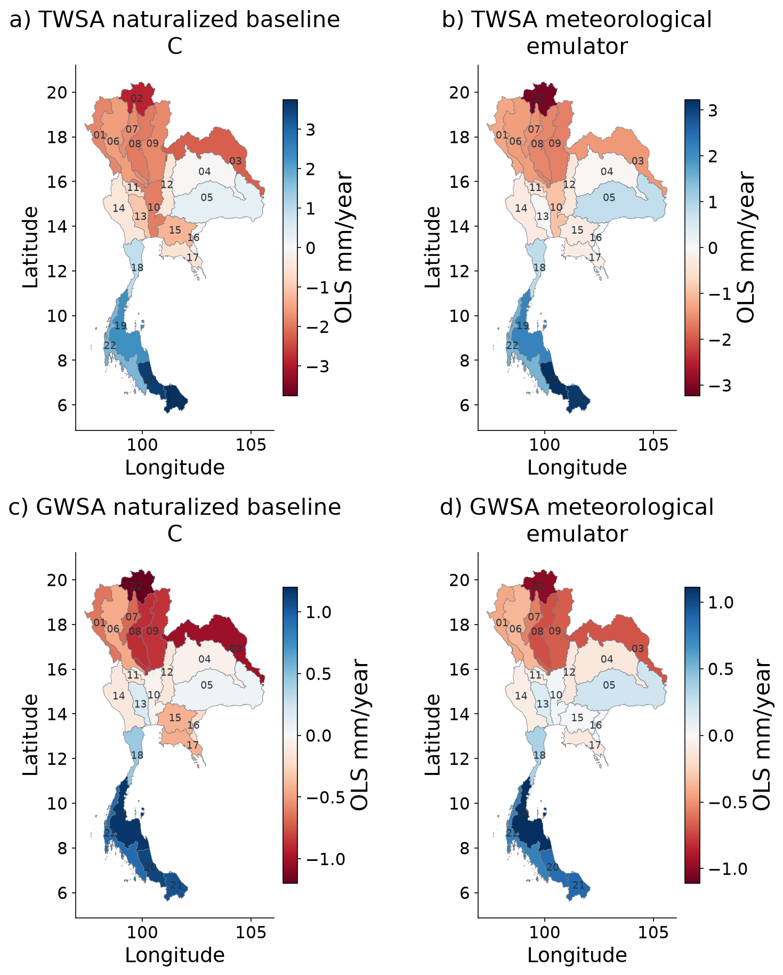
Figure 5 Calendar-month fixed-effect slopes. C is the naturalized WaterGAP baseline used in R=O−C; the statistical emulator reconstructs its parent-model target on its retained verification footprint. Emulator slopes use CSR-available dates through 2023, not a fit to GRACE. These columns are related model estimates, not independent observations.
TWSA climate reconstruction for all 22 basins
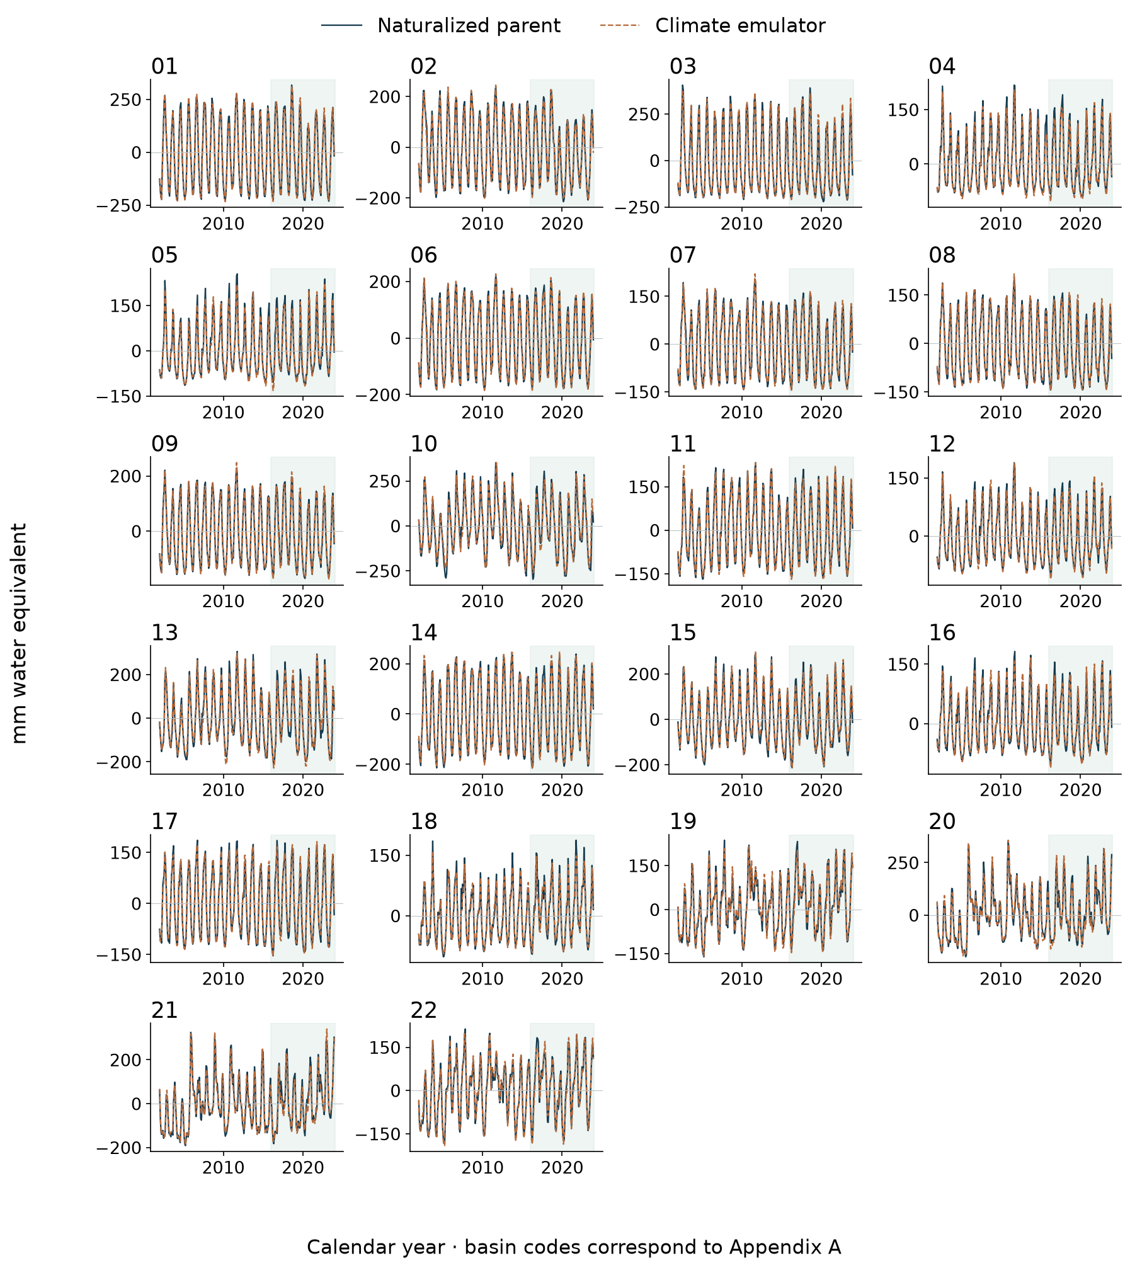
Figure 6 Naturalized parent-model target and frozen meteorological ensemble reconstruction. Green shading identifies the held-out 2016–2023 period; earlier values are training or validation context. The emulator targets a hydrological model, not independently observed storage.
GWSA climate reconstruction for all 22 basins
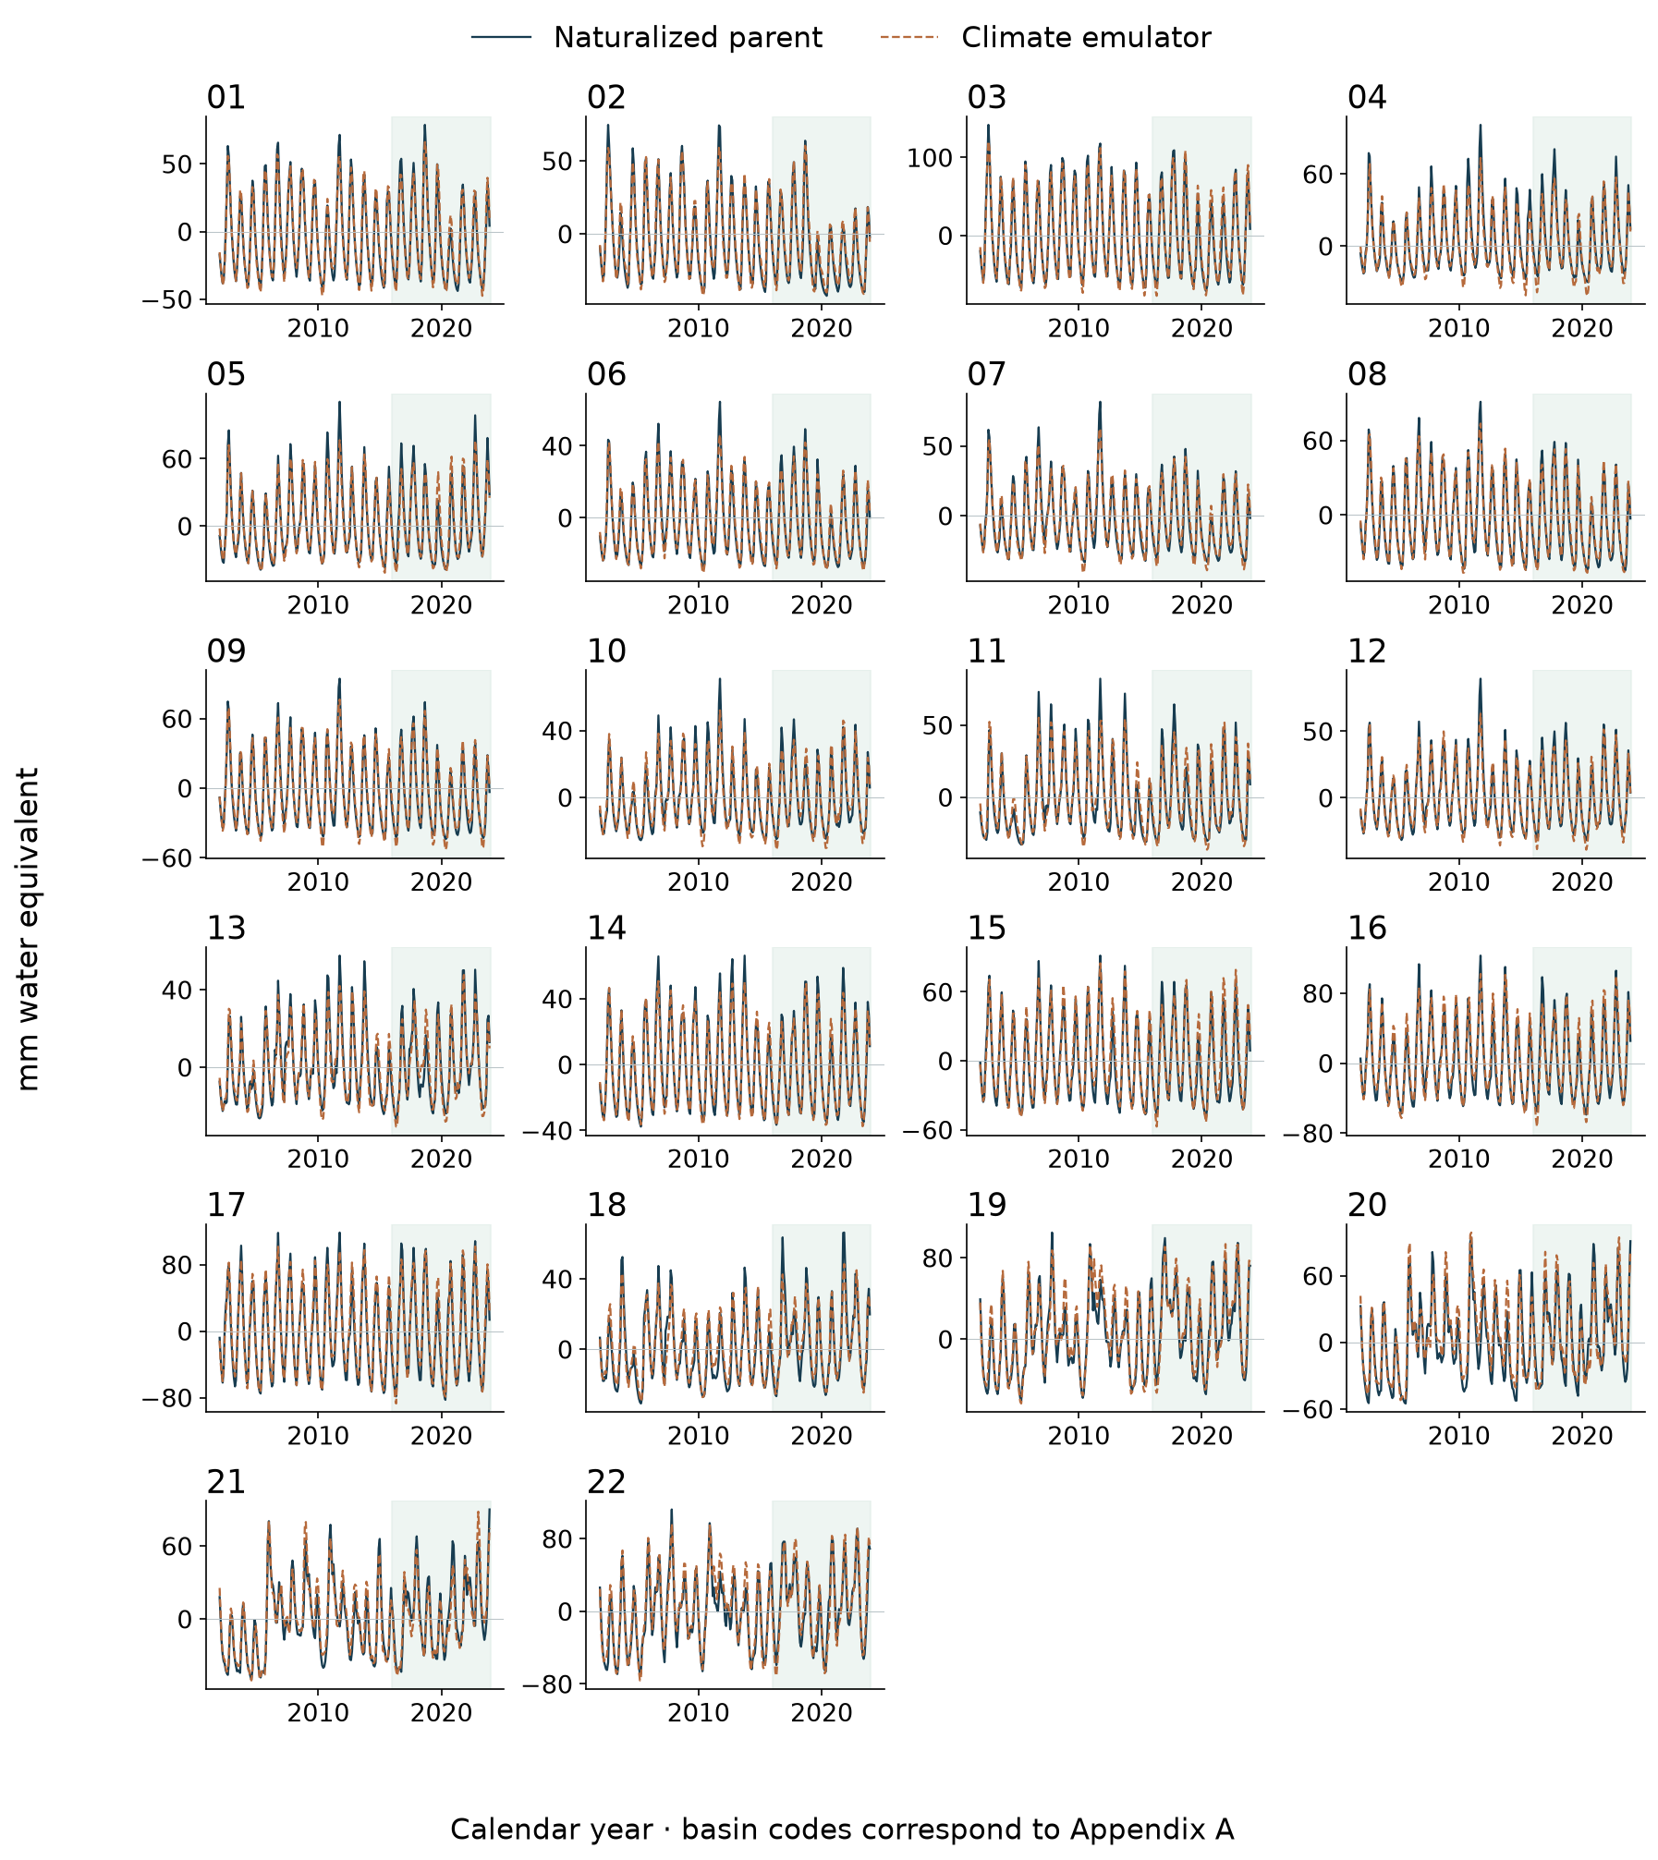
Figure 7 Naturalized parent-model target and frozen meteorological ensemble reconstruction. Green shading identifies the held-out 2016–2023 period; earlier values are training or validation context. The emulator targets a hydrological model, not independently observed storage.
Spatial climate model evaluation
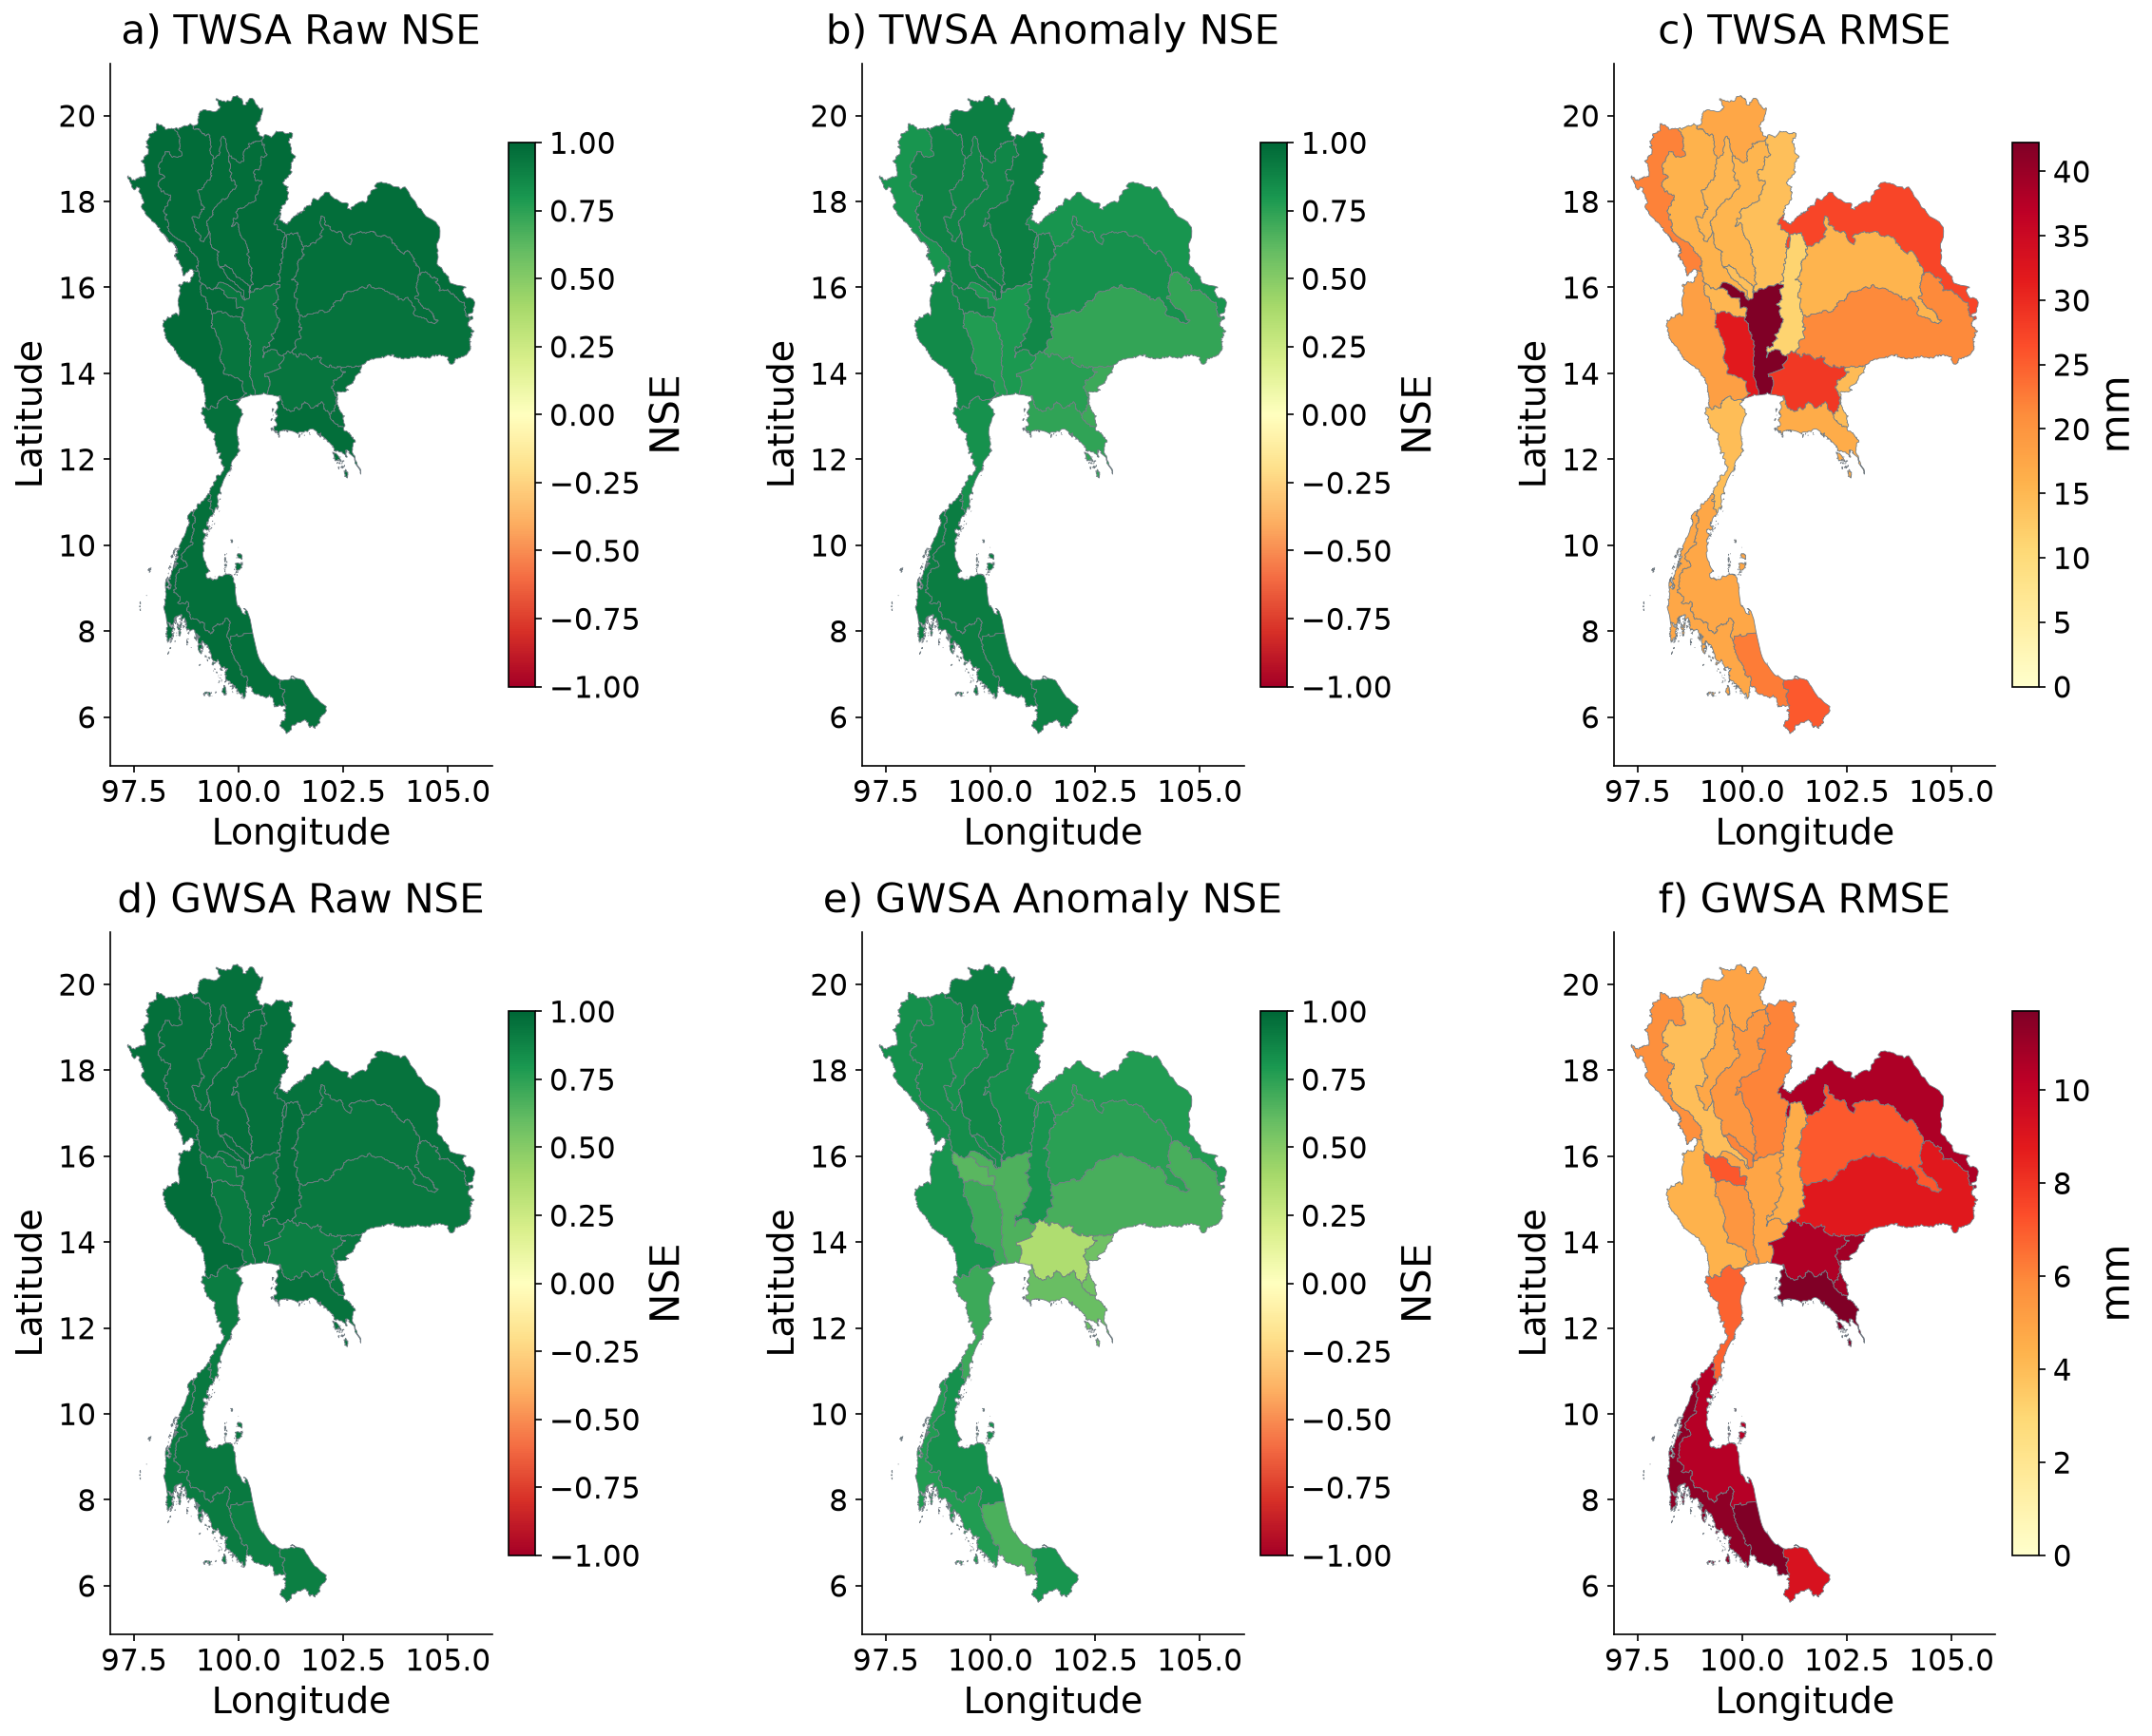
Figure 8 Frozen ensemble verification against naturalized parent storage during 2016–2023. Maps distinguish raw NSE, training-climatology-anomaly NSE and RMSE; NSE colours saturate below −1. High seasonal skill is not observational validation of a natural counterfactual.
Climate model evaluation through time
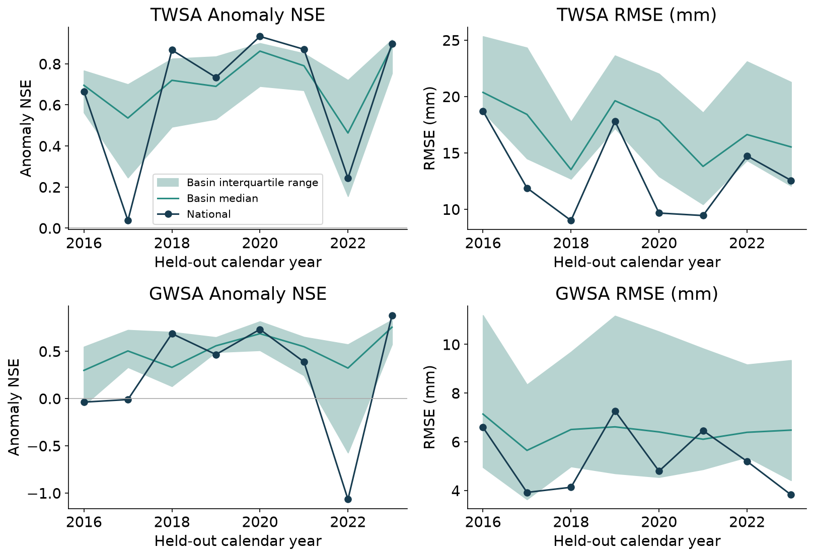
Figure 9 Metrics are calculated separately for each held-out year using the training-climatology anomaly definition. Shading is spatial interquartile variation, not a confidence interval. Annual scores use 12 modeled months and may be unstable when anomaly variance is small; pooled 96-month results remain primary.
Climate memory ablation
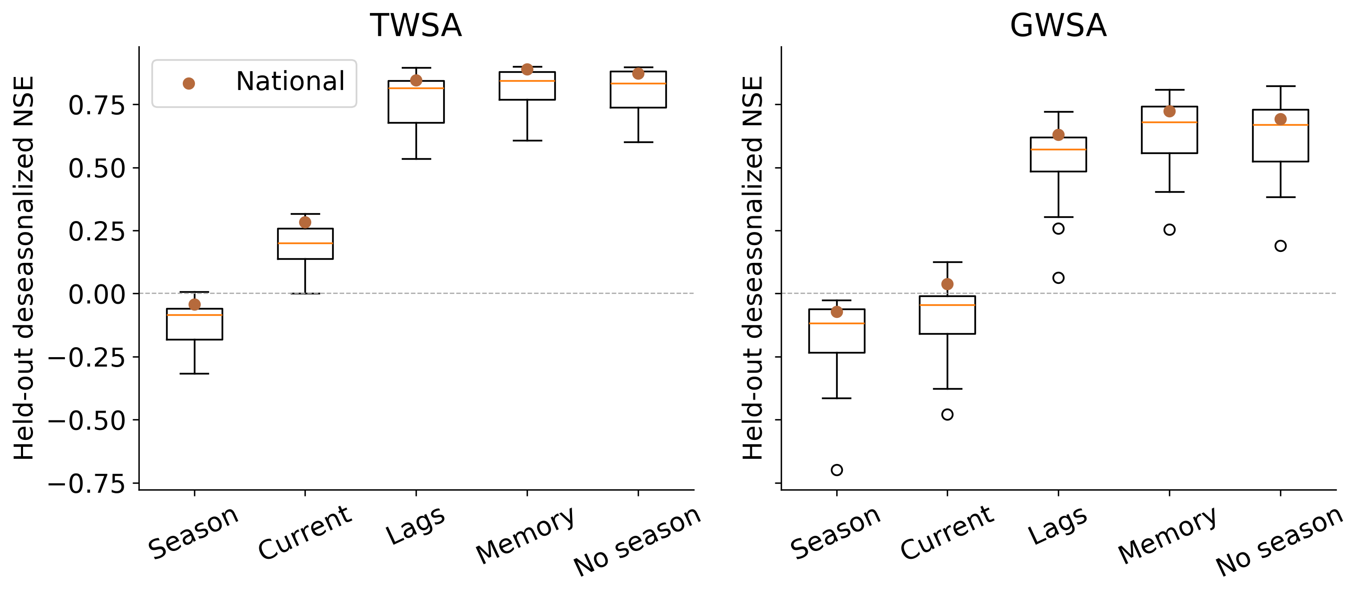
Figure 10 Controlled Ridge test-year anomaly NSE across basins. This is a separate method comparison from the frozen multi-family ensemble mapped above.

3.3 The represented human perturbation does not explain the full residual
The additive national TWSA OLS slopes are −8.36 mm/year observed, −0.54 naturalized, −0.49 modeled human, −7.81 residual and −7.32 discrepancy. Their exact point-trend identities distinguish the accounting partition from the non-additive Sen summaries. The two-year-block interval for the modeled-human term is approximately −0.96 to −0.005 mm/year, close to zero at its upper limit and sensitive to the conditional uncertainty specification.
For groundwater the corresponding slopes are −7.28, −0.21, +0.06, −7.07 and −7.13 mm/year. The paired modeled-human interval spans approximately −0.01 to +0.13 mm/year, while residual and discrepancy intervals remain negative. Thus the historical-human model does not reproduce the magnitude of the observation-based groundwater residual trend in the present experiment.
The national discrepancy-magnitude diagnostics are 0.938 for TWSA and 0.991 for GWSA, with principal conditional intervals approximately 0.822–0.997 and 0.978–0.999. These values express the relative size of modeled terms, not a percentage of human depletion. The residual and discrepancy series are highly similar, but that similarity cannot determine whether omitted management or other structural error dominates the unexplained difference.
Table 2 Additive national slopes and conditional two-year-block intervals
Component | TWSA mm/year | GWSA mm/year
Observed | -8.36 [-12.16, -4.71] | -7.28 [-10.30, -4.12]
Naturalized | -0.54 [-2.28, 1.09] | -0.21 [-0.79, 0.38]
Modeled human | -0.49 [-0.96, -0.00] | 0.06 [-0.01, 0.13]
Residual | -7.81 [-11.72, -3.90] | -7.07 [-10.21, -3.93]
Discrepancy | -7.32 [-11.48, -3.44] | -7.13 [-10.25, -4.02]
Spatial residual and modeled human perturbation
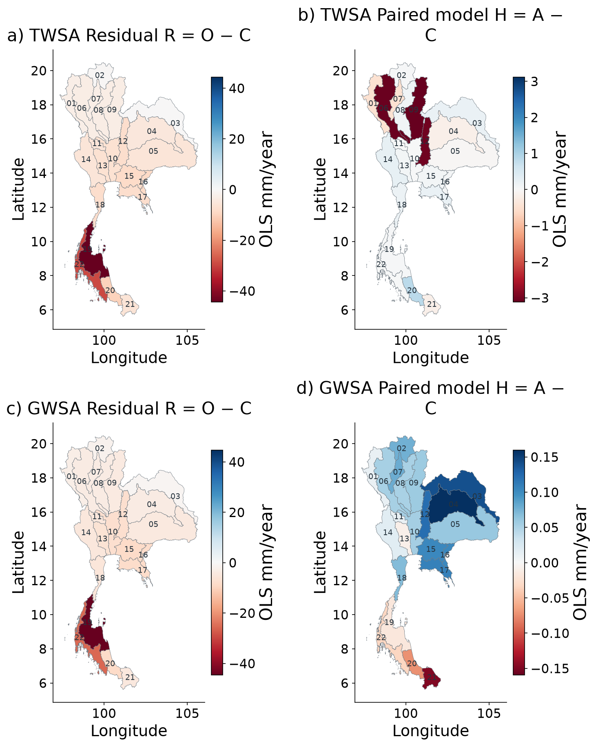
Figure 11 Calendar-month fixed-effect slopes on the same observation-valid support. R includes the represented direct-human perturbation H and discrepancy E. Each panel has its own labelled scale to keep small H visible; compare numerical scales before comparing colours. These slopes are not additive Sen-slope fractions.
TWSA residual histories for all 22 basins
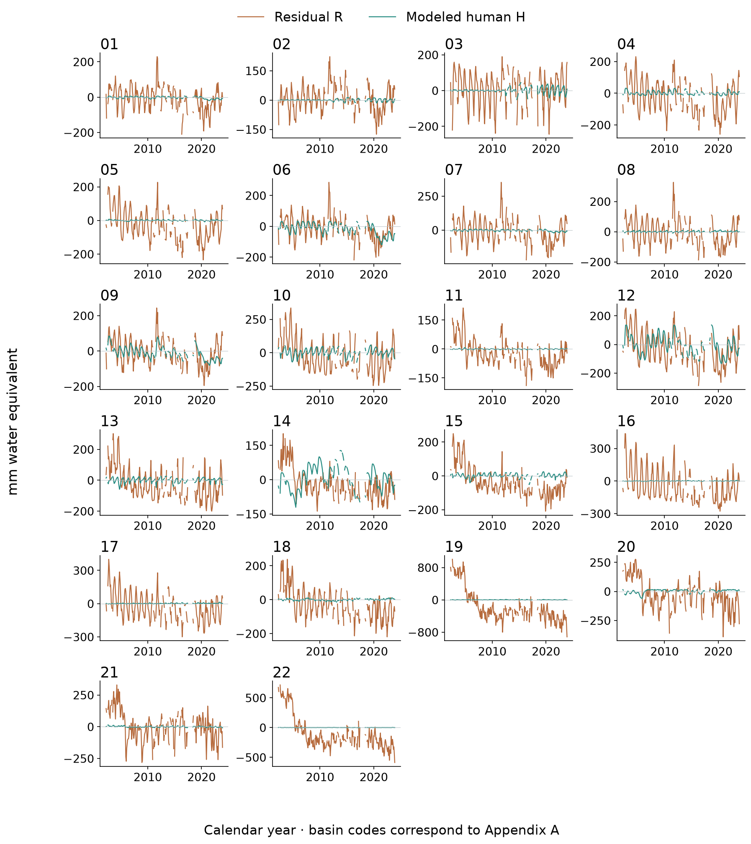
Figure 12 Observed-minus-naturalized residual R and paired modeled human perturbation H. Missing observed months are retained. R−H is unresolved observation–historical-model discrepancy; a negative R is not automatically measured pumping.
GWSA residual histories for all 22 basins
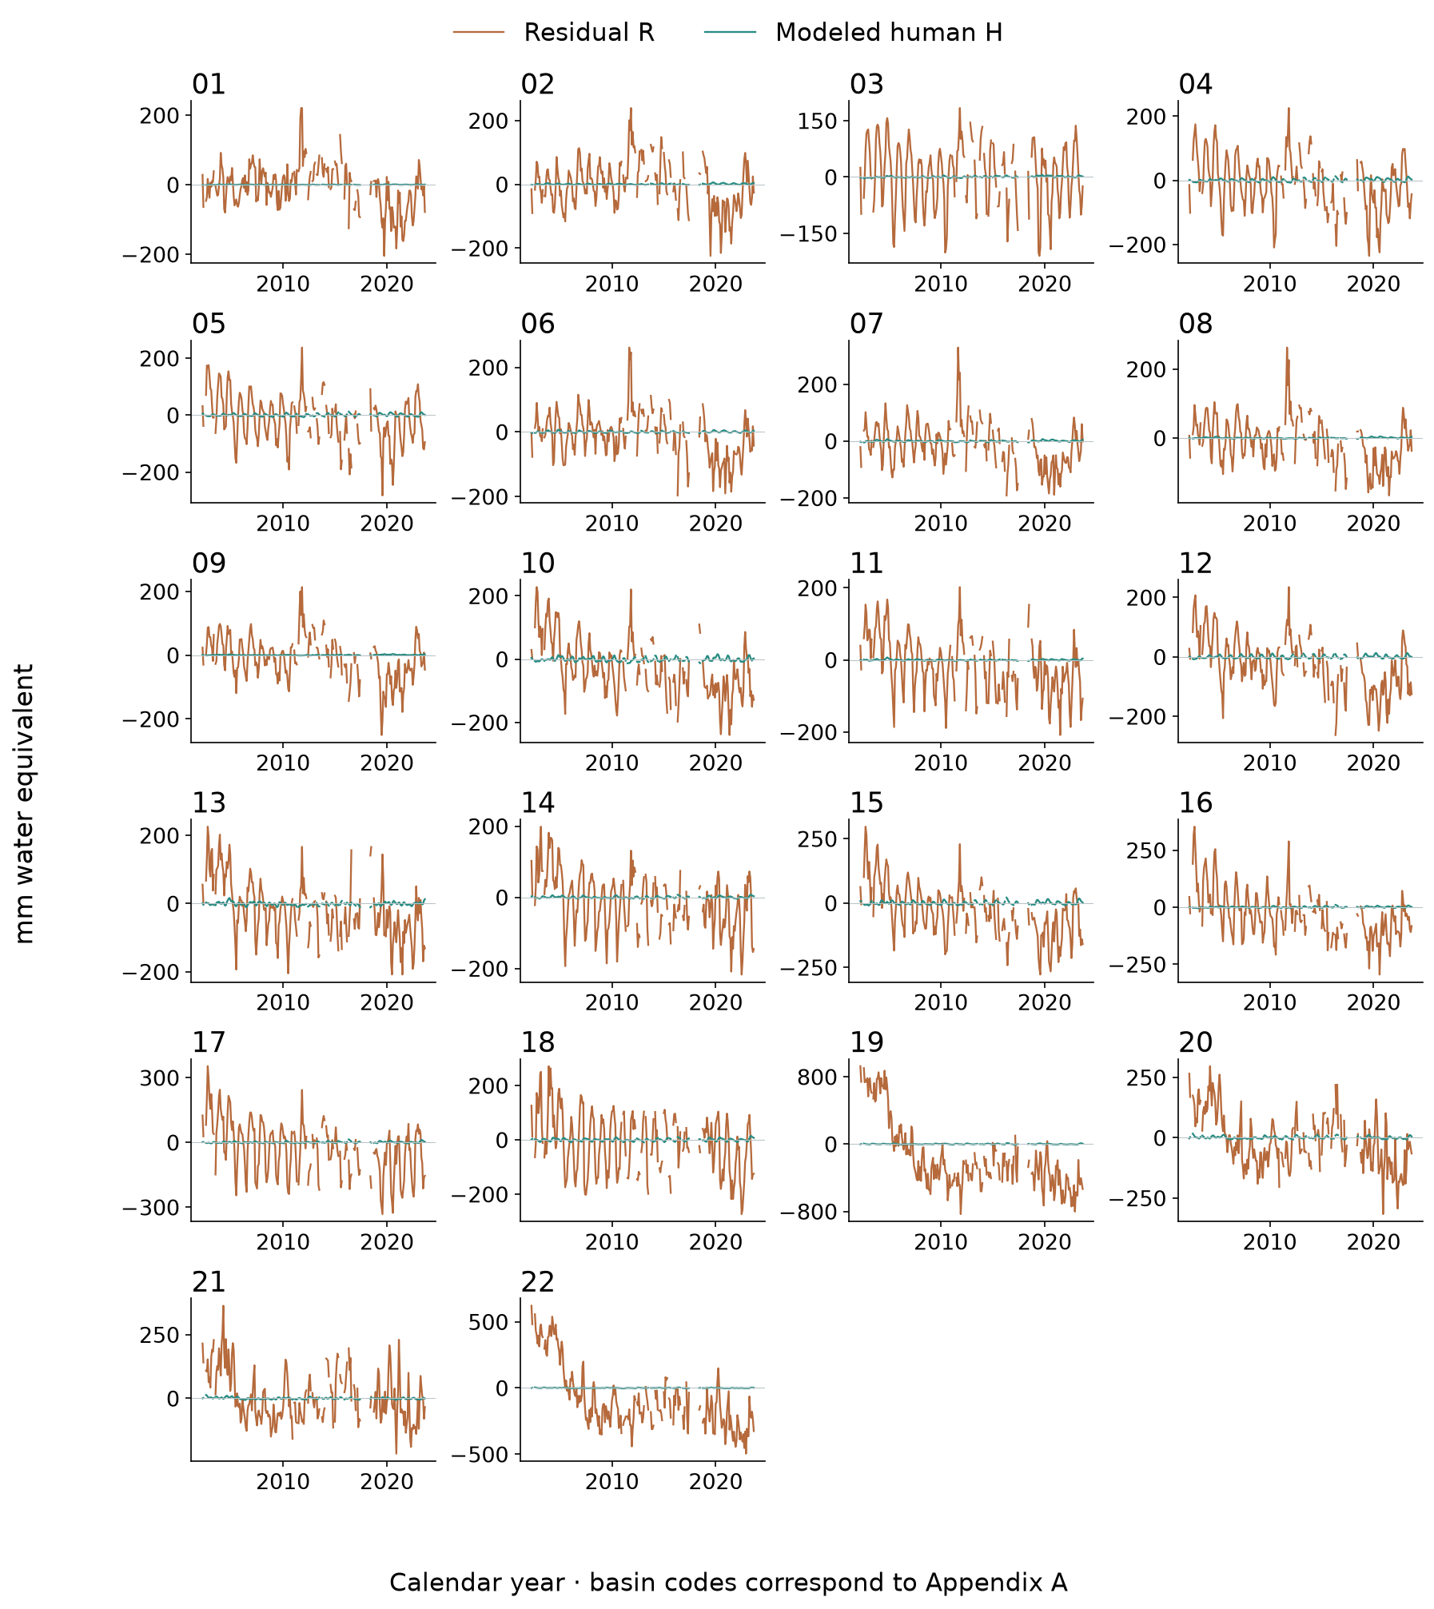
Figure 13 Observed-minus-naturalized residual R and paired modeled human perturbation H. Missing observed months are retained. R−H is unresolved observation–historical-model discrepancy; a negative R is not automatically measured pumping.
Additive trend partition and uncertainty
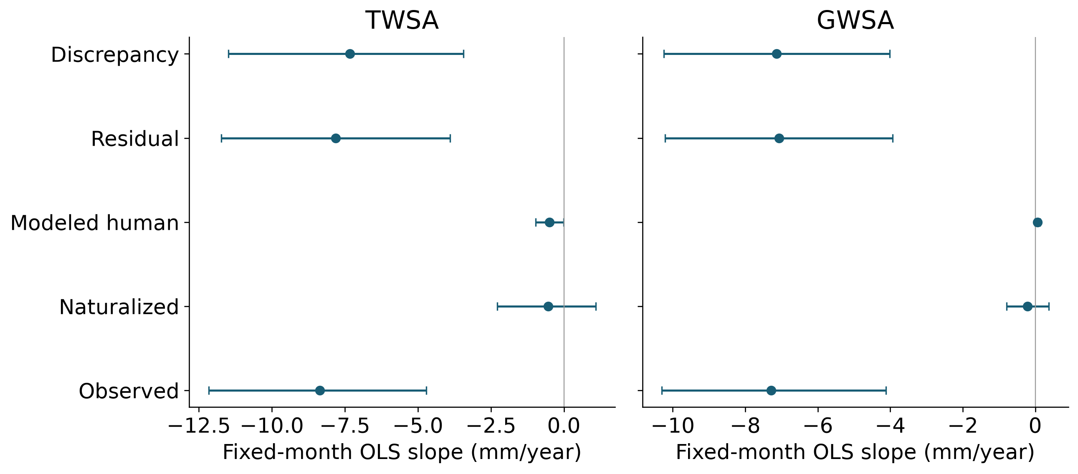
Figure 14 Calendar-month fixed-effect national slopes with shared two-year wild-block intervals. R=H+E exactly on common support; discrepancy dominance does not establish that the full residual is either anthropogenic or non-human error.

3.4 GLDAS land storage and residual comparison
The matched-compartment comparison retains soil moisture, canopy and snow in both WaterGAP and GLDAS Noah. National agreement is r=0.969, NSE=0.738 and RMSE=52.49 mm over 261 months. Spatial trend and temporal panels expose where a high seasonal correlation coexists with different storage trends or amplitudes. Groundwater and surface water are excluded from this benchmark.
Direct GLDAS–residual comparisons answer a separate question. The displayed land-storage and TWS/GWS residual series are standardized on identical observed months within each basin; maps show standardized slopes and descriptive timing correlations. Their different compartment definitions prevent treating GLDAS land storage as residual ground truth or calculating cross-compartment volume-error metrics. GLDAS is also used in GWS subtraction, which makes groundwater-residual comparisons partly dependent by construction.
Spatial GLDAS matched compartment comparison
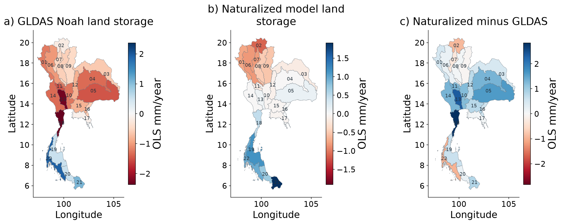
Figure 15 Soil + canopy + snow only, common valid-cell support and common 2004–2009 reference. The record extends through December 2023. Each panel has a labelled scale; groundwater and surface water are excluded. This is a cross-model benchmark, not independent full-TWS or residual validation.
Matched GLDAS time series for all 22 basins
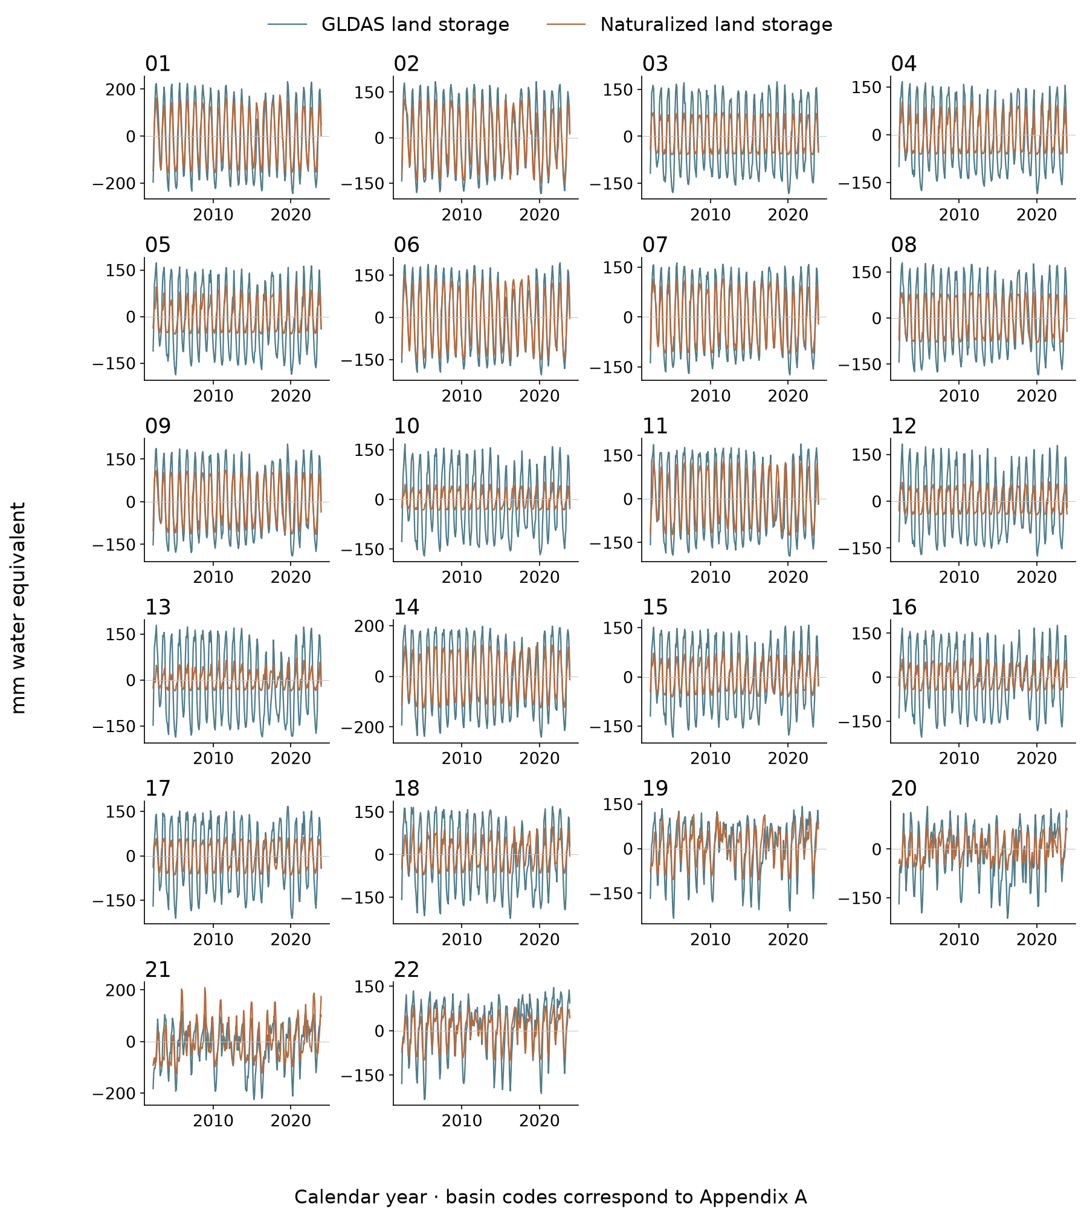
Figure 16 Matched soil + canopy + snow anomalies in mm. GLDAS and WaterGAP share climatic influences. Agreement evaluates land-component consistency; it cannot validate groundwater or the entire human residual.
Spatial GLDAS and residual comparisons
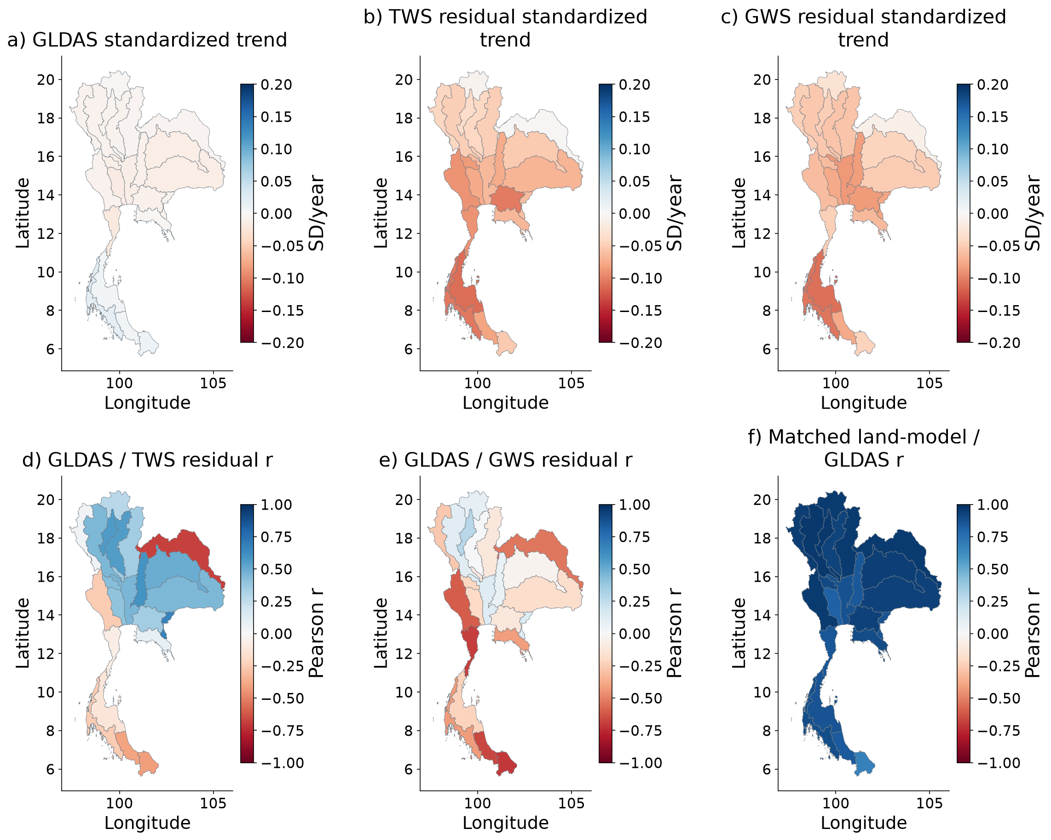
Figure 17 Top: slopes of separately standardized series on identical joint months; scale saturates at ±0.2 SD/year. Bottom: descriptive correlations, with the matched land-component correlation for context. GLDAS land storage and residual storage are different quantities. No cross-compartment NSE, RMSE or claim of human validation is made. GLDAS also contributes to GWS subtraction.
GLDAS and residual histories for all 22 basins
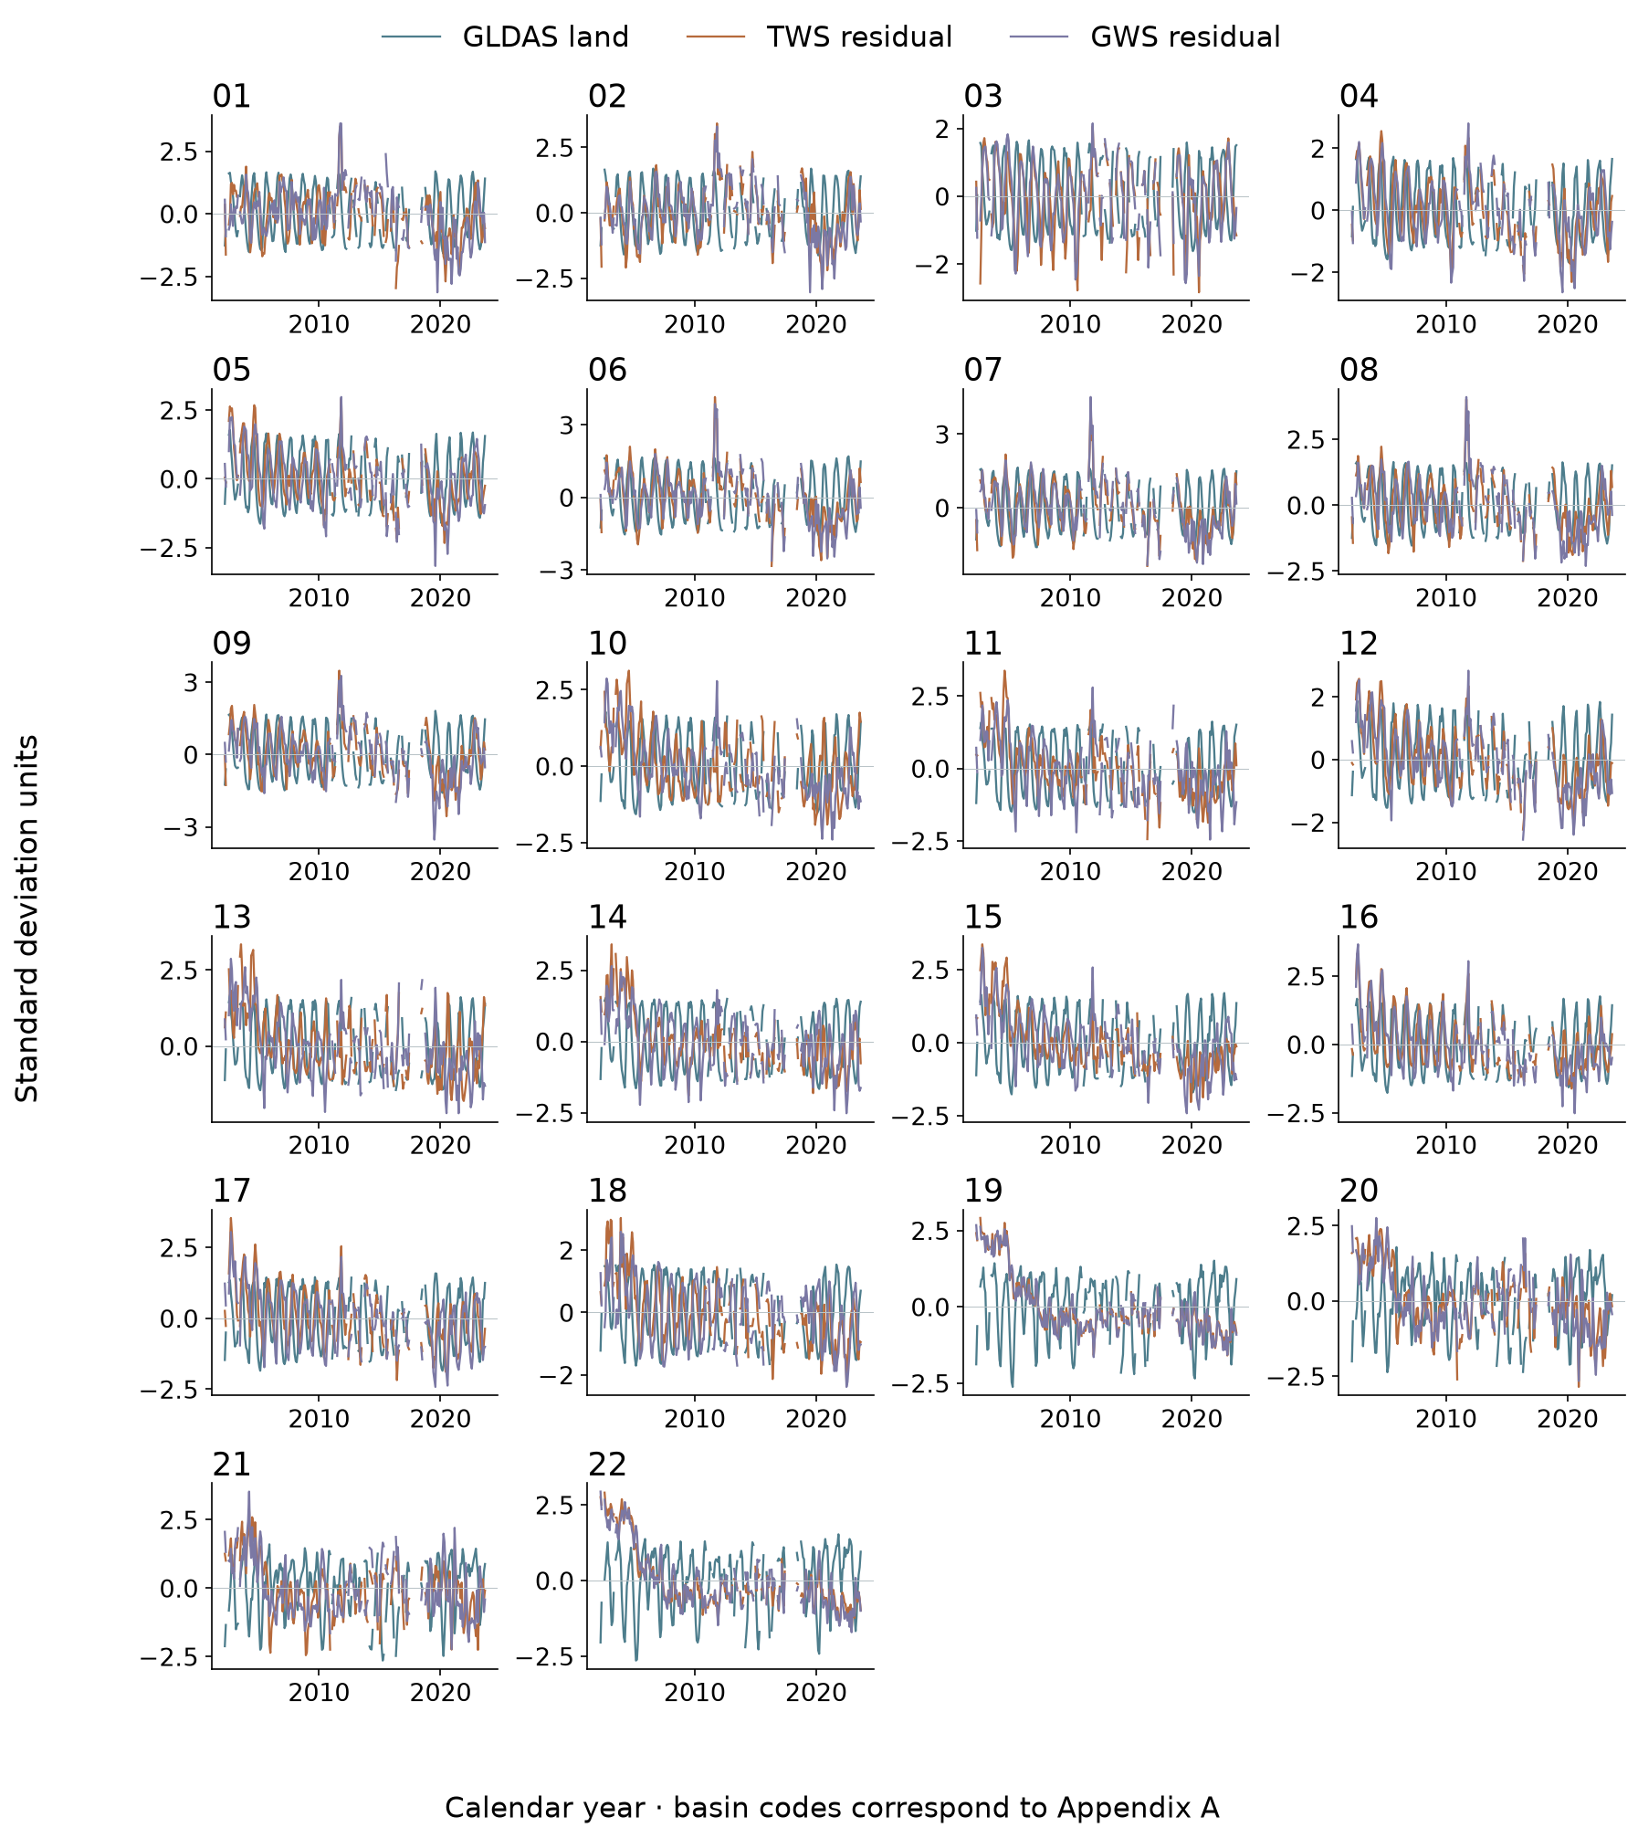
Figure 18 Each variable is standardized on the same jointly observed months within each basin. Different compartments are compared in timing and shape, not treated as equivalent water volumes. Missing months remain gaps. This is a dependence diagnostic, not independent anthropogenic validation.

3.5 Groundwater validation in space and time
The longest-overlap national residual–head correlations are 0.127 for TWSA and 0.037 for GWSA over 18 and 17 annual pairs. Coordinate-station bootstrap intervals are broad: approximately −0.277 to 0.601 and −0.304 to 0.466. Climate-controlled correlations are 0.102 and 0.001, and detrended correlations are −0.046 and −0.107. These results do not establish independent groundwater confirmation of the residual.
The wider-history fixed-eligibility panel yields raw correlations of 0.657 and 0.511, apparently stronger than the primary series. However, the all-well 2013–2022 comparison and strict balanced panel share only eight usable storage years because mission-gap availability rules remain in force. GWSA residual correlations are 0.029 and approximately −0.0004, respectively. The strict panel comprises 189 coordinate groups. Its near-zero relationship shows why an attractive wider-history panel correlation should not be read as validation without a time-matched check.
The well-level trend screen retains 382 annual wells and 225 coordinate-station trajectories. Their median head slope is approximately −0.016 m/year; 54.2 percent of station-median slopes are negative, with a station-resampling interval of 47.1–60.0 percent. This neither establishes a dominant national head direction in the monitored population nor supplies a mass-storage rate. The observation network is not a random sample of Thai aquifers.
Across basins, available annual pairs and station groups are uneven, and some comparisons lack adequate support. The 460 panel/component checks retain those insufficient cases. Missing evidence is not classified as successful or failed pumping validation. The combined results identify a monitoring and interpretation limit that remains visible even though the climate emulators reproduce their parent model well.
Table 3 Residual–head association and temporal support
Panel | TWS/GWS years | TWS r | GWS r
Longest overlap | 18/17 | 0.127 | 0.037
Fixed eligibility | 18/17 | 0.657 | 0.511
Common period | 8/8 | 0.325 | 0.029
Strict balanced | 8/8 | 0.305 | -0.000
Spatial evaluation of residual agreement with groundwater
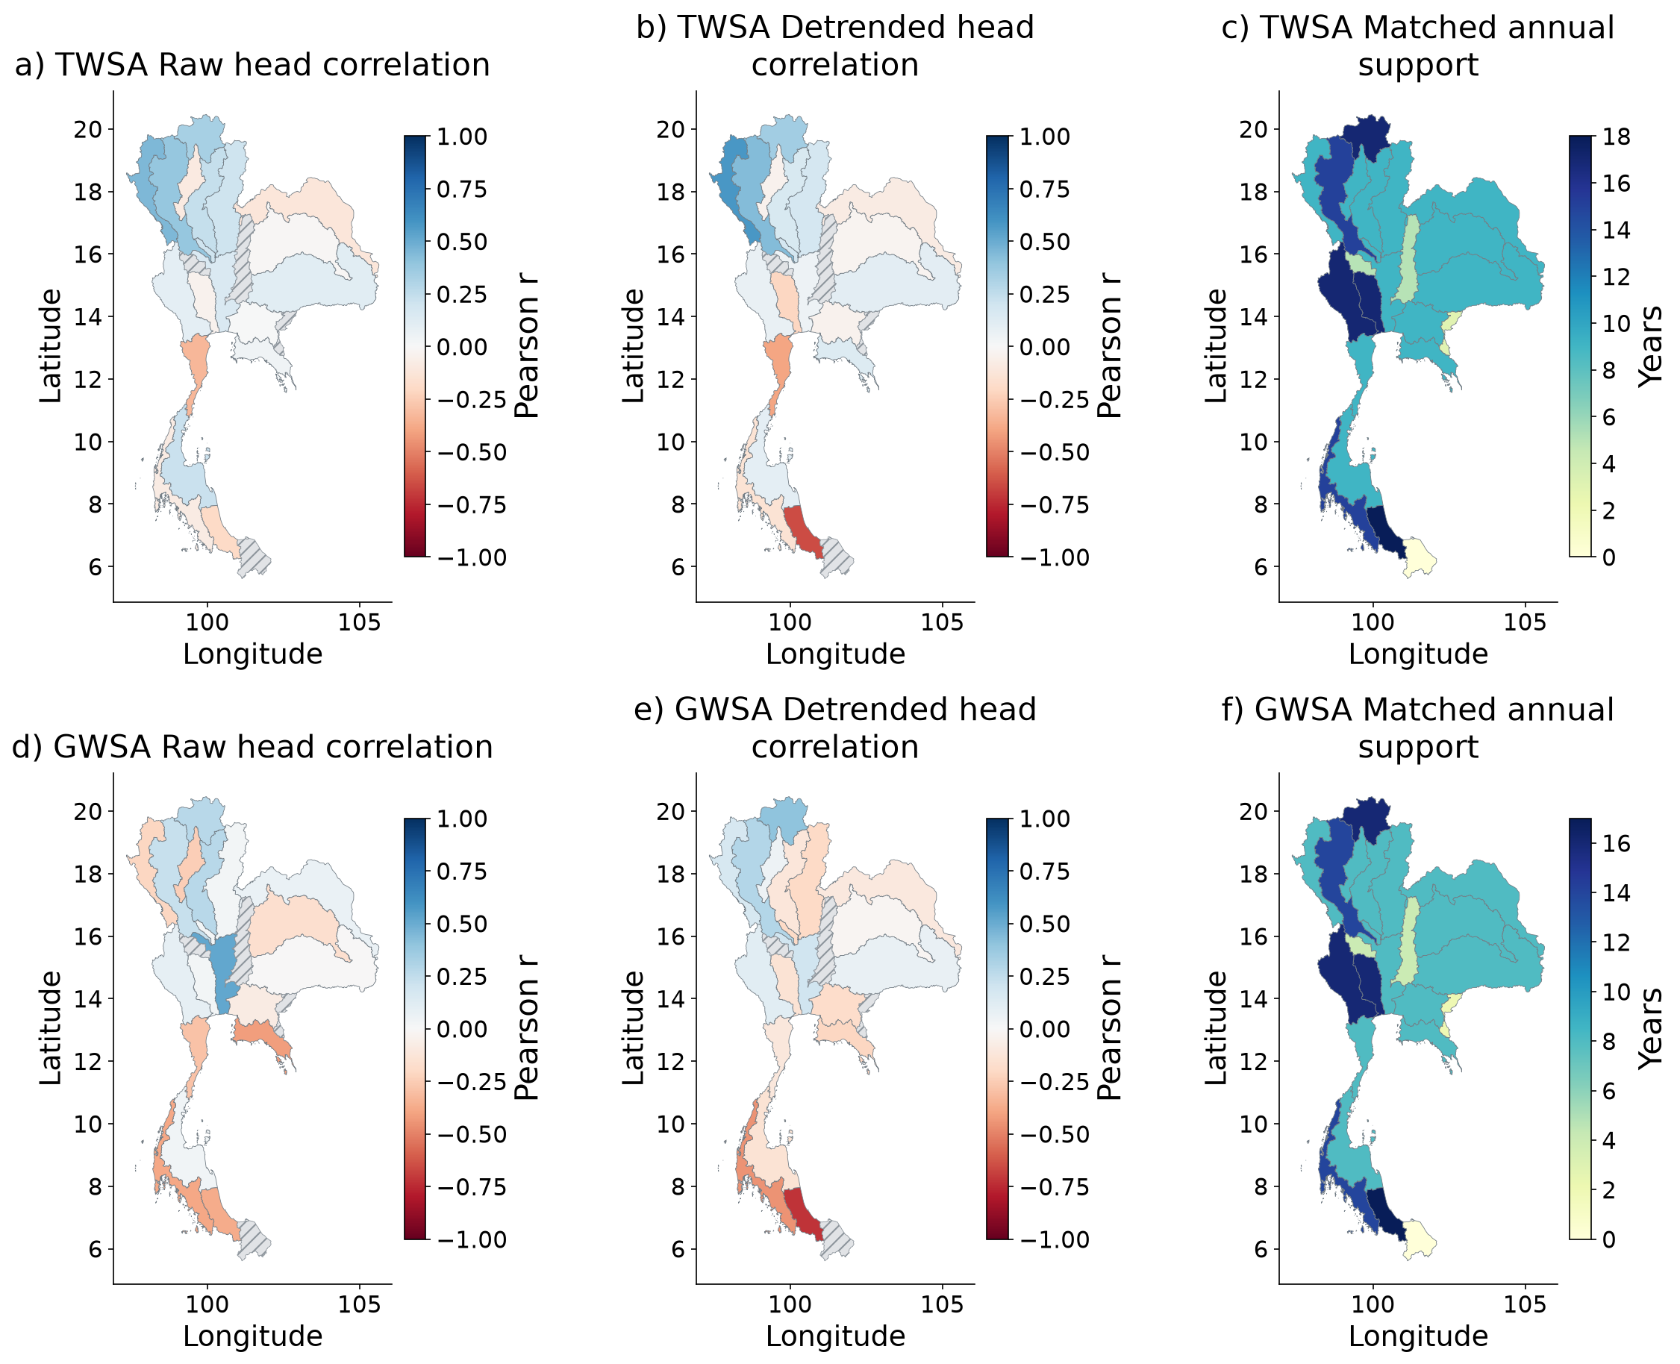
Figure 19 Observed annual heads compared separately with TWS and GWS residuals. Hatching marks unavailable correlations or fewer than eight matched years. Support maps expose small samples. Heads and equivalent water depth are not commensurate volumes, so head–storage NSE and RMSE are not calculated. Raw association is indirect groundwater evidence for TWS, not total-human validation.
Annual groundwater and residual histories for all 22 basins
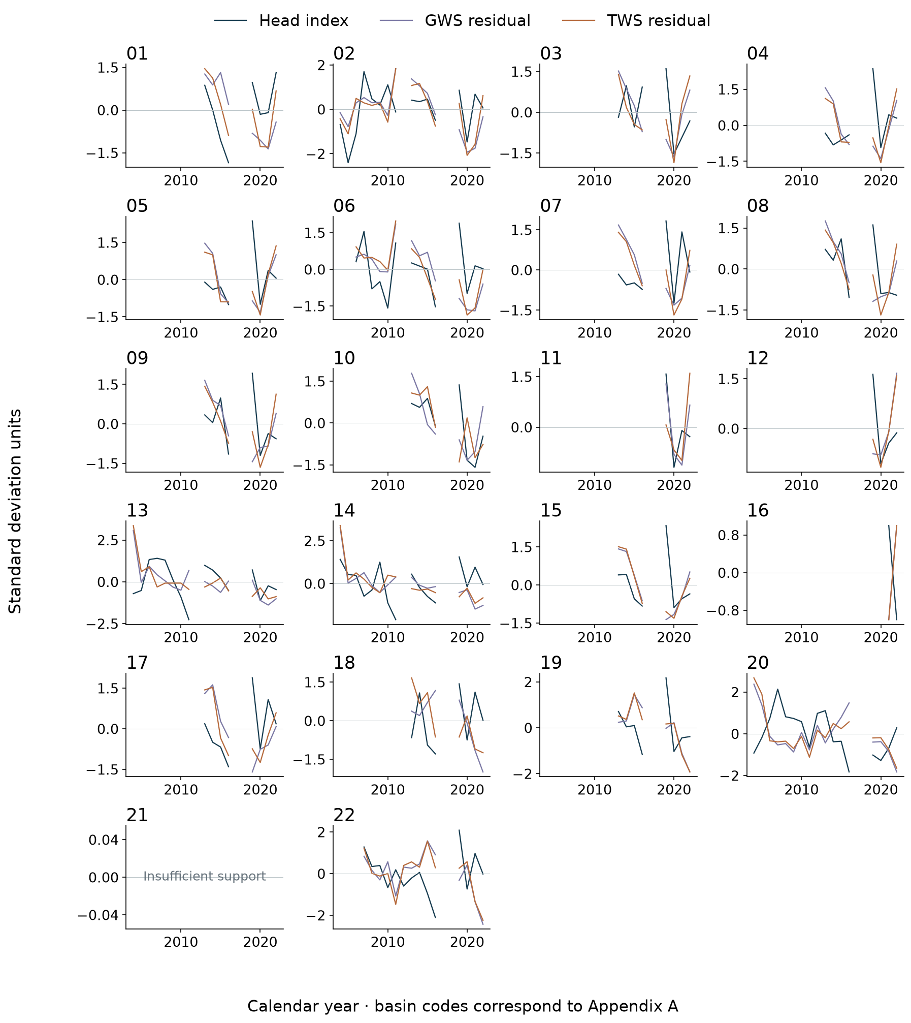
Figure 20 Co-located wells are first grouped by station, then averaged. Displayed series are standardized on their joint annual support; they are not water-volume conversions. Annual storage requires at least eight valid months and complete year endpoints. Gaps remain missing. Numerical correlation maps use each target’s own longest eligible support, whereas this three-line display uses joint support.
Residual validation metrics and network support through time
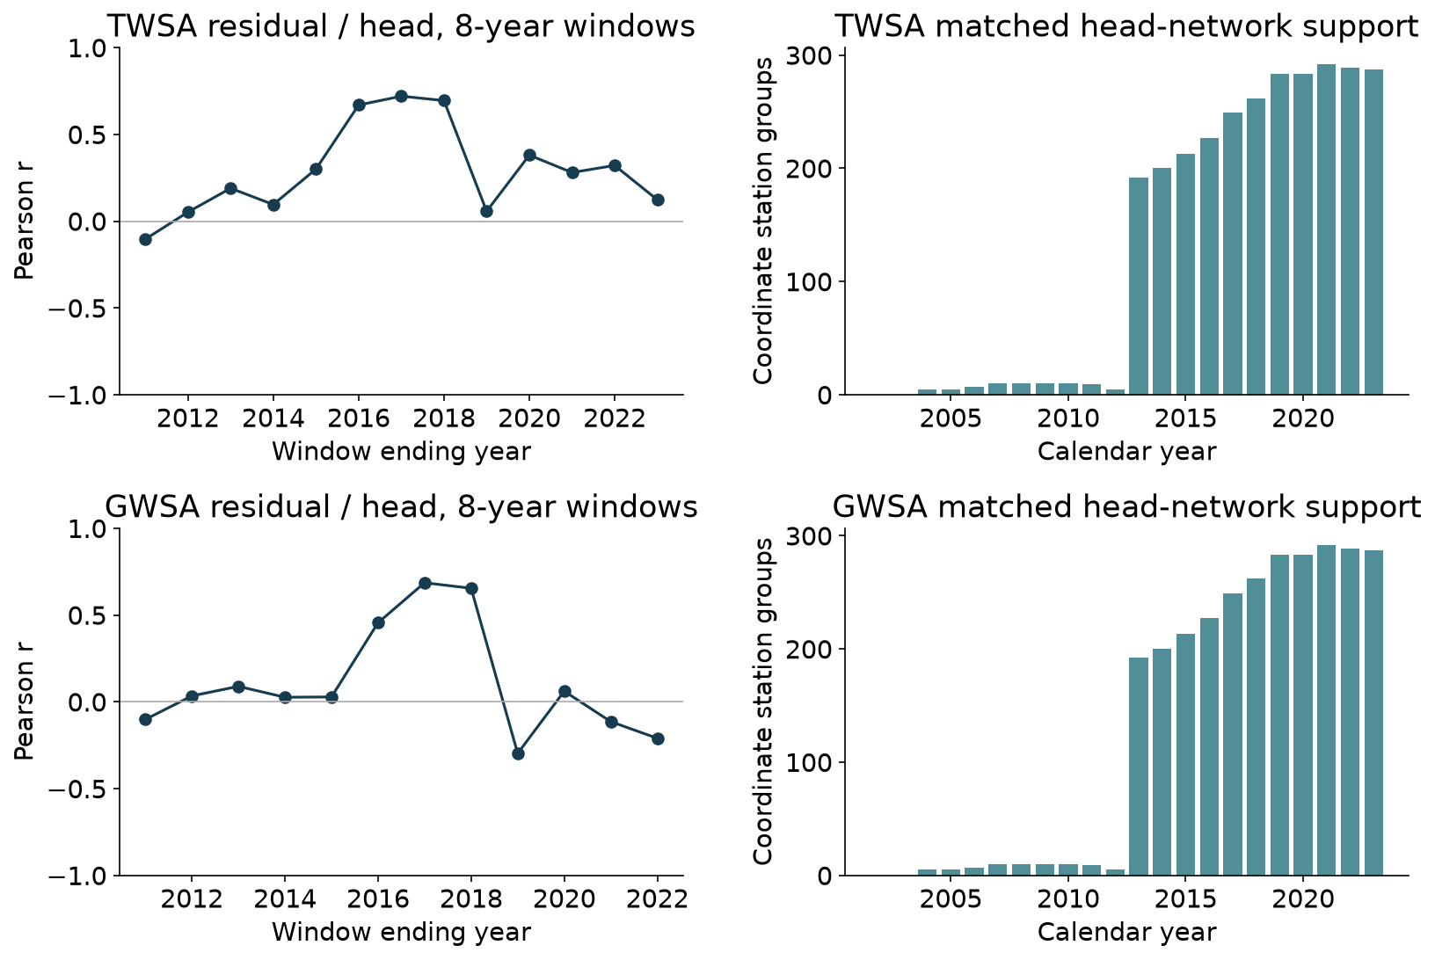
Figure 21 National rolling head–residual correlations require at least six observed annual pairs in an eight-calendar-year window. Windows overlap and are descriptive, not independent tests or a model-selection device. Bars show represented coordinate-station groups; station counts are not the temporal correlation sample size. Basin-specific rolling metrics accompany the figure.

3.6 Independent reservoir component evidence
Twenty-seven reservoirs fall within the Thai basin polygons; 26 were commissioned before 2004. For the national TWS residual, Level-1 storage gives raw r=0.521 over 73 matched months, falling to 0.439 after removing calendar-month effects and linear trend (conditional year-cluster interval 0.188–0.665). Only 12 scene-supported national panel months occur in the 2004–2009 reference; this shifts the anomaly origin but leaves correlations unchanged. The provider-interpolated Level-2 comparison covers 228 months and gives adjusted r=0.381 (0.144–0.552). Agreement persists beyond a raw seasonal comparison, with sampling and processing sensitivity retained.
This broadens observational evidence beyond wells without closing the causal argument. The reservoir index omits smaller impoundments and other surface waters and contains climatic responses as well as operations. Its positive correlation with the groundwater residual could reflect shared forcing or imperfect compartment removal rather than a groundwater measurement. Pumping records, reservoir inflow/release histories and independent naturalized experiments remain necessary to isolate management mechanisms.
Spatial independent reservoir component evidence
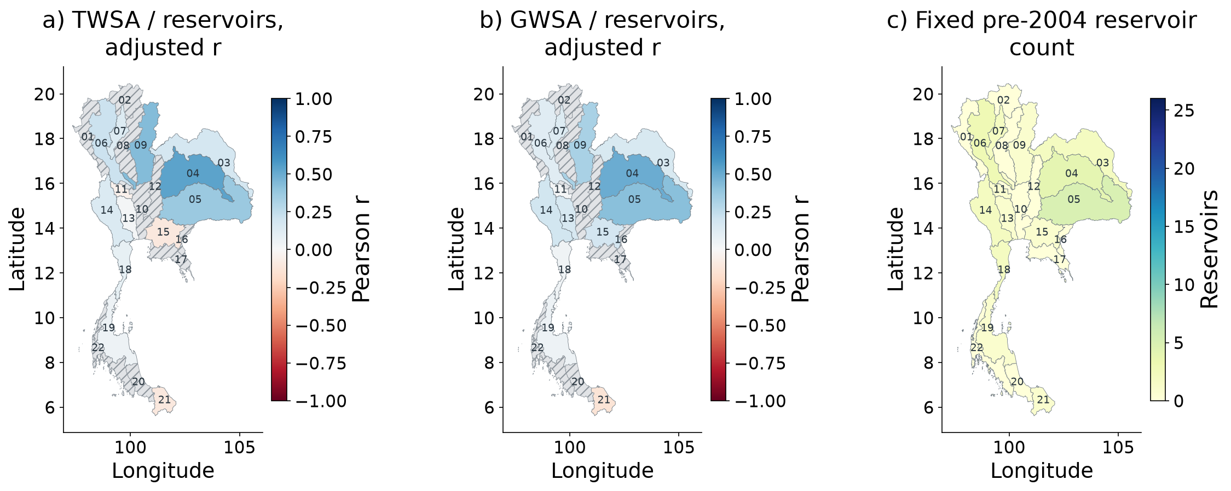
Figure 22 MSEA-Res Level-1 scene estimates, fixed pre-2004 populations and matched-month season/trend-adjusted correlations. Grey hatching means unavailable evidence, not zero effect. Reservoir correlations with GWS residuals are dependence diagnostics and do not directly validate groundwater. No naturalized observed reservoir counterfactual is available.

4 Discussion

4.1 National direction and local attribution require different evidence
The results support concern about broad storage decline, but they do not support a product-independent ranking of basin depletion. This distinction matters because policy applications often seek a local priority list from a single map. The present common-support comparison shows that processing-chain choices can preserve a national sign while substantially changing the ordering of smaller reporting units. Conditional trend significance alone cannot resolve that spatial uncertainty.
Native mapping helps explain why raster detail is not a sufficient answer. A basin may intersect many quarter-degree cells while sharing the same mapped native elements with neighbouring basins. Regularization can extend that dependence further. Our concentration and overlap diagnostics therefore qualify spatial interpretation without claiming to estimate the true averaging kernels or inversion covariance. They are useful screening measures, not substitutes for a full geodetic error analysis.
The groundwater product comparison is additionally sensitive to compartment structure. The CSR-plus-Noah and native G3P chains do not isolate a single processing difference, so their spread should not be labelled a gravity-only uncertainty. A further physically harmonized multi-product study could separate these effects more fully. The present result is already sufficient to show that exact local magnitudes and rankings require more support than a stable national direction.

4.2 Climate reconstruction is not counterfactual validation
The memory ablation is a positive result: antecedent meteorology materially improves reconstruction of naturalized storage anomalies. Because the comparison holds the statistical family and chronology constant, the gain is more informative than a contest among many algorithms evaluated only on raw monthly seasonality. Removing seasonal harmonics still leaves substantial memory-model skill, supporting the role of antecedent weather within the parent system.
The forcing replacement limits how far that success can be interpreted. A frozen model loses anomaly skill when its precipitation input changes, even after a limited training-only mean adjustment. This is expected when a model approximates a target generated with particular forcing. It warns against presenting a high native-forcing emulator score as independent evidence that the parent model supplies the true unobserved climatic trajectory.
A second naturalized hydrological model and forcing ensemble would help assess structural counterfactual uncertainty, but that experiment has not been performed here. Actual-ET or remotely sensed soil products could improve empirical reconstruction while also carrying management information. They should therefore be evaluated according to their intended predictive role rather than automatically added to a model labelled purely climatic.

4.3 Residual disagreement and the groundwater validation problem
The paired decomposition shows why the residual should retain an unresolved interpretation. Most of its trend lies in the discrepancy from the historical-human simulation, while the represented direct-human perturbation is small. It would be unjustified to call the full discrepancy measurement error, just as it would be unjustified to call the full residual human depletion. Both unrepresented management and model or observation mismatch remain plausible.
The groundwater comparison does not resolve that ambiguity. Heads are an independent observation type, but the retained network lacks the aquifer properties required for volumetric conversion and is uneven in time and space. The strict time-matched panel gives weak groundwater residual agreement, while the wider-history eligibility panel looks stronger. The latter contrast is itself useful evidence about validation design and should not be hidden by selecting the best-looking panel.
Climate control also has a precise mathematical limit. Since R=O−C, residualizing both O and R against the same C yields the same storage residual vector. Similar partial correlations for observed and residual storage are therefore expected from the accounting identity. They do not demonstrate that the true climatic head component has been removed. Independent pumping, screened-interval and recharge information would be needed for a stronger causal test.
The annual record count further limits apparent statistical power. Hundreds of wells do not create hundreds of independent temporal replicates of a national storage trajectory. The balanced comparison contains only eight usable storage years, and station-resampling intervals condition on those years. Treating the well count as the correlation sample size would greatly overstate the evidence.

4.4 Contribution, limitations and decision use
The proposed contribution is an integrated, auditable credibility assessment rather than a new depletion algorithm. It connects documented gravity support, controlled climate-memory reconstruction, a discrepancy-preserving paired experiment and observation-network sensitivity across an entire principal-basin framework. The empirical combination reveals a mismatch between robust broad decline, unstable local ranks and weak groundwater residual confirmation. That mismatch is a scientific result, not a reason to force an attribution percentage.
Several limitations remain. Only one naturalized hydrological-model/forcing pairing supplies the principal counterfactual. Noah and G3P compartments differ in depth or filtering. Native mapping is not a complete gravity-error model. Network bootstrap intervals omit temporal uncertainty, and the annual head observations are sparse summaries with incomplete aquifer metadata. These conditions limit causal and volumetric interpretation even where conditional tests or parent-model scores are strong.
For decision support, the appropriate outputs are evidence-qualified storage screens and monitoring priorities. A basin with large decline but poor product agreement needs source and compartment checks. A basin with inadequate wells needs representative aquifer-specific monitoring. The interactive system retains these qualifications beside downloadable results, while the executable package allows reviewers to reproduce the calculations and inspect insufficient-support cases.

5 Conclusions
A documented CSR-based national record supports declining TWSA and derived GWSA over the analyzed periods, but common-support product comparisons reveal weak stability in basin rankings. Climate memory strongly improves naturalized-model reconstruction beyond current weather and seasonality, while precipitation-source replacement exposes forcing dependence. These are useful reconstruction findings, not independent validation of the counterfactual or of human depletion.
The paired experiment retains the exact residual identity and shows that observation–historical-model discrepancy is much larger than the represented direct-human trend. Groundwater-head agreement remains weak under longest-overlap and strict common-period balanced-panel comparisons. The results therefore do not validate treating the entire residual as human-caused groundwater loss.
The study's contribution is to make these inferential limits measurable and reproducible across Thailand's principal basins. A stronger attribution requires additional naturalized models, physically harmonized compartments and aquifer-specific head, storage-coefficient, pumping and reservoir records. The present evidence supports regional storage concern and targeted investigation while preserving uncertainty about local severity and cause.

Data and code availability
All compact inputs, original and extended numerical scripts, figure-revision source, derived plot tables and verification receipts are available at https://github.com/pratikkhanal16/thailand-water-storage-dss . The figure atlas is an extension of the verified analysis, not a new test-fitted climate model. GROW noncommercial/share-alike and other source-specific terms remain attached to the supplied inputs.

Acknowledgment
Academic supervision is acknowledged to Dr. Natthachet Tangdamrongsub, Asian Institute of Technology. The cited data providers are acknowledged for the underlying records.

References
Abhishek, Kinouchi, T., Abolafia-Rosenzweig, R., Ito, M. (2022). Water Budget Closure in the Upper Chao Phraya River Basin, Thailand Using Multisource Data. Remote Sensing, 14, 173. https://doi.org/10.3390/rs14010173
Abhishek, Kinouchi, T., Sayama, T. (2021). A comprehensive assessment of water storage dynamics and hydroclimatic extremes in the Chao Phraya River Basin during 2002–2020. Journal of Hydrology, 603, 126868. https://doi.org/10.1016/j.jhydrol.2021.126868
Asian Institute of Technology Language Center. (2026). Master thesis format January 2026 and thesis-format guidance. https://languages.ait.ac.th/thesis-format-template/
Benjamini, Y., Hochberg, Y. (1995). Controlling the False Discovery Rate: A Practical and Powerful Approach to Multiple Testing. Journal of the Royal Statistical Society Series B: Statistical Methodology, 57, 289-300. https://doi.org/10.1111/j.2517-6161.1995.tb02031.x
Breiman, L. (2001). Random Forests. Machine Learning, 45, 5-32. https://doi.org/10.1023/A:1010933404324
Bäthge, A., Ruz Vargas, C., Lischeid, G., Collenteur, R., Cuthbert, M., et al. (2026). GROW A Global-Scale Time Series Dataset for Groundwater Studies within the Earth System [Data set]. Zenodo. https://doi.org/10.5281/zenodo.15149480
Cameron, A. C., Gelbach, J. B., Miller, D. L. (2008). Bootstrap-Based Improvements for Inference with Clustered Errors. Review of Economics and Statistics, 90, 414-427. https://doi.org/10.1162/rest.90.3.414
Center for Space Research (CSR). (2026). CSR GRACE and GRACE-FO RL06.3 mascon solutions and processing guidance. Data update 7 October 2026; accessed 24 October 2026. https://www2.csr.utexas.edu/grace/RL0603_mascons.html
Dahle, C., Boergens, E., Sasgen, I., Döhne, T., Reißland, S., Dobslaw, H., et al. (2025). GravIS: mass anomaly products from satellite gravimetry. Earth System Science Data, 17, 611-631. https://doi.org/10.5194/essd-17-611-2025
Funk, C., Peterson, P., Landsfeld, M., Pedreros, D., Verdin, J., Shukla, S., et al. (2015). The climate hazards infrared precipitation with stations—a new environmental record for monitoring extremes. Scientific Data, 2. https://doi.org/10.1038/sdata.2015.66
Gruber, A., Scanlon, T., van der Schalie, R., Wagner, W., Dorigo, W. (2019). Evolution of the ESA CCI Soil Moisture climate data records and their underlying merging methodology. Earth System Science Data, 11, 717-739. https://doi.org/10.5194/essd-11-717-2019
Gupta, H. V., Kling, H., Yilmaz, K. K., Martinez, G. F. (2009). Decomposition of the mean squared error and NSE performance criteria: Implications for improving hydrological modelling. Journal of Hydrology, 377, 80-91. https://doi.org/10.1016/j.jhydrol.2009.08.003
Güntner, A., Sharifi, E., Haas, J., Boergens, E., Dahle, C., et al. (2024). Global Gravity-based Groundwater Product G3P version 1.12 [Data set]. GFZ Data Services. https://doi.org/10.5880/G3P.2024.001
Hirsch, R. M., Slack, J. R. (1984). A Nonparametric Trend Test for Seasonal Data With Serial Dependence. Water Resources Research, 20, 727-732. https://doi.org/10.1029/WR020i006p00727
Hirsch, R. M., Slack, J. R., Smith, R. A. (1982). Techniques of trend analysis for monthly water quality data. Water Resources Research, 18, 107-121. https://doi.org/10.1029/WR018i001p00107
Hoerl, A. E., Kennard, R. W. (1970). Ridge Regression: Biased Estimation for Nonorthogonal Problems. Technometrics, 12, 55-67. https://doi.org/10.1080/00401706.1970.10488634
Knoben, W. J. M., Freer, J. E., Woods, R. A. (2019). Technical note: Inherent benchmark or not? Comparing Nash–Sutcliffe and Kling–Gupta efficiency scores. Hydrology and Earth System Sciences, 23, 4323-4331. https://doi.org/10.5194/hess-23-4323-2019
Kratzert, F., Klotz, D., Shalev, G., Klambauer, G., Hochreiter, S., Nearing, G. (2019). Towards learning universal, regional, and local hydrological behaviors via machine learning applied to large-sample datasets. Hydrology and Earth System Sciences, 23, 5089-5110. https://doi.org/10.5194/hess-23-5089-2019
Longuevergne, L., Scanlon, B. R., Wilson, C. R. (2010). GRACE Hydrological estimates for small basins: Evaluating processing approaches on the High Plains Aquifer, USA. Water Resources Research, 46. https://doi.org/10.1029/2009WR008564
Mahto, S. S., Fatichi, S., & Galelli, S. (2025). A 1985–2023 time series dataset of absolute reservoir storage in Mainland Southeast Asia (MSEA-Res). Earth System Science Data, 17, 2693–2712. https://doi.org/10.5194/essd-17-2693-2025
Martens, B., Miralles, D. G., Lievens, H., van der Schalie, R., de Jeu, R. A. M., et al. (2017). GLEAM v3: Satellite-based land evaporation and root-zone soil moisture. Geoscientific Model Development, 10, 1903–1925. https://doi.org/10.5194/gmd-10-1903-2017
Müller Schmied, H., Trautmann, T., Ackermann, S., Cáceres, D., Flörke, M., et al. (2024a). WaterGAP v2.2e model output driven by GSWP3–ERA5 neglecting direct human impacts [Data set]. Goethe University Frankfurt. https://doi.org/10.25716/GUDE.1TWP-GNQP
Müller Schmied, H., Trautmann, T., Ackermann, S., Cáceres, D., Flörke, M., et al. (2024b). WaterGAP v2.2e model output driven by GSWP3–ERA5 including direct human impacts [Data set]. Goethe University Frankfurt. https://doi.org/10.25716/GUDE.14B4-KQ6R
Müller Schmied, H., Trautmann, T., Ackermann, S., Cáceres, D., Flörke, M., Gerdener, H., et al. (2024). The global water resources and use model WaterGAP v2.2e: description and evaluation of modifications and new features. Geoscientific Model Development, 17, 8817-8852. https://doi.org/10.5194/gmd-17-8817-2024
NASA. (n.d.). Global Land Data Assimilation System dataset specifications. https://ldas.gsfc.nasa.gov/gldas/dataset
Office of the National Water Resources. (n.d.). Thailand principal-basin boundaries [Project-supplied MainBasin_ONWR_Law_WGS84 spatial data].
Roberts, D. R., Bahn, V., Ciuti, S., Boyce, M. S., Elith, J., Guillera‐Arroita, G., et al. (2017). Cross‐validation strategies for data with temporal, spatial, hierarchical, or phylogenetic structure. Ecography, 40, 913-929. https://doi.org/10.1111/ecog.02881
Rodell, M., Houser, P. R., Jambor, U., Gottschalck, J., Mitchell, K., Meng, C. J., et al. (2004). The Global Land Data Assimilation System. Bulletin of the American Meteorological Society, 85, 381-394. https://doi.org/10.1175/BAMS-85-3-381
Save, H. (2020). CSR GRACE and GRACE-FO RL06 Mascon Solutions v02 [Data set]. University of Texas at Austin. https://doi.org/10.15781/cgq9-nh24
Save, H., Bettadpur, S., & Tapley, B. D. (2016). High-resolution CSR GRACE RL05 mascons. Journal of Geophysical Research Solid Earth, 121, 7547–7569. https://doi.org/10.1002/2016JB013007
Sen, P. K. (1968). Estimates of the Regression Coefficient Based on Kendall's Tau. Journal of the American Statistical Association, 63, 1379-1389. https://doi.org/10.1080/01621459.1968.10480934
Sharifi, E., Haas, J., Boergens, E., Dobslaw, H., Güntner, A. (2025). Technical note: GRACE-compatible filtering of water storage data sets via spatial autocorrelation analysis. Hydrology and Earth System Sciences, 29, 6985-6998. https://doi.org/10.5194/hess-29-6985-2025
Sharma, Y. K., Mohanasundaram, S., Kim, S., Shrestha, S., Babel, M. S., & Loc, H. H. (2025). Enhancing aquifer reliability and resilience assessment in data-scarce regions using satellite data: Application to the Chao Phraya River Basin. Remote Sensing, 17, 1731. https://doi.org/10.3390/rs17101731
Sutterley, T., et al. (2026). Gravity toolkit time utilities and special GRACE month adjustments [Software documentation]. https://read-grace-harmonics.readthedocs.io/en/latest/api_reference/time.html
Zou, H., Hastie, T. (2005). Regularization and Variable Selection Via the Elastic Net. Journal of the Royal Statistical Society Series B: Statistical Methodology, 67, 301-320. https://doi.org/10.1111/j.1467-9868.2005.00503.x

The table body may be single-spaced, one-and-a-half-spaced or double-spaced. Notes can be written in a smaller font size, if necessary, of not less than 10. You can also reduce the font size for the table body to fit everything on one page or one table. However, uniformity should be observed for all figures and tables.
The same font should be used throughout the thesis, but the font size for figures can be between 10-14 making sure that the presentation is legible. Adjust the footnotes, if necessary, between 10-12 font size.
This means that crowding in the image should be avoided in order to give enough space between words.

