WATER STORAGE CHANGE AND CLIMATE ATTRIBUTION ACROSS THAILAND
Basin trends climate memory ENSO and independent component evidence
by
Farzeen Khan
Master of Science in Water Engineering and Management
Asian Institute of Technology
Advisor Dr. Natthachet Tangdamrongsub
Research report
October 2026

Abstract
Thailand requires basin-scale information on water storage, but climatic variability, water management and measurement uncertainty overlap in satellite observations. We analysed terrestrial water storage anomalies (TWSA) and derived groundwater storage anomalies (GWSA) across all 22 principal basins. CSR GRACE and GRACE-FO observations were combined with a full-compartment groundwater balance, paired naturalized and historical WaterGAP simulations, chronological climate-model evaluation, GLDAS land-storage comparisons, groundwater levels and independent reservoir observations. National seasonal Sen slopes were −7.51 mm/year for TWSA through September 2024 and −6.84 mm/year for GWSA through September 2023. Basin trend ranks agreed weakly between processing chains. A meteorological ensemble reconstructed its naturalized parent with held-out 2016–2023 NSE of 0.981 for TWSA and 0.961 for GWSA. These scores describe model reconstruction, not validation of an observed natural counterfactual. At a six-month ONI lead, season-, trend- and DMI-adjusted national correlations were −0.536 and −0.528 for naturalized TWSA and GWSA, compared with −0.142 and −0.136 for their observation-minus-baseline residuals. No basin association passed the conservative multiple-comparison screen; the short record limits statistical power. Groundwater agreement was weak and sensitive to station selection. Independent reservoir storage supported one surface-water component of the TWS residual, with adjusted r = 0.439 across 73 scene-supported months. The study distinguishes a detectable national decline from less certain basin rankings and human attribution. Its contribution is an explicit assessment of attribution credibility, supported by reproducible code and an interactive basin decision-support system.
Keywords GRACE groundwater storage climate memory ENSO Thailand attribution uncertainty

Contents
Abstract 2
Abbreviations and reading guide 4
Chapter 1 Introduction and research contribution 5
Chapter 2 Study area and datasets 8
Chapter 3 Methodology 10
Chapter 4 Results 18
Storage trends and product sensitivity 18
Forcing and climate reconstruction 22
GLDAS and residual comparisons 34
ENSO diagnostics 41
Independent groundwater and reservoir evidence 44
Chapter 5 Discussion 48
Chapter 6 Conclusions and reproducibility 49
References 50
Basin codes, full numerical tables and vector figures are supplied with the report. The website provides one searchable figure collection and full-precision CSV downloads.

Abbreviations and reading guide
Table 1 Principal quantities
Symbol | Meaning
TWSA | Terrestrial water storage anomaly
GWSA | Groundwater storage anomaly
O | Observed TWSA or compartment-derived GWSA
C | Naturalized WaterGAP baseline
A | Historical WaterGAP with represented human activities
R = O − C | Residual relative to the baseline
H = A − C | Human effect represented by the paired model
E = O − A | Unresolved observation–historical-model discrepancy
ONI / RONI | Oceanic / Relative Oceanic Niño Index
DMI | Dipole Mode Index for the Indian Ocean Dipole
NSE / RMSE | Nash–Sutcliffe efficiency / root mean square error
FDR q | Multiple-comparison adjusted probability measure
Read the observed trend, climate-model score and independent component evidence as separate results. In particular, R = H + E; the residual is not a measured pumping record. Missing data are shown as gaps or unavailable values. Different record lengths and evaluation targets are stated at each comparison.

CHAPTER 1
INTRODUCTION
Water storage integrates rainfall, evapotranspiration, runoff and human water use. A rainfall deficit can reduce soil moisture, river storage and groundwater recharge at the same time that irrigation demand increases. Storage decline in such a year can therefore reflect several connected processes. For Thailand, this distinction affects how satellite observations should inform drought preparation, reservoir operation and groundwater monitoring. A map of declining storage is useful evidence of water loss, but the map alone does not identify its cause.
GRACE and GRACE-FO observe broad changes in terrestrial water mass. Their anomalies include groundwater, soil water, surface water, canopy water and snow. Groundwater must be inferred by subtracting the other compartments. The resulting GWSA inherits errors from both the gravity solution and the component estimates. Spatial averaging reduces some noise but cannot create information below the native observational support. Thailand's principal basins are useful reporting units even when their boundaries do not define independent gravimetric observations.
This study asks three connected questions. First, how do TWSA and GWSA vary across Thailand's 22 principal basins and through time? Second, how well can meteorological information reconstruct a naturalized model baseline, and what evidence supports interpreting the remaining residual? Third, how can these results be made accessible and reproducible through a decision-support website? The objectives deliberately distinguish storage detection, model evaluation and causal attribution.

Literature and research gap
Previous research in the Chao Phraya has related storage dynamics to hydroclimatic extremes, demonstrating the regional value of GRACE while leaving questions about wider basin coverage and attribution (Abhishek, Kinouchi and Sayama, 2021). Chueasa, Humphries and Waqas (2024) examined ENSO and station rainfall in Northeast Thailand. That work motivates a lag-sensitive storage analysis, but a rainfall relationship cannot simply be transferred to groundwater or treated as a national causal coefficient.
The 2025 International Journal of Digital Earth article “Separating climate and human induced terrestrial water storage anomalies with GRACE data and hydrological models” provides a useful reconstruction-and-residual framework and clear multi-panel figure design. We use its visual approach for original Thailand results, while treating the residual as a mixture of human effects and discrepancy. Its use of mean absolute deviation motivates a variability diagnostic; such ratios are not complementary fractions of causal responsibility.
Sharifi et al. (2025) show why non-groundwater compartments should have a spatial response compatible with GRACE before subtraction. WaterGAP supplies a physically interpretable naturalized/historical pair (Müller Schmied et al., 2024), but agreement with its own emulator cannot establish observational accuracy. MSEA-Res supplies independently derived reservoir observations (Mahto, Fatichi and Galelli, 2025), allowing a partial surface-water check. The research gap is therefore an integrated assessment of what each source can identify, rather than another unrestricted claim that observed storage minus a model equals human water use.

Contribution and research objectives
The proposed contribution joins four tests in one reproducible basin framework: common-support processing-chain sensitivity, chronological climate-memory reconstruction, ENSO/IOD diagnostics and monitoring-network sensitivity. The novelty is their joint use to assess attribution credibility in Thailand. Neither machine learning, GRACE subtraction nor an interactive map is novel by itself. The contribution remains a proposal to be assessed against the final journal scope and the broader literature.
The first expectation is that broad national storage decline will be more stable than the rank of individual basin trends. The second is that meteorological memory improves reconstruction beyond contemporaneous weather because water storage integrates earlier inputs. The third is that a credible naturalized baseline should capture part of the ENSO-related storage signal, although a small residual correlation cannot establish complete removal. The fourth is that independent head and reservoir evidence will be incomplete and sensitive to their observation support.
These expectations are evaluated with transparent alternatives. National and basin results are reported separately; raw and deseasonalized skill are both retained; all selected ENSO lags are shown; and well-panel variants are compared. Results that fail a significance screen or disagree across products remain in the release. This design makes a negative or inconclusive attribution result scientifically interpretable rather than hiding it behind one high model score.

CHAPTER 2
STUDY AREA
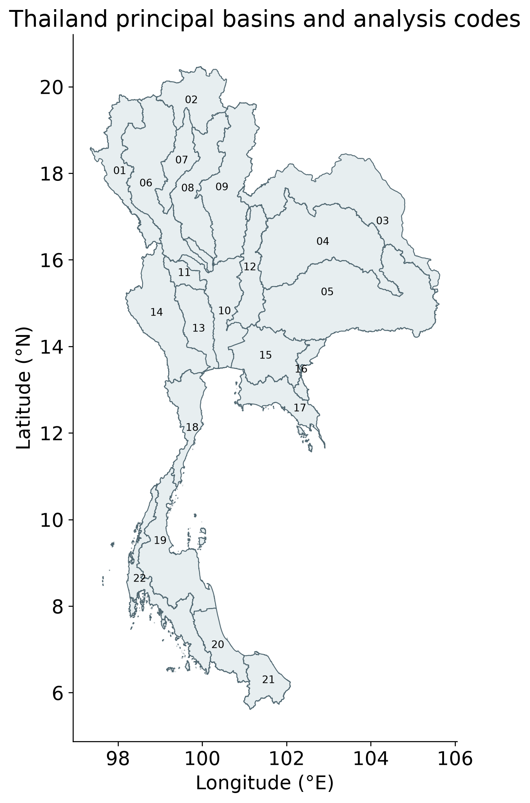
Figure 1 Thailand principal basins
The 22 ONWR principal basins. Administrative reporting polygons do not create independent GRACE resolution.
All principal basins fall below CSR's approximate 200,000 km² small-area caution. The national footprint intersects 68 native mascons; inverse weight concentration is approximately 50.1, which describes spatial weighting and does not count independent observations. Adjacent basin maps share broad gravity support. Interpretation should emphasize coherent regional patterns and monitoring priorities rather than precise local aquifer attribution.

Datasets and observation support
Table 2 Data roles and limitations
Input | Role | Important limit
CSR RL06.3 | Observed total storage | Broad native gravity support
GLDAS Noah | Soil canopy and snow | Partial land storage only
G3P surface water | Groundwater subtraction | Modeled component uncertainty
WaterGAP paired runs | Naturalized and historical baseline | Model-defined counterfactual
Native P and PET | Emulator predictors | Native forcing dependence
CHIRPS and other satellites | Alternative forcing and context | Unequal spatial and temporal coverage
GROW well archive | Head comparison | Mostly annual local observations
MSEA-Res Level 1 | Reservoir component check | Sparse scene-supported months
ONI RONI v5 and DMI | Teleconnection diagnostics | Short record and version sensitivity
Independent supporting inputs include CHIRPS rainfall, GLEAM and MODIS actual evapotranspiration, ESA CCI surface and root-zone moisture, MODIS land-surface temperature, GROW well observations and MSEA-Res reservoir storage. NOAA ONI, historical RONI v5 and HadISST-based DMI are frozen locally for the new teleconnection analysis. File hashes, download URLs and index versions are retained. Data coverage varies by source, and each comparison uses its own eligible paired dates.

CHAPTER 3
HARMONIZATION AND MISSING DATA
Storage anomalies are expressed as millimetres of equivalent water depth over the represented area. CSR centimetres are multiplied by ten. Each compartment is referenced to the available 2004–2009 mean before subtraction. A water flux is not a storage anomaly: native precipitation and potential evapotranspiration in mm/day are converted to monthly totals using actual month lengths only for the relevant forcing summaries and plots.
Spatial weights use area overlap and valid support. A groundwater balance requires the relevant storage terms on common valid cells and months. The fraction represented by valid observations is retained, because a changing footprint can otherwise create apparent storage change. Cross-product comparisons are additionally restricted to common dates. Reference offsets affect anomaly levels, whereas changing spatial or temporal support can also affect slopes and correlations.
GRACE and GRACE-FO mission gaps are not filled in the scientific trend and validation series. Lines are broken across unavailable months. Annual storage summaries require at least eight eligible months and the previously specified endpoint checks. Reservoir absence is not zero storage. Independent scene estimates remain sparse, and smoothed provider Level 2 reservoir values are treated separately from primary scene-screened Level 1 evidence. These rules prevent visually complete records from being mistaken for observed data.

Groundwater storage calculation
Groundwater storage anomalies are calculated as GWSA = TWSA − SMSA − SWSA − CWSA − SWEA. SMSA denotes soil moisture storage anomaly; SWSA denotes surface water storage anomaly; CWSA denotes canopy water storage anomaly; and SWEA denotes snow water equivalent anomaly. Snow is small in Thailand but is retained to keep the storage accounting explicit. All terms must share units, a reference period and valid spatial support.
The standard equation does not make the result directly observed groundwater. Error in a soil or surface-water term appears with the opposite sign in GWSA. In tropical monsoon conditions, uncertain floodplain and reservoir storage can therefore affect an apparent groundwater signal. The GLDAS component sum excludes open surface water and groundwater and must not be labelled total terrestrial water storage.
Spatial response remains a limitation. The primary CSR calculation does not apply an additional arbitrary filter to the mascon field. Its component subtraction may still have a different effective response from the gravity signal. The contrasting COST-G/G3P chain and native-support diagnostics expose sensitivity but do not remove it. A publication claiming quantitative aquifer depletion would require a stronger matched-filter or forward-model assessment and aquifer-specific evidence.

Trend estimation and significance
For each basin and storage variable, the primary trend estimate is a seasonal Sen slope. Slopes are calculated between values from the same calendar month in different years, reducing the effect of the annual storage cycle. The seasonal Mann–Kendall test evaluates ordered change. Basin-level false discovery rate adjustment is reported with the original probabilities and sample counts. A small q value describes evidence within that testing procedure, not the size or cause of storage change.
Seasonal Mann–Kendall does not automatically remove serial dependence. Annual Hamed–Rao sensitivity, trend windows and resampling-based slope intervals provide complementary checks. Seasonal Sen slopes are robust descriptive rates but are not algebraically additive. The report therefore uses a separate calendar-month fixed-effect ordinary least-squares model when decomposing observed, climate, human and discrepancy trends on identical dates.
Additive OLS intervals use paired wild calendar blocks, with 999 replicates and one-, two- and three-year block choices. The same perturbation structure is applied to paired series to preserve the decomposition. These intervals are conditional on the chosen data products and observed calendar. They do not include the full uncertainty in gravity processing, groundwater compartments or hydrological structure. Common-date processing-chain contrasts are reported separately rather than folded into an unjustified single confidence interval.

Climate reconstruction and test design
The climate baseline C is the published naturalized WaterGAP simulation. A statistical emulator is developed to reconstruct this baseline from meteorological information. Keeping these roles separate is essential: C defines the primary residual, while the emulator tests how much of the parent simulation is recoverable from weather. The emulator is a basin-scale storage reconstruction model, not a global circulation model or a verified future climate projection.
The evaluated candidates are regularized linear models, a spline-based model and a random forest, combined using validation-period performance. Inputs include precipitation, potential evapotranspiration, calendar season and climate-memory features. Lagged and accumulated weather represent delayed storage responses. Neither GRACE nor groundwater head is an emulator predictor. Preprocessing and tuning are fitted chronologically so future test information cannot influence parameter selection.
The model chronology uses 1981–1990 for warm-up, 1991–2009 for training, 2010–2015 for validation and 2016–2023 for held-out testing. Test observations are not used to choose models, weights or ENSO phase-specific fits. Raw NSE, RMSE, MAE, bias and amplitude are reported alongside anomaly NSE based on the training monthly climatology. A controlled Ridge comparison isolates memory gains; a frozen rainfall substitution tests sensitivity to the native forcing.

Residual accounting and variability
Let O denote observed or derived storage, C naturalized WaterGAP storage and A historical WaterGAP storage with the model's represented direct human activities. The observation-minus-baseline residual is R = O − C. The paired modeled human effect is H = A − C, and the observation–historical-model discrepancy is E = O − A. Consequently, R = H + E on every matched month. The identity is exact and is checked numerically.
A negative R is consistent with storage below the naturalized baseline, but does not identify all of the difference as human depletion. E can contain errors in forcing, model structure, observations, component subtraction and unrepresented management. H can omit real processes or misrepresent their timing. Calling R a human-only measurement would require independent evidence that the non-human discrepancy is sufficiently small, which is not established here.
The paper reports slopes and variability for these quantities without forcing them into complementary percentages. Annual variability ratios divide each component's mean absolute deviation about its own mean by the observed mean absolute deviation on the same months. Covariance means the ratios need not sum to one and can exceed one. A discrepancy-magnitude index is also descriptive; it is not the percentage of storage decline caused by model error or human use.

Evaluation using GLDAS wells and reservoirs
Model evaluation follows the quantity being compared. The climate emulator is evaluated against its naturalized parent in mm. GLDAS is compared with matching soil, canopy and snow storage, excluding groundwater and open surface water. GRACE-versus-baseline differences are reported as an observation-model benchmark. RMSE bars for these different targets are not a competition in which the smallest number identifies the best overall hydrological model.
Groundwater observations measure level or depth, rather than equivalent water volume over a basin. Depth to water is converted to a head-oriented sign by negation. Co-located wells are grouped by station before basin aggregation, reducing domination by repeated records at one location. Residual–head agreement is examined using raw, detrended and common-panel comparisons. No storage RMSE or NSE is calculated across these incompatible units. Without representative specific yield and aquifer geometry, head change is not converted to groundwater storage.
Independent MSEA-Res estimates check a surface-water component of the TWS residual. A fixed pre-2004 reservoir panel avoids interpreting new-reservoir inclusion as a storage trend. Primary Level 1 comparisons require scene support and remove season and linear trend. Calendar-year cluster bootstraps quantify conditional correlation uncertainty. Reservoir operations and climatic inflow both influence storage, so this remains component evidence rather than an observed human-only counterfactual.

ENSO and IOD methodology
The teleconnection analysis uses January 2003–December 2023, with missing storage months retained. NOAA ONI is a three-month Niño 3.4 SST anomaly index; DJF is assigned to its centre month January. Historical RONI v5 provides index-version sensitivity. NOAA's operational monitoring has moved to RONI, and its current page uses ERSSTv6; this study explicitly freezes v5 rather than mixing versions. DMI represents the Indian Ocean Dipole and is obtained from the NOAA PSL HadISST series.
The selected ENSO leads are 0, 3, 6, 9 and 12 months. A positive lead means the ENSO index precedes storage. On each exact paired sample, storage and lagged ENSO are residualized against calendar-month indicators, linear time and contemporaneous DMI. Their residual correlation is a partial association. DMI is a competing teleconnection covariate, not a complete adjustment for all climate influences; lagged IOD and nonlinear responses remain possible omissions.
A finite phase-randomization diagnostic uses all 20 nonzero whole-year circular rotations of the 21-year ENSO calendar. Nuisance regressions are refitted and the observed missing-month pattern is retained. The two-sided rank probability includes the observed alignment, giving minimum p = 1/21. FDR is applied across all basin tests, both indices, all five lags and nine storage/forcing series; national tests form a separate family. These rotations preserve within-index patterns but assume shift comparability and have low inferential resolution. They are a conservative sensitivity screen, not an exact general-purpose causal test.
ENSO phases require at least five consecutive overlapping seasons beyond ±0.5°C, using provider-table precision of 0.1°C. Phase composites remove season and trend but retain joint IOD conditions. Monthly means and equal-episode means are supplied separately, with episode-bootstrap intervals where at least three episodes exist. Held-out emulator errors are stratified by phase without refitting. Non-significant residual associations do not establish that all climate influence has been removed.

Uncertainty and reproducibility
The uncertainty assessment separates observation support, product choice, model reconstruction, discrepancy and independent monitoring. These sources are related but not interchangeable. A narrow conditional slope interval can coexist with substantial differences between processing chains. A high emulator NSE can coexist with poor observational agreement. A large number of station records can coexist with only a few independent years for a temporal correlation.
Input checksums, pinned numerical dependencies and executable workflows accompany the results. The original and extended packages rebuild the storage, climate and validation analyses. The publication extension freezes ONI, historical RONI v5 and DMI and rebuilds all new diagnostics. Reference CSV comparisons check the numerical outputs. Figure sources remain vector PDFs with original numerical tables; web displays do not replace the scientific calculations.
The dashboard is a research decision-support system. It supports basin selection, storage-variable selection, temporal inspection, climate and residual comparisons, ENSO diagnostics and data download. It does not prescribe groundwater abstraction limits or infer a particular user's pumping. Its practical use is to identify coherent storage concerns, inspect the supporting evidence and prioritize monitoring or further study.

CHAPTER 4
OBSERVED STORAGE TRENDS
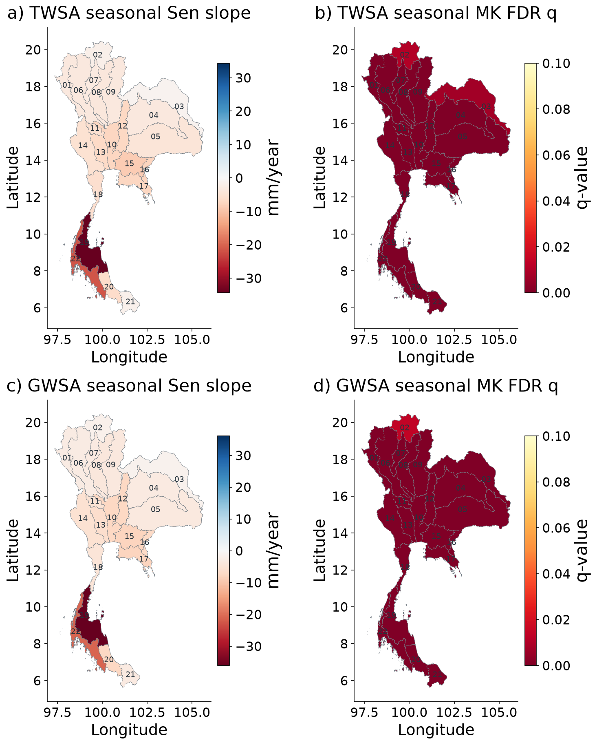
Figure 2 Spatial GRACE storage trends and Mann Kendall evidence
Basin-average CSR TWSA and compartment-derived GWSA; seasonal Sen slopes and basin FDR q. q colours saturate at 0.10. Seasonal MK does not correct serial dependence; slope intervals are supplied in the numerical tables. All basins retain the CSR small-support caution.
National CSR-based TWSA declines at a seasonal Sen rate of −7.51 mm/year over 237 observed months from April 2002 to September 2024. The conditional 95% interval is −9.79 to −5.68 mm/year. Derived GWSA declines at −6.84 mm/year over 225 observed months through September 2023, with interval −8.77 to −5.11 mm/year. The dates differ because the component data end earlier than the gravity record. These national rates should not be compared as if they came from identical samples.

Observed storage in every basin
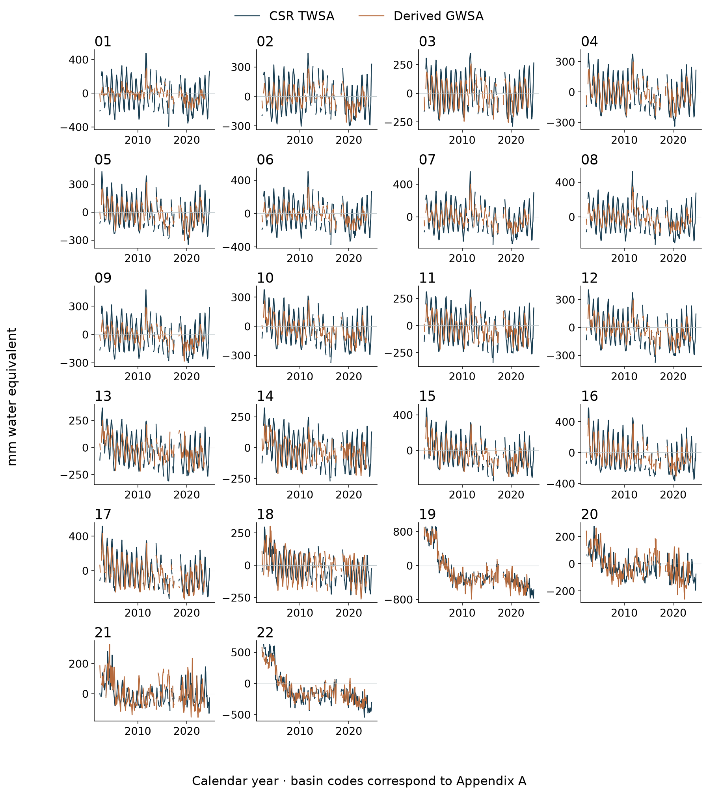
Figure 3 Observed storage time series for all 22 basins
Monthly CSR TWSA and full-compartment GWSA, in mm. Mission gaps remain missing and GWSA ends in September 2023. Basin codes identify every subplot; full names are in Appendix A.

Basin trend values
Table 3 Observed storage trends for every basin
Basin | TWS slope | TWS q | n | GWS slope | GWS q | n
01 | -3.59 | <.001 | 237 | -2.88 | <.001 | 225
02 | -1.90 | 0.010 | 237 | -1.83 | 0.014 | 225
03 | -1.32 | 0.007 | 237 | -1.59 | <.001 | 225
04 | -3.65 | <.001 | 237 | -3.32 | <.001 | 225
05 | -4.42 | <.001 | 237 | -3.47 | <.001 | 225
06 | -3.71 | <.001 | 237 | -3.10 | <.001 | 225
07 | -3.21 | <.001 | 237 | -3.32 | <.001 | 225
08 | -3.79 | <.001 | 237 | -3.97 | <.001 | 225
09 | -3.74 | <.001 | 237 | -3.94 | <.001 | 225
10 | -7.36 | <.001 | 237 | -7.47 | <.001 | 225
11 | -5.50 | <.001 | 237 | -5.20 | <.001 | 225
12 | -7.06 | <.001 | 237 | -7.35 | <.001 | 225
13 | -6.89 | <.001 | 237 | -6.36 | <.001 | 225
14 | -5.25 | <.001 | 237 | -5.48 | <.001 | 225
15 | -8.64 | <.001 | 237 | -8.12 | <.001 | 225
16 | -7.68 | <.001 | 237 | -7.30 | <.001 | 225
17 | -7.51 | <.001 | 237 | -7.92 | <.001 | 225
18 | -5.85 | <.001 | 237 | -4.75 | <.001 | 225
19 | -34.37 | <.001 | 237 | -36.08 | <.001 | 225
20 | -6.25 | <.001 | 237 | -7.45 | <.001 | 225
21 | -1.62 | <.001 | 237 | -3.16 | <.001 | 225
22 | -21.48 | <.001 | 237 | -20.95 | <.001 | 225
Slopes are seasonal Sen estimates in mm/year. q is seasonal Mann–Kendall FDR across basins; n is observed months. Full intervals and original p-values remain in CSR_basin_trends.csv. Basin names are listed in Appendix A.
Basin maps and temporal panels reveal spatially varying amplitude and interannual histories. Seasonal MK q values must be read with sample sizes, serial-dependence sensitivity and native support. A basin with a more negative displayed slope is not necessarily statistically distinguishable from its neighbour. The website and tables retain full values so that users can inspect the magnitude, evidence and coverage together.

Sensitivity to the processing chain
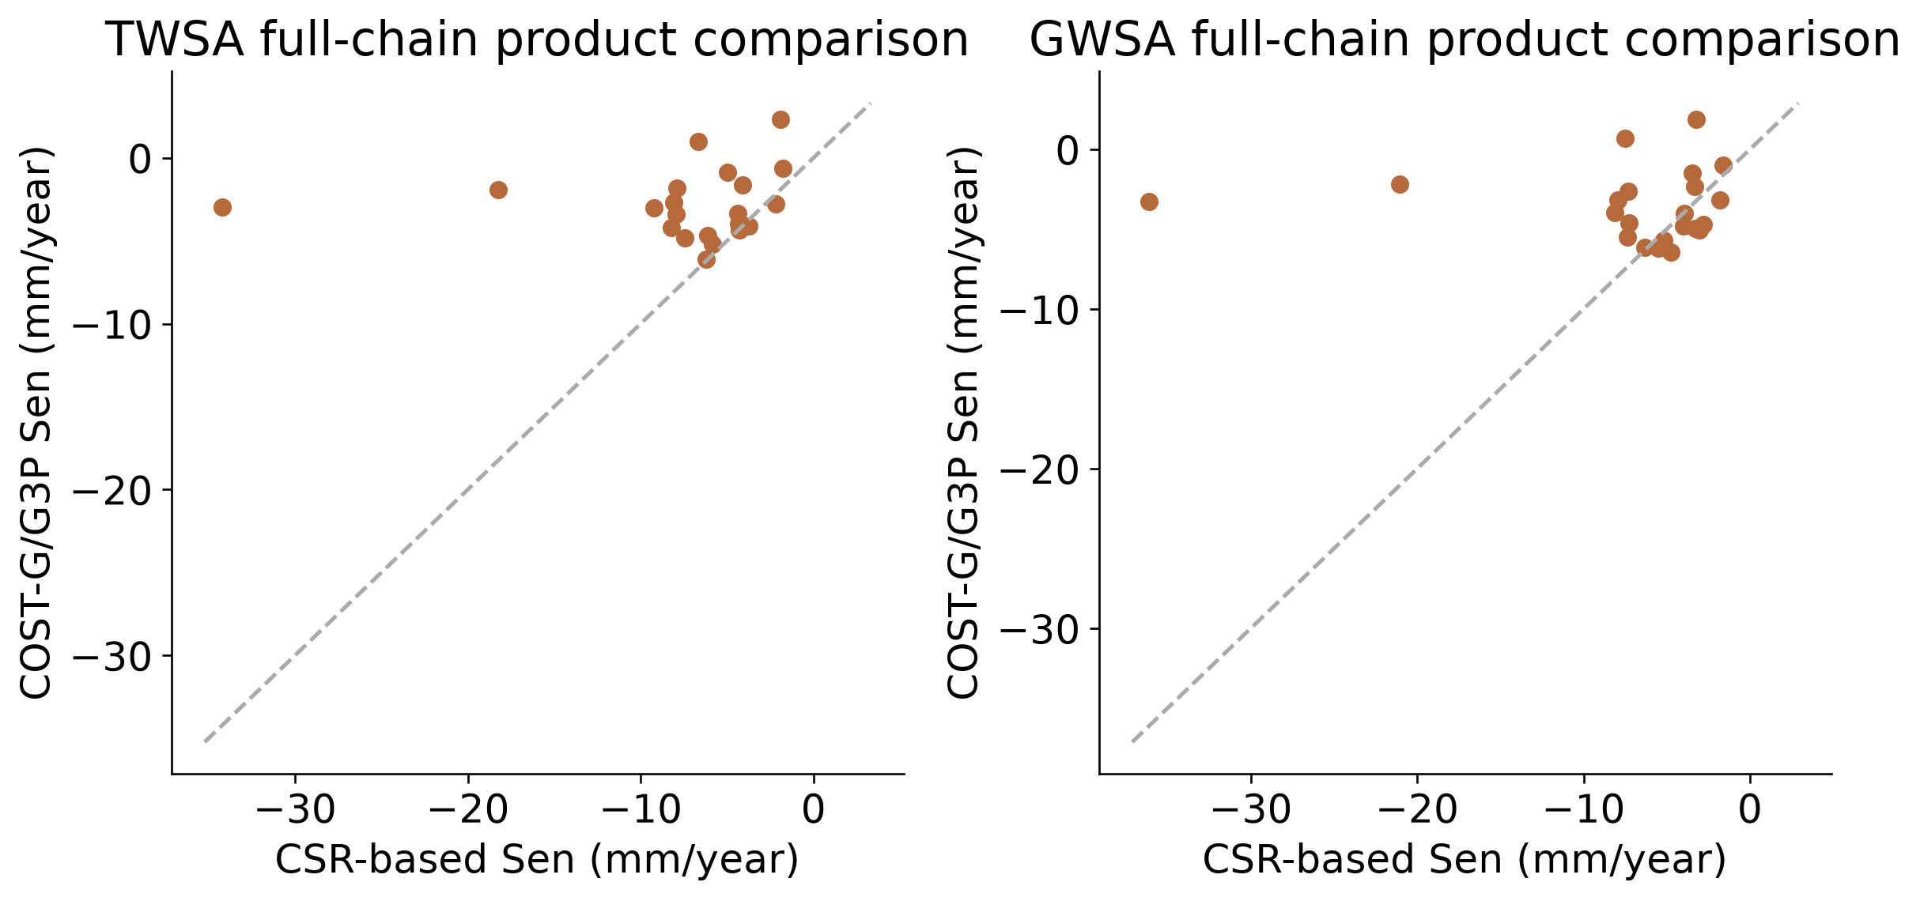
Figure 4 Processing-chain sensitivity
Common-date comparison of CSR and COST-G/G3P chains. Basin trend-ranking agreement is weak: Spearman 0.138 for TWSA and 0.027 for GWSA. Gravity and compartment processing differ, so groundwater contrasts cannot be attributed solely to GRACE.
On the common 223-month processing comparison, national TWSA slopes are approximately −7.67 mm/year for CSR and −2.56 mm/year for COST-G/G3P. Groundwater slopes are −6.88 and −3.45 mm/year. Both chains retain a negative national direction, but the contrast is substantial in magnitude. Basin trend-ranking correlations are only 0.138 for TWSA and 0.027 for GWSA. The primary conclusion is broad decline with unstable local ordering, rather than a definitive ranking of the most depleted aquifers.

Meteorological inputs in space and time
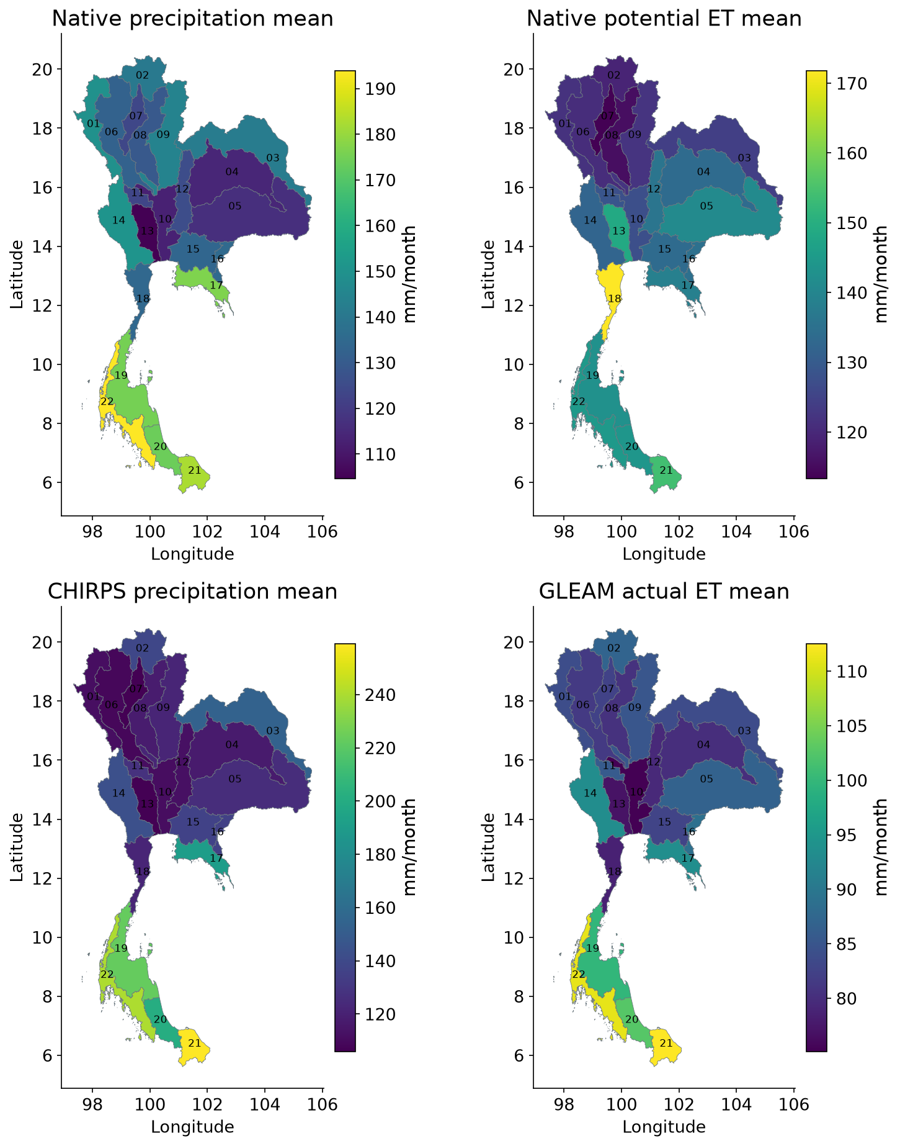
Figure 5 Mean forcing and supporting data 1
Available-month means within 2003–2023; values describe basin averages, not native pixel trends. Native precipitation and PET drive the climate reconstruction; CHIRPS is alternative rainfall. Actual ET, soil moisture and surface temperature provide context. Unequal product coverage is retained; no significance or causal attribution is implied.
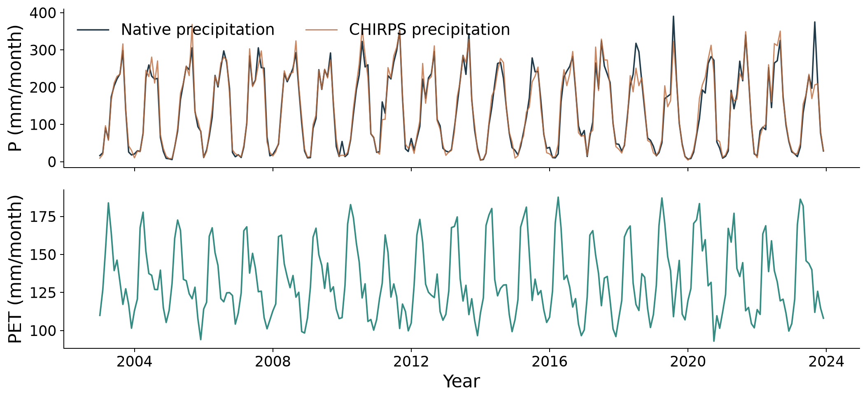
Figure 6 National precipitation and potential ET
Native rainfall and PET drive the emulator. CHIRPS is independent alternative rainfall; native P/PET monthly totals use actual calendar month lengths.

GLDAS and residual spatial comparison
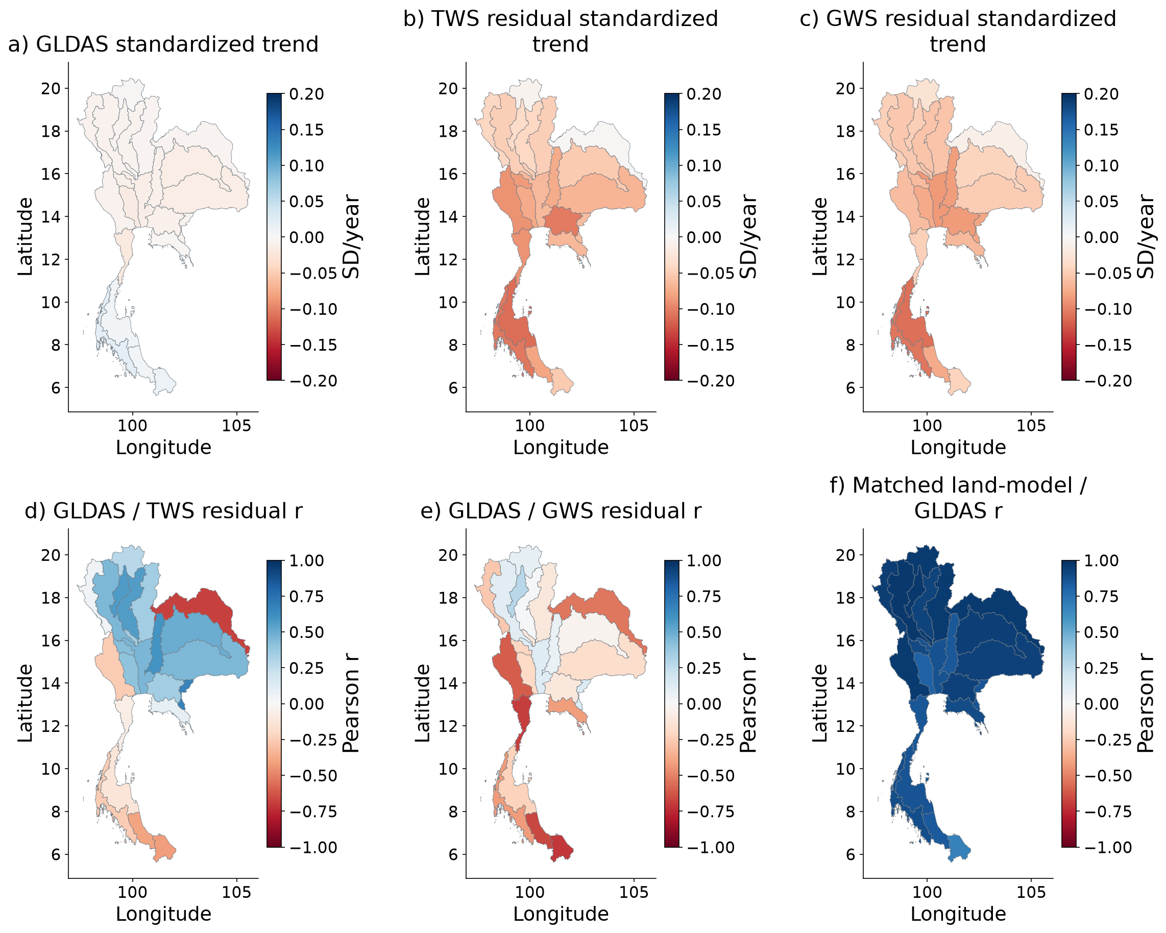
Figure 7 Spatial GLDAS and residual comparisons
Top: slopes of separately standardized series on identical joint months; scale saturates at ±0.2 SD/year. Bottom: descriptive correlations, with the matched land-component correlation for context. GLDAS land storage and residual storage are different quantities. No cross-compartment NSE, RMSE or claim of human validation is made. GLDAS also contributes to GWS subtraction.
This comparison deliberately standardizes quantities with different component definitions. Correlated timing can indicate shared climate or model dependence; it cannot establish equal water volume or validate anthropogenic storage. GLDAS contributes to GWS subtraction, so independence is especially limited for the groundwater residual.

Rainfall and storage seasonality
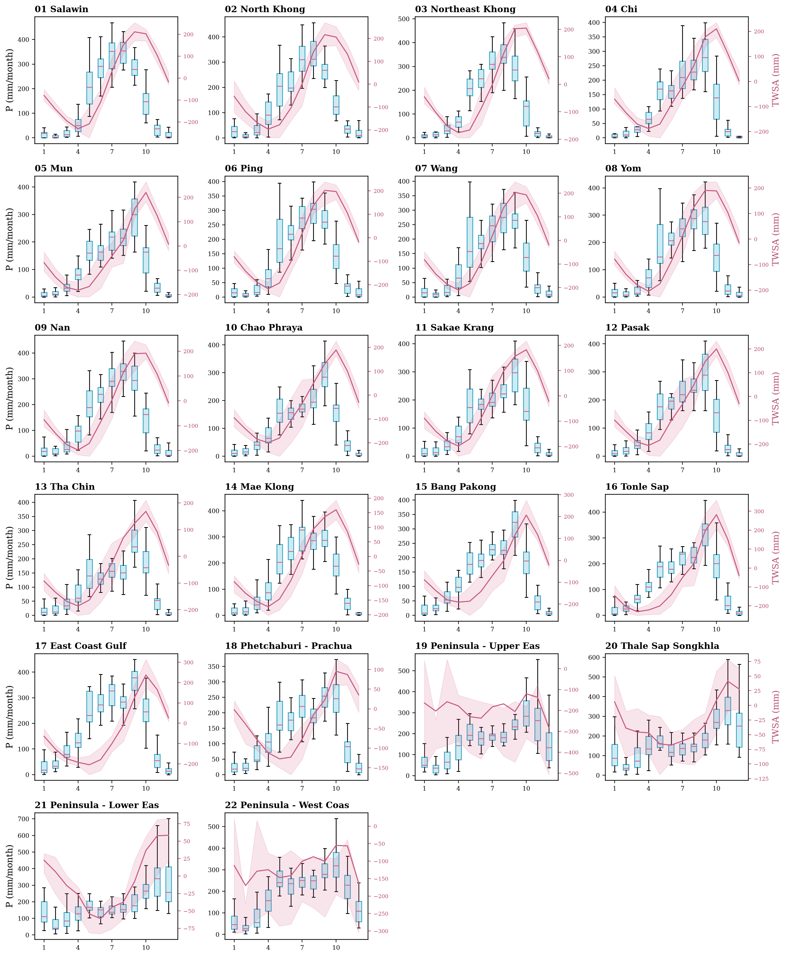
Figure 8 Rainfall and storage seasonality
Native precipitation distributions by calendar month, 2003–2023 (boxes: quartiles; whiskers: 1.5 IQR; outliers suppressed). Pink mean observed TWSA and interannual interquartile band on right axis. Distribution spread is not confidence in the mean. Missing GRACE months are retained.

Climate baseline and reconstruction maps
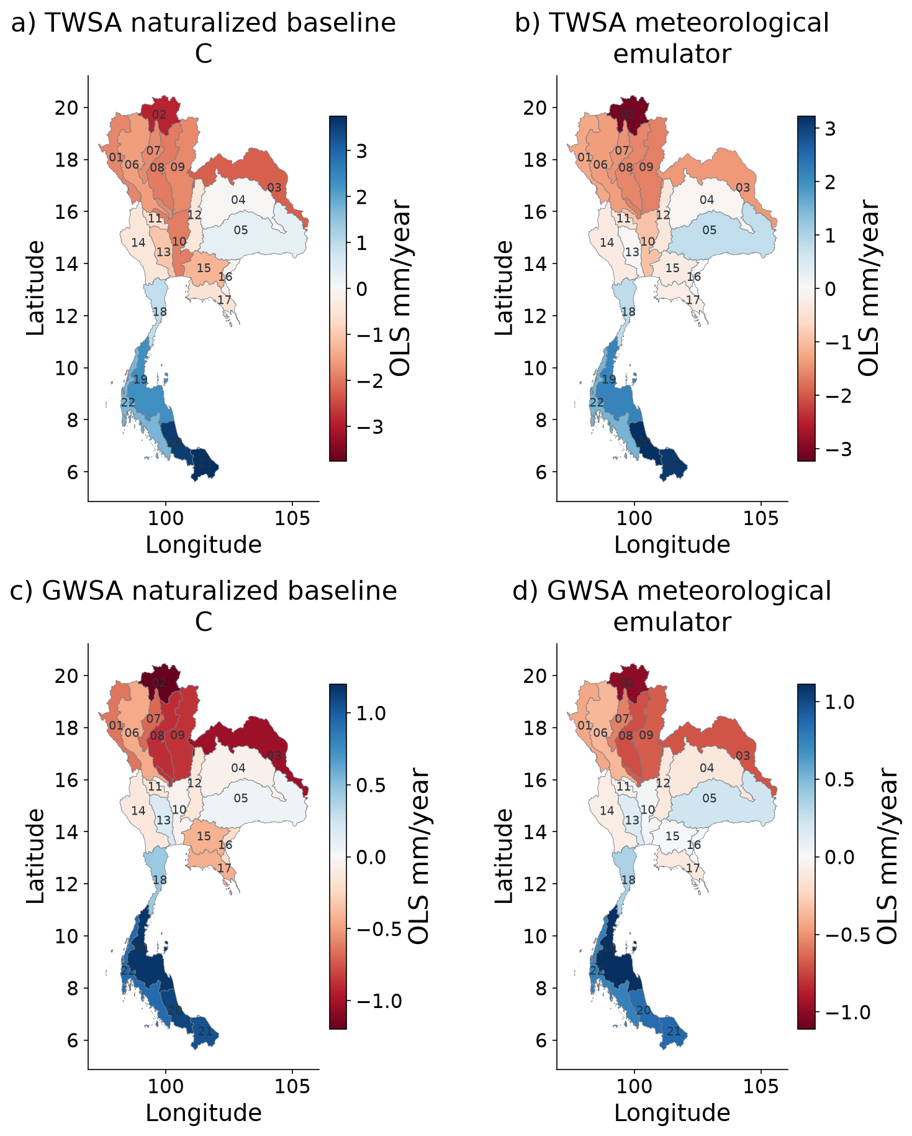
Figure 9 Spatial naturalized storage and climate reconstruction
Calendar-month fixed-effect slopes. C is the naturalized WaterGAP baseline used in R=O−C; the statistical emulator reconstructs its parent-model target on its retained verification footprint. Emulator slopes use CSR-available dates through 2023, not a fit to GRACE. These columns are related model estimates, not independent observations.
C is the naturalized WaterGAP baseline, while the emulator is a weather-based approximation of that parent. Their slopes are calculated on stated comparable support. The baseline used in the primary residual is not silently replaced by the statistical prediction. This distinction separates hydrological counterfactual uncertainty from reconstruction error.

TWSA reconstruction in every basin
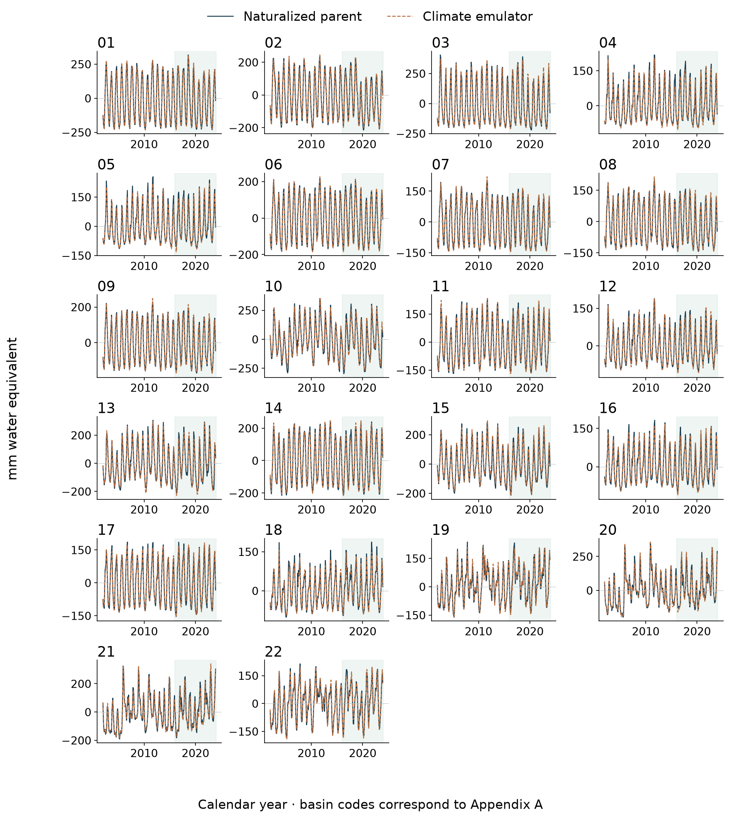
Figure 10 TWSA climate reconstruction for all 22 basins
Naturalized parent-model target and frozen meteorological ensemble reconstruction. Green shading identifies the held-out 2016–2023 period; earlier values are training or validation context. The emulator targets a hydrological model, not independently observed storage.

GWSA reconstruction in every basin
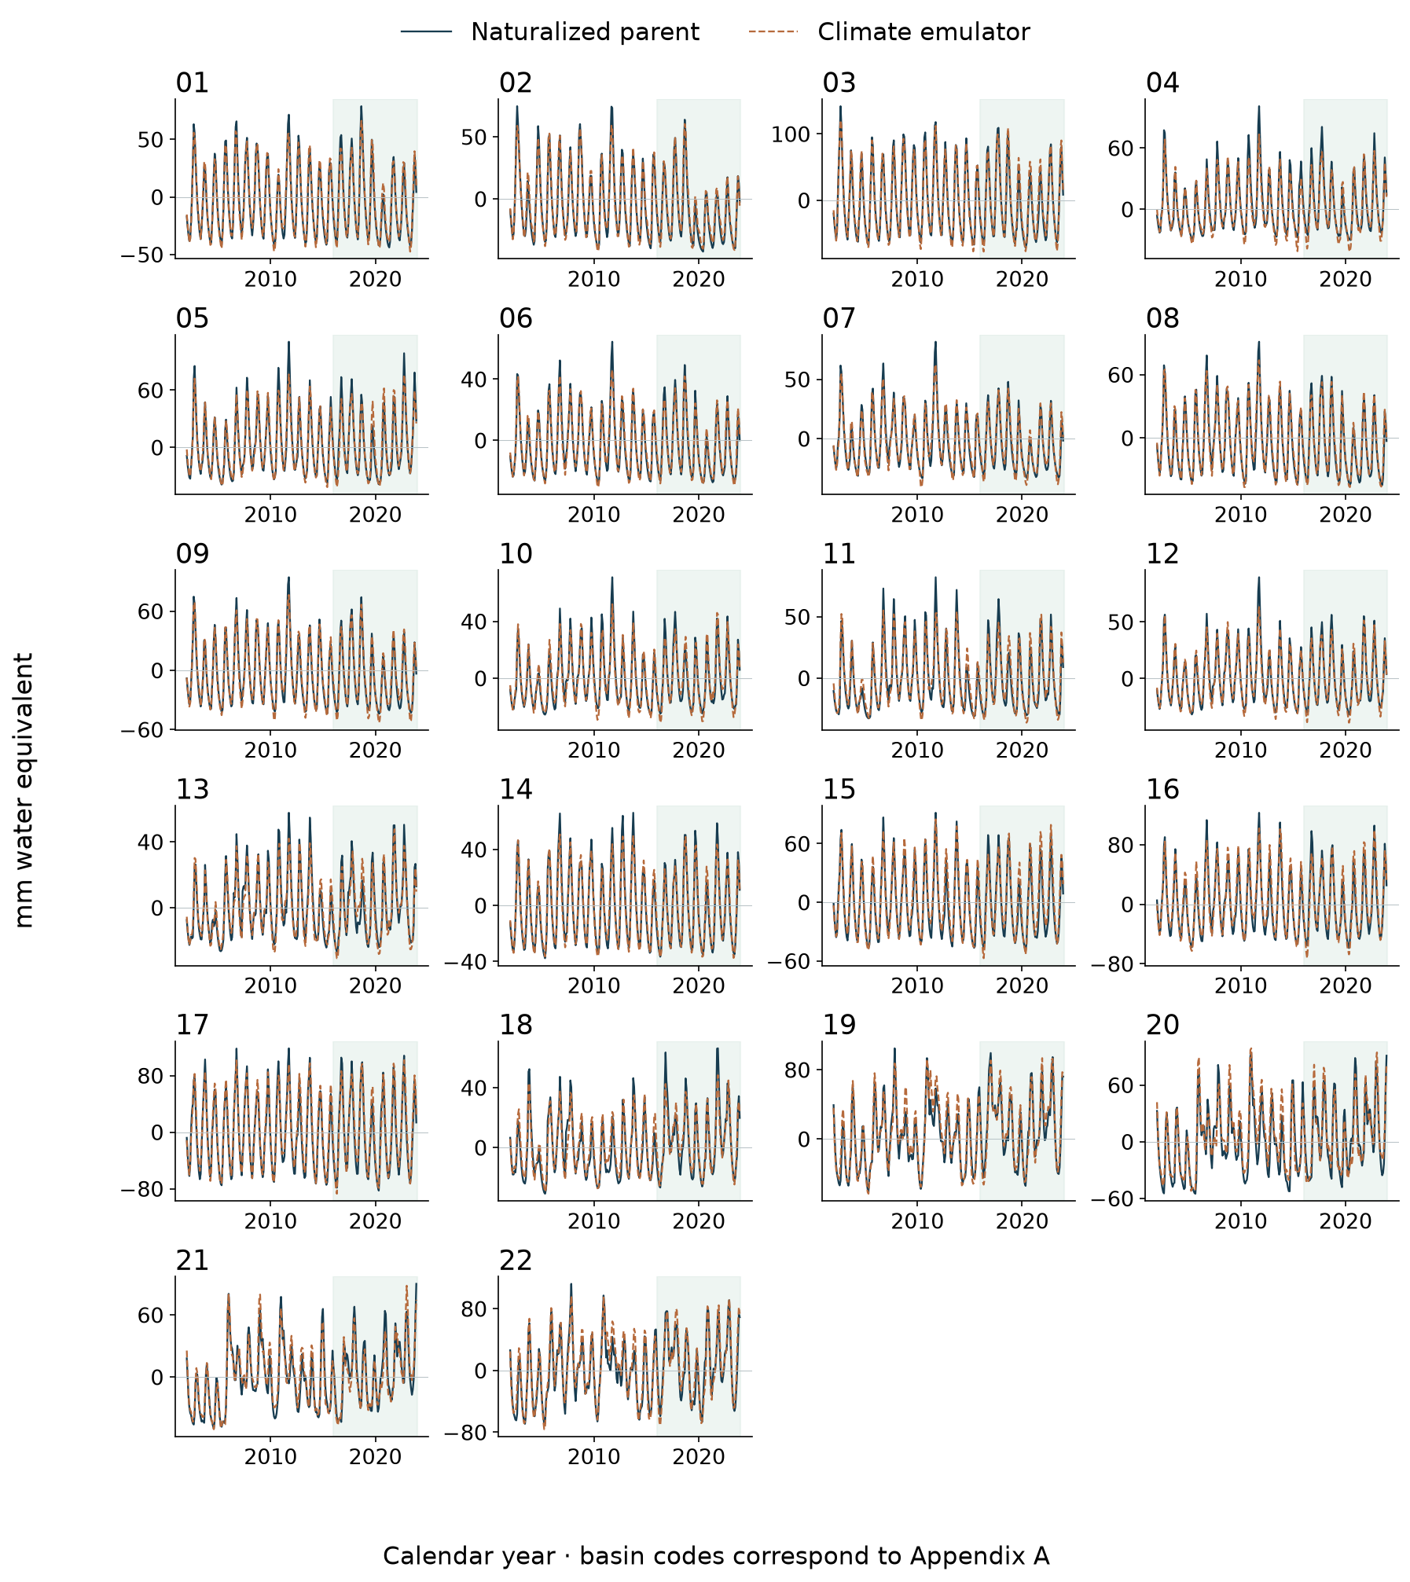
Figure 11 GWSA climate reconstruction for all 22 basins
Naturalized parent-model target and frozen meteorological ensemble reconstruction. Green shading identifies the held-out 2016–2023 period; earlier values are training or validation context. The emulator targets a hydrological model, not independently observed storage.

Held out TWSA reconstruction scatterplots
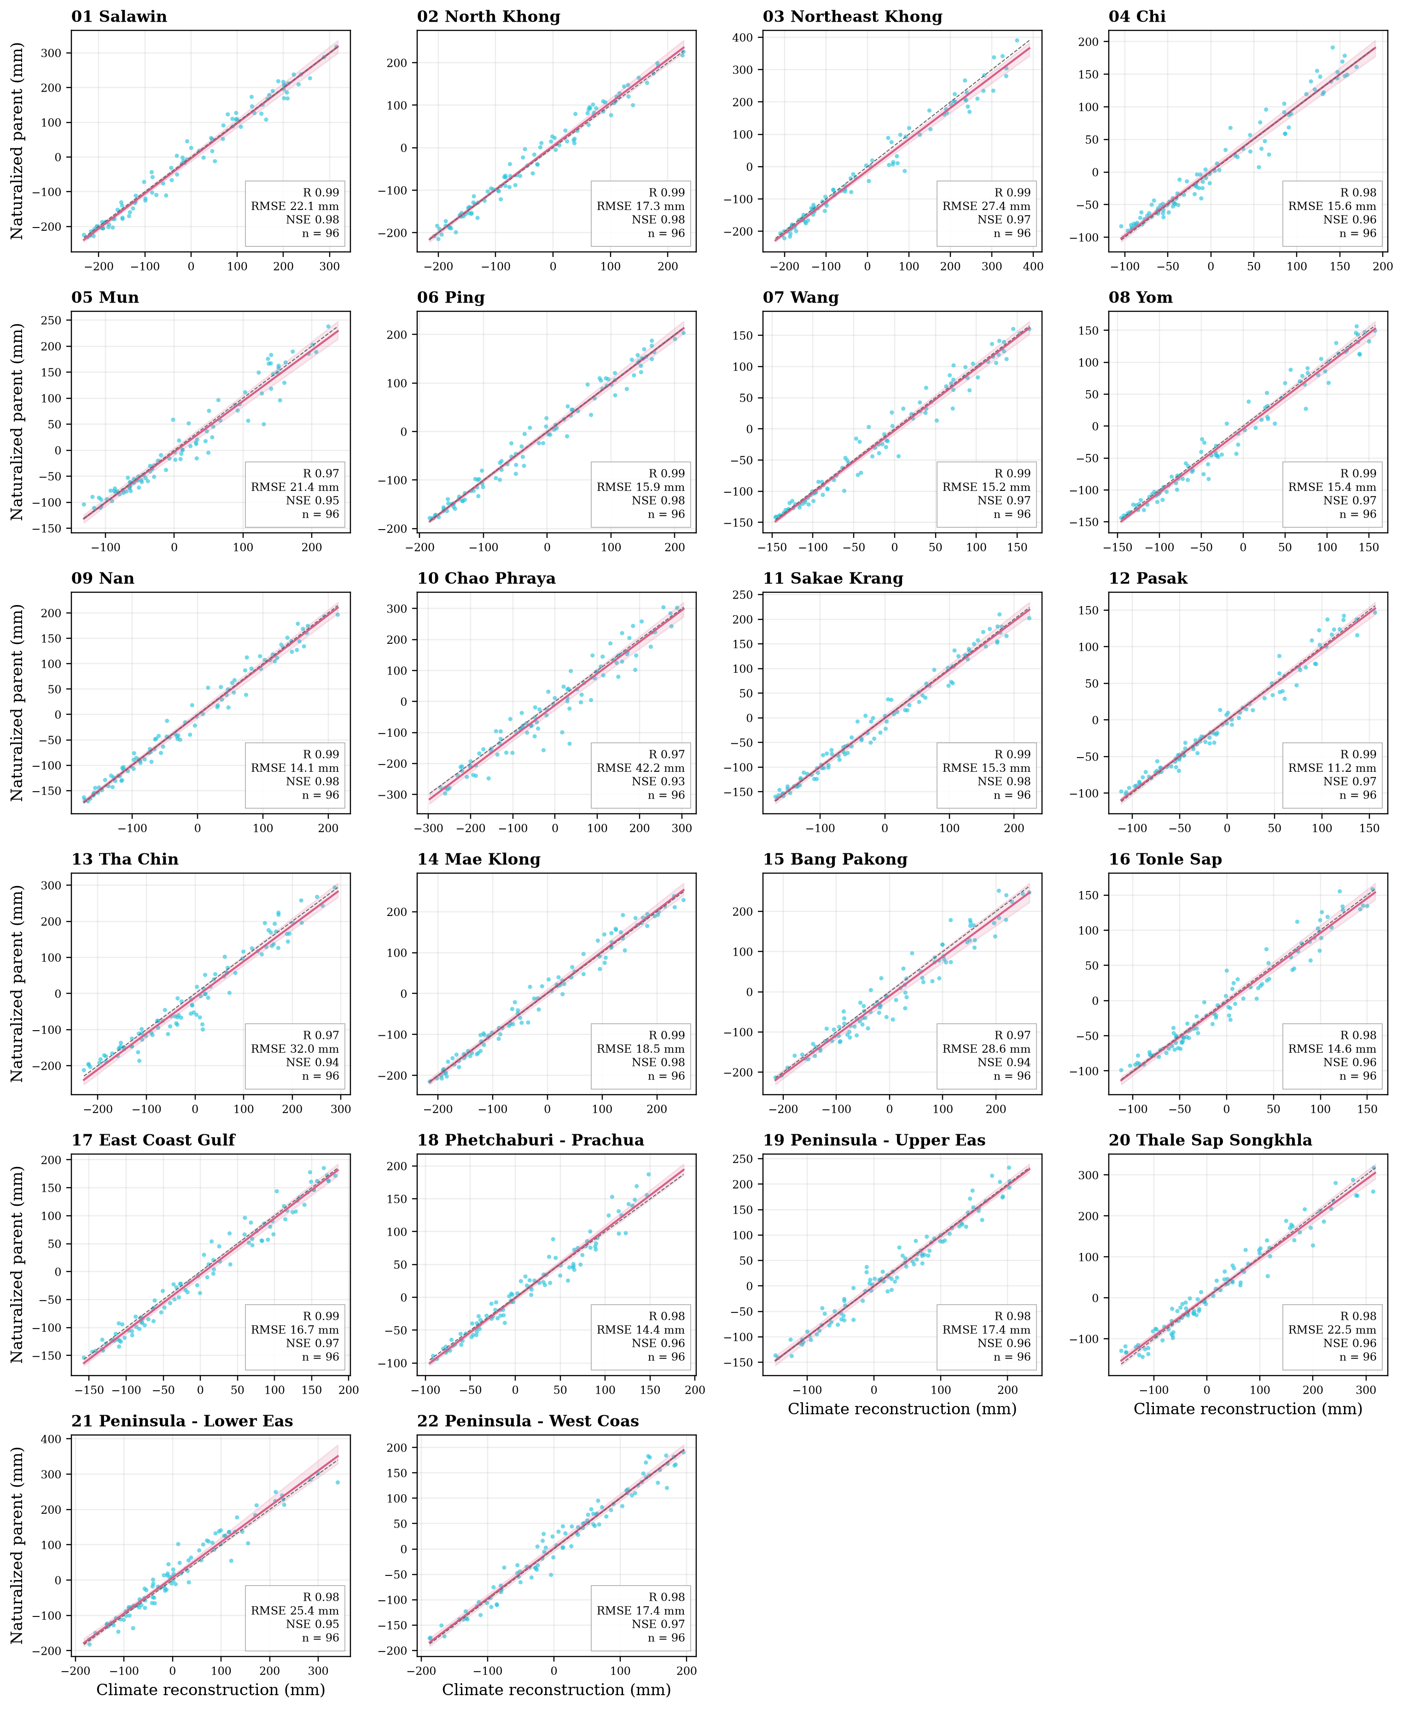
Figure 12 TWSA reconstruction in all basins
Held-out 2016–2023 only. Cyan monthly pairs; pink OLS descriptive fit and calendar-year bootstrap 95% band (399 replicates); grey identity. R, RMSE and NSE evaluate predictions directly, not the fitted line. The target is a naturalized model, not independent observed storage.

Held out GWSA reconstruction scatterplots
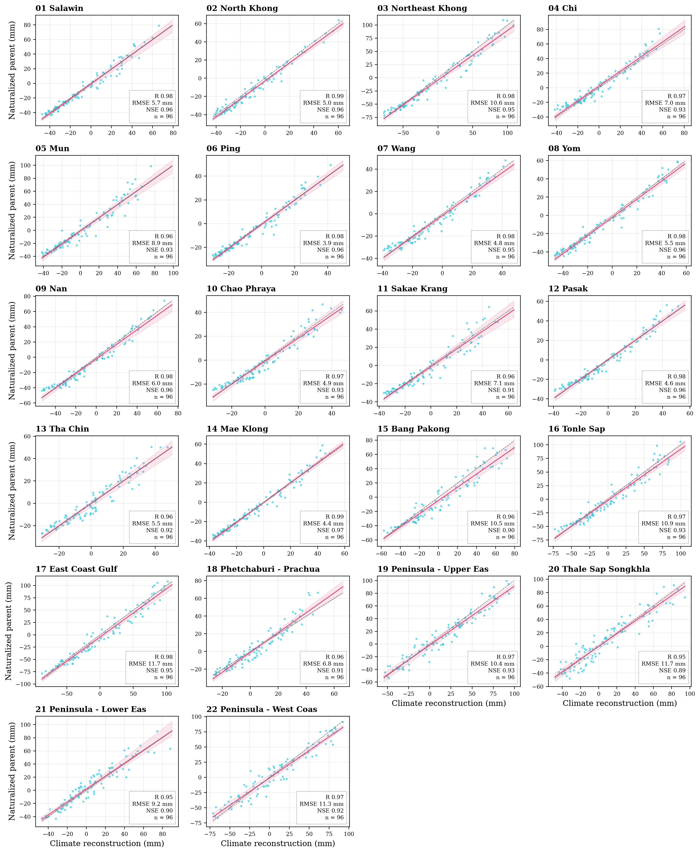
Figure 13 GWSA reconstruction in all basins
Held-out 2016–2023 only. Cyan monthly pairs; pink OLS descriptive fit and calendar-year bootstrap 95% band (399 replicates); grey identity. R, RMSE and NSE evaluate predictions directly, not the fitted line. The target is a naturalized model, not independent observed storage.

TWSA reconstruction performance by basin
Table 4 TWSA climate reconstruction performance
Basin | n | r | NSE | Anom NSE | RMSE | MAE
01 | 96 | 0.991 | 0.981 | 0.807 | 22.08 | 16.90
02 | 96 | 0.990 | 0.979 | 0.904 | 17.32 | 13.88
03 | 96 | 0.990 | 0.973 | 0.812 | 27.37 | 19.39
04 | 96 | 0.981 | 0.961 | 0.821 | 15.61 | 11.58
05 | 96 | 0.974 | 0.946 | 0.732 | 21.43 | 15.40
06 | 96 | 0.991 | 0.981 | 0.876 | 15.90 | 12.00
07 | 96 | 0.987 | 0.974 | 0.868 | 15.24 | 11.08
08 | 96 | 0.987 | 0.972 | 0.873 | 15.38 | 11.43
09 | 96 | 0.992 | 0.983 | 0.901 | 14.14 | 10.83
10 | 96 | 0.967 | 0.928 | 0.792 | 42.23 | 30.13
11 | 96 | 0.990 | 0.980 | 0.875 | 15.34 | 12.27
12 | 96 | 0.987 | 0.974 | 0.864 | 11.22 | 8.35
13 | 96 | 0.974 | 0.942 | 0.778 | 32.00 | 23.99
14 | 96 | 0.991 | 0.981 | 0.856 | 18.49 | 14.13
15 | 96 | 0.975 | 0.942 | 0.764 | 28.65 | 22.72
16 | 96 | 0.979 | 0.957 | 0.705 | 14.60 | 11.45
17 | 96 | 0.987 | 0.972 | 0.742 | 16.75 | 13.62
18 | 96 | 0.979 | 0.957 | 0.827 | 14.38 | 10.97
19 | 96 | 0.982 | 0.965 | 0.911 | 17.38 | 13.55
20 | 96 | 0.982 | 0.963 | 0.903 | 22.54 | 18.01
21 | 96 | 0.977 | 0.951 | 0.887 | 25.44 | 18.76
22 | 96 | 0.985 | 0.970 | 0.903 | 17.36 | 13.16
Frozen ensemble, 2016–2023 test data. Target: naturalized WaterGAP, not GRACE. Errors are mm; anomaly NSE removes the training monthly climatology. Higher NSE and lower errors are better.
The frozen ensemble achieves national held-out NSE of 0.981 for TWSA and 0.961 for GWSA against naturalized WaterGAP. Basin scatterplots show predicted values directly against their parent targets, with descriptive regressions and identity lines. Calendar-year bootstrap bands describe uncertainty in the fitted relationship conditional on these eight test years; they do not quantify the full uncertainty of a natural climate counterfactual.

GWSA reconstruction performance by basin
Table 5 GWSA climate reconstruction performance
Basin | n | r | NSE | Anom NSE | RMSE | MAE
01 | 96 | 0.982 | 0.963 | 0.830 | 5.74 | 4.47
02 | 96 | 0.986 | 0.956 | 0.901 | 4.98 | 4.08
03 | 96 | 0.982 | 0.953 | 0.781 | 10.59 | 7.70
04 | 96 | 0.969 | 0.933 | 0.755 | 7.04 | 5.33
05 | 96 | 0.963 | 0.927 | 0.678 | 8.87 | 6.32
06 | 96 | 0.980 | 0.958 | 0.842 | 3.94 | 2.92
07 | 96 | 0.977 | 0.948 | 0.824 | 4.83 | 3.96
08 | 96 | 0.984 | 0.963 | 0.865 | 5.52 | 4.22
09 | 96 | 0.982 | 0.958 | 0.832 | 6.04 | 4.78
10 | 96 | 0.968 | 0.935 | 0.661 | 4.90 | 4.09
11 | 96 | 0.958 | 0.914 | 0.627 | 7.09 | 5.40
12 | 96 | 0.981 | 0.962 | 0.812 | 4.62 | 3.61
13 | 96 | 0.959 | 0.920 | 0.703 | 5.50 | 4.45
14 | 96 | 0.985 | 0.970 | 0.812 | 4.39 | 3.12
15 | 96 | 0.963 | 0.902 | 0.360 | 10.51 | 8.46
16 | 96 | 0.970 | 0.933 | 0.564 | 10.88 | 8.87
17 | 96 | 0.980 | 0.952 | 0.589 | 11.67 | 9.60
18 | 96 | 0.958 | 0.907 | 0.711 | 6.84 | 5.11
19 | 96 | 0.968 | 0.926 | 0.823 | 10.40 | 8.46
20 | 96 | 0.946 | 0.892 | 0.668 | 11.69 | 9.70
21 | 96 | 0.953 | 0.904 | 0.808 | 9.19 | 7.33
22 | 96 | 0.967 | 0.922 | 0.780 | 11.32 | 8.94
Frozen ensemble, 2016–2023 test data. Target: naturalized WaterGAP, not GRACE. Errors are mm; anomaly NSE removes the training monthly climatology. Higher NSE and lower errors are better.
The target remains the modeled naturalized groundwater baseline. The scores do not directly validate derived GRACE groundwater or pumping. Test dates are excluded from fitting and ensemble-weight selection; climate-memory predictors use preceding meteorological information. Full annual metrics and forcing-ablation results remain downloadable.

Spatial climate model performance
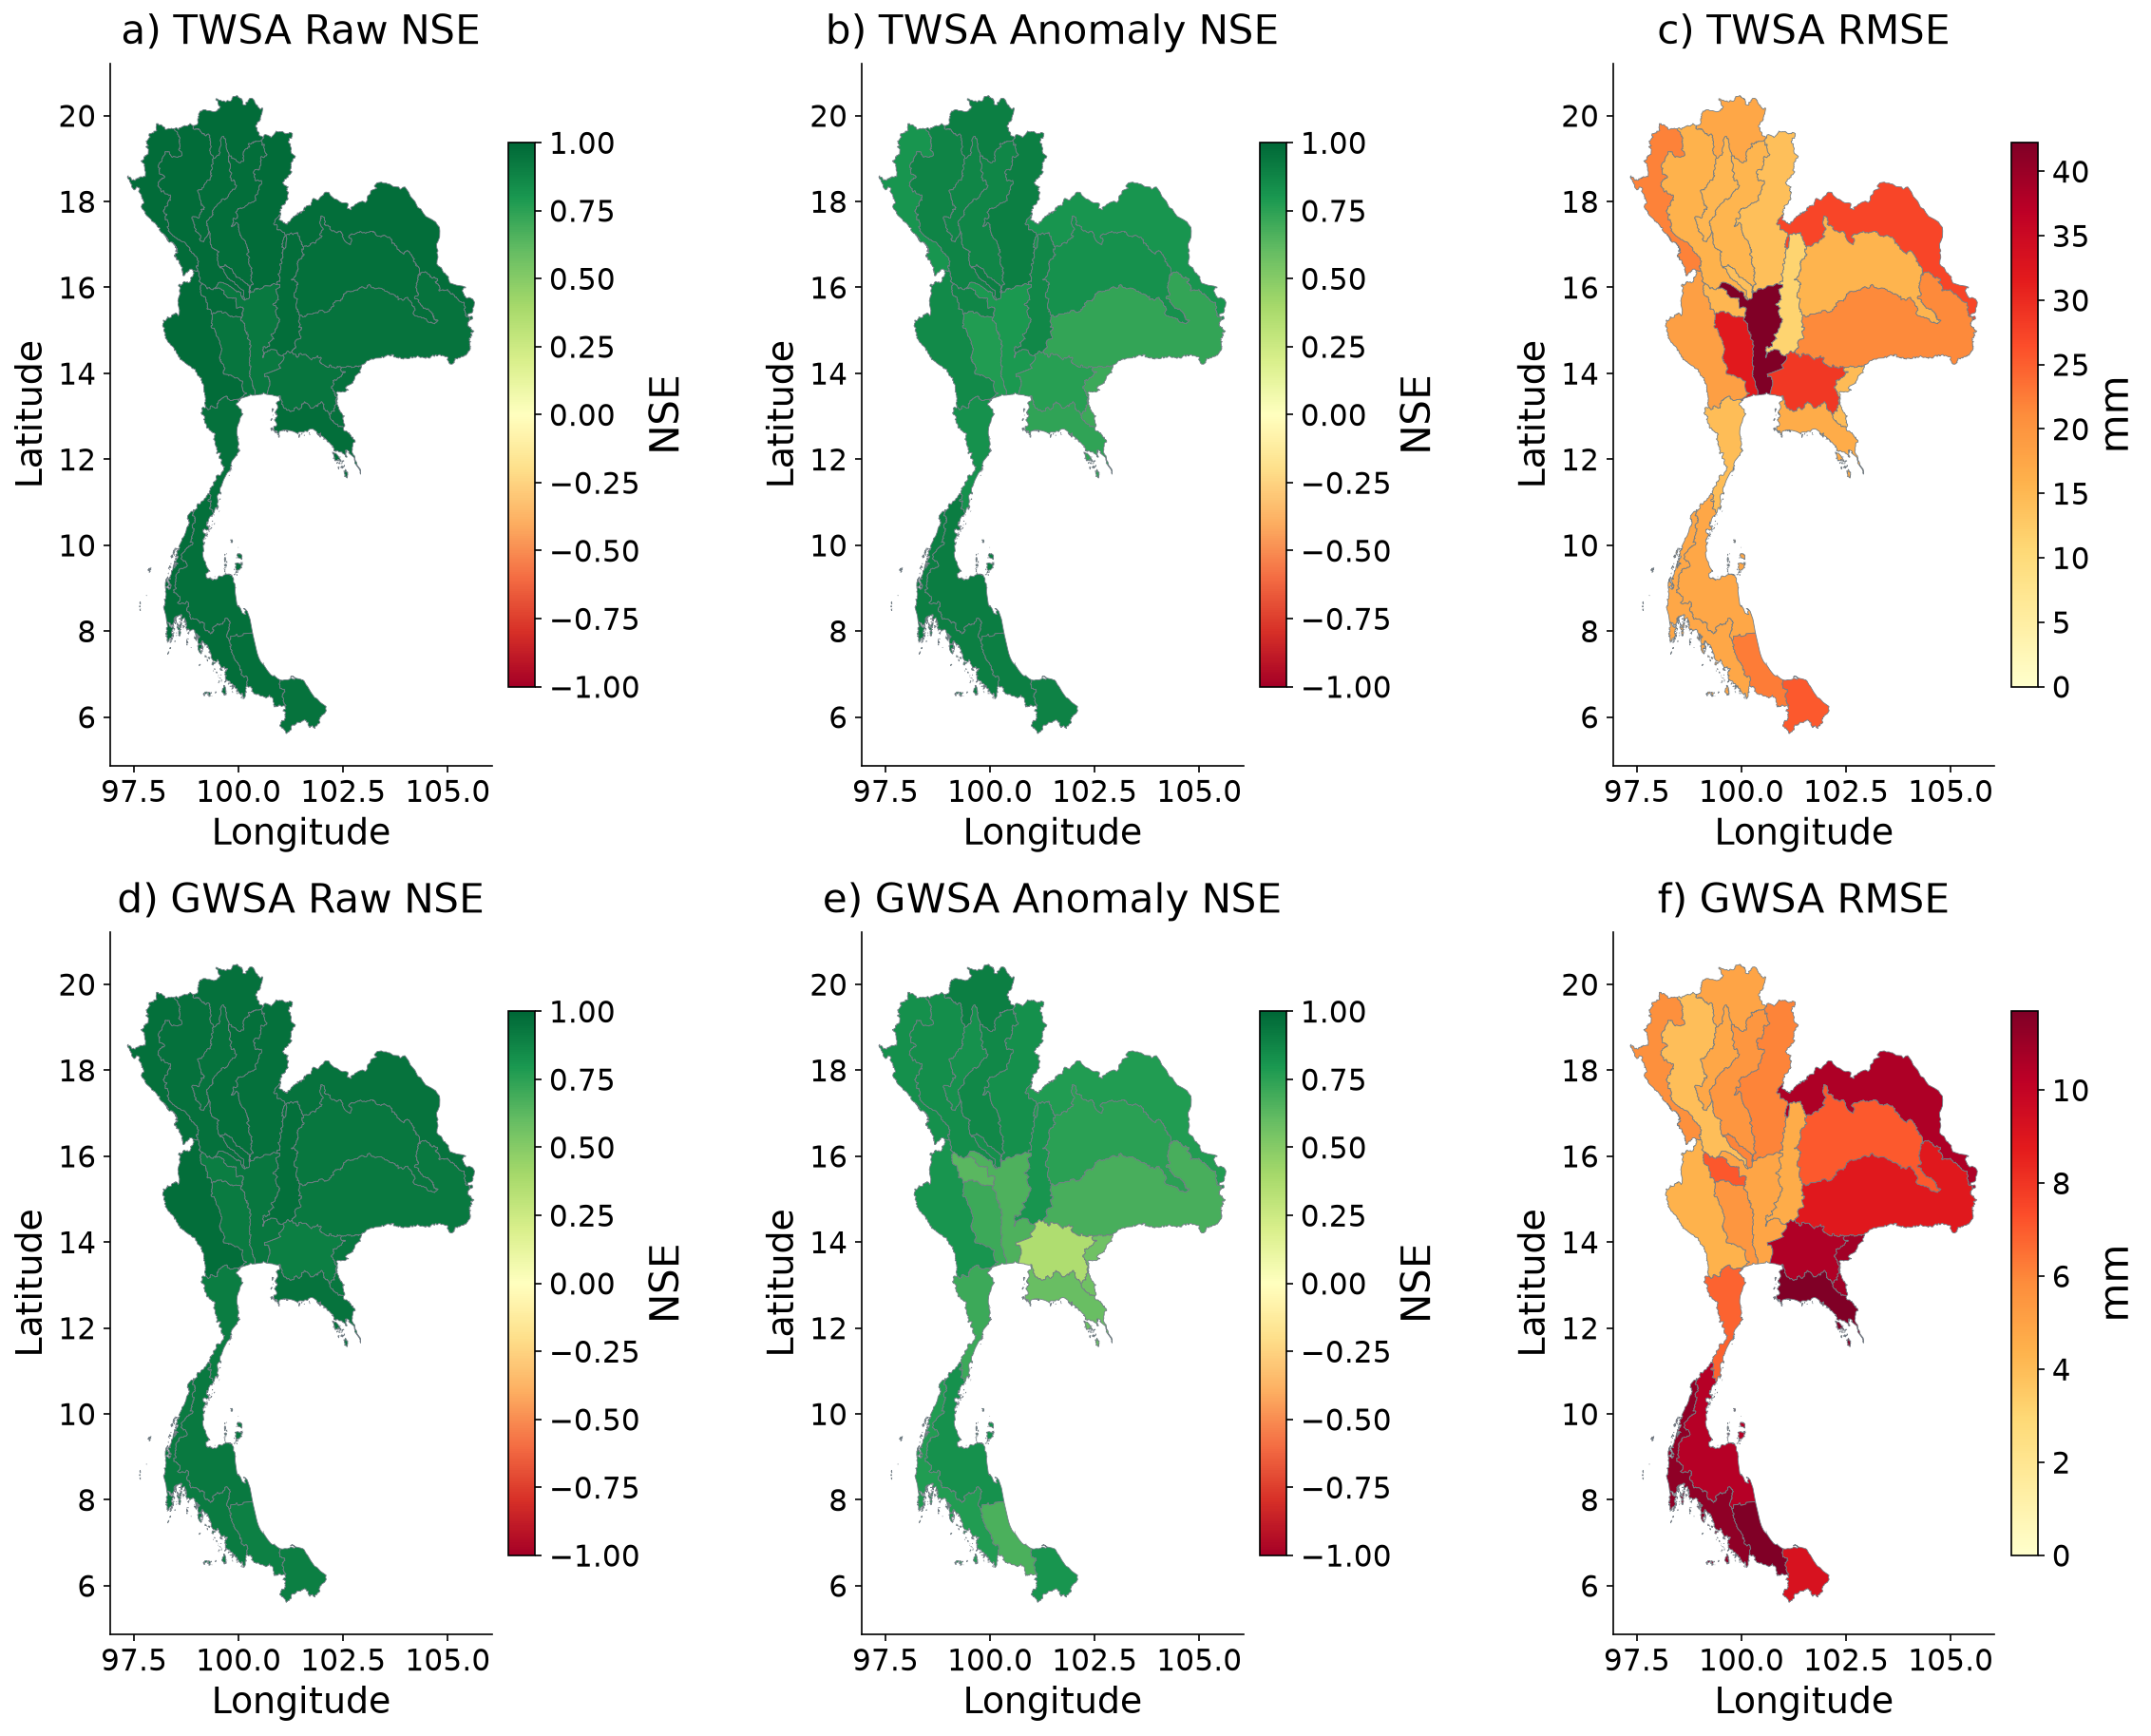
Figure 14 Spatial climate model evaluation
Frozen ensemble verification against naturalized parent storage during 2016–2023. Maps distinguish raw NSE, training-climatology-anomaly NSE and RMSE; NSE colours saturate below −1. High seasonal skill is not observational validation of a natural counterfactual.
Raw NSE can be high when a model captures the annual cycle. Anomaly NSE is therefore a required companion, with the monthly reference learned from training. The map includes both TWSA and GWSA and preserves negative skill. A good score against a parent model is a reconstruction result, not proof that its naturalized baseline is observationally correct.

Time varying climate skill and memory
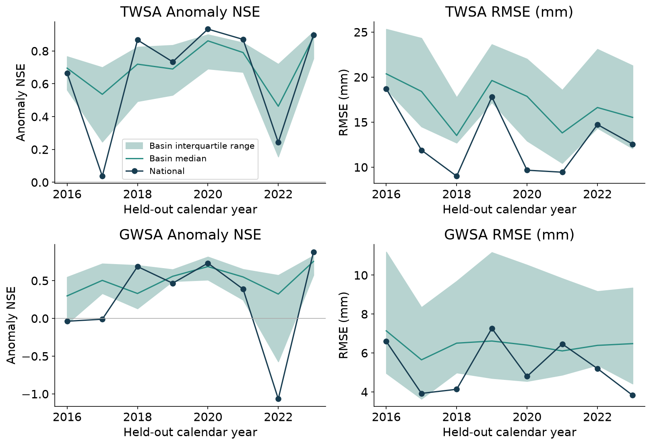
Figure 15 Climate model evaluation through time
Metrics are calculated separately for each held-out year using the training-climatology anomaly definition. Shading is spatial interquartile variation, not a confidence interval. Annual scores use 12 modeled months and may be unstable when anomaly variance is small; pooled 96-month results remain primary.
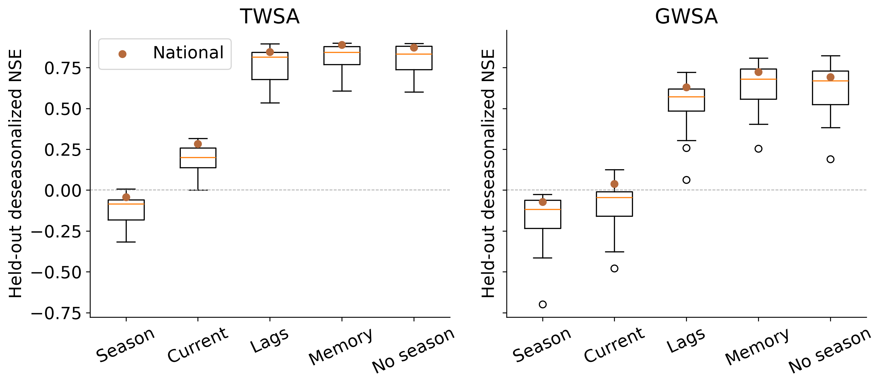
Figure 16 Climate memory ablation
Controlled Ridge experiment: current weather compared with weather-memory predictors; same training, validation and test splits. National test anomaly NSE rises from 0.283 to 0.890 for TWSA and 0.039 to 0.723 for GWSA.
The controlled Ridge experiment provides stronger methodological evidence than the pooled score alone. Adding weather memory raises national test anomaly NSE from 0.283 to 0.890 for TWSA and from 0.039 to 0.723 for GWSA. Replacing native precipitation with unadjusted CHIRPS reduces anomaly skill when PET and the native-forced target remain fixed. This demonstrates forcing dependence, not that CHIRPS is less accurate. Annual results retain failures: national 2022 anomaly NSE is 0.234 for TWSA and −1.067 for GWSA.

GLDAS spatial land storage benchmark
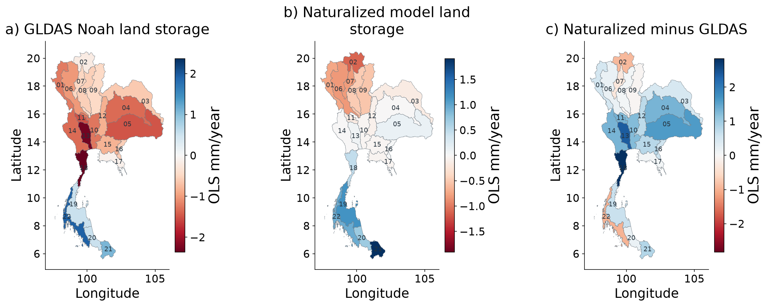
Figure 17 Spatial GLDAS matched compartment comparison
Soil + canopy + snow only, common valid-cell support and common 2004–2009 reference. The record extends through December 2023. Each panel has a labelled scale; groundwater and surface water are excluded. This is a cross-model benchmark, not independent full-TWS or residual validation.
For the matched soil-plus-canopy-plus-snow sum, naturalized WaterGAP and GLDAS have national r = 0.969, NSE = 0.738 and RMSE = 52.49 mm across 261 paired months. The agreement supports consistency of seasonal land storage but is not an independent validation of total storage or human effects. GLDAS also enters the derived groundwater balance, so comparisons involving GWSA have structural dependence. Standardized GLDAS–residual maps are therefore timing diagnostics only.

GLDAS matched compartment scatterplots
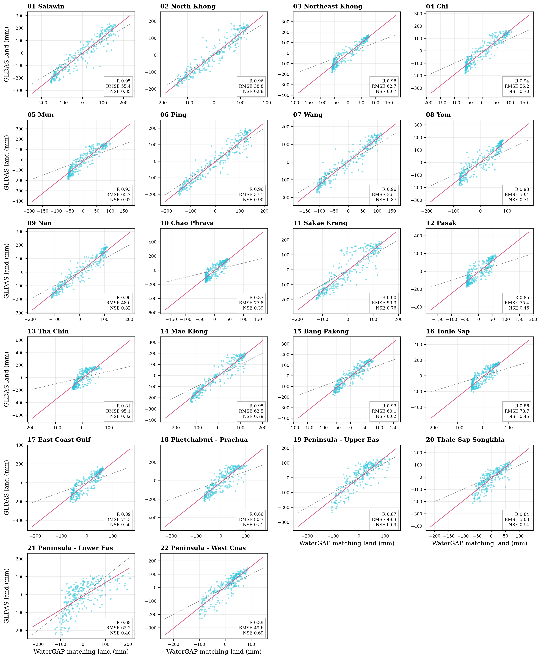
Figure 18 Matched land storage benchmark
Soil, canopy and snow only, April 2002–December 2023 available pairs. GLDAS excludes groundwater and open surface water. Cross-model agreement is not human-component validation; shared climate inputs and the GWS subtraction create dependence. Regression is descriptive.

GLDAS matched temporal histories
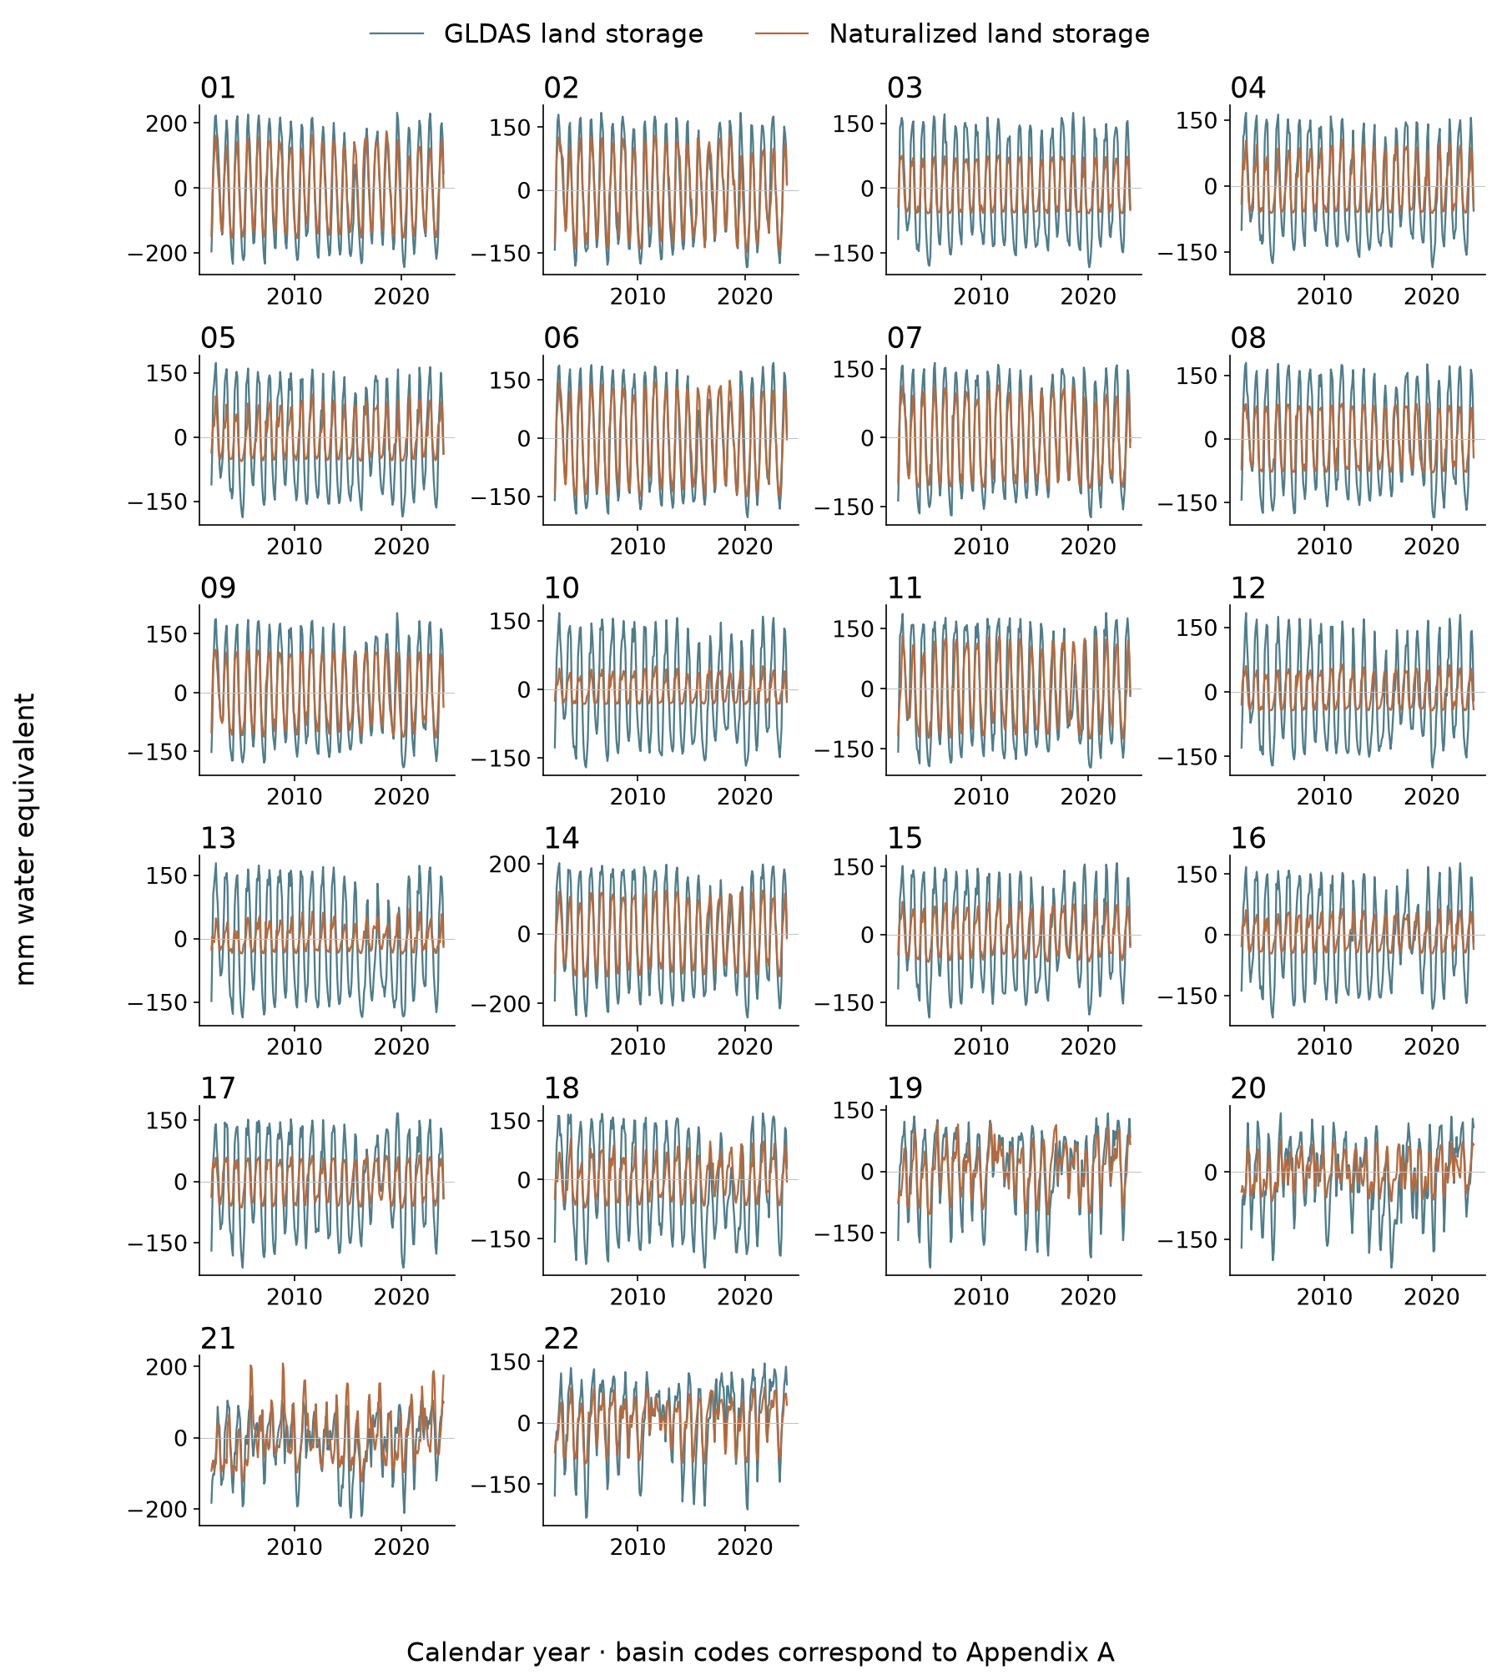
Figure 19 Matched GLDAS time series for all 22 basins
Matched soil + canopy + snow anomalies in mm. GLDAS and WaterGAP share climatic influences. Agreement evaluates land-component consistency; it cannot validate groundwater or the entire human residual.

Residual and modeled human trend maps
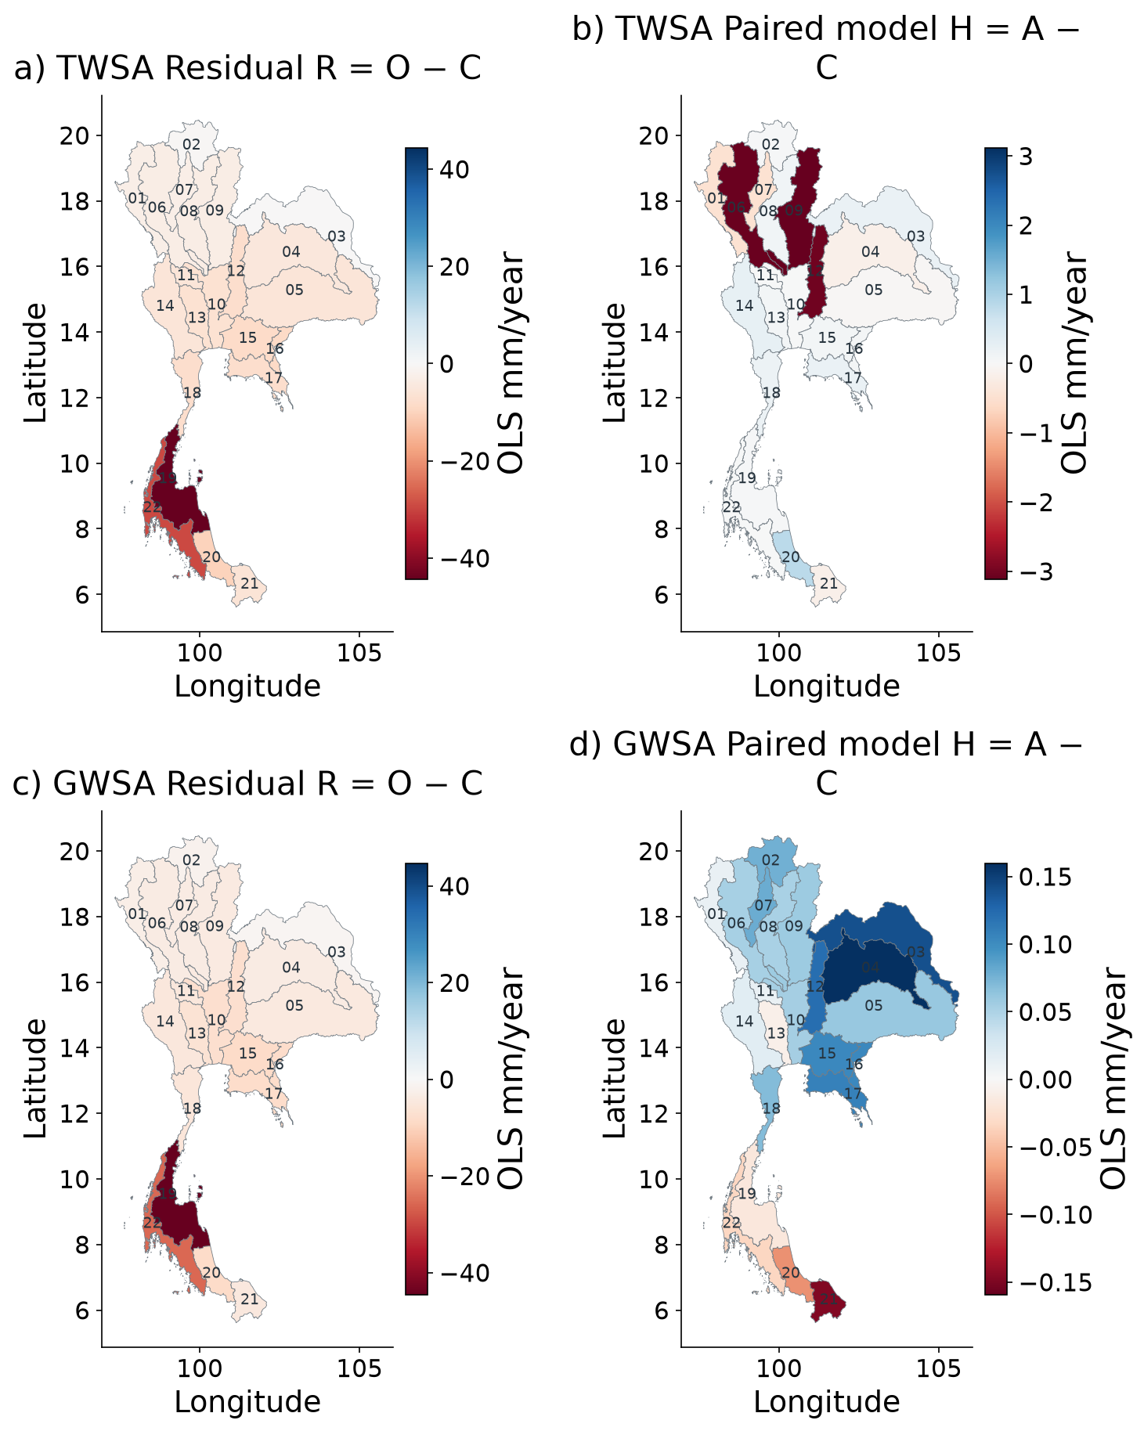
Figure 20 Spatial residual and modeled human perturbation
Calendar-month fixed-effect slopes on the same observation-valid support. R includes the represented direct-human perturbation H and discrepancy E. Each panel has its own labelled scale to keep small H visible; compare numerical scales before comparing colours. These slopes are not additive Sen-slope fractions.
The additive calendar-month OLS decomposition gives national TWS trends of O = −8.36, C = −0.54, H = −0.49, R = −7.81 and E = −7.32 mm/year on matched dates. For groundwater the corresponding values are −7.28, −0.21, +0.06, −7.07 and −7.13 mm/year. These OLS rates intentionally differ from the primary seasonal Sen slopes. The large discrepancy relative to the represented model human effect prevents treating the residual as an independently measured anthropogenic mass balance.

TWSA residual histories
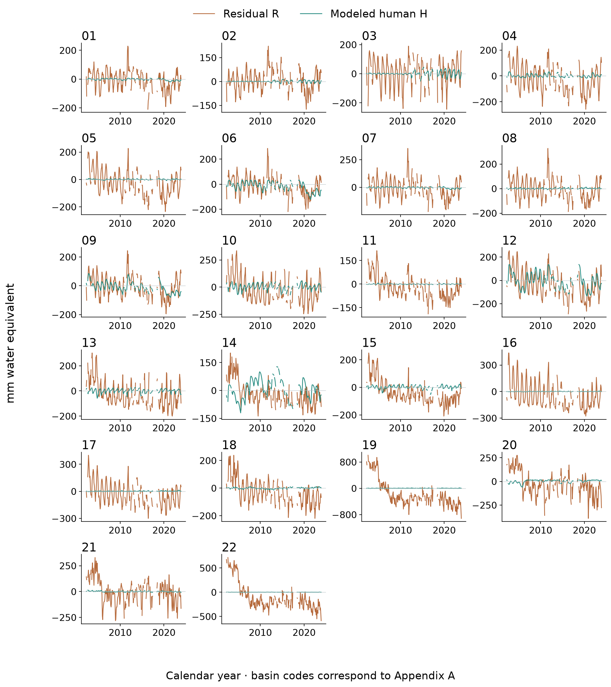
Figure 21 TWSA residual histories for all 22 basins
Observed-minus-naturalized residual R and paired modeled human perturbation H. Missing observed months are retained. R−H is unresolved observation–historical-model discrepancy; a negative R is not automatically measured pumping.

GWSA residual histories
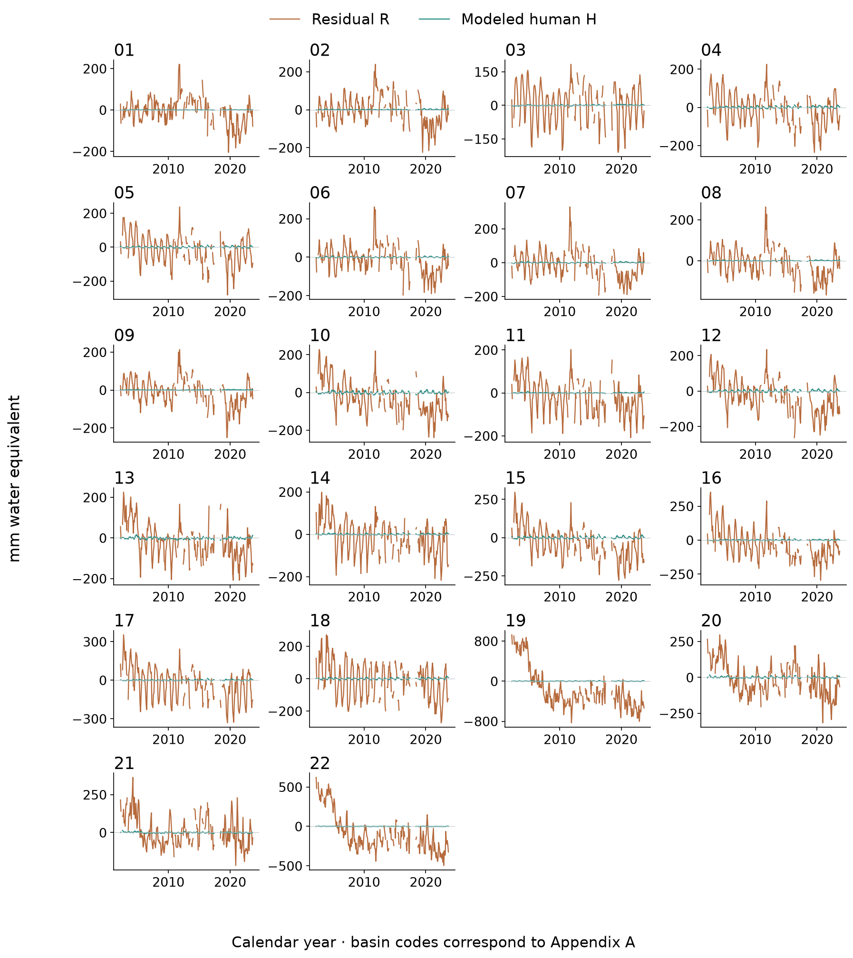
Figure 22 GWSA residual histories for all 22 basins
Observed-minus-naturalized residual R and paired modeled human perturbation H. Missing observed months are retained. R−H is unresolved observation–historical-model discrepancy; a negative R is not automatically measured pumping.

GLDAS and residual temporal comparison
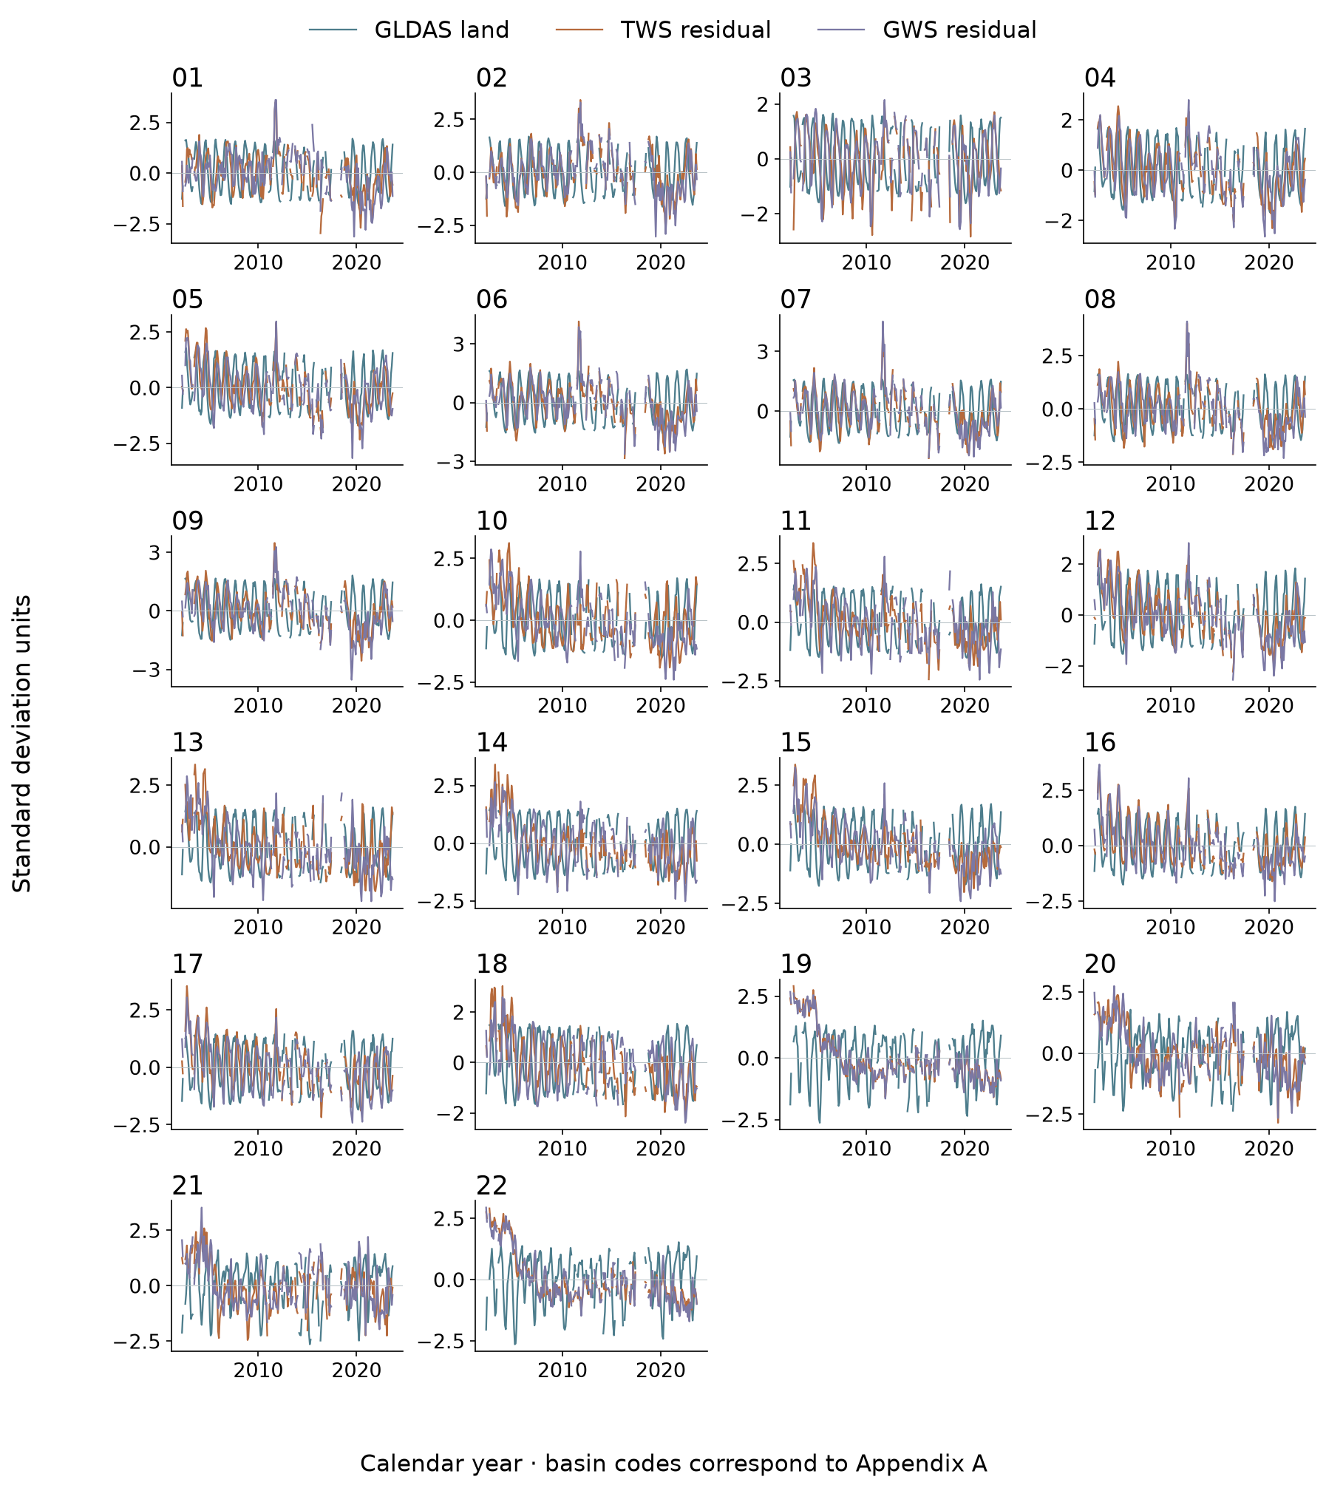
Figure 23 GLDAS and residual histories for all 22 basins
Each variable is standardized on the same jointly observed months within each basin. Different compartments are compared in timing and shape, not treated as equivalent water volumes. Missing months remain gaps. This is a dependence diagnostic, not independent anthropogenic validation.

ENSO associations in space
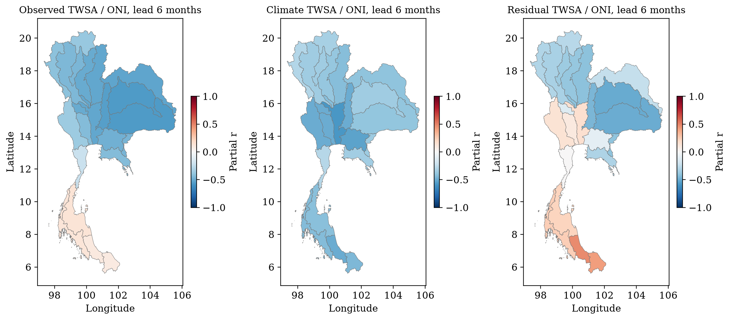
Figure 24 ENSO associations across Thailand
Prespecified six-month ENSO lead. Partial Pearson correlations remove calendar month, linear trend and contemporaneous DMI on paired months, 2003–2023. Dots indicate FDR q<0.05 from whole-year circular rotations. All five candidate lags and both ENSO indices are retained in CSV; no best-lag significance claim. Basins share GRACE support.
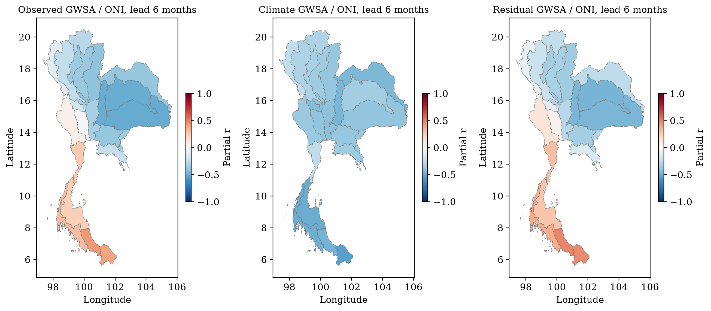
Figure 25 ENSO and derived groundwater storage
As the TWSA spatial diagnostic, with derived GWSA. Association can reflect recharge, compartment errors and management responses; it does not identify groundwater pumping. The finite rotation p value has resolution 1/21; this conservative screen has low power after multiple comparisons.

ENSO lead and index sensitivity
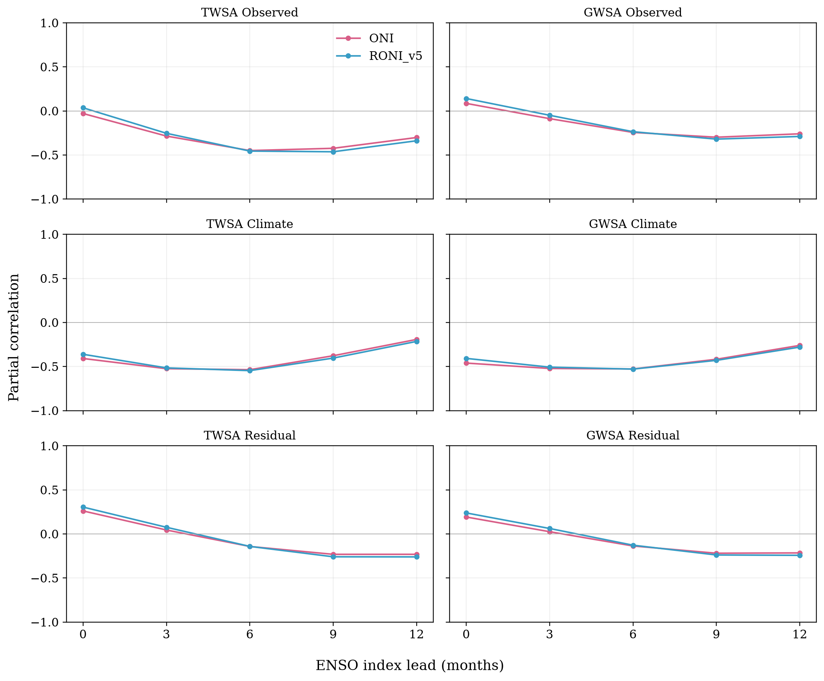
Figure 26 National lag and index sensitivity
Calendar season, trend and DMI controlled. ONI and historical RONI v5 are frozen at acquisition; RONI v6 is operational in 2026, whereas v5 is deliberately retained here for index-version comparability. The five candidate lags are reported together. Correlation is association, not climate causation or evidence of human-only residuals.
At the selected six-month ONI lead, national partial correlations are −0.449 for observed TWSA, −0.536 for its naturalized baseline and −0.142 for its residual. The corresponding groundwater correlations are −0.244, −0.528 and −0.136. The adjustment removes calendar season, linear trend and contemporaneous DMI on each paired sample. The baseline therefore carries a clearer descriptive ENSO association than the residual in this comparison, but differences between dependent correlations are not themselves tested as independent effects.
No basin test passes FDR q < 0.05 across the complete exploratory family. This result must be read alongside the minimum rotation probability of 1/21 and the limited 21-year calendar: the screen has low power and does not prove absence of a teleconnection. Index and lag plots retain all selected alternatives rather than selecting the most favourable basin or lag. Residual climate leakage remains possible through untested lags, nonlinear responses, other circulation modes and forcing error.

ENSO phase conditions and climate skill
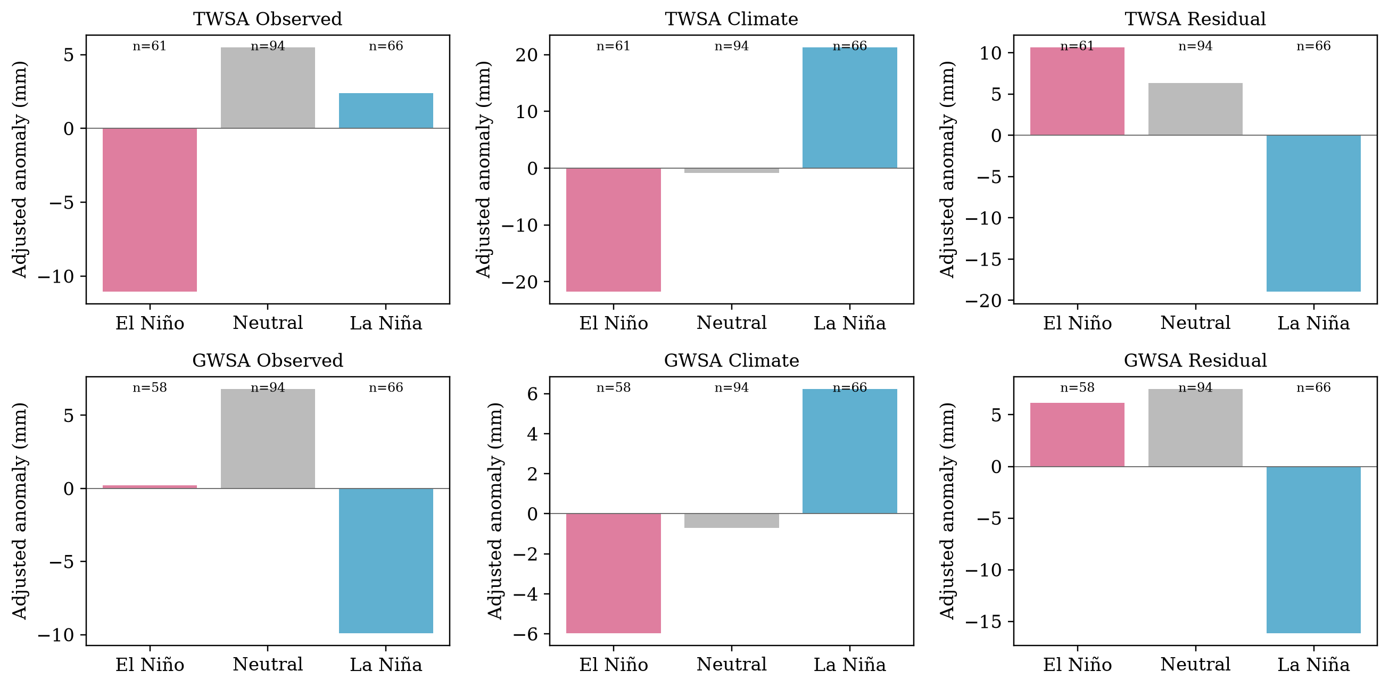
Figure 27 Storage during ENSO phases
Monthly means after calendar-season and linear-trend removal, 2003–2023. ONI episodes require five consecutive overlapping seasons at ±0.5 C, classified on provider-table 0.1 C precision. Numbers are available months, not independent events. Equal-episode estimates and episode-bootstrap intervals are supplied separately in CSV; phase bars are descriptive and do not remove IOD.
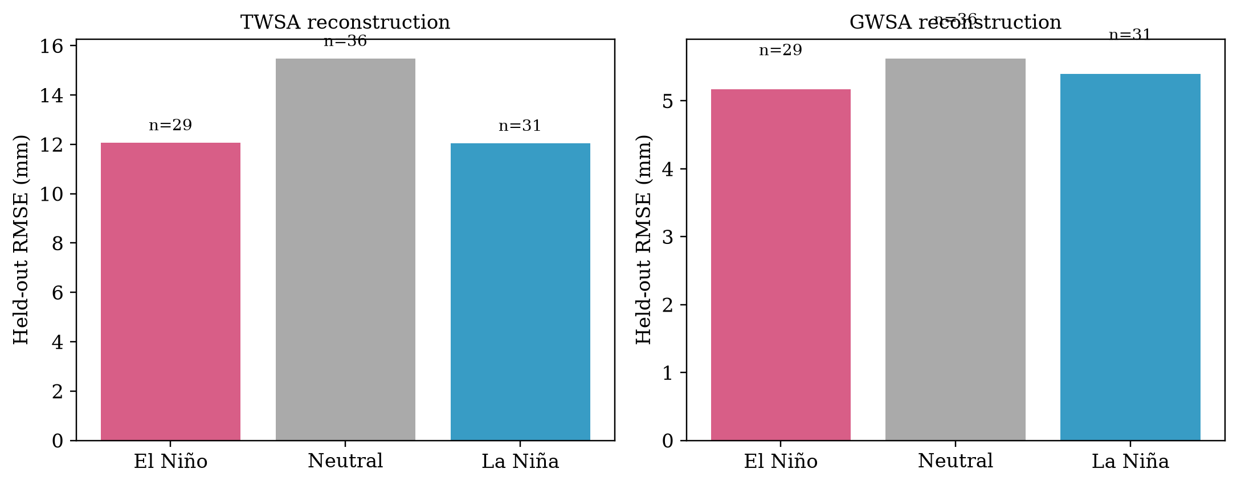
Figure 28 Climate reconstruction by ENSO phase
Frozen climate ensemble evaluated in 2016–2023, with the naturalized parent as target. Phase subsets differ in sample size and target variance; do not compare phase NSE without these counts. No phase-specific refitting or ENSO predictor was introduced after examining test performance.
The held-out 2016–2023 sample contains 29 El Niño, 31 La Niña and 36 neutral centre months. National TWSA emulator RMSE is 12.07, 12.05 and 15.49 mm in those groups, respectively; GWSA RMSE is 5.17, 5.40 and 5.63 mm. These are phase-conditioned reconstruction scores against the same parent model, not independent ENSO-event prediction skill. Monthly samples share events and target variances differ. Phase composites and equal-episode estimates describe the observations without assigning a uniquely ENSO-caused storage loss.

Groundwater agreement in space
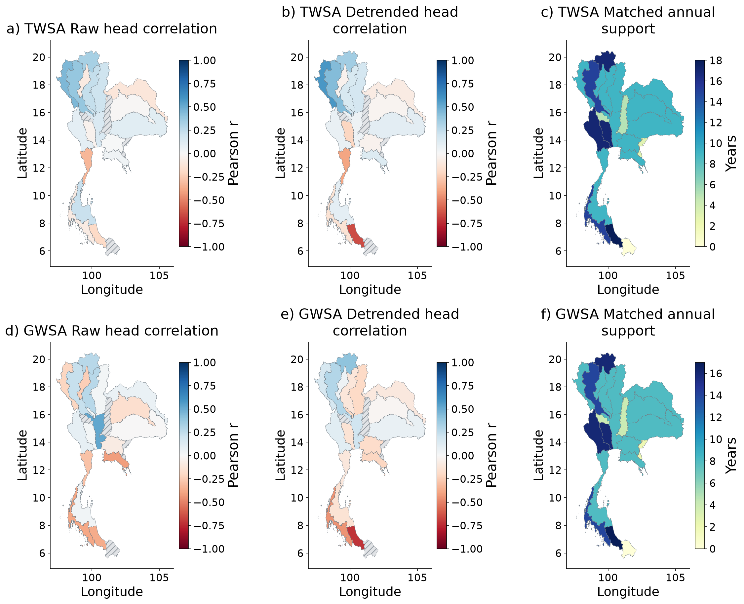
Figure 29 Spatial evaluation of residual agreement with groundwater
Observed annual heads compared separately with TWS and GWS residuals. Hatching marks unavailable correlations or fewer than eight matched years. Support maps expose small samples. Heads and equivalent water depth are not commensurate volumes, so head–storage NSE and RMSE are not calculated. Raw association is indirect groundwater evidence for TWS, not total-human validation.
The well archive contains 5,484 observed aggregates from 511 wells, predominantly annual observations. Longest-overlap national residual–head correlations are 0.127 for TWSA and 0.037 for GWSA over 18 and 17 years. Stronger agreement in one eligible network variant does not persist in all fixed and balanced panels. In the strict balanced 2013–2022 panel, GWS residual correlation is approximately zero over eight usable storage years. This is inconclusive groundwater support, not validation of national human depletion.

Groundwater and residual temporal histories
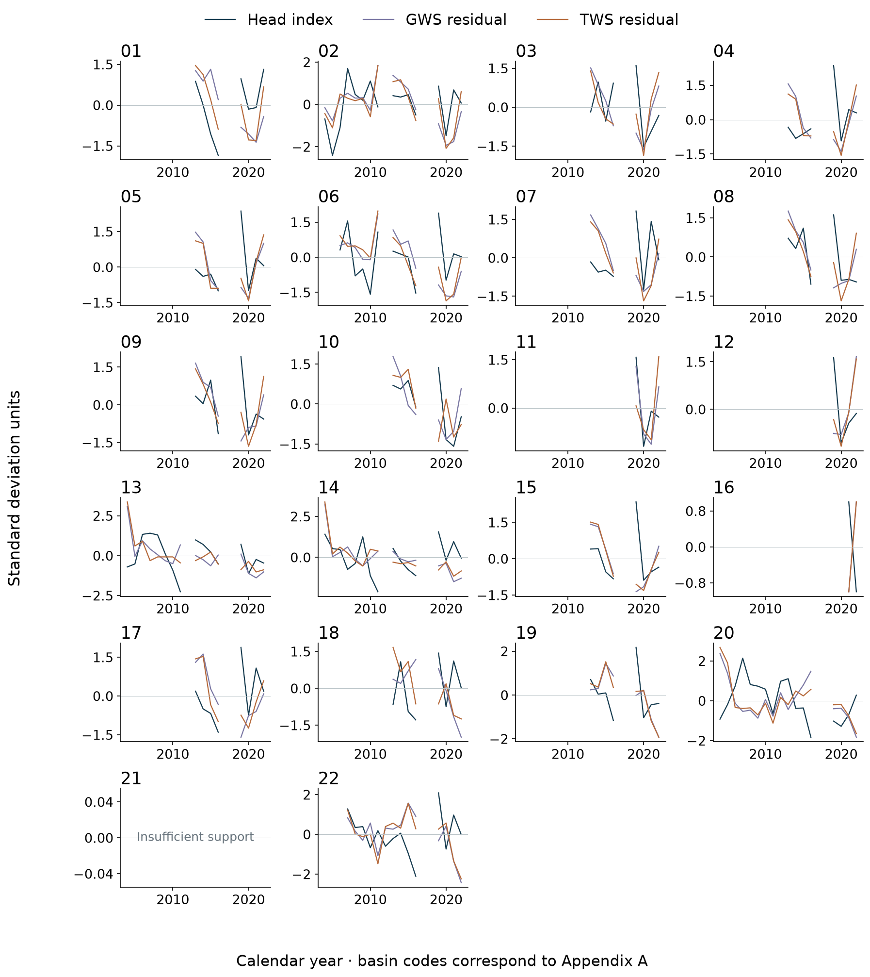
Figure 30 Annual groundwater and residual histories for all 22 basins
Co-located wells are first grouped by station, then averaged. Displayed series are standardized on their joint annual support; they are not water-volume conversions. Annual storage requires at least eight valid months and complete year endpoints. Gaps remain missing. Numerical correlation maps use each target’s own longest eligible support, whereas this three-line display uses joint support.

Independent reservoir evidence
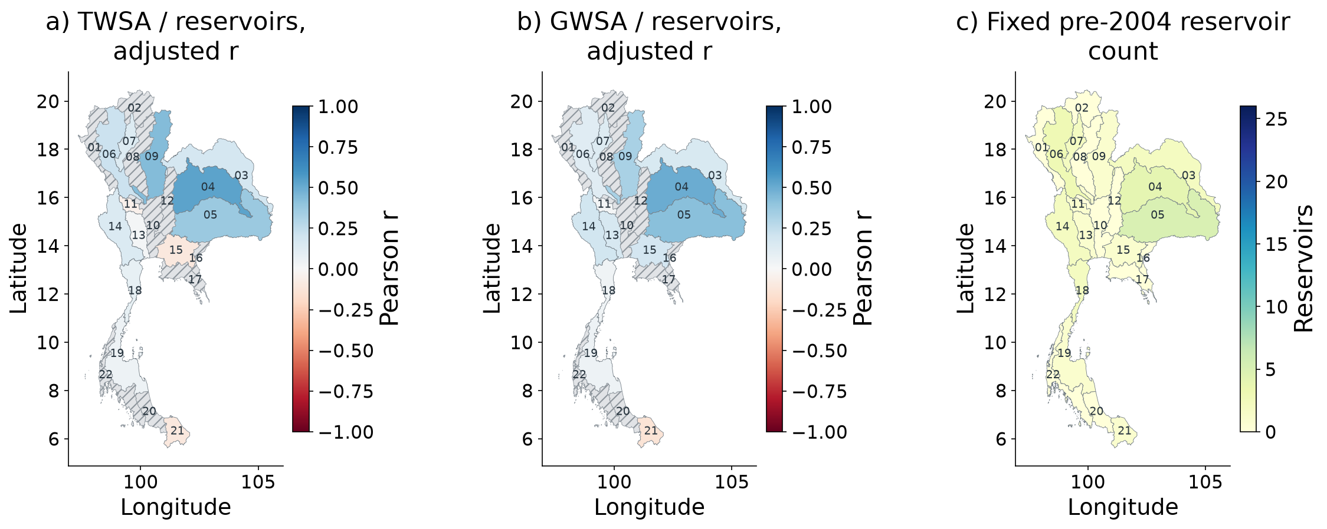
Figure 31 Spatial independent reservoir component evidence
MSEA-Res Level-1 scene estimates, fixed pre-2004 populations and matched-month season/trend-adjusted correlations. Grey hatching means unavailable evidence, not zero effect. Reservoir correlations with GWS residuals are dependence diagnostics and do not directly validate groundwater. No naturalized observed reservoir counterfactual is available.
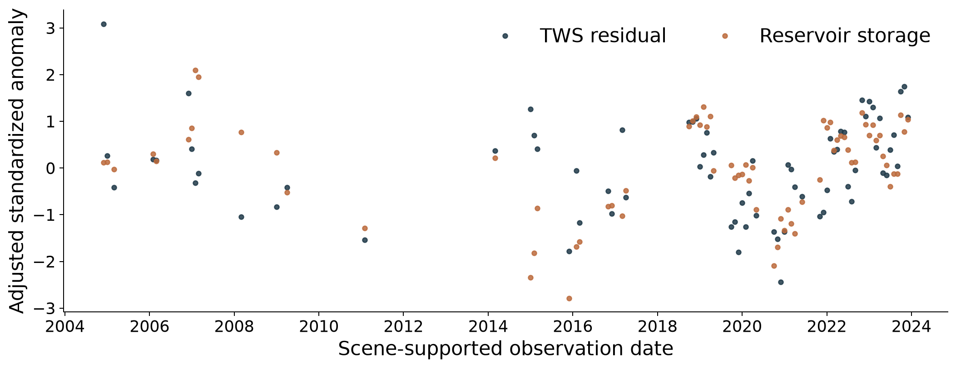
Figure 32 Independent reservoir component evidence
Scene-supported national reservoir and TWS residual anomalies after removing season and trend, then standardizing. Points retain missing scene support; no gap interpolation. r = 0.439 across 73 paired months; year-cluster interval 0.188–0.665.
Independent scene-screened reservoir evidence is more supportive for a surface-water component. Across 73 national paired months, raw TWS-residual correlation is 0.521 and season/trend-adjusted correlation is 0.439. The calendar-year bootstrap interval is 0.188–0.665. Provider-smoothed Level 2 estimates give a longer but less independent temporal record and are retained as sensitivity. Reservoir evidence cannot resolve total-human storage or groundwater pumping because the observed series contains climate-driven inflow and operating decisions.

Groundwater agreement values by basin
Table 6 Residual agreement with annual groundwater head
Basin | TWS r | TWS detr r | Years | GWS r | GWS detr r | Years
01 | 0.449 | 0.582 | 9 | -0.215 | 0.167 | 8
02 | 0.330 | 0.345 | 17 | 0.279 | 0.399 | 16
03 | -0.121 | -0.084 | 9 | 0.063 | -0.109 | 8
04 | -0.009 | -0.030 | 9 | -0.168 | -0.023 | 8
05 | 0.113 | 0.103 | 9 | -0.007 | 0.070 | 8
06 | 0.385 | 0.432 | 15 | 0.229 | 0.293 | 14
07 | -0.089 | -0.043 | 9 | -0.244 | 0.047 | 8
08 | 0.236 | 0.157 | 9 | 0.277 | -0.124 | 8
09 | 0.208 | 0.176 | 9 | 0.026 | -0.198 | 8
10 | 0.152 | 0.050 | 9 | 0.519 | 0.200 | 8
11 | — | — | 5 | — | — | 4
12 | — | — | 5 | — | — | 4
13 | -0.044 | -0.212 | 17 | 0.027 | -0.147 | 16
14 | 0.094 | 0.074 | 17 | 0.093 | 0.116 | 16
15 | 0.001 | -0.041 | 9 | -0.082 | -0.187 | 8
16 | — | — | 3 | — | — | 2
17 | 0.041 | 0.136 | 9 | -0.420 | -0.215 | 8
18 | -0.335 | -0.394 | 9 | -0.289 | -0.115 | 8
19 | 0.227 | 0.096 | 9 | 0.033 | -0.147 | 8
20 | -0.197 | -0.656 | 18 | -0.375 | -0.722 | 17
21 | — | — | 0 | — | — | 0
22 | -0.080 | -0.143 | 15 | -0.389 | -0.450 | 14
Longest-overlap retained-flags panel. Positive r means lower residual tends to occur with lower head. Detr r removes a linear trend. An em dash means unavailable evidence, not zero. Head is not converted into storage; no cross-unit NSE or RMSE is reported. Other station panels and conditional intervals remain in the complete CSV.
An unavailable correlation is an observation gap, not zero effect. The full release also includes matched GLDAS scores, reservoir counts and intervals, additive component slopes, forcing summaries and ENSO diagnostics for each basin. Groundwater head is a supporting state measurement; no cross-unit volume error score is calculated.

CHAPTER 5
DISCUSSION
The evidence is strongest for a national decline in the primary storage records and for the value of climate memory in reconstructing the chosen naturalized simulation. Evidence is weaker for fine basin rankings and for a quantitative human-only residual. This hierarchy is consequential: a model can closely reproduce another model while both differ from satellite observations, and a statistically clear residual trend can still contain substantial structural discrepancy.
The ENSO extension improves interpretation by asking whether large-scale climate variation remains visible after baseline subtraction. The relatively weak six-month residual associations are compatible with partial removal of this linear climate signal, but do not establish an exhaustive natural counterfactual. The conservative rotation screen and the number of available ENSO episodes constrain inference. A stronger future study would combine longer records, physically matched spatial responses, alternative naturalized models and independent management or abstraction histories.
Groundwater level provides a local state response and reservoirs provide a surface-water state response. They are complementary to GRACE but neither is a direct measurement of national human storage change. A conversion ΔGWS ≈ Sy × Δh requires representative specific yield, compatible aquifer thickness and area, and appropriate treatment of confined conditions. Those data are not available at the required basin scale here. Reporting a volumetric pumping validation from the present wells would therefore overstate the observations.
The proposed publication contribution is an attribution-credibility assessment across all principal basins, not the assertion that a new machine-learning method uniquely separates climate and human effects. Journal submission should follow advisor review of source licensing, final bibliography, spatial-response treatment and whether the scientific contribution fits the target journal. The reproducible negative and sensitivity results are part of that contribution; improving figure appearance alone cannot remove the underlying identification limits.

CHAPTER 6
CONCLUSIONS AND REPRODUCIBLE WORKFLOW
The primary CSR-based analysis identifies a national decrease in total and derived groundwater storage, with seasonal Sen slopes of −7.51 and −6.84 mm/year on their respective records. Alternative processing retains a negative national direction but changes the estimated magnitude and basin ordering. The basin results are therefore most useful when viewed as broad screening evidence with explicit observational support.
Weather memory materially improves reconstruction of the naturalized WaterGAP target. Held-out ensemble scores are high, while anomaly metrics and individual years expose weaknesses. GLDAS adds a matched land-component benchmark. ENSO diagnostics describe lagged climate associations and phase-dependent reconstruction without providing a unique causal attribution. The residual remains R = H + E; independent wells are inconclusive and reservoirs support only a surface-water component.
The three objectives are delivered as basin trend products, an evaluated reconstruction-and-residual framework, and a reproducible decision-support website. The final release includes original publication figures, full-precision tables, frozen teleconnection inputs, executable code, a separate manuscript and an academic presentation. Monitoring priorities should follow coherent regional signals and gaps in evidence. Quantitative aquifer-management conclusions require additional pumping, aquifer-property and spatial-response information.
Repository https://github.com/pratikkhanal16/thailand-water-storage-dss
Website https://pratikkhanal16.github.io/thailand-water-storage-dss/
Start with research_v6/README.md for commands and the distinction between frozen-input verification and the complete raw-input rebuild.

References
Ji, Wang, Cui, Wang et al. (2025). Separating climate and human induced terrestrial water storage anomalies with GRACE data and hydrological models. International Journal of Digital Earth. https://doi.org/10.1080/17538947.2025.2557516
Chueasa, Humphries, Waqas (2024). Influence of El Niño southern oscillation on precipitation variability in Northeast Thailand. MethodsX. https://doi.org/10.1016/j.mex.2024.102954
Abhishek, Kinouchi, Sayama (2021). A comprehensive assessment of water storage dynamics and hydroclimatic extremes in the Chao Phraya River Basin during 2002–2020. Journal of Hydrology. https://doi.org/10.1016/j.jhydrol.2021.126868
Sharifi, Haas, Boergens, Dobslaw et al. (2025). Technical note: GRACE-compatible filtering of water storage data sets via spatial autocorrelation analysis. Hydrology and Earth System Sciences. https://doi.org/10.5194/hess-29-6985-2025
Müller Schmied, Trautmann, Ackermann, Cáceres et al. (2024). The global water resources and use model WaterGAP v2.2e: description and evaluation of modifications and new features. Geoscientific Model Development. https://doi.org/10.5194/gmd-17-8817-2024
Mahto, Fatichi, Galelli (2025). A 1985–2023 time series dataset of absolute reservoir storage in Mainland Southeast Asia (MSEA-Res). Earth System Science Data. https://doi.org/10.5194/essd-17-2693-2025
Save, H., Bettadpur, S., and Tapley, B. D. (2016). High-resolution CSR GRACE RL05 mascons. Journal of Geophysical Research Solid Earth. https://doi.org/10.1002/2016JB013007
CSR (2026). GRACE and GRACE-FO RL06.3 mascon solutions and processing guidance. https://www2.csr.utexas.edu/grace/RL0603_mascons.html
Güntner, A., et al. (2024). Global Gravity-based Groundwater Product G3P version 1.12. https://doi.org/10.5880/G3P.2024.001
Bäthge, A., et al. (2026). GROW global groundwater time series dataset. https://doi.org/10.5281/zenodo.15149480
NOAA CPC (2026). Historical Oceanic Niño Index and Relative Oceanic Niño Index version 5. Frozen index data and download URLs accompany the release. https://www.cpc.ncep.noaa.gov/products/analysis_monitoring/enso/oni/v5/
NOAA PSL (2026). HadISST Dipole Mode Index monthly time series. https://psl.noaa.gov/data/timeseries/month/DMI/
NASA (n.d.). GLDAS dataset specifications. https://ldas.gsfc.nasa.gov/gldas/dataset
Mann, H. B. (1945). Nonparametric tests against trend. Econometrica, 13, 245–259. https://doi.org/10.2307/1907187
Sen, P. K. (1968). Estimates of the regression coefficient based on Kendall’s tau. JASA, 63, 1379–1389. https://doi.org/10.1080/01621459.1968.10480934
Benjamini, Y., and Hochberg, Y. (1995). Controlling the false discovery rate. JRSS B, 57, 289–300. https://doi.org/10.1111/j.2517-6161.1995.tb02031.x

The table body may be single-spaced, one-and-a-half-spaced or double-spaced. Notes can be written in a smaller font size, if necessary, of not less than 10. You can also reduce the font size for the table body to fit everything on one page or one table. However, uniformity should be observed for all figures and tables.
The same font should be used throughout the thesis, but the font size for figures can be between 10-14 making sure that the presentation is legible. Adjust the footnotes, if necessary, between 10-12 font size.
This means that crowding in the image should be avoided in order to give enough space between words.

