Attribution credibility of water storage change across Thailand
Farzeen Khan
Water Engineering and Management, Asian Institute of Technology
Advisor: Dr. Natthachet Tangdamrongsub

Abstract
Thailand requires basin-scale information on water storage, but climatic variability, water management and measurement uncertainty overlap in satellite observations. We analysed terrestrial water storage anomalies (TWSA) and derived groundwater storage anomalies (GWSA) across all 22 principal basins. CSR GRACE and GRACE-FO observations were combined with a full-compartment groundwater balance, paired naturalized and historical WaterGAP simulations, chronological climate-model evaluation, GLDAS land-storage comparisons, groundwater levels and independent reservoir observations. National seasonal Sen slopes were −7.51 mm/year for TWSA through September 2024 and −6.84 mm/year for GWSA through September 2023. Basin trend ranks agreed weakly between processing chains. A meteorological ensemble reconstructed its naturalized parent with held-out 2016–2023 NSE of 0.981 for TWSA and 0.961 for GWSA. These scores describe model reconstruction, not validation of an observed natural counterfactual. At a six-month ONI lead, season-, trend- and DMI-adjusted national correlations were −0.536 and −0.528 for naturalized TWSA and GWSA, compared with −0.142 and −0.136 for their observation-minus-baseline residuals. No basin association passed the conservative multiple-comparison screen; the short record limits statistical power. Groundwater agreement was weak and sensitive to station selection. Independent reservoir storage supported one surface-water component of the TWS residual, with adjusted r = 0.439 across 73 scene-supported months. The study distinguishes a detectable national decline from less certain basin rankings and human attribution. Its contribution is an explicit assessment of attribution credibility, supported by reproducible code and an interactive basin decision-support system.
Keywords GRACE groundwater storage climate memory ENSO uncertainty

1 Introduction

1.1 Introduction
Water storage integrates rainfall, evapotranspiration, runoff and human water use. A rainfall deficit can reduce soil moisture, river storage and groundwater recharge at the same time that irrigation demand increases. Storage decline in such a year can therefore reflect several connected processes. For Thailand, this distinction affects how satellite observations should inform drought preparation, reservoir operation and groundwater monitoring. A map of declining storage is useful evidence of water loss, but the map alone does not identify its cause.
GRACE and GRACE-FO observe broad changes in terrestrial water mass. Their anomalies include groundwater, soil water, surface water, canopy water and snow. Groundwater must be inferred by subtracting the other compartments. The resulting GWSA inherits errors from both the gravity solution and the component estimates. Spatial averaging reduces some noise but cannot create information below the native observational support. Thailand's principal basins are useful reporting units even when their boundaries do not define independent gravimetric observations.
This study asks three connected questions. First, how do TWSA and GWSA vary across Thailand's 22 principal basins and through time? Second, how well can meteorological information reconstruct a naturalized model baseline, and what evidence supports interpreting the remaining residual? Third, how can these results be made accessible and reproducible through a decision-support website? The objectives deliberately distinguish storage detection, model evaluation and causal attribution.

1.2 Literature and research gap
Previous research in the Chao Phraya has related storage dynamics to hydroclimatic extremes, demonstrating the regional value of GRACE while leaving questions about wider basin coverage and attribution (Abhishek, Kinouchi and Sayama, 2021). Chueasa, Humphries and Waqas (2024) examined ENSO and station rainfall in Northeast Thailand. That work motivates a lag-sensitive storage analysis, but a rainfall relationship cannot simply be transferred to groundwater or treated as a national causal coefficient.
The 2025 International Journal of Digital Earth article “Separating climate and human induced terrestrial water storage anomalies with GRACE data and hydrological models” provides a useful reconstruction-and-residual framework and clear multi-panel figure design. We use its visual approach for original Thailand results, while treating the residual as a mixture of human effects and discrepancy. Its use of mean absolute deviation motivates a variability diagnostic; such ratios are not complementary fractions of causal responsibility.
Sharifi et al. (2025) show why non-groundwater compartments should have a spatial response compatible with GRACE before subtraction. WaterGAP supplies a physically interpretable naturalized/historical pair (Müller Schmied et al., 2024), but agreement with its own emulator cannot establish observational accuracy. MSEA-Res supplies independently derived reservoir observations (Mahto, Fatichi and Galelli, 2025), allowing a partial surface-water check. The research gap is therefore an integrated assessment of what each source can identify, rather than another unrestricted claim that observed storage minus a model equals human water use.

1.3 Contribution and hypotheses
The proposed contribution joins four tests in one reproducible basin framework: common-support processing-chain sensitivity, chronological climate-memory reconstruction, ENSO/IOD diagnostics and monitoring-network sensitivity. The novelty is their joint use to assess attribution credibility in Thailand. Neither machine learning, GRACE subtraction nor an interactive map is novel by itself. The contribution remains a proposal to be assessed against the final journal scope and the broader literature.
The first expectation is that broad national storage decline will be more stable than the rank of individual basin trends. The second is that meteorological memory improves reconstruction beyond contemporaneous weather because water storage integrates earlier inputs. The third is that a credible naturalized baseline should capture part of the ENSO-related storage signal, although a small residual correlation cannot establish complete removal. The fourth is that independent head and reservoir evidence will be incomplete and sensitive to their observation support.
These expectations are evaluated with transparent alternatives. National and basin results are reported separately; raw and deseasonalized skill are both retained; all selected ENSO lags are shown; and well-panel variants are compared. Results that fail a significance screen or disagree across products remain in the release. This design makes a negative or inconclusive attribution result scientifically interpretable rather than hiding it behind one high model score.

2 Study area and data

2.1 Study area and reporting scale
The domain comprises Thailand and all 22 principal river basins represented by the supplied Office of the National Water Resources boundary layer. The analysis covers the northern headwater basins, central plains, northeastern plateau, eastern drainage systems and peninsular basins. Basin codes are stable join keys across figures, CSV tables and the website. National values are aggregated from represented spatial support rather than calculated as an unweighted average of basin means.
Monsoon seasonality creates a strong annual storage cycle, while interannual circulation, droughts, floods and water management alter its timing and amplitude. Rainfall and potential evapotranspiration are therefore treated as meteorological inputs with memory. Actual evapotranspiration, satellite soil moisture and land-surface temperature provide additional context; they are not silently introduced as predictors in the evaluated climate ensemble.
All principal basins fall below CSR's approximate 200,000 km² small-area caution. The national footprint intersects 68 native mascons; inverse weight concentration is approximately 50.1, which describes spatial weighting and does not count independent observations. Adjacent basin maps share broad gravity support. Interpretation should emphasize coherent regional patterns and monitoring priorities rather than precise local aquifer attribution.

2.2 Data and provenance
The primary total-storage record is CSR RL06.3 GRACE/GRACE-FO. The project retains its provider documentation, special-month adjustments and original units. The gridded distribution is not interpreted as independent information at every grid cell. A contrasting COST-G/G3P chain provides a processing sensitivity analysis. It is not a fully independent replicate, and its groundwater compartments differ from the CSR-based calculation.
The groundwater balance uses soil moisture, surface water, canopy water and snow anomalies with compatible units and reference periods. GLDAS Noah supplies soil, canopy and snow terms, while the G3P surface-water component supplies represented open-water storage. Paired WaterGAP v2.2e outputs use the same meteorological forcing with direct human activities excluded or included. Their difference is the human perturbation represented by that model, not an observed pumping record.
Independent supporting inputs include CHIRPS rainfall, GLEAM and MODIS actual evapotranspiration, ESA CCI surface and root-zone moisture, MODIS land-surface temperature, GROW well observations and MSEA-Res reservoir storage. NOAA ONI, historical RONI v5 and HadISST-based DMI are frozen locally for the new teleconnection analysis. File hashes, download URLs and index versions are retained. Data coverage varies by source, and each comparison uses its own eligible paired dates.

3 Methods

3.1 Common units reference and missing data
Storage anomalies are expressed as millimetres of equivalent water depth over the represented area. CSR centimetres are multiplied by ten. Each compartment is referenced to the available 2004–2009 mean before subtraction. A water flux is not a storage anomaly: native precipitation and potential evapotranspiration in mm/day are converted to monthly totals using actual month lengths only for the relevant forcing summaries and plots.
Spatial weights use area overlap and valid support. A groundwater balance requires the relevant storage terms on common valid cells and months. The fraction represented by valid observations is retained, because a changing footprint can otherwise create apparent storage change. Cross-product comparisons are additionally restricted to common dates. Reference offsets affect anomaly levels, whereas changing spatial or temporal support can also affect slopes and correlations.
GRACE and GRACE-FO mission gaps are not filled in the scientific trend and validation series. Lines are broken across unavailable months. Annual storage summaries require at least eight eligible months and the previously specified endpoint checks. Reservoir absence is not zero storage. Independent scene estimates remain sparse, and smoothed provider Level 2 reservoir values are treated separately from primary scene-screened Level 1 evidence. These rules prevent visually complete records from being mistaken for observed data.

3.2 Groundwater storage balance
Groundwater storage anomalies are calculated as GWSA = TWSA − SMSA − SWSA − CWSA − SWEA. SMSA denotes soil moisture storage anomaly; SWSA denotes surface water storage anomaly; CWSA denotes canopy water storage anomaly; and SWEA denotes snow water equivalent anomaly. Snow is small in Thailand but is retained to keep the storage accounting explicit. All terms must share units, a reference period and valid spatial support.
The standard equation does not make the result directly observed groundwater. Error in a soil or surface-water term appears with the opposite sign in GWSA. In tropical monsoon conditions, uncertain floodplain and reservoir storage can therefore affect an apparent groundwater signal. The GLDAS component sum excludes open surface water and groundwater and must not be labelled total terrestrial water storage.
Spatial response remains a limitation. The primary CSR calculation does not apply an additional arbitrary filter to the mascon field. Its component subtraction may still have a different effective response from the gravity signal. The contrasting COST-G/G3P chain and native-support diagnostics expose sensitivity but do not remove it. A publication claiming quantitative aquifer depletion would require a stronger matched-filter or forward-model assessment and aquifer-specific evidence.

3.3 Trends and significance
For each basin and storage variable, the primary trend estimate is a seasonal Sen slope. Slopes are calculated between values from the same calendar month in different years, reducing the effect of the annual storage cycle. The seasonal Mann–Kendall test evaluates ordered change. Basin-level false discovery rate adjustment is reported with the original probabilities and sample counts. A small q value describes evidence within that testing procedure, not the size or cause of storage change.
Seasonal Mann–Kendall does not automatically remove serial dependence. Annual Hamed–Rao sensitivity, trend windows and resampling-based slope intervals provide complementary checks. Seasonal Sen slopes are robust descriptive rates but are not algebraically additive. The report therefore uses a separate calendar-month fixed-effect ordinary least-squares model when decomposing observed, climate, human and discrepancy trends on identical dates.
Additive OLS intervals use paired wild calendar blocks, with 999 replicates and one-, two- and three-year block choices. The same perturbation structure is applied to paired series to preserve the decomposition. These intervals are conditional on the chosen data products and observed calendar. They do not include the full uncertainty in gravity processing, groundwater compartments or hydrological structure. Common-date processing-chain contrasts are reported separately rather than folded into an unjustified single confidence interval.

3.4 Climate reconstruction design
The climate baseline C is the published naturalized WaterGAP simulation. A statistical emulator is developed to reconstruct this baseline from meteorological information. Keeping these roles separate is essential: C defines the primary residual, while the emulator tests how much of the parent simulation is recoverable from weather. The emulator is a basin-scale storage reconstruction model, not a global circulation model or a verified future climate projection.
The evaluated candidates are regularized linear models, a spline-based model and a random forest, combined using validation-period performance. Inputs include precipitation, potential evapotranspiration, calendar season and climate-memory features. Lagged and accumulated weather represent delayed storage responses. Neither GRACE nor groundwater head is an emulator predictor. Preprocessing and tuning are fitted chronologically so future test information cannot influence parameter selection.
The model chronology uses 1981–1990 for warm-up, 1991–2009 for training, 2010–2015 for validation and 2016–2023 for held-out testing. Test observations are not used to choose models, weights or ENSO phase-specific fits. Raw NSE, RMSE, MAE, bias and amplitude are reported alongside anomaly NSE based on the training monthly climatology. A controlled Ridge comparison isolates memory gains; a frozen rainfall substitution tests sensitivity to the native forcing.

3.5 Residual and represented human effect
Let O denote observed or derived storage, C naturalized WaterGAP storage and A historical WaterGAP storage with the model's represented direct human activities. The observation-minus-baseline residual is R = O − C. The paired modeled human effect is H = A − C, and the observation–historical-model discrepancy is E = O − A. Consequently, R = H + E on every matched month. The identity is exact and is checked numerically.
A negative R is consistent with storage below the naturalized baseline, but does not identify all of the difference as human depletion. E can contain errors in forcing, model structure, observations, component subtraction and unrepresented management. H can omit real processes or misrepresent their timing. Calling R a human-only measurement would require independent evidence that the non-human discrepancy is sufficiently small, which is not established here.
The paper reports slopes and variability for these quantities without forcing them into complementary percentages. Annual variability ratios divide each component's mean absolute deviation about its own mean by the observed mean absolute deviation on the same months. Covariance means the ratios need not sum to one and can exceed one. A discrepancy-magnitude index is also descriptive; it is not the percentage of storage decline caused by model error or human use.

3.6 Evaluation and independent evidence
Model evaluation follows the quantity being compared. The climate emulator is evaluated against its naturalized parent in mm. GLDAS is compared with matching soil, canopy and snow storage, excluding groundwater and open surface water. GRACE-versus-baseline differences are reported as an observation-model benchmark. RMSE bars for these different targets are not a competition in which the smallest number identifies the best overall hydrological model.
Groundwater observations measure level or depth, rather than equivalent water volume over a basin. Depth to water is converted to a head-oriented sign by negation. Co-located wells are grouped by station before basin aggregation, reducing domination by repeated records at one location. Residual–head agreement is examined using raw, detrended and common-panel comparisons. No storage RMSE or NSE is calculated across these incompatible units. Without representative specific yield and aquifer geometry, head change is not converted to groundwater storage.
Independent MSEA-Res estimates check a surface-water component of the TWS residual. A fixed pre-2004 reservoir panel avoids interpreting new-reservoir inclusion as a storage trend. Primary Level 1 comparisons require scene support and remove season and linear trend. Calendar-year cluster bootstraps quantify conditional correlation uncertainty. Reservoir operations and climatic inflow both influence storage, so this remains component evidence rather than an observed human-only counterfactual.

3.7 ENSO and IOD diagnostics
The teleconnection analysis uses January 2003–December 2023, with missing storage months retained. NOAA ONI is a three-month Niño 3.4 SST anomaly index; DJF is assigned to its centre month January. Historical RONI v5 provides index-version sensitivity. NOAA's operational monitoring has moved to RONI, and its current page uses ERSSTv6; this study explicitly freezes v5 rather than mixing versions. DMI represents the Indian Ocean Dipole and is obtained from the NOAA PSL HadISST series.
The selected ENSO leads are 0, 3, 6, 9 and 12 months. A positive lead means the ENSO index precedes storage. On each exact paired sample, storage and lagged ENSO are residualized against calendar-month indicators, linear time and contemporaneous DMI. Their residual correlation is a partial association. DMI is a competing teleconnection covariate, not a complete adjustment for all climate influences; lagged IOD and nonlinear responses remain possible omissions.
A finite phase-randomization diagnostic uses all 20 nonzero whole-year circular rotations of the 21-year ENSO calendar. Nuisance regressions are refitted and the observed missing-month pattern is retained. The two-sided rank probability includes the observed alignment, giving minimum p = 1/21. FDR is applied across all basin tests, both indices, all five lags and nine storage/forcing series; national tests form a separate family. These rotations preserve within-index patterns but assume shift comparability and have low inferential resolution. They are a conservative sensitivity screen, not an exact general-purpose causal test.
ENSO phases require at least five consecutive overlapping seasons beyond ±0.5°C, using provider-table precision of 0.1°C. Phase composites remove season and trend but retain joint IOD conditions. Monthly means and equal-episode means are supplied separately, with episode-bootstrap intervals where at least three episodes exist. Held-out emulator errors are stratified by phase without refitting. Non-significant residual associations do not establish that all climate influence has been removed.

4 Results

4.1 Storage results
National CSR-based TWSA declines at a seasonal Sen rate of −7.51 mm/year over 237 observed months from April 2002 to September 2024. The conditional 95% interval is −9.79 to −5.68 mm/year. Derived GWSA declines at −6.84 mm/year over 225 observed months through September 2023, with interval −8.77 to −5.11 mm/year. The dates differ because the component data end earlier than the gravity record. These national rates should not be compared as if they came from identical samples.
On the common 223-month processing comparison, national TWSA slopes are approximately −7.67 mm/year for CSR and −2.56 mm/year for COST-G/G3P. Groundwater slopes are −6.88 and −3.45 mm/year. Both chains retain a negative national direction, but the contrast is substantial in magnitude. Basin trend-ranking correlations are only 0.138 for TWSA and 0.027 for GWSA. The primary conclusion is broad decline with unstable local ordering, rather than a definitive ranking of the most depleted aquifers.
Basin maps and temporal panels reveal spatially varying amplitude and interannual histories. Seasonal MK q values must be read with sample sizes, serial-dependence sensitivity and native support. A basin with a more negative displayed slope is not necessarily statistically distinguishable from its neighbour. The website and tables retain full values so that users can inspect the magnitude, evidence and coverage together.

4.2 Climate and GLDAS results
The frozen ensemble achieves national held-out NSE of 0.981 for TWSA and 0.961 for GWSA against naturalized WaterGAP. Basin scatterplots show predicted values directly against their parent targets, with descriptive regressions and identity lines. Calendar-year bootstrap bands describe uncertainty in the fitted relationship conditional on these eight test years; they do not quantify the full uncertainty of a natural climate counterfactual.
The controlled Ridge experiment provides stronger methodological evidence than the pooled score alone. Adding weather memory raises national test anomaly NSE from 0.283 to 0.890 for TWSA and from 0.039 to 0.723 for GWSA. Replacing native precipitation with unadjusted CHIRPS reduces anomaly skill when PET and the native-forced target remain fixed. This demonstrates forcing dependence, not that CHIRPS is less accurate. Annual results retain failures: national 2022 anomaly NSE is 0.234 for TWSA and −1.067 for GWSA.
For the matched soil-plus-canopy-plus-snow sum, naturalized WaterGAP and GLDAS have national r = 0.969, NSE = 0.738 and RMSE = 52.49 mm across 261 paired months. The agreement supports consistency of seasonal land storage but is not an independent validation of total storage or human effects. GLDAS also enters the derived groundwater balance, so comparisons involving GWSA have structural dependence. Standardized GLDAS–residual maps are therefore timing diagnostics only.

4.3 Residual and independent observations
The additive calendar-month OLS decomposition gives national TWS trends of O = −8.36, C = −0.54, H = −0.49, R = −7.81 and E = −7.32 mm/year on matched dates. For groundwater the corresponding values are −7.28, −0.21, +0.06, −7.07 and −7.13 mm/year. These OLS rates intentionally differ from the primary seasonal Sen slopes. The large discrepancy relative to the represented model human effect prevents treating the residual as an independently measured anthropogenic mass balance.
The well archive contains 5,484 observed aggregates from 511 wells, predominantly annual observations. Longest-overlap national residual–head correlations are 0.127 for TWSA and 0.037 for GWSA over 18 and 17 years. Stronger agreement in one eligible network variant does not persist in all fixed and balanced panels. In the strict balanced 2013–2022 panel, GWS residual correlation is approximately zero over eight usable storage years. This is inconclusive groundwater support, not validation of national human depletion.
Independent scene-screened reservoir evidence is more supportive for a surface-water component. Across 73 national paired months, raw TWS-residual correlation is 0.521 and season/trend-adjusted correlation is 0.439. The calendar-year bootstrap interval is 0.188–0.665. Provider-smoothed Level 2 estimates give a longer but less independent temporal record and are retained as sensitivity. Reservoir evidence cannot resolve total-human storage or groundwater pumping because the observed series contains climate-driven inflow and operating decisions.

4.4 ENSO results
At the selected six-month ONI lead, national partial correlations are −0.449 for observed TWSA, −0.536 for its naturalized baseline and −0.142 for its residual. The corresponding groundwater correlations are −0.244, −0.528 and −0.136. The adjustment removes calendar season, linear trend and contemporaneous DMI on each paired sample. The baseline therefore carries a clearer descriptive ENSO association than the residual in this comparison, but differences between dependent correlations are not themselves tested as independent effects.
No basin test passes FDR q < 0.05 across the complete exploratory family. This result must be read alongside the minimum rotation probability of 1/21 and the limited 21-year calendar: the screen has low power and does not prove absence of a teleconnection. Index and lag plots retain all selected alternatives rather than selecting the most favourable basin or lag. Residual climate leakage remains possible through untested lags, nonlinear responses, other circulation modes and forcing error.
The held-out 2016–2023 sample contains 29 El Niño, 31 La Niña and 36 neutral centre months. National TWSA emulator RMSE is 12.07, 12.05 and 15.49 mm in those groups, respectively; GWSA RMSE is 5.17, 5.40 and 5.63 mm. These are phase-conditioned reconstruction scores against the same parent model, not independent ENSO-event prediction skill. Monthly samples share events and target variances differ. Phase composites and equal-episode estimates describe the observations without assigning a uniquely ENSO-caused storage loss.

5 Discussion
The evidence is strongest for a national decline in the primary storage records and for the value of climate memory in reconstructing the chosen naturalized simulation. Evidence is weaker for fine basin rankings and for a quantitative human-only residual. This hierarchy is consequential: a model can closely reproduce another model while both differ from satellite observations, and a statistically clear residual trend can still contain substantial structural discrepancy.
The ENSO extension improves interpretation by asking whether large-scale climate variation remains visible after baseline subtraction. The relatively weak six-month residual associations are compatible with partial removal of this linear climate signal, but do not establish an exhaustive natural counterfactual. The conservative rotation screen and the number of available ENSO episodes constrain inference. A stronger future study would combine longer records, physically matched spatial responses, alternative naturalized models and independent management or abstraction histories.
Groundwater level provides a local state response and reservoirs provide a surface-water state response. They are complementary to GRACE but neither is a direct measurement of national human storage change. A conversion ΔGWS ≈ Sy × Δh requires representative specific yield, compatible aquifer thickness and area, and appropriate treatment of confined conditions. Those data are not available at the required basin scale here. Reporting a volumetric pumping validation from the present wells would therefore overstate the observations.
The proposed publication contribution is an attribution-credibility assessment across all principal basins, not the assertion that a new machine-learning method uniquely separates climate and human effects. Journal submission should follow advisor review of source licensing, final bibliography, spatial-response treatment and whether the scientific contribution fits the target journal. The reproducible negative and sensitivity results are part of that contribution; improving figure appearance alone cannot remove the underlying identification limits.

6 Conclusions
The primary CSR-based analysis identifies a national decrease in total and derived groundwater storage, with seasonal Sen slopes of −7.51 and −6.84 mm/year on their respective records. Alternative processing retains a negative national direction but changes the estimated magnitude and basin ordering. The basin results are therefore most useful when viewed as broad screening evidence with explicit observational support.
Weather memory materially improves reconstruction of the naturalized WaterGAP target. Held-out ensemble scores are high, while anomaly metrics and individual years expose weaknesses. GLDAS adds a matched land-component benchmark. ENSO diagnostics describe lagged climate associations and phase-dependent reconstruction without providing a unique causal attribution. The residual remains R = H + E; independent wells are inconclusive and reservoirs support only a surface-water component.
The three objectives are delivered as basin trend products, an evaluated reconstruction-and-residual framework, and a reproducible decision-support website. The final release includes original publication figures, full-precision tables, frozen teleconnection inputs, executable code, a separate manuscript and an academic presentation. Monitoring priorities should follow coherent regional signals and gaps in evidence. Quantitative aquifer-management conclusions require additional pumping, aquifer-property and spatial-response information.

Data and code availability
All analysis inputs, provenance, frozen climate indices, reference outputs and executable workflows are supplied in the public repository https://github.com/pratikkhanal16/thailand-water-storage-dss. Original source datasets remain subject to their provider terms. The dashboard and release downloads are available at https://pratikkhanal16.github.io/thailand-water-storage-dss/. No synthetic groundwater observations or assumed specific-yield conversions are introduced.

Study scope and declarations
This manuscript is prepared for advisor review. The analysis does not establish a validated human-only water balance. Author contributions, funding, conflicts of interest and final author order must be confirmed by the author and advisor before journal submission; no committee approval, funding award or signature is implied.

References
Ji, Wang, Cui, Wang et al. (2025). Separating climate and human induced terrestrial water storage anomalies with GRACE data and hydrological models. International Journal of Digital Earth. https://doi.org/10.1080/17538947.2025.2557516
Chueasa, Humphries, Waqas (2024). Influence of El Niño southern oscillation on precipitation variability in Northeast Thailand. MethodsX. https://doi.org/10.1016/j.mex.2024.102954
Abhishek, Kinouchi, Sayama (2021). A comprehensive assessment of water storage dynamics and hydroclimatic extremes in the Chao Phraya River Basin during 2002–2020. Journal of Hydrology. https://doi.org/10.1016/j.jhydrol.2021.126868
Sharifi, Haas, Boergens, Dobslaw et al. (2025). Technical note: GRACE-compatible filtering of water storage data sets via spatial autocorrelation analysis. Hydrology and Earth System Sciences. https://doi.org/10.5194/hess-29-6985-2025
Müller Schmied, Trautmann, Ackermann, Cáceres et al. (2024). The global water resources and use model WaterGAP v2.2e: description and evaluation of modifications and new features. Geoscientific Model Development. https://doi.org/10.5194/gmd-17-8817-2024
Mahto, Fatichi, Galelli (2025). A 1985–2023 time series dataset of absolute reservoir storage in Mainland Southeast Asia (MSEA-Res). Earth System Science Data. https://doi.org/10.5194/essd-17-2693-2025
Save, H., Bettadpur, S., and Tapley, B. D. (2016). High-resolution CSR GRACE RL05 mascons. Journal of Geophysical Research Solid Earth. https://doi.org/10.1002/2016JB013007
CSR (2026). GRACE and GRACE-FO RL06.3 mascon solutions and processing guidance. https://www2.csr.utexas.edu/grace/RL0603_mascons.html
Güntner, A., et al. (2024). Global Gravity-based Groundwater Product G3P version 1.12. https://doi.org/10.5880/G3P.2024.001
Bäthge, A., et al. (2026). GROW global groundwater time series dataset. https://doi.org/10.5281/zenodo.15149480
NOAA CPC (2026). Historical Oceanic Niño Index and Relative Oceanic Niño Index version 5. Frozen index data and download URLs accompany the release. https://www.cpc.ncep.noaa.gov/products/analysis_monitoring/enso/oni/v5/
NOAA PSL (2026). HadISST Dipole Mode Index monthly time series. https://psl.noaa.gov/data/timeseries/month/DMI/
NASA (n.d.). GLDAS dataset specifications. https://ldas.gsfc.nasa.gov/gldas/dataset
Mann, H. B. (1945). Nonparametric tests against trend. Econometrica, 13, 245–259. https://doi.org/10.2307/1907187
Sen, P. K. (1968). Estimates of the regression coefficient based on Kendall’s tau. JASA, 63, 1379–1389. https://doi.org/10.1080/01621459.1968.10480934
Benjamini, Y., and Hochberg, Y. (1995). Controlling the false discovery rate. JRSS B, 57, 289–300. https://doi.org/10.1111/j.2517-6161.1995.tb02031.x

Spatial GRACE storage trends and Mann Kendall evidence
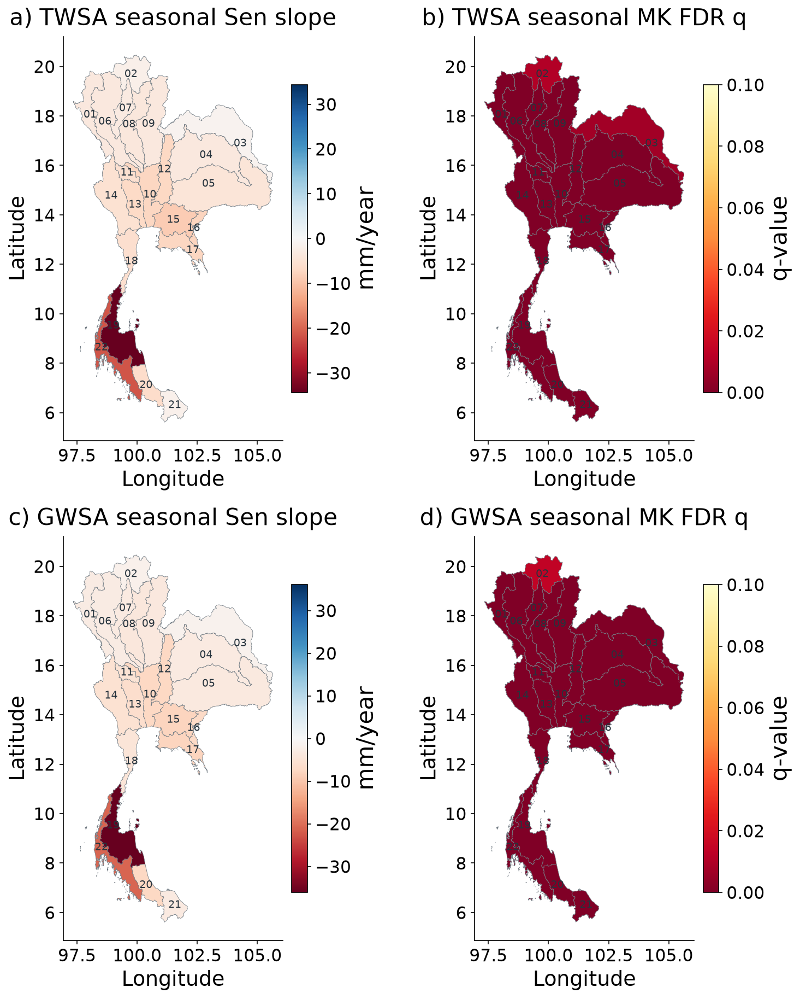
Figure 1 Spatial GRACE storage trends and Mann Kendall evidence
Basin-average CSR TWSA and compartment-derived GWSA; seasonal Sen slopes and basin FDR q. q colours saturate at 0.10. Seasonal MK does not correct serial dependence; slope intervals are supplied in the numerical tables. All basins retain the CSR small-support caution.

Processing-chain sensitivity
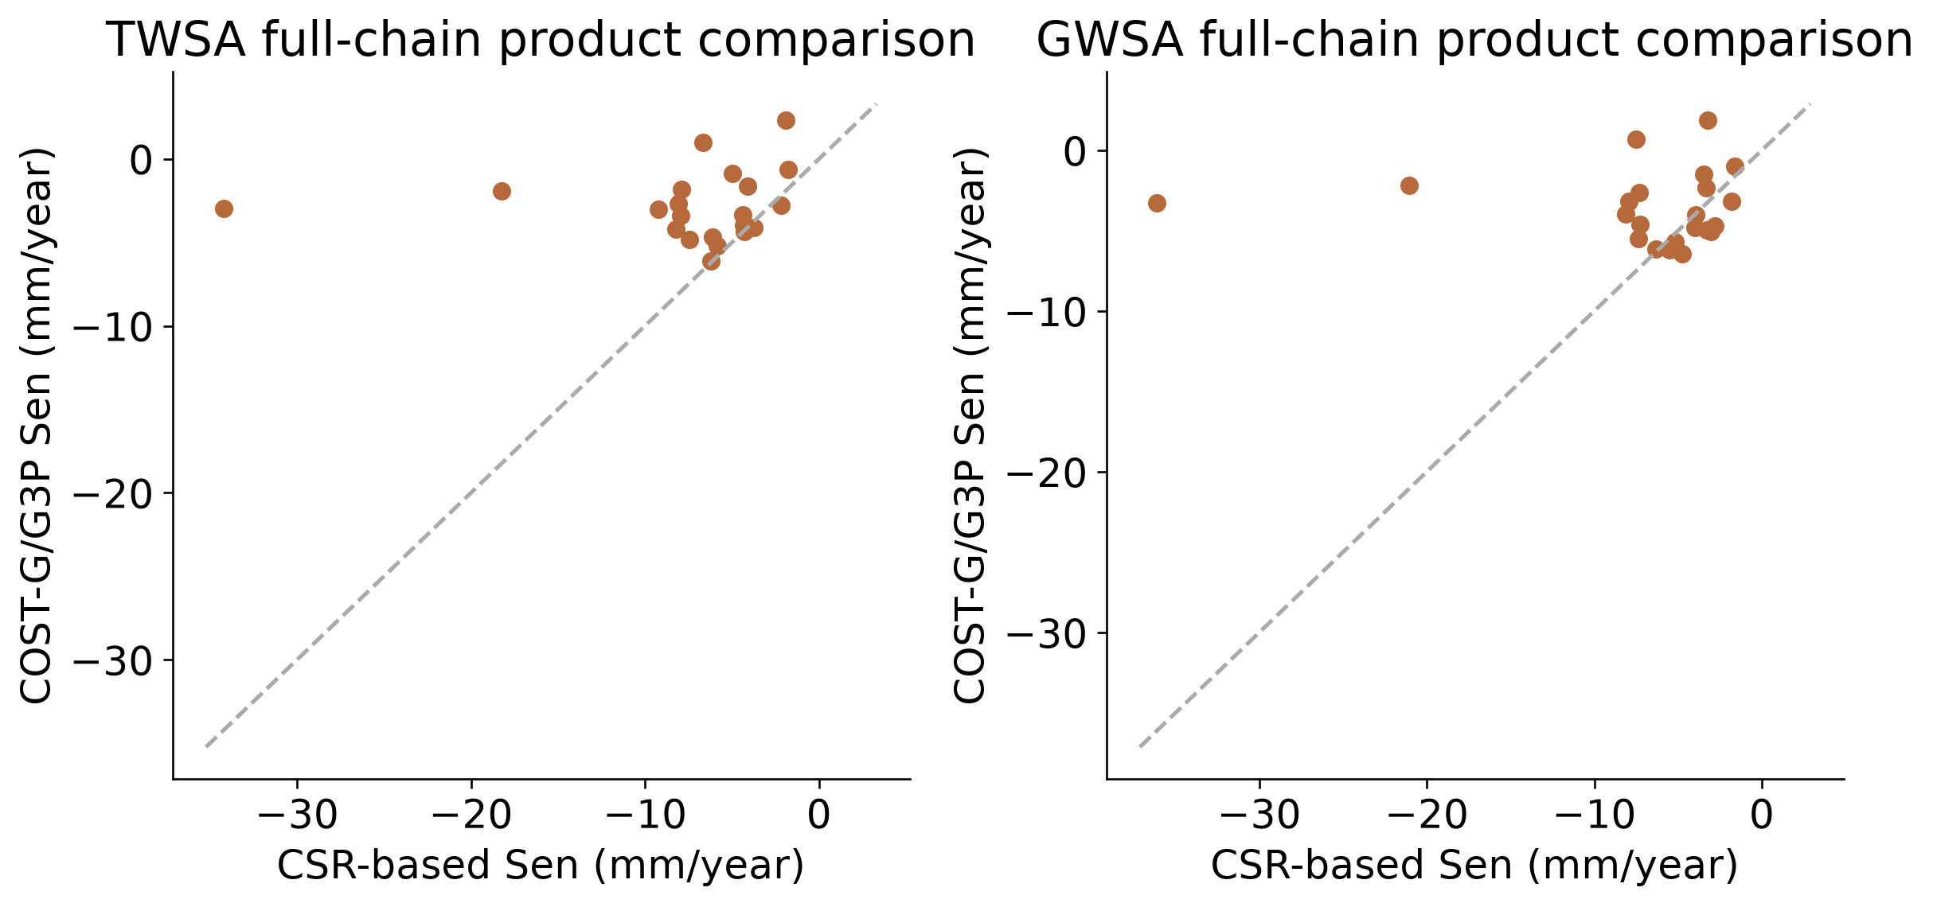
Figure 2 Processing-chain sensitivity
Common-date comparison of CSR and COST-G/G3P chains. Basin trend-ranking agreement is weak: Spearman 0.138 for TWSA and 0.027 for GWSA. Gravity and compartment processing differ, so groundwater contrasts cannot be attributed solely to GRACE.

Climate memory ablation
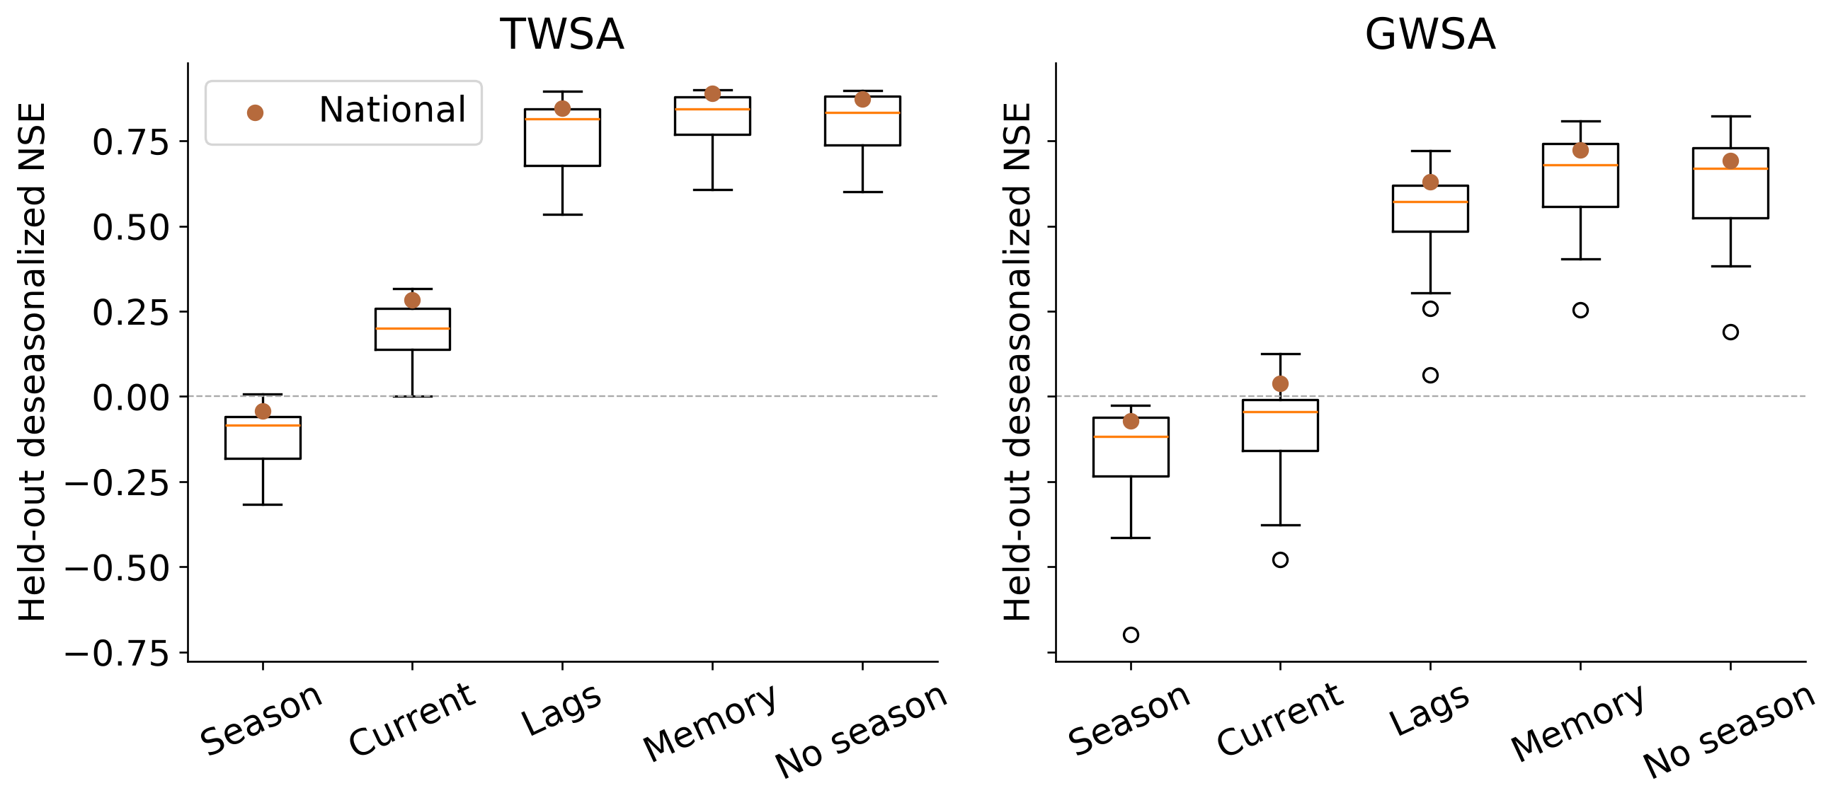
Figure 3 Climate memory ablation
Controlled Ridge experiment: current weather compared with weather-memory predictors; same training, validation and test splits. National test anomaly NSE rises from 0.283 to 0.890 for TWSA and 0.039 to 0.723 for GWSA.

Spatial climate model evaluation
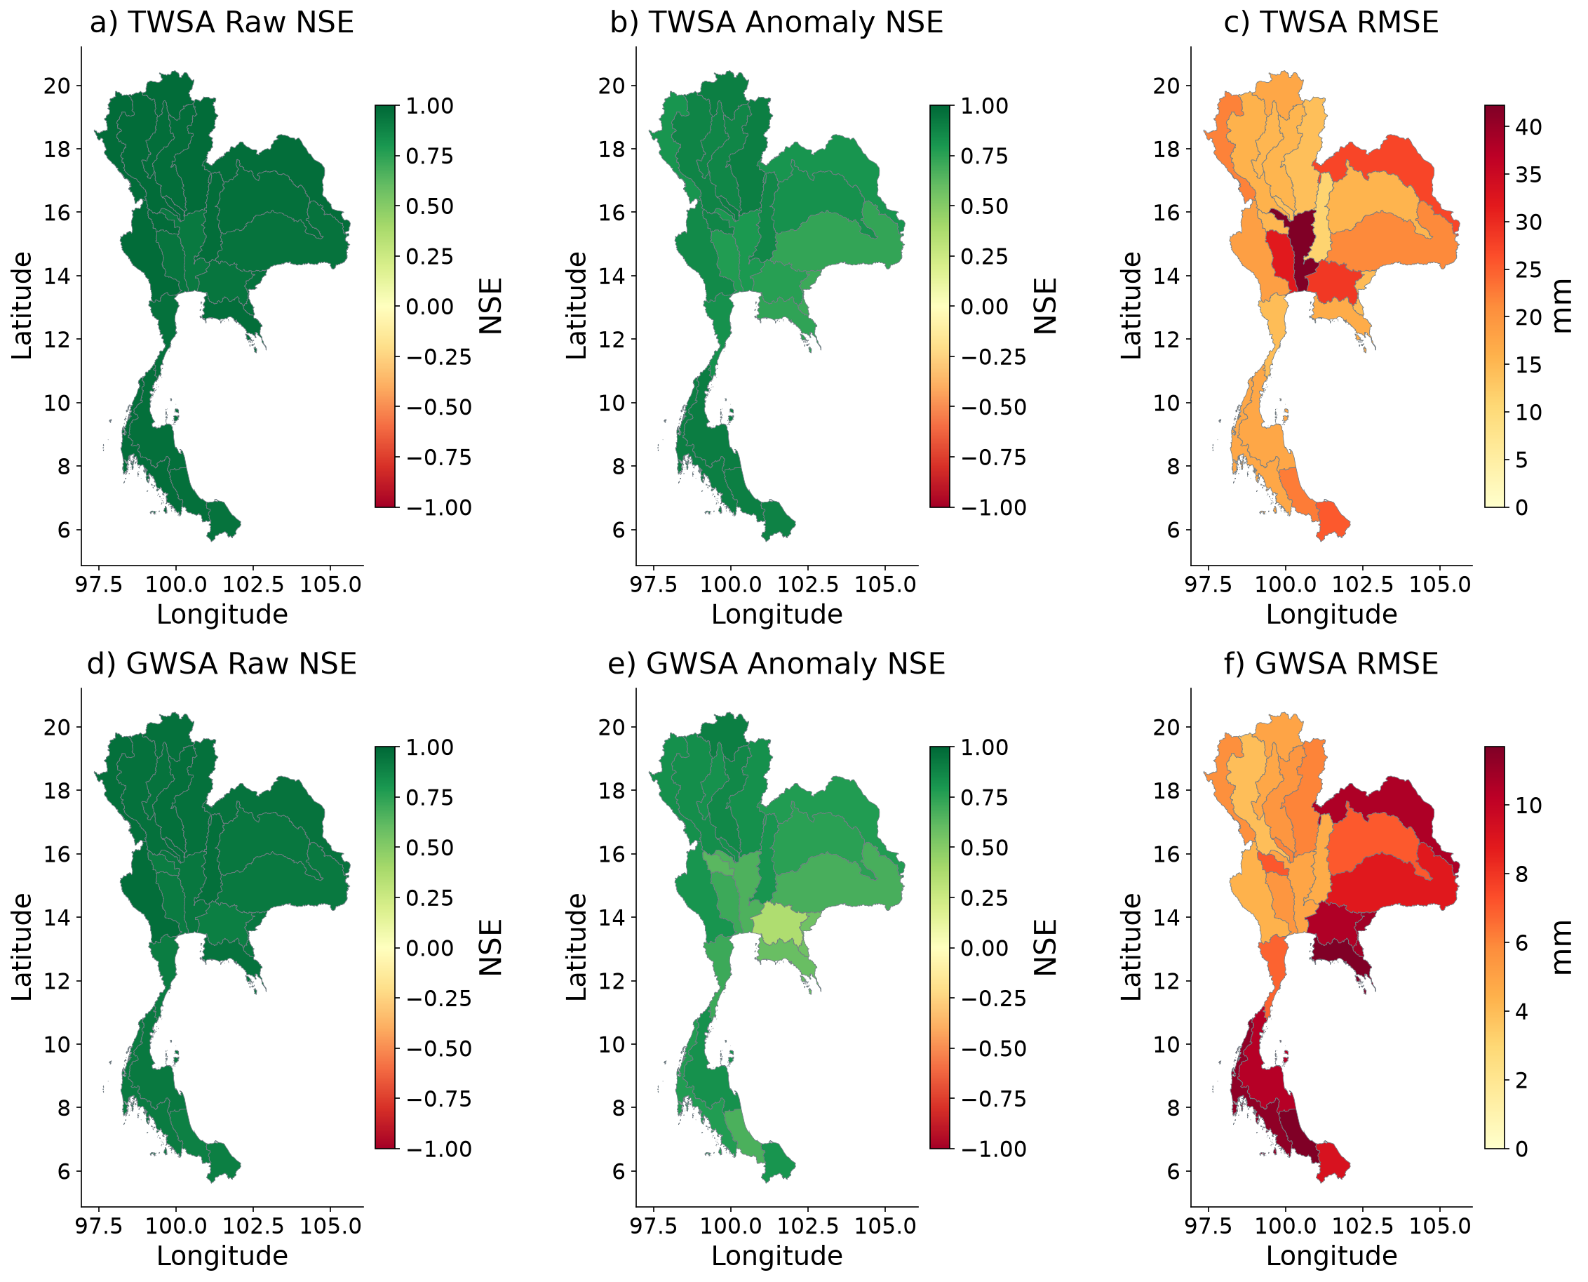
Figure 4 Spatial climate model evaluation
Frozen ensemble verification against naturalized parent storage during 2016–2023. Maps distinguish raw NSE, training-climatology-anomaly NSE and RMSE; NSE colours saturate below −1. High seasonal skill is not observational validation of a natural counterfactual.

Storage histories and period benchmarks
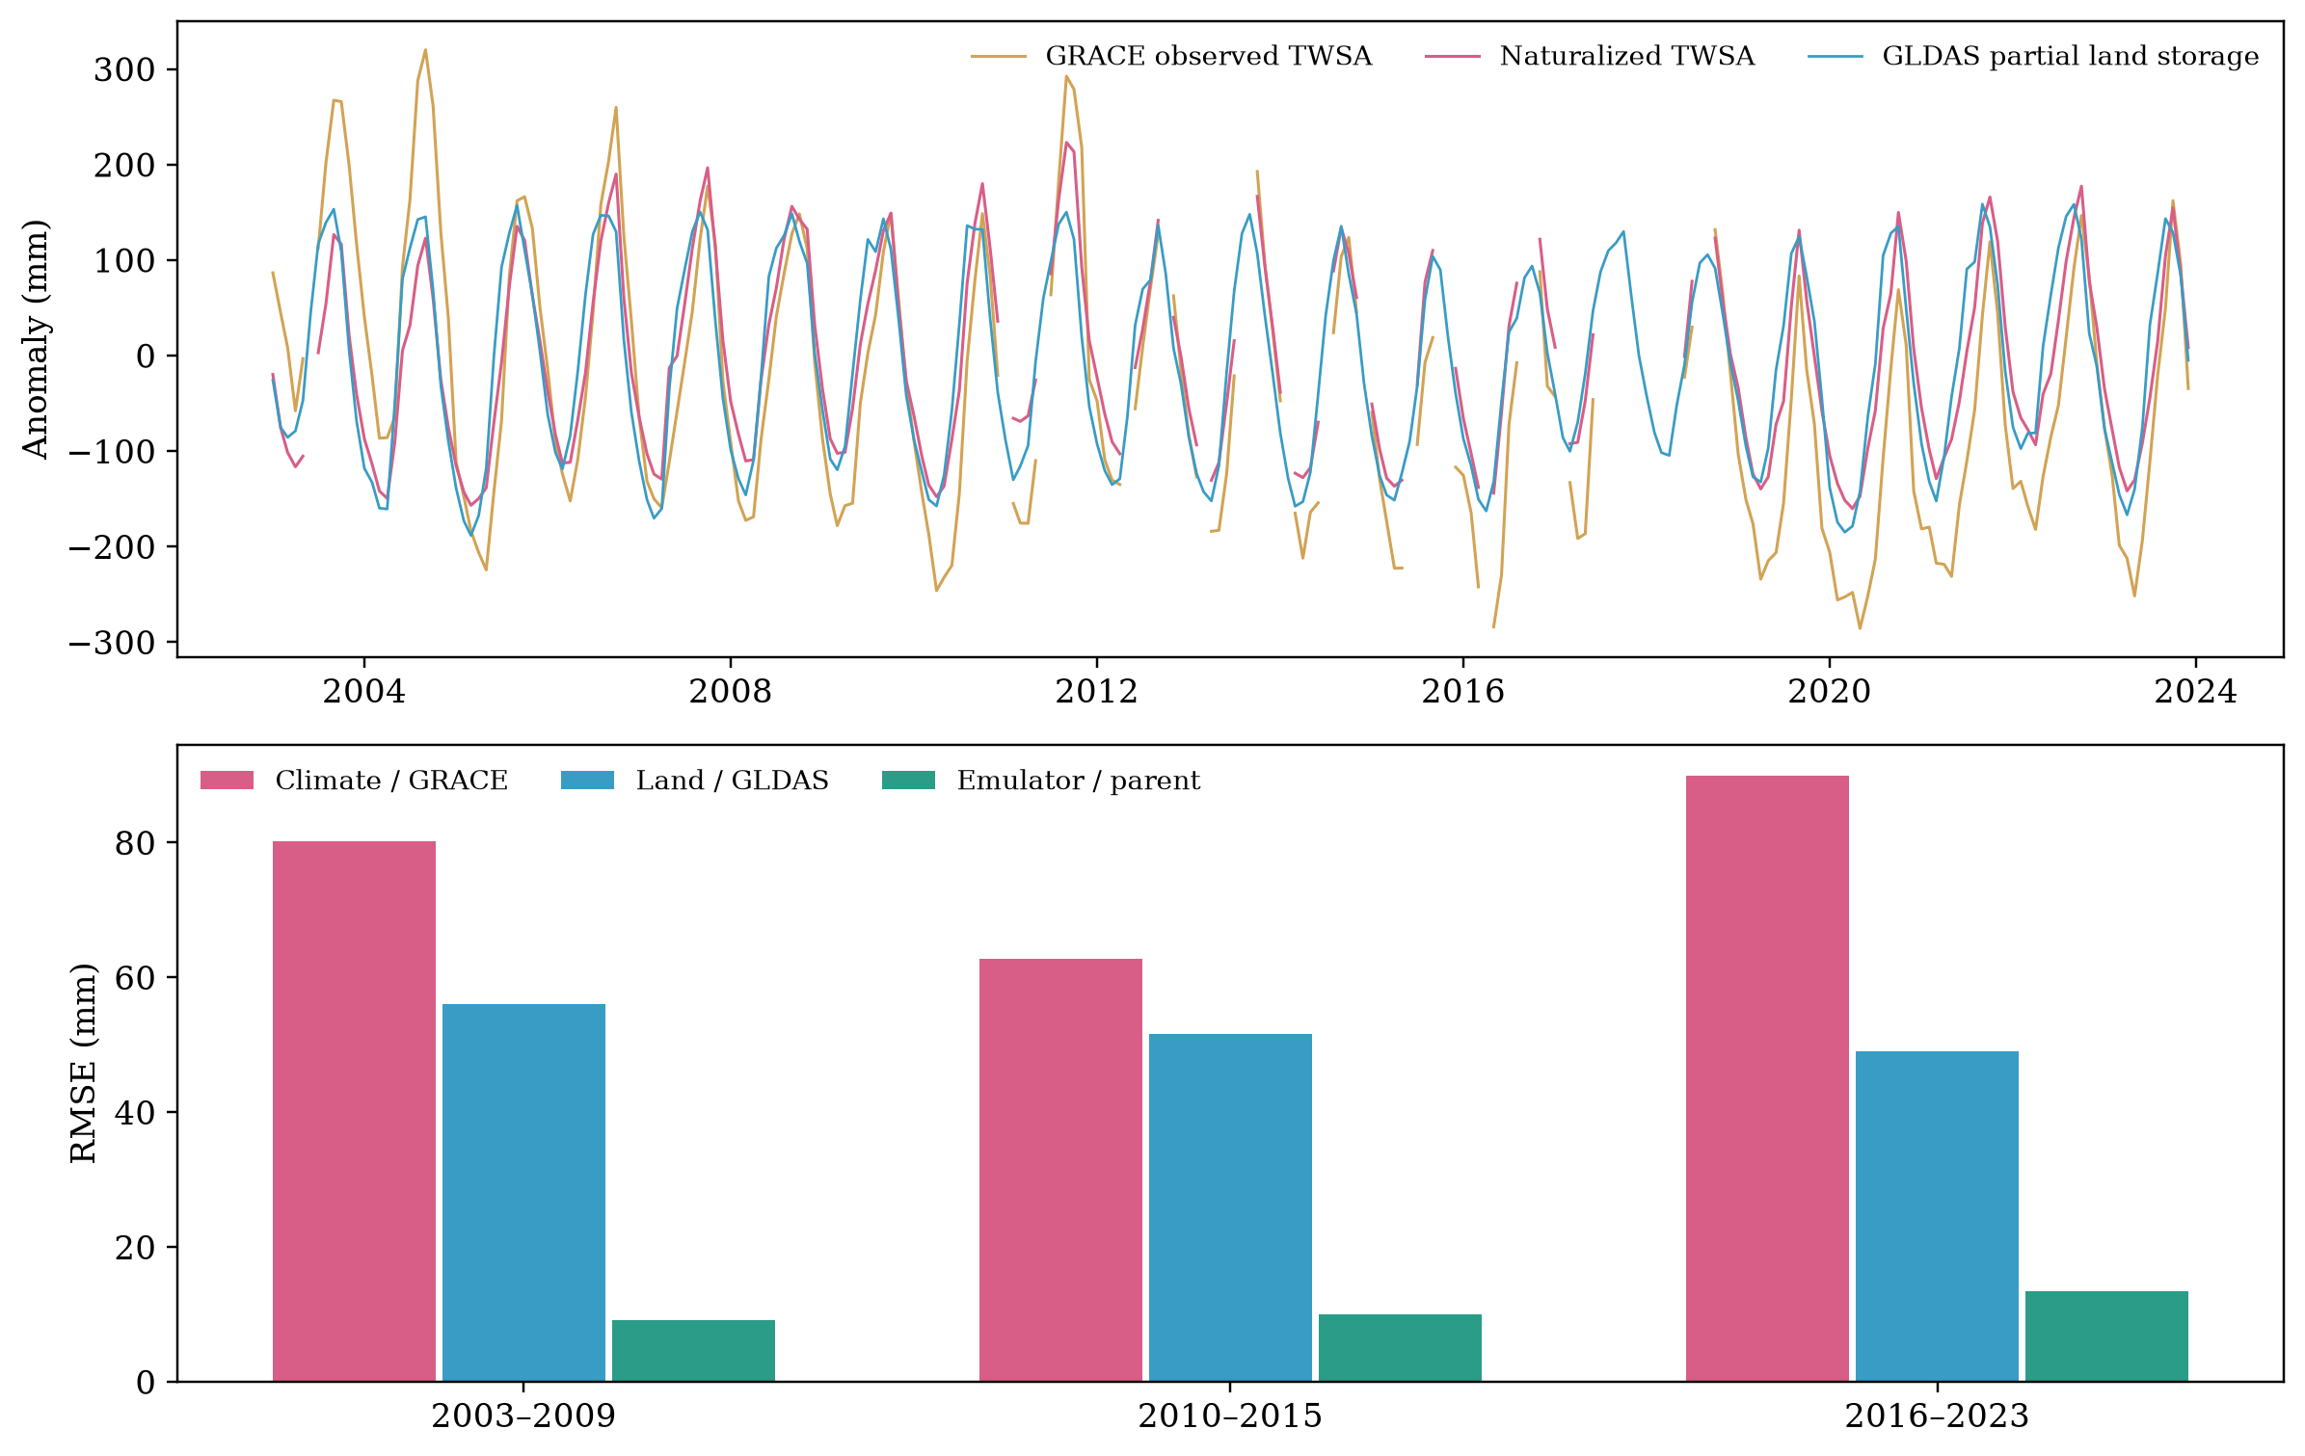
Figure 5 Storage histories and period benchmarks
National overview. GLDAS is partial land storage, not total TWSA. RMSE bars use distinct explicit targets, so their heights do not rank competing models. Emulator periods 2003–2009, 2010–2015 and 2016–2023 respectively overlap training, validation and held-out testing; only the final period is a test.

Spatial residual and modeled human perturbation
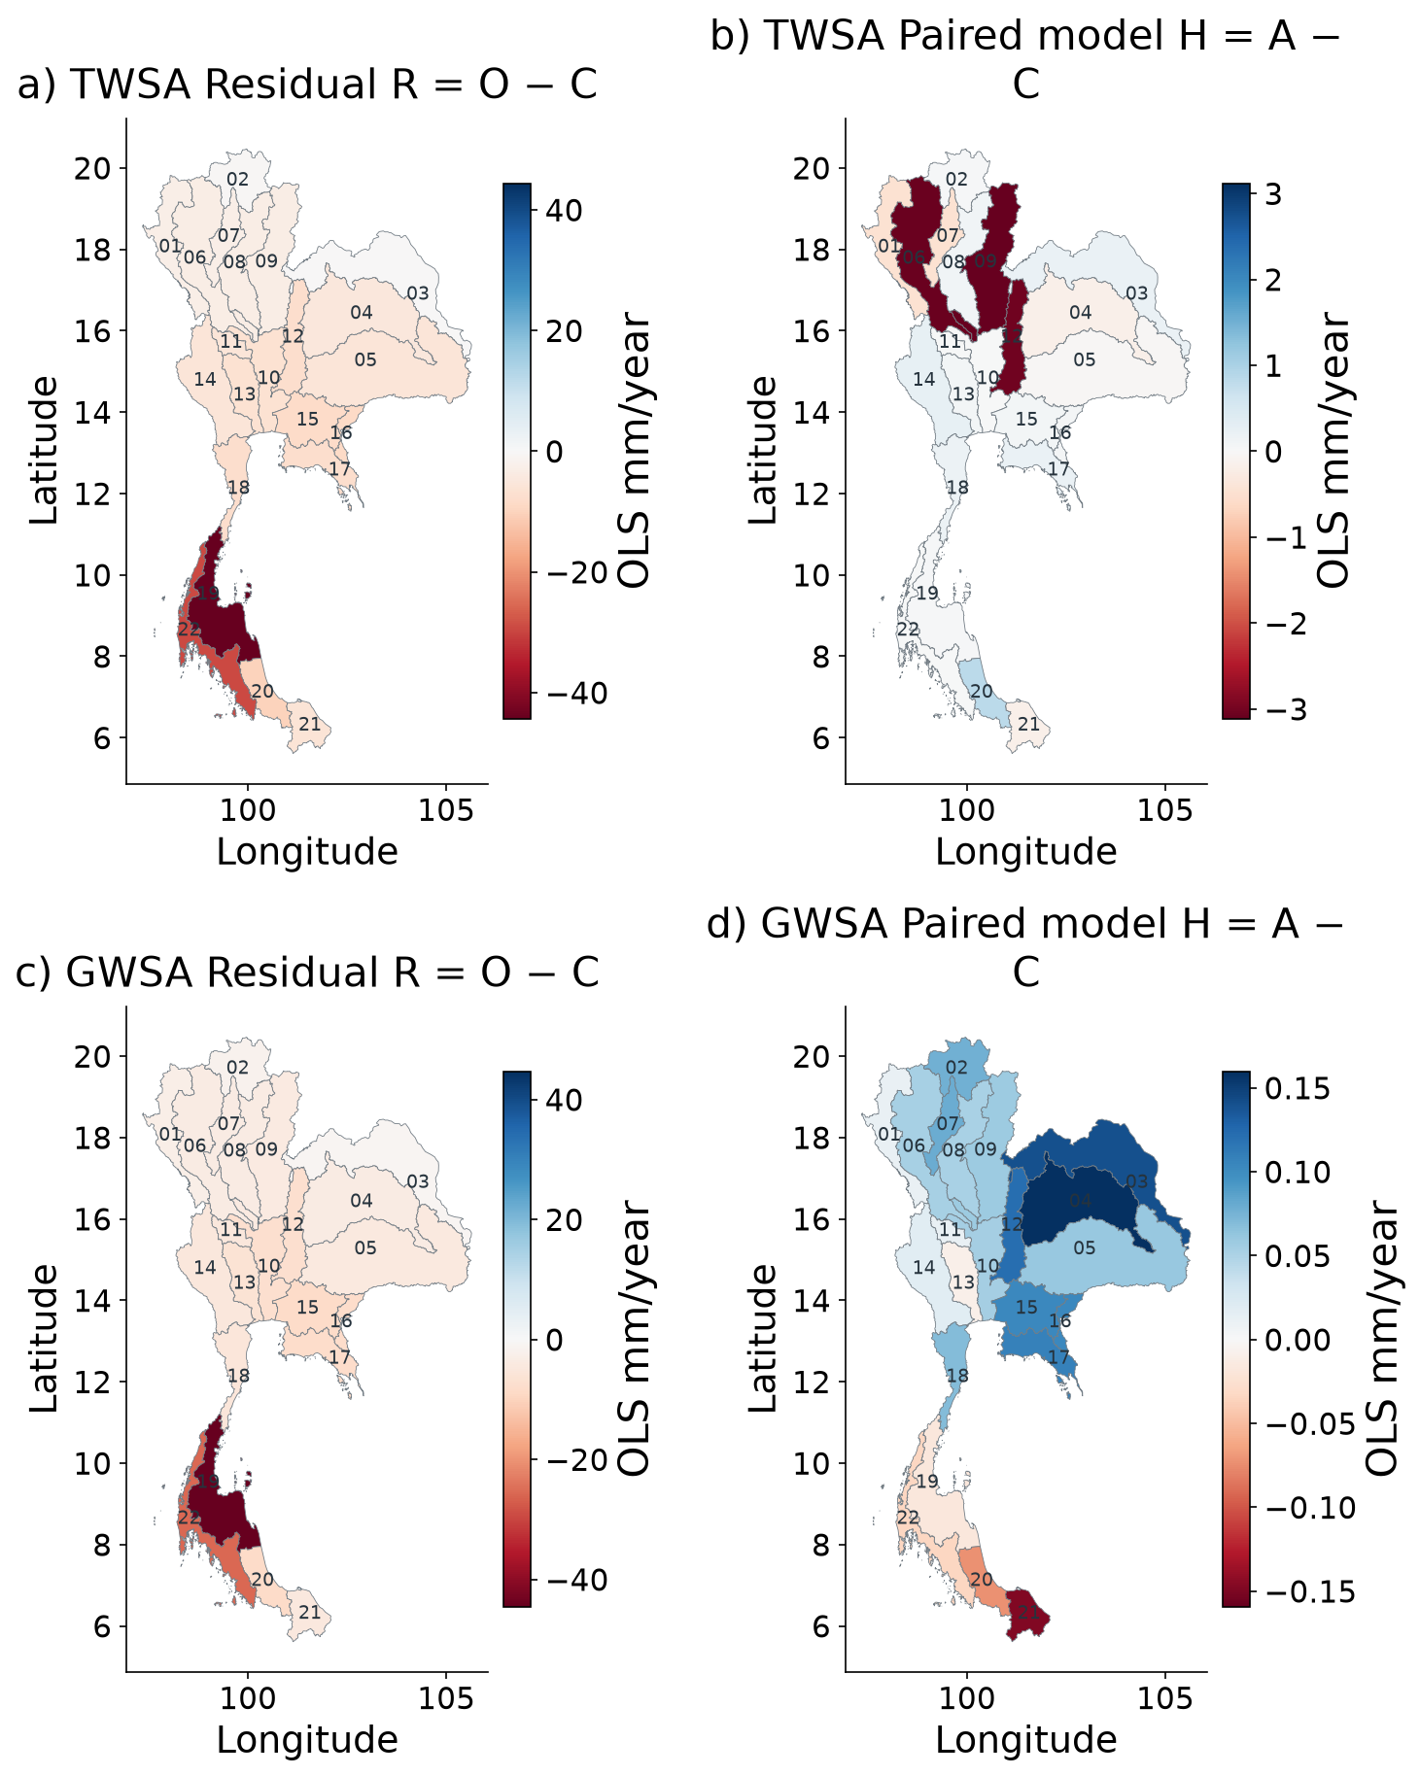
Figure 6 Spatial residual and modeled human perturbation
Calendar-month fixed-effect slopes on the same observation-valid support. R includes the represented direct-human perturbation H and discrepancy E. Each panel has its own labelled scale to keep small H visible; compare numerical scales before comparing colours. These slopes are not additive Sen-slope fractions.

ENSO associations across Thailand
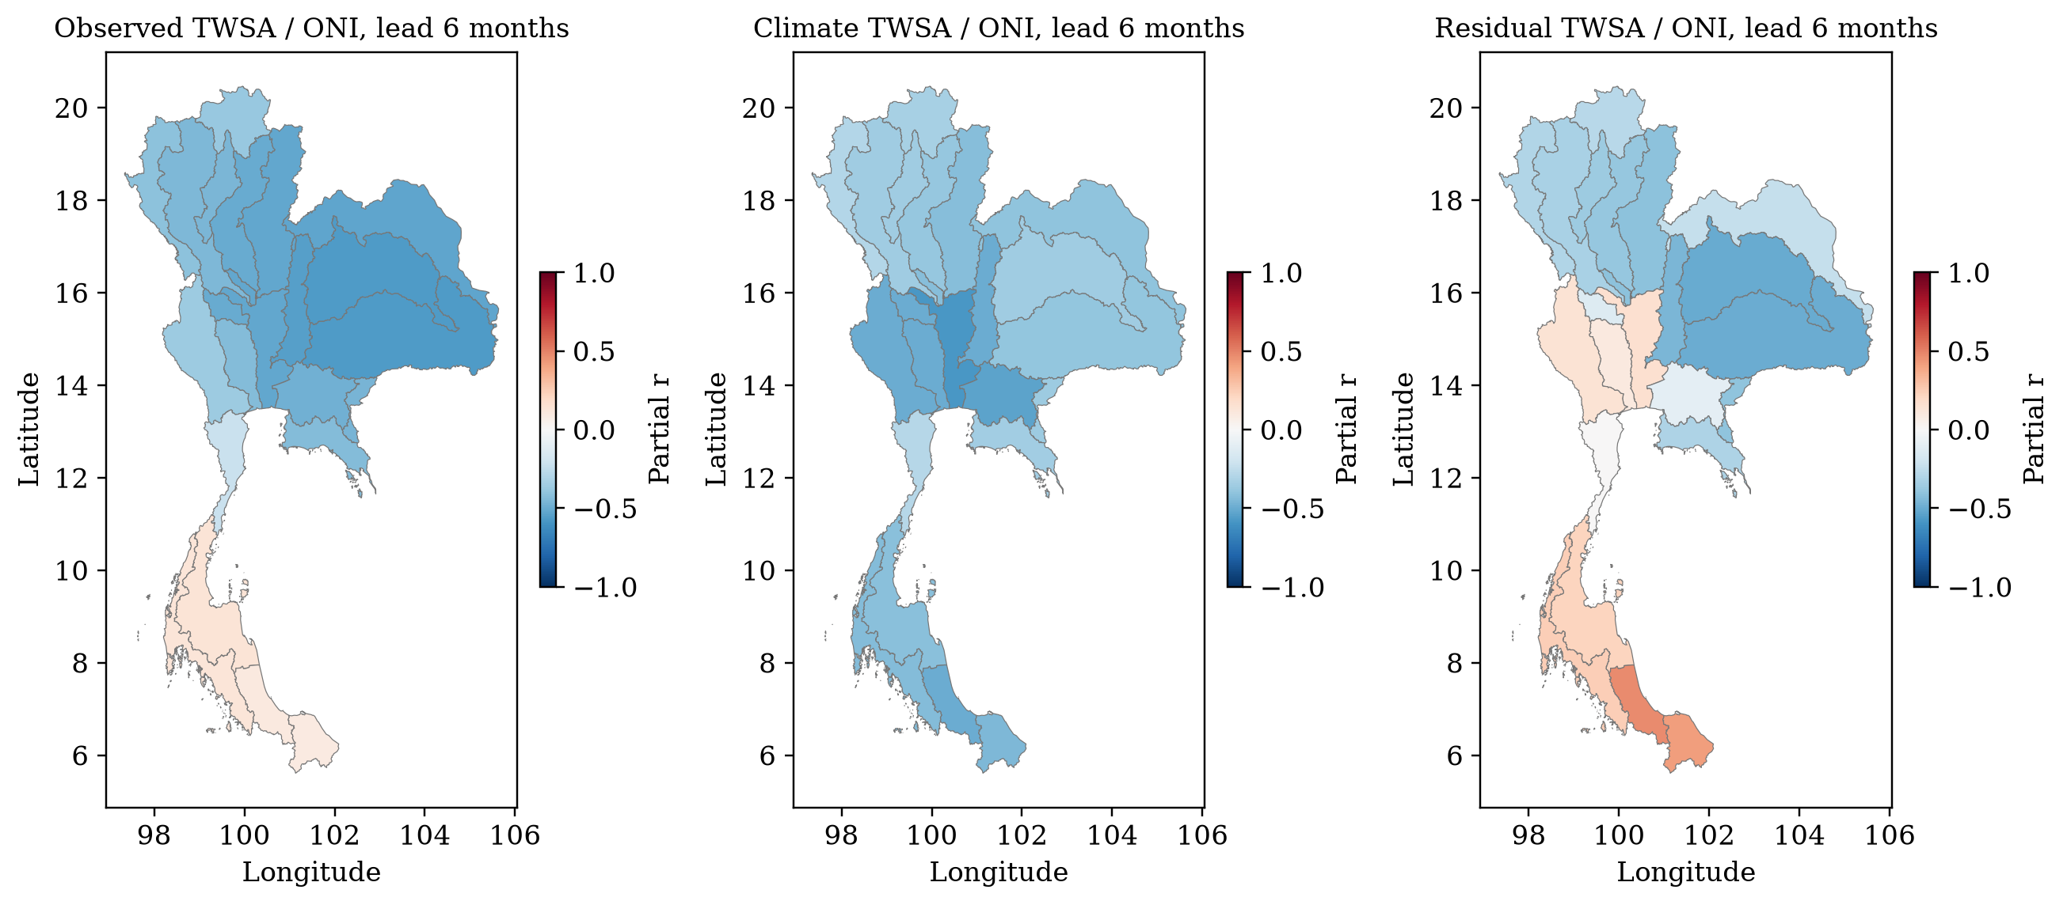
Figure 7 ENSO associations across Thailand
Prespecified six-month ENSO lead. Partial Pearson correlations remove calendar month, linear trend and contemporaneous DMI on paired months, 2003–2023. Dots indicate FDR q<0.05 from whole-year circular rotations. All five candidate lags and both ENSO indices are retained in CSV; no best-lag significance claim. Basins share GRACE support.

National lag and index sensitivity
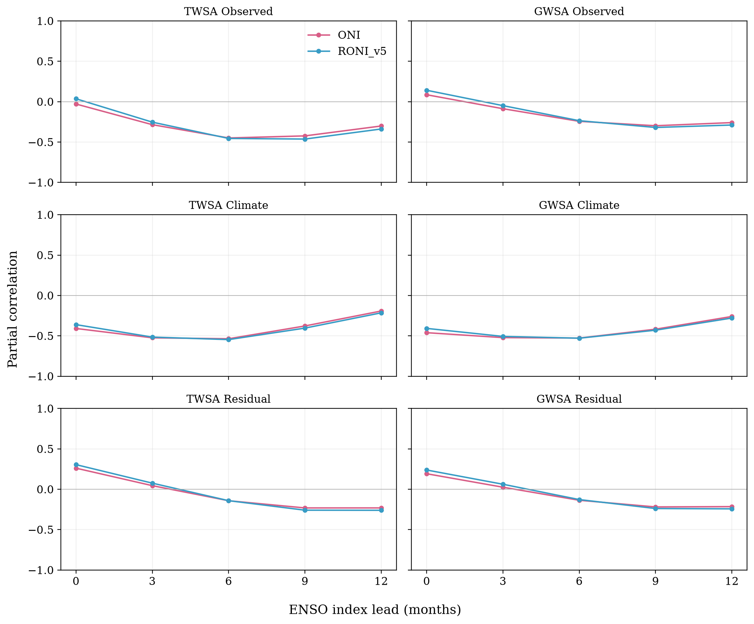
Figure 8 National lag and index sensitivity
Calendar season, trend and DMI controlled. ONI and historical RONI v5 are frozen at acquisition; RONI v6 is operational in 2026, whereas v5 is deliberately retained here for index-version comparability. The five candidate lags are reported together. Correlation is association, not climate causation or evidence of human-only residuals.

Spatial evaluation of residual agreement with groundwater
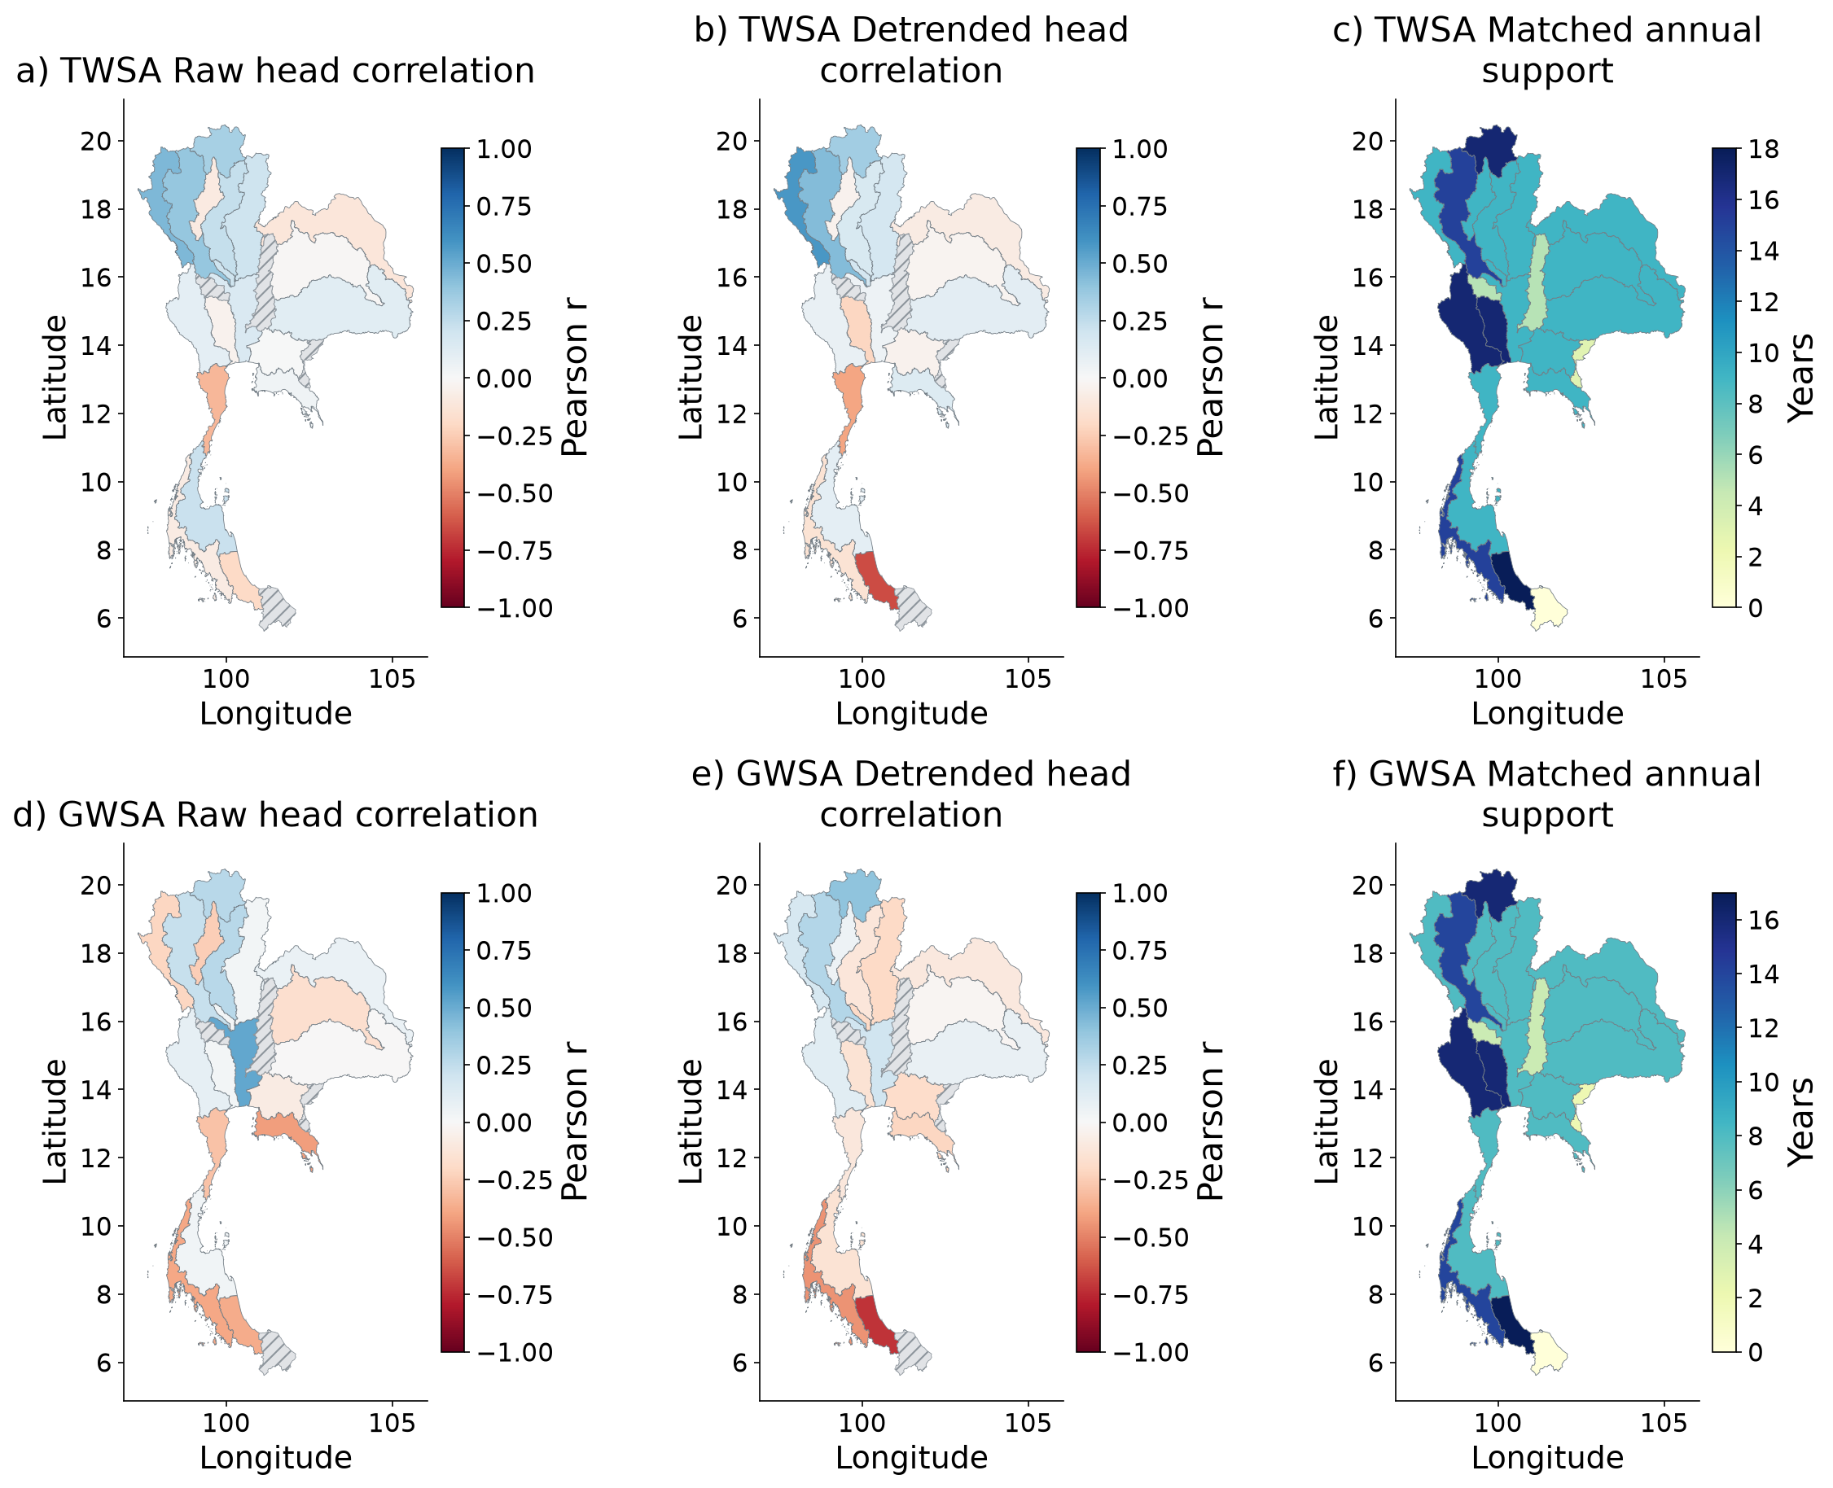
Figure 9 Spatial evaluation of residual agreement with groundwater
Observed annual heads compared separately with TWS and GWS residuals. Hatching marks unavailable correlations or fewer than eight matched years. Support maps expose small samples. Heads and equivalent water depth are not commensurate volumes, so head–storage NSE and RMSE are not calculated. Raw association is indirect groundwater evidence for TWS, not total-human validation.

Independent reservoir component evidence
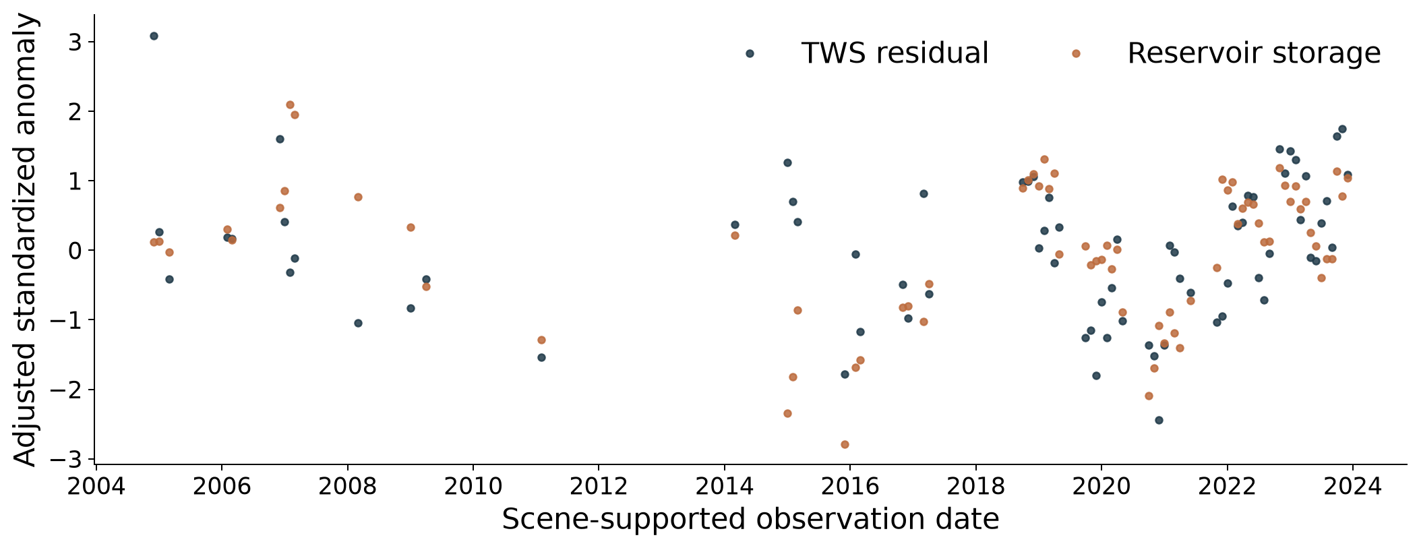
Figure 10 Independent reservoir component evidence
Scene-supported national reservoir and TWS residual anomalies after removing season and trend, then standardizing. Points retain missing scene support; no gap interpolation. r = 0.439 across 73 paired months; year-cluster interval 0.188–0.665.

Selected basin performance tables
Table 1 TWSA climate reconstruction performance
Basin | n | r | NSE | Anom NSE | RMSE | MAE
01 | 96 | 0.991 | 0.981 | 0.807 | 22.08 | 16.90
02 | 96 | 0.990 | 0.979 | 0.904 | 17.32 | 13.88
03 | 96 | 0.990 | 0.973 | 0.812 | 27.37 | 19.39
04 | 96 | 0.981 | 0.961 | 0.821 | 15.61 | 11.58
05 | 96 | 0.974 | 0.946 | 0.732 | 21.43 | 15.40
06 | 96 | 0.991 | 0.981 | 0.876 | 15.90 | 12.00
07 | 96 | 0.987 | 0.974 | 0.868 | 15.24 | 11.08
08 | 96 | 0.987 | 0.972 | 0.873 | 15.38 | 11.43
09 | 96 | 0.992 | 0.983 | 0.901 | 14.14 | 10.83
10 | 96 | 0.967 | 0.928 | 0.792 | 42.23 | 30.13
11 | 96 | 0.990 | 0.980 | 0.875 | 15.34 | 12.27
12 | 96 | 0.987 | 0.974 | 0.864 | 11.22 | 8.35
13 | 96 | 0.974 | 0.942 | 0.778 | 32.00 | 23.99
14 | 96 | 0.991 | 0.981 | 0.856 | 18.49 | 14.13
15 | 96 | 0.975 | 0.942 | 0.764 | 28.65 | 22.72
16 | 96 | 0.979 | 0.957 | 0.705 | 14.60 | 11.45
17 | 96 | 0.987 | 0.972 | 0.742 | 16.75 | 13.62
18 | 96 | 0.979 | 0.957 | 0.827 | 14.38 | 10.97
19 | 96 | 0.982 | 0.965 | 0.911 | 17.38 | 13.55
20 | 96 | 0.982 | 0.963 | 0.903 | 22.54 | 18.01
21 | 96 | 0.977 | 0.951 | 0.887 | 25.44 | 18.76
22 | 96 | 0.985 | 0.970 | 0.903 | 17.36 | 13.16
Frozen ensemble, 2016–2023 test data. Target: naturalized WaterGAP, not GRACE. Errors are mm; anomaly NSE removes the training monthly climatology. Higher NSE and lower errors are better.
Table 2 GWSA climate reconstruction performance
Basin | n | r | NSE | Anom NSE | RMSE | MAE
01 | 96 | 0.982 | 0.963 | 0.830 | 5.74 | 4.47
02 | 96 | 0.986 | 0.956 | 0.901 | 4.98 | 4.08
03 | 96 | 0.982 | 0.953 | 0.781 | 10.59 | 7.70
04 | 96 | 0.969 | 0.933 | 0.755 | 7.04 | 5.33
05 | 96 | 0.963 | 0.927 | 0.678 | 8.87 | 6.32
06 | 96 | 0.980 | 0.958 | 0.842 | 3.94 | 2.92
07 | 96 | 0.977 | 0.948 | 0.824 | 4.83 | 3.96
08 | 96 | 0.984 | 0.963 | 0.865 | 5.52 | 4.22
09 | 96 | 0.982 | 0.958 | 0.832 | 6.04 | 4.78
10 | 96 | 0.968 | 0.935 | 0.661 | 4.90 | 4.09
11 | 96 | 0.958 | 0.914 | 0.627 | 7.09 | 5.40
12 | 96 | 0.981 | 0.962 | 0.812 | 4.62 | 3.61
13 | 96 | 0.959 | 0.920 | 0.703 | 5.50 | 4.45
14 | 96 | 0.985 | 0.970 | 0.812 | 4.39 | 3.12
15 | 96 | 0.963 | 0.902 | 0.360 | 10.51 | 8.46
16 | 96 | 0.970 | 0.933 | 0.564 | 10.88 | 8.87
17 | 96 | 0.980 | 0.952 | 0.589 | 11.67 | 9.60
18 | 96 | 0.958 | 0.907 | 0.711 | 6.84 | 5.11
19 | 96 | 0.968 | 0.926 | 0.823 | 10.40 | 8.46
20 | 96 | 0.946 | 0.892 | 0.668 | 11.69 | 9.70
21 | 96 | 0.953 | 0.904 | 0.808 | 9.19 | 7.33
22 | 96 | 0.967 | 0.922 | 0.780 | 11.32 | 8.94
Frozen ensemble, 2016–2023 test data. Target: naturalized WaterGAP, not GRACE. Errors are mm; anomaly NSE removes the training monthly climatology. Higher NSE and lower errors are better.

The table body may be single-spaced, one-and-a-half-spaced or double-spaced. Notes can be written in a smaller font size, if necessary, of not less than 10. You can also reduce the font size for the table body to fit everything on one page or one table. However, uniformity should be observed for all figures and tables.
The same font should be used throughout the thesis, but the font size for figures can be between 10-14 making sure that the presentation is legible. Adjust the footnotes, if necessary, between 10-12 font size.
This means that crowding in the image should be avoided in order to give enough space between words.

