Water Storage Trends and Climate Attribution Across River Basins in Thailand
by
Farzeen Khan
A research thesis report
Master of Science in Water Engineering and Management
Advisor Dr. Natthachet Tangdamrongsub
Asian Institute of Technology
Thailand
October 2026
ABSTRACT
This study examines changes in total and groundwater storage across Thailand's 22 principal river basins. It addresses three objectives: measure storage trends, assess the climate-related baseline and the remaining residual, and provide a reproducible decision-support website. GRACE and GRACE-FO observations provide total water storage anomalies (TWSA). Groundwater storage anomalies (GWSA) are calculated by subtracting soil, surface, canopy and snow water anomalies. All terms use compatible units, reference periods and spatial coverage. National TWSA decreased by 7.51 mm/year through September 2024, while GWSA decreased by 6.84 mm/year through September 2023. Basin rankings change substantially between processing chains, so local rankings need caution. A naturalized WaterGAP simulation provides the baseline without the direct human activities represented in its paired historical simulation. Statistical models reconstruct this baseline from rainfall, potential evapotranspiration and climate memory; they are tested on 2016–2023 data that were excluded from fitting and model selection. GLDAS is used to compare matching soil, canopy and snow compartments. The observation-minus-baseline residual contains both human effects and errors in the observations and models. Groundwater levels and independent reservoir records therefore provide supporting checks rather than a direct measurement of the full human component. Groundwater agreement is weak and changes with the selected wells and years. The season- and trend-adjusted national reservoir correlation is 0.439 across 73 scene-supported months. The main finding is a national storage decline, with greater uncertainty in basin rankings and human attribution. The report presents the results through 21 figures, an interactive website and code that can be rerun independently.
CONTENTS
Water Storage Trends and Climate Attribution Across River Basins in Thailand i
CHAPTER 1 INTRODUCTION 1
Why climate and human effects are difficult to separate 2
Objectives and proposed contribution 3
CHAPTER 2 LITERATURE REVIEW 5
Groundwater isolation and compartment compatibility 6
Naturalized models and the meaning of attribution 7
Model skill beyond a seasonal cycle 8
Groundwater observations and network effects 9
Thai studies and the remaining research gap 10
CHAPTER 3 STUDY AREA AND DATA 12
Input records and analysis periods 13
CSR processing and calendar audit 14
Groundwater records and representativeness 17
CHAPTER 4 METHODOLOGY 18
Steps 1 to 3 Prepare data and estimate storage trends 19
Step 4 Define the climate baseline and residual 20
Step 6 Build and test the statistical climate models 22
Step 8 Compare GLDAS and independent reservoir data 24
Step 9 Evaluate residuals with groundwater levels 25
Step 10 Check the reliability of basin conclusions 26
Step 11 Deliver the results and reproduce the analysis 27
CHAPTER 5 RESULTS 28
Observed storage time series for all 22 basins 29
Spatial naturalized storage and climate reconstruction 31
Climate model evaluation through time 35
GWSA residual histories for all 22 basins 38
Spatial GLDAS matched compartment comparison 39
GLDAS and residual histories for all 22 basins 42
Spatial evaluation of residual agreement with groundwater 43
CHAPTER 6 DISCUSSION 47
What the climate model and residual mean 48
What wells and reservoirs can validate 49
CHAPTER 7 CONCLUSIONS AND RECOMMENDATIONS 50
REFERENCES 51
APPENDIX A ALL BASIN RESULTS 53
APPENDIX B REPRODUCIBILITY AND INTERPRETATION CONTRACT 54
APPENDIX C BASIN PERFORMANCE AND VALUES 55
APPENDIX D FORCING AND SUPPORTING DATA 67

LIST OF MAIN TEXT FIGURES
Figure 3.1 Official principal basins and analysis codes; full names appear in Appendix A. 12
Figure 3.2 National calendar-month climatologies from the retained multisource cube; the products have different physical meanings. 16
Figure 5.1 CSR TWSA and derived GWSA seasonal Sen slopes and seasonal Mann–Kendall FDR maps. 28
Figure 5.2 Monthly TWSA and GWSA for all 22 basins; observation gaps are retained. 29
Figure 5.3 Common-support CSR and COST-G/G3P trend comparisons; compartment processing also differs. 30
Figure 5.4 Spatial naturalized climate baseline and meteorological emulator trends for TWSA and GWSA. 31
Figure 5.5 TWSA climate reconstruction for all 22 basins; shading marks held-out years. 32
Figure 5.6 GWSA climate reconstruction for all 22 basins; shading marks held-out years. 33
Figure 5.7 Spatial held-out climate-model raw NSE, anomaly NSE and RMSE. 34
Figure 5.8 Climate-model anomaly NSE and RMSE by held-out year, with spatial interquartile variation. 35
Figure 5.9 Spatial TWSA and GWSA residual trends and paired modeled direct-human perturbations. 36
Figure 5.10 TWSA residual and modeled human time series for all 22 basins. 37
Figure 5.11 GWSA residual and modeled human time series for all 22 basins. 38
Figure 5.12 Spatial GLDAS and naturalized-model land-storage trends on matched compartment support. 39
Figure 5.13 GLDAS and naturalized land-storage time series for all 22 basins. 40
Figure 5.14 Spatial standardized trends and dependence between GLDAS land storage and residuals. 41
Figure 5.15 GLDAS land storage and both residual histories for all 22 basins, standardized on common months. 42
Figure 5.16 Spatial raw and detrended residual–head correlations and observed annual support. 43
Figure 5.17 Annual groundwater and residual histories for all 22 basins on joint support. 44
Figure 5.18 Spatial reservoir–residual agreement and fixed reservoir populations; hatching denotes missing evidence. 45
Figure 5.19 Residual–head evaluation and represented observation-network support through time. 46
LIST OF MAIN TEXT TABLES
Table 3.1 Input records and scientific roles 13
Table 3.2 Storage-compartment definitions 15
Table 4.1 Evaluation chronology 22
Table 5.1 National source and structure comparisons 30
Table 5.2 National groundwater-panel comparisons 43
Table A.1 All-basin storage, native support and head evidence 53
ABBREVIATIONS AND SYMBOLS
AIT — Asian Institute of Technology
CSR — Center for Space Research
TWSA — Terrestrial water storage anomaly
GWSA — Groundwater storage anomaly
GLDAS — Global Land Data Assimilation System
G3P — Global Gravity-based Groundwater Product
NSE — Nash–Sutcliffe efficiency
FDR — False discovery rate
OLS — Ordinary least squares
P and PET — Precipitation and potential evapotranspiration
O, C and A — Observed, naturalized and historical-human storage
R, H and E — Residual, modeled direct-human perturbation and discrepancy
D — Descriptive discrepancy-magnitude index
Head — Signed negative depth to water; not water-storage volume

CHAPTER 1
INTRODUCTION
1.1 Water storage and the research problem
Water-storage change integrates processes that are observed separately by rain gauges, land-surface sensors, reservoir records and groundwater wells. Precipitation supplies water, evapotranspiration returns part of it to the atmosphere, and routing and subsurface storage determine when the remainder becomes available. A persistent storage decline can therefore matter even where rainfall remains strongly seasonal. The practical question is whether the available observations identify a regional change, its location and the processes that explain it.
Satellite gravimetry provides a broad view of terrestrial water storage anomaly, or TWSA. It responds to changes in total water mass rather than to groundwater alone. Groundwater storage anomaly, GWSA, must be estimated by removing the other storage compartments. This subtraction introduces information from hydrological models, so the resulting groundwater series inherits their structural assumptions as well as the limitations of the gravity observations. Spatially detailed output grids do not remove that dependence.
Thailand offers an important setting for this distinction. Its principal river basins provide a useful administrative framework for comparing storage conditions, while the satellite observations integrate information across areas that can exceed individual basin boundaries. The study uses all 22 official principal basins and national context. It retains the basin definitions supplied with the project rather than redrawing boundaries to obtain stronger statistical associations or more favourable trends.
The research connects three tasks: describing storage change, evaluating a climate-related baseline and delivering results through an interactive decision-support system. These tasks require different evidence. A trend estimate describes a record; an emulator score describes a model comparison; and well agreement describes a relationship between spatially mismatched observations. Keeping these meanings distinct makes the analysis useful even where an attribution hypothesis is not confirmed.
The central proposition of this thesis is that attribution should be assessed through its sensitivity and observational support, rather than through a single high correlation. The analysis therefore evaluates product dependence, climate-memory skill, paired model discrepancy and groundwater-network uncertainty together. Its conclusions concern both the observed water-storage changes and the strength of the evidence available to interpret them.

Why climate and human effects are difficult to separate
A common attribution procedure predicts storage from meteorological variables and labels observed minus predicted storage as a human component. That interpretation is demanding. If a statistical model is trained directly on GRACE observations, its target already contains any effects of abstraction, irrigation and reservoir operation present during the training period. The fitted relationship is not automatically an estimate of a world without those activities. Adding more predictors does not resolve this identification problem.
Some predictors also respond to management. Actual evapotranspiration can increase where irrigation supplies water, and observed soil moisture can reflect both rainfall and irrigation. Such variables are useful for prediction and for describing the hydroclimatic system, but they cannot be assumed to represent an external climatic cause. This thesis consequently uses meteorological precipitation and potential evapotranspiration for the principal naturalized-model emulators and treats actual-ET and moisture products as supporting context.
A naturalized hydrological simulation supplies a more explicit counterfactual experiment. In the WaterGAP pairing used here, direct water use and artificial reservoirs are removed in one run and represented in the historical-human run. The simulations share a model and meteorological forcing. Their difference identifies the direct human perturbation represented by that model, conditional on its processes and parameters. It remains an experiment, not an independently measured pumping history.
The observation-based residual also contains whatever the historical-human run fails to reproduce. This discrepancy can include unrepresented management, climate-forcing error, groundwater-model error, compartment mismatch and gravity-processing effects. The thesis retains it explicitly. The analytical goal is to determine how much interpretive confidence remains when these alternatives are visible, rather than to force every unexplained millimetre into a human-use category.
The groundwater comparison creates a further challenge. Wells record local hydraulic head, whereas storage anomalies describe water mass over a region. Heads respond to climate, pumping and aquifer properties, and the monitored network changes over time. The study therefore asks whether apparent agreement survives detrending, climate control and changes in station composition before treating it as supporting evidence.

Objectives and proposed contribution
Objective 1 is to quantify temporal and spatial patterns of TWSA and GWSA for every principal basin in Thailand. It includes seasonal Sen slopes, original and seasonal Mann–Kendall tests, false-discovery-rate adjustment, uncertainty intervals and coverage information. The principal gravity record is the identified CSR RL06.3 product. The original project export and the documented COST-G/G3P chain provide sensitivity comparisons on common observational support.
Objective 2 is to develop and assess a climate-storage reconstruction framework, compare appropriate components with GLDAS, and examine the climate–human decomposition using groundwater observations. The study distinguishes naturalized-parent emulation, agreement with observed storage and agreement with groundwater heads. It adds controlled feature ablations, a change-of-precipitation-source experiment, held-out rainfall–storage associations and observation-network resampling to the paired hydrological experiment.
Objective 3 is to deliver an interactive decision-support system and a reproducible research package. The interface should expose basin results, missing dates, model-verification scores, observation coverage and limitations. Reproducibility includes the input subsets, executable code, dependency versions and comparison records, so that an advisor can rerun the numerical analysis without access to the original workstation.
The proposed contribution is an integrated assessment of attribution credibility across an entire national basin framework. It tests whether national decline, basin rankings, climate-memory reconstruction and groundwater agreement tell a consistent story. The mathematical decomposition itself is an accounting identity, and the statistical algorithms are established methods. The contribution lies in their controlled combination, the product and network tests, and the resulting evidence about what can be inferred in this setting.
Novelty is therefore framed as a defensible research proposition, not a claim that this is the first use of GRACE, machine learning or groundwater wells in Thailand. The literature review identifies related work and explains the differences in domain, comparison target and uncertainty treatment. Publication quality ultimately depends on the evidence, clarity and review of those differences, not on the number of methods listed.
Research questions and scope
The first research question concerns robustness: does the direction of storage change persist across documented gravity and groundwater-estimation chains, and do basin rankings remain stable? A consistent national sign would support a broad storage-change conclusion. Instability in rankings would limit local prioritization even if every individual map appeared statistically significant. These are separate questions and are evaluated on identical months and common valid cells wherever products are compared.
The second question concerns climatic information. Can precipitation, potential evapotranspiration and antecedent memory reproduce the naturalized parent model beyond a seasonal baseline? The associated expectation is that delayed hydrological response should add information about interannual anomalies. A high raw monthly score alone would not establish this, because monsoonal seasonality can produce a strong relationship with limited ability to explain unusual wet or dry conditions.
The third question concerns transfer across data sources. Does a frozen emulator remain useful when native-model precipitation is replaced with CHIRPS? This is a forcing-sensitivity experiment, not independent validation of the unobserved naturalized target. It nevertheless tests whether the reported skill depends strongly on using the same meteorological information that drove the parent simulation. Any deterioration is reported rather than repaired using the test period.
The fourth question concerns groundwater evidence. Does residual–head agreement persist when station groups are resampled and when a strictly balanced network is compared on a common period? A fixed eligibility rule alone does not guarantee a stable annual station composition. The common-period and strict-panel tests were added as an explicitly exploratory extension after this distinction became apparent in the initial network assessment.
The study is retrospective. It does not predict future climate, estimate time to aquifer exhaustion or provide measured pumping volumes. TWSA extends to September 2024, full-balance GWSA to September 2023 and paired hydrological attribution to the available 2023 model record. This scope keeps the observed and simulated periods explicit and avoids extending the counterfactual merely to fill the final observed year.

CHAPTER 2
LITERATURE REVIEW
Satellite gravimetry and spatial interpretation
GRACE and GRACE-FO infer mass redistribution from changes in the Earth's gravity field. Their hydrological value comes from observing broad storage changes that are difficult to measure through sparse compartment-specific networks. Their limitation is that the gravity inversion is regularized and spatially coarse. The estimates should therefore be interpreted through the support of the observing system rather than through the density of coordinates in a delivered raster.
CSR supplies a native geodesic mascon representation resampled to a quarter-degree grid. The provider documents corrections, a land mask and a mapping between native mascons and the convenience grid. It cautions against single-grid-point interpretation and against assuming that small basins are independently resolved. The present study follows that advice by using basin averages and by describing shared native support rather than presenting pointwise CSR significance maps (Save et al., 2016; CSR, 2026).
Product comparison remains necessary because processing choices can change amplitudes, leakage and trends. The COST-G/G3P record offers a documented contrasting chain. Both products still derive from the same satellite observing missions, so agreement is not replication by an independent physical instrument. The unidentified project export is retained as a legacy sensitivity; its close numerical relationship with CSR cannot establish its processing provenance.
Earlier work demonstrated the sensitivity of small-region estimates to processing and leakage treatment (Longuevergne et al., 2010). That literature motivates a scale-aware presentation, but it does not supply an automatic correction for the basins studied here. No gain factor is inferred by forcing agreement with wells or with a hydrological model. Such a calibration would introduce additional assumptions and could make a subsequent comparison circular.
The spatial analysis consequently has two outputs: basin-level estimates useful for screening, and explicit support diagnostics that limit their interpretation. A basin with a precise conditional slope interval can still have uncertain spatial attribution. Statistical precision within one processed record should not be confused with evidence that its boundaries isolate a physically independent gravity signal.

Groundwater isolation and compartment compatibility
Terrestrial storage combines groundwater, soil moisture, surface water, canopy water and snow or ice where present. The standard groundwater balance subtracts the non-groundwater anomalies from TWSA. In Thailand, snow is generally a minor contribution, but retaining the supplied snow and canopy terms avoids making an undocumented zero assumption. Surface water is particularly relevant because lakes, rivers and reservoirs can contribute to both seasonal variability and long-term change.
The subtraction is valid as an accounting operation only when terms share units, a reference period and spatial support. Rebaselining each component to the same valid 2004–2009 months removes offsets that would otherwise contaminate a regional balance. Applying the same valid-cell mask makes the basin means additive. The study verifies the resulting identities numerically rather than assuming that independently aggregated component means will cancel exactly.
Compatibility extends beyond regridding. A finer land-surface field can contain variability that GRACE cannot resolve. Sharifi et al. (2025) examine this problem for storage-compartment filtering and motivate matching spatial characteristics before subtraction. Their approach does not imply that every published GRACE product should receive an additional Gaussian filter. CSR explicitly advises against further empirical smoothing or scaling of its delivered mascons, which this study respects.
The primary GWSA estimate therefore retains a documented structural limitation: Noah soil storage and filtered G3P surface water have different representations. A filtered root-zone soil alternative and the native G3P groundwater product are used to assess sensitivity. The latter differs in its gravity and compartment chain, so differences cannot be assigned solely to a soil model or solely to gravity processing.
This distinction affects management interpretation. A decline that appears across alternatives is stronger evidence for direction than for magnitude. A basin whose relative position changes across alternatives should not be ranked as a uniquely severe pumping hotspot from one subtraction product. The analysis reports both the common features and the disagreements, preserving the information needed to identify where better compartment observations would be valuable.

Naturalized models and the meaning of attribution
Hydrological models represent storage through simplified processes and parameters. A naturalized simulation changes specified human interventions while retaining the model's remaining structure. WaterGAP provides a documented framework for this comparison, including historical-human and naturalized runs driven by the same forcing. The model description and dataset metadata establish the experiment; they do not guarantee that regional groundwater dynamics are reproduced accurately (Müller Schmied et al., 2024).
Let observed storage be O, naturalized storage C and historical-human storage A. The paired model difference H equals A minus C. The observational residual R equals O minus C. These quantities are equal only when A reproduces O. Defining discrepancy E as O minus A gives the exact identity R equals H plus E. The identity is useful because it prevents the part unexplained by the historical-human model from disappearing into a human-use label.
Even H has a specific interpretation. Because all series are anomalies, it describes changes in the modeled human perturbation relative to the common reference period. It does not estimate the total amount of groundwater depletion that occurred before the GRACE record or the absolute water stored in an aquifer. A small anomaly trend in H is compatible with a persistent modeled abstraction level whose influence was already present in the reference period.
Causal interpretation requires assumptions that an accounting identity cannot verify. The naturalized run must approximate the relevant counterfactual, the forcing and process representation must be adequate, and the observed and modeled storage definitions must be comparable. Errors can correlate across compartments and models. The study consequently treats the paired experiment as structured evidence and the remaining discrepancy as unresolved, rather than as an identified measurement-error term.
A useful attribution assessment should ask whether an interpretation survives a change of product, model feature set and observational network. This thesis adopts that approach. It does not assume that a larger residual proves stronger human influence, and it avoids reporting a human percentage obtained by dividing one robust slope by another. Such a percentage would mix non-additive statistics and unverified causal assumptions.

Model skill beyond a seasonal cycle
Monsoonal storage series have a strong annual cycle. A model can reproduce that cycle and achieve high correlation while missing the interannual anomalies most relevant to drought and long-term storage stress. The principal evaluation therefore reports both monthly performance and performance after removing a training-derived calendar-month climatology. The reference climatology is fitted without using the later test period.
Nash–Sutcliffe efficiency compares squared prediction error with the variance of the evaluation target. Its value depends on the benchmark and on the variability present in the chosen period. Gupta et al. (2009) and Knoben et al. (2019) show why a single efficiency score is an incomplete description of hydrological performance. This thesis pairs NSE with correlation, bias, RMSE and anomaly skill, while stating the physical meaning of each target.
Chronological separation addresses another source of optimistic assessment. Training, validation and testing occupy distinct periods, and tuning occurs within training folds. The validation period fixes ensemble membership and weights before the test is evaluated. These practices reduce temporal leakage, although they do not make an unobserved naturalized target observational truth. Structured-data validation must match the intended use of the model (Roberts et al., 2017).
Ridge regression, ElasticNet, additive splines and Random Forest provide contrasting statistical approximations to the parent model. Their role is to examine reconstructability from meteorological information. The controlled Ridge ablations hold the model family and tuning protocol constant while adding lagged and memory features. This makes it possible to identify the value of antecedent information without attributing every performance difference to algorithm complexity.
The models use weather available up to and including the reconstructed month. They are consequently hindcast or contemporaneous emulators, not operational forecasts of future storage. Independent precipitation replacement is a sensitivity experiment within that interpretation. A test score against a naturalized hydrological model, a matched-compartment GLDAS benchmark and a comparison with wells answer different questions and remain separately labelled throughout the results.

Groundwater observations and network effects
A groundwater well measures hydraulic head or depth to water at a location and within a screened interval. It can provide independent information about aquifer response, but it does not directly observe the integrated water mass represented by GWSA. Converting head change to storage requires defensible aquifer storage coefficients and information about confinement. These are unavailable for the present Thai well records, so the study compares signed head patterns and trends without inventing a conversion factor.
A regional head index also depends on the monitoring network. Several wells may occupy the same coordinate group, and their records may begin in different years. Simply averaging all available wells can change the represented population over time. The study first combines colocated wells and gives equal weight to coordinate station groups. It then reports how many groups actually contribute to each annual index.
Annual observations cannot be treated as monthly measurements merely because the satellite record is monthly. Most retained Thai observations are provider aggregates for annual intervals, often based on few measurements. The comparison therefore uses annual storage means with a minimum observed-month requirement and excludes incomplete endpoint years. Missing GRACE months and mission-gap years are not filled to obtain a more convenient sample.
Correlation is informative only with its conditioning choices visible. Shared seasonality, climate variability and broad trends can create positive relationships between heads and a storage residual. Raw correlations are supplemented by climate-controlled, detrended and contiguous-year-change comparisons. Partial correlation is still descriptive, because the naturalized model is not a direct observation of the true climatic head component.
Network uncertainty is examined by resampling coordinate groups and by comparing observation panels. A fixed eligibility rule permits some annual missingness; a strict balanced panel requires all ten annual observations in 2013–2022. The all-well common-period comparison separates a change in time window from a change in monitored population. These tests make the groundwater evidence more transparent, including cases where an apparently stronger correlation does not survive a fair comparison.

Thai studies and the remaining research gap
Previous research has already combined GRACE, land-surface modeling and groundwater observations in the Chao Phraya system. Abhishek et al. (2021) examined storage dynamics and hydroclimatic extremes, while Abhishek et al. (2022) investigated a multisource water budget in the upper basin. These studies establish relevant regional context. The present work does not claim that storage separation or hydroclimatic analysis is new to Thailand.
Sharma et al. (2025) developed a GRACE-based aquifer reliability and resilience framework and reported strong in situ agreement in their Chao Phraya sub-basin application. Their result does not imply that the different well population, basin system and comparison periods used here must show the same correlations. Validation statistics should be interpreted with the exact head records, storage definitions and sampling support that produced them.
Basin terminology requires particular care. The official 22-basin framework separates Ping, Wang, Yom, Nan and other principal basins from the basin labelled Chao Phraya. A study of the greater Chao Phraya drainage system can therefore cover a larger area than the official Chao Phraya polygon used in this analysis. Directly comparing slope magnitudes without checking those boundaries would confound domain definition with hydrological change.
The remaining gap addressed here is the joint assessment of several inferential links across every principal basin. The study tests gravity-product dependence and shared native support, checks climate memory beyond seasonality, retains observation–model discrepancy and examines the observation network used for groundwater agreement. Its public interface and portable code expose those tests alongside the basin estimates.
The resulting novelty claim is intentionally specific: the research offers an auditable national attribution-credibility assessment with controlled product, forcing and network sensitivities. A claim of priority would require a broader systematic literature search than the focused review used here. The defensible contribution is the completed experiment and its findings, including negative validation evidence that would be hidden by reporting only the most favourable model or panel.
Synthesis of the analytical framework
The literature points to three distinct levels of evidence. The first is measurement and accounting: identify the gravity product, preserve its time support, harmonize units and references, and verify the compartment balance. The second is model evaluation: determine whether meteorological information reconstructs a documented naturalized simulation and whether that simulation agrees with observed storage. The third is independent consistency: examine groundwater observations with their spatial and temporal support retained.
None of these levels replaces the others. A strong model-emulation result does not repair an inaccurate parent model. A significant basin trend does not establish an independent spatial signal. A positive head correlation does not convert a total-storage residual into a human pumping volume. The research design makes these distinctions explicit in both the computational workflow and the final decision-support interface.
The controlled tests are arranged to identify where interpretations are sensitive. The product audit holds observational support constant while changing the processed storage chain. The feature ablation holds the statistical family and data split constant while changing antecedent information. The forcing stress test freezes the fitted model while changing precipitation source. The common-period head comparison holds time support constant while changing the station panel.
The paired hydrological experiment supplies the central decomposition. It is evaluated with a common-date, monthly-fixed-effect linear trend partition and shared-multiplier uncertainty analysis. That linear partition is kept separate from the robust Sen summaries. This separation preserves exact additivity where it is mathematically justified and avoids creating spurious fractions from statistics that do not add.
The practical output is a set of evidence-qualified basin assessments. A user can identify a declining record, inspect the dependence of its magnitude and ranking on the product, examine climate reconstruction and see whether groundwater observations provide consistent support. The framework can guide further monitoring and model improvement without claiming that the currently available data resolve every component of human influence.

CHAPTER 3
STUDY AREA AND DATA
Study area and official basin framework
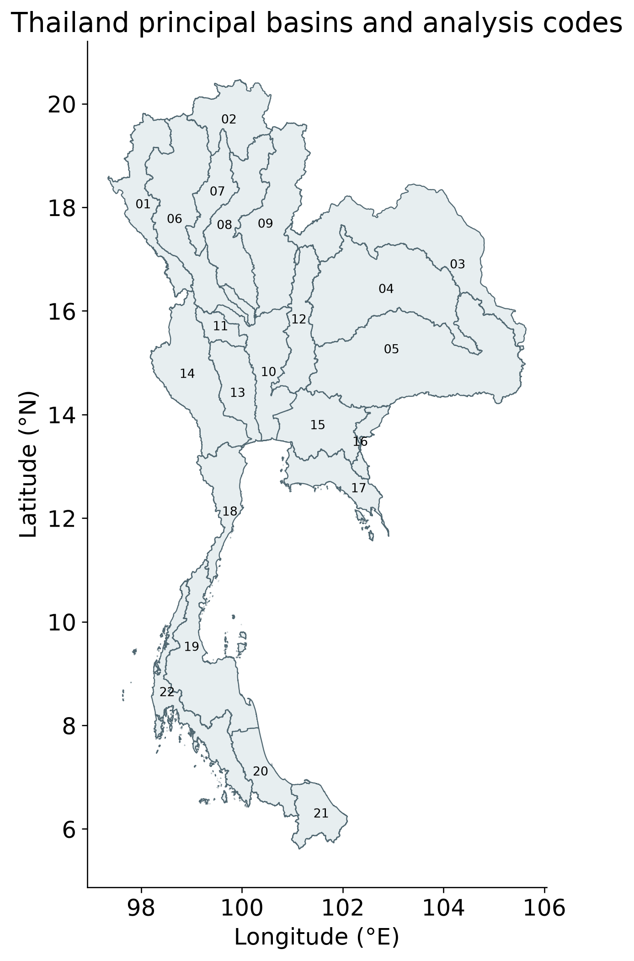
Figure 3.1 Official principal basins and analysis codes; full names appear in Appendix A.
The spatial framework contains 22 principal basins and separately coded island features assigned to their parent basin for the revised analysis. The retained polygon–grid intersection area totals approximately 515,230 km² for national context. This is the analytical intersection-area total, not a replacement estimate of Thailand's official national area.
The official Chao Phraya principal basin is not synonymous with the entire greater Chao Phraya drainage system used in some earlier studies. The distinction is retained when interpreting local literature or comparing basin slopes. No basin boundaries are selected to maximize a trend or correlation. National context provides a larger-scale comparison, while all individual principal basins retain the CSR provider's small-basin caution.

Input records and analysis periods
Table 3.1 Input records and scientific roles
Record | Period used | Role
CSR RL06.3 | Apr 2002–Sep 2024 | Primary gravity storage
GLDAS Noah | Apr 2002–Sep 2024 | Soil, canopy, snow
G3P v1.12 | Apr 2002–Sep 2023 | Surface water and alternatives
WaterGAP 2.2e | 1981–2023 | Naturalized/historical pairing
Multisource cube | 2003–2024 | CHIRPS and ancillary context
Thai GROW observations | 2004–2024 annual; 2018–2023 monthly | Groundwater consistency
The study combines an identified satellite-gravity baseline, land-surface storage components, naturalized and historical-human hydrological simulations, multisource hydroclimate fields and actual groundwater observations. The roles are deliberately different. CSR supplies the principal observed mass-anomaly record. GLDAS Noah and G3P supply non-groundwater compartments or structural sensitivities. WaterGAP supplies the paired counterfactual experiment and the target for climate emulation.
The main calendar spans April 2002 to September 2024, but availability differs by product. The documented CSR subset contains 237 observed monthly solutions over that interval. Surface-water availability limits primary GWSA to September 2023, producing 225 observed GWS months. No interpolation is introduced between the GRACE and GRACE-FO missions. The common-support source audit uses fewer months where the legacy and G3P records require it.
Each supplied or downloaded input is accompanied by a source inventory or provenance record. The extended package adds CSR release information, download checksums, nominal-month assignments and native mapping. This improves the baseline provenance while preserving a clear distinction between the new primary analysis and the earlier unidentified export.

CSR processing and calendar audit
The CSR RL06.3 all-corrections NetCDF is downloaded from the provider together with its land mask and native-mascon mapping. A compact Thai-buffer subset is retained, and the original source checksum is recorded. The primary analysis uses the delivered corrected mass field in centimetres, converted to millimetres. It does not undo provider corrections or add an empirical gain factor.
The source uses an uppercase Units attribute for time and thickness. The acquisition code explicitly interprets the declared time epoch rather than assuming that a generic CF decoder has converted the floating-point time coordinate. This check is important because a time-selection operation can otherwise return a numerically plausible but incorrect subset. The complete monthly assignment audit is saved with the input data.
Two source midpoints fall in the preceding calendar month of their nominal GRACE solution: the second October 2011 entry is assigned to November 2011, and the late-April 2015 entry to May 2015. They are retained as distinct observations. The audit records the original midpoint and the assigned month, while the source averaging bounds remain available. These assignments follow the established special-month issue described in GRACE time-processing guidance.
The CSR provider land mask is applied before basin aggregation. This reduces the use of ocean-coded cells at coastlines but does not constitute a full leakage correction. Missing observations are reindexed onto a complete calendar as missing values. The resulting time series therefore distinguishes absence of a satellite solution from a measured anomaly close to zero.
The data audit is part of the scientific method rather than an incidental software step. Misread units, merged special months or silently filled mission gaps can influence an apparent trend, lag or validation sample. Explicit checks and retained metadata make those choices inspectable and allow a reviewer to separate data-handling decisions from later hydrological interpretation.
Storage compartments and structural alternatives
Table 3.2 Storage-compartment definitions
Term | Primary representation
TWSA | CSR corrected mass anomaly
SMSA | Four GLDAS Noah soil layers
SWSA | G3P modeled surface-water anomaly
CWSA and SWEA | GLDAS canopy and snow
Soil sensitivity | Filtered root-zone alternative
Primary soil storage is the sum of the four GLDAS Noah soil-moisture layers. Canopy interception and snow-water-equivalent storage are retained as separate terms, and their sum with soil storage is checked against the supplied Noah land-storage total. The source units are interpreted as equivalent water depth. This component check guards against a scale or band-selection error in the regional conversion.
Surface-water anomalies are obtained from the documented G3P surface-water chain, which represents rivers, lakes and reservoirs through its underlying modeled fields. This is not a replacement for independently observed Thai reservoir histories. The distinction matters in attribution, because the surface-water model may not reproduce actual operations or the full volume change associated with specific infrastructure.
The filtered root-zone moisture alternative changes the soil contribution to the groundwater subtraction while retaining the CSR gravity baseline and the remaining compartments. It tests sensitivity to soil representation and filtering. It should not be interpreted as a correction that proves either soil product is right. The products represent different depths and spatial characteristics, so their differences are a structural uncertainty.
Hydroclimatic context and seasonal structure
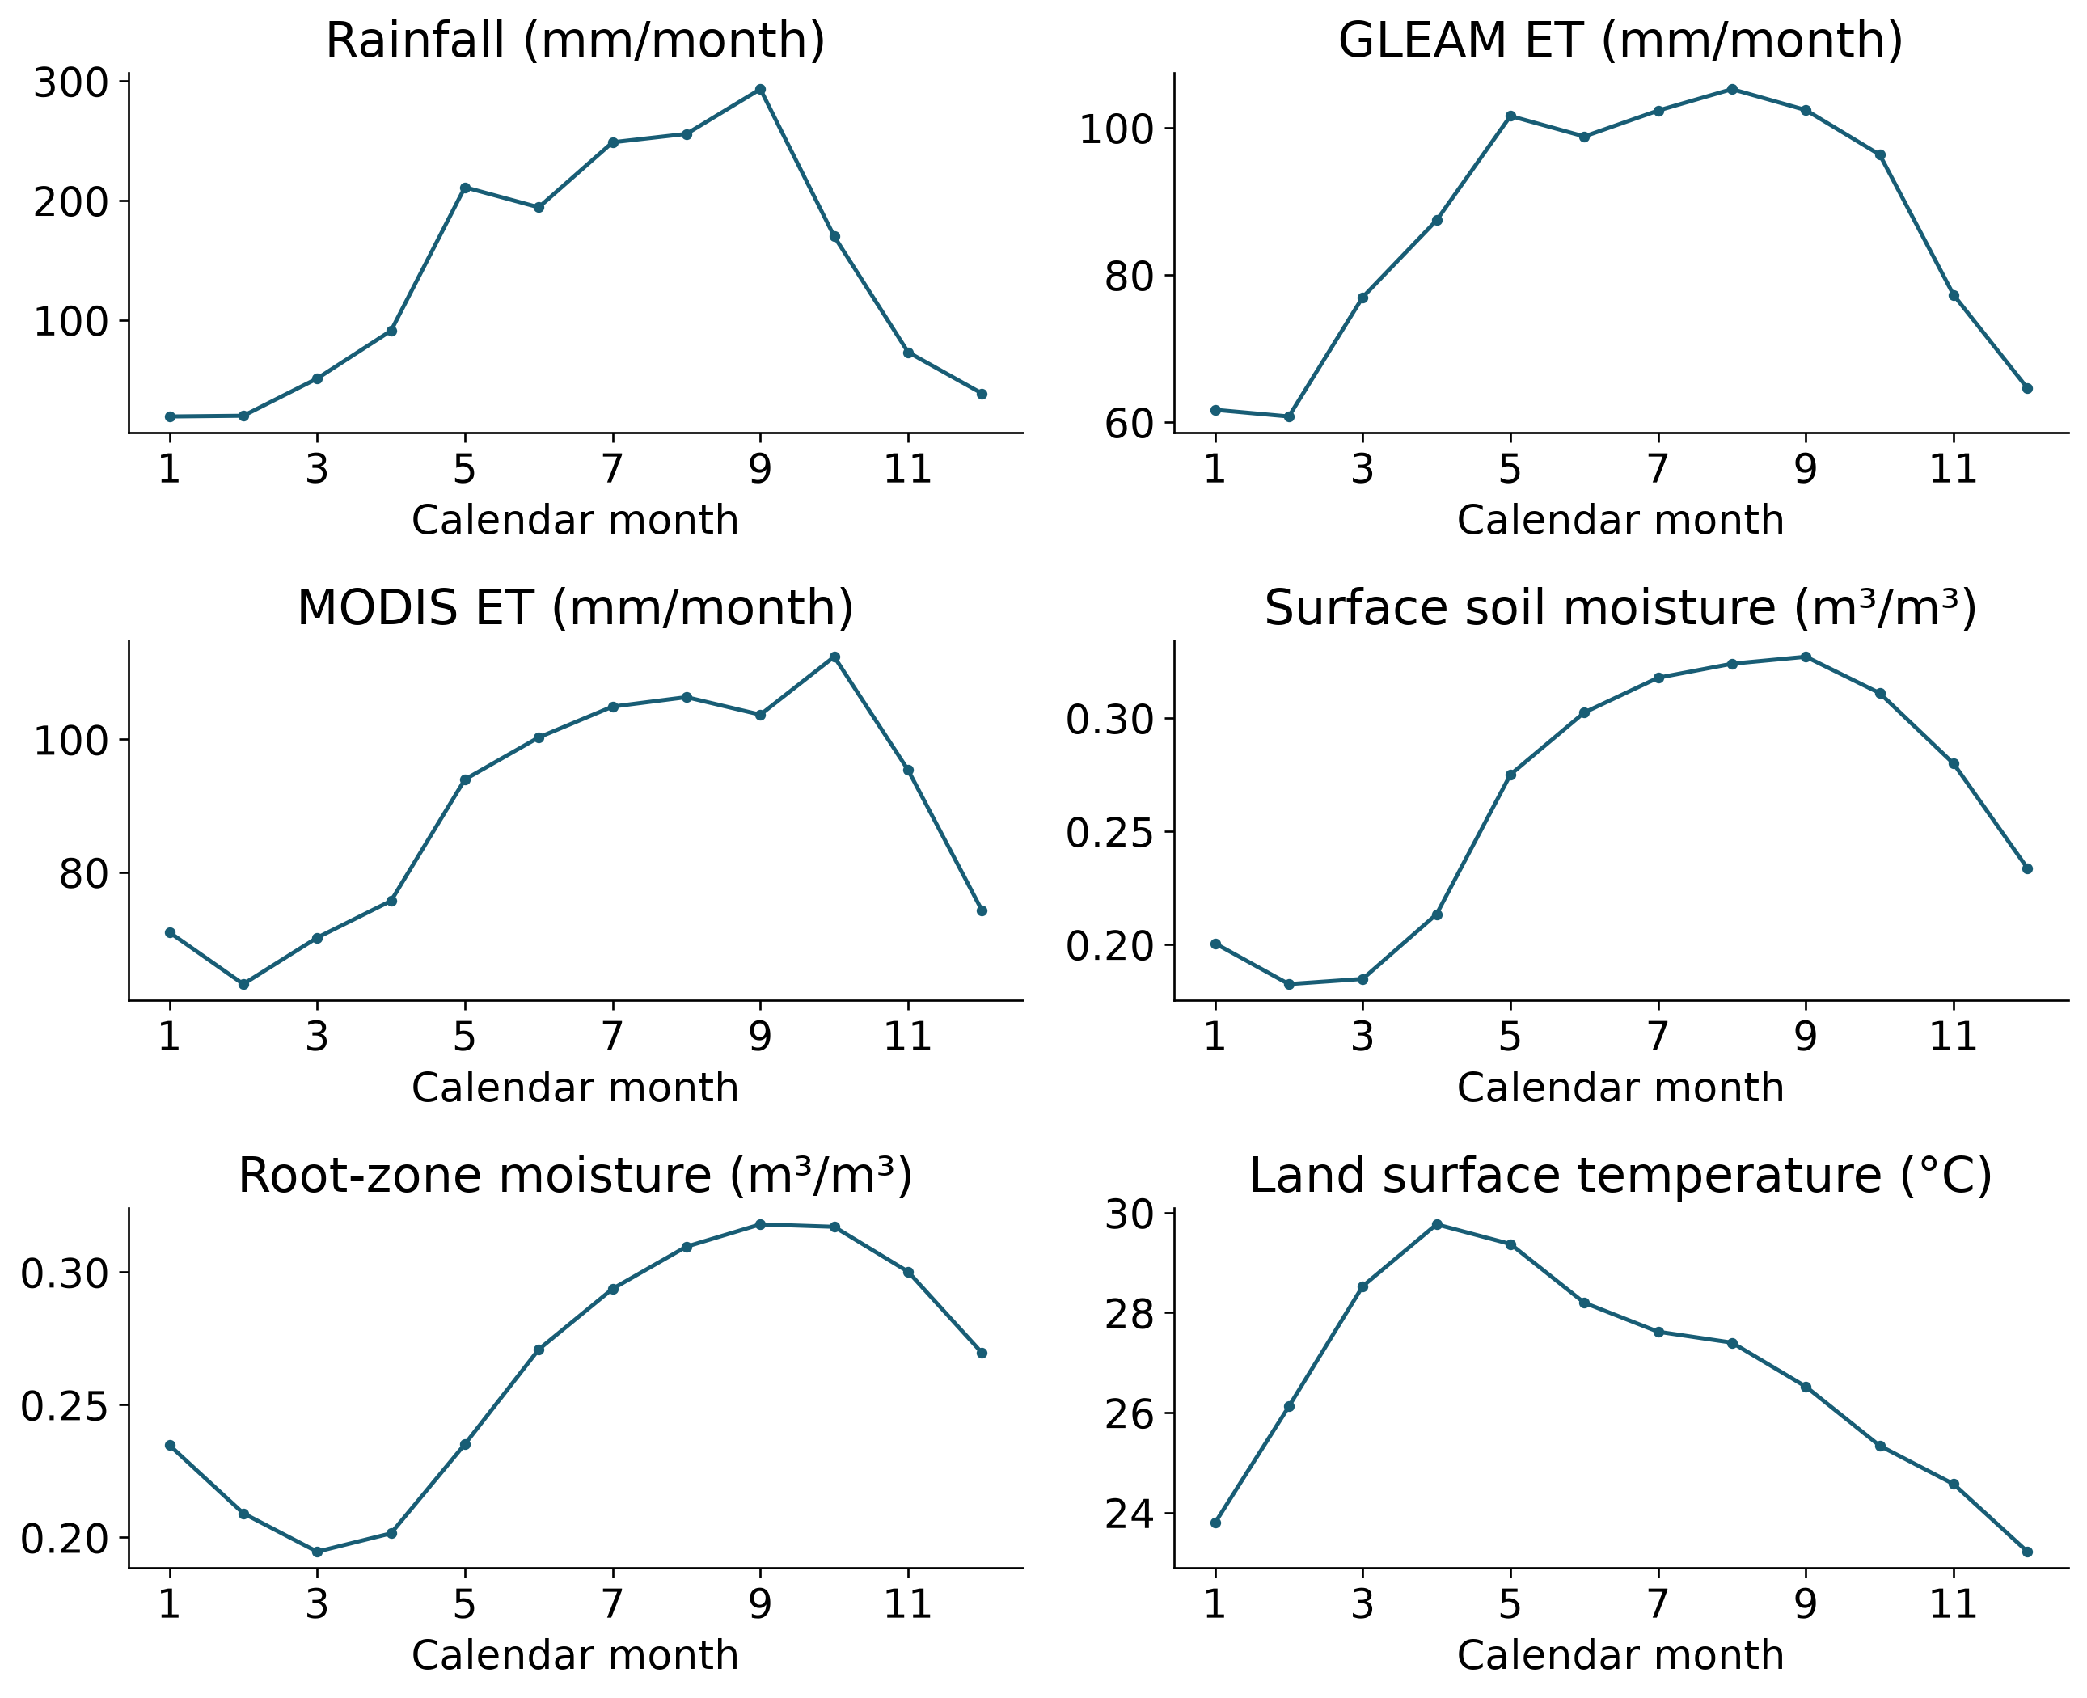
Figure 3.2 National calendar-month climatologies from the retained multisource cube; the products have different physical meanings.
Rainfall, actual evapotranspiration, soil moisture and land-surface temperature describe complementary parts of the regional seasonal cycle. The plotted climatologies summarize available 2003–2024 observations in the harmonized cube; they are not used to fill missing gravity or groundwater measurements.
The two ET records and the soil products are retained as context rather than assumed to be external climatic causes. Their response can include management effects, and their structural definitions differ. CHIRPS supplies the independent precipitation forcing and the observed rainfall–storage test. The main naturalized-model emulators use meteorological P and potential ET, with training-derived seasonal references.

Groundwater records and representativeness
The retained groundwater tables contain actual observed aggregates from the GROW dataset, attributed to the Thai source through the package metadata. Six Thai source rows without observed depth were removed during normalization. Filled groundwater columns are not used. The extraction preserves identifiers, coordinates, aggregation interval and provider quality flags, allowing the well population to be audited independently of the storage analysis.
Depth below ground is positive downward. The analysis therefore defines signed head as negative depth: rising signed head indicates a shallower water table or higher hydraulic head under the supplied convention. Unitless per-well indices are constructed from the observed head series for descriptive regional comparison. This normalization is not used as a climate-model predictor or as a basis for converting head to groundwater mass.
Co-located wells are combined into coordinate station groups before regional averaging. This avoids allowing several wells at one location to dominate a basin index. Annual availability is still uneven, and network density changes materially through the record. The coverage table reports observed station counts by basin, year and panel, so a smooth regional line cannot hide a change in the population it represents.
Aquifer names, screened intervals and storage coefficients are not sufficiently documented for aquifer-specific volumetric validation. Some package attributes describe mapped environmental conditions; these are not a substitute for verified well construction and hydrostratigraphic information. The analysis consequently reports pattern consistency, well-head trend direction and observation support rather than a calibrated groundwater storage volume.
The strict-panel experiment requires ten of ten annual observations during 2013–2022 and compares it with the all-well index over the same calendar window. Only years with adequate observed storage contribute to the correlation. Mission-gap years remain unavailable even where wells were observed. This deliberately reduces sample size in exchange for a more interpretable comparison of station composition.

CHAPTER 4
METHODOLOGY
Methodology overview and storage balance
$$GWSA = TWSA - SMSA - SWSA - CWSA - SWEA$$
The analysis follows a sequence of steps. First, put the observations and models on a common basis. Second, calculate groundwater storage. Third, estimate storage trends. Fourth, reconstruct the naturalized climate baseline from weather. Fifth, calculate and examine the residual. Sixth, compare matching land-storage components with GLDAS. Seventh, check the residual against wells and reservoirs. Eighth, assess uncertainty and publish the results with reproducible code. The following pages explain the input, calculation and output of each step.
The equation above is the groundwater balance. TWSA is total water storage anomaly; SMSA is soil moisture storage anomaly; SWSA is surface water storage anomaly; CWSA is canopy water storage anomaly; and SWEA is snow water equivalent anomaly. An anomaly is a difference from a reference-period average. Each term must therefore use the same reference before subtraction. Snow is small in Thailand, but its term is retained for a consistent balance.
GRACE measures changes in water mass over large areas. It does not measure groundwater separately. The groundwater result depends on both GRACE and the products used to remove the other compartments. A negative GWSA means less groundwater storage than the reference average; it is not the total volume of groundwater left in an aquifer.
The main outputs are monthly basin time series, maps of trends and significance, climate-model test scores, residual series and independent observation comparisons. Every map is read together with the corresponding time series and coverage information. Missing data remain missing throughout the analysis.

Steps 1 to 3 Prepare data and estimate storage trends
Step 1 prepares monthly records for all 22 basins and Thailand as a whole. Convert storage to millimetres of water over the represented area. Use area weights when averaging grid cells. Subtract the available 2004–2009 reference mean, with common valid coverage for the storage balance. Preserve GRACE mission gaps and reject comparisons without enough paired observations. The TWSA and GWSA records end at different dates because the supporting compartment data have different coverage.
Step 2 applies the groundwater balance on the common valid footprint. The primary calculation uses CSR RL06.3 total storage, GLDAS soil moisture, canopy water and snow, and G3P surface water. The code applies the documented CSR unit conversion and special month assignments. Comparisons with alternative processing chains use their common dates, so a change in record length does not become a product difference.
Step 3 estimates change using the seasonal Sen slope. This is a robust summary of the rate of change, expressed in mm/year. A negative slope indicates decline. The seasonal Mann–Kendall test checks for a consistent trend while accounting for the calendar-month pattern. The original Mann–Kendall result is also retained in the output tables.
Because many basins are tested, false discovery rate adjustment is applied to the basin tests. Maps distinguish trend size from statistical evidence. A low adjusted p-value does not remove uncertainty in the storage products or make neighbouring basins independent. GRACE has broad spatial support, so a detailed basin outline does not imply equally detailed gravity information.

Step 4 Define the climate baseline and residual
$$R = O - C = (A - C) + (O - A) = H + E$$
Use O for observed storage, C for the naturalized WaterGAP simulation, and A for the paired historical-human WaterGAP simulation. The naturalized run removes the direct human water use and artificial reservoir effects represented in the paired experiment. It provides an explicit model baseline for this study. It remains a simulation and can contain errors in rainfall, hydrology and storage representation.
Calculate the residual as R = O − C. Calculate the human effect represented by WaterGAP as H = A − C. Calculate the remaining observation–model difference as E = O − A. The equation above shows that R = H + E exactly when the same dates and spatial coverage are used. This accounting separates the modeled human effect from the unexplained difference.
For illustration only, if O is −20 mm, C is −5 mm and A is −8 mm, then R is −15 mm, H is −3 mm and E is −12 mm. These numbers demonstrate the equation; they are not study results. Calling the full −15 mm a measured human effect would assign the entire unexplained difference to human activity.
The primary residual uses the published naturalized WaterGAP baseline C. The statistical climate models described next reconstruct that baseline from weather; their predictions do not silently replace C in the primary residual. The report uses the term residual where a causal human interpretation is not established.
Step 5 Separate residual trends and assess uncertainty
$$D = |β_E| / (|β_H| + |β_E|)$$
Estimate the trends in O, C, A, H, R and E on identical months using linear regression with calendar-month effects. These ordinary least squares slopes add exactly: the residual slope equals the modeled human slope plus the discrepancy slope. Seasonal Sen slopes remain the main description of observed storage trends, but they are not added because robust median slopes do not generally preserve this identity.
The diagnostic D above compares the absolute discrepancy slope with the sum of the absolute human and discrepancy slopes. The symbol beta means the slope of the named component. A value near one means the discrepancy slope is large relative to the modeled human slope. D is not a percentage of storage loss caused by people and does not identify which model or observation is wrong.
Uncertainty is examined with 999 paired wild block resamples, using calendar blocks of one, two and three years. Each repetition treats the components together so the accounting identity is preserved. Blocks retain more of the time dependence than resampling individual months independently. The intervals describe uncertainty conditional on the available records and the chosen model pairing.
Read the residual maps alongside the modeled human maps and the uncertainty intervals. A large negative residual is a useful signal for further investigation. Its causes may include abstraction, other management effects, forcing errors, missing storage processes or gravity-processing differences. The decomposition makes these alternatives visible rather than resolving them by assumption.

Step 6 Build and test the statistical climate models
Table 4.1 Evaluation chronology
Role | Years | Target use
Warm-up | 1981–1990 | Antecedent climate memory
Train | 1991–2009 | Fit and internal tuning
Validation | 2010–2015 | Freeze model selection
Test | 2016–2023 | Held-out evaluation
The statistical models answer a specific question: how well can weather reconstruct naturalized WaterGAP storage? The predictors are precipitation, potential evapotranspiration, their lagged or accumulated values and seasonality. The target is naturalized storage. GRACE observations and groundwater levels are excluded from the predictors, so those records remain available for separate comparisons. The task is a reconstruction using available weather, not a forecast of future weather or water storage.
Candidate methods include Ridge regression, Elastic Net, splines and Random Forest. Climate memory allows earlier wet and dry conditions to affect current storage. The chronology in Table 4.1 is fixed before test evaluation. Fit transformations and tune models using the training period, select the model configuration using validation years, then freeze it before evaluating 2016–2023. Do not randomly mix months between training and testing.
Evaluate both the full seasonal series and departures from the training-period monthly climatology. Report correlation, Nash–Sutcliffe efficiency (NSE) and root mean squared error (RMSE), with basin maps, all-basin time series and separate test-year scores. NSE of one is perfect; zero equals the mean benchmark; negative values are worse than that benchmark. RMSE gives error size in mm. High agreement with the naturalized target is evidence of successful reconstruction of that model, not independent proof of climate-only storage in nature.
The retained base analysis also compares naturalized WaterGAP soil, canopy and snow storage with the same GLDAS Noah compartments. National agreement over 261 months is r=0.969, NSE=0.738 and RMSE=52.49 mm. This matched-compartment benchmark is distinct from full TWS and GWS validation: groundwater and surface water are excluded, climatic drivers may be shared, and GLDAS already contributes to the GWS subtraction.
Step 7 Check climate memory and rainfall dependence
Use a controlled Ridge comparison to test whether climate memory improves reconstruction. Compare a model using current weather with a model that also includes earlier rainfall and potential evapotranspiration. Keep the target and chronological evaluation periods fixed. This isolates the value of the additional memory information more clearly than comparing unrelated algorithms with different settings.
A second test replaces the native precipitation input with CHIRPS. Keep the evaluation design and naturalized target fixed, then compare the test scores. This measures sensitivity to the rainfall source. It does not establish which precipitation product is more accurate, because the target was generated using its own forcing and may favour that forcing.
Inspect each basin and each test year, rather than relying on one national score. A model can reproduce the seasonal cycle well while missing an unusual drought or wet year. The annual plots therefore retain poor scores and gaps. The 2022 national anomaly NSE is 0.234 for TWSA and −1.067 for GWSA, showing that strong overall reconstruction does not ensure good performance in every year.
Keep this controlled Ridge experiment separate from the selected multi-method ensemble. Their scores answer related but different questions and should not be presented as the same model result. The figure captions identify which experiment is being shown. Together, these tests assess the role of storage memory and the dependence of reconstruction skill on the rainfall input.

Step 8 Compare GLDAS and independent reservoir data
The GLDAS comparison uses matching compartments: soil moisture, canopy water and snow in both GLDAS Noah and naturalized WaterGAP. Use the same dates, reference and spatial coverage, then calculate correlation, NSE and RMSE. This is a land-storage benchmark. GLDAS does not provide the groundwater and surface-water terms needed to validate full TWSA, GWSA or the human residual in this comparison.
The direct GLDAS–residual figures answer a different question: do their timing and broad patterns agree? Standardize each series on common months before plotting them together. Show descriptive correlations and standardized trends. Do not calculate a volume-error score between different storage compartments. Also remember that GLDAS is used in the groundwater subtraction, so some dependence is built into the GWS residual comparison.
Reservoir storage provides an additional observation check for part of total storage. Use MSEA-Res scene-screened storage estimates and analyse its provider-interpolated series separately. Use a fixed pre-2004 reservoir population, require every member to be represented in a summed month, convert volume to basin-equivalent mm and use the available 2004–2009 reference. Missing reservoirs are not assigned zero storage.
Compare reservoir storage with the TWS residual on common months, before and after removing calendar-month effects and a linear trend. Use whole-year cluster resampling for conditional intervals. Reservoir changes reflect both climate and operations. Agreement therefore supports a surface-water part of the residual; it does not validate a human-only total or groundwater mass.

Step 9 Evaluate residuals with groundwater levels
Wells measure local groundwater level or depth, while GRACE-derived storage is a regional water-mass estimate. Reverse the sign of depth-to-water so that increasing values consistently mean rising groundwater head. Aggregate co-located wells first to avoid giving a densely sampled location extra weight. Use annual observations because most available Thai well records are annual. Retain the actual observation years.
Compare annual heads with annual TWS and GWS residuals using correlation on paired years. Show both raw and detrended correlations. A positive correlation means that lower residual storage tends to occur with lower head. It is a consistency check on direction and timing. It does not show that the whole residual was caused by pumping, because both series may also respond to climate.
Do not convert head changes in metres to storage changes in millimetres without suitable aquifer storage coefficients, such as specific yield for an unconfined aquifer, and a defensible area representation. Those inputs are unavailable here. Accordingly, the study reports head correlations and trends, not head-to-storage RMSE or NSE. The GWS residual is more directly related to groundwater than the total-storage residual, which also includes other compartments.
Repeat the comparison using the longest overlap, a fixed eligibility period, common years and a strictly balanced station panel. Resample station trajectories to assess sensitivity to the wells included. Report the number of paired years and represented stations with every result. Eight-year rolling correlations are descriptive because their windows overlap. Partial correlations after climate control are also interpreted cautiously; residual subtraction alone does not create independent evidence.

Step 10 Check the reliability of basin conclusions
Compare the primary CSR analysis with the alternative processing chain on shared months. Check both the national trend direction and the ranking of basins. These are different questions: two products can agree that storage declined nationally while disagreeing about which basin declined fastest. The groundwater comparison also changes the compartment-processing chain, so its difference cannot be attributed to gravity alone.
Record the native gravity units contributing to each basin. Several basin estimates share information from the same mascons, and every principal basin is below the provider's approximate 200,000 km² small-area caution. The inverse concentration of aggregation weights describes how concentrated those weights are. It is not a count of independent observations. Do not treat 22 basin estimates as 22 independent gravity experiments.
Separate three sources of uncertainty when interpreting results. Temporal uncertainty concerns the available months and years. Product uncertainty concerns gravity and compartment processing. Observation-network uncertainty concerns which wells and reservoirs are represented. The resampling intervals address specified parts of these problems; they do not cover every source of uncertainty.
A basin conclusion is more useful when its trend, alternative-product result and observation support are read together. Where evidence is missing, the maps show missing or hatched areas. Where results change with the chosen product or station panel, the discussion reports that change. Neither a small p-value nor a high model score removes these limitations.

Step 11 Deliver the results and reproduce the analysis
The decision-support website presents each basin's storage history, trend maps, climate reconstruction, residual and evaluation results. Users can compare basins, inspect missing dates and download the underlying tables. Labels distinguish observed storage, naturalized model storage, modeled human effects and residuals. Coverage and interpretation notes accompany the figures so a residual is not mistaken for a measured abstraction volume.
The GitHub repository supplies compact input data, pinned dependencies, analysis scripts, figure-generation code and reference outputs. An independent user can check the inputs, run the original analysis, run the extended analysis and compare the generated tables with the saved reference tables. The numerical workflows have also been executed on a clean Linux runner. Report editing changes the explanation, not the stored numerical results.
The final workflow is therefore: harmonize data; calculate TWSA and GWSA; estimate trends; define the naturalized baseline; test weather-based reconstruction; calculate R, H and E; compare matching GLDAS compartments; evaluate wells and reservoirs; examine uncertainty; and publish the outputs. The result of each stage is checked before it is used by the next stage.
Objective 1 is assessed using storage trends and their spatial and temporal coverage. Objective 2 is assessed using held-out climate-model scores, matched GLDAS comparisons, the residual decomposition and observation checks. Objective 3 is assessed using the working interactive application and reproducible code. These outputs answer the research questions without requiring an unsupported claim that every residual change is human-caused.

CHAPTER 5
RESULTS
Spatial GRACE storage trends and Mann Kendall evidence
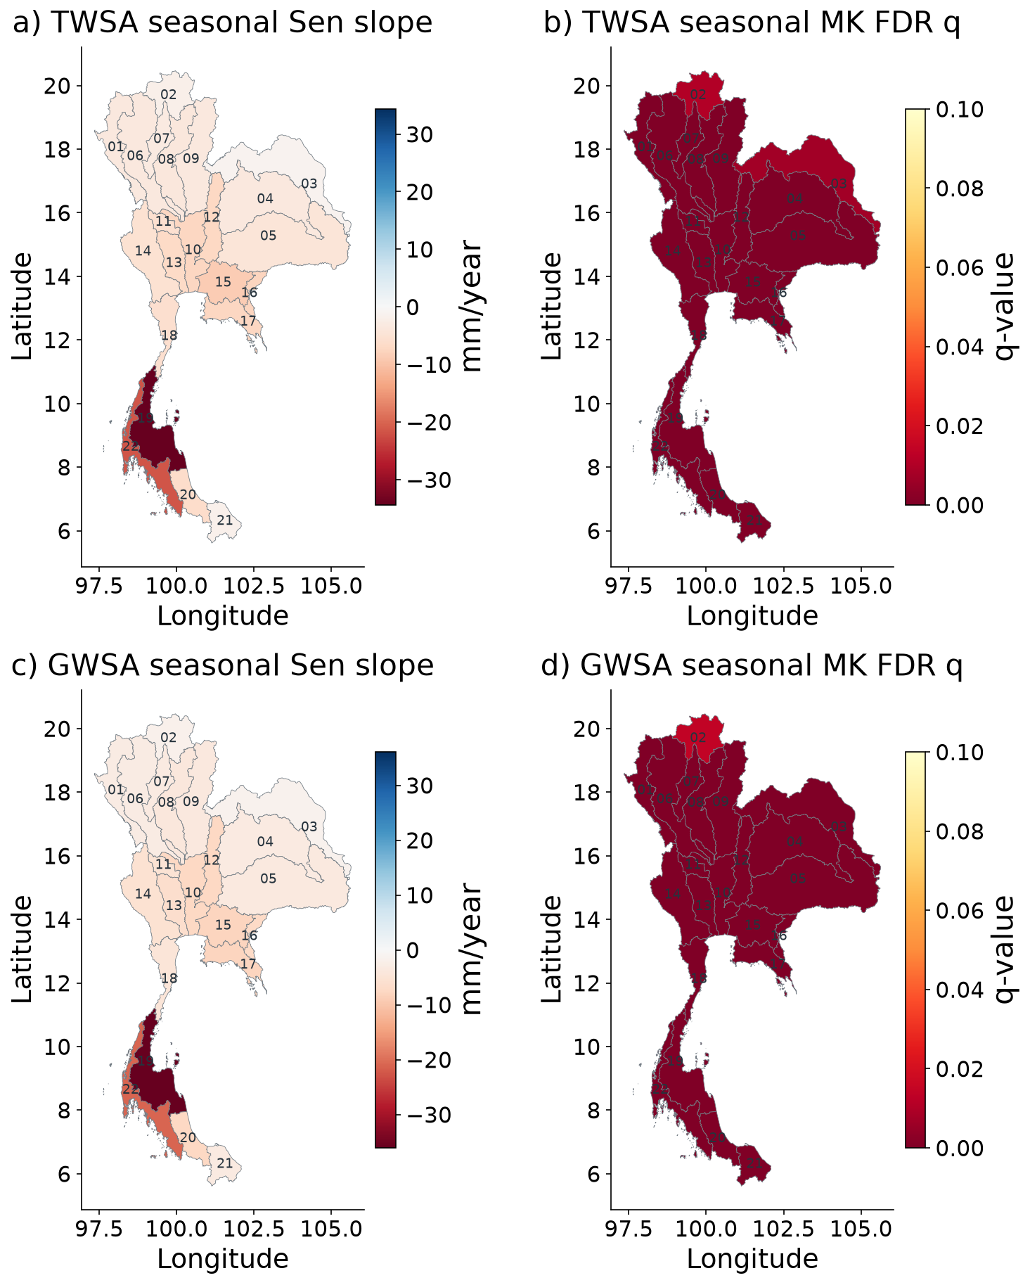
Figure 5.1 CSR TWSA and derived GWSA seasonal Sen slopes and seasonal Mann–Kendall FDR maps.
Colours show the rate of storage change in mm/year; negative values mean decline. The significance panels show the seasonal Mann–Kendall results after false discovery rate adjustment. Read the size of the change separately from the strength of the statistical evidence. Basin boundaries do not increase GRACE resolution.

Observed storage time series for all 22 basins
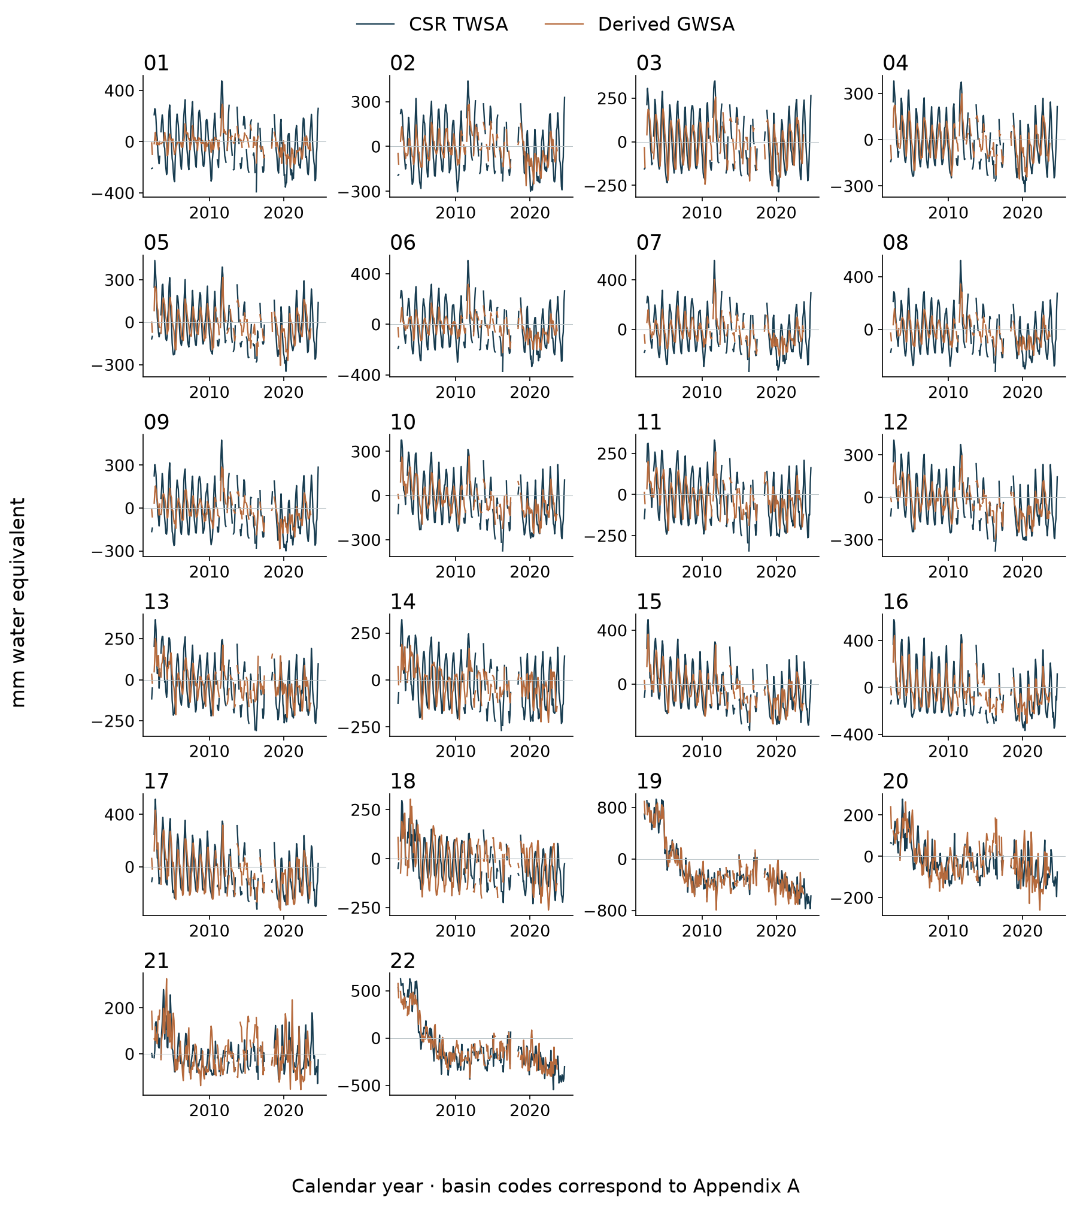
Figure 5.2 Monthly TWSA and GWSA for all 22 basins; observation gaps are retained.
Each panel shows one basin, with total and derived groundwater storage on their actual monthly dates. Gaps mark missing data. Compare the long-term movement with the seasonal variation rather than reading a single dry month as a trend.
Product dependent basin trend ranking
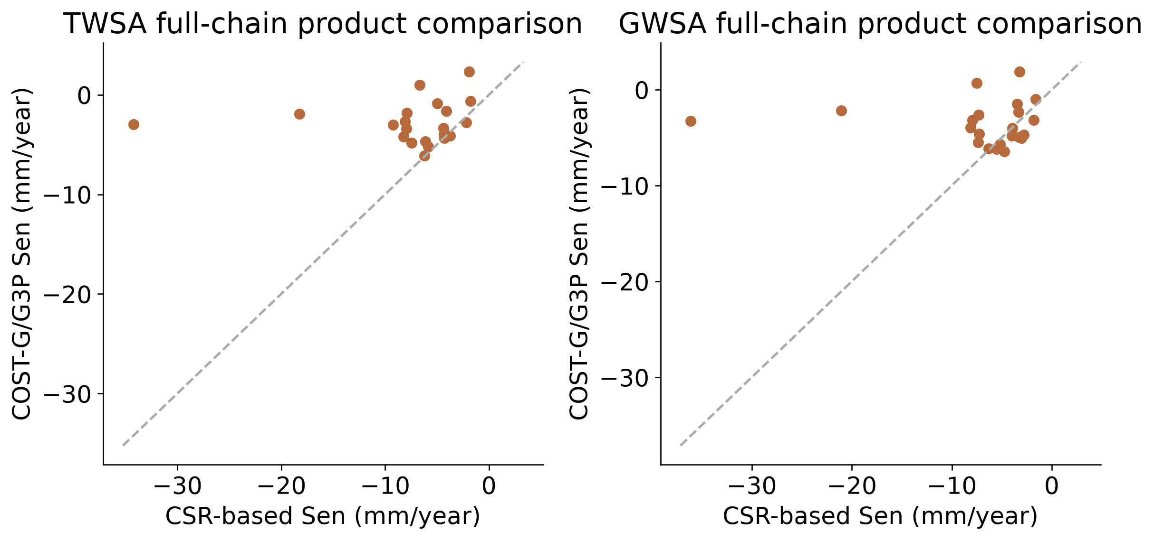
Figure 5.3 Common-support CSR and COST-G/G3P trend comparisons; compartment processing also differs.
On common dates, the national total-storage slopes are about −7.67 mm/year for CSR and −2.56 mm/year for COST-G/G3P. Basin ranking correlations are only 0.138 for TWSA and 0.027 for GWSA. Thus, national decline is more consistent than the ordering of individual basins. The groundwater chains also use different compartment processing.
Table 5.1 National common-support Sen slopes in millimetres per year
Processing chain | TWSA | GWSA
CSR-based | -7.67 | -6.88
COST-G/G3P | -2.56 | -3.45
Legacy unidentified | -7.68 | -6.86

Spatial naturalized storage and climate reconstruction
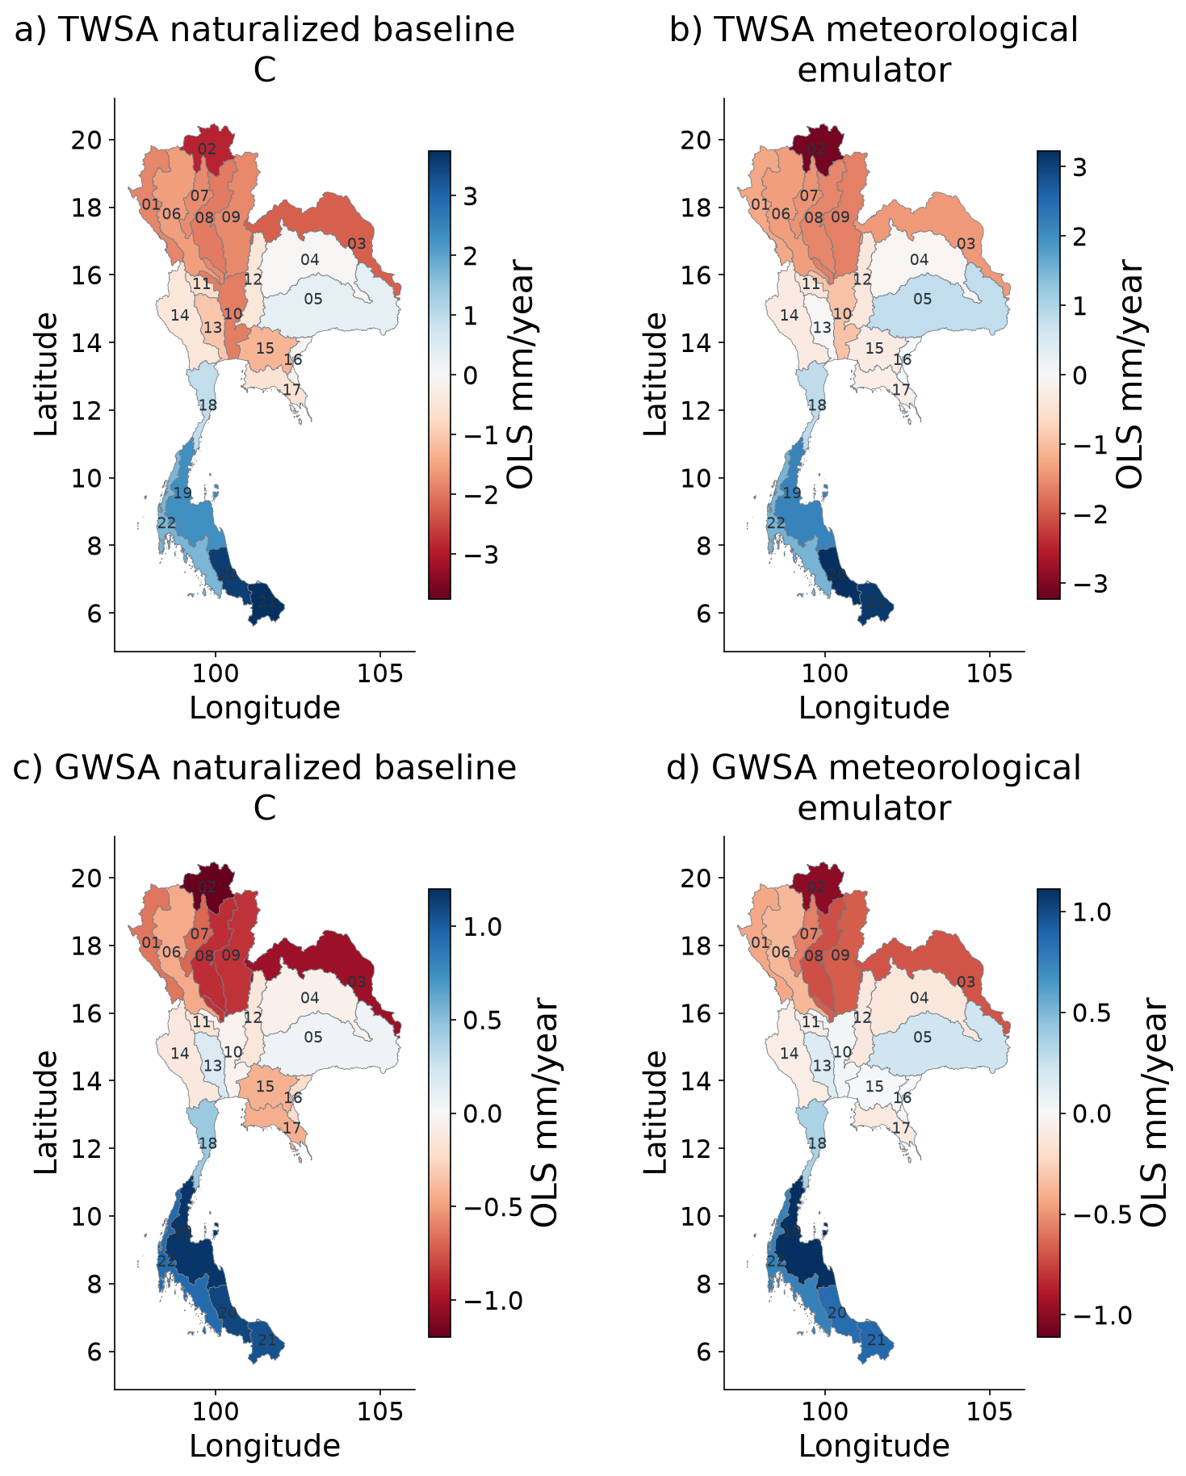
Figure 5.4 Spatial naturalized climate baseline and meteorological emulator trends for TWSA and GWSA.
These maps compare the naturalized WaterGAP baseline with its weather-based reconstruction. Agreement shows how well the statistical models reproduce their parent simulation. It is not an independent observation of storage without human activity.
TWSA climate reconstruction for all 22 basins
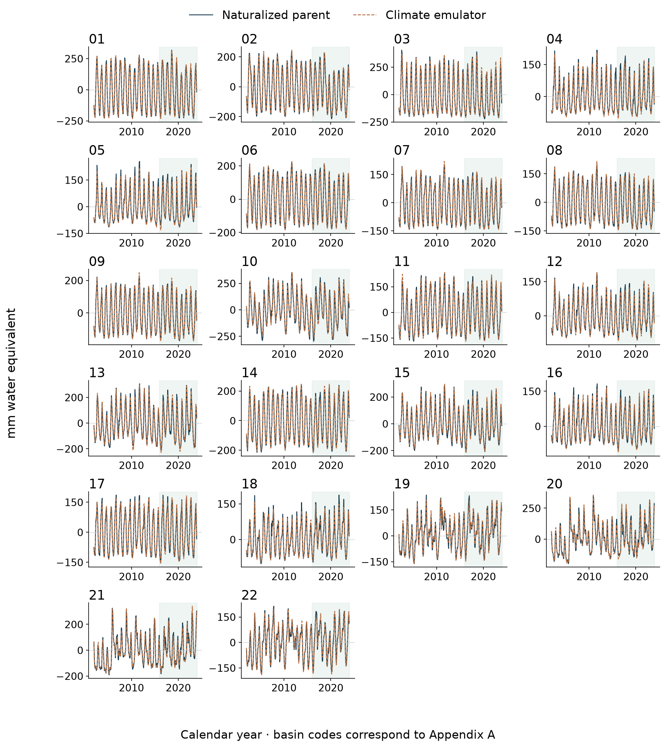
Figure 5.5 TWSA climate reconstruction for all 22 basins; shading marks held-out years.
For each basin, compare naturalized total storage with its statistical reconstruction. The shaded years were excluded from fitting and model selection. Good seasonal agreement can coexist with errors during individual wet or dry years.
GWSA climate reconstruction for all 22 basins
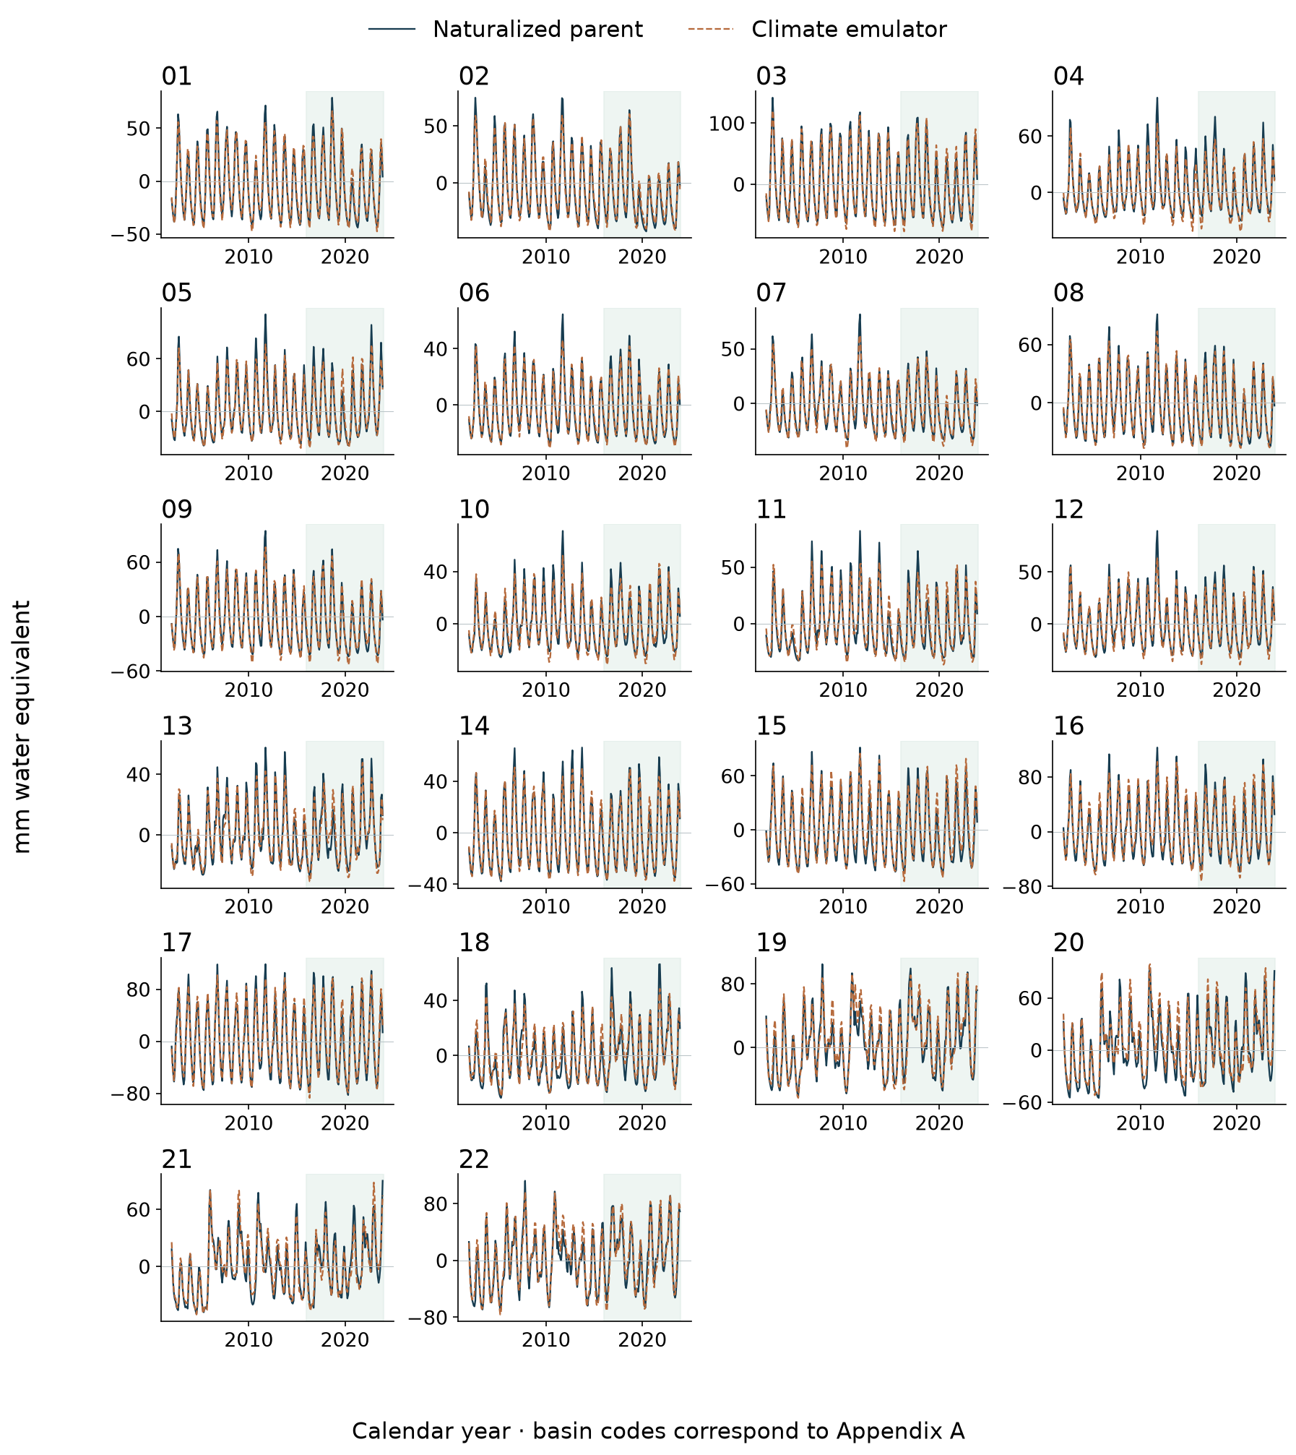
Figure 5.6 GWSA climate reconstruction for all 22 basins; shading marks held-out years.
For each basin, compare naturalized groundwater storage with its statistical reconstruction. Shading identifies held-out years. The target is modeled groundwater storage, so these panels assess reconstruction skill rather than direct groundwater validation.
Spatial climate model evaluation
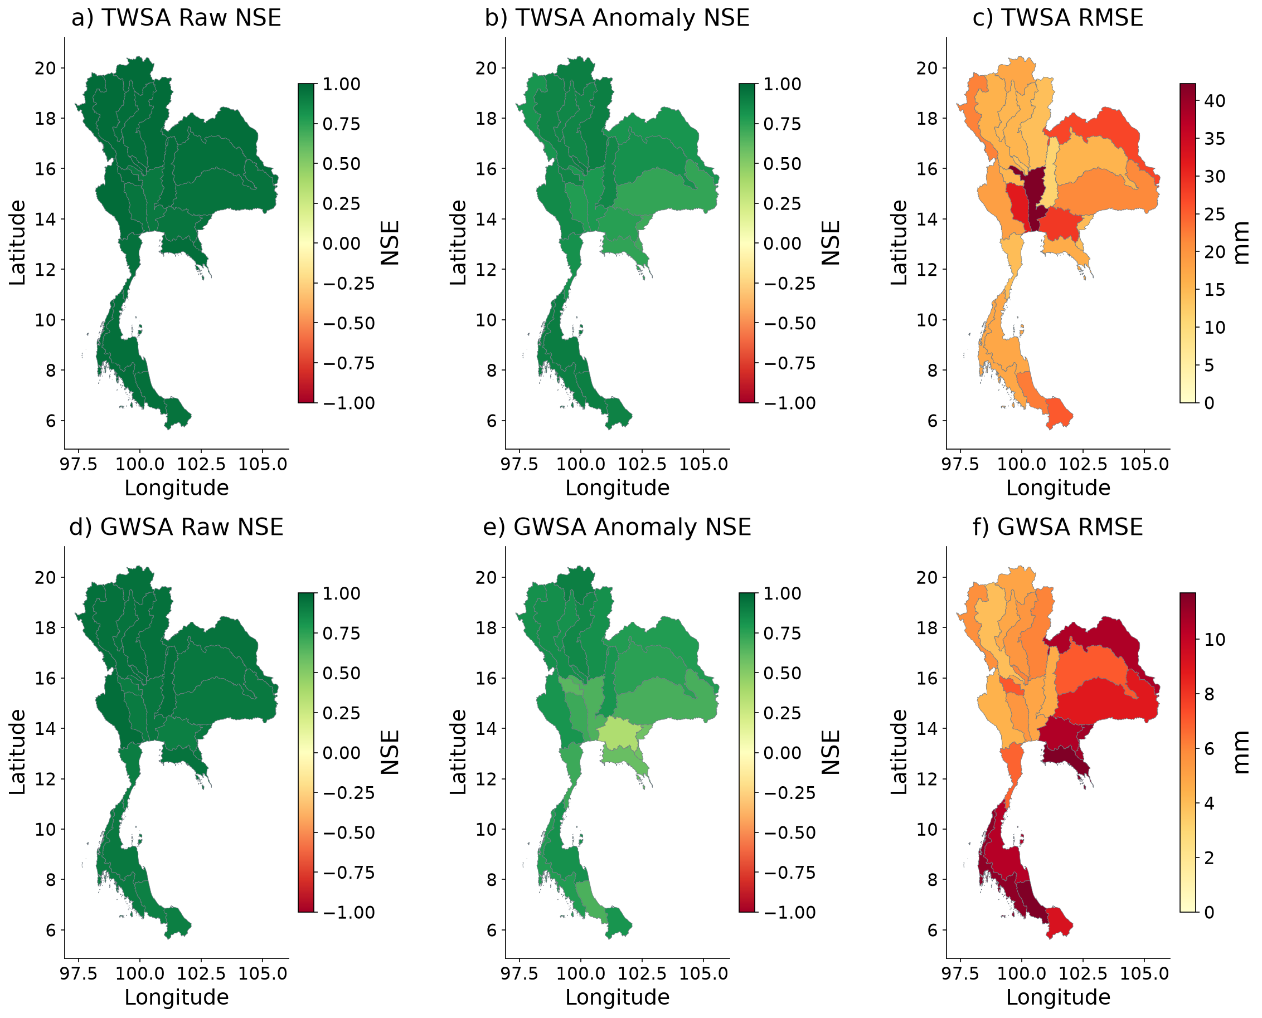
Figure 5.7 Spatial held-out climate-model raw NSE, anomaly NSE and RMSE.
These scores use the frozen climate models on 2016–2023 data. Higher NSE is better; negative NSE is worse than the mean benchmark. Lower RMSE means a smaller error in mm. Scores refer to the naturalized parent target, not directly to GRACE observations.

Climate model evaluation through time
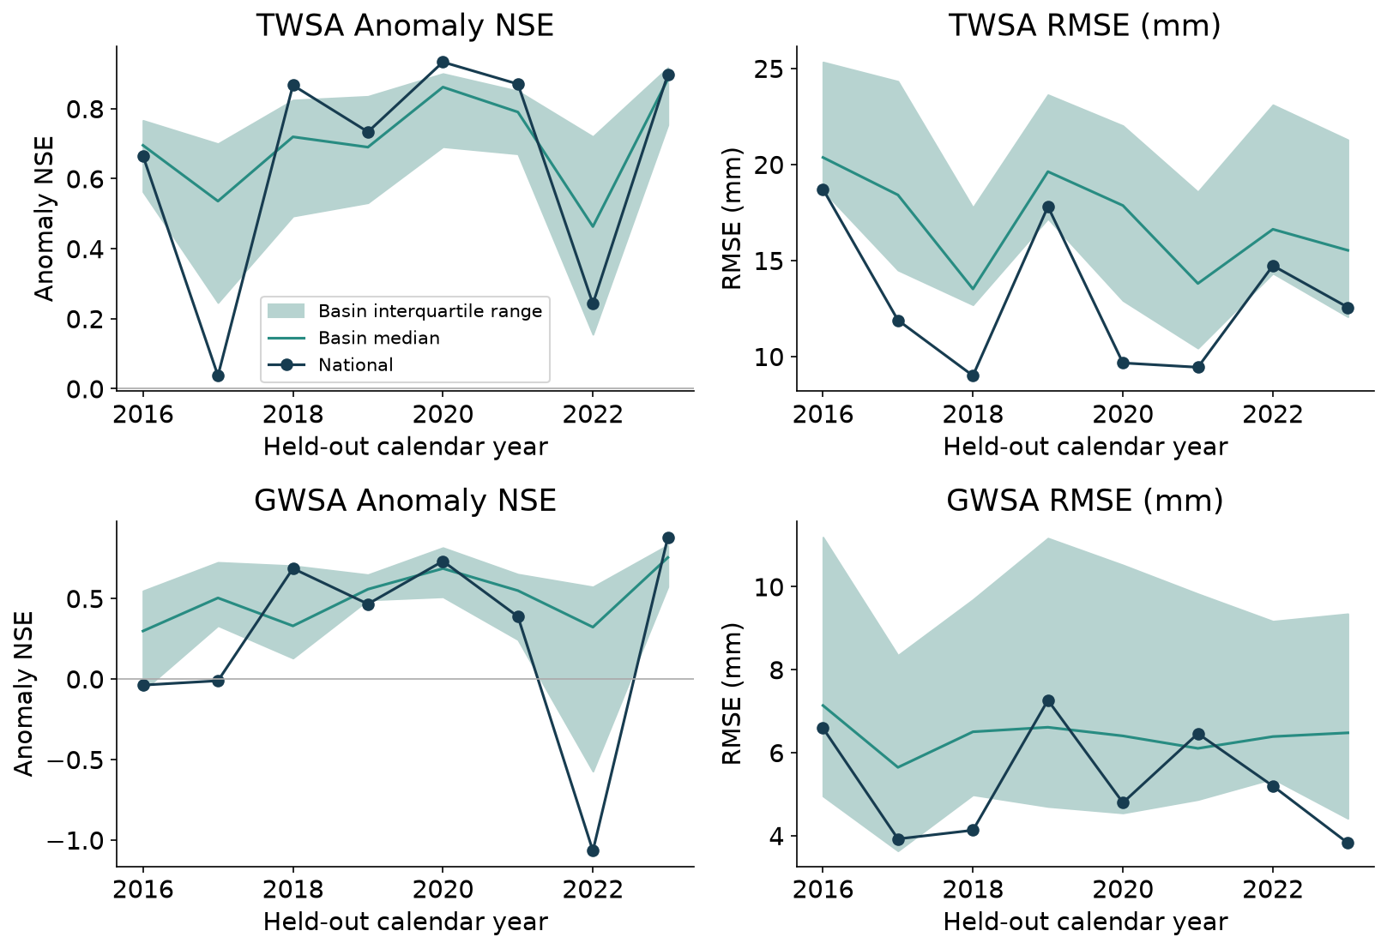
Figure 5.8 Climate-model anomaly NSE and RMSE by held-out year, with spatial interquartile variation.
Year-by-year scores reveal weaknesses hidden by one pooled test score. The spread shows differences among basins. In 2022, national anomaly NSE is 0.234 for total storage and −1.067 for groundwater storage; the poor groundwater result is retained.
Spatial residual and modeled human perturbation
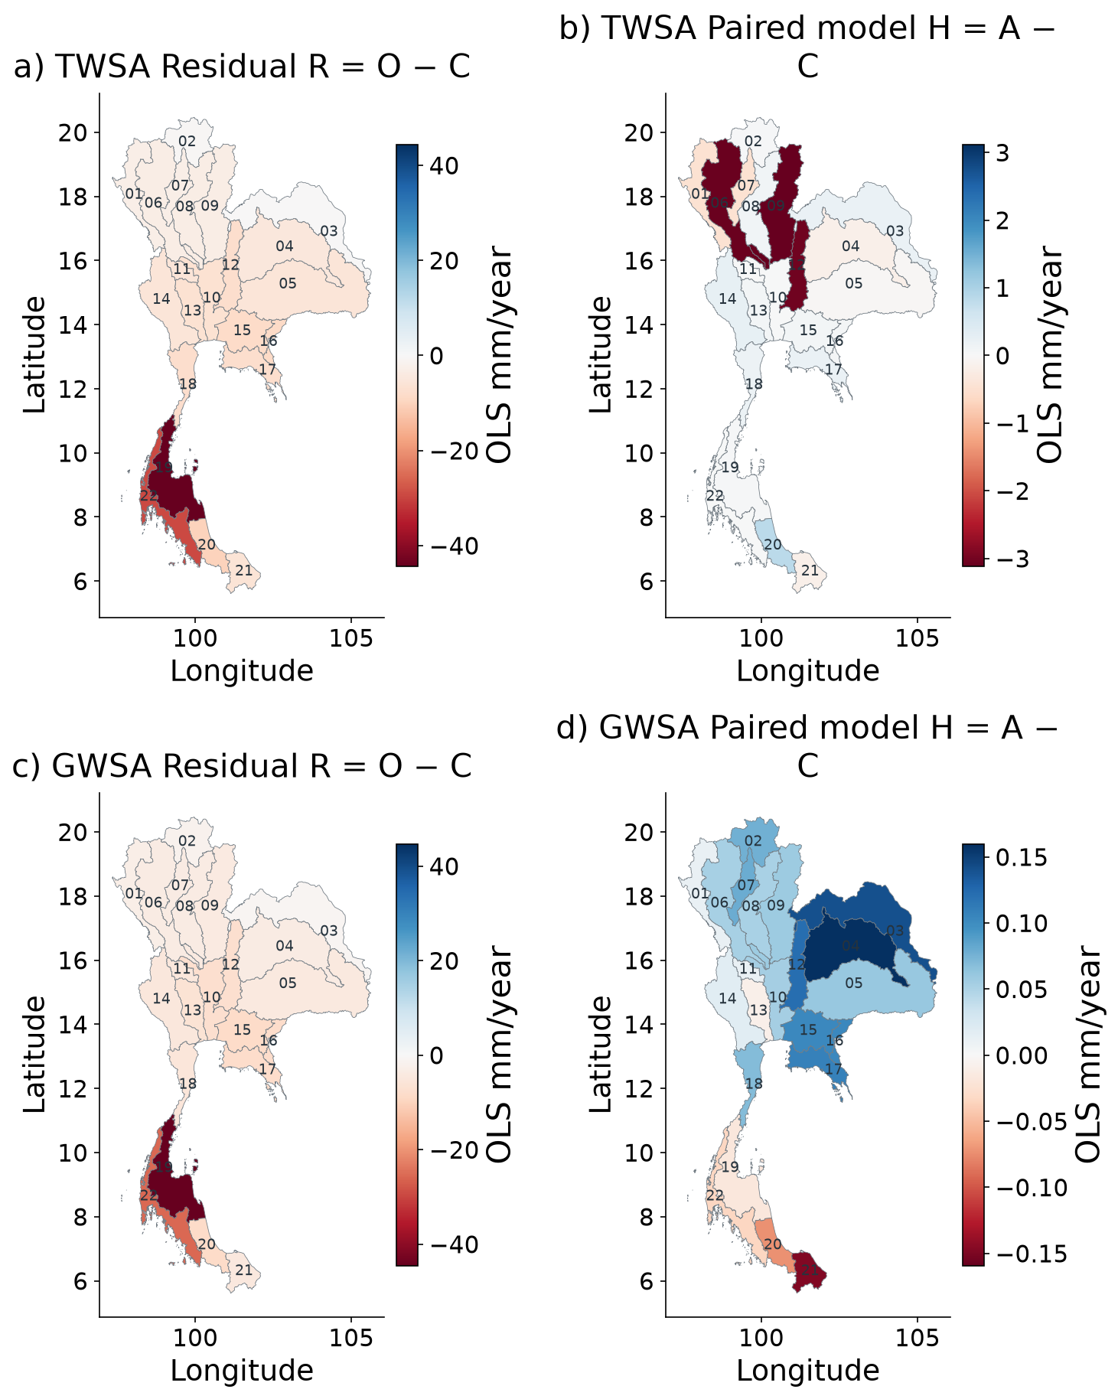
Figure 5.9 Spatial TWSA and GWSA residual trends and paired modeled direct-human perturbations.
These maps show the residual R = O − C and the human effect H = A − C represented by the paired WaterGAP runs. Their difference is E = O − A. The residual can include human effects and observation or model errors; it should not be read as a measured pumping rate.
TWSA residual histories for all 22 basins
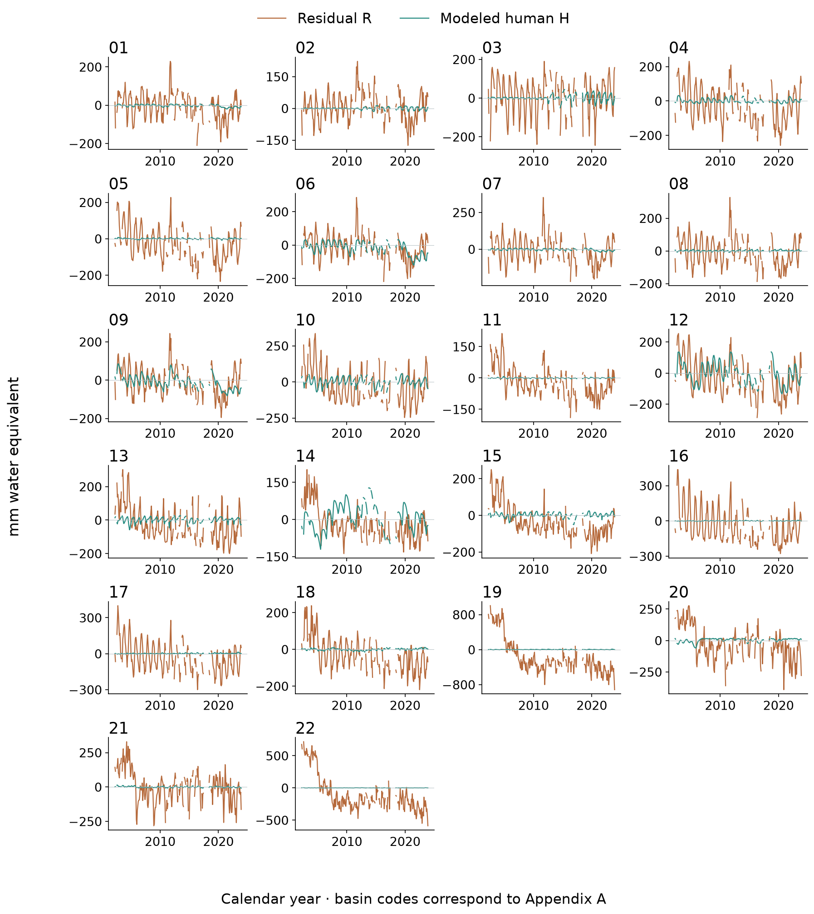
Figure 5.10 TWSA residual and modeled human time series for all 22 basins.
Each basin panel compares the total-storage residual with the human effect represented by WaterGAP. Differences in timing or size contribute to the unexplained discrepancy. Both series use compatible dates and units.

GWSA residual histories for all 22 basins
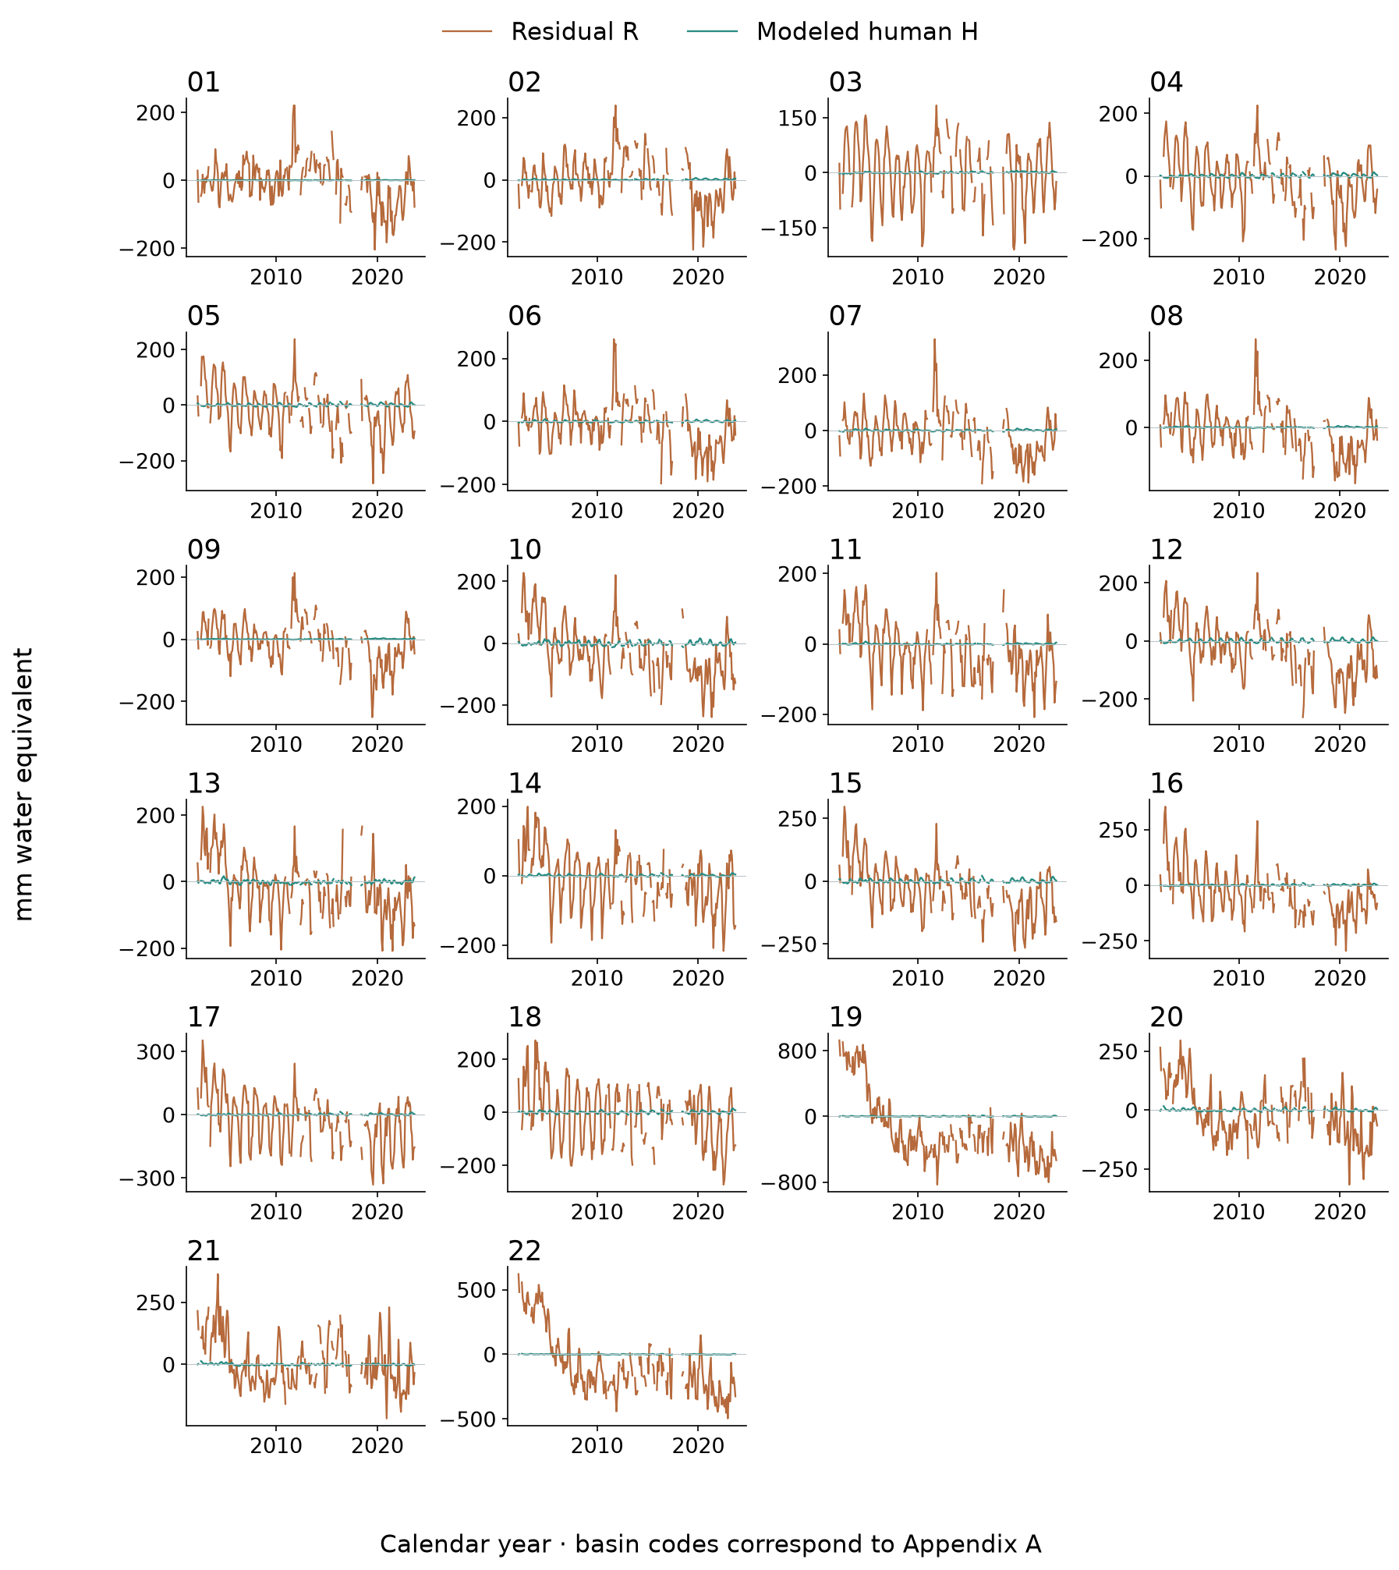
Figure 5.11 GWSA residual and modeled human time series for all 22 basins.
Each basin panel compares the groundwater residual with the modeled human effect. A large gap between the curves identifies a mismatch requiring further evidence. It does not by itself identify the cause of that mismatch.

Spatial GLDAS matched compartment comparison
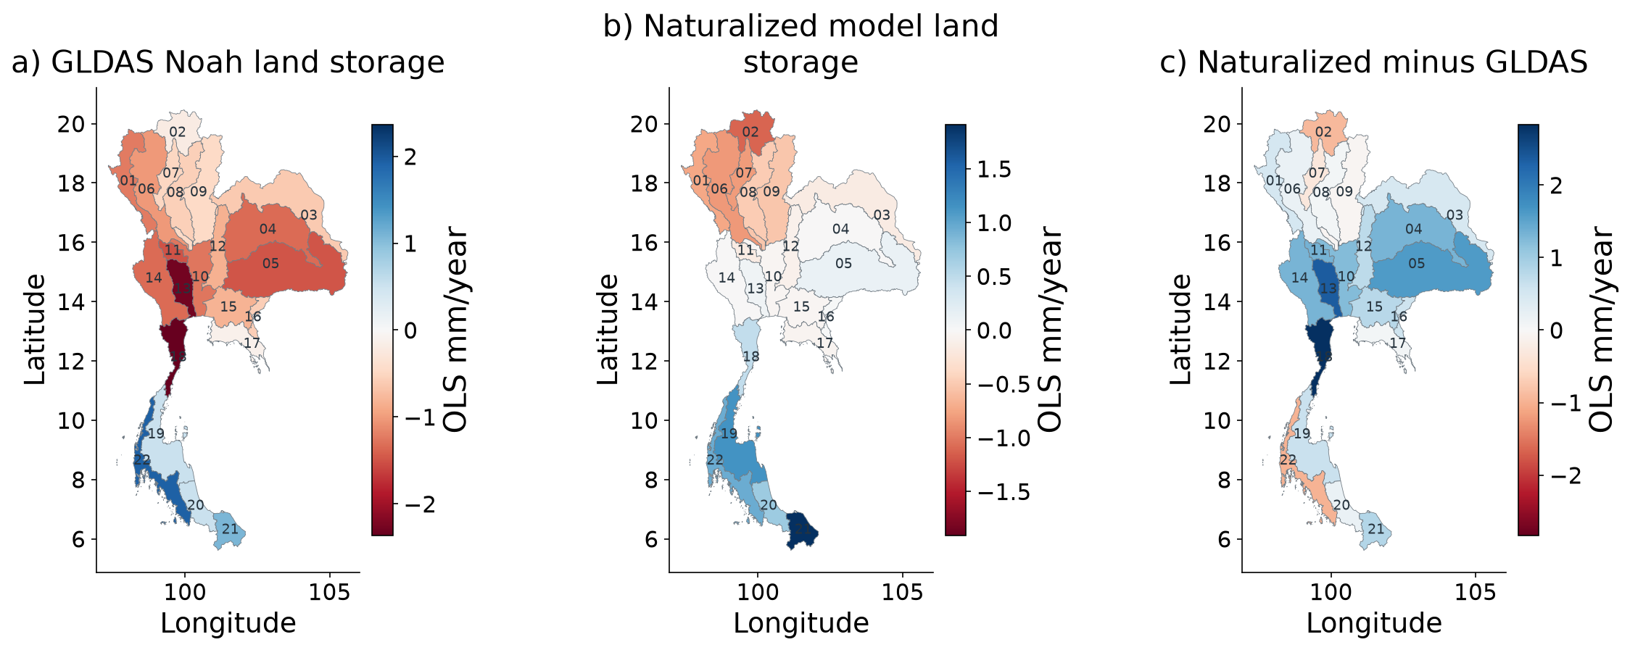
Figure 5.12 Spatial GLDAS and naturalized-model land-storage trends on matched compartment support.
Both models are compared using soil, canopy and snow storage only. The difference map shows where their trends disagree. Groundwater and surface water are excluded, so this comparison does not validate the full residual.
Matched GLDAS time series for all 22 basins
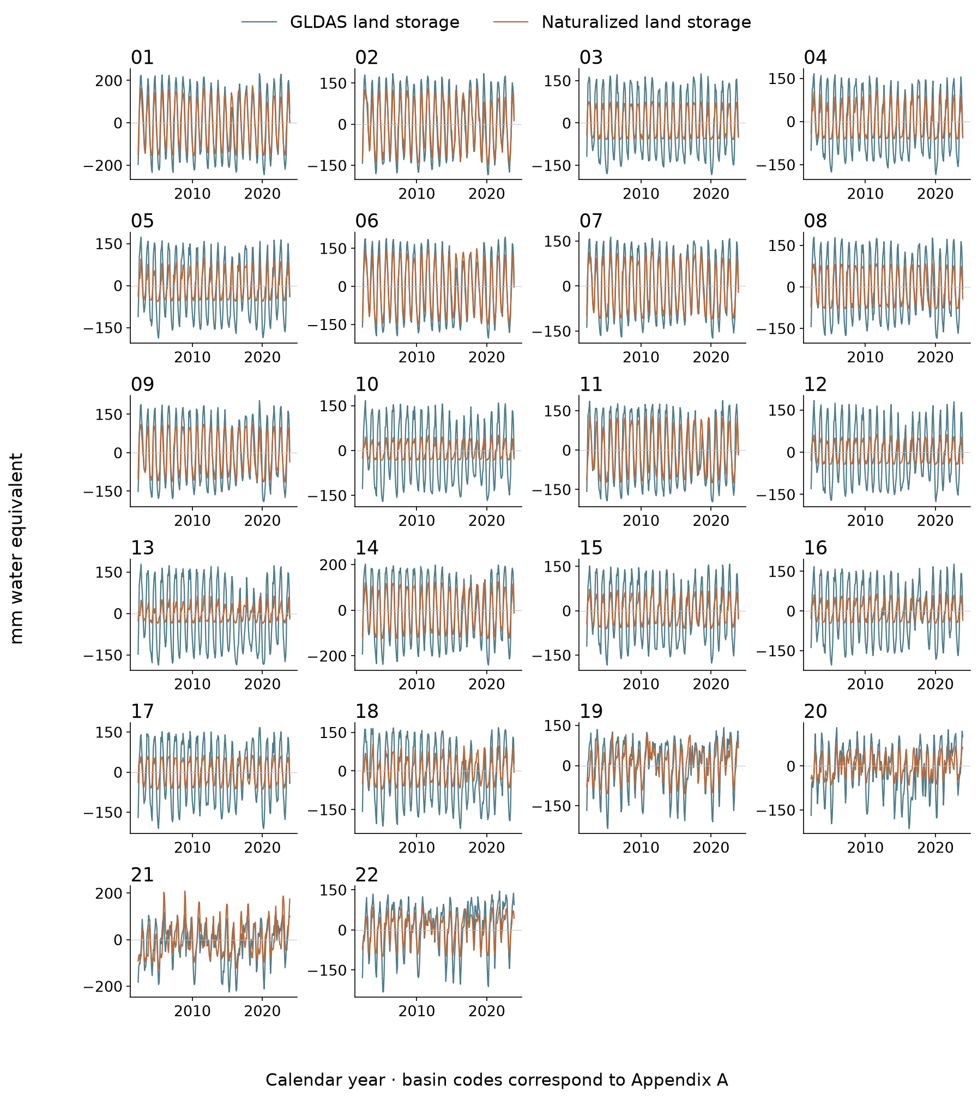
Figure 5.13 GLDAS and naturalized land-storage time series for all 22 basins.
Each basin panel compares GLDAS and naturalized WaterGAP for the same land-storage compartments. Check timing and amplitude as well as the long-term direction. Shared climate drivers can contribute to agreement.
Spatial GLDAS and residual comparisons
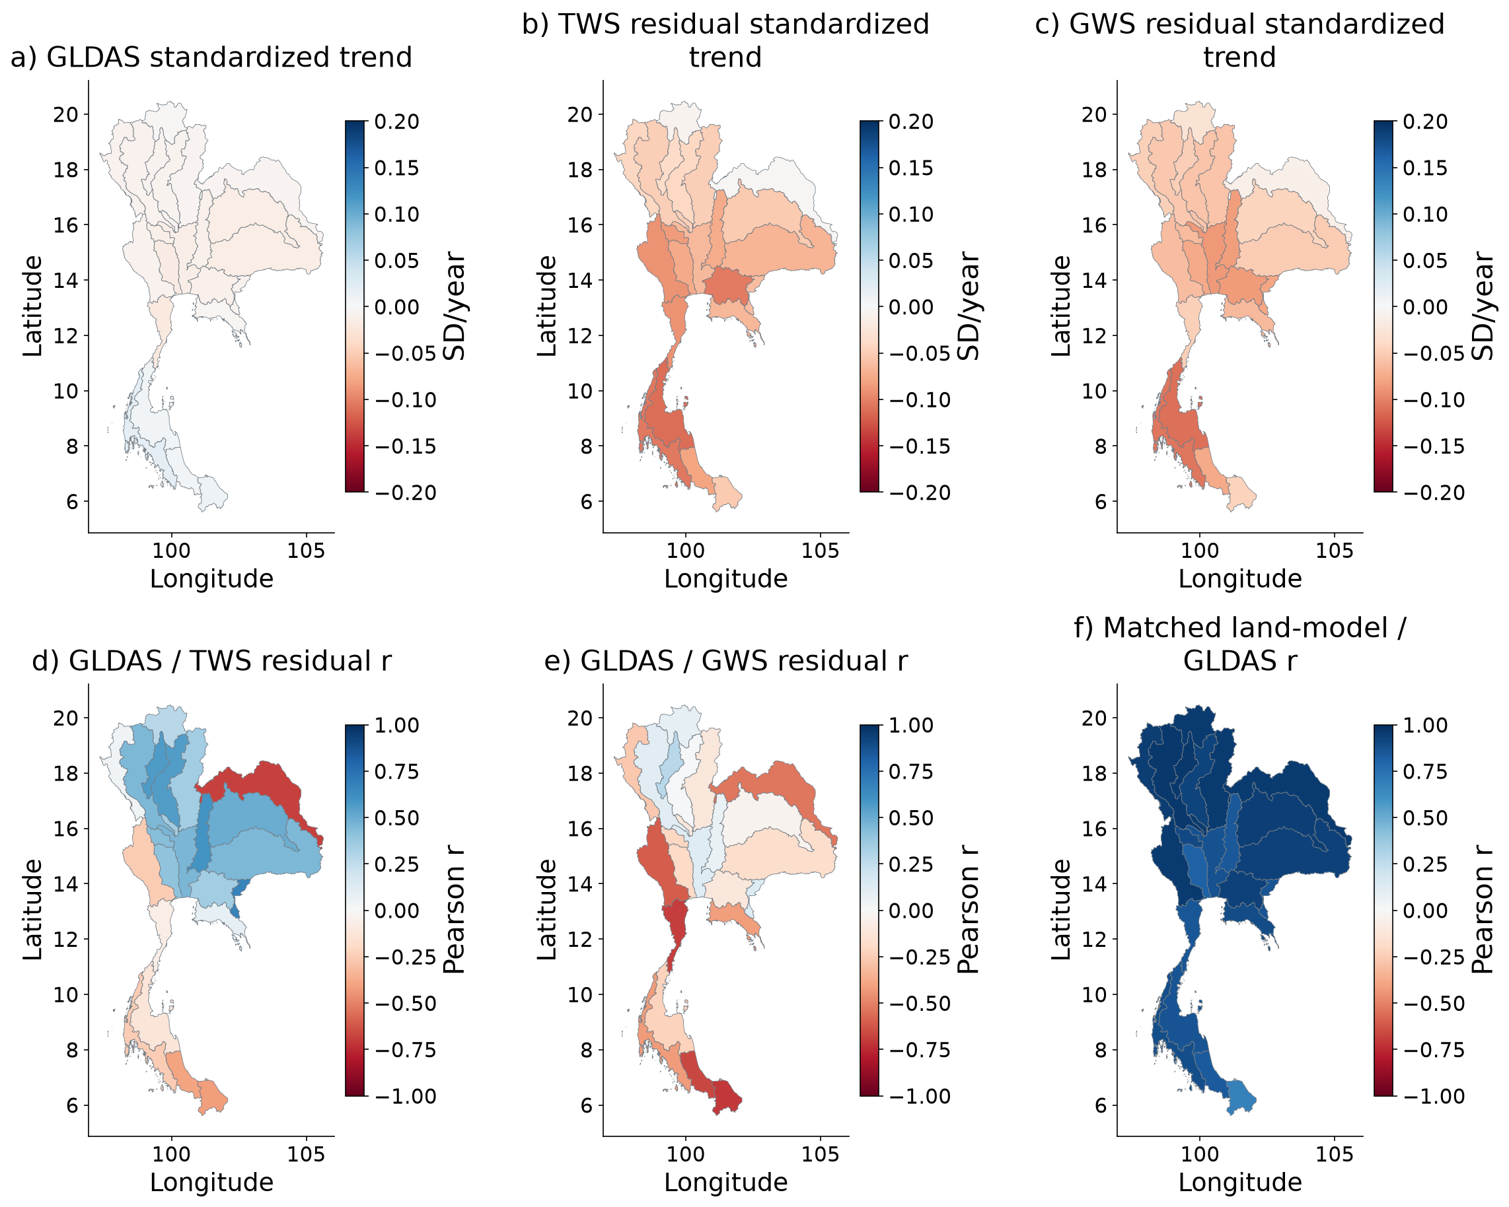
Figure 5.14 Spatial standardized trends and dependence between GLDAS land storage and residuals.
The series are standardized before comparison because GLDAS land storage and the residuals represent different quantities. These maps describe timing and relative change. They do not measure residual volume error or independently validate human water use.

GLDAS and residual histories for all 22 basins
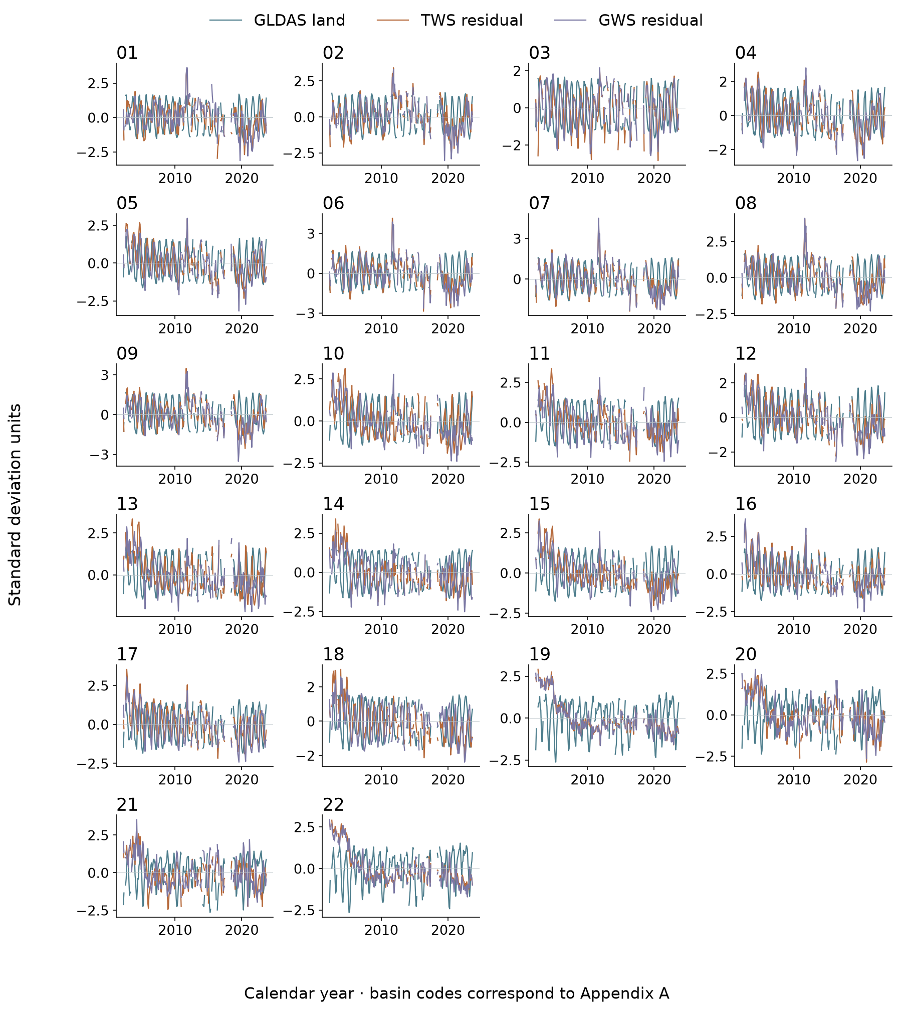
Figure 5.15 GLDAS land storage and both residual histories for all 22 basins, standardized on common months.
Within each basin, the three series use common months and a standardized scale. Similar peaks indicate similar timing, not equal water volumes. GLDAS also contributes to the groundwater calculation, so the comparisons are partly dependent.

Spatial evaluation of residual agreement with groundwater
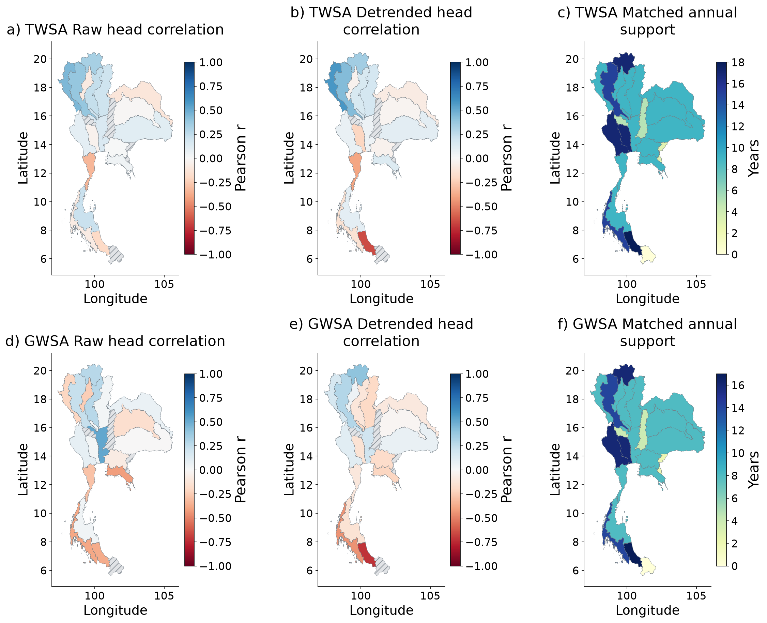
Figure 5.16 Spatial raw and detrended residual–head correlations and observed annual support.
The maps show annual residual–head correlations before and after detrending, together with the number of paired years. Missing evidence is marked. Head and storage have different units, so no volume-error score is calculated.
Table 5.2 National GWS residual and head comparisons
Panel | Years | Raw r
All overlap | 17 | 0.037
Fixed eligibility | 17 | 0.511
All wells common period | 8 | 0.029
Strict balanced | 8 | -0.000
Annual groundwater and residual histories for all 22 basins
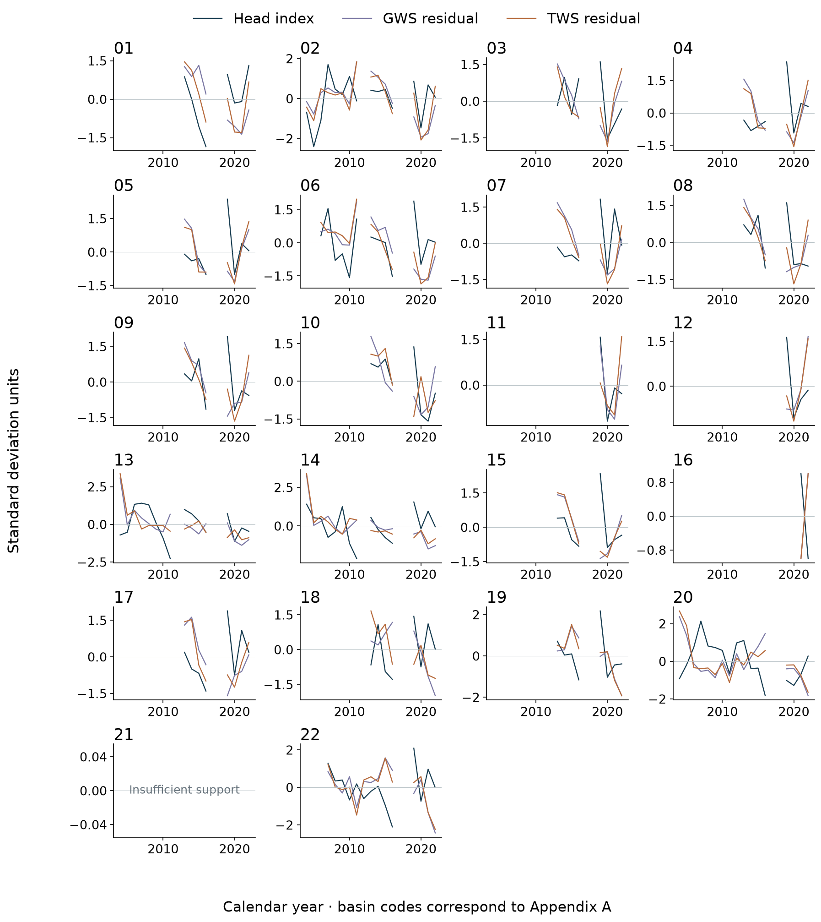
Figure 5.17 Annual groundwater and residual histories for all 22 basins on joint support.
Each basin panel compares groundwater head and both residuals on the same observed years. Standardization permits comparison of timing. It does not convert groundwater head to regional storage. Gaps and changing station coverage limit interpretation.
Spatial independent reservoir component evidence
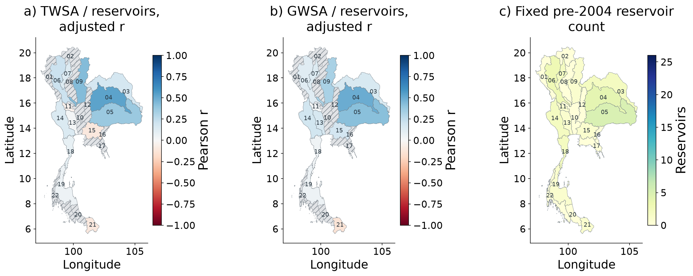
Figure 5.18 Spatial reservoir–residual agreement and fixed reservoir populations; hatching denotes missing evidence.
The reservoir comparison provides an independent check on a surface-water part of the total residual. National correlation after removing seasonality and trend is 0.439 across 73 scene-supported months. Missing basin evidence is hatched. Reservoirs reflect both climate and management.
Residual validation metrics and network support through time
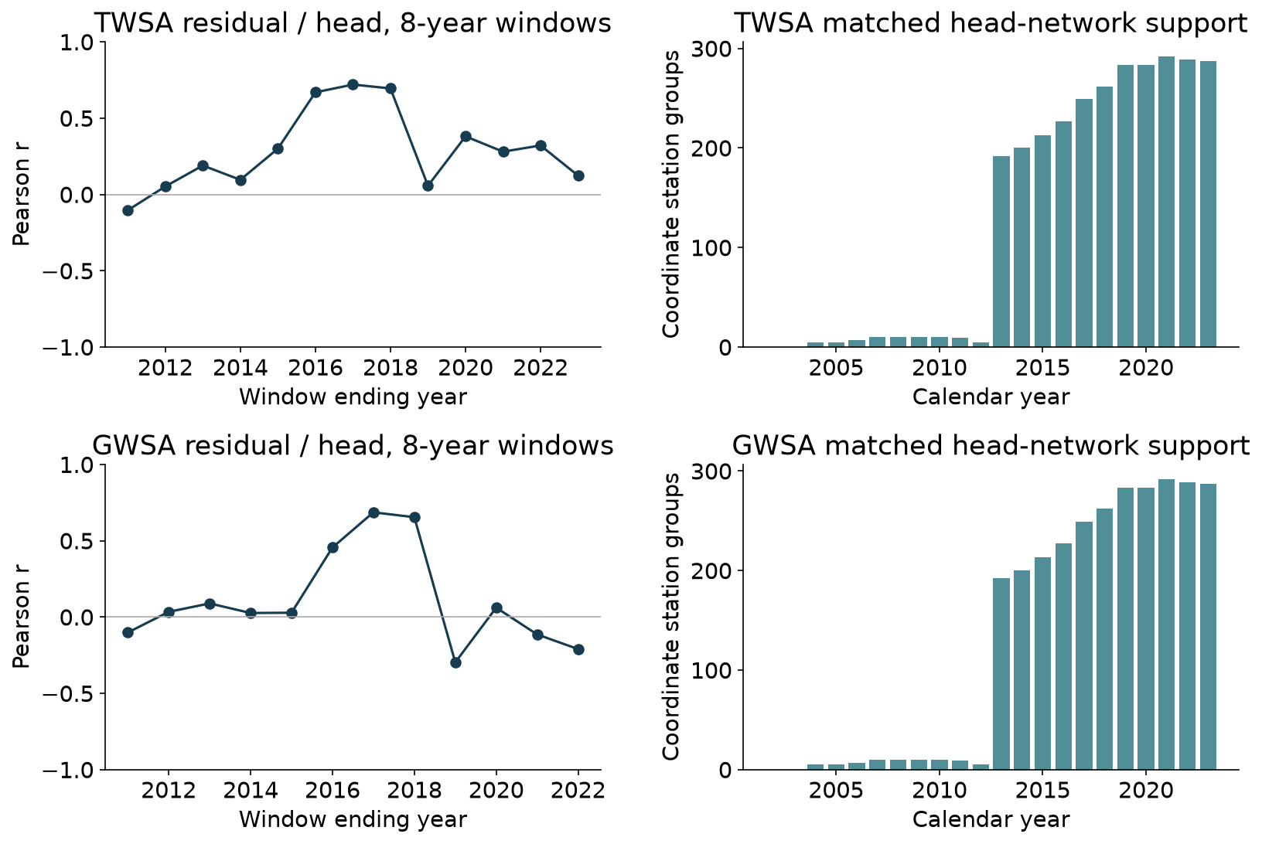
Figure 5.19 Residual–head evaluation and represented observation-network support through time.
The upper panels show how residual–head correlations change across overlapping eight-year windows; the lower panels show the represented network. These windows are descriptive, not independent tests. Changing stations can change the apparent agreement.

CHAPTER 6
DISCUSSION
What the storage trends show
The primary analysis shows a national decline in both total and groundwater storage. The seasonal Sen slope is −7.51 mm/year for TWSA and −6.84 mm/year for GWSA over their respective available records. The time-series panels show how these long-term rates sit within strong seasonal changes, wet and dry years, and missing observation periods. A trend is a summary of this record, not a prediction that every future year will change at the same rate.
The exact basin ranking is much less stable than the national direction. On common dates, the CSR and COST-G/G3P chains give different trend magnitudes and weak ranking agreement. This matters for decisions: the national finding can justify further monitoring, while a claim that one small basin is definitively the most depleted needs stronger local evidence.
The derived groundwater result adds uncertainty from soil, surface, canopy and snow storage. Surface-water representation is especially relevant in a country with large managed reservoirs. The full balance is preferable to silently omitting a compartment, but including a model estimate does not make that compartment perfectly observed.
The study's contribution is to show the storage results alongside the tests that challenge their interpretation. The combination of product comparisons, model-memory tests, paired simulations and changing well panels makes the evidence easier to assess. It supports a national decline while leaving some local and causal questions open.

What the climate model and residual mean
The climate models reconstruct their naturalized parent well over the full test period. Climate memory improves the controlled Ridge comparison, showing that current rainfall alone is insufficient to represent storage. However, poor scores in some individual years remain visible. The models reproduce a hydrological simulation; their high scores do not independently prove that the simulation is the true storage history without human activity.
The residual is observed storage minus the naturalized baseline. The paired historical simulation allows that residual to be written as a modeled human effect plus an observation–model discrepancy. The large discrepancy diagnostic shows that the modeled human effect alone does not account for the residual trend in this experiment. It does not prove that human influence is absent or that the entire discrepancy is measurement error.
GLDAS provides useful agreement for matching land-storage compartments: national correlation is 0.969, NSE is 0.738 and RMSE is 52.49 mm across 261 months. These results support a comparison of soil, canopy and snow storage. Shared climate drivers and the use of GLDAS in the GWS subtraction limit its independence as a residual check.
Human attribution would be stronger with observed abstraction histories, managed reservoir releases, irrigation records and aquifer information. Those records would help test the causes of the residual rather than just its timing. The current analysis reports what the available evidence supports and identifies the observations most likely to reduce the remaining uncertainty.

What wells and reservoirs can validate
Groundwater observations check whether storage changes are accompanied by changes in groundwater level. They do not directly measure regional water mass. In the national longest-overlap comparison, residual–head correlations are 0.127 for total storage and 0.037 for groundwater storage. The strictly balanced groundwater panel gives a correlation close to zero over eight usable storage years. Agreement changes with the stations and years included, so groundwater support for the residual is weak.
A weak correlation can arise from a poor storage estimate, a poor baseline, local well conditions, different spatial support or limited temporal sampling. The present comparison cannot identify one cause by itself. Similarly, a strong correlation would not establish pumping as the cause because rainfall can influence both head and storage.
Independent reservoir records offer another check. The national TWS residual–reservoir correlation is 0.439 after removing seasonality and trend, across 73 scene-supported months; the conditional 95% interval is 0.188–0.665. This is useful evidence for a surface-water component of the total residual. Reservoirs also respond to rainfall and operating decisions, so they do not provide an observed human-only counterfactual.
The answer to whether total minus climate can be checked with data other than groundwater is therefore yes. Reservoir storage is one such observation used here. Future checks could use independently observed river or lake storage and documented water-use changes. Each comparison must match the represented compartment and coverage. Validation becomes stronger by combining complementary evidence, not by treating any single proxy as the full human component.

CHAPTER 7
CONCLUSIONS AND RECOMMENDATIONS
Conclusions and practical next steps
Objective 1 is completed through monthly TWSA and GWSA records, seasonal Sen slopes, Mann–Kendall tests and spatial and temporal figures for all 22 principal basins. The primary national records decline, but basin rankings depend strongly on the processing chain. Basin-scale conclusions should retain the gravity-resolution caution and the uncertainty introduced by groundwater compartment subtraction.
Objective 2 is completed as an evaluated climate-reconstruction and residual framework. The naturalized WaterGAP baseline is explicit, statistical models are tested on held-out years, and GLDAS comparisons use matching compartments. The residual is separated into the modeled human effect and the remaining discrepancy. This provides a transparent analysis without claiming that the full residual is a measured human impact.
Groundwater and reservoir checks add observation evidence with clear limits. Well agreement is weak and sensitive to the observation panel. Reservoir records support a part of total-storage variability, but cannot validate all groundwater change or isolate management from climate. The study therefore finds stronger evidence for storage decline than for a unique human explanation of that decline.
Objective 3 is completed through the interactive website and a GitHub package containing input subsets, code, dependencies and reference outputs. The immediate research priority is to strengthen the independent observations: longer consistent well histories, aquifer storage coefficients, abstraction records and reservoir operations. These additions would allow stronger causal tests while the present package remains a reproducible basis for comparison.

REFERENCES
Abhishek, Kinouchi, T., Abolafia-Rosenzweig, R., Ito, M. (2022). Water Budget Closure in the Upper Chao Phraya River Basin, Thailand Using Multisource Data. Remote Sensing, 14, 173. https://doi.org/10.3390/rs14010173
Abhishek, Kinouchi, T., Sayama, T. (2021). A comprehensive assessment of water storage dynamics and hydroclimatic extremes in the Chao Phraya River Basin during 2002–2020. Journal of Hydrology, 603, 126868. https://doi.org/10.1016/j.jhydrol.2021.126868
Asian Institute of Technology Language Center. (2026). Master thesis format January 2026 and thesis-format guidance. https://languages.ait.ac.th/thesis-format-template/
Benjamini, Y., Hochberg, Y. (1995). Controlling the False Discovery Rate: A Practical and Powerful Approach to Multiple Testing. Journal of the Royal Statistical Society Series B: Statistical Methodology, 57, 289-300. https://doi.org/10.1111/j.2517-6161.1995.tb02031.x
Breiman, L. (2001). Random Forests. Machine Learning, 45, 5-32. https://doi.org/10.1023/A:1010933404324
Bäthge, A., Ruz Vargas, C., Lischeid, G., Collenteur, R., Cuthbert, M., et al. (2026). GROW A Global-Scale Time Series Dataset for Groundwater Studies within the Earth System [Data set]. Zenodo. https://doi.org/10.5281/zenodo.15149480
Cameron, A. C., Gelbach, J. B., Miller, D. L. (2008). Bootstrap-Based Improvements for Inference with Clustered Errors. Review of Economics and Statistics, 90, 414-427. https://doi.org/10.1162/rest.90.3.414
Center for Space Research (CSR). (2026). CSR GRACE and GRACE-FO RL06.3 mascon solutions and processing guidance. Data update 7 October 2026; accessed 24 October 2026. https://www2.csr.utexas.edu/grace/RL0603_mascons.html
Dahle, C., Boergens, E., Sasgen, I., Döhne, T., Reißland, S., Dobslaw, H., et al. (2025). GravIS: mass anomaly products from satellite gravimetry. Earth System Science Data, 17, 611-631. https://doi.org/10.5194/essd-17-611-2025
Funk, C., Peterson, P., Landsfeld, M., Pedreros, D., Verdin, J., Shukla, S., et al. (2015). The climate hazards infrared precipitation with stations—a new environmental record for monitoring extremes. Scientific Data, 2. https://doi.org/10.1038/sdata.2015.66
Gruber, A., Scanlon, T., van der Schalie, R., Wagner, W., Dorigo, W. (2019). Evolution of the ESA CCI Soil Moisture climate data records and their underlying merging methodology. Earth System Science Data, 11, 717-739. https://doi.org/10.5194/essd-11-717-2019
Gupta, H. V., Kling, H., Yilmaz, K. K., Martinez, G. F. (2009). Decomposition of the mean squared error and NSE performance criteria: Implications for improving hydrological modelling. Journal of Hydrology, 377, 80-91. https://doi.org/10.1016/j.jhydrol.2009.08.003
Güntner, A., Sharifi, E., Haas, J., Boergens, E., Dahle, C., et al. (2024). Global Gravity-based Groundwater Product G3P version 1.12 [Data set]. GFZ Data Services. https://doi.org/10.5880/G3P.2024.001
Hirsch, R. M., Slack, J. R. (1984). A Nonparametric Trend Test for Seasonal Data With Serial Dependence. Water Resources Research, 20, 727-732. https://doi.org/10.1029/WR020i006p00727
Hirsch, R. M., Slack, J. R., Smith, R. A. (1982). Techniques of trend analysis for monthly water quality data. Water Resources Research, 18, 107-121. https://doi.org/10.1029/WR018i001p00107
Hoerl, A. E., Kennard, R. W. (1970). Ridge Regression: Biased Estimation for Nonorthogonal Problems. Technometrics, 12, 55-67. https://doi.org/10.1080/00401706.1970.10488634
Knoben, W. J. M., Freer, J. E., Woods, R. A. (2019). Technical note: Inherent benchmark or not? Comparing Nash–Sutcliffe and Kling–Gupta efficiency scores. Hydrology and Earth System Sciences, 23, 4323-4331. https://doi.org/10.5194/hess-23-4323-2019
Kratzert, F., Klotz, D., Shalev, G., Klambauer, G., Hochreiter, S., Nearing, G. (2019). Towards learning universal, regional, and local hydrological behaviors via machine learning applied to large-sample datasets. Hydrology and Earth System Sciences, 23, 5089-5110. https://doi.org/10.5194/hess-23-5089-2019
REFERENCES CONTINUED
Longuevergne, L., Scanlon, B. R., Wilson, C. R. (2010). GRACE Hydrological estimates for small basins: Evaluating processing approaches on the High Plains Aquifer, USA. Water Resources Research, 46. https://doi.org/10.1029/2009WR008564
Mahto, S. S., Fatichi, S., & Galelli, S. (2025). A 1985–2023 time series dataset of absolute reservoir storage in Mainland Southeast Asia (MSEA-Res). Earth System Science Data, 17, 2693–2712. https://doi.org/10.5194/essd-17-2693-2025
Martens, B., Miralles, D. G., Lievens, H., van der Schalie, R., de Jeu, R. A. M., et al. (2017). GLEAM v3: Satellite-based land evaporation and root-zone soil moisture. Geoscientific Model Development, 10, 1903–1925. https://doi.org/10.5194/gmd-10-1903-2017
Müller Schmied, H., Trautmann, T., Ackermann, S., Cáceres, D., Flörke, M., et al. (2024a). WaterGAP v2.2e model output driven by GSWP3–ERA5 neglecting direct human impacts [Data set]. Goethe University Frankfurt. https://doi.org/10.25716/GUDE.1TWP-GNQP
Müller Schmied, H., Trautmann, T., Ackermann, S., Cáceres, D., Flörke, M., et al. (2024b). WaterGAP v2.2e model output driven by GSWP3–ERA5 including direct human impacts [Data set]. Goethe University Frankfurt. https://doi.org/10.25716/GUDE.14B4-KQ6R
Müller Schmied, H., Trautmann, T., Ackermann, S., Cáceres, D., Flörke, M., Gerdener, H., et al. (2024). The global water resources and use model WaterGAP v2.2e: description and evaluation of modifications and new features. Geoscientific Model Development, 17, 8817-8852. https://doi.org/10.5194/gmd-17-8817-2024
NASA. (n.d.). Global Land Data Assimilation System dataset specifications. https://ldas.gsfc.nasa.gov/gldas/dataset
Office of the National Water Resources. (n.d.). Thailand principal-basin boundaries [Project-supplied MainBasin_ONWR_Law_WGS84 spatial data].
Roberts, D. R., Bahn, V., Ciuti, S., Boyce, M. S., Elith, J., Guillera‐Arroita, G., et al. (2017). Cross‐validation strategies for data with temporal, spatial, hierarchical, or phylogenetic structure. Ecography, 40, 913-929. https://doi.org/10.1111/ecog.02881
Rodell, M., Houser, P. R., Jambor, U., Gottschalck, J., Mitchell, K., Meng, C. J., et al. (2004). The Global Land Data Assimilation System. Bulletin of the American Meteorological Society, 85, 381-394. https://doi.org/10.1175/BAMS-85-3-381
Save, H. (2020). CSR GRACE and GRACE-FO RL06 Mascon Solutions v02 [Data set]. University of Texas at Austin. https://doi.org/10.15781/cgq9-nh24
Save, H., Bettadpur, S., & Tapley, B. D. (2016). High-resolution CSR GRACE RL05 mascons. Journal of Geophysical Research Solid Earth, 121, 7547–7569. https://doi.org/10.1002/2016JB013007
Sen, P. K. (1968). Estimates of the Regression Coefficient Based on Kendall's Tau. Journal of the American Statistical Association, 63, 1379-1389. https://doi.org/10.1080/01621459.1968.10480934
Sharifi, E., Haas, J., Boergens, E., Dobslaw, H., Güntner, A. (2025). Technical note: GRACE-compatible filtering of water storage data sets via spatial autocorrelation analysis. Hydrology and Earth System Sciences, 29, 6985-6998. https://doi.org/10.5194/hess-29-6985-2025
Sharma, Y. K., Mohanasundaram, S., Kim, S., Shrestha, S., Babel, M. S., & Loc, H. H. (2025). Enhancing aquifer reliability and resilience assessment in data-scarce regions using satellite data: Application to the Chao Phraya River Basin. Remote Sensing, 17, 1731. https://doi.org/10.3390/rs17101731
Sutterley, T., et al. (2026). Gravity toolkit time utilities and special GRACE month adjustments [Software documentation]. https://read-grace-harmonics.readthedocs.io/en/latest/api_reference/time.html
Zou, H., Hastie, T. (2005). Regularization and Variable Selection Via the Elastic Net. Journal of the Royal Statistical Society Series B: Statistical Methodology, 67, 301-320. https://doi.org/10.1111/j.1467-9868.2005.00503.x

APPENDIX A
ALL BASIN RESULTS
Table A.1 All-basin primary slopes and mapped support
Basin | TWSA mm/yr | GWSA mm/yr | Native conc.
01 Salawin | -3.59 | -2.88 | 4.2
02 North Khong | -1.90 | -1.83 | 3.1
03 Northeast Khong | -1.32 | -1.59 | 6.9
04 Chi | -3.65 | -3.32 | 6.1
05 Mun | -4.42 | -3.47 | 8.4
06 Ping | -3.71 | -3.10 | 6.0
07 Wang | -3.21 | -3.32 | 3.7
08 Yom | -3.79 | -3.97 | 3.8
09 Nan | -3.74 | -3.94 | 6.5
10 Chao Phraya | -7.36 | -7.47 | 4.5
11 Sakae Krang | -5.50 | -5.20 | 2.7
12 Pasak | -7.06 | -7.35 | 3.9
13 Tha Chin | -6.89 | -6.36 | 2.2
14 Mae Klong | -5.25 | -5.48 | 4.3
15 Bang Pakong | -8.64 | -8.12 | 3.6
16 Tonle Sap | -7.68 | -7.30 | 1.9
17 East Coast Gulf | -7.51 | -7.92 | 3.0
18 Phetchaburi - Prachuap Khiri Khan | -5.85 | -4.75 | 2.4
19 Peninsula - Upper East Coast | -34.37 | -36.08 | 4.9
20 Thale Sap Songkhla | -6.25 | -7.45 | 2.8
21 Peninsula - Lower East Coast | -1.62 | -3.16 | 1.7
22 Peninsula - West Coast | -21.48 | -20.95 | 4.8
Native concentration is inverse weight concentration, not an independent sample count. All principal basins retain the provider small-support caution. Complete tests, intervals, coverage and groundwater evidence are in the versioned CSV tables.

APPENDIX B
REPRODUCIBILITY AND INTERPRETATION CONTRACT
The extended numerical study is implemented in numbered acquisition, storage, robustness, climate, groundwater and synthesis scripts. Compact regional inputs and their provenance are retained. The documented CSR record is a new primary input, while the earlier supplied export remains a sensitivity. No original research output is silently overwritten; the extended study occupies its own versioned directory.
A reproducible run verifies input checksums, rebuilds the scientific tables and figures, and checks the accounting identities, model split rules, observation counts and table schemas. Frozen reference outputs are used for comparison only. They are not substituted for recomputed scientific results. The repository documentation distinguishes the original executable release from the extended analyses and records the environment used.
Interpretation follows the same contract as execution: groundwater heads remain heads, model-emulation skill remains model-emulation skill, and a residual remains the sum of the represented human perturbation and unresolved discrepancy. Conditional bootstrap intervals do not become full product uncertainties, and native support concentration does not become a count of independent observations. Keeping those meanings intact is necessary for a reader to reproduce the scientific argument as well as the numerical tables.
The accompanying manuscript focuses on product dependence, climate memory and network uncertainty; the thesis provides the fuller data, methods and basin context. The Beamer source and presentation summarize the same checked results. All author information uses Farzeen Khan, with academic supervision acknowledged to Dr. Natthachet Tangdamrongsub. Original dataset attributions and source-specific reuse terms remain attached to the released material.
Code and data access: https://github.com/pratikkhanal16/thailand-water-storage-dss

APPENDIX C
BASIN PERFORMANCE AND VALUES
This appendix gives the values behind the basin figures. Every table contains all 22 basin codes; full basin names are in Appendix A. An em dash means that the comparison is unavailable or cannot be estimated. It does not mean zero change or zero effect.
Table C.1 Observed storage trends for every basin
Table C.2 TWSA climate reconstruction performance
Table C.3 GWSA climate reconstruction performance
Table C.4 TWSA additive trends and residual components
Table C.5 GWSA additive trends and residual components
Table C.6 GLDAS matched land storage performance
Table C.7 Residual agreement with annual groundwater head
Table C.8 TWS residual agreement with independent reservoir storage
Table C.9 Rainfall source sensitivity in the controlled Ridge model
Table C.10 Basin mean forcing and supporting data 1
Table C.11 Basin mean forcing and supporting data 2
Read model scores against their stated targets. The climate model reconstructs naturalized WaterGAP. GLDAS checks matching land compartments. Wells and reservoirs provide observation consistency checks. Their scores cannot be combined into one measure of human-impact accuracy.
Observed storage trends for every basin
Table C.1 Observed storage trends for every basin
Basin | TWS slope | TWS q | n | GWS slope | GWS q | n
01 | -3.59 | <0.001 | 237 | -2.88 | <0.001 | 225
02 | -1.90 | 0.010 | 237 | -1.83 | 0.014 | 225
03 | -1.32 | 0.007 | 237 | -1.59 | <0.001 | 225
04 | -3.65 | <0.001 | 237 | -3.32 | <0.001 | 225
05 | -4.42 | <0.001 | 237 | -3.47 | <0.001 | 225
06 | -3.71 | <0.001 | 237 | -3.10 | <0.001 | 225
07 | -3.21 | <0.001 | 237 | -3.32 | <0.001 | 225
08 | -3.79 | <0.001 | 237 | -3.97 | <0.001 | 225
09 | -3.74 | <0.001 | 237 | -3.94 | <0.001 | 225
10 | -7.36 | <0.001 | 237 | -7.47 | <0.001 | 225
11 | -5.50 | <0.001 | 237 | -5.20 | <0.001 | 225
12 | -7.06 | <0.001 | 237 | -7.35 | <0.001 | 225
13 | -6.89 | <0.001 | 237 | -6.36 | <0.001 | 225
14 | -5.25 | <0.001 | 237 | -5.48 | <0.001 | 225
15 | -8.64 | <0.001 | 237 | -8.12 | <0.001 | 225
16 | -7.68 | <0.001 | 237 | -7.30 | <0.001 | 225
17 | -7.51 | <0.001 | 237 | -7.92 | <0.001 | 225
18 | -5.85 | <0.001 | 237 | -4.75 | <0.001 | 225
19 | -34.37 | <0.001 | 237 | -36.08 | <0.001 | 225
20 | -6.25 | <0.001 | 237 | -7.45 | <0.001 | 225
21 | -1.62 | <0.001 | 237 | -3.16 | <0.001 | 225
22 | -21.48 | <0.001 | 237 | -20.95 | <0.001 | 225
Slopes are seasonal Sen estimates in mm/year. q is seasonal Mann–Kendall FDR across basins; n is observed months. Full intervals and original p-values remain in CSR_basin_trends.csv. Basin names are listed in Appendix A.
Machine-readable values: C01_basin_values.csv
TWSA climate reconstruction performance
Table C.2 TWSA climate reconstruction performance
Basin | n | r | NSE | Anom NSE | RMSE | MAE
01 | 96 | 0.991 | 0.981 | 0.807 | 22.08 | 16.90
02 | 96 | 0.990 | 0.979 | 0.904 | 17.32 | 13.88
03 | 96 | 0.990 | 0.973 | 0.812 | 27.37 | 19.39
04 | 96 | 0.981 | 0.961 | 0.821 | 15.61 | 11.58
05 | 96 | 0.974 | 0.946 | 0.732 | 21.43 | 15.40
06 | 96 | 0.991 | 0.981 | 0.876 | 15.90 | 12.00
07 | 96 | 0.987 | 0.974 | 0.868 | 15.24 | 11.08
08 | 96 | 0.987 | 0.972 | 0.873 | 15.38 | 11.43
09 | 96 | 0.992 | 0.983 | 0.901 | 14.14 | 10.83
10 | 96 | 0.967 | 0.928 | 0.792 | 42.23 | 30.13
11 | 96 | 0.990 | 0.980 | 0.875 | 15.34 | 12.27
12 | 96 | 0.987 | 0.974 | 0.864 | 11.22 | 8.35
13 | 96 | 0.974 | 0.942 | 0.778 | 32.00 | 23.99
14 | 96 | 0.991 | 0.981 | 0.856 | 18.49 | 14.13
15 | 96 | 0.975 | 0.942 | 0.764 | 28.65 | 22.72
16 | 96 | 0.979 | 0.957 | 0.705 | 14.60 | 11.45
17 | 96 | 0.987 | 0.972 | 0.742 | 16.75 | 13.62
18 | 96 | 0.979 | 0.957 | 0.827 | 14.38 | 10.97
19 | 96 | 0.982 | 0.965 | 0.911 | 17.38 | 13.55
20 | 96 | 0.982 | 0.963 | 0.903 | 22.54 | 18.01
21 | 96 | 0.977 | 0.951 | 0.887 | 25.44 | 18.76
22 | 96 | 0.985 | 0.970 | 0.903 | 17.36 | 13.16
Frozen ensemble, 2016–2023 test data. Target: naturalized WaterGAP, not GRACE. Errors are mm; anomaly NSE removes the training monthly climatology. Higher NSE and lower errors are better.
Machine-readable values: C02_basin_values.csv
GWSA climate reconstruction performance
Table C.3 GWSA climate reconstruction performance
Basin | n | r | NSE | Anom NSE | RMSE | MAE
01 | 96 | 0.982 | 0.963 | 0.830 | 5.74 | 4.47
02 | 96 | 0.986 | 0.956 | 0.901 | 4.98 | 4.08
03 | 96 | 0.982 | 0.953 | 0.781 | 10.59 | 7.70
04 | 96 | 0.969 | 0.933 | 0.755 | 7.04 | 5.33
05 | 96 | 0.963 | 0.927 | 0.678 | 8.87 | 6.32
06 | 96 | 0.980 | 0.958 | 0.842 | 3.94 | 2.92
07 | 96 | 0.977 | 0.948 | 0.824 | 4.83 | 3.96
08 | 96 | 0.984 | 0.963 | 0.865 | 5.52 | 4.22
09 | 96 | 0.982 | 0.958 | 0.832 | 6.04 | 4.78
10 | 96 | 0.968 | 0.935 | 0.661 | 4.90 | 4.09
11 | 96 | 0.958 | 0.914 | 0.627 | 7.09 | 5.40
12 | 96 | 0.981 | 0.962 | 0.812 | 4.62 | 3.61
13 | 96 | 0.959 | 0.920 | 0.703 | 5.50 | 4.45
14 | 96 | 0.985 | 0.970 | 0.812 | 4.39 | 3.12
15 | 96 | 0.963 | 0.902 | 0.360 | 10.51 | 8.46
16 | 96 | 0.970 | 0.933 | 0.564 | 10.88 | 8.87
17 | 96 | 0.980 | 0.952 | 0.589 | 11.67 | 9.60
18 | 96 | 0.958 | 0.907 | 0.711 | 6.84 | 5.11
19 | 96 | 0.968 | 0.926 | 0.823 | 10.40 | 8.46
20 | 96 | 0.946 | 0.892 | 0.668 | 11.69 | 9.70
21 | 96 | 0.953 | 0.904 | 0.808 | 9.19 | 7.33
22 | 96 | 0.967 | 0.922 | 0.780 | 11.32 | 8.94
Frozen ensemble, 2016–2023 test data. Target: naturalized WaterGAP, not GRACE. Errors are mm; anomaly NSE removes the training monthly climatology. Higher NSE and lower errors are better.
Machine-readable values: C03_basin_values.csv
TWSA additive trends and residual components
Table C.4 TWSA additive trends and residual components
Basin | O | C | H | R | E
01 | -4.74 | -1.84 | -0.48 | -2.90 | -2.42
02 | -3.25 | -2.89 | 0.03 | -0.37 | -0.39
03 | -2.35 | -2.25 | 0.22 | -0.11 | -0.32
04 | -4.98 | -0.06 | -0.18 | -4.93 | -4.75
05 | -5.37 | 0.34 | -0.02 | -5.72 | -5.69
06 | -4.98 | -1.57 | -3.08 | -3.41 | -0.32
07 | -4.85 | -1.77 | -0.48 | -3.08 | -2.61
08 | -5.11 | -1.96 | 0.11 | -3.15 | -3.26
09 | -5.03 | -1.80 | -3.12 | -3.23 | -0.11
10 | -8.62 | -1.92 | 0.02 | -6.69 | -6.71
11 | -6.31 | -0.66 | 0.01 | -5.65 | -5.66
12 | -8.39 | -0.45 | -3.04 | -7.94 | -4.90
13 | -7.95 | -1.04 | 0.09 | -6.91 | -6.99
14 | -6.13 | -0.46 | 0.25 | -5.67 | -5.91
15 | -9.67 | -1.29 | 0.09 | -8.39 | -8.48
16 | -8.95 | -0.13 | 0.06 | -8.82 | -8.88
17 | -8.49 | -0.53 | 0.20 | -7.96 | -8.16
18 | -6.82 | 0.93 | 0.17 | -7.74 | -7.92
19 | -42.10 | 2.31 | 0.04 | -44.41 | -44.45
20 | -6.52 | 3.57 | 0.85 | -10.09 | -10.94
21 | -2.22 | 3.75 | -0.19 | -5.97 | -5.78
22 | -27.62 | 1.71 | 0.01 | -29.33 | -29.33
Calendar-month fixed-effect OLS slopes, mm/year, on common available months. O observed; C naturalized; H historical minus naturalized; R observed minus naturalized; E observed minus historical. R = H + E. These are not additive Sen slopes or measured pumping rates. Conditional intervals are supplied in attribution_wild_block_intervals.csv.
Machine-readable values: C04_basin_values.csv
GWSA additive trends and residual components
Table C.5 GWSA additive trends and residual components
Basin | O | C | H | R | E
01 | -3.69 | -0.64 | 0.01 | -3.05 | -3.06
02 | -3.27 | -1.20 | 0.08 | -2.07 | -2.15
03 | -1.98 | -1.02 | 0.14 | -0.96 | -1.10
04 | -3.88 | -0.06 | 0.16 | -3.82 | -3.98
05 | -4.24 | 0.05 | 0.06 | -4.29 | -4.35
06 | -4.23 | -0.46 | 0.05 | -3.77 | -3.83
07 | -4.44 | -0.69 | 0.08 | -3.75 | -3.83
08 | -4.66 | -0.89 | 0.05 | -3.77 | -3.82
09 | -4.81 | -0.86 | 0.06 | -3.95 | -4.00
10 | -7.71 | -0.05 | 0.05 | -7.65 | -7.71
11 | -5.16 | -0.16 | 0.01 | -5.00 | -5.01
12 | -7.82 | -0.15 | 0.12 | -7.67 | -7.79
13 | -6.24 | 0.18 | -0.01 | -6.42 | -6.41
14 | -5.14 | -0.13 | 0.02 | -5.01 | -5.03
15 | -9.00 | -0.43 | 0.10 | -8.57 | -8.67
16 | -8.44 | -0.22 | 0.10 | -8.22 | -8.32
17 | -8.56 | -0.43 | 0.11 | -8.12 | -8.23
18 | -4.80 | 0.44 | 0.07 | -5.24 | -5.31
19 | -43.51 | 1.17 | -0.02 | -44.67 | -44.65
20 | -7.50 | 1.10 | -0.07 | -8.59 | -8.52
21 | -3.62 | 1.04 | -0.15 | -4.67 | -4.52
22 | -24.72 | 0.93 | -0.03 | -25.65 | -25.62
Calendar-month fixed-effect OLS slopes, mm/year, on common available months. O observed; C naturalized; H historical minus naturalized; R observed minus naturalized; E observed minus historical. R = H + E. These are not additive Sen slopes or measured pumping rates. Conditional intervals are supplied in attribution_wild_block_intervals.csv.
Machine-readable values: C05_basin_values.csv
GLDAS matched land storage performance
Table C.6 GLDAS matched land storage performance
Basin | n | r | NSE | RMSE | MAE | Bias
01 | 261 | 0.949 | 0.850 | 55.42 | 46.06 | 4.24
02 | 261 | 0.955 | 0.877 | 38.82 | 31.16 | -3.20
03 | 261 | 0.957 | 0.670 | 62.72 | 55.91 | 3.44
04 | 261 | 0.940 | 0.702 | 56.19 | 48.08 | 11.12
05 | 261 | 0.931 | 0.620 | 65.72 | 57.34 | 12.09
06 | 261 | 0.961 | 0.901 | 37.15 | 30.56 | 3.75
07 | 261 | 0.962 | 0.874 | 36.09 | 29.37 | -2.62
08 | 261 | 0.926 | 0.712 | 59.38 | 51.34 | -2.20
09 | 261 | 0.956 | 0.825 | 48.01 | 41.12 | 1.04
10 | 261 | 0.871 | 0.390 | 77.84 | 69.70 | 7.74
11 | 261 | 0.900 | 0.756 | 59.88 | 49.64 | 3.91
12 | 261 | 0.848 | 0.465 | 75.38 | 66.62 | 7.09
13 | 261 | 0.814 | 0.317 | 95.06 | 85.91 | 13.97
14 | 261 | 0.955 | 0.788 | 62.51 | 53.84 | 4.43
15 | 261 | 0.934 | 0.621 | 60.08 | 51.92 | 5.74
16 | 261 | 0.860 | 0.453 | 78.69 | 68.66 | 9.02
17 | 261 | 0.891 | 0.559 | 71.30 | 62.24 | 3.90
18 | 261 | 0.858 | 0.514 | 80.68 | 71.40 | 13.50
19 | 261 | 0.866 | 0.690 | 49.28 | 39.89 | 0.01
20 | 261 | 0.844 | 0.544 | 53.29 | 41.99 | 10.73
21 | 261 | 0.678 | 0.403 | 62.21 | 51.62 | 9.14
22 | 261 | 0.887 | 0.686 | 49.60 | 40.29 | -6.04
Soil, canopy and snow only; naturalized WaterGAP compared with GLDAS Noah on matched months. Errors are mm; bias = WaterGAP minus GLDAS. This does not validate full TWS, GWS or human-only storage.
Machine-readable values: C06_basin_values.csv
Residual agreement with annual groundwater head
Table C.7 Residual agreement with annual groundwater head
Basin | TWS r | TWS detr r | Years | GWS r | GWS detr r | Years
01 | 0.449 | 0.582 | 9 | -0.215 | 0.167 | 8
02 | 0.330 | 0.345 | 17 | 0.279 | 0.399 | 16
03 | -0.121 | -0.084 | 9 | 0.063 | -0.109 | 8
04 | -0.009 | -0.030 | 9 | -0.168 | -0.023 | 8
05 | 0.113 | 0.103 | 9 | -0.007 | 0.070 | 8
06 | 0.385 | 0.432 | 15 | 0.229 | 0.293 | 14
07 | -0.089 | -0.043 | 9 | -0.244 | 0.047 | 8
08 | 0.236 | 0.157 | 9 | 0.277 | -0.124 | 8
09 | 0.208 | 0.176 | 9 | 0.026 | -0.198 | 8
10 | 0.152 | 0.050 | 9 | 0.519 | 0.200 | 8
11 | — | — | 5 | — | — | 4
12 | — | — | 5 | — | — | 4
13 | -0.044 | -0.212 | 17 | 0.027 | -0.147 | 16
14 | 0.094 | 0.074 | 17 | 0.093 | 0.116 | 16
15 | 0.001 | -0.041 | 9 | -0.082 | -0.187 | 8
16 | — | — | 3 | — | — | 2
17 | 0.041 | 0.136 | 9 | -0.420 | -0.215 | 8
18 | -0.335 | -0.394 | 9 | -0.289 | -0.115 | 8
19 | 0.227 | 0.096 | 9 | 0.033 | -0.147 | 8
20 | -0.197 | -0.656 | 18 | -0.375 | -0.722 | 17
21 | — | — | 0 | — | — | 0
22 | -0.080 | -0.143 | 15 | -0.389 | -0.450 | 14
Longest-overlap retained-flags panel. Positive r means lower residual tends to occur with lower head. Detr r removes a linear trend. An em dash means unavailable evidence, not zero. Head is not converted into storage; no cross-unit NSE or RMSE is reported. Other station panels and conditional intervals remain in the complete CSV.
Machine-readable values: C07_basin_values.csv
TWS residual agreement with independent reservoir storage
Table C.8 TWS residual agreement with independent reservoir storage
Basin | Reservoirs | Months | Raw r | Adjusted r | 95% low | 95% high
01 | 0 | 0 | — | — | — | —
02 | 0 | 0 | — | — | — | —
03 | 2 | 179 | 0.31 | 0.18 | -0.08 | 0.37
04 | 4 | 132 | 0.62 | 0.53 | 0.26 | 0.69
05 | 5 | 135 | 0.60 | 0.37 | 0.09 | 0.57
06 | 3 | 106 | 0.08 | 0.22 | -0.06 | 0.41
07 | 2 | 176 | 0.25 | 0.13 | -0.04 | 0.33
08 | 0 | 0 | — | — | — | —
09 | 1 | 198 | 0.62 | 0.44 | 0.24 | 0.59
10 | 0 | 0 | — | — | — | —
11 | 1 | 192 | -0.02 | -0.05 | -0.33 | 0.21
12 | 0 | 0 | — | — | — | —
13 | 1 | 189 | -0.33 | 0.02 | -0.17 | 0.20
14 | 2 | 176 | 0.23 | 0.15 | -0.05 | 0.32
15 | 1 | 164 | -0.04 | -0.11 | -0.31 | 0.10
16 | 0 | 0 | — | — | — | —
17 | 0 | 0 | — | — | — | —
18 | 2 | 170 | 0.32 | 0.08 | -0.11 | 0.27
19 | 1 | 171 | -0.49 | 0.05 | -0.15 | 0.26
20 | 0 | 0 | — | — | — | —
21 | 1 | 201 | -0.23 | -0.11 | -0.32 | 0.14
22 | 0 | 0 | — | — | — | —
Scene-screened Level 1 estimates; fixed pre-2004 reservoir panel. Adjusted correlation removes season and trend. Intervals resample whole calendar years. Missing or insufficient evidence is left unavailable. This checks a surface-water component, not a human-only total.
Machine-readable values: C08_basin_values.csv
Rainfall source sensitivity in the controlled Ridge model
Table C.9 Rainfall source sensitivity in the controlled Ridge model
Basin | TWS native | TWS CHIRPS | GWS native | GWS CHIRPS
01 | 0.805 | -0.478 | 0.809 | -2.161
02 | 0.894 | 0.632 | 0.748 | 0.361
03 | 0.666 | -0.039 | 0.711 | 0.032
04 | 0.794 | 0.599 | 0.700 | 0.610
05 | 0.699 | 0.369 | 0.527 | 0.271
06 | 0.872 | -0.458 | 0.711 | -1.843
07 | 0.861 | 0.120 | 0.673 | -0.259
08 | 0.867 | 0.443 | 0.678 | 0.361
09 | 0.899 | 0.025 | 0.667 | -0.062
10 | 0.801 | 0.493 | 0.543 | 0.091
11 | 0.863 | 0.473 | 0.476 | 0.271
12 | 0.849 | 0.211 | 0.767 | 0.110
13 | 0.761 | 0.413 | 0.603 | -0.040
14 | 0.839 | -0.046 | 0.760 | -0.382
15 | 0.757 | 0.449 | 0.254 | -0.470
16 | 0.606 | -0.166 | 0.404 | -0.618
17 | 0.728 | -1.063 | 0.530 | -2.159
18 | 0.832 | -0.174 | 0.682 | -0.387
19 | 0.892 | -2.219 | 0.755 | -5.834
20 | 0.893 | -0.517 | 0.665 | -0.465
21 | 0.882 | -4.630 | 0.794 | -9.769
22 | 0.892 | -2.001 | 0.722 | -4.740
Test-period anomaly NSE for the frozen Weather_memory Ridge experiment, holding PET and the native-forced parent target fixed. CHIRPS is unadjusted here. This is forcing sensitivity, not evidence that one rainfall product is more accurate. It is a different experiment from the ensemble in Tables C.2–C.3.
Machine-readable values: C09_basin_values.csv
Basin mean forcing and supporting data 1
Table C.10 Basin mean forcing and supporting data 1
Basin | Native precipitation | Native potential ET | CHIRPS precipitation | GLEAM actual ET
01 | 149.55 | 121.72 | 111.70 | 83.77
02 | 140.64 | 119.26 | 138.54 | 86.99
03 | 141.80 | 124.17 | 153.52 | 83.69
04 | 114.36 | 133.45 | 116.78 | 80.04
05 | 116.68 | 141.06 | 125.41 | 86.68
06 | 132.51 | 120.80 | 108.65 | 81.52
07 | 123.64 | 113.35 | 106.19 | 82.45
08 | 129.17 | 115.63 | 117.76 | 80.48
09 | 144.45 | 122.17 | 121.76 | 85.13
10 | 113.02 | 127.43 | 111.04 | 75.13
11 | 123.23 | 128.71 | 128.09 | 85.70
12 | 125.50 | 136.00 | 112.30 | 79.37
13 | 104.66 | 148.63 | 105.96 | 76.95
14 | 150.83 | 132.13 | 143.16 | 93.31
15 | 133.77 | 133.54 | 136.28 | 82.72
16 | 135.02 | 134.64 | 135.45 | 88.83
17 | 176.67 | 138.46 | 190.57 | 93.50
18 | 134.30 | 171.78 | 121.74 | 78.54
19 | 175.10 | 142.65 | 222.62 | 99.78
20 | 173.94 | 144.05 | 201.14 | 102.72
21 | 182.62 | 154.02 | 259.10 | 112.53
22 | 193.88 | 144.66 | 240.37 | 111.15
Available-month means within January 2003–December 2023. Rainfall and ET are mm/month; moisture is m³/m³; temperature is °C. Means are not annual totals. Coverage and sample counts differ between products and are supplied in forcing_summary_and_trends.csv. Actual ET, moisture and temperature are supporting context, not added climate-model predictors.
Machine-readable values: C10_basin_values.csv
Basin mean forcing and supporting data 2
Table C.11 Basin mean forcing and supporting data 2
Basin | MODIS actual ET | ESA CCI surface moisture | ESA CCI root zone moisture | MODIS surface temperature
01 | 102.80 | 0.279 | 0.278 | 23.36
02 | 93.22 | 0.285 | 0.285 | 24.53
03 | 81.08 | 0.248 | 0.249 | 26.65
04 | 74.64 | 0.237 | 0.237 | 27.52
05 | 75.16 | 0.239 | 0.239 | 28.00
06 | 97.66 | 0.266 | 0.266 | 24.81
07 | 100.11 | 0.274 | 0.274 | 25.73
08 | 88.64 | 0.264 | 0.265 | 26.70
09 | 91.89 | 0.260 | 0.260 | 25.95
10 | 69.25 | 0.276 | 0.276 | 29.40
11 | 81.33 | 0.249 | 0.250 | 27.74
12 | 86.13 | 0.262 | 0.262 | 27.61
13 | 71.98 | 0.249 | 0.249 | 29.15
14 | 101.70 | 0.269 | 0.270 | 25.56
15 | 84.29 | 0.291 | 0.291 | 28.01
16 | 92.44 | 0.266 | 0.265 | 27.84
17 | 101.42 | 0.276 | 0.276 | 27.29
18 | 100.61 | 0.292 | 0.292 | 26.68
19 | 115.39 | 0.293 | 0.292 | 25.89
20 | 110.09 | 0.292 | 0.292 | 26.52
21 | 120.24 | 0.311 | 0.311 | 25.49
22 | 114.28 | 0.305 | 0.305 | 25.84
Available-month means within January 2003–December 2023. Rainfall and ET are mm/month; moisture is m³/m³; temperature is °C. Means are not annual totals. Coverage and sample counts differ between products and are supplied in forcing_summary_and_trends.csv. Actual ET, moisture and temperature are supporting context, not added climate-model predictors.
Machine-readable values: C11_basin_values.csv

APPENDIX D
FORCING AND SUPPORTING DATA
The figures cover January 2003–December 2023, the shared calendar window for the native forcing and supporting products. Available-month means and trends keep each product’s actual gaps. A spatial map reports a basin average, not a new high-resolution climate field.
Native precipitation and potential evapotranspiration are the actual meteorological inputs to the climate reconstruction. CHIRPS precipitation is used in the rainfall replacement test. GLEAM and MODIS actual evapotranspiration, ESA CCI surface and root-zone moisture, and MODIS land surface temperature describe the surrounding hydroclimatic conditions. They were not added to the primary model as predictors.
Figure D.1 Mean forcing and supporting data 1
Figure D.2 Trend in forcing and supporting data 1
Figure D.3 Mean forcing and supporting data 2
Figure D.4 Trend in forcing and supporting data 2
Figure D.5 Native precipitation for all basins
Figure D.6 Native potential ET for all basins
Figure D.7 CHIRPS precipitation for all basins
Figure D.8 GLEAM actual ET and MODIS actual ET for all basins
Figure D.9 ESA CCI surface moisture and ESA CCI root zone moisture for all basins
Figure D.10 MODIS surface temperature for all basins
Monthly precipitation and ET use mm/month; soil moisture uses m³/m³; temperature uses °C. Native daily-rate precipitation and potential ET are multiplied by the number of days in the month. Trend-map units are the displayed variable per year. Product sample counts, coverage and physical units are available in the accompanying CSV tables.
Mean forcing and supporting data 1
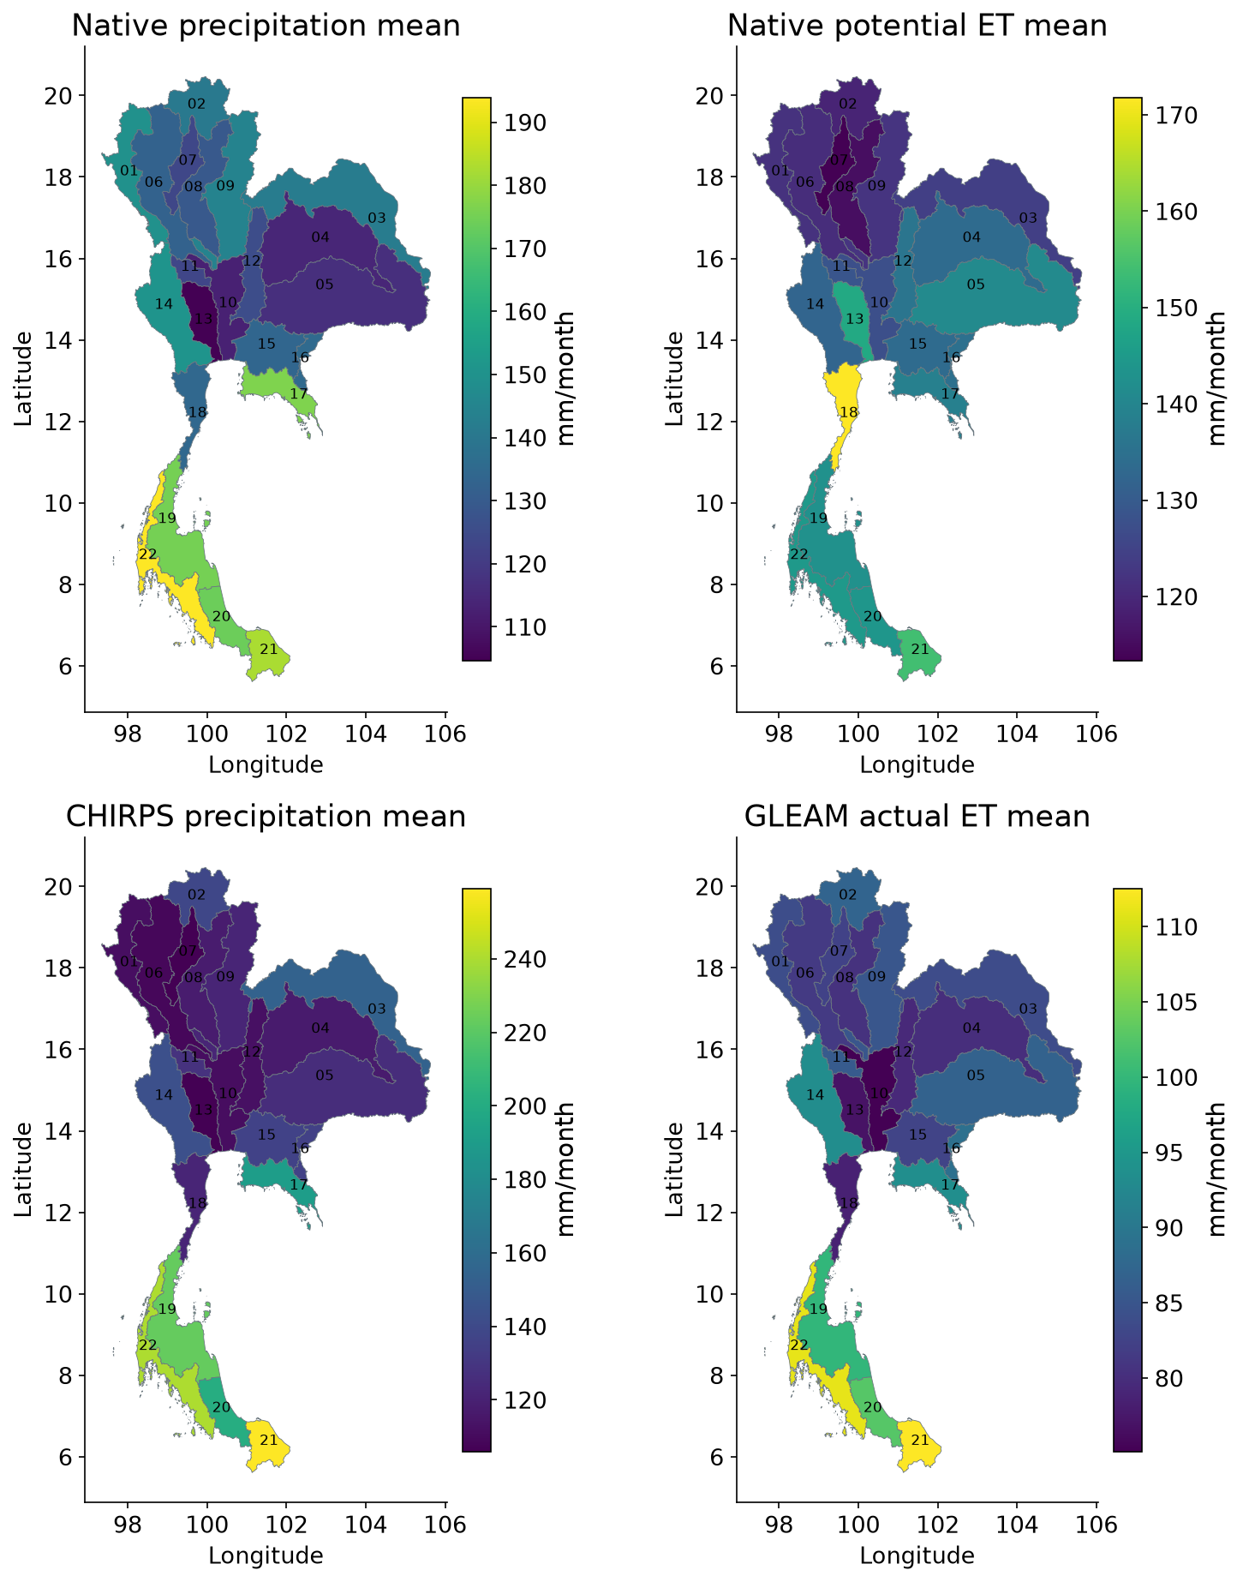
Figure D.1 Mean forcing and supporting data 1
Available-month means within 2003–2023; values describe basin averages, not native pixel trends. Native precipitation and PET drive the climate reconstruction; CHIRPS is alternative rainfall. Actual ET, soil moisture and surface temperature provide context. Unequal product coverage is retained; no significance or causal attribution is implied.
Trend in forcing and supporting data 1
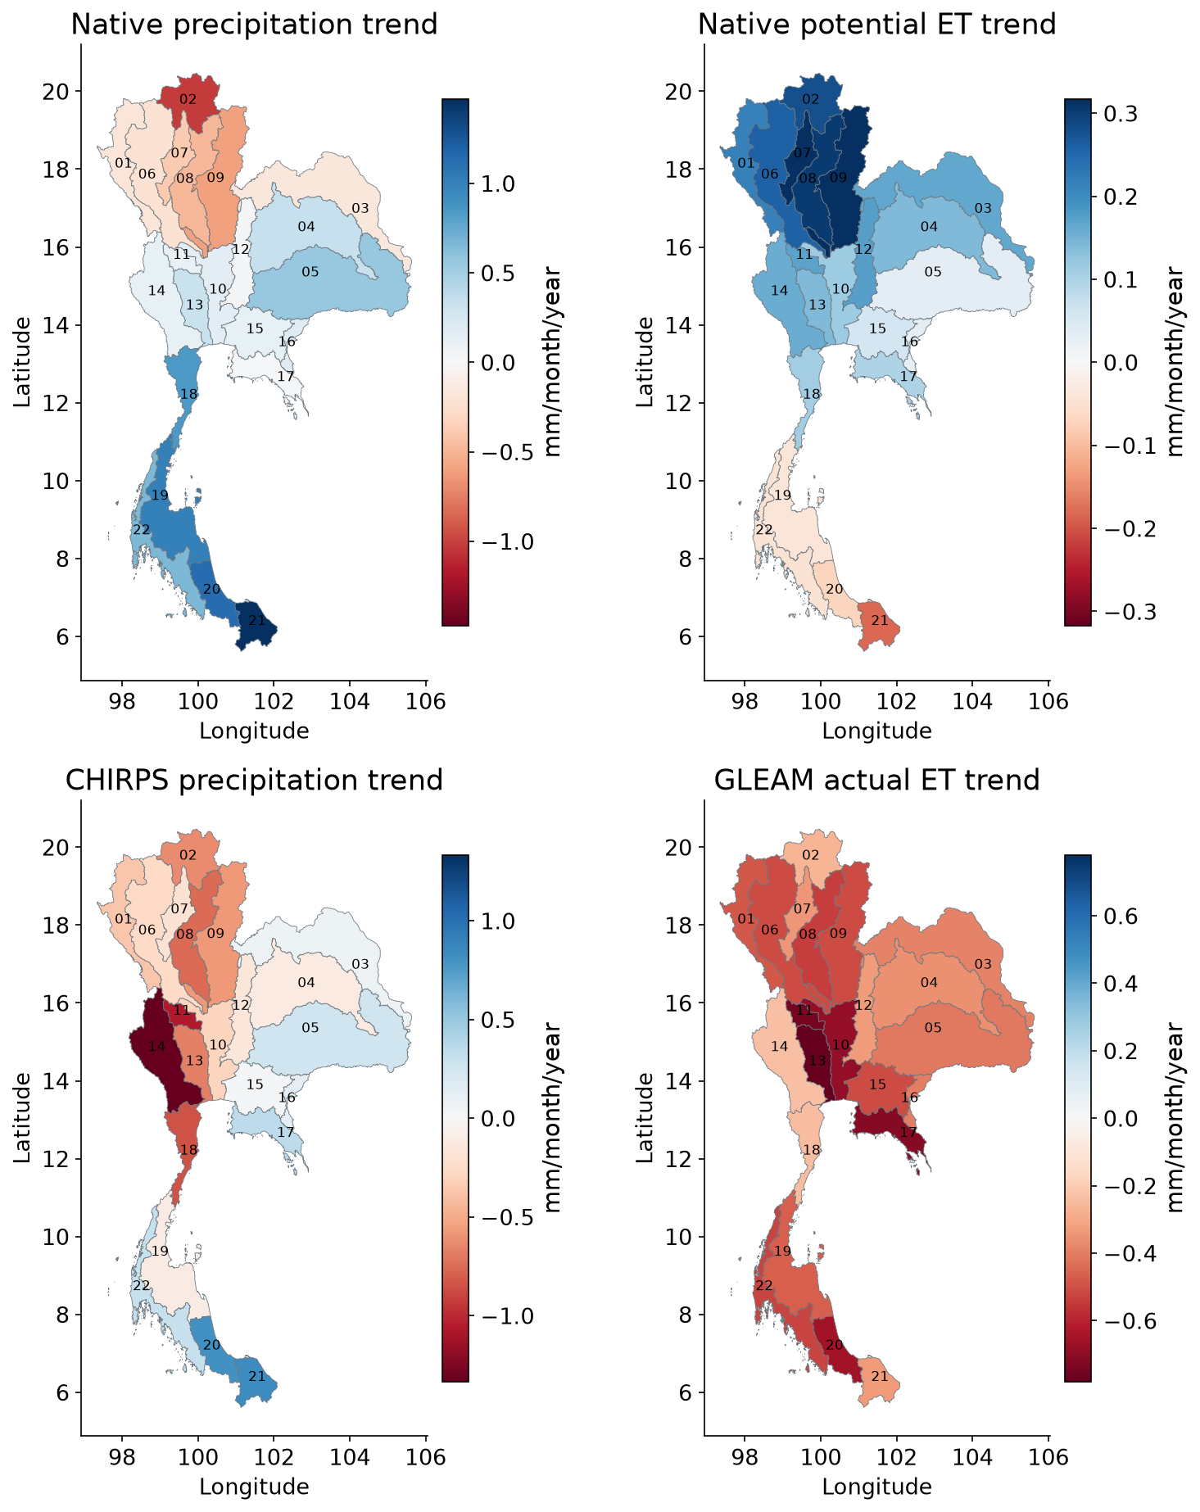
Figure D.2 Trend in forcing and supporting data 1
OLS slopes with calendar-month effects within 2003–2023; values describe basin averages, not native pixel trends. Native precipitation and PET drive the climate reconstruction; CHIRPS is alternative rainfall. Actual ET, soil moisture and surface temperature provide context. Unequal product coverage is retained; no significance or causal attribution is implied.
Mean forcing and supporting data 2
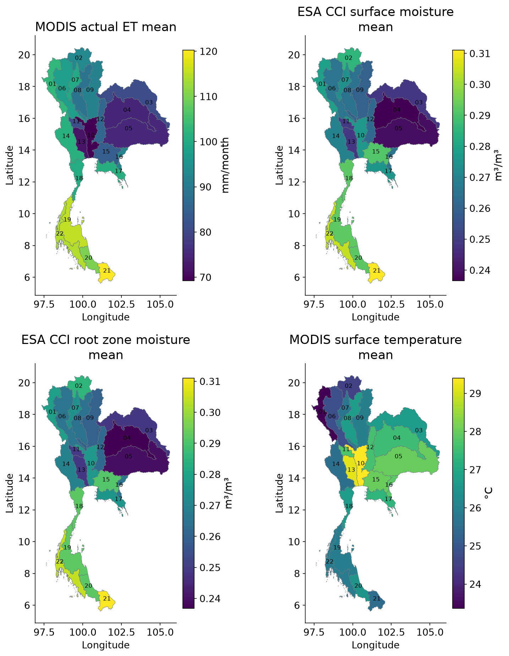
Figure D.3 Mean forcing and supporting data 2
Available-month means within 2003–2023; values describe basin averages, not native pixel trends. Native precipitation and PET drive the climate reconstruction; CHIRPS is alternative rainfall. Actual ET, soil moisture and surface temperature provide context. Unequal product coverage is retained; no significance or causal attribution is implied.
Trend in forcing and supporting data 2
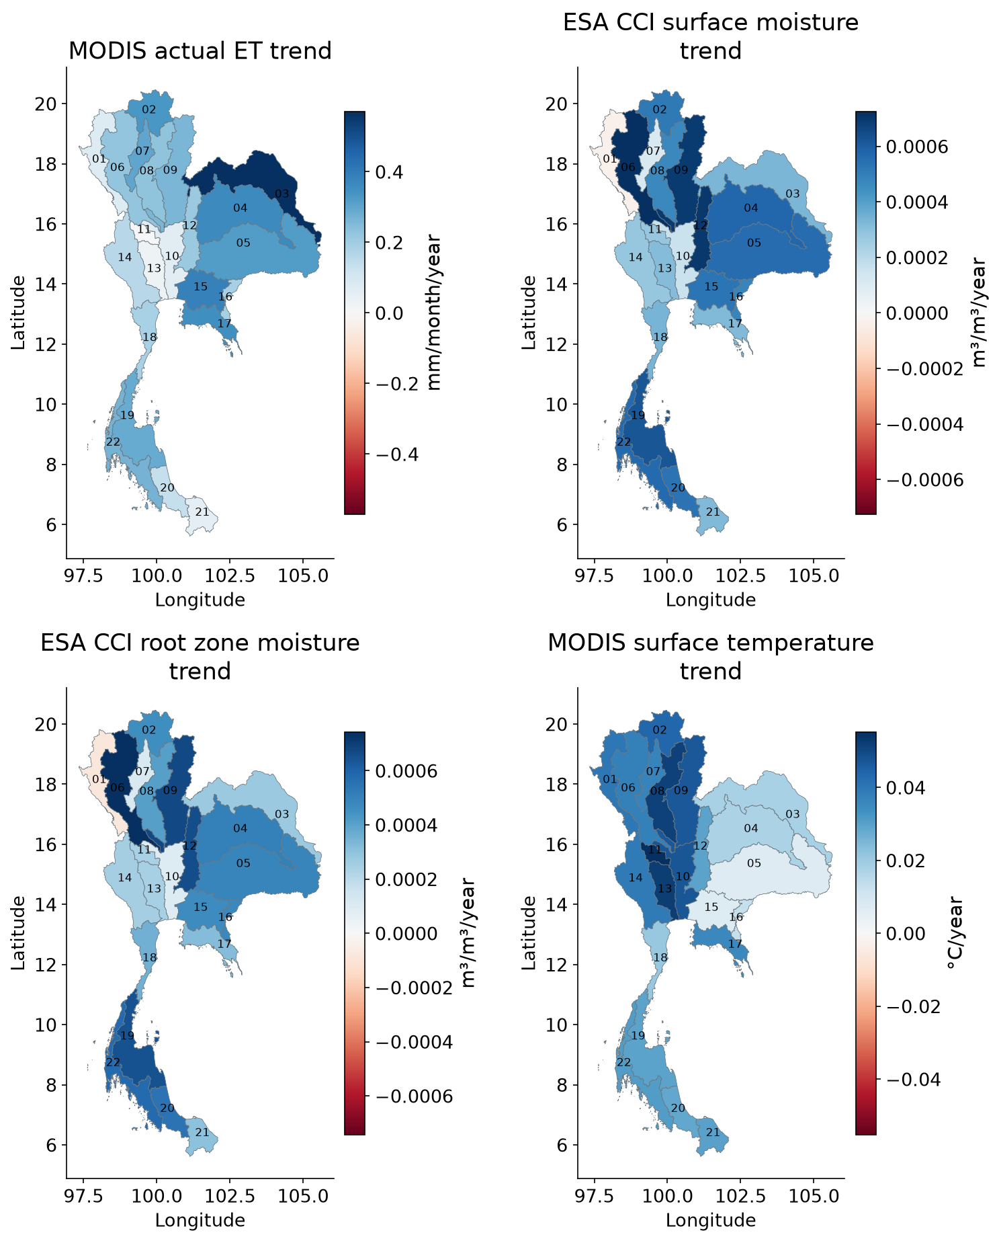
Figure D.4 Trend in forcing and supporting data 2
OLS slopes with calendar-month effects within 2003–2023; values describe basin averages, not native pixel trends. Native precipitation and PET drive the climate reconstruction; CHIRPS is alternative rainfall. Actual ET, soil moisture and surface temperature provide context. Unequal product coverage is retained; no significance or causal attribution is implied.
Native precipitation for all basins
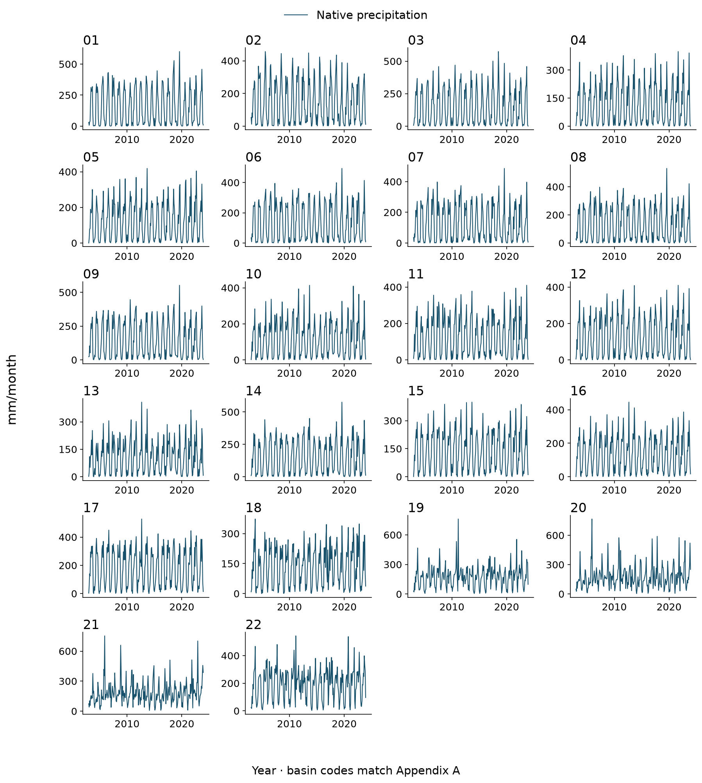
Figure D.5 Native precipitation for all basins
Monthly basin means during 2003–2023, in the stated physical units. Every basin is shown; unavailable months remain gaps. These are actual meteorological climate-model inputs.
Native potential ET for all basins
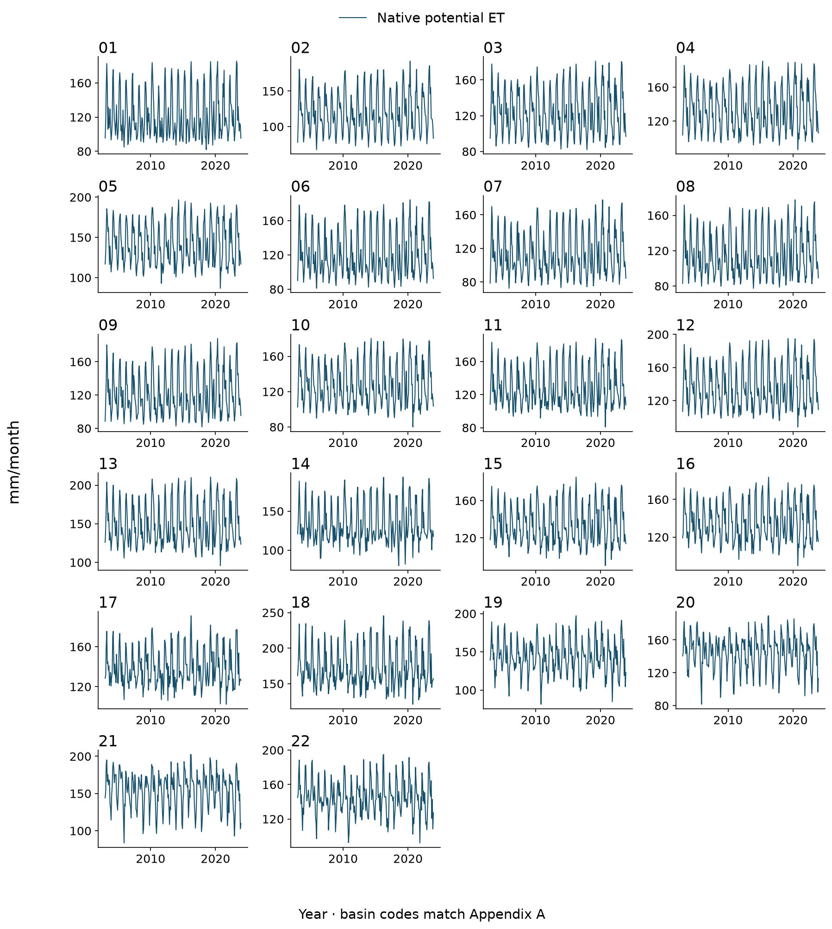
Figure D.6 Native potential ET for all basins
Monthly basin means during 2003–2023, in the stated physical units. Every basin is shown; unavailable months remain gaps. These are actual meteorological climate-model inputs.
CHIRPS precipitation for all basins
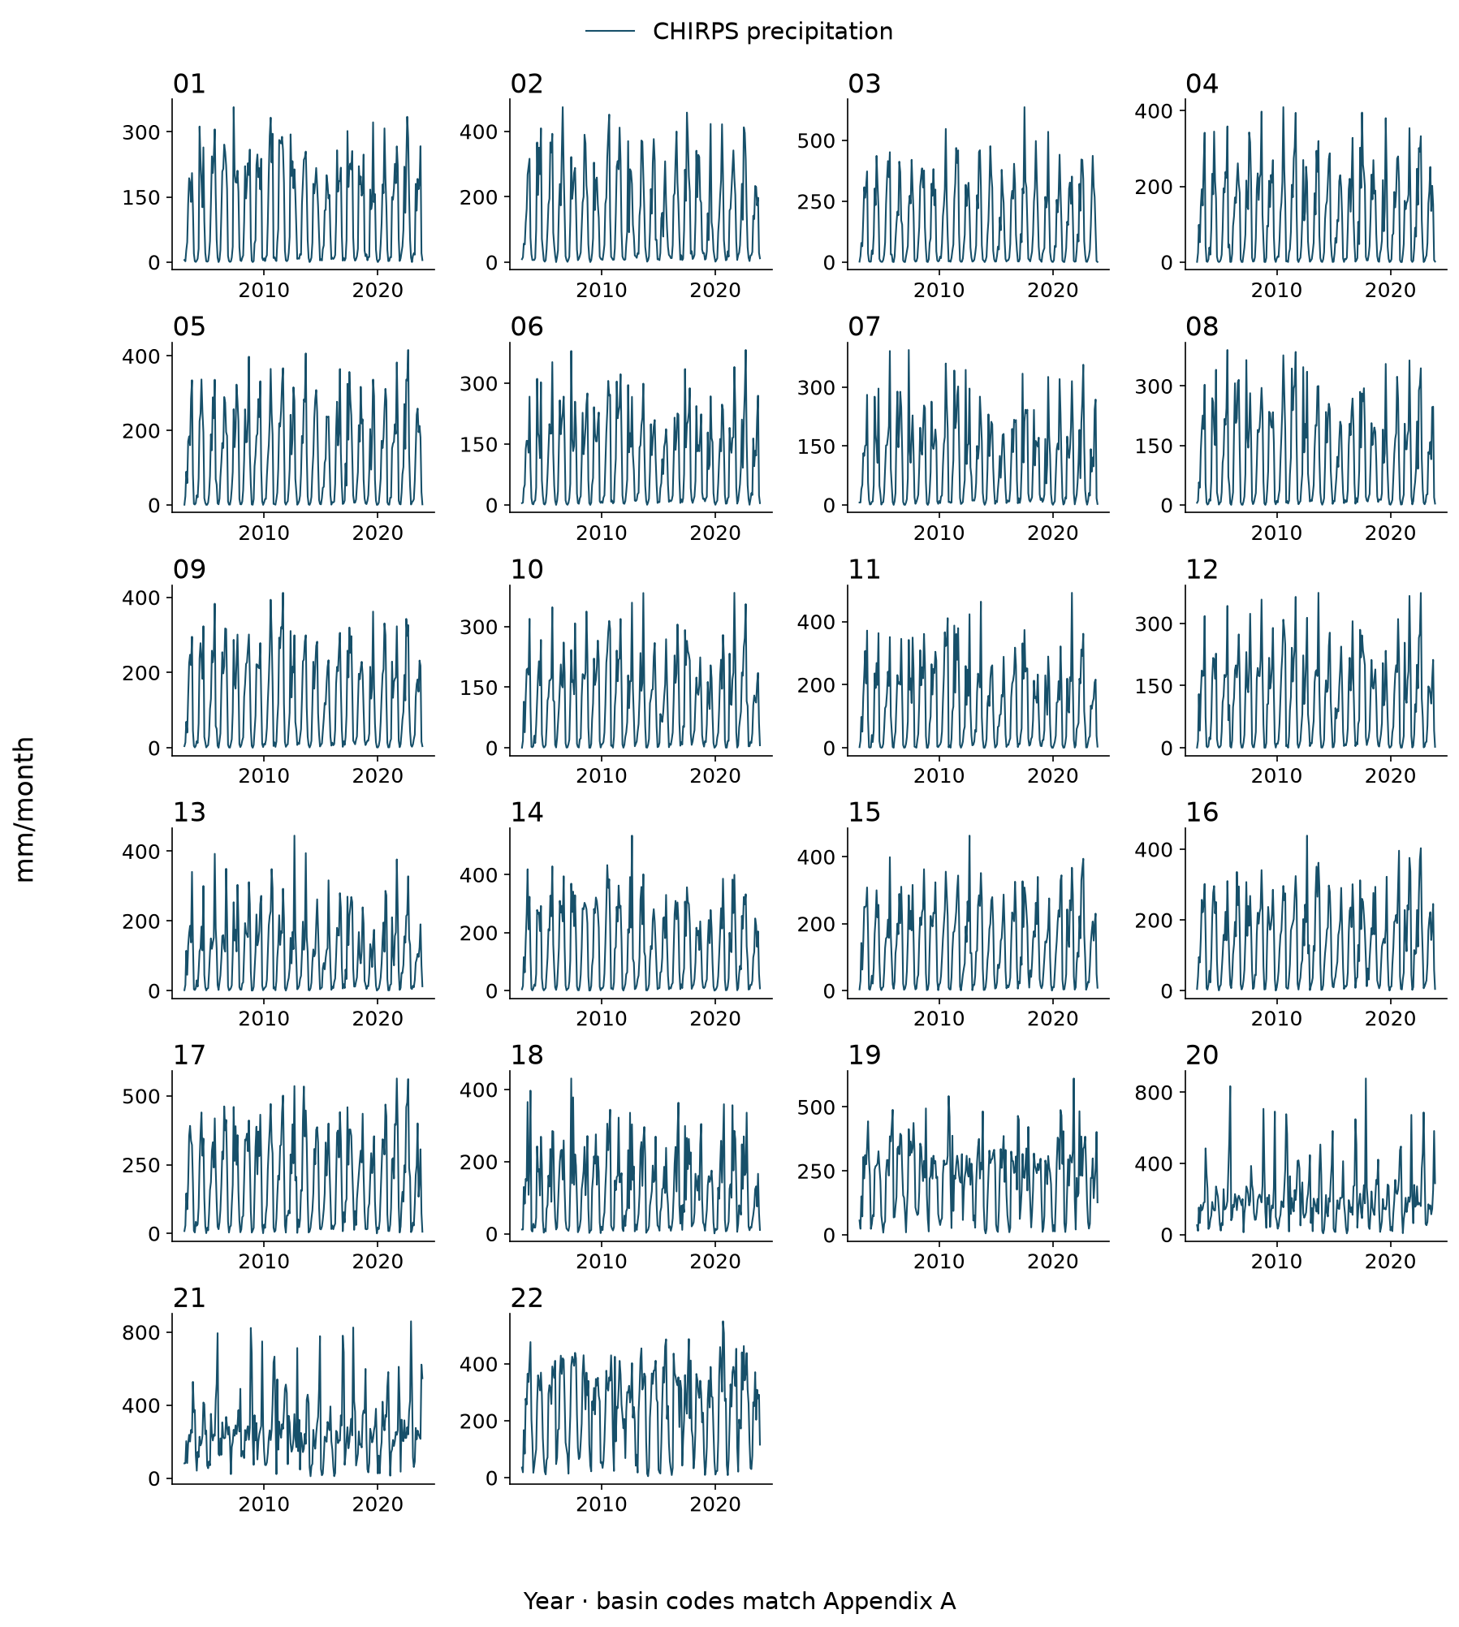
Figure D.7 CHIRPS precipitation for all basins
Monthly basin means during 2003–2023, in the stated physical units. Every basin is shown; unavailable months remain gaps. CHIRPS is used as alternative rainfall in the forcing test.
GLEAM actual ET and MODIS actual ET for all basins
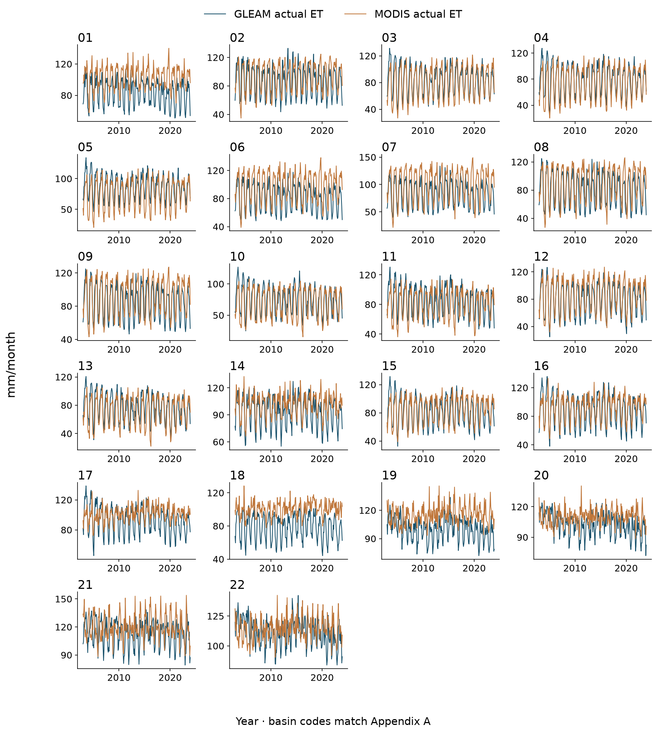
Figure D.8 GLEAM actual ET and MODIS actual ET for all basins
Monthly basin means during 2003–2023, in the stated physical units. Every basin is shown; unavailable months remain gaps. These datasets provide supporting context; they are not additional predictors in the primary climate reconstruction.
ESA CCI surface moisture and ESA CCI root zone moisture for all basins
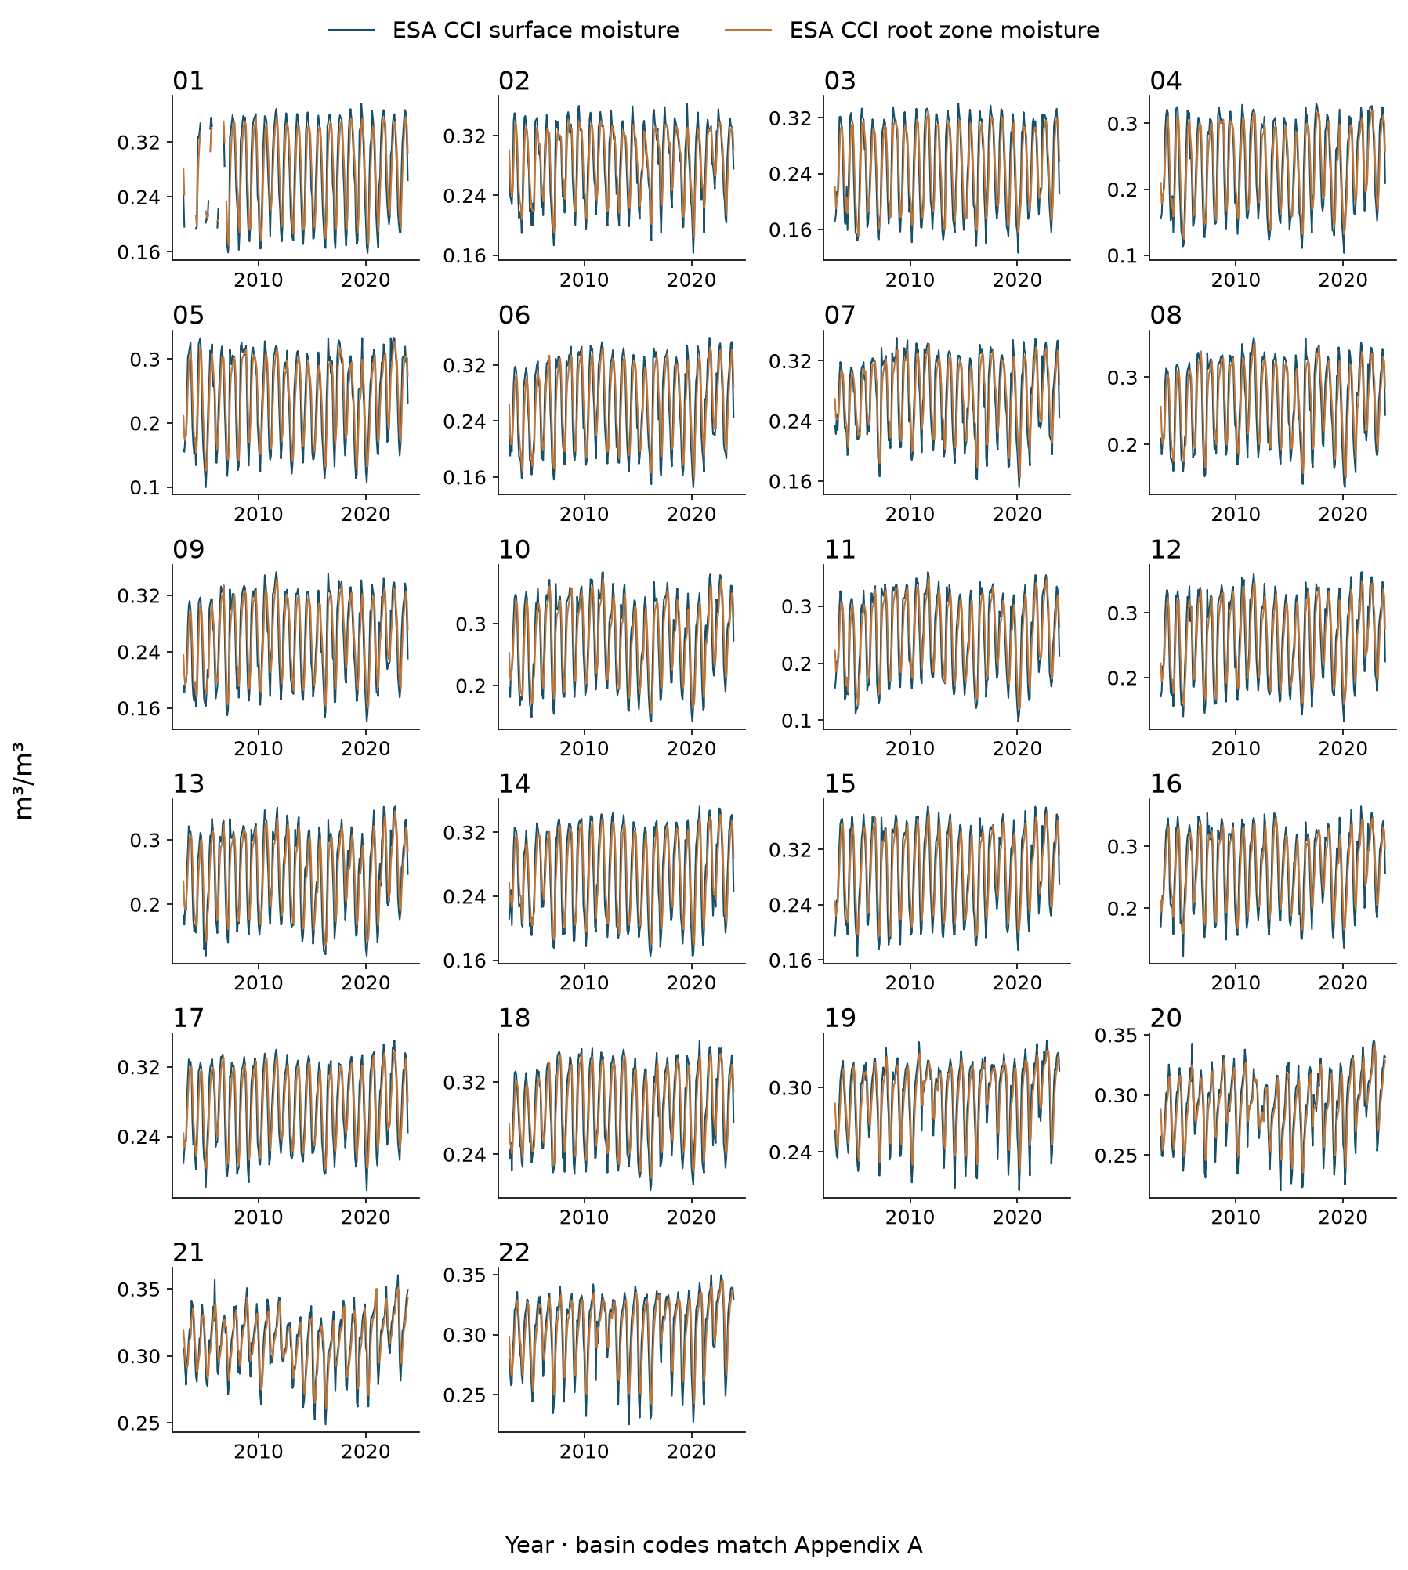
Figure D.9 ESA CCI surface moisture and ESA CCI root zone moisture for all basins
Monthly basin means during 2003–2023, in the stated physical units. Every basin is shown; unavailable months remain gaps. These datasets provide supporting context; they are not additional predictors in the primary climate reconstruction.
MODIS surface temperature for all basins
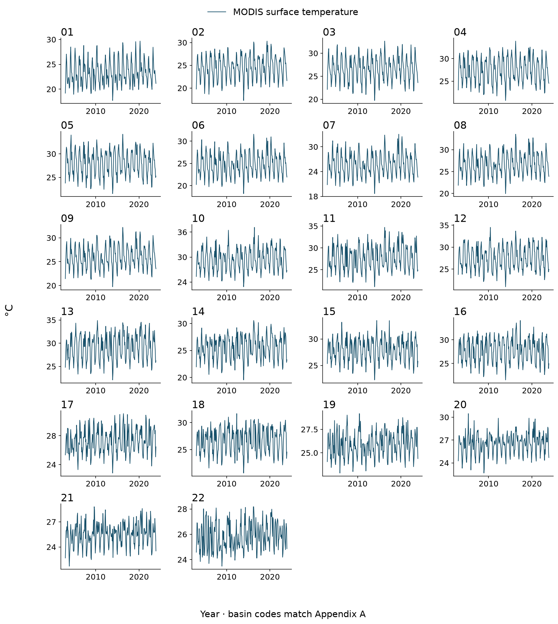
Figure D.10 MODIS surface temperature for all basins
Monthly basin means during 2003–2023, in the stated physical units. Every basin is shown; unavailable months remain gaps. These datasets provide supporting context; they are not additional predictors in the primary climate reconstruction.

