Basin Scale Water Storage Trends and Climate Attribution in Thailand
by
Farzeen Khanal
Research Report
Master of Science in Water Engineering and Management
Advisor Dr. Natthachet Tangdamrongsub
Asian Institute of Technology
Thailand
October 2026

ABSTRACT
Thailand requires basin-scale evidence that distinguishes water-storage trends from the drivers of change. This study assessed terrestrial water storage anomalies (TWSA) and groundwater storage anomalies (GWSA) in 22 principal basins using the supplied GRACE/GRACE-FO record, a full-compartment groundwater balance, naturalized and historical-human WaterGAP simulations, and observed groundwater heads. Seasonal Sen slopes, Mann–Kendall tests, false-discovery-rate adjustment and calendar-year bootstrap intervals characterized trends. Climate emulators were trained on naturalized model storage rather than GRACE, using meteorological precipitation, potential evapotranspiration and antecedent memory. Training in 1991–2009, validation in 2010–2015 and testing in 2016–2023 separated model development from evaluation. The original national records showed seasonal Sen slopes of −7.46 mm/year for TWSA through September 2024 and −6.82 mm/year for GWSA through September 2023. National emulator test NSE was 0.981 for TWSA and 0.961 for GWSA; deseasonalized NSE was 0.888 and 0.781. These scores verify reproduction of a hydrological model, not observed human depletion. Naturalized-model comparison with observed storage was weaker, especially for GWSA. Groundwater evidence comprised 5,484 aggregates from 511 wells, predominantly annual. Residual–head correlations were 0.142 for TWSA and 0.054 for GWSA, with similarly weak climate-controlled associations. A public decision-support application exposes all basin results and their limitations. The study establishes a reproducible climate-baseline framework but does not validate interpreting the entire unexplained residual as human-caused depletion. Coarse GRACE support, compartment filtering, sparse aquifer information and incomplete original GRACE processing metadata constrain causal interpretation.

CONTENTS
ABSTRACT ii
LIST OF TABLES v
LIST OF FIGURES v
ABBREVIATIONS vi
CHAPTER 1 INTRODUCTION 1
1.1 Background 1
1.2 Problem statement 1
1.3 Research objectives 1
1.4 Scope and organization 2
CHAPTER 2 LITERATURE REVIEW 3
2.1 Satellite storage and spatial support 3
2.2 Groundwater balance and head observations 3
2.3 Naturalized hydrological counterfactuals 4
2.4 Trend inference 4
CHAPTER 3 METHODOLOGY 5
3.1 Study area and data 5
3.2 Storage balance and spatial support 5
3.3 Naturalized and human decomposition 6
3.4 Climate emulator development and verification 6
3.5 Groundwater observations and validation 7
3.6 Trend inference and uncertainty 7
3.7 Decision support and reproducibility 8
CHAPTER 4 RESULTS AND DISCUSSION 9
4.1 Storage trends across all basins 9
4.2 Climate emulator verification 9
4.3 Hydrological benchmarks 10
4.4 Climate residual and model discrepancy 11
4.5 Groundwater evidence 13
4.6 Integrated discussion 14
4.7 Limitations and uncertainty 15
4.8 Interactive decision support 15
CHAPTER 5 CONCLUSIONS AND RECOMMENDATIONS 16
5.1 Conclusions 16
5.2 Recommendations 16
REFERENCES 17
APPENDIX A BASIN RESULTS 19
APPENDIX B REPRODUCIBILITY AND DATA PROVENANCE 21

LIST OF TABLES
Table 4.1 National observed trends 9
Table 4.2 Climate emulator test performance 10
Table 4.3 Climate and human component trends 12
Table 4.4 Groundwater residual evidence 14
Table A.1 All basin storage trends 19
Table A.2 All basin climate emulator verification 20

LIST OF FIGURES
Figure 4.1 Emulator verification 10
Figure 4.2 Observed and modeled national storage 11
Figure 4.3 Residual and model discrepancy 12
Figure 4.4 Basin climate and residual trends 13
Figure 4.5 Groundwater residual agreement 14

ABBREVIATIONS
AIT Asian Institute of Technology
TWSA Terrestrial water storage anomaly
GWSA Groundwater storage anomaly
GLDAS Global Land Data Assimilation System
G3P Global Gravity based Groundwater Product
NSE Nash Sutcliffe efficiency
FDR False discovery rate
OLS Ordinary least squares
O Observed storage C Naturalized model A Historical human model
R Observed residual H Modeled human effect E Model discrepancy

CHAPTER 1
INTRODUCTION

1.1 Background
Water-storage change integrates processes that rainfall or streamflow alone cannot describe. Soil water, surface water, canopy water, snow and groundwater contribute to terrestrial storage, but each responds differently to climate and management. In a monsoonal setting, a model may achieve a high correlation simply by following the wet and dry seasons. Basin planning therefore requires tests of interannual variability as well as transparent treatment of the seasonal cycle.
Thailand's principal basins provide an operational framework for comparing water availability and evidence gaps. Satellite gravimetry adds broad spatial coverage, while wells supply local observations of aquifer response. These measurements have different physical meanings and effective spatial scales. Their joint use is informative only when differences in units, sampling frequency, aquifer support and storage compartments are kept explicit.

1.2 Problem statement
A regression trained directly against GRACE learns the combined effects present in observed storage. If irrigation, abstraction or reservoir operations already affect the training target, the fitted relationship cannot automatically represent a world without those activities. Actual evapotranspiration, soil moisture and land-surface temperature can also respond to management. Calling the prediction purely climatic and the residual purely human would therefore exceed what that design identifies.
A second problem concerns validation. A well records hydraulic head at a point, whereas TWSA represents the integrated mass of several water compartments over a broad region. Even a groundwater head series contains both natural recharge effects and human effects. Agreement between a total-storage residual and well levels is consequently supporting groundwater evidence, not a direct measurement of human TWSA.

1.3 Research objectives
The first objective was to characterize temporal and spatial TWSA and GWSA trends for every principal basin, retaining uncertainty, missing observations and statistical limitations. The second objective was to develop and evaluate climate-storage emulators against a documented naturalized hydrological baseline, then assess observed residuals alongside paired modeled human effects and groundwater evidence. The third objective was to provide an interactive decision-support system with basin comparison, time-series exploration and downloadable results. Together these objectives connect observation, model evaluation and evidence-based interpretation without requiring every basin to demonstrate anthropogenic depletion.

1.4 Scope and organization
The supplied TWSA record spans April 2002 to September 2024; the full-compartment GWSA record ends September 2023 because the surface-water correction ends then. WaterGAP simulations were extracted for 1981–2023, providing a longer climate-model development period and a common observed-attribution period where records overlap. The national aggregate supplies context and is not a twenty-third independent basin. Results describe anomalies relative to 2004–2009 rather than total historical water loss before the satellite record.

CHAPTER 2
LITERATURE REVIEW

2.1 Satellite storage and spatial support
GRACE-based storage estimates are useful because they integrate water mass across compartments rather than observing only the surface. Their spatial information is nevertheless much coarser than a nominal grid spacing may suggest. Replicating a parent model cell onto smaller grid cells does not create new observations, and adjacent small basins may share most of their gravimetric information. This study therefore reports basin and grid results while retaining the limitation of shared spatial support.
The supplied GRACE NetCDF declares centimetres, EPSG 4326 and nominal 0.25-degree sampling, but does not identify the processing centre, release or leakage correction. The calculations convert the declared units explicitly and preserve the input record, rather than guessing a mascon product. Quantitative magnitudes remain conditional on that supplied dataset. Recovery of the original processing metadata and comparison with another identified GRACE solution are required before definitive publication claims.

2.2 Groundwater balance and head observations
Groundwater anomalies are obtained by subtracting non-groundwater storage anomalies from TWSA, with all terms on compatible units, references and support. G3P illustrates the importance of combining gravimetry with compartment estimates and documenting spatial filtering (Güntner et al., 2024). Different soil definitions or filters can produce different groundwater estimates even when the same gravimetric information is used. This study retains a filtered-soil sensitivity and a related G3P groundwater product rather than treating one subtraction as exact truth.
Groundwater head offers a separate observation type but not an automatic mass conversion. For an unconfined aquifer, storage change depends on specific yield and head change; confined storage requires an appropriate storage coefficient. Those coefficients, aquifer boundaries and representative spatial weights are not available for the Thai records used here. Correlation and direction checks are therefore used without inventing storage volumes or storage NSE against raw heads.

2.3 Naturalized hydrological counterfactuals
WaterGAP provides a documented naturalized experiment in which direct water use is disabled and artificial reservoirs are removed, alongside historical-human simulations driven by the same climate forcing (Müller Schmied et al., 2024). This offers a more explicit climate baseline than fitting observed total storage and naming the fitted part natural. It remains a model counterfactual conditional on forcing, parameters, routing and land representation. The paired difference identifies modeled direct human effects, not an independently measured pumping history.
GLDAS supplies another hydrological perspective but its model structure must be respected. Noah land storage contains soil, canopy and snow, without a groundwater compartment (Rodell et al., 2004; NASA, n.d.). The revised benchmark compares matching compartment types rather than demanding that Noah validate full TWSA or GWSA. Soil column definitions still differ across models, so even this comparison is cross-model consistency rather than observational truth.

2.4 Trend inference
Seasonality, missing observations and serial dependence complicate hydrological trend assessment. Seasonal rank methods reduce the influence of within-year cycling, but ordinary seasonal Mann–Kendall significance does not remove all temporal dependence (Hirsch et al., 1982; Hirsch & Slack, 1984). False-discovery-rate adjustment addresses multiple comparisons, not common GRACE spatial support. Robust slopes, annual checks and block-bootstrap intervals are consequently reported together rather than interpreting a small p-value as a causal result.

CHAPTER 3
METHODOLOGY

3.1 Study area and data
The project uses the supplied ONWR principal-basin shapefile and authoritative polygon–grid intersection weights. Six separately coded island features are assigned to their parent basin for map geometry and well assignment. Observational inputs include GRACE TWSA, GLDAS Noah soil/canopy/snow storage, G3P modeled surface water, and previously harmonized CHIRPS, GLEAM, MODIS and ESA CCI predictors. Original inputs, source subsets, acquisition provenance and analysis scripts remain available in the local project.
The revised climate baseline uses public WaterGAP 2.2e GSWP3–ERA5 naturalized and historical-human outputs ending December 2023. Ten variable/scenario subsets were extracted from publisher-supported byte ranges and retained with source identifiers and checksums. The source uses a synthetic 360-day calendar for monthly labels; year and month identities were mapped to month starts without generating daily values or interpolating observations. Meteorological rates were converted to mean mm/day for the emulator predictors, avoiding an assumed conversion from synthetic months to physical monthly totals.

3.2 Storage balance and spatial support
Every groundwater balance term is expressed in millimetres of equivalent water height and rebased to the common 2004–2009 reference. Regional compartment exports use the identical groundwater-valid cells and months, with the corresponding TWSA exported as TWSA_GWS_reference. Soil moisture includes the four GLDAS Noah layers; surface water includes modeled rivers, lakes and reservoirs. Canopy and snow are retained rather than silently assumed zero.
Primary observed and model components are compared on a common valid footprint, with a minimum 50 percent basin-area threshold for the revised attribution. The original trend analysis retains its own documented coverage policy, so its full-record slopes need not equal the shorter common-support slopes. Parent-cell replication is used only for aligned grids and adds no information. Component filtering differences, soil depth differences and coastal leakage remain structural uncertainties.
$${GWSA}_{obs} = {TWSA}_{obs} - SMSA - SWSA - CWSA - SWEA$$

3.3 Naturalized and human decomposition
Let O denote observed storage, C the naturalized model, and A the paired historical-human model. The observation-based residual is R = O − C, the modeled direct-human effect is H = A − C, and model discrepancy is E = O − A. On identical support, R = H + E exactly. This identity prevents the entire residual from being assigned to humans when the historical-human model still differs substantially from observations.
Naturalized and historical-human simulations are each rebased on the same observed reference months. Consequently H describes the change in modeled human influence relative to the reference period; it is not cumulative depletion since the beginning of development. No hydrological model values beyond December 2023 are invented. The published physical simulation supplies the primary counterfactual, while statistical emulators test how well meteorological information reproduces that simulation.
$$R = O - C = (A - C) + (O - A) = H + E$$

3.4 Climate emulator development and verification
The emulator predictors are meteorological precipitation, potential evapotranspiration, causal lags, antecedent exponential memory indices and annual/semiannual harmonics. Lags of 0, 1, 2, 3, 6 and 12 months and memory constants of 1, 3, 6, 12 and 24 months represent immediate and delayed response. No GRACE lag, observed well level or unrestricted calendar-year trend is included. This prevents an apparent improvement obtained simply by learning an observed depletion trend.
The years 1981–1990 provide warm-up, 1991–2009 training, 2010–2015 validation and 2016–2023 the untouched test. Ridge, ElasticNet, additive splines and Random Forest are tuned using two chronological folds within training. Scaling and spline transformations are fitted only in each training fold. Validation selects up to three members that improve on training climatology and have positive deseasonalized NSE; inverse-validation-error weights are then frozen before testing.
Monthly NSE, r, RMSE, bias and skill relative to training climatology are reported. Deseasonalized performance subtracts the same training-derived calendar-month reference from target and prediction, preserving prediction bias. These are emulator-verification scores against naturalized model output and must not be relabelled independent groundwater validation. The original GRACE-trained M0–M4 experiments remain a separate empirical sensitivity because their actual-ET, soil and temperature predictors can include management effects.

3.5 Groundwater observations and validation
The groundwater extraction contains 5,484 observed aggregates from 511 wells: 5,259 annual aggregates from 506 wells and 225 monthly aggregates from five wells. Positive depth below ground is converted to signed head by negation. Per-well standardized anomalies are descriptive indices, and co-located wells are collapsed into coordinate-station groups before equal-weight basin aggregation. Annual observations remain annual; the source typically aggregates only two readings in a year.
Annual comparisons require at least eight observed storage months and exclude incomplete endpoint years. Raw annual agreement is supplemented by partial correlation controlling naturalized climate, linear detrending and differences between consecutive observed years only. At least six annual pairs are required for raw correlations and eight for partial/detrended checks. Provider-flag exclusion and a fixed-eligibility panel test sensitivity to record quality and observation-network composition.
These checks test consistency rather than human pumping volumes. A groundwater head index can support or challenge the groundwater residual interpretation, but it cannot observe river, reservoir or soil contributions to human TWSA. Even a positive groundwater correlation can reflect shared climate or trend, which motivates the additional checks. Missing aquifer metadata and storage coefficients prevent direct conversion from head to groundwater mass.
$${ΔS}_{gw} = 1000 S_{y} Δh$$

3.6 Trend inference and uncertainty
Seasonal Sen slopes use same-calendar-month pairs and actual elapsed years. Original and seasonal Mann–Kendall, annual tests and false-discovery-rate q-values are retained; annual serial-correlation correction is reported only when annual records are contiguous. Original basin slope intervals use 300 calendar-year residual-block resamples, while the revised component analysis uses 100 exploratory resamples. These intervals do not propagate all observation, forcing and structural errors.
Sen slopes of components are not additive because a median is not a linear operator. An additional trend partition therefore uses ordinary least squares with calendar-month fixed effects and identical observed dates. Its point slopes satisfy the component identities exactly, but the coefficients are not causal fractions. No percentage of human depletion is reported simply by dividing a residual Sen slope by the observed Sen slope.

3.7 Decision support and reproducibility
The decision-support system is a static, publicly hosted GitHub Pages application using Leaflet and ECharts. It presents the 22 principal basins plus national context, storage selection, trend maps, time-series zoom, annual aggregation and CSV export. The revised validation panel separates emulator verification, matched-compartment GLDAS comparison, historical-human model agreement and well-head consistency. Source and interpretation notes are accessible beside the results.
Scientific checks verify groundwater-balance identities, the residual decomposition, common-date linear trend additivity, target/region counts and preservation of missing observations. Browser checks exercise basin selection, all three views, storage controls and download rows on desktop and mobile. A working interface does not establish that an attribution hypothesis is true. Its contribution is to make both the evidence and its weaknesses reviewable.

CHAPTER 4
RESULTS AND DISCUSSION

4.1 Storage trends across all basins
All 22 basins have TWSA and GWSA seasonal trend estimates in the supplied dataset. National full-record TWSA declines at −7.46 mm/year, with a 300-resample interval of −9.60 to −5.69 mm/year. GWSA declines at −6.82 mm/year, with an interval of −8.64 to −5.13 mm/year. The records contain 235 and 223 observed monthly values, respectively, and the GWSA period is shorter.
The strongest negative slopes occur in several coastal southern basins, where leakage and compartment/support differences deserve particular attention. Statistical significance cannot resolve these spatial-processing uncertainties. The filtered-soil GWSA sensitivity gives a national slope of −7.79 mm/year, whereas the related G3P groundwater product gives −3.45 mm/year. The direction is consistent nationally across those estimates, but the magnitude is clearly product dependent.
Table 4.1 National full record observed storage trends
Storage | Months | Sen mm/year | 95 percent interval
TWSA | 235 | −7.46 | −9.60 to −5.69
GWSA | 223 | −6.82 | −8.64 to −5.13

4.2 Climate emulator verification
The revised national emulator achieves test NSE 0.981, r 0.991 and RMSE 13.45 mm for naturalized TWSA, using 96 test months. For naturalized GWSA, NSE is 0.961, r 0.982 and RMSE 5.42 mm. Deseasonalized NSE remains positive at 0.888 and 0.781, respectively. This addresses the earlier weakness of evaluating success mainly through the seasonal cycle.
Across the 22 basins, TWSA emulator NSE ranges from 0.928 to 0.983 and GWSA NSE from 0.892 to 0.970. Deseasonalized NSE ranges from 0.705 to 0.911 for TWSA and from 0.360 to 0.901 for GWSA. Those results show that meteorological memory captures much of the parent model's variability. They do not demonstrate that the parent model's naturalized storage is the true unobserved counterfactual.
Table 4.2 National test performance against naturalized model output
Target | NSE | Anomaly NSE | RMSE mm
TWSA | 0.981 | 0.888 | 13.45
GWSA | 0.961 | 0.781 | 5.42
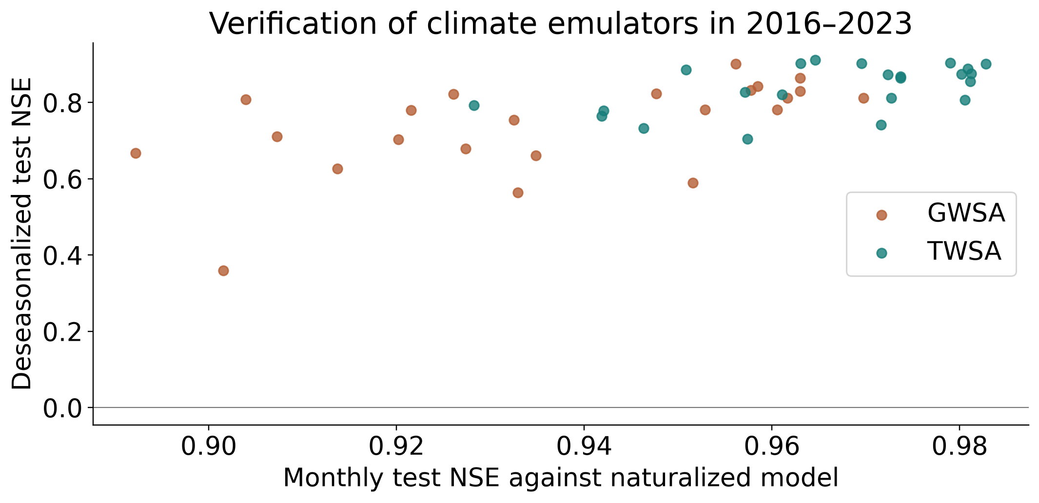
Figure 4.1 Climate emulator verification for 2016 to 2023

4.3 Hydrological benchmarks
The naturalized WaterGAP land-compartment benchmark against GLDAS Noah gives national NSE 0.738 and r 0.969. Agreement is higher than for groundwater because Noah does not supply a groundwater target and the models represent different subsurface storage. Against observed TWSA, the historical-human WaterGAP run gives NSE 0.673 and r 0.873, compared with 0.652 and 0.862 for the naturalized run. This is a modest improvement in observation consistency rather than independent validation of water-use quantities.
For GWSA, naturalized-model observation NSE is only 0.110, and the historical-human run gives 0.093. Thus adding the modeled human effects does not improve national groundwater agreement in this comparison. The results separate strong statistical emulation from weaker hydrological realism. The original GRACE-trained model's test NSE of −0.401 for GWSA is retained as a different empirical experiment, not compared as if its evaluation target were identical.
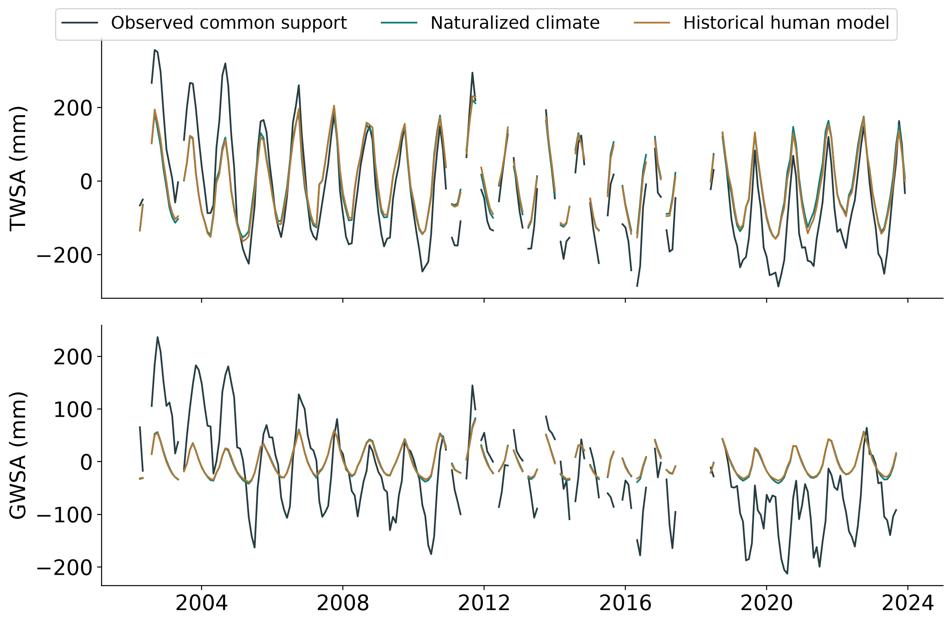
Figure 4.2 Observed and modeled national storage on common support

4.4 Climate residual and model discrepancy
On the common observed-model record, the national naturalized climate Sen slope is −0.25 mm/year for TWSA and −0.05 mm/year for GWSA. The observed residual slopes are −6.61 and −6.55 mm/year. However, the paired modeled-human slopes are only −0.52 mm/year for TWSA and +0.04 mm/year for GWSA. Substantial observation–model discrepancy therefore remains after the model's direct human effects are included.
This result is incompatible with naming every residual unit a validated human contribution. It could reflect unrepresented abstraction, inadequate groundwater dynamics, forcing error, compartment/filtering mismatch, problems in the supplied gravimetry or several mechanisms together. The analysis cannot discriminate those explanations quantitatively with the available observations. Component Sen slopes are shown as separate robust summaries, with an additive fixed-month OLS partition provided separately.
Table 4.3 Common record seasonal Sen component slopes in millimetres per year
Component | TWSA | GWSA
Observed | -7.71 | -6.82
Naturalized climate | -0.25 | -0.05
Modeled direct human | -0.52 | 0.04
Observed residual | -6.61 | -6.55
Model discrepancy | -5.87 | -6.65
The component Sen slopes are not additive. Table values summarize each series robustly; the downloadable fixed-month OLS table provides an additive point-trend decomposition on the same dates.
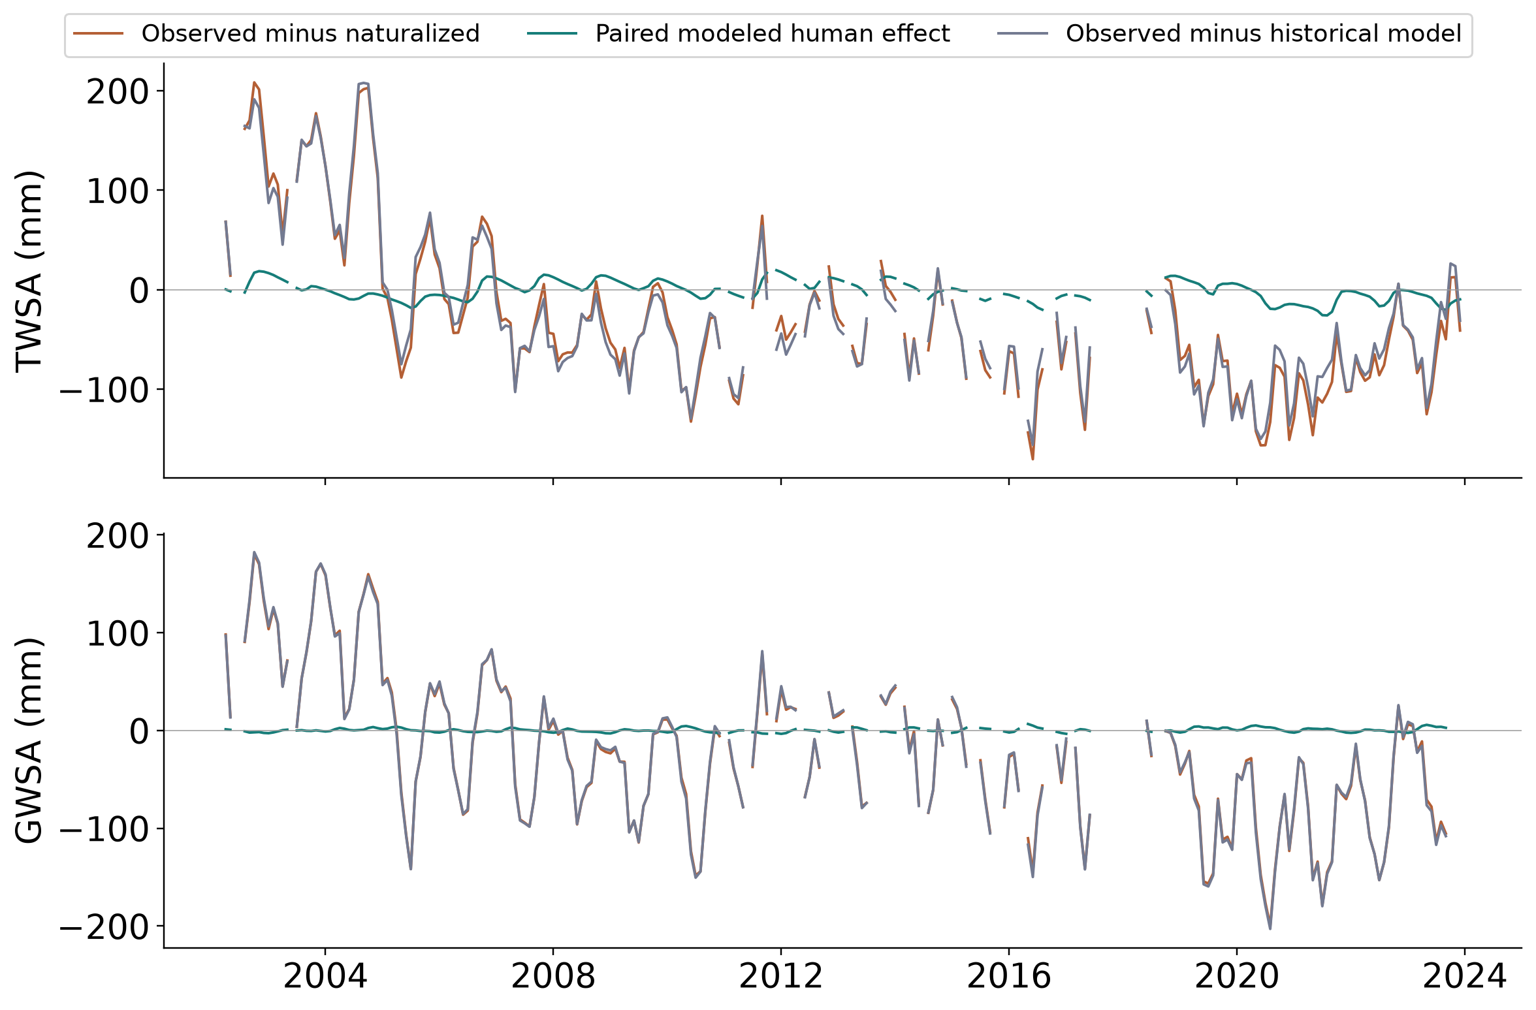
Figure 4.3 Residual and modeled human effect with remaining discrepancy
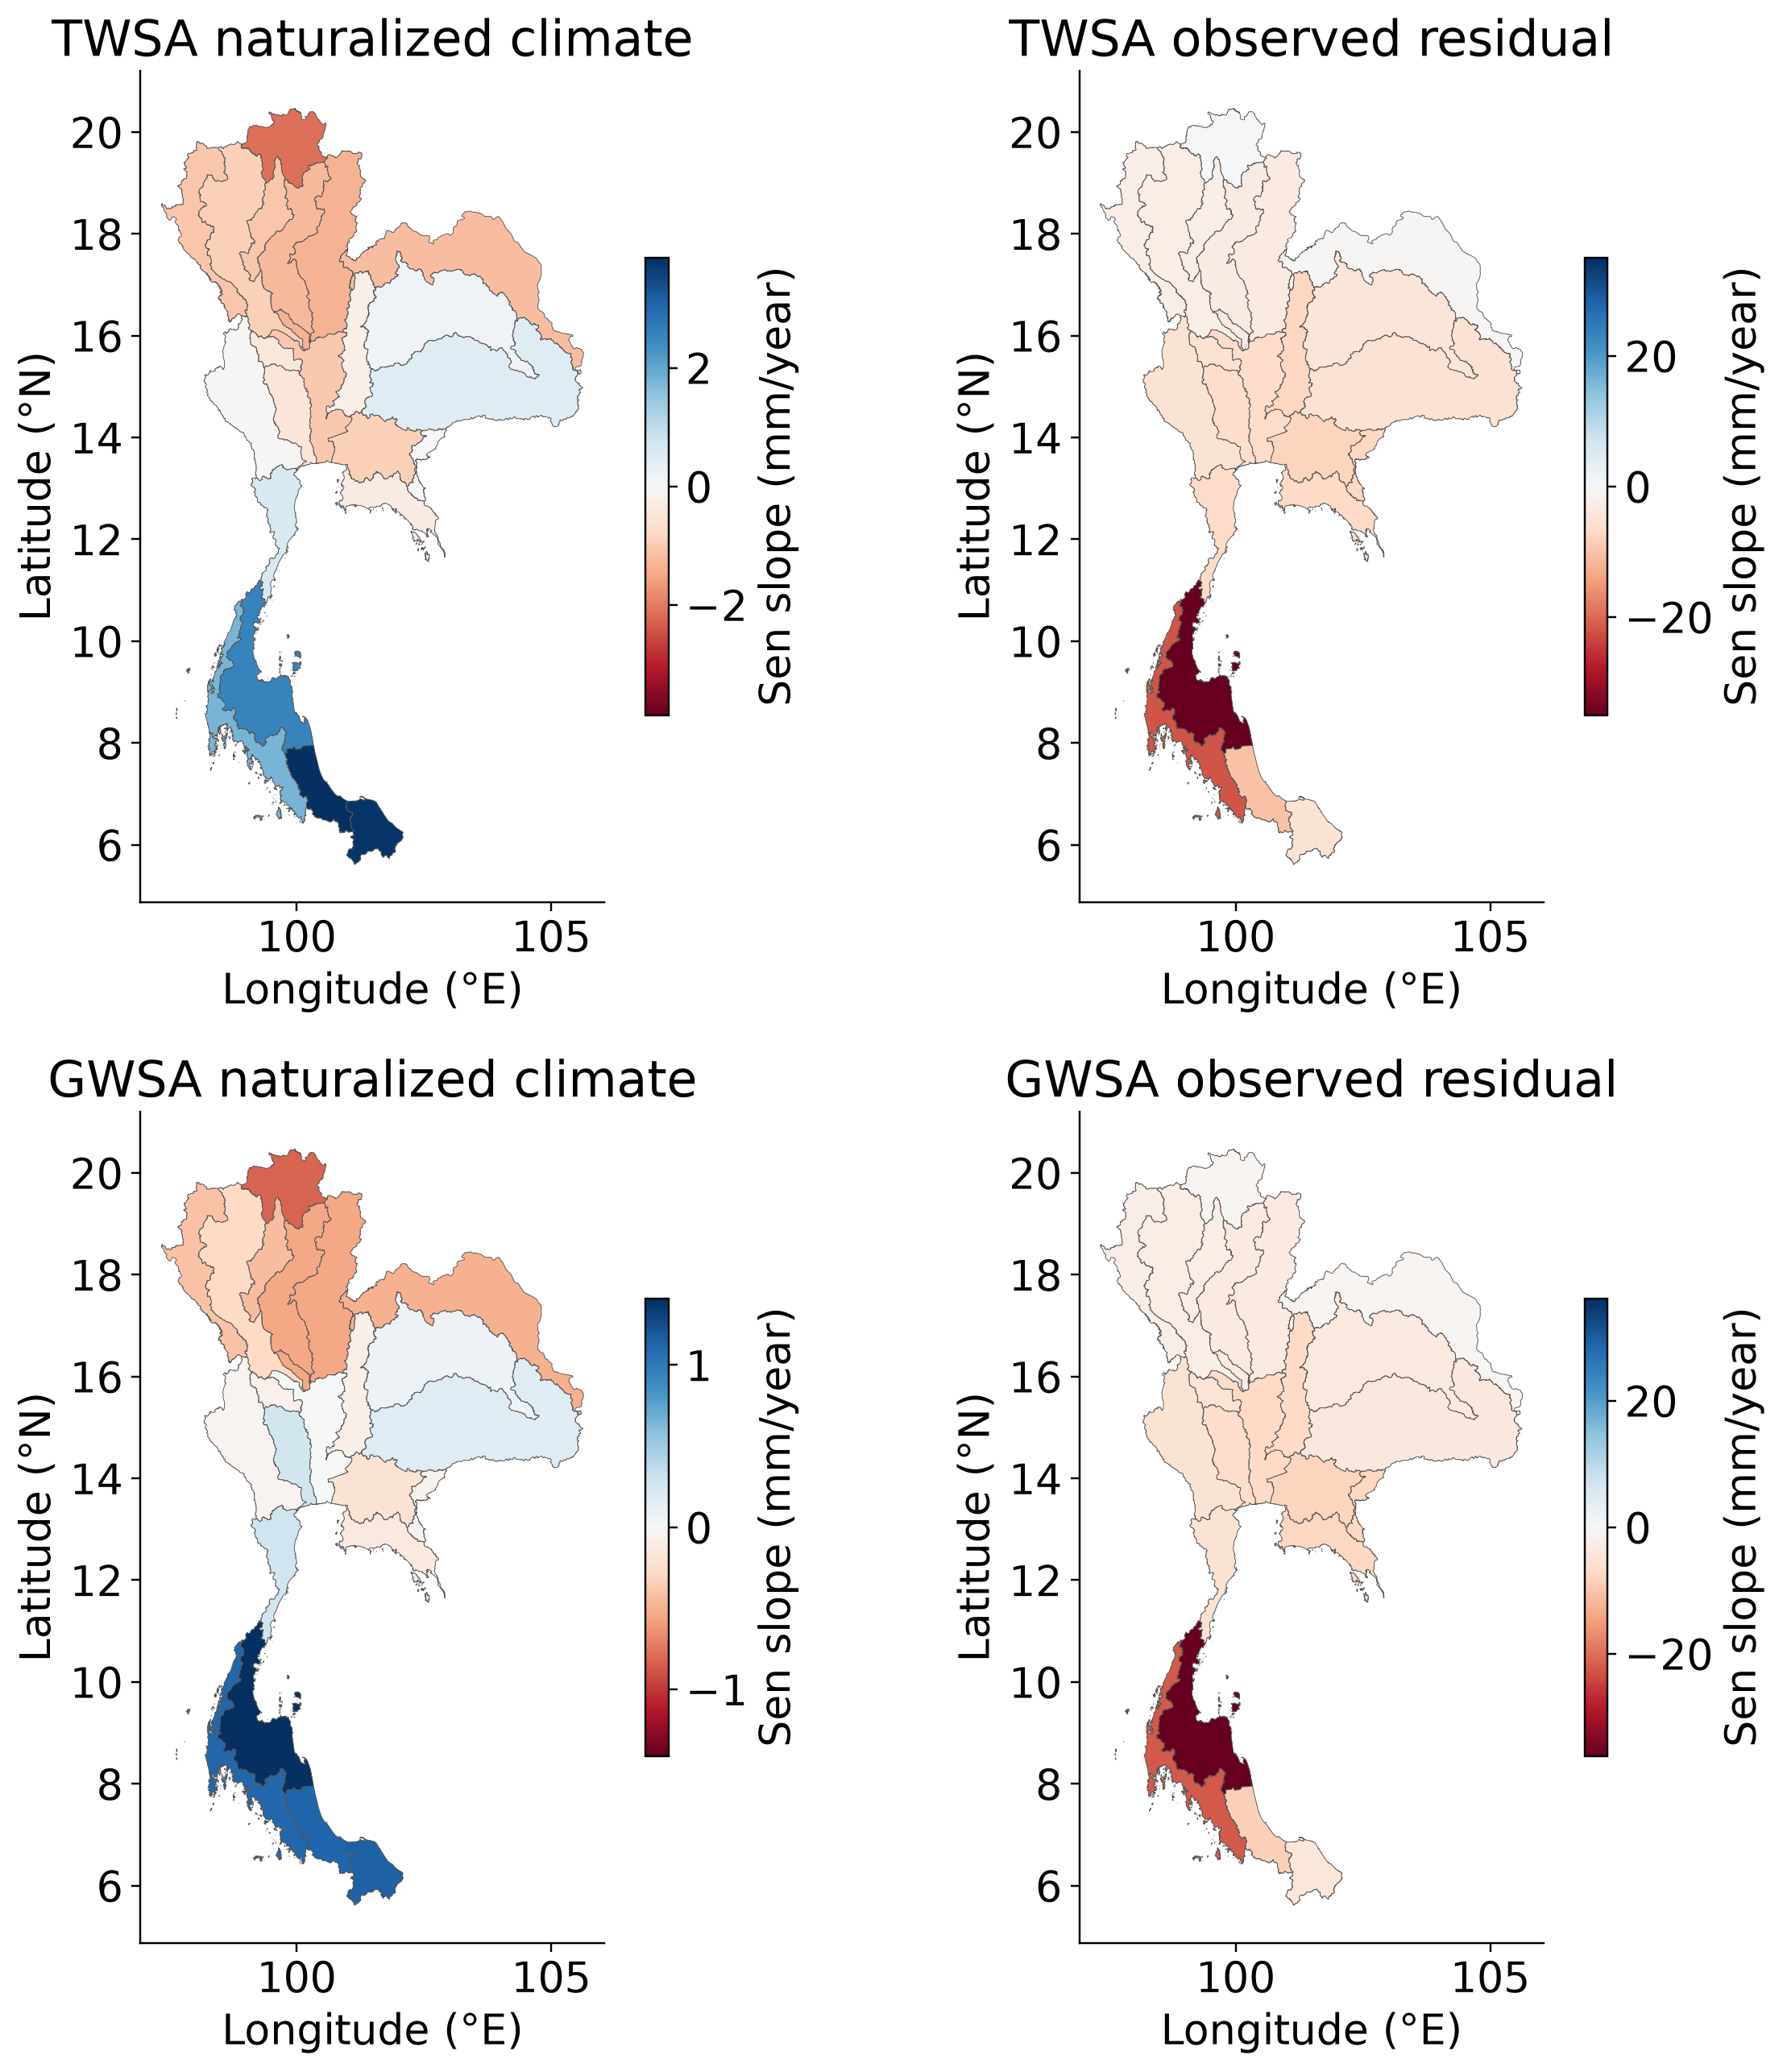
Figure 4.4 Basin climate and residual trends at shared coarse spatial support

4.5 Groundwater evidence
National annual TWSA-residual agreement with the head index is r = 0.142 over 18 years; for GWSA it is r = 0.054 over 17 years. Controlling naturalized climate gives partial correlations of 0.131 and 0.029. Detrended associations are −0.023 and −0.082. These weak results do not confirm the human-depletion interpretation of the residual.
The result is informative even though it is not the desired strong validation. It prevents high emulator NSE or a declining gravimetric record from being mistaken for independent confirmation of human groundwater loss. Basin results and flag/panel sensitivities are retained, including insufficient-support cases rather than fabricated correlations. Head observations are affected by sparse seasonal sampling, changing station availability, mixed aquifers and a point-to-basin scale mismatch.
Table 4.4 Annual residual association with observed groundwater head
Residual | Years | Raw r | Climate controlled r
TWSA | 18 | 0.142 | 0.131
GWSA | 17 | 0.054 | 0.029
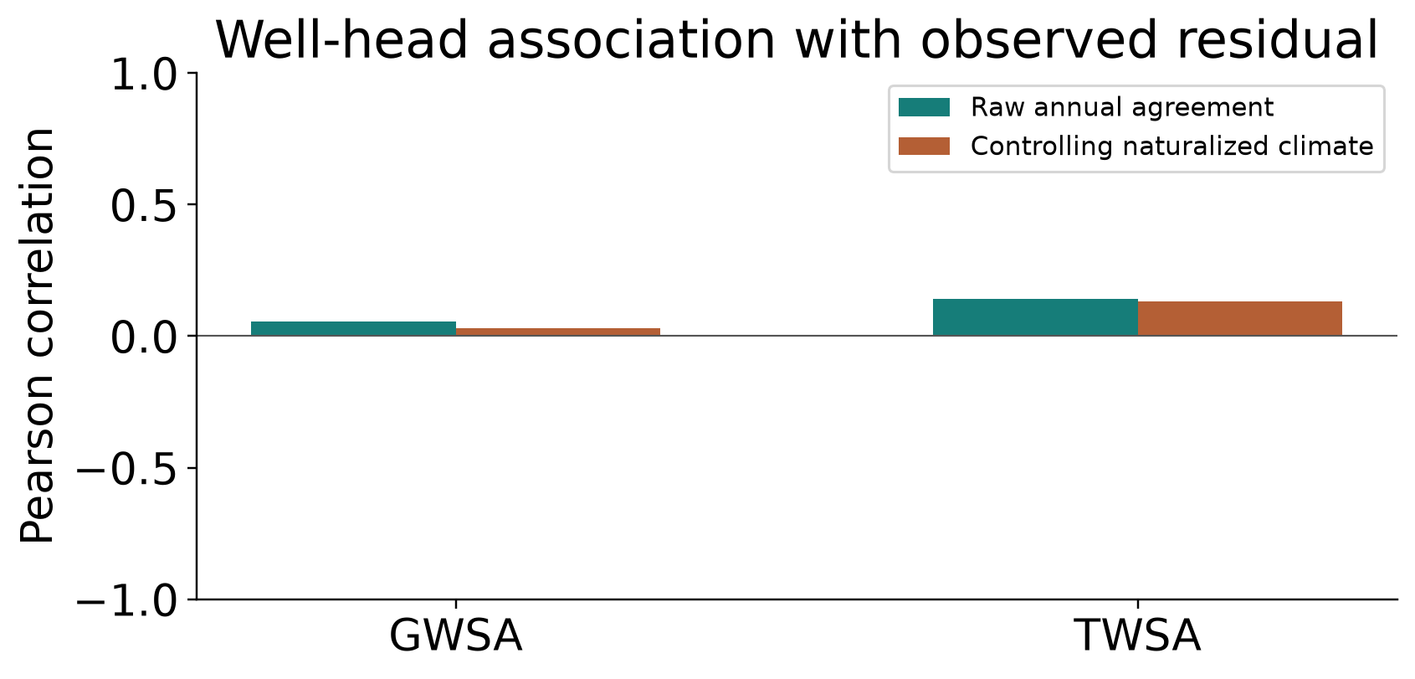
Figure 4.5 Weak groundwater consistency remains visible

4.6 Integrated discussion
The methodological improvement is the explicit separation of three evaluation questions: whether an emulator reproduces a model, whether a hydrological model agrees with observed storage, and whether independent heads support the residual interpretation. Strong performance in the first question cannot answer the other two. The revised workflow makes that distinction numerically visible. In particular, national GWSA emulator skill exceeds 0.96 while the historical-human model's observation NSE is only about 0.09.
The difference between the observed residual and the paired modeled-human effect is scientifically important. It shows that the attribution is structurally underdetermined, rather than simply providing an uncertain estimate of a known pumping signal. Naturalized-model error should be retained in the discrepancy term instead of allocated to human water use. The study consequently contributes a testable attribution framework and a negative validation result, not a confirmed map of human-caused depletion.
Residual correlation with observed head is not a direct test of a purely human head component. Both variables can contain climate variability, broad trends and measurement error. Partial, detrended and consecutive-change checks reduce some confounding but cannot replace aquifer-specific observations or pumping records. Their weak national values here support cautious interpretation even when a few basin-level correlations appear stronger.

4.7 Limitations and uncertainty
Several limitations matter before journal submission or management use. The original GRACE processing centre and release must be recovered, and sensitivity to a second identified gravimetric solution should be quantified. Model-cell replication does not correct leakage, and neighboring small basins are not independent. The primary counterfactual is a single hydrological-model/forcing combination, so emulator spread is not total counterfactual uncertainty.
WaterGAP and GLDAS represent different soil and aquifer systems, while GWSA subtraction combines sources with different filtering. The groundwater observations lack aquifer identities and storage coefficients and are predominantly annual, often based on two readings. Fixed-eligibility panels still vary in annual availability. Finally, updated climate attribution ends in 2023 rather than inventing a model extension to match the final 2024 TWSA observations.

4.8 Interactive decision support
The application presents all 22 basins and national context, with both storage types, interactive maps and time-series controls. The revised panel separates emulator verification, matched-compartment GLDAS benchmarking and groundwater consistency. Browser checks passed for desktop and mobile interaction and CSV export. The public site at https://pratikkhanal16.github.io/thailand-water-storage-dss/ retains weak validation results alongside downloadable basin evidence.

CHAPTER 5
CONCLUSIONS AND RECOMMENDATIONS

5.1 Conclusions
Objective 1 was completed with basin and grid TWSA/GWSA trends, statistical tests, uncertainty and source sensitivities. Objective 2 was strengthened by naturalized-target climate emulation, chronological verification, matched-compartment GLDAS benchmarking, a paired human-impact experiment and actual-head consistency checks. Objective 3 was completed as an interactive, hosted application with downloadable results. Completion describes the analyses and deliverables, not proof of a predetermined attribution hypothesis.
The supplied national storage records decline, and the naturalized-model emulators reproduce seasonal and interannual variability well. Independent groundwater consistency remains weak, and the paired human simulation leaves substantial unexplained storage discrepancy. The full residual must therefore remain an observation-informed candidate signal. It cannot be reported as a validated human pumping volume or an exact human share of TWSA.

5.2 Recommendations
The next scientific priority is to establish original gravimetry provenance and harmonize model/observation filtering before adding model complexity. Monthly heads should be grouped by aquifer, screened for representative sampling and linked to documented storage coefficients. Independent pumping and reservoir histories are needed to test timing and magnitude of human influences. Multiple naturalized hydrological models and forcing realizations would then permit an uncertainty assessment broader than emulation error.
For present decision support, use the application to compare observed trends, inspect data coverage and identify basins needing investigation. Do not rank abstraction controls from the residual alone. Strong-looking seasonal scores should always be read beside anomaly skill and independent evidence. Advisor review should assess the source provenance and scale assumptions before the manuscript is submitted or the results are used operationally.

REFERENCES
Asian Institute of Technology Language Center. (2026). Master’s thesis format January 2026 and thesis format guidance. https://languages.ait.ac.th/thesis-format-template/
Bäthge, A., Ruz Vargas, C., Lischeid, G., Collenteur, R., Cuthbert, M., Fleckenstein, J. H., Floerke, M., De Graaf, I., Gnann, S., Hartmann, A., Huggins, X., Moosdorf, N., Wada, Y., Wagener, T., & Reinecke, R. (2026). GROW A global-scale time series dataset for groundwater studies within the Earth system [Data set]. Zenodo. https://doi.org/10.5281/zenodo.15149480
Güntner, A., Sharifi, E., Haas, J., Boergens, E., Dahle, C., Dobslaw, H., Dorigo, W., Dussaillant, I., Flechtner, F., Jäggi, A., Kosmale, M., Luojus, K., Mayer-Gürr, T., Meyer, U., Preimesberger, W., Ruz Vargas, C., & Zemp, M. (2024). Global Gravity-based Groundwater Product G3P version 1.12 [Data set]. GFZ Data Services. https://doi.org/10.5880/G3P.2024.001
Hirsch, R. M., Slack, J. R., & Smith, R. A. (1982). Techniques of trend analysis for monthly water quality data. Water Resources Research, 18(1), 107–121. https://doi.org/10.1029/WR018i001p00107
Hirsch, R. M., & Slack, J. R. (1984). A nonparametric trend test for seasonal data with serial dependence. Water Resources Research, 20(6), 727–732. https://doi.org/10.1029/WR020i006p00727
Müller Schmied, H., Trautmann, T., Ackermann, S., Cáceres, D., Flörke, M., Gerdener, H., Kynast, E., Peiris, T. A., Schiebener, L., Schumacher, M., & Döll, P. (2024). The global water resources and use model WaterGAP v2.2e Description and evaluation of modifications and new features. Geoscientific Model Development, 17, 8817–8852. https://doi.org/10.5194/gmd-17-8817-2024
Müller Schmied, H., Trautmann, T., Ackermann, S., Cáceres, D., Flörke, M., Gerdener, H., Kynast, E., Peiris, T. A., Schiebener, L., Schumacher, M., & Döll, P. (2024). WaterGAP v2.2e model output driven by GSWP3–ERA5 neglecting direct human impacts [Data set]. Goethe University Frankfurt. https://doi.org/10.25716/GUDE.1TWP-GNQP
Müller Schmied, H., Trautmann, T., Ackermann, S., Cáceres, D., Flörke, M., Gerdener, H., Kynast, E., Peiris, T. A., Schiebener, L., Schumacher, M., & Döll, P. (2024). WaterGAP v2.2e model output driven by GSWP3–ERA5 with historical direct human impacts [Data set]. Goethe University Frankfurt. https://doi.org/10.25716/GUDE.14B4-KQ6R
NASA. (n.d.). Global Land Data Assimilation System dataset specifications. https://ldas.gsfc.nasa.gov/gldas/dataset
Office of the National Water Resources. (n.d.). Thailand principal-basin boundaries [Project-supplied shapefile MainBasin_ONWR_Law_WGS84].
Rodell, M., Houser, P. R., Jambor, U., Gottschalck, J., Mitchell, K., Meng, C.-J., Arsenault, K., Cosgrove, B., Radakovich, J., Bosilovich, M., Entin, J. K., Walker, J. P., Lohmann, D., & Toll, D. (2004). The global land data assimilation system. Bulletin of the American Meteorological Society, 85(3), 381–394. https://doi.org/10.1175/BAMS-85-3-381

APPENDIX A
BASIN RESULTS
Table A.1 All basin original full record Sen slopes in millimetres per year
Basin | TWSA | GWSA
Salawin | -3.55 | -2.82
North Khong | -1.94 | -1.82
Northeast Khong | -1.34 | -1.61
Chi | -3.62 | -3.35
Mun | -4.46 | -3.48
Ping | -3.67 | -3.02
Wang | -3.16 | -3.28
Yom | -3.75 | -3.98
Nan | -3.75 | -3.94
Chao Phraya | -7.32 | -7.36
Sakae Krang | -5.49 | -5.21
Pasak | -7.01 | -7.29
Tha Chin | -6.85 | -6.35
Mae Klong | -5.24 | -5.54
Bang Pakong | -8.61 | -8.16
Tonle Sap | -7.56 | -7.29
East Coast Gulf | -7.66 | -7.83
Phetchaburi - Prachuap Khiri Khan | -5.96 | -4.76
Peninsula - Upper East Coast | -33.65 | -35.24
Thale Sap Songkhla | -6.25 | -7.51
Peninsula - Lower East Coast | -1.37 | -3.02
Peninsula - West Coast | -20.71 | -21.05

Table A.2 Naturalized model emulator test scores for all basins
Basin | TWS NSE | GWS NSE | GWS anomaly NSE
Salawin | 0.981 | 0.963 | 0.830
North Khong | 0.979 | 0.956 | 0.901
Northeast Khong | 0.973 | 0.953 | 0.781
Chi | 0.961 | 0.933 | 0.755
Mun | 0.946 | 0.927 | 0.678
Ping | 0.981 | 0.958 | 0.842
Wang | 0.974 | 0.948 | 0.824
Yom | 0.972 | 0.963 | 0.865
Nan | 0.983 | 0.958 | 0.832
Chao Phraya | 0.928 | 0.935 | 0.661
Sakae Krang | 0.980 | 0.914 | 0.627
Pasak | 0.974 | 0.962 | 0.812
Tha Chin | 0.942 | 0.920 | 0.703
Mae Klong | 0.981 | 0.970 | 0.812
Bang Pakong | 0.942 | 0.902 | 0.360
Tonle Sap | 0.957 | 0.933 | 0.564
East Coast Gulf | 0.972 | 0.952 | 0.589
Phetchaburi - Prachuap Khiri Khan | 0.957 | 0.907 | 0.711
Peninsula - Upper East Coast | 0.965 | 0.926 | 0.823
Thale Sap Songkhla | 0.963 | 0.892 | 0.668
Peninsula - Lower East Coast | 0.951 | 0.904 | 0.808
Peninsula - West Coast | 0.970 | 0.922 | 0.780

APPENDIX B
REPRODUCIBILITY AND DATA PROVENANCE
Authoritative revised outputs are in Thailand_Objective2/analysis_v4. Objective 1 remains in Thailand_Objective1/analysis_v3. Scripts 06 to 10 implement the naturalized decomposition, emulators, groundwater checks, release figures and application export. Earlier GRACE-trained experiments remain in analysis_v3 and must not be relabelled naturalized training. The source inventory and subset provenance are retained under shared_data/WaterGAP.
The supplied GRACE file identifies only units centimetres, CRS EPSG 4326 and 0.25-degree resolution. Processing centre, product release and leakage corrections cannot be established from that file. The published G3P groundwater product is a related sensitivity, not an independent observation. GROW derivatives retain package CC BY-NC-SA 4.0 terms; WaterGAP is CC BY 4.0. Source-specific provenance and licensing must accompany redistribution.
Scientific QA verifies R = H + E and O = C + R on the common footprint, additive OLS point slopes, 46 emulator ensembles and actual well observation counts. Missing GRACE months and post-2023 counterfactuals remain absent. The website and manuscript do not provide measured pumping volumes or a direct human TWSA validation by wells.

