

SURVEY OF PAKISTAN
Ministry of Defence, Government of Pakistan

INTERNSHIP FINAL REPORT
Automated Road Features Classification Toolbox
A Python-Based ArcGIS Geoprocessing Tool for Classifying and Cross-Validating Motorway / National Highway Features between NHA and OpenStreetMap Data

Submitted By | Faseeh Tahir
Institute | University of Gujrat
Internship Department | Cartography and GIS Section, Survey of Pakistan
Supervisor | Dr. Munir
Internship Period | Commencing 10 August 2026
Report Date | 10 September 2026

Table of Contents

1. Background
2. Objective of the Internship / Assignment
3. Introduction to the Tool
4. Input Data
5. Methodology / Procedure
6. Classification Rules and Logic
7. Outputs Produced
8. The Final Statistical Summary Report
9. Tools and Technologies Used
10. Results and Discussion
11. Challenges Faced
12. Skills Gained
13. Conclusion
14. Recommendations / Future Work

1. Background
The Survey of Pakistan (SoP), operating under the Ministry of Defence, is the national mapping agency of Pakistan and the principal authority responsible for topographic surveying, cartography, geodesy, and the production of authoritative geospatial data for the country. As part of its mandate, the Cartography and GIS Section maintains and continuously updates digital road network datasets, including the classification and verification of Motorway and National Highway features managed by the National Highway Authority (NHA).
Road network data at SoP is drawn from multiple sources, most notably the NHA's own reference layer and open-source datasets such as OpenStreetMap (OSM). While the NHA dataset is treated as the authoritative source for official classification, OSM offers a widely maintained, community-updated alternative that can serve as a valuable secondary reference for quality control. In practice, however, manually comparing thousands of road segments between the two datasets — checking classification consistency, geometric alignment, and attribute agreement — is a slow, repetitive, and error-prone task when performed by hand in ArcGIS.
This internship was undertaken in the Cartography and GIS Department of Survey of Pakistan, where the intern was assigned the task of designing and developing an automated geoprocessing solution to streamline this classification and comparison workflow, reducing manual effort while improving the traceability and defensibility of the resulting classification decisions.

2. Objective of the Internship / Assignment
The core assignment given during the internship was to design and build a custom ArcGIS Python Toolbox (.pyt) capable of automatically classifying road features from the NHA dataset, cross-referencing them against the OpenStreetMap roads layer, and producing a single authoritative, quality-controlled output — without requiring the analyst to manually inspect or edit every feature.
The specific objectives set for this assignment were:
- Automatically classify NHA road features into Motorway, National Highway, Strategic, or Review categories based on route-code naming conventions.
- Automatically classify OSM road features into a comparable class scheme using their functional class (fclass) attribute.
- Spatially match NHA features to nearby OSM features using a configurable distance tolerance, without requiring exact geometric overlap.
- Compare the two classifications for each matched pair and flag agreement, conflict, or severe mismatch.
- Preserve NHA as the sole authoritative source of classification — OSM should support and verify, but never silently override, NHA's classification.
- Maintain full traceability, so that every value in the final output can be traced back to the exact rule or match that produced it.
- Generate a comprehensive statistical summary report suitable for data-quality assessment and management review.
The deliverable was required to run inside ArcMap 10.8 (ArcGIS Desktop), consistent with the software environment used operationally within the department, and to operate as a single, self-contained, single-click tool that a GIS analyst with no programming background could run safely and repeatedly.

3. Introduction to the Tool
The result of this assignment is the “Automated Road Features Classification” tool, packaged inside a custom ArcGIS Python Toolbox named Road_Features_Classification.pyt. It is a single, end-to-end geoprocessing tool — not a chain of several separate tools — that a user runs once from the ArcToolbox pane, and which internally performs safe data preparation, dual classification, spatial matching, comparison, final authoritative labelling, and (optionally) statistical report generation.
Design Principle
At every stage the tool treats the NHA dataset as authoritative. OSM is used only as supporting, verifying evidence. The original input layers supplied by the user are never modified — the tool always works on safe copies inside the chosen output geodatabase.

Key Characteristics
- Single-click execution — the entire seven-stage pipeline runs in one execution of one tool.
- Non-destructive — original NHA and OSM input layers are read-only throughout; all work happens on copies.
- Rule-based and transparent — every classification rule (route-code patterns, OSM class mapping, agreement/conflict rules) is defined explicitly and can be edited by the analyst without touching the pipeline logic.
- Fully traceable — every field in the final output (Final_Class, Match_Status, Match_Count, OSM_Match_ID) can be traced back through the pipeline.
- Self-documenting output — produces both GIS-ready feature classes/tables and a formatted PDF statistical summary report.

Tool Interface
From the analyst's perspective, the entire workflow is exposed through a single, standard ArcGIS tool dialog. The NHA and OSM input layers, the output geodatabase, and every configurable parameter described in Section 4.2 are entered here before execution.
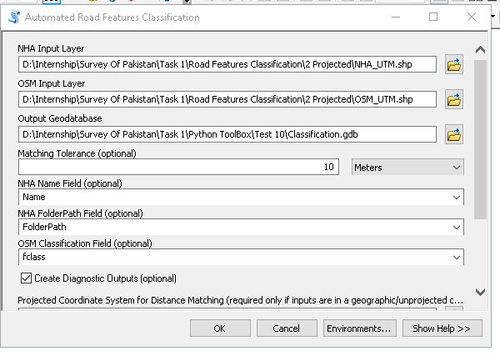
Figure 1: The Automated Road Features Classification tool dialog inside ArcMap, showing the input layers, output geodatabase, and configurable parameters.

Toolbox Source Code
The toolbox is implemented as a single, well-documented .pyt file. The header docstring below summarizes the tool's purpose and the eight-stage pipeline it executes internally, while the execute() method carries out each step in sequence and writes the paths for every intermediate and final output dataset.
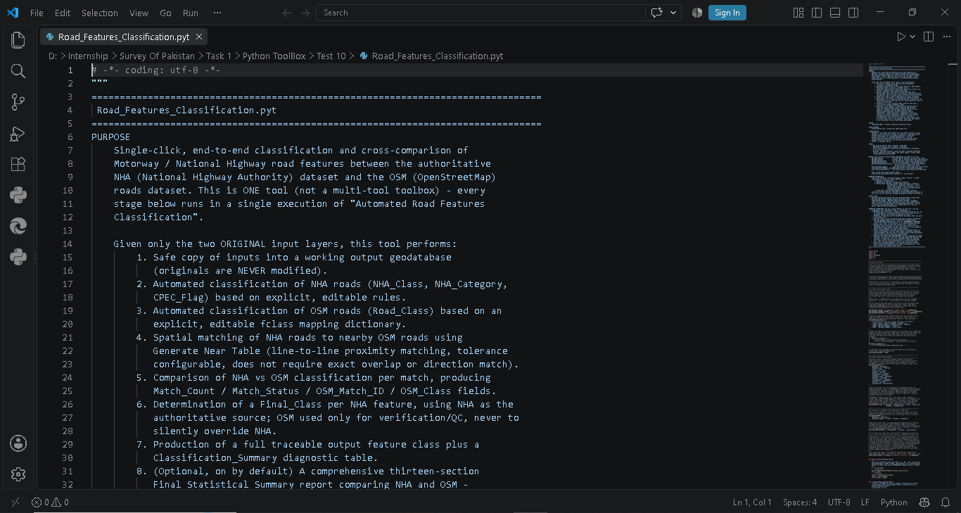
Figure 2: Header docstring of Road_Features_Classification.pyt, summarizing the tool's purpose and processing stages.
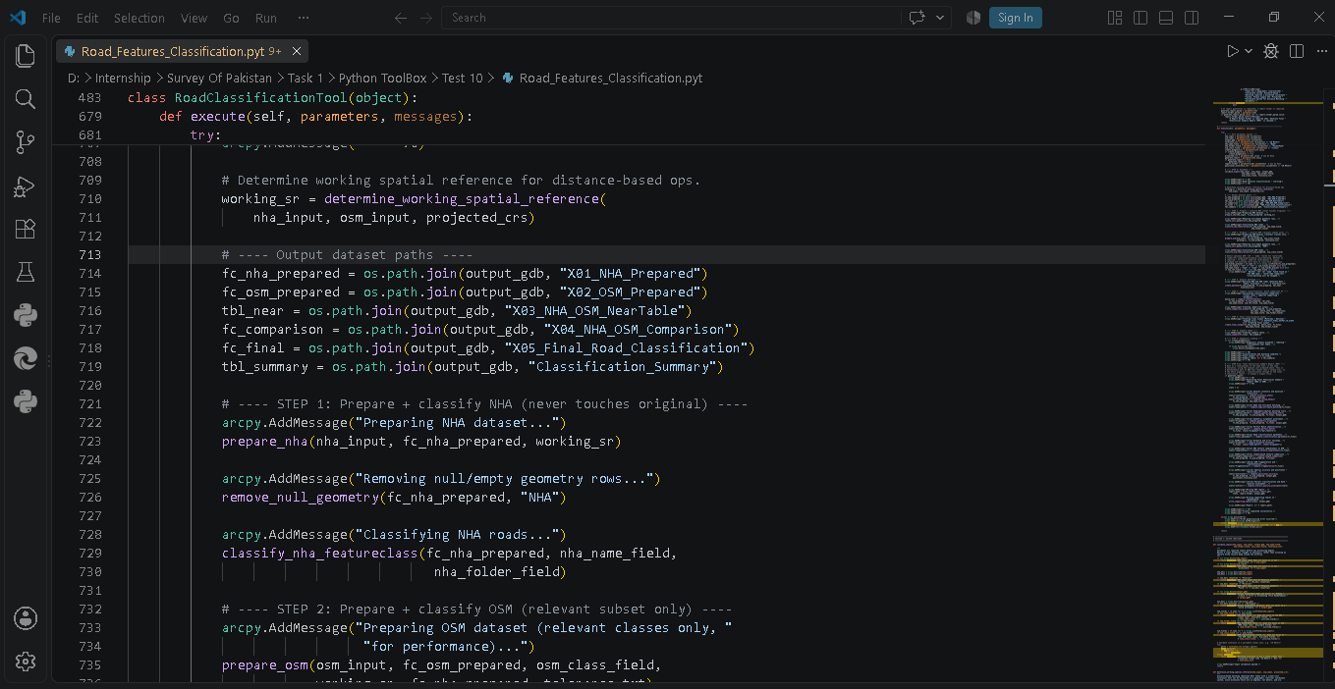
Figure 3: Excerpt of the execute() method, showing the output dataset paths and Step 1 (NHA preparation and classification).

4. Input Data
The tool is designed around two primary polyline datasets supplied by the user, plus a small set of configuration parameters that control how they are compared.

4.1 Primary Input Layers
Input | Description | Role
NHA Roads Layer | Polyline feature layer of National Highway Authority routes (Motorways, National Highways, Strategic roads), including a Name field carrying route codes (e.g. M-2, N-5, S-1) and a FolderPath field. | Authoritative reference layer
OSM Roads Layer | Polyline feature layer exported from OpenStreetMap, carrying a functional classification field (typically fclass) such as motorway, trunk, primary, etc. | Supporting / verification layer

4.2 User-Configurable Parameters
In addition to the two input layers, the tool exposes the following parameters through the standard ArcGIS tool dialog, allowing the analyst to adapt the run without editing code:
Parameter | Purpose | Default
Output Geodatabase | File geodatabase where all working and final outputs are written. | User-specified
Matching Tolerance | Search radius used for spatial (near-table) matching between NHA and OSM. | 10 Meters
NHA Name Field | Field read for route-code classification and naming. | Name (auto-detected)
NHA FolderPath Field | Field used only to derive the informational CPEC_Flag. | FolderPath (auto-detected)
OSM Classification Field | Field mapped to the internal Road_Class scheme. | fclass (auto-detected)
Create Diagnostic Outputs | Whether to retain intermediate/diagnostic tables. | True
Projected Coordinate System | Required only if inputs are geographic (unprojected); needed for accurate distance-based matching. | None
Generate Statistical Summary Report | Whether to produce the 13-section PDF report. | True
Report Output Folder | Destination folder for the PDF/TXT report. | Required if report is enabled
Positional Accuracy Tolerance | Tolerance used specifically in the report's positional accuracy statistics. | 10 Meters

A validation step in the tool's updateMessages() logic warns the user if either input layer is in a geographic (unprojected) coordinate system, since Pakistan spans three UTM zones (41N, 42N, 43N) and the tool deliberately does not guess a projection — the analyst must explicitly supply one to ensure distance-based matching remains accurate.

5. Methodology / Procedure
The tool executes as a single, ordered pipeline of seven stages every time it is run. Each stage writes its result as a distinct, named dataset inside the output geodatabase, so the analyst can inspect the process at any intermediate point without re-running the whole tool.

- Safe Copy of Inputs — The original NHA and OSM layers are copied into the output geodatabase as X01_NHA_Prepared and X02_OSM_Prepared. Rows with null or empty geometry are removed from these working copies only; the original source layers are never touched.
- NHA Classification — Each NHA feature's Name field is parsed for a leading route-code prefix (M-, N-, S-) using regular expressions to assign NHA_Class (Motorway / National Highway / Strategic). Known non-numbered named routes (e.g. Lowari Tunnel, Lahore Eastern Bypass) are matched by an explicit substring rule list. Anything unmatched is conservatively labelled Review rather than guessed. A CPEC_Flag is separately derived from the FolderPath field for informational purposes only.
- OSM Classification — Each OSM feature is mapped from its raw functional class (fclass) to a normalized Road_Class (Motorway, Trunk, Primary, Secondary, etc.) using an explicit lookup dictionary. Only classes plausibly relevant to Motorway/National Highway comparison (motorway, trunk, primary and their link variants) are carried forward into matching, as a performance and relevance pre-filter.
- Spatial Matching — ArcGIS's Generate Near Table is run between the prepared NHA and OSM layers using the user-specified tolerance, with the 'closest = ALL' option so that every OSM candidate within range is retained (not just the single nearest), preserving legitimate one-to-many matches. This produces the diagnostic X03_NHA_OSM_NearTable.
- Classification Comparison — For every NHA-to-OSM match, the tool compares NHA_Class against the matched OSM_Class using an explicit agreement table, and additionally checks for route-code (name/ref) agreement as supporting — never sole — evidence. The result is written to X04_NHA_OSM_Comparison with a Match_Status of Matched, Matched (Name Confirmed), Conflict, Severe Mismatch, Multiple, or Unmatched.
- Final Classification — A clean, authoritative Final_Class is assigned per NHA feature. Final_Class always equals NHA_Class for genuine road classes; OSM evidence is never allowed to override it — it only ever affects the separate Match_Status/QC fields. This distinction keeps the classification label and the quality-control signal cleanly separated. The result, scoped by default to Motorway and National Highway features only, is written to X05_Final_Road_Classification.
- Summary and Reporting — A Classification_Summary pivot table is generated, and, if enabled, a full thirteen-section Final Statistical Summary Report is produced as a formatted PDF (see Section 8).

Traceability Chain
Final_Class ← NHA_Class (authoritative) ← OSM_Match_ID / OSM_Class (supporting evidence) ← Match_Status (QC signal) ← Match_Count (number of spatial candidates). Every link in this chain is retained in the final output table.

Tool Execution
During execution, ArcMap's standard progress dialog reports each stage as it runs, including live feature and row counts. In the run captured below, the tool filtered 14,942 OSM features against the relevant functional-class list and applied an 80-metre spatial filter around the NHA features before matching; the same run went on to process all 92 in-scope NHA features and produced a 121-row comparison table.
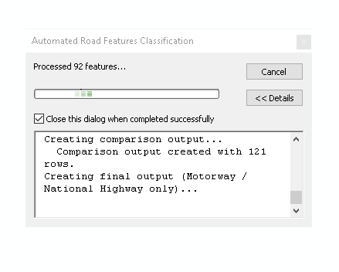
Figure 4: Progress dialog during OSM pre-filtering, showing the fclass filter and the 80-metre spatial filter being applied.
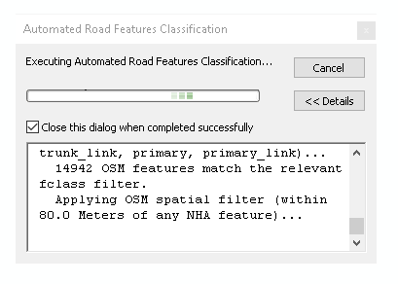
Figure 5: Progress dialog on completion, reporting 92 NHA features processed and a 121-row comparison output.

6. Classification Rules and Logic

6.1 NHA Route-Code Classification
NHA_Class is derived primarily by pattern-matching the route-code prefix at the start of the Name field, mirroring NHA's own route-naming convention:
Pattern (Name prefix) | Assigned NHA_Class | Example
M followed by digits (e.g. M-2, M2) | Motorway | "M-2 (Lahore–Islamabad)"
N followed by digits (e.g. N-5, N5) | National Highway | "N-5 (Torkham–Karachi)"
S followed by digits (e.g. S-1, S1) | Strategic | "S-1 (Peshawar–Torkham)"
No recognized prefix | Review | Requires manual attention

A small library of known, non-numbered named routes (such as the Lowari Tunnel or the Lahore Eastern Bypass) is separately matched by a case-insensitive substring rule. A manual override dictionary is also provided, keyed by feature OID or exact Name, allowing the analyst to hard-code corrections that always take precedence over the automated rules.

6.2 OSM Class Mapping
OSM's fclass attribute is mapped explicitly to a normalized Road_Class scheme. Any fclass value encountered that is not in the mapping is labelled Other and a warning is logged — never silently dropped.
OSM fclass | Road_Class
motorway, motorway_link | Motorway
trunk, trunk_link | Trunk
primary, primary_link | Primary
secondary, secondary_link | Secondary
tertiary, tertiary_link | Tertiary
residential / service / unclassified | Residential / Service / Unclassified

6.3 Agreement, Conflict, and Severe Mismatch
An explicit agreement table defines which OSM_Class values are considered consistent with a given NHA_Class (e.g. an NHA Motorway agrees with an OSM Motorway; an NHA National Highway agrees with OSM Trunk, Primary, or Motorway). Any matched pair outside this agreement set is flagged as a Conflict. If an NHA Motorway or National Highway is matched to an OSM Residential, Service, or Unclassified road — which should be rare given the relevance pre-filter — it is flagged distinctly as a Severe Mismatch, acting as a safety net for unexpected data conditions.

7. Outputs Produced
A single run of the tool produces the following datasets inside the chosen output geodatabase, plus an optional PDF report in a separate folder.
Output Dataset | Description
X01_NHA_Prepared | Working copy of NHA roads with classification fields added (NHA_Class, NHA_Category, CPEC_Flag).
X02_OSM_Prepared | Working copy of relevant OSM roads with Road_Class assigned.
X03_NHA_OSM_NearTable | Raw Generate Near Table output (diagnostic only).
X04_NHA_OSM_Comparison | One row per NHA feature × matched OSM feature, with Match_Status and agreement flags.
X05_Final_Road_Classification | Final authoritative output: one row per NHA feature (Motorway / National Highway scope) with Final_Class and full traceability fields.
Classification_Summary | Pivot-style table summarizing counts by class and match status.
Stat_NameAttributeMatch, Stat_SpatialMatchTiers, Stat_GeometricAlignment, Stat_ClassificationMatrix | Per-feature detail tables backing each section of the statistical PDF report.
Final_Statistical_Summary_NHA_vs_OSM.pdf | Thirteen-section formatted PDF report (see Section 8), written to the user-selected report folder.

By default, X05_Final_Road_Classification and Classification_Summary are scoped to only Motorway and National Highway features, since these were the focus of the assignment. Strategic roads and unresolved Review features are still fully computed and remain visible in the earlier working tables — nothing is silently discarded upstream, it is simply kept out of the two final, scope-restricted deliverables. This behavior is controlled by a single configuration flag and can be switched off for a full quality-control pass covering every road class.

Final Output in ArcMap
The screenshot below shows the working geodatabase loaded in ArcMap after a complete run, with X05_Final_Road_Classification symbolized by Road_Type. The final Motorway and National Highway network (black) is displayed over the full OSM road backdrop (green), illustrating how the tool's output isolates exactly the authoritative NHA routes of interest from the much larger surrounding OSM network.
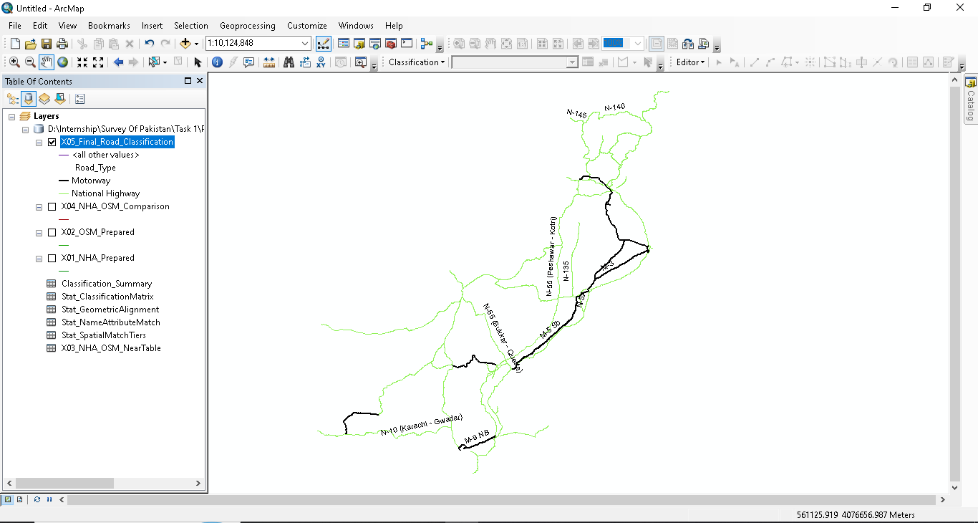
Figure 6: X05_Final_Road_Classification displayed in ArcMap, symbolized by Road_Type (Motorway / National Highway) over the OSM basemap layer.

8. The Final Statistical Summary Report
Beyond the GIS outputs, the tool can automatically generate a professional, thirteen-section PDF report comparing the NHA and OSM datasets, intended for data-quality review and management reporting without requiring anyone to open ArcMap. The report includes an executive summary box stating an overall data-quality score and rating, followed by:
- Inventory statistics for both datasets
- Name / attribute matching analysis
- Spatial matching tiers (overlapping, partial, nearby, unmatched)
- Geometric alignment analysis (Perfect / Slight / Significant deviation / Misaligned)
- Identification of "Perfect Match" features (class agreement + geometric alignment + no route-code conflict)
- Classification agreement matrix (confusion matrix between NHA_Class and OSM_Class)
- Mismatch taxonomy (breakdown of conflict types)
- Network completeness analysis
- Length comparison between the two datasets
- Fragmentation analysis
- Positional accuracy statistics
- An overall data-quality assessment and score
- A closing methodological notes and limitations section

Charts are embedded directly into the relevant sections of the PDF, and the report gracefully falls back to a plain-text summary with an on-screen instruction if the optional reportlab library is not installed in the ArcGIS Python environment — ensuring the tool never fails outright just because a reporting dependency is missing.

Sample Report Output
The extract below is taken from an actual generated report, Final_Statistical_Summary_NHA_vs_OSM, opened here in plain-text form. It shows the report's scope statement and the opening of Section 1 (Dataset Inventory and Baseline Statistics) for a real run against the department's data: 121 total NHA reference features (20 Motorway, 58 National Highway, 3 Strategic, and 40 requiring classification review), of which 78 Motorway and National Highway features fell within the comparison scope, matched against 6,899 pre-filtered OSM candidate features.
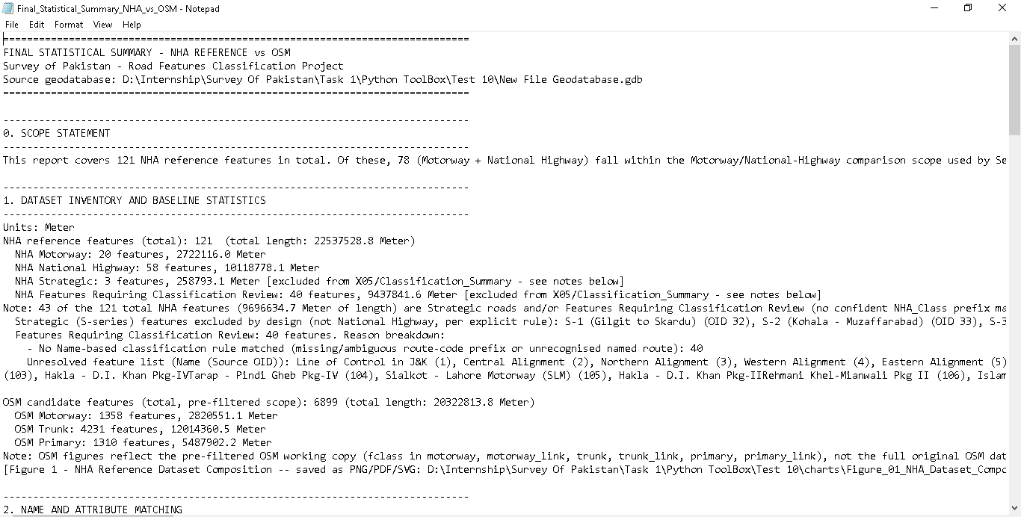
Figure 7: Opening section of the generated Final_Statistical_Summary_NHA_vs_OSM report, showing the scope statement and dataset inventory statistics.

Statistical Results — Selected Figures
The report's embedded charts summarizing how the 78 in-scope NHA reference features (Motorway and National Highway) compare against OpenStreetMap. The four figures below are reproduced directly from an actual run of the tool.
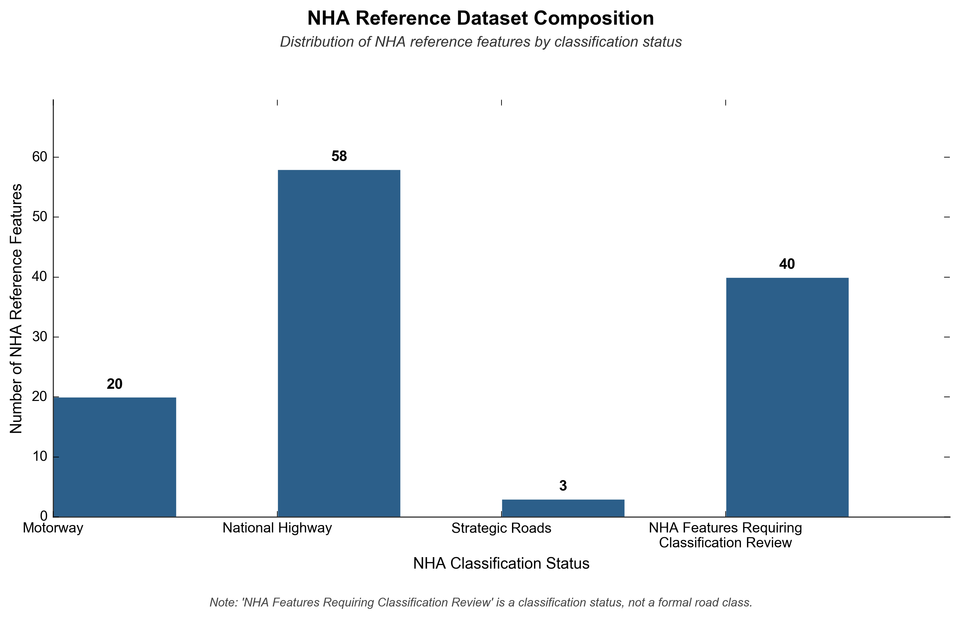
Figure 8: Composition of the 121-feature NHA reference dataset by classification status — 20 Motorway, 58 National Highway, 3 Strategic, and 40 features requiring manual classification review.
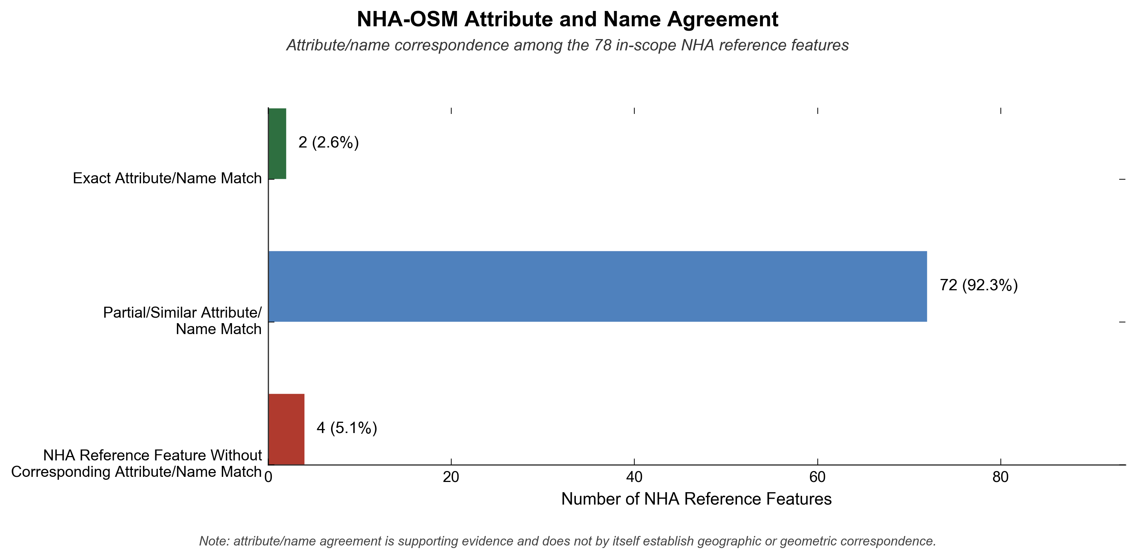
Figure 9: Attribute/name correspondence between NHA and OSM for the 78 in-scope features: 92.3% show a partial or similar name match, 2.6% an exact match, and 5.1% no corresponding name match.
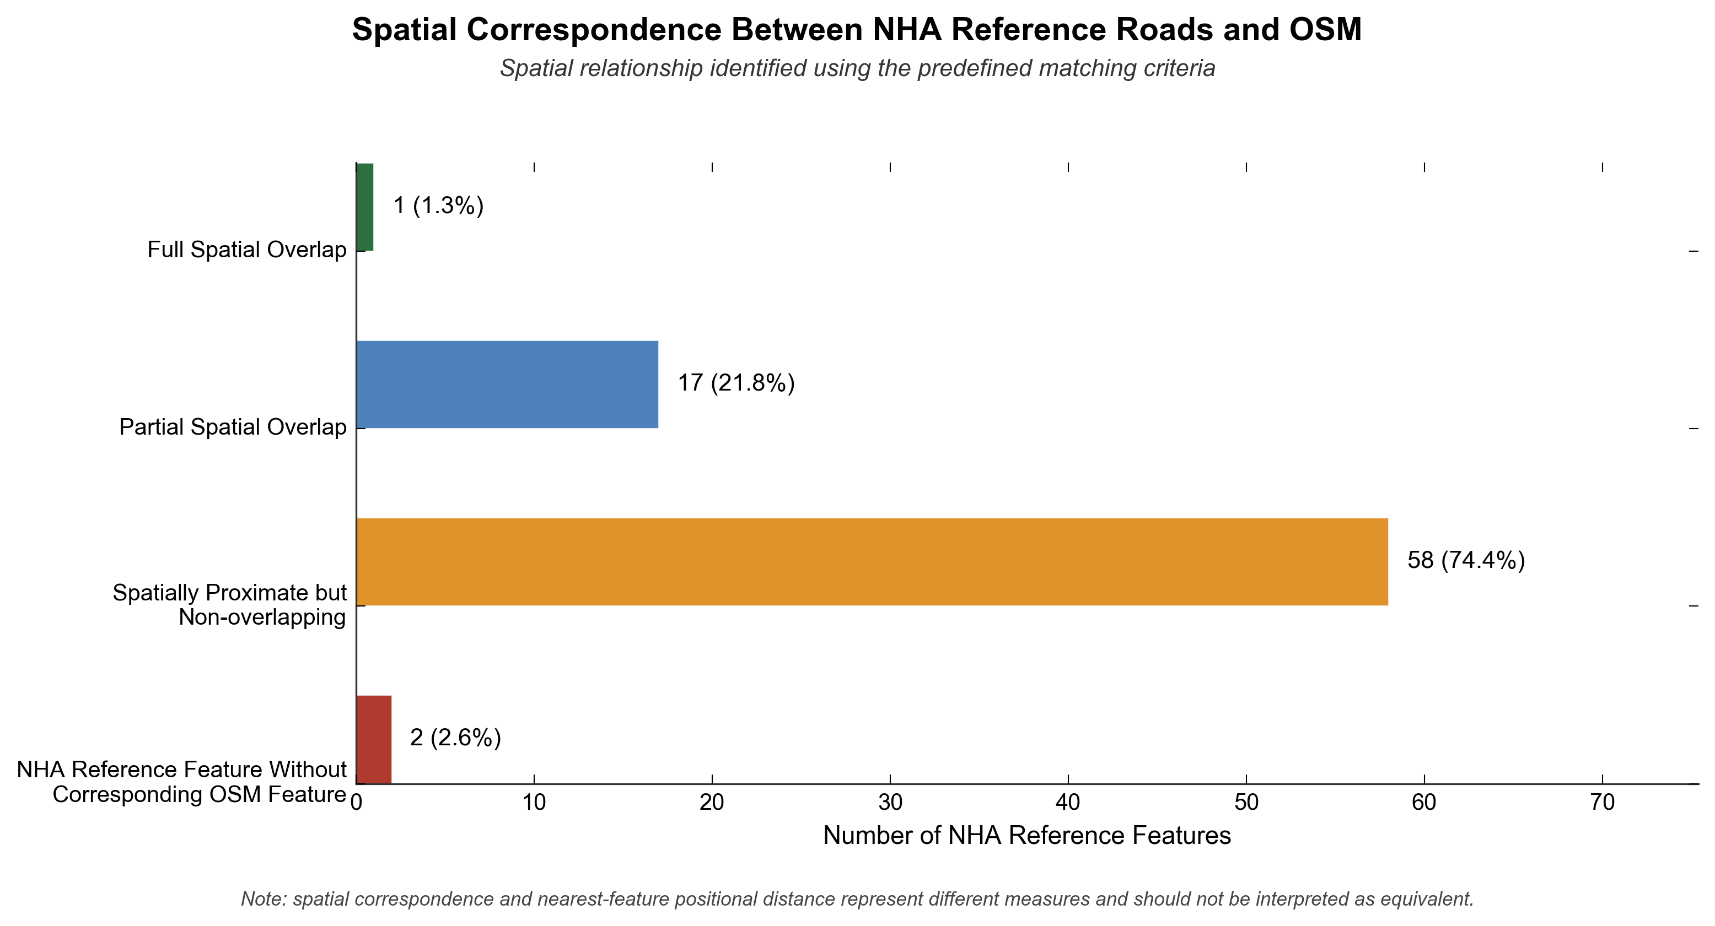
Figure 10: Spatial correspondence between NHA reference roads and OSM: 74.4% of features are spatially proximate but non-overlapping, 21.8% show partial spatial overlap, and 2.6% have no corresponding OSM feature.
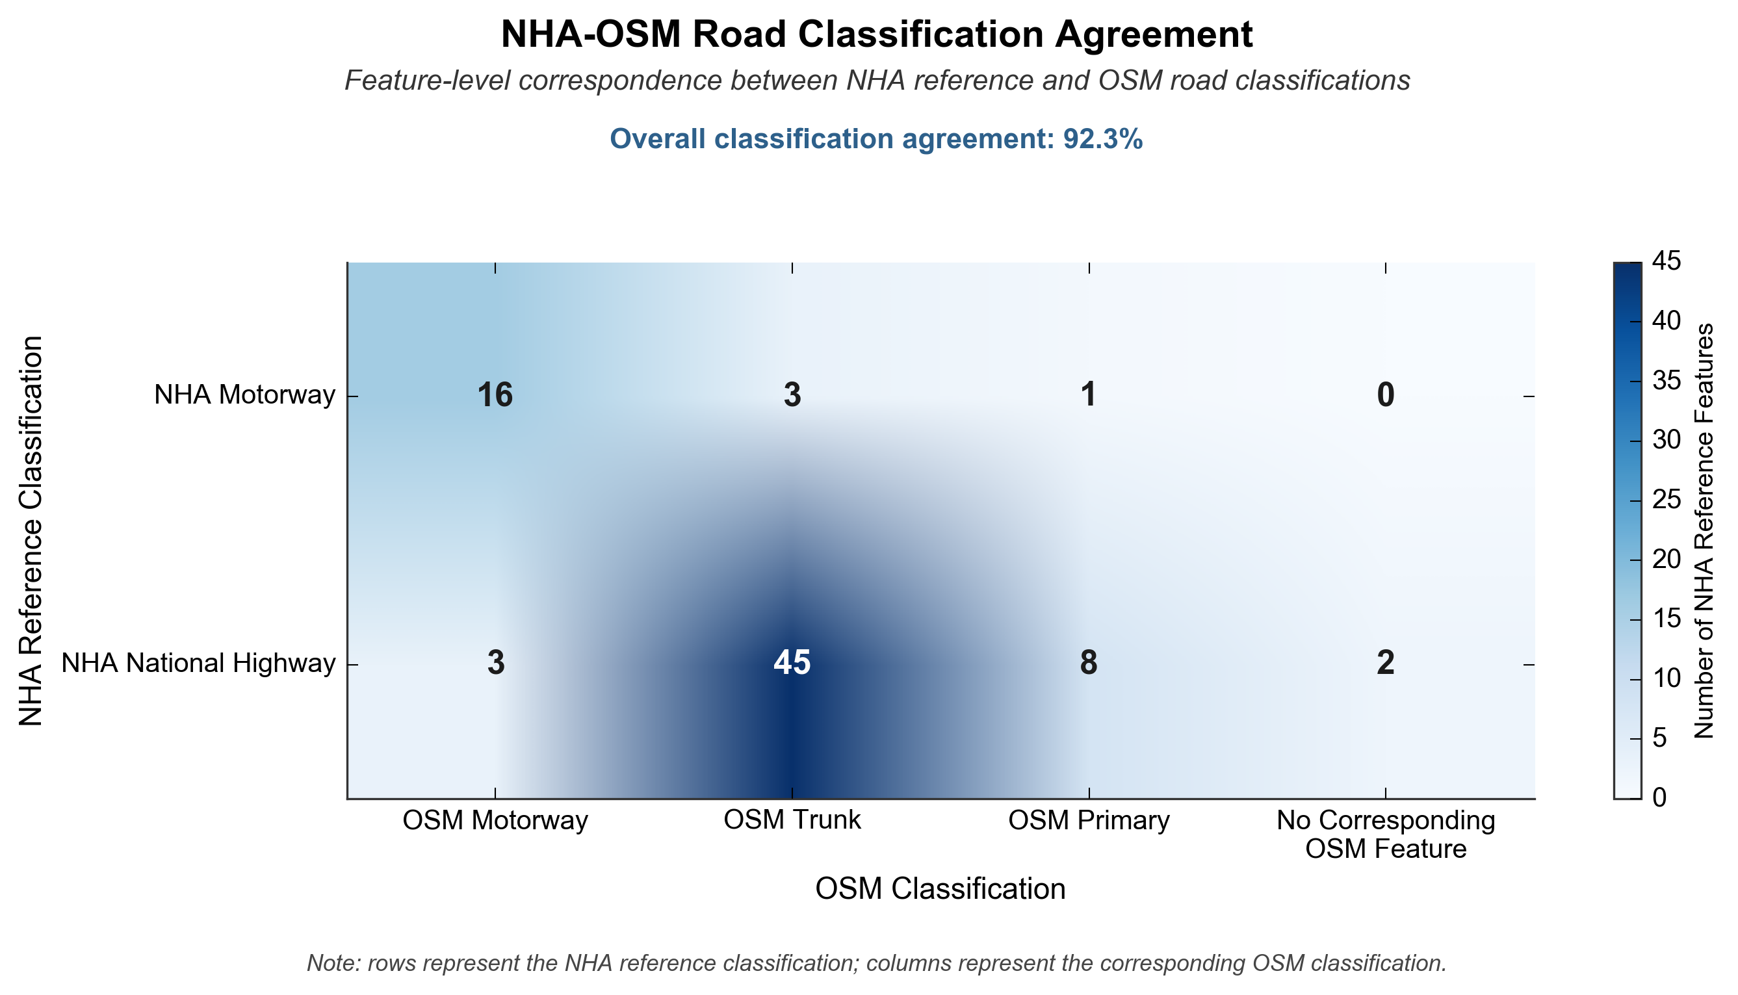
Figure 11: NHA–OSM classification agreement matrix, showing an overall classification agreement of 92.3% between NHA reference classification and matched OSM classification.

9. Tools and Technologies Used
Category | Technology
GIS Platform | ArcGIS Desktop 10.8 / ArcMap 10.8
Scripting Environment | Python 2.7 (as shipped with ArcMap 10.8)
Core Library | ArcPy (Esri's geoprocessing API)
Geoprocessing Tool | Generate Near Table (spatial proximity matching)
Reporting Library | reportlab (PDF generation), with plain-text fallback
Data Formats | File Geodatabase feature classes and tables; PDF report output
Toolbox Type | Custom ArcGIS Python Toolbox (.pyt)

10. Results and Discussion
Running the tool against the department's NHA and OSM road datasets successfully automated a comparison process that would previously have required extensive manual attribute inspection and visual overlay checking in ArcMap. Every NHA Motorway and National Highway feature is assigned a defensible Final_Class together with a transparent Match_Status describing exactly how confidently that classification is supported by independent OSM evidence.
In the sample run documented in Section 8, the tool processed 92 in-scope NHA features and produced a 121-row comparison table, ultimately achieving an overall classification agreement of 92.3% between NHA and OSM (Figure 11). Spatial analysis showed that the great majority of matched pairs — 74.4% — were spatially proximate but non-overlapping rather than exactly coincident (Figure 10), which is expected given that NHA and OSM digitize the same physical roads independently and rarely trace identical centerlines. Name/attribute agreement followed a similar pattern, with 92.3% of features showing at least a partial or similar name match (Figure 9), confirming that route-code naming is a reliable secondary signal even where exact string matches are rare.
The clean separation between Final_Class (a pure classification label) and Match_Status (a quality-control signal) proved to be an important design refinement during development. An earlier version of the logic allowed QC terms such as "Conflict" or "Review" to appear directly inside Final_Class, which risked confusing end users scanning the classification column. Moving QC terminology exclusively into Match_Status made the final output easier to read while keeping every discrepancy fully auditable in a separate, dedicated field.
The statistical summary report added significant value beyond the raw GIS output: by scoring geometric alignment, classification agreement, and positional accuracy together into a single overall data-quality rating, it gives departmental supervisors a quick, evidence-based way to gauge the reliability of the NHA reference layer relative to OSM, without needing to open ArcMap at all.

11. Challenges Faced
- Coordinate reference system handling — Since Pakistan spans three UTM zones (41N, 42N, 43N), the tool could not safely auto-select a projection for distance-based matching; this required building an explicit validation and warning step rather than a silent assumption.
- Legacy Python 2.7 environment — ArcMap 10.8 ships with Python 2.7, which meant avoiding modern Python 3 syntax (f-strings, pathlib, type hints) throughout development.
- Balancing automation with authority — Ensuring OSM data could meaningfully support quality control without ever being allowed to silently override the authoritative NHA classification required careful, deliberate rule design (see Section 6.3).
- Avoiding false negatives in matching — Using Generate Near Table with the 'closest = ALL' option, rather than nearest-only, was necessary to correctly preserve legitimate one-to-many segment matches instead of collapsing them.
- Optional dependency handling — Since reportlab is not part of the standard ArcMap Python installation, the report-generation step needed a safe fallback so the rest of the tool never fails due to a missing third-party package.

12. Skills Gained
- Practical experience building a custom, production-quality ArcGIS Python Toolbox (.pyt) from scratch, including parameter validation and dynamic field auto-detection.
- Applied use of ArcPy geoprocessing functions, including Generate Near Table, cursor-based attribute manipulation, and file geodatabase management.
- Rule-based classification design using regular expressions and explicit, editable lookup/agreement tables.
- Understanding of national road reference datasets (NHA) and open geospatial data (OpenStreetMap), and how to reconcile authoritative versus crowd-sourced sources responsibly.
- Automated PDF report generation from geospatial analysis results using the reportlab library.
- Exposure to real departmental data-quality workflows at Pakistan's national mapping agency, and to professional documentation and traceability standards expected in an operational GIS environment.

13. Conclusion
The Automated Road Features Classification toolbox successfully met the objectives set for this internship assignment. It replaces a manual, error-prone comparison process with a single, repeatable, fully traceable ArcGIS tool that classifies NHA road features, cross-verifies them against OpenStreetMap, and produces both GIS-ready outputs and a professional statistical summary report — all while strictly preserving NHA's role as the authoritative data source.
Beyond the technical deliverable, this internship provided valuable hands-on exposure to real-world geospatial data-quality challenges faced by Survey of Pakistan, and to the discipline required to build tools that are safe, transparent, and trustworthy enough to be used operationally within a national mapping agency.

14. Recommendations / Future Work
- Migrate the toolbox to Python 3 / ArcGIS Pro as the department transitions away from ArcMap 10.8, to ensure long-term compatibility.
- Extend the OSM relevant-class filter to optionally include lower OSM classes, to catch cases where a Motorway or National Highway has been mis-tagged in OSM.
- Periodically review and expand the NHA_MANUAL_OVERRIDES and named-route rule list as new special routes are added to the network.
- Consider scheduling the tool to run automatically whenever the NHA or OSM source layers are refreshed, so the statistical summary report always reflects the latest available data.

