|  |  |
| --- | --- |
| Name: ___FaseehAhmed______________ | EE-272L Digital Systems Design |
| Reg. No.: 2023-EE-078________________ | Marks Obtained: ____________ |

**Lab Manual**

**Experiment # 1(MOSFET as an inverter)**

|  |  |  |  |  |  |
| --- | --- | --- | --- | --- | --- |
| **DSD Lab Manual Evaluation Rubrics** | | | | | |
|  |  |  |  |  |  |
| **Assessment** | **Total Marks** | **Marks Obtained** | **0-30%** | **30-60%** | **70-100%** |
| Code Organization (CLO1) | 3 |  | No Proper Indentation and descriptive naming, no code organization.  Zero to Some understanding but not working | Proper Indentation or descriptive naming or code organization.  Mild to Complete understanding but not working | Proper Indentation and descriptive naming, code organization.  Complete understanding, and proper working |
| Simulation (CLO2) | 5 |  | Simulation not done or incorrect, without any understanding of waveforms | Working simulation with errors, don't cares's(x) and high impedance(z), partial understanding of waveforms | Working simulation without any errors, etc and complete understanding of waveforms |
| FPGA (CLO2) | 2 |  | Not implemented on FPGA and questions related to synthesis and implementation not answered. | Correctly Implemented on FPGA or questions related to synthesis and implementation answered. | Correctly Implemented on FPGA and questions related to synthesis and implementation answered. |

**Task # 1:**

No, LED does not glow when we apply 5V at terminal A and the “0” volts are displayed by DMM when connected in parallel across LED

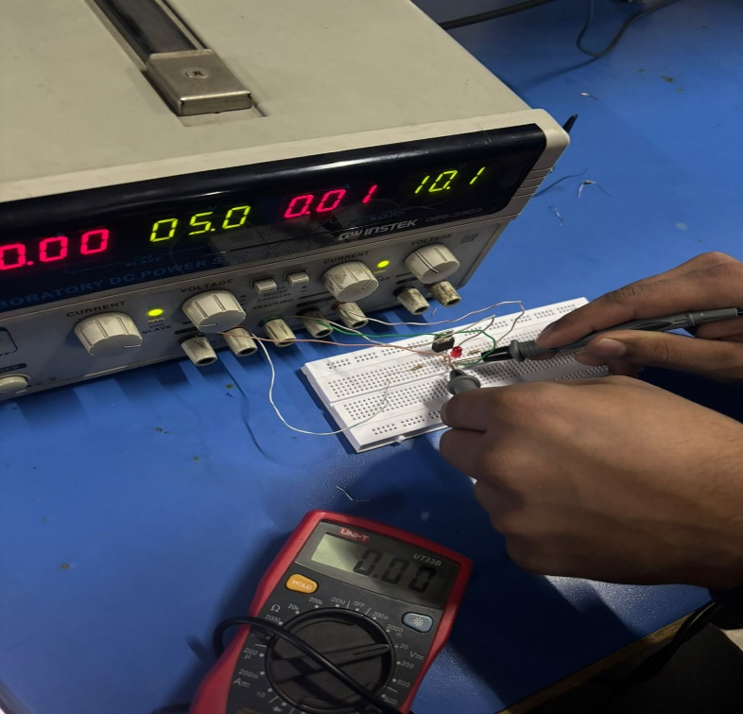

**Task # 2:**

Yes, the LED glows when 0V at the terminal A and the voltage the terminal B are “1.97” volts

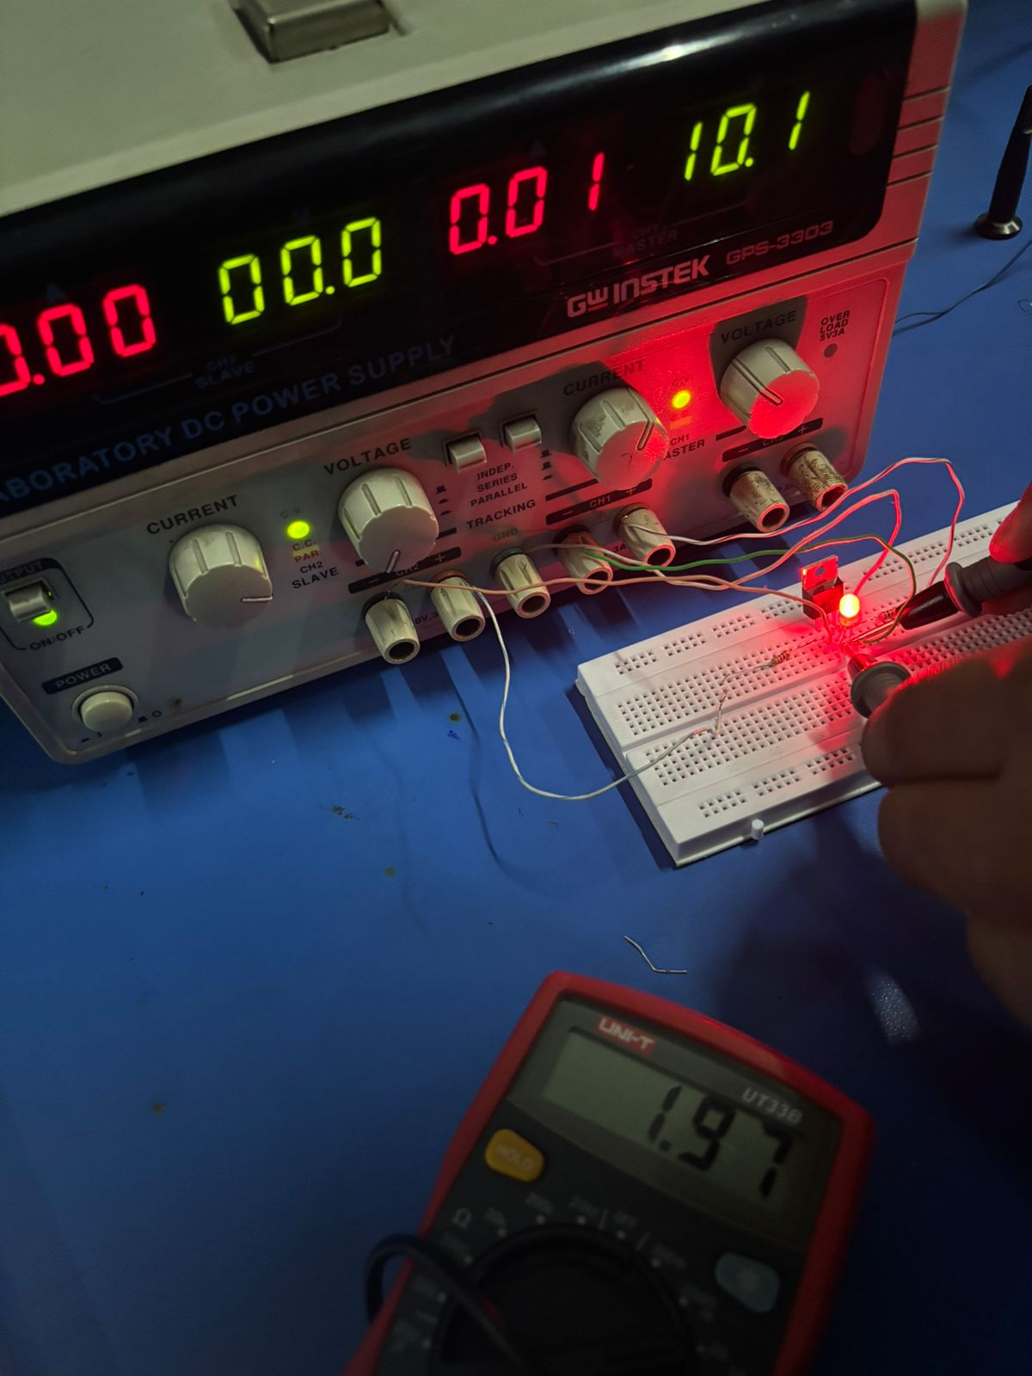

**Task # 3:**

When the frequency of 1KHz and voltage of 5V peak is applied, then, when the output goes from high to low the propagation delay is “2.32 micro seconds”.

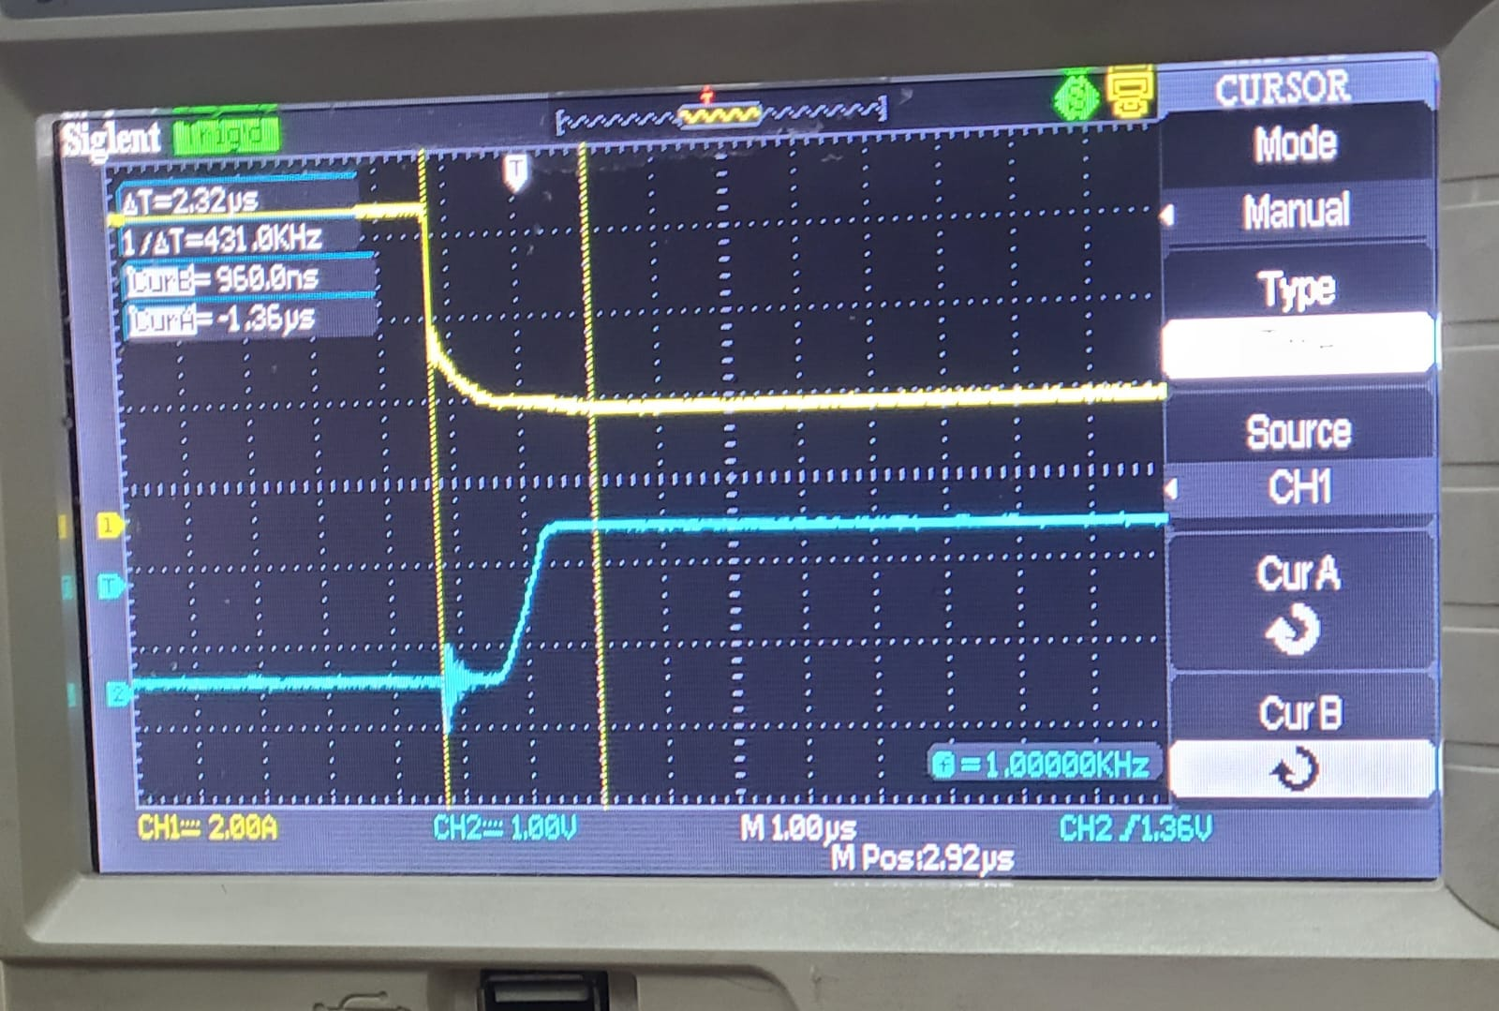

When the output goes from low to high then the propagation delay is “2.00 micro seconds”.

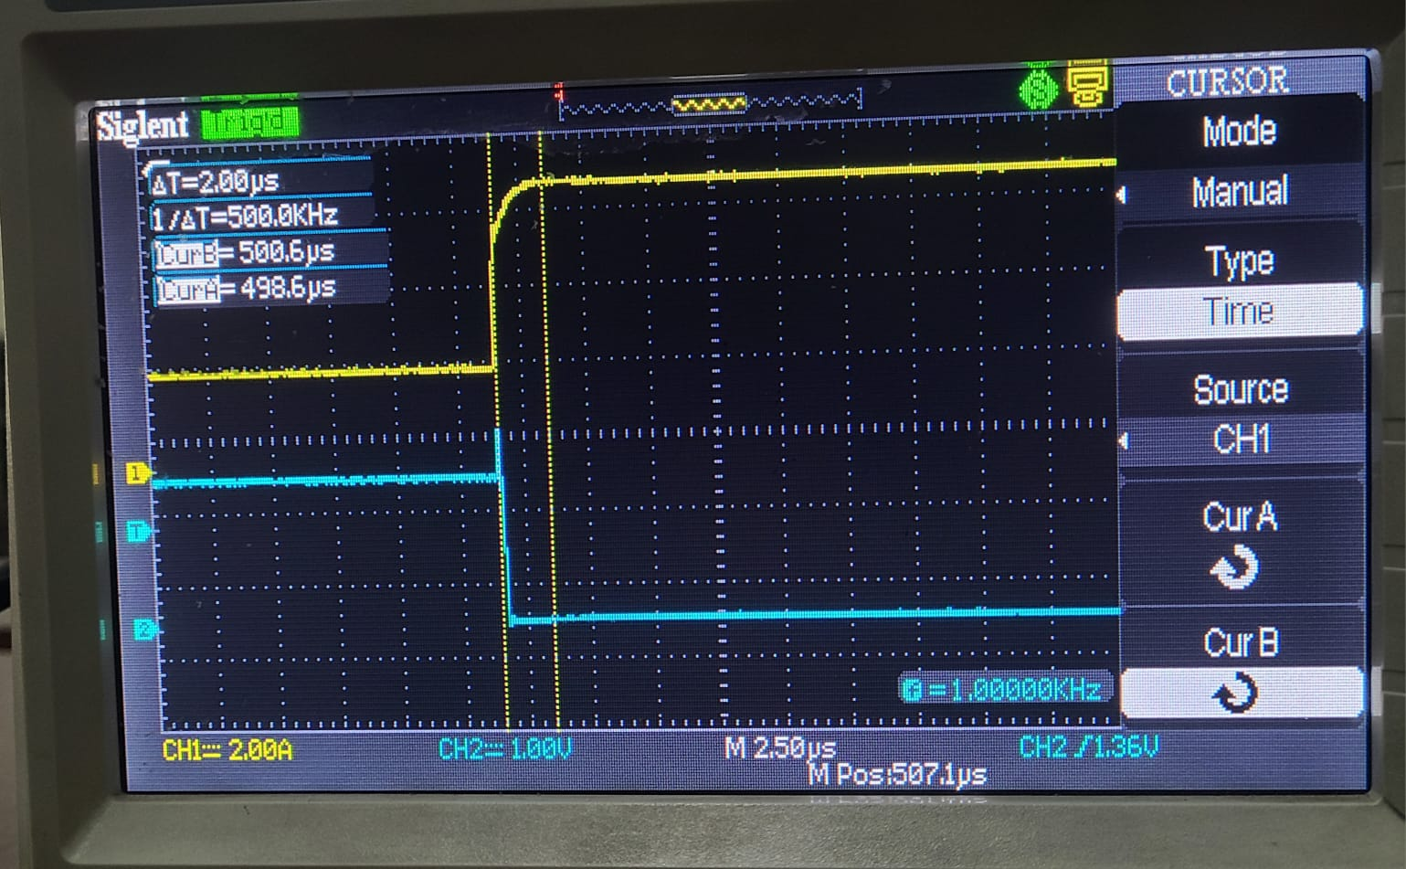

**Task # 4:**

When the frequency of 100KHz and voltage of 5V peak is applied, then, when the output goes from high to low the propagation delay is “2.20 micro seconds”.

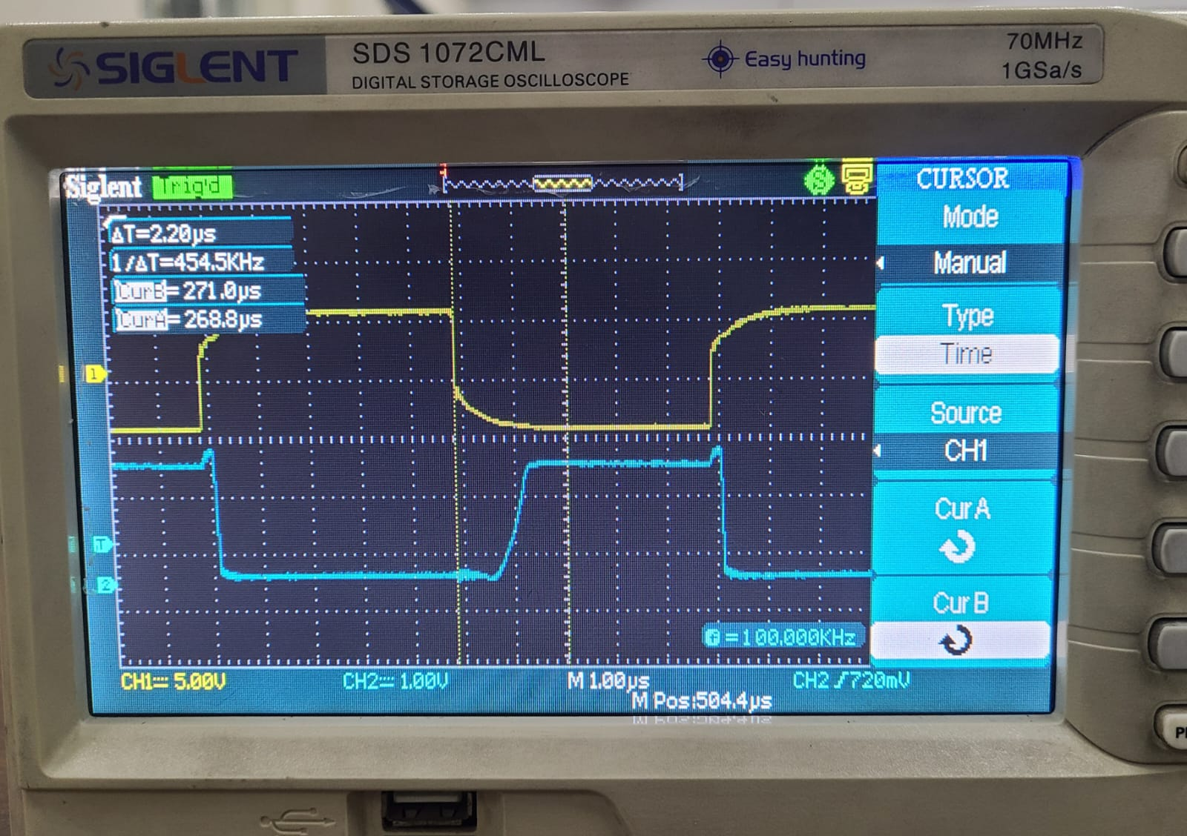

When the output goes from low to high then the propagation delay is “2.48 micro seconds”.

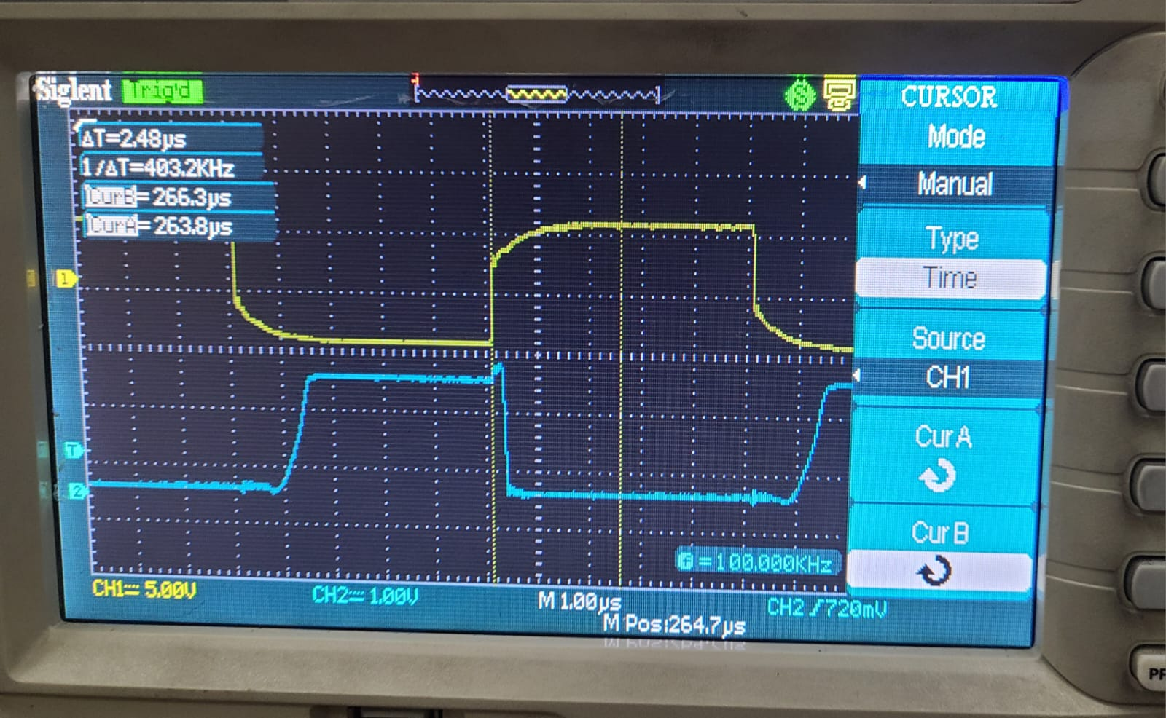

**Task # 5:**

At low frequency(1 KHz) the transistor is more efficient as compared to high frequency(100 KHz)

By my observations, we know that, every capacitor takes time to charge and discharge, also as we increases the frequency the switching delays(propagation delays) increases. So that’s why our output wave have round edges(representing the propagation delay) at some points instead of having corner edges.