|  |  |
| --- | --- |
| Name: Faseeh Ahmed | EE-272L Digital Systems Design |
| Reg. No.: 2023-EE-078 | Marks Obtained: ____________ |

**Lab Manual**

**Experiment # 3**

|  |  |  |  |  |  |
| --- | --- | --- | --- | --- | --- |
| **DSD Lab Manual Evaluation Rubrics** | | | | | |
|  |  |  |  |  |  |
| **Assessment** | **Total Marks** | **Marks Obtained** | **0-30%** | **30-60%** | **70-100%** |
| Code Organization (CLO1) | 3 |  | No Proper Indentation and descriptive naming, no code organization.  Zero to Some understanding but not working | Proper Indentation or descriptive naming or code organization.  Mild to Complete understanding but not working | Proper Indentation and descriptive naming, code organization.  Complete understanding, and proper working |
| Simulation (CLO2) | 5 |  | Simulation not done or incorrect, without any understanding of waveforms | Working simulation with errors, don't cares's(x) and high impedance(z), partial understanding of waveforms | Working simulation without any errors, etc and complete understanding of waveforms |
| FPGA (CLO2) | 2 |  | Not implemented on FPGA and questions related to synthesis and implementation not answered. | Correctly Implemented on FPGA or questions related to synthesis and implementation answered. | Correctly Implemented on FPGA and questions related to synthesis and implementation answered. |

**Truth Table:**

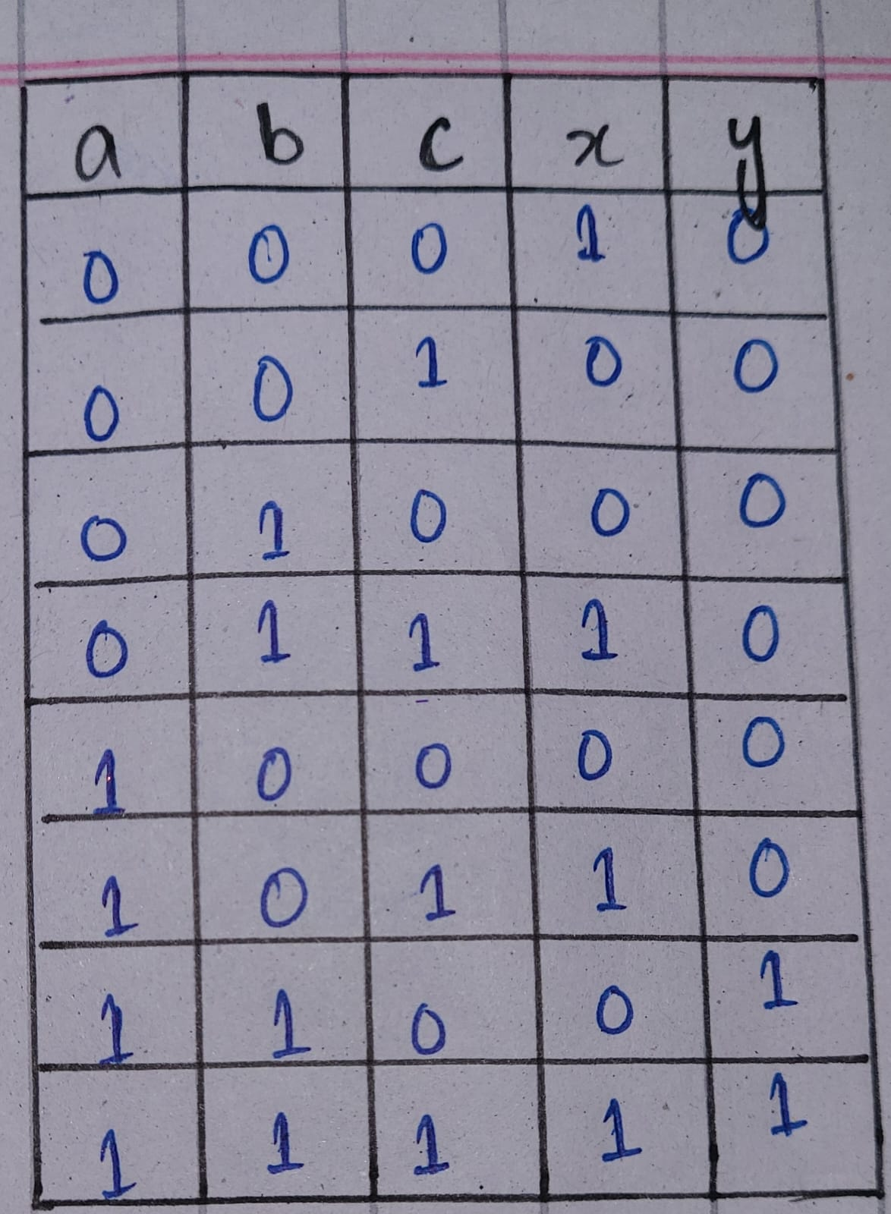

**Combinational Delay:**

The maximum combinational delay is in the path from ‘a’ to ‘y’ of “6.769 ns”

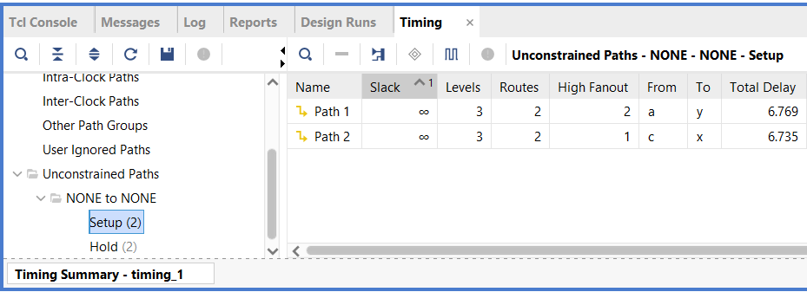

**Resource Utilization:**

