Software Requirements Specification

for

Online Car Rental System

Version 1.0

Prepared by

Asfa Jamil (134637)

Faseih Saad (131607)

Hafiz Adnan Iqbal khan (121846)

April 12, 2018

# Table of Contents

Table of Contents i

Revision History i

1. Introduction 2

1.1 Purpose 2

1.2 Product Scope 2

2. Overall Description 3

2.1 Objective: 3

2.2 Product Functions: 3

2.3 Assumptions and Dependencies 5

2.4 System Design 5

2.4.1 ER Diagram 5

2.4.2 Class Diagram 6

# Revision History

|  |  |  |  |
| --- | --- | --- | --- |
| **Name** | **Date** | **Reason For Changes** | **Version** |
|  |  |  |  |
|  |  |  |  |

# Introduction

## Purpose

The Auto Rental System (AR System) is able to handle car reservations, customer billing, and car auctions. When a customer reserves a car, he/she can use online reservation to make a general reservation. The system must be able to look for the matched available car in Car Data Base and form a new reservation in Reservation Data Base. If the customer makes reservation in person, the assistant of rental company is able to access the customer data base, car data base, and reservation data base internally and make a reservation for the customer. After the each reservation is made, the corresponding car will be shown as unavailable in car database. When the customer picks up the car, the assistant can access the customer’s reservation record with the reservation number customer provided. The customer and the assistant are able to complete the rental lease using the system. After the completion of the rental lease, the new lease will be recorded in customer data base. (Each lease is directly related to customer’s billing information.) Then the system will print out a car rental card (internally used in the company). The customer obtains the key of the car from Technician of the rental company with the car rental card. After the customer checks the status of the car and accept the car, the Technician is able to use AR system to update the car data base that the corresponding car is “ in-rental” status. Then the corresponding rental lease status is updated as “ 1/3 completion”

When the customer returns the car, the technician will check the status of the car. A damage report and a miles report will be made with the AR system. The damage report will be directly related to car database and customer’s billing information. And the miles report will update the car database. If the car has accumulated over 20,000 miles, it will be listed to the “ Car Auction List” and deleted in “ available car list” . And the corresponding rental lease status is updated as “ 2/3 completion” .

AR system is able to print out a bill. If the customer pays the bill, the transaction will be completed immediately. After the customer pays the bill, the “ rental lease status” is updated as “ Full completion” . If the customer’s corporation pays the bill for the customer, the system will send the bill to the corporation where customer works for. The “ rental lease status” will not be “ Full completion” until the rental company receive the payments.

## Product Scope

The system will be done according to the scope of Rental Car Online System (RCOS) which is state as below:

**System:**

1. Provide car catalog for users as an alternative for them to select car if they want to choose car by their own.

2. Allows admin to search user information from the database based on the user's ID card number or their name.

**User**:

1. All owner car at campus can advertise their car in the system.

2. All student in campus can access the system.

# Overall Description

## Objective:

* To transform the manual process of hiring car to a computerize system.
* To validate the Rental Car system using user satisfaction test.
* To produce the documentation such as Software Requirement Specification (SRS), Software Design Description (SDD) as system development references.

## Product Functions:

**Functional Requirements**

**Hardware Requirements**

The software should be ran on any sort of desktop or laptop environment, regardless of the operating system. The software also has the potential of running on tablets, but with a more simplified version. Essential input/output devices are keyboards, mouse, and printers; nothing else is required but can be recommended if desired.

**Website Interface**

**Primary Tasks:**

1. **View all available rental cars**

Connects with the database through JavaScript to call all car objects and display them accordingly

1. **Search for desired car by model, seating capacity, and cost**

A search bar will be implemented on the website that will search the site based on the input

1. **Select their desired rental car**

A button will be displayed under the rental car previews that will allow for the selection

1. **Allow for registration**

registration display form

1. **Allow the customer to log in**

log in display form

1. **Allow administrators to change what cars are available for rent**

Administrators will log in through the log in display form such as customers would, but would have a different looking interface to allow for them to add and remove options.

**Secondary Tasks**

1. **Allow for rent cancellation by customer**

Only for users who are registered, there were be a cancel button on the display page that shows all rents present by customer

1. **Allow the user select and provide a payment type**

Display form - with options for typical card information - type, number, code on back, month, year etc.

1. **Authenticate any user logging in**

Communicates with the database to verify the inputted username and password is correct

1. **Authenticate any form of payment**

Communicates with verifiers to confirm the input information on the card is correct

1. **Calculate tax rates, customer totals**

Algorithms implemented within the code that will calculate all totals ‘behind the scenes’

1. **Send an email to verify a registration**

Once a customer registers and click the complete registration button, an email will be sent to the email the customer provided, provided a link in the email that will allow for a verification that this is the said-customer.

1. **Display a transaction summary / email a summary**

After customer submits their payment and it is confirmed client-side, a transaction summary will display on the website and a copy will be emailed to the customer

1. **Select date of desired delivery ( & choose delivery destination), or date of planned pick-up at nearest store location**

Calendar options will be displayed that will allow the user to select directly on the calendars - if they want it as soon as possible, there will be a checkbox for that option

1. **Select length of rental and planned drop-off date**

Calendar options as well

1. **Store customer information in the database**

When registering, the customer will provide their information in the form - this information will be sent securely sent and stored in the database

**Admin Interface**

**Primary Tasks**

1. **Allow company workers to open and view customer information**

navigation option that will allow for search of customer by name or rental car and implementation of search bar.

1. **Track customer payments**

Displays with the customer’s information

1. **Keep and display available rental car records (for damages purposes and such)**

Searching and viewing much like with customers

**Secondary Tasks**

1. **Print invoice**
   * If print option is selected, a printable version of the page being viewed by the worker will display with a confirm print button to selected printer
2. **Calculate total of all transactions**
   * **A**lgorithms behind the scenes
3. **Allow for rent cancellation by company worker**
   * A button will cancel a rent request by a customer

**Non Functional Requirements**

**Performance Requirements:**

* Ability to maintain mass amount of customers on the website at once without crashing
* Speedy performance / transmission of data
* Send any emails immediately
* Being logged in should allow for customers to quickly make payments without reentering information, and allow for any potential registered perks the company may have
* Have a quick recovery time if anything were to go wrong
* Display accurately and efficiently on all devices (responsive view)

**Security Requirements:**

* Secure any transmissions of private information between the customer and the company
* Prevent any potential threats such as SQL injections through the forms or search boxes.
* Prevent third party users at administration level
* Verify website security certificates (that lock in the address bar)
* Prevent false information from being used as payment
* Prevent false email inputs from being used when registering

**Quality Attributes:**

* Maintain a user friendly environment that is visually appealing
* Easy to see and use navigation
* Maintain readable content
* Searching cars should be accessible to people who are and are not logged in
* Selecting and making a payment should be available to customers who are and are not logged in

## Assumptions and Dependencies

**Assumptions:**

* Customer database consists all the information about a customer with Name, Age, Driver License Number, Corporation, Log-in ID, Log-in Pass Word, billing information.
* Car database consists all general information of the available cars and cars auctions, such as brand, passenger capacity, miles, available date, etc.
* Reservation database contains all the reservations the auto rental company have. The information includes date made reservation, date to pick up car, customer’s name, reservation number.
* Lease database contains all the leases the auto rental company have. The information includes date, customer, rental plan, accident insurance option, Loss Damage Waiver option, Gas Charges option, and completion status.

## System Design

### ER Diagram

### Class Diagram

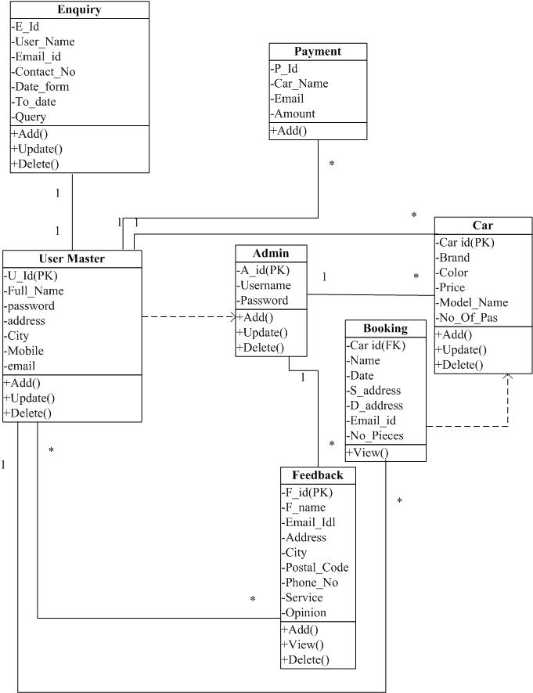

**Breakdown of Tasks**

* Lab 10
  + Asfa Jamil : Hibernate and Database Objects
  + Faseih Saad : Hibernate Mapping and Controllers
  + Adnan Iqbal: Web Designing and Integrating
* Lab 11
  + Asfa Jamil : Desktop App Front End
  + Adnan Iqbal : Hibernate and Controllers
  + Faseih Saad : Hibernate and Database Objects