

**Enterprise Azure Skills Learning Plan**

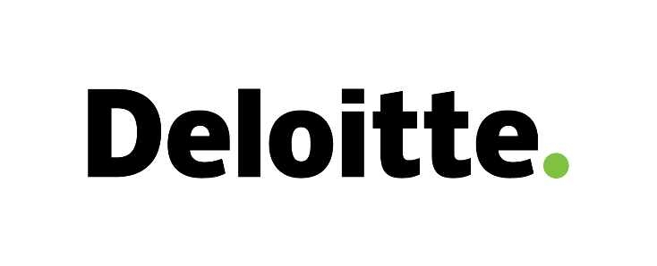

**Customer Account Azure Skills Learning Plan**

* **Customer key contact:**
* **Details:**
* **Name:**
* **MSX Success Engagement ID:**
* **Email:**
* **Phone:**
* **Address/location:**

Table of Contents 1

1 Enterprise Learning Plan 2

1.1 Customer Situation 2

1.2 Skill Requirements 2

1.3 Recommended Learning Plans 3

1.3.1 Foundational (T1) 3

1.3.2 Advanced Role-based (T2) 4

1.3.3 Advanced Workload-based (T3) 5

1.4 Customer Training Plan and Schedule 6

2 Appendix 7

2.1 Organization Information 7

2.1.1 Key Contacts information 7

2.1.2 Role Information 7

3 Reference 8

3.1 Role Definitions 8

1. Enterprise Learning Plan
   1. Customer Situation

Describe the business goals. How will the learning and development support the business goals?

*For example: XYZ is currently setting up a Cloud strategy and looking at enabling multiple cloud solutions within the business to help them reduce production cost and improve speed of technology delivery. As part of this strategy, they want to train these different groups within the organization: Developers, IT Operations, Security, IT Architecture, Innovation.*

* 1. Skill Requirements

Describe the skills required to meet the business goals.

*For example: In order to accomplish their business goals, XYZ has a need to help ramp up specific skills in Application Modernization (App Services, Containers, LogicApps, Functions, API Management, Application Insights) along with some Cloud Infrastructure Fundamentals (Compute, Storage, Networking, Backup, Monitoring) for staff that have not yet had the opportunity to work with Azure. They plan to train 100 people total in different cities: New York, Tempa, Toronto and London.*

* 1. Recommended Learning Plans

Based on the outlined business goals and aligned skills requirements, and leveraging the menu of training resources available, outline the recommended training plans for each role in the organization in the table below. Be sure to bring in the PSE for help and understanding with the training menu.

Training Menu

The training menu is divided into three tiers of training packages: *Foundational (Required), Advanced Role-Based,* and *Advanced Workload-Based*.

* Tier 1 offers an introductory start to Azure with self-paced and instructor-led options. (Required)
* Tier 2 provides master Azure skills within more in-depth training with self-paced MOOC and instructor-led options.
* Tier 3 provides instructor-led and facilitated training for a deep dive into Azure workloads with topic-based workshops and Hacks.

[Both T2 and T3 are advanced level content. T1 as introductory and required, then straight to T3 if the desire is to learn about specific services\workloads.]

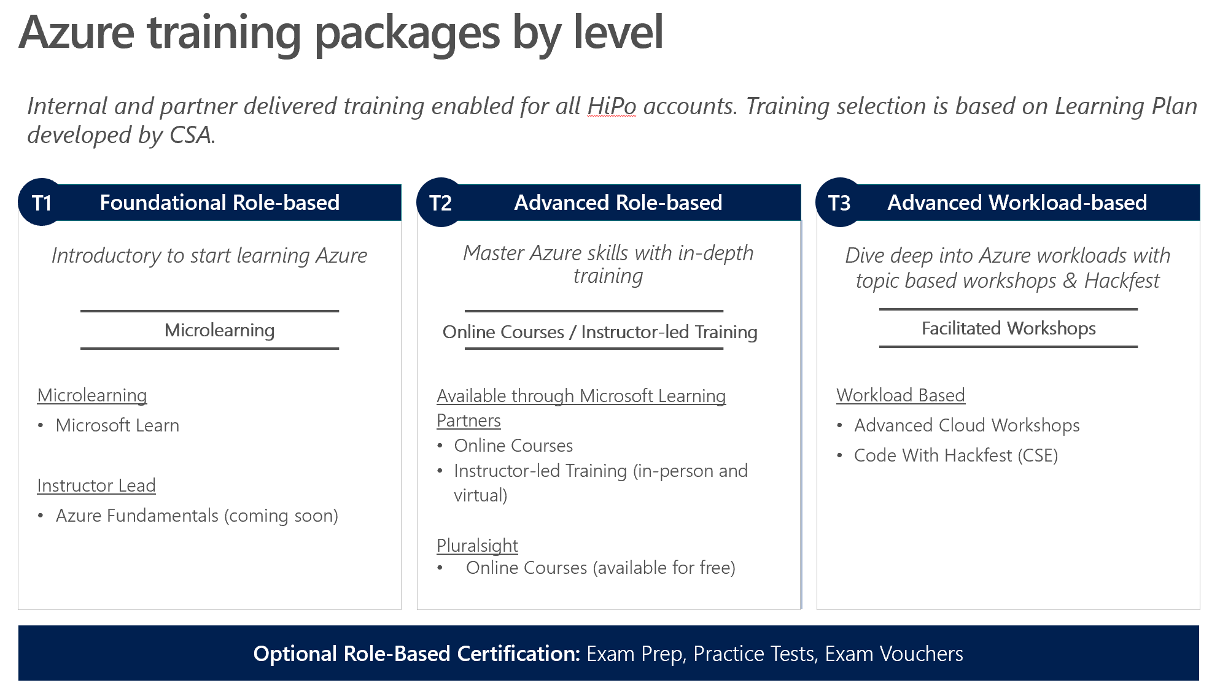

* + 1. Foundational (T1)

Introductory start to learning Azure. Available as Self-Paced (online) or Instructor Led.

1. **Azure Essentials -** Micro learning with quick overview of a variety topics
   * 16 tracks available
   * 1 day in-person
   * Self-paced, online
   * Prerequisite: None
   * Available on [Azure.com/essentials](https://azure.com/essentials)
   * Cost: Free
2. **Pluralsight Learning Paths –** Video based learning across various job roles
   * 7 Paths available across 26 Courses
   * Self-paced, online
   * Prerequisite: None
   * Available on [azure.microsoft.com/en-us/training/learning-paths/](https://docs.microsoft.com/en-us/learn/azure/)
   * Cost: Free
     1. Advanced Role-based (T2)

Master Azure skills with in-depth role-based training that is aligned to certification.

T2 Training tracks:

* + - * Cloud Administration
      * Solutions Architect
      * Data and Analytics
      * DevOps

1. **Instructor Led**

* Traditional classroom trainings taught by Microsoft Certified trainers (MCT) and composed of Microsoft Official Courses (MOC)
* 20 Titles Available
* In-Person or Online Instructor Led
* Courses are 5 Days in Length
* Delivered by Learning Partners
* Prerequisite: T1, Azure Fundamental
* Cost: Fee based through Learning Partners

1. **Online Self-Paced**

* Self-Paced MOOC
* Opt for flexibility and choose online learning modalities such as Massive Open Online Courses (MOOC)
* 40+ Titles Available
* Courses vary in Length
* 4 Learning Paths (Cloud Administration, Solutions Architect, Data & Analytics, and DevOps)
* Delivered by Learning Partners with tracking available
* Prerequisite: Foundational Azure Experience or Training
* Cost: Fee based through Learning Partners

1. **Certification –** Validate your skills with Certification

* In-Person and Online Proctor Available
* 10+ Azure Exams Available
* Prerequisite: Varies per exam
* Available on <http://aka.ms/AzureCertification>
* Cost: Fee based
  + 1. Advanced Workload-based (T3)

Deep dive into Azure workloads with topic-based workshops and Hacks.

**Scenario-Based Workshops – “Microsoft Cloud Workshops”** Develop technical skills via architectural solution design and Hands on Lab

* Instructor-Led
* 27 Available Workload focused topics available
* Delivered by CSA/GBB
* Prerequisite: Azure Experience in relevant topic, T1-Fundamental
* Workshop Details [aka.ms/mscloudworkshop](http://aka.ms/mscloudworkshop)
* Cost: Free if utilizing internal CSA/GBB

**Suggested Workshop:**

* T3 track a customized workshop tailored to migration of on premise workloads into Azure
* Azure design session that is specific to the workload to migrate.
* Targeted to specifically moving an existing workload into Azure

**Hackathons–** Large-scale coding engagement focused on the development and knowledge transfer of strategic tech skills to both MSFT (CSA, TSP, GBB) and industry (customer, partner, developer) tech roles through challenge-based hack

* OpenHack details: [aka.ms/CSEOpenHackRegister](https://aka.ms/CSEOpenHackRegister)
* Duration: 3 days
* Delivered by CSE
* Prerequisite: Prequalified by CSE
* Cost: Free

**Hackathons Topics:**

Business Apps and Enterprise Developer

* Design solution architecture of AI Chatbot using Azure Bot Service, Logic Apps, Functions and Cosmos DB
* Hands on lab: Event grid, Event hub, Logic Aps
* Design and architect end-to-end solutions, Azure Container Service, PaaS
* Design and hands on creating Serverless application

AI and AA

* Hand on lab with Azure Machine Learning Workbench
* Integration of machine learning outputs in web/mobile application
* Design and develop AI applications QnA chatbot for customer service
* Serverless application for data analytics
* Building AI applications with Cognitive Search
* Architecting Intelligent Agents
* Intelligent Analytics
* Enterprise Grade BI models with Power BI

DevOps

Azure Pipelines

* Containers and Kubernetes

Easily build and push images to container registries like Docker Hub and Azure Container Registry. Deploy containers to individual hosts or Kubernetes.

* Continuous Integration, Delivery and Deployment (CI/CD)

Azure Test Plans

Azure Stack

* + Deploying and integrating an Azure Stack environment
  + Configuring PaaS and IaaS for an Azure Stack environment
  + Maintaining and monitoring an Azure Stack environment

Data Operations

* SQL 2017 - Modern Data Platform
* Azure SQL Data Warehouse
* Azure Databricks
* Scaling ML models with Azure Databricks
* Deep Learning with GPU's on Azure Data Bricks
* Big Data Visualization
* Azure Database Services for MySQL, PostgreSQL and MariaDB
* SQL Server on Linux and Docker
* Business continuity and DR of Data
* Data Estate modernization
* Opportunities for HPC

**TAM Workshop:**

|  |  |  |  |  |  |  |  |  |
| --- | --- | --- | --- | --- | --- | --- | --- | --- |
| Workshop - Azure: Advanced Cloud Business Analytics - Closed Workshop | Microsoft Advanced Cloud Business Analytics is a 5 (five) days workshop which offers to attendees advanced learning on Microsoft Cloud Analytics solutions with focus on HDInsight and Azure Machine Learning through a solution proof of concept type approach. The program is composed of classroom training that may include some theory is focused on practical solution development based on a real world scenario. The attendees will be expected to develop the solution with support from the instructor. This approach should allow attendees to deepen their knowledge on Hadoop framework technologies and Machine Learning techniques that Microsoft build on Azure. | Workshop | 2,600.00 | USD | Azure | 400 | Level1 | Secure Infrastructure |

|  |  |  |  |  |  |  |  |  |  |  |
| --- | --- | --- | --- | --- | --- | --- | --- | --- | --- | --- |
| WorkshopPLUS - Microsoft Azure: Application, Monitoring and Diagnostics for IT Professionals - Closed Workshop | The three-day Microsoft Azure Application Monitoring and Diagnostics WorkshopPLUS course provides attendees with deep knowledge on how to monitor applications hosted on Microsoft Azure. | WorkshopPLUS | 28,020.00 | USD | Availability and Business Continuity | Business Continuity Processes,Reliability and Stability,Resiliency,Backup and Restore | Azure | 300 | Level3 | Secure Infrastructure |

1. Reference

2.1 Role Definitions

**Microsoft Certified: Azure Administrator Associate**

Role:

* Manage cloud services that span storage, security, networking, and compute cloud capabilities
* Deep understanding of each service across the full IT lifecycle
* Take requests for infrastructure services, applications, and environments
* Make recommendations on services to use for optimal performance and scale, as well as provision, size, monitor, and adjust resources as appropriate
* Have proficiency in using PowerShell and the Command Line Interface
* Basic familiarity or knowledge of Azure Portal, ARM templates, operating systems, virtualization, cloud infrastructure, storage structures, and networking

**Microsoft Certified: Azure Developer Associate**

Role:

* Design and build cloud solutions such as applications and services
* Participate in all phases of development, from solution design, to development and deployment, to testing and maintenance
* Partner with cloud solution architects, cloud DBAs, cloud administrators, and clients to implement the solution
* Proficient in developing apps and services by using Azure tools and technologies, including storage, security, compute, and communications have at least one year of experience developing scalable solutions through all phases of software development and be skilled in at least one cloud-supported programming language

**Microsoft Certified: Azure Solution Architect Expert**

Role:

* Advises stakeholders and translates business requirements into secure, scalable, and reliable solutions
* Have advanced experience and knowledge across various aspects of IT operations, including networking, virtualization, identity, security, business continuity, disaster recovery, data management, budgeting, and governance
* Manages how decisions in each area affects an overall solution

Proficient in Azure administration, Azure development, and DevOps, and have expert-level skills in at least one of those domains

* 1. Customer Training Plan and Schedule

|  |  |  |  |  |  |  |  |  |
| --- | --- | --- | --- | --- | --- | --- | --- | --- |
| **Targeted Role(s)** | **# to be trained** | **Title of Training** | **Level** | **Delivery Approach (Learning Partner or MSFT and specific role/person to deliver)** | **Length** | **Delivered by** | **Scheduled Delivery Date** | **Completed Delivery Date** |
| **Foundational Training** | | | | | | | | | |
| *SAMPLE: Business Decision Makers and Project Managers* | *100* | *Azure Essentials* | *Foundational* | *In-person, Learning Partner* | *varies* | *Self-paced* | *January 4th (ongoing monthly)* |  |
|  |  |  |  |  |  |  |  |  |
|  |  |  |  |  |  |  |  |  |
| **Role-Based Training** | | | | | | | | | |
| *SAMPLE: System Administrators, Architects, and Engineers* | *20* | *Implementing Azure Infrastructure* | *Role-based Advanced* | *ILT at customer* | *5 days* | *Learning Partner* | *Januray 4th- 9th* |  |
|  |  |  |  |  |  |  |  |  |
|  |  |  |  |  |  |  |  |  |
| **Workload-Based Training** | | | | | | | | | |
| *SAMPLE: Architects, and Developers* | *15* | *<<Specific Workshop titles>>* | *Workload-based Advanced* | *Two Workshops with Hands-on Labs at customer site* | *2 days* | *CSA, GBB* | *Xx - xx* |  |
|  |  |  |  |  |  |  |  |  |
|  |  |  |  |  |  |  |  |  |

1. Appendix

3.1 Organization Information

* + 1. Key Contacts information

|  |  |  |
| --- | --- | --- |
| **Role** | **Name(s) & Title** | **Contact Info (Email/Phone)** |
| Azure Technical Enablement Sponsor |  |  |
| SATV Administrator |  |  |
| Premier Contract Owner |  |  |
| Additional Executive Sponsors |  |  |
| Additional Stakeholders |  |  |

* + 1. Role Information

|  |  |  |
| --- | --- | --- |
| **Role** | **Number** | **Department/Location** |
| *Example: IT Administrator* | *25* | *Shared Services* |
|  |  |  |
|  |  |  |
|  |  |  |
|  |  |  |

TBD:

Operation Support Based Role

Cost Management Focused Workshop – Customer firms have cost as the primary concern