Correction wall of share

Photo:

1.



After submitting the form it needs to be redirected to the website home page.

5.

attachment field required to add CV and photo

6. 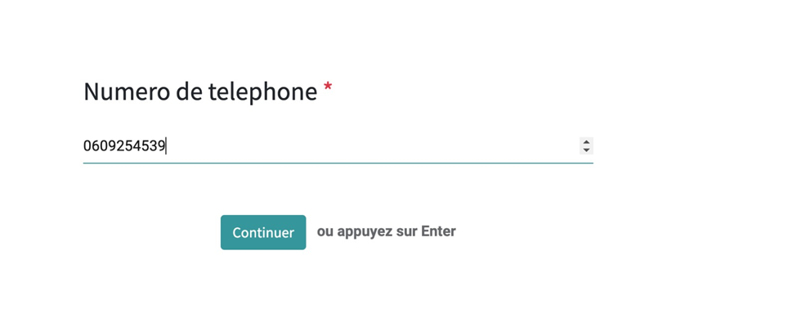

Country drop down list

7. 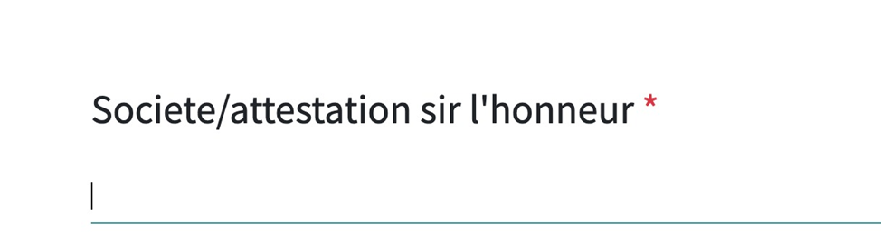

Check option(eg: if he choose yes then the it will be different form if he choose no then it will be different).

suppose the worker has a company then :

Forme de la société :

Dénomination sociale

Documents officiel (kbis/insee ect)

if he dont have a company or If he dont have documents

You have an option

Je n’est pas de documents (attestation sur l’honneur)

Invoicing with payment gateway: invoice creation of 1 from behalf of worker company and one from wallofshare and it should take the worker company logo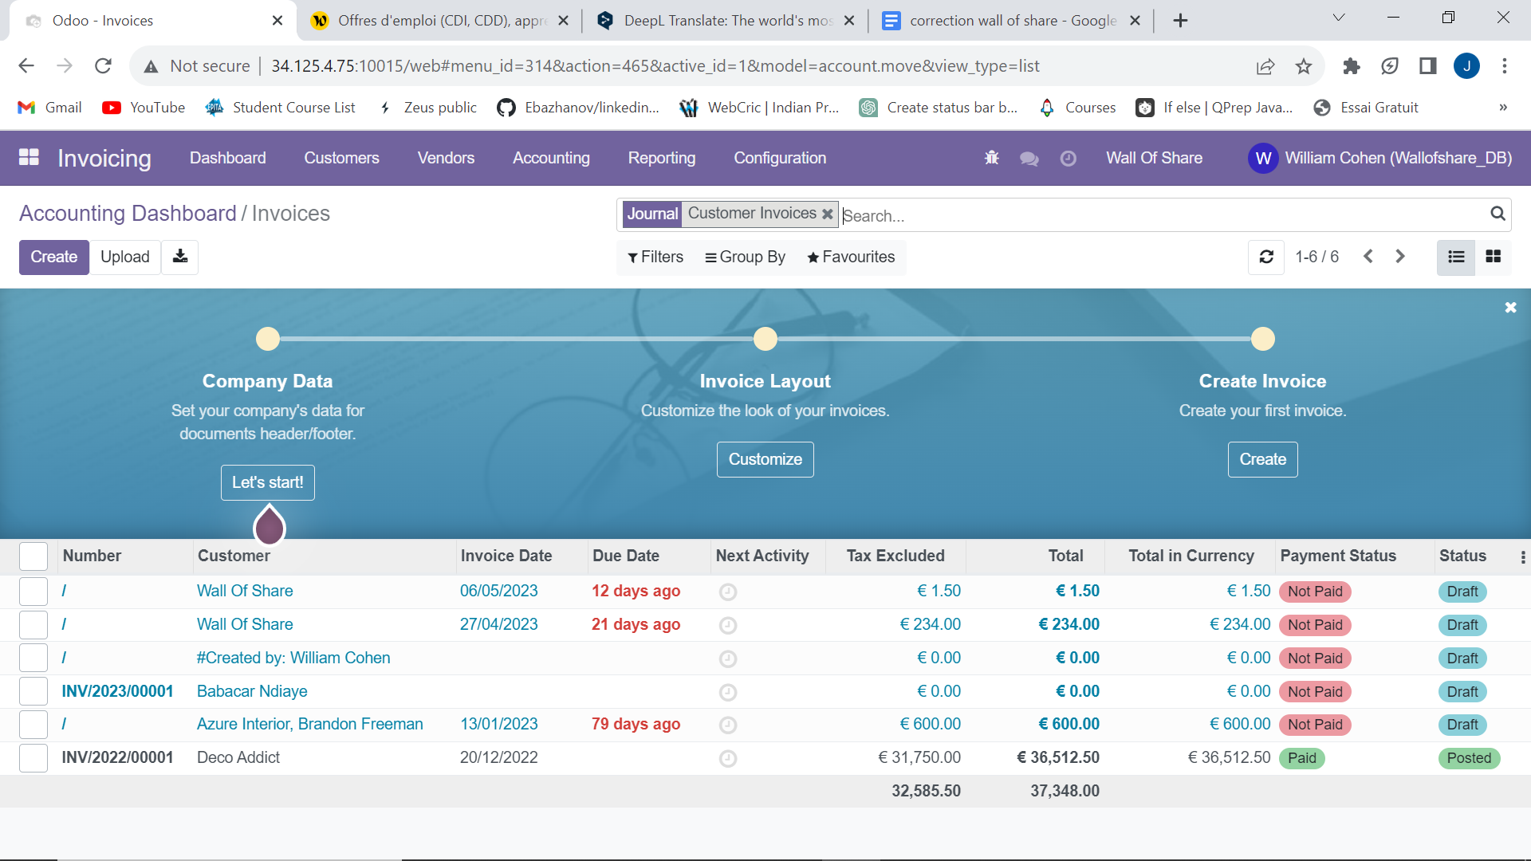

8. Worker profile :

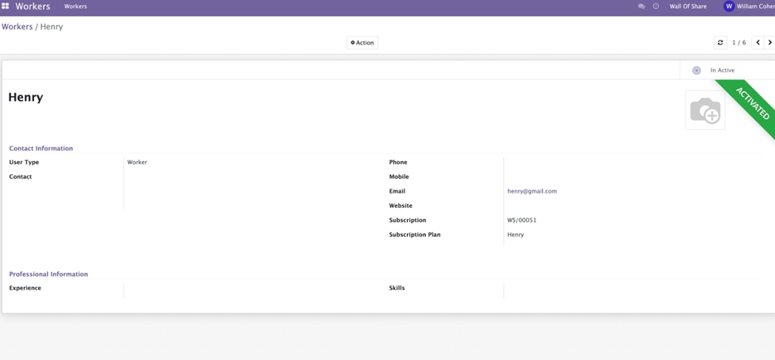

we need to make it good Like the documents which he uploaded with the pic of the worker CV , audio file and what we have asked in the question it will highlight in his profile. If any other change ragavane please add into this. Logo of his company and his profile pic

And same for the customer if we can highlight the profile.

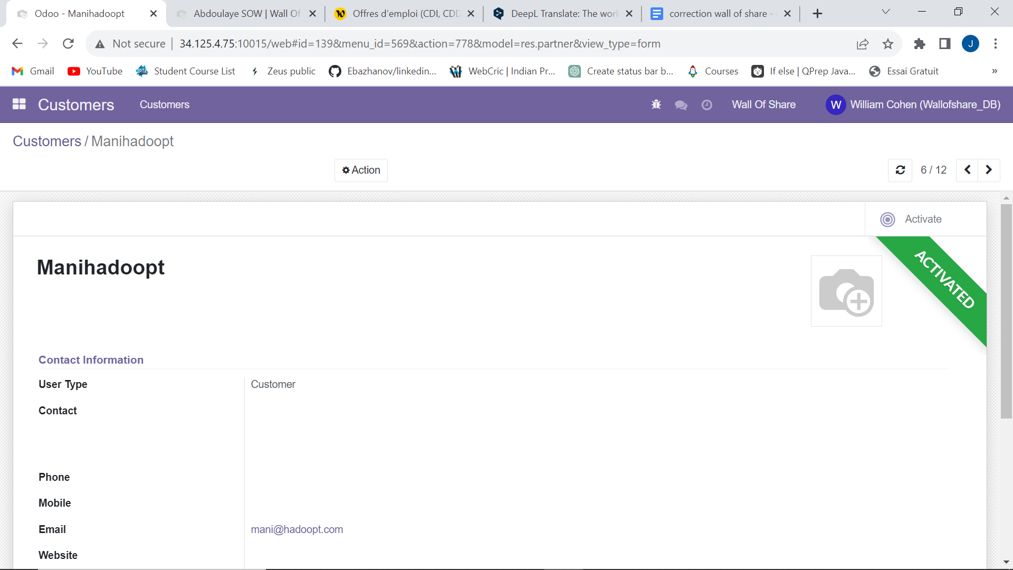

9. Here in the right corner if we can add a bar of 4 stages like Presentation , Parcores, Motivatin , CGV,CGU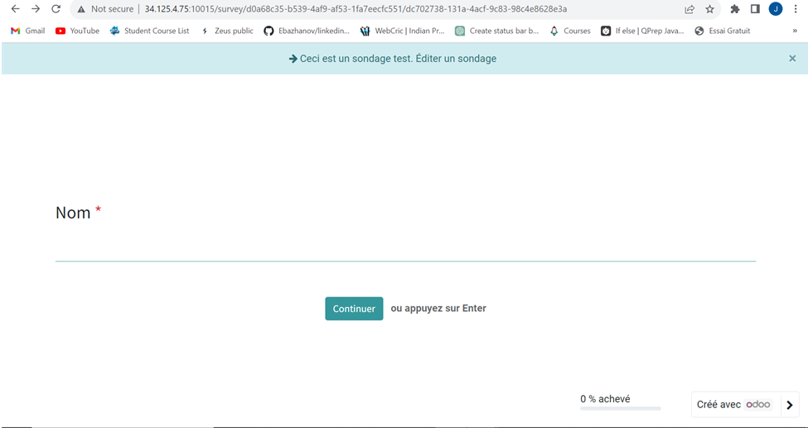

Example:



Cancel button for subscription for customers :

In this how can we check which worker the customer has hired to we need to create an submenu hired woker or my workers

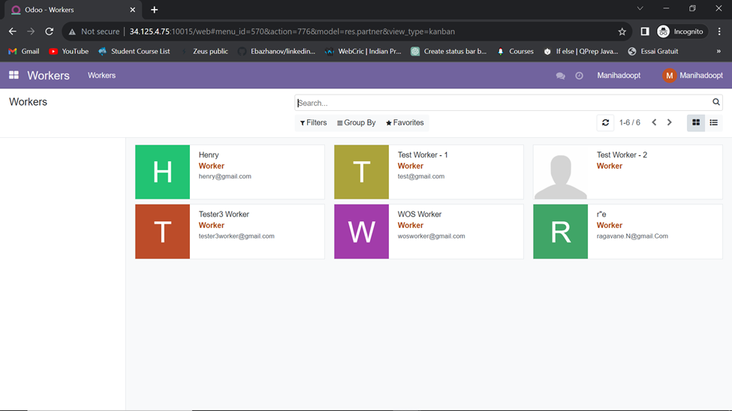

In place of hire worker we will add cancel subscription in sub menu hired worker or my workers

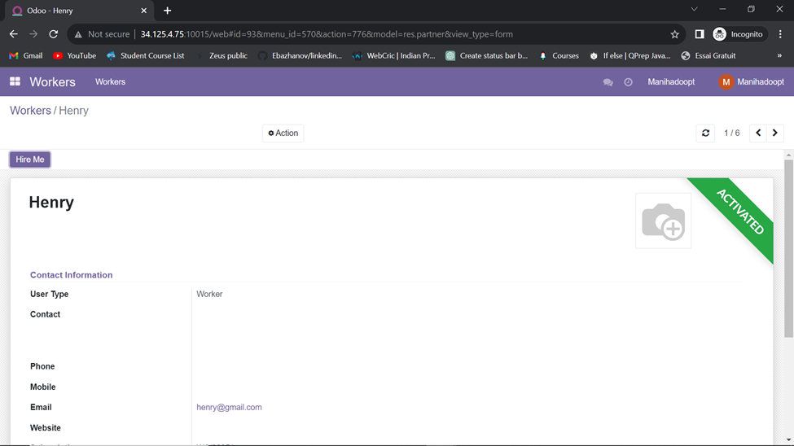

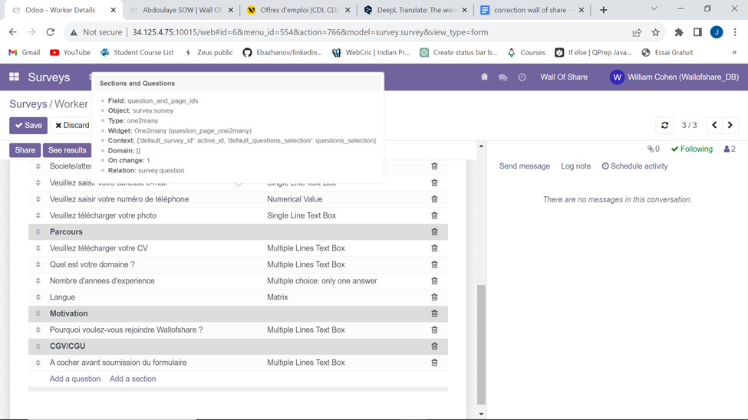

here i added the sections but when i am running the server its not working as it is showing the old questions. and in CGV/CGU we need to show all the summary of what he has done in the form.

same for customer.

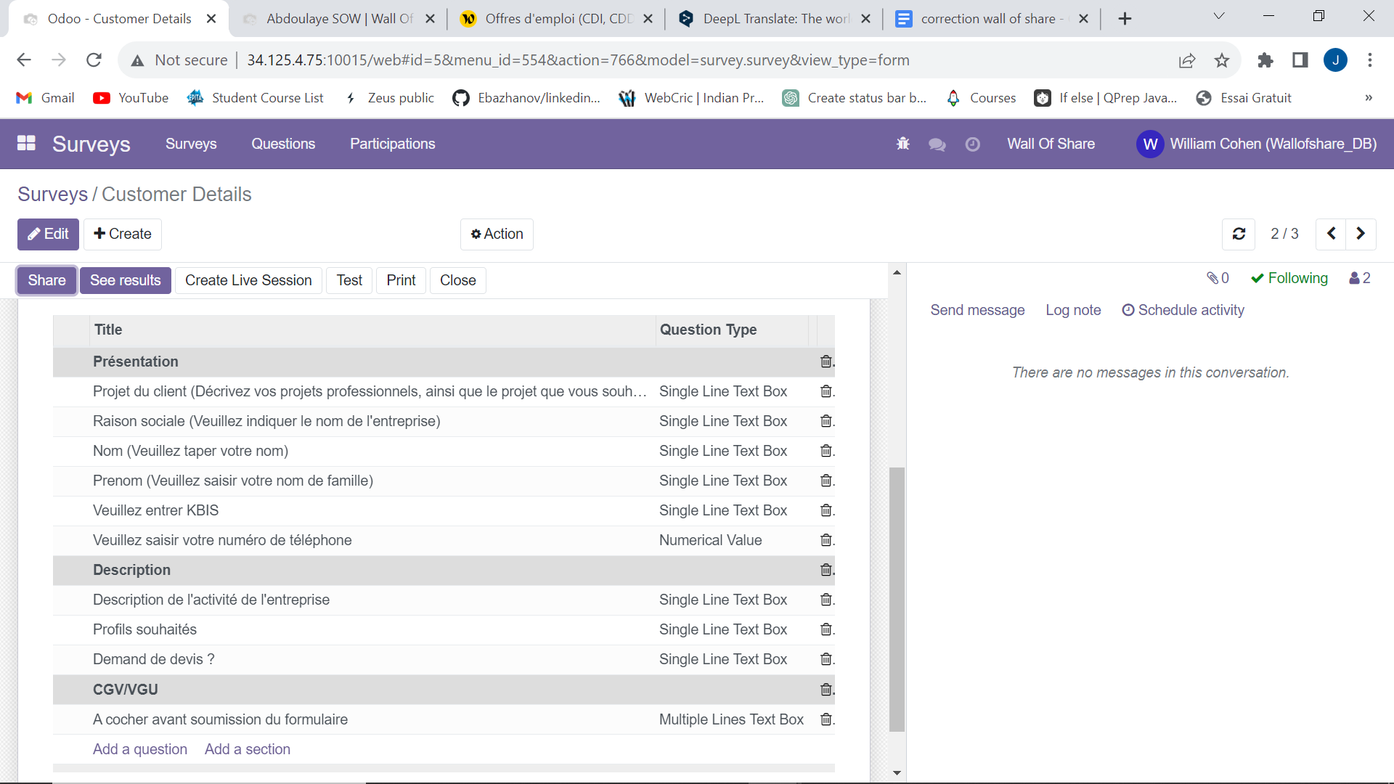

Website module : Need to set the audio file in the place of audio section

and Uplodation of worker in the website after validation with its documents and image

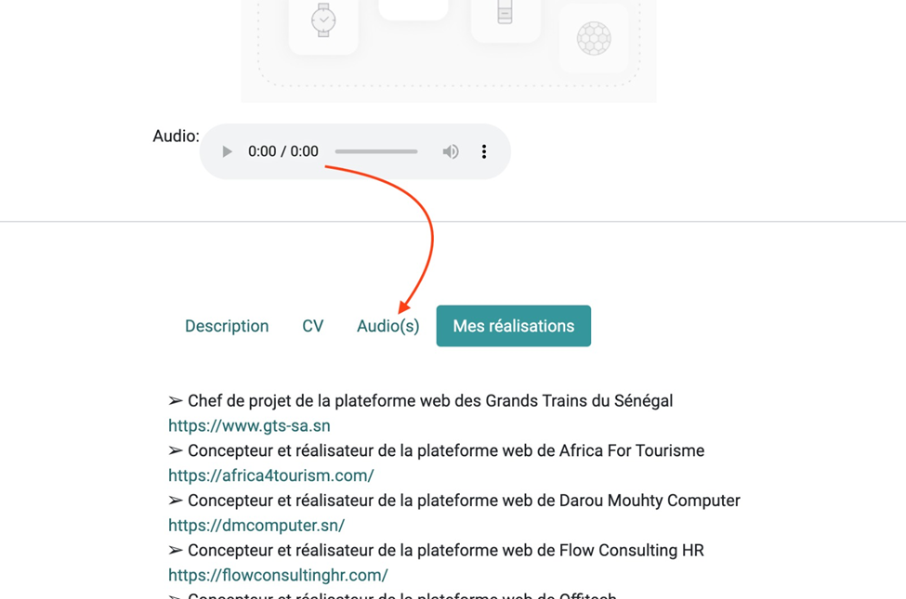

Subscription part ; we need to create 3 packages for subscription BASIC , PREMIUM

i want to possibility to choose one package for multiple workers other wise we need to create 3 packages for every worker again and again

If customer want to hire multiple user so we can not hire multiple user . suppose we need to hire team of 10 we can not do it. and the renew of an worker will be added automatically.

If we can add back button with continue button

Here we need to create package for every worker like there will be 3 packages basic premium and custom basic will be free , premimum will have some amount i guess it will be 500 euro and custom

So the packages will be same for every worker but we dont need to create manually suppose we have 100 workers we need to create 100\*3 packages manually.

What we can do is we create packages and when i select basic and i can choose all the worker in one time same for premium and customize will the option for customer to create.

there is an question in my mind here the thing is we need to do something in basic so the customer need to go for premium because basic is free but we need to put some restrictions in basic or something any comments ?