

**IUB ALUMNI NETWORKING (AlumnIUB)**

**Ayatullah Arefin, Fahim Shahriar, Syed Niaz Mohtasim & Mehedi Hasan Surem**  
**2022353@iub.edu.bd, 2022523@iub.edu.bd, 2021607@iub.edu.bd, 2030069@iub.edu.bd**  
**Department Of Computer Science & Engineering, Independent University, Bangladesh**

This is where " **AlumnIUB** " seeks to make a difference by linking Alumni with other Alumni, Students and University to connect. Users can seek help and connect with other alumni and also can share their experience on that application. The connections with students, both past and present, will be improved with the help of that effective alumni engagement plan.

|  |
| --- |
| Objective |
| The objective of this networking application project is to design and build a mobile application to help students and University to connect with all the alumni who graduated from IUB or going to graduate from IUB. The long-term viability of any university depends on alumni participation. |

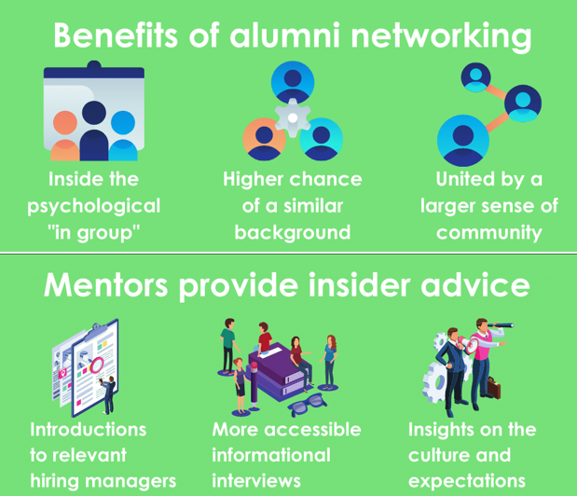

|  |
| --- |
| Introduction |
| “**AlumnIUB**” is a social networking application whose main focus is to connect all the Alumni of IUB with each other’s, Connect with all of the IUBian fellows to teach them about career prospects, share about their accomplishments, learn about IUB initiatives, and donate to a good cause. |



History Leading the project:

In general, Universities are not practicing what they teach when it comes to their former customers- their alumni. In short, they are failing in alumni engagement. We know about the importance of alumni engagement for alumni relations offices at colleges, universities, and other institutions around the country and across the world. The idea and act of alumni engagement is important because there are alumni organizations of all kinds that want to serve their members better in this particular area. According to a recent study done by Marketing General Incorporated, 87% of alumni professionals shared they need to improve upon engaging their members. Attracting and engaging young alumni is a vital piece of this puzzle.

|  |
| --- |
| Why We think AlumnIUB is necessary? |
| **Story**  One day We were talking with one of our seniors Tahmid Ahmed from IUB who graduated in 2010. He lives in the USA now. So, in that conversation he told us he is searching for one of his classmates who graduated with him but after the graduation he could not find his information. It could have been easier if IUB had a system where he might find his classmate’s social media account like Facebook or LinkedIn. He also added that he doesn’t get any news regarding any events that IUB arranges because of his busy working life. He misses his university life. He sometimes wants to know all the great things happening in IUB.  **Findings from the story**   * There is demand for a better alternative social networking application for IUB. * Former Students want a reliable site to get information from university. |



|  |
| --- |
| System Design |
| **Development Environment:**  The minimum hardware requirement of implement the system would be an intel dual core processor or a AMD Ryzen dual core processor with at least 2GB RAM, 120GB hard disk and other standard hardware  The software’s required in the process would be VS code, MySQL server and any desktop operating system |

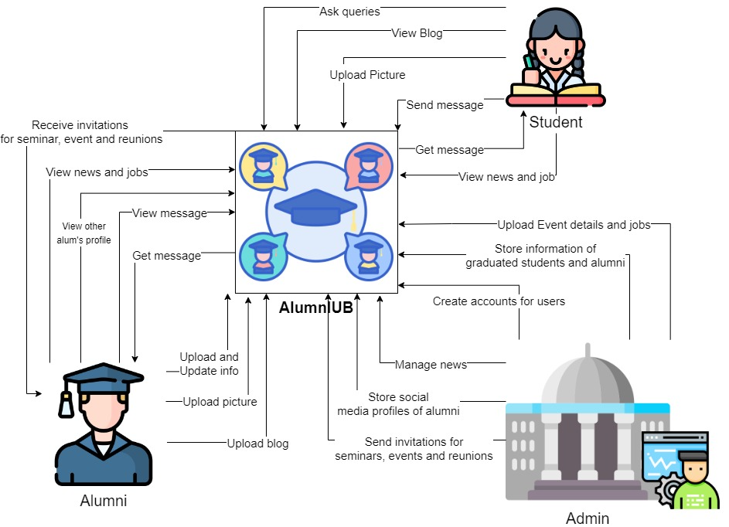

**The goals and objectives of AlumnIUB’s are:**

* To create a database to store information about students who already graduated from IUB.
* To store information of their other social media information of Facebook, Email and LinkedIn to connect.
* To share their achievements.
* If new graduates need any help regards finding new jobs, then they can ask for mentorship from their Alumni.
* For the information database University can invite Alumni of IUB for any events and seminars so that they can share their experience with all the new students.
* To Donate for social cause, Charity, Raising Money for any individuals or fellow IUBians with Health Conditions.

|  |
| --- |
| Goals |
| The main goal of this project is to develop a social networking platform only for IUB’ students and alumni. The application will also aim to effectively reduce the problem of not finding their course mates and friends information. University authorities arrange any event and at that time they can find all the information or give all the information on this application. |