**Description:** You have to create a simple task tracker app. There will be a form which will consist of a **text input field and a submit button**. Submitting the form will store that task in your storage system (**Local Storage**) **along with its completion status**. Also you will be able to see all the tasks you have created in your UI.

A dummy wireframe is provided below. **DO NOT FOCUS ON MAKING THE APP PRETTY**

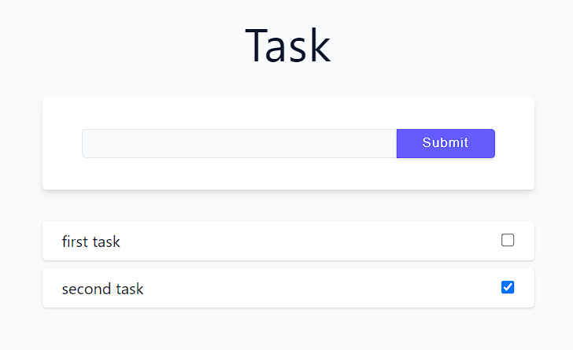

**Important Notes:**

* By default completions status will be **false** for all the tasks
* Updating the completion status will update the same in the local storage as well for that specific task.

**Bonus:**

* Clicking on any particular task will remove that task from the UI as well as from the local storage