
Trustworthy AI: A Comparative Experimental Study of Bias Mitigation Techniques in AI Driven Hiring Algorithms
Student: Faisal Aleem
Supervisor: Janusz
IS4T702 MSc Project

REVISED DRAFT: Chapter 2: Literature Review

Chapter 2: Literature Review
2.1 Introduction
This chapter surveys the academic literature relevant to the comparative study of bias mitigation techniques in AI driven hiring algorithms. It begins by establishing the conceptual foundations of algorithmic bias and tracing its sources in training data and model design. It then examines the specific context of AI in recruitment, including documented evidence of discriminatory outcomes. A dedicated section provides a detailed description of the benchmark datasets used in this study along with the full preprocessing pipeline applied to prepare those datasets for experimentation. The chapter proceeds to review formal definitions of fairness, the three main families of bias mitigation technique presented as formal algorithms, the open source toolkits available to practitioners, and the legal and regulatory environment governing high risk AI in employment contexts. The chapter closes with a critical synthesis that identifies gaps in the existing literature and articulates the specific contribution of the present study.
2.2 Algorithmic Bias: Definitions and Origins
2.2.1 Conceptual Foundations of Algorithmic Bias
Bias in algorithmic systems has attracted sustained academic attention since at least the early 2000s, though its practical significance has grown sharply as machine learning models have moved from research settings into consequential real-world applications. Pedreshi, Ruggieri and Turini (2008) provided one of the earliest formal treatments, introducing the concept of discrimination-aware data mining to describe the phenomenon whereby patterns extracted from historical data reproduce and institutionalise unequal treatment of protected groups. Their work established a working distinction between direct discrimination, which operates through the explicit use of protected attributes, and indirect discrimination, which emerges through proxy variables that correlate with those attributes. This distinction has since been refined and contested throughout the literature (Barocas and Selbst, 2016; Romei and Ruggieri, 2014). Mehrabi et al. (2021) produced a comprehensive taxonomy of bias sources, cataloguing over twenty distinct varieties spanning data collection, pretraining, model design, and deployment.
2.2.2 Sources of Bias in Machine Learning Systems
The origins of bias in machine learning models are typically traced to three interacting sources: biased training data, biased problem formulation, and biased evaluation criteria (Barocas, Hardt and Moritz, 2023). Training data bias is the most extensively studied. When historical decisions are recorded and used as ground truth labels, any systematic unfairness in those decisions is transferred to the model. Calders and Verwer (2010) illustrated this empirically using naive Bayes classifiers trained on income prediction data, demonstrating that even when protected attributes were removed from the feature set, the model continued to produce discriminatory predictions through correlated variables. This is known as the redundant encoding problem (Feldman et al., 2015). O'Neil (2016) and Eubanks (2018) both demonstrated from a social science perspective that algorithmic systems amplify rather than mitigate existing societal inequalities. Buolamwini and Gebru (2018) provided a striking quantitative illustration in commercial facial recognition, finding error rates for darker-skinned women up to 34 percentage points higher than for lighter-skinned men.
2.3 AI in Recruitment and Hiring
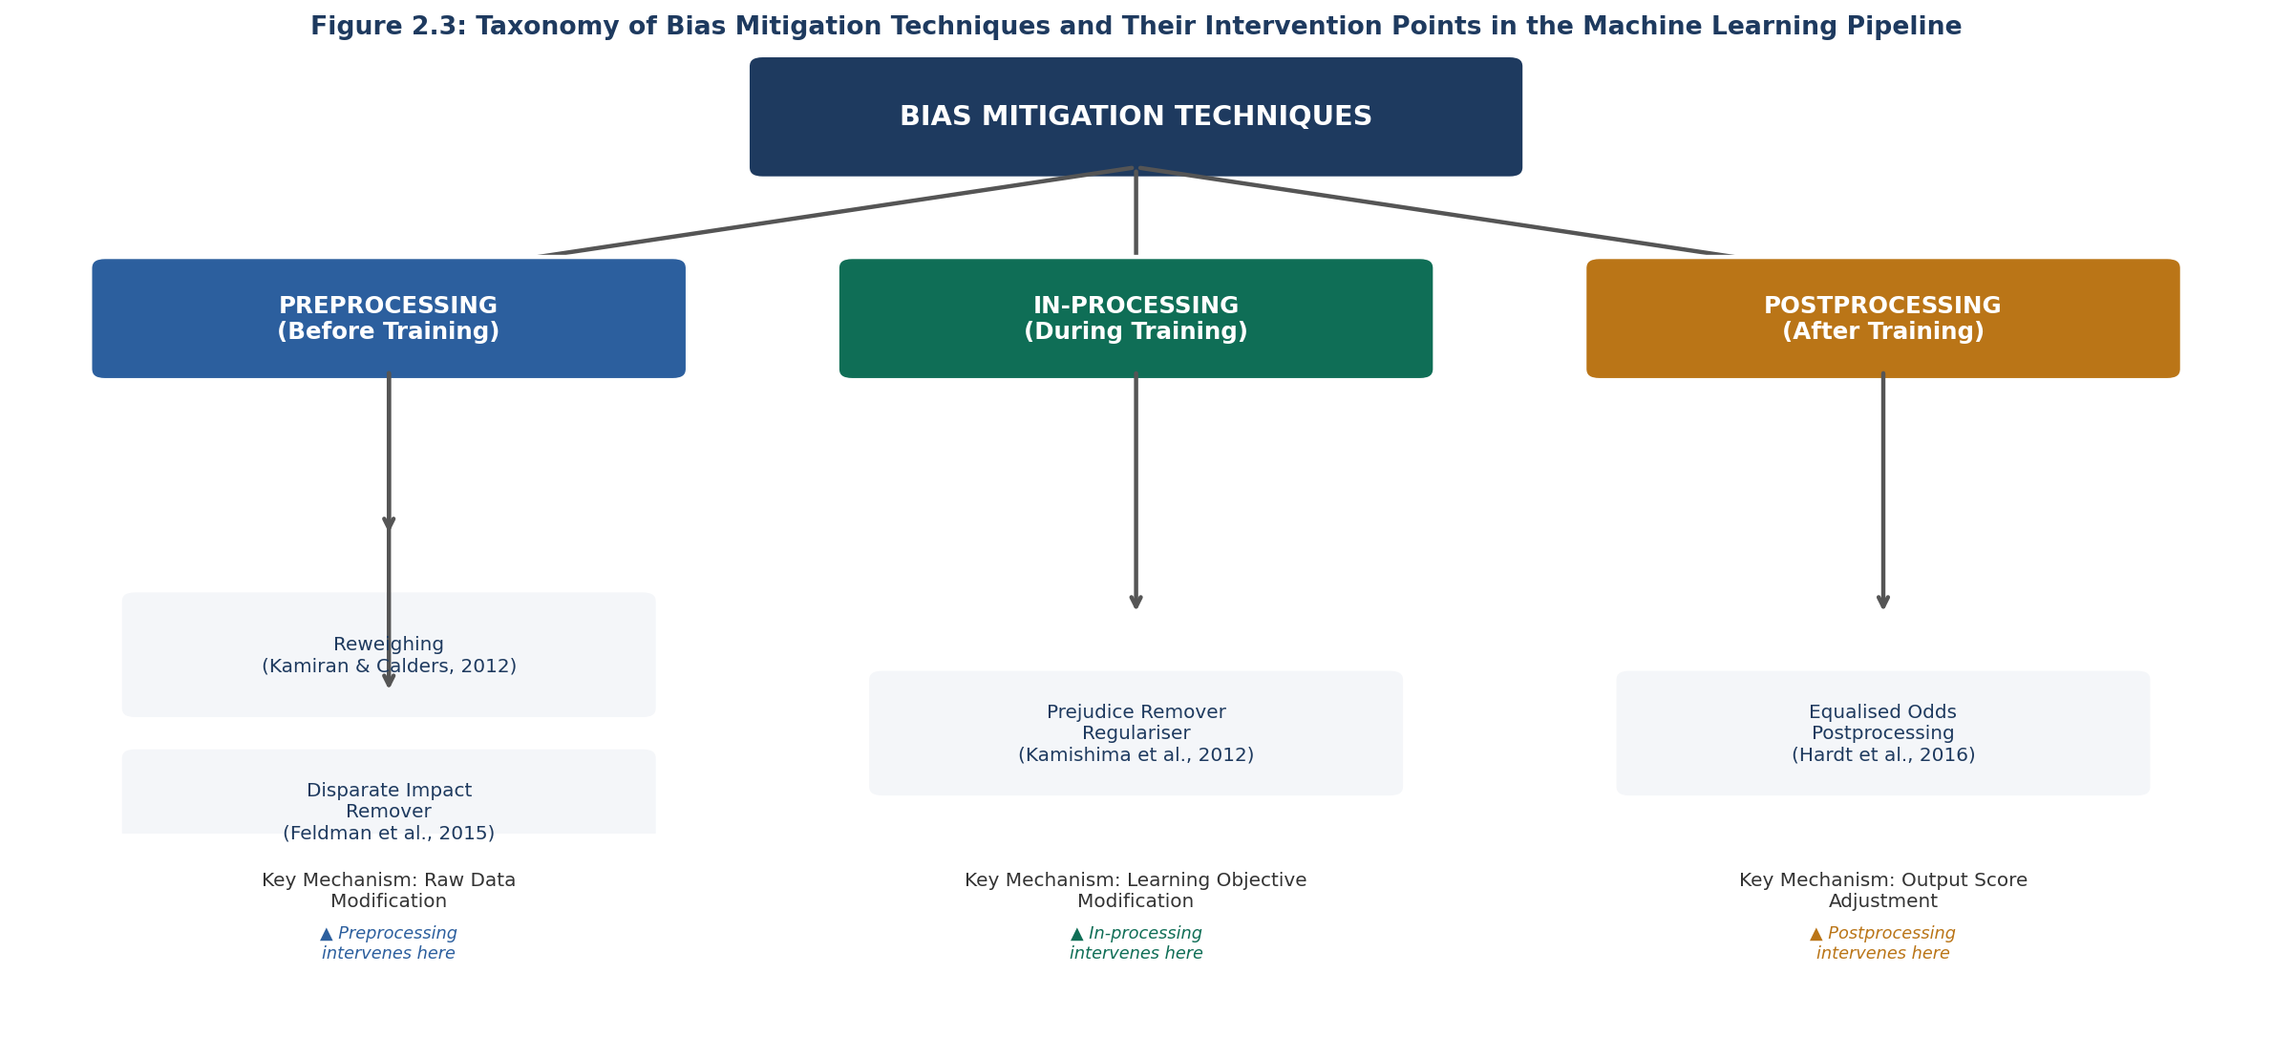
Figure 2.3: Taxonomy of Bias Mitigation Techniques and Their Intervention Points in the Machine Learning Pipeline

2.3.1 The Rise of Algorithmic Hiring Systems
The adoption of algorithmic tools in recruitment has accelerated substantially over the past decade. Organisations have applied machine learning to CV screening, psychometric assessment, video interview analysis, and candidate ranking, with vendors claiming improvements in efficiency, objectivity, and diversity (Kochling and Wehner, 2020; Raghavan et al., 2020). Kochling and Wehner (2020) conducted a systematic review of 36 studies and found that while theoretical potential exists for algorithmic tools to reduce human bias, empirical evidence for this effect was weak and several studies documented the reproduction of discriminatory patterns in deployed systems.
2.3.2 Documented Cases of Bias in Hiring Algorithms
The most widely cited real-world case is the Amazon recruitment tool, which was found to penalise CVs containing the word women and was scrapped in 2018 (Dastin, 2018). Raghavan et al. (2020) found that most vendors offering algorithmic assessment products did not publish evidence that their tools had been tested for adverse impact on protected groups. The COMPAS recidivism scoring system was found by Angwin et al. (2016) to be roughly twice as likely to misclassify Black defendants as high risk compared with white defendants. Chouldechova (2017) subsequently proved mathematically that when base rates differ across groups, no classifier can simultaneously achieve equal false positive rates, equal false negative rates, and equal positive predictive values. This impossibility result has significant implications for bias mitigation strategy design.
2.4 Datasets Used in This Study
Two publicly available benchmark datasets are used in this study. Both are well established in the algorithmic fairness literature, enabling direct comparison with results from prior work. Full documentation of each dataset is provided below, consistent with the datasheets for datasets framework proposed by Gebru et al. (2021).
2.4.1 UCI Adult Income Dataset
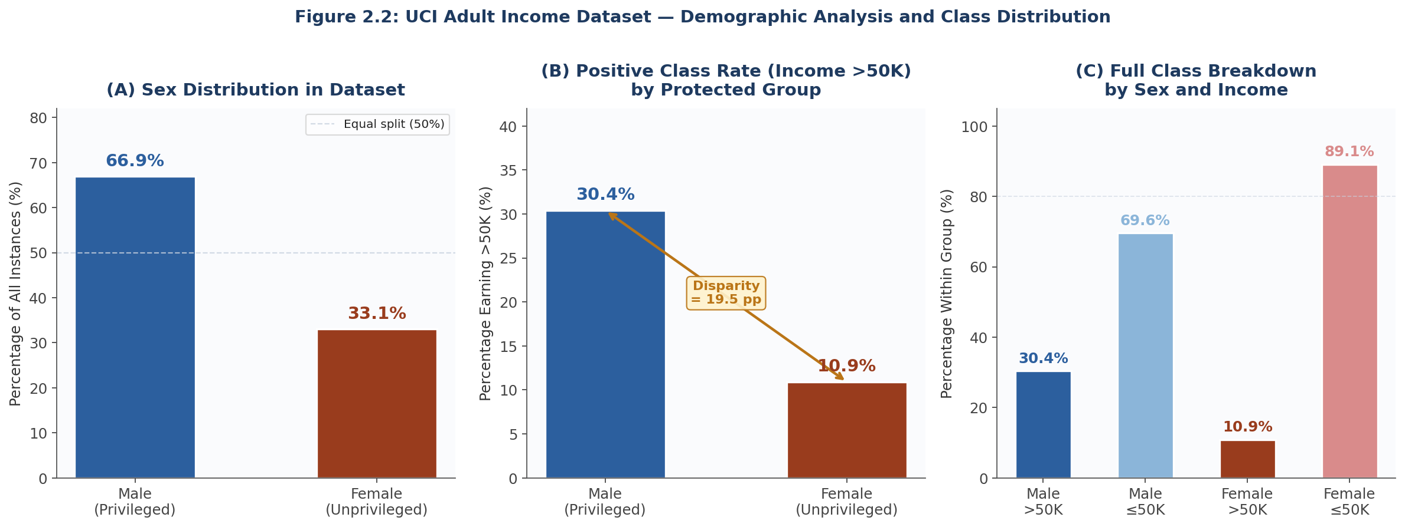
Figure 2.2: UCI Adult Income Dataset Demographic Analysis and Class Distribution by Protected Group (Sex)

The UCI Adult Income dataset, also known as the Census Income dataset, was extracted from the 1994 United States census database by Dua and Graff (2019). It is widely used as a benchmark for algorithmic fairness research because it contains both a well-defined binary classification task and multiple sensitive attributes relevant to discrimination analysis. The prediction task is to determine whether an individual earns more than 50,000 US dollars per year based on demographic and employment attributes. The protected attribute used in this study is sex, with male classified as the privileged group and female as the unprivileged group.
Dataset Property | Value | Notes
Total instances | 48,842 | Combines training and test partitions
Training instances | 32,561 (70%) | Used for model training and mitigation
Test instances | 16,281 (30%) | Held out for fairness evaluation
Number of features | 14 input features | Mixed continuous and categorical
Target variable | income (binary) | >50K or ≤50K per year
Protected attribute | sex | Male (privileged) vs. Female (unprivileged)
Privileged group size | ~66.9% Male | Significant class imbalance
Unprivileged group size | ~33.1% Female | Underrepresented in positive class
Positive class rate (M) | ~30.4% | Male earning >50K
Positive class rate (F) | ~10.9% | Female earning >50K
Missing values | ~7.4% of records | In workclass, occupation, native-country
Table 2.1: UCI Adult Income Dataset Summary Statistics
Table 2.2 below provides a complete description of all 14 input features in the UCI Adult Income dataset, including data type, a brief description, and representative sample values. Features of particular note are sex (the protected attribute), education-num (a continuous proxy for social privilege), and hours-per-week (which may interact with gender-related patterns in part-time employment).
Feature Name | Data Type | Description | Sample Values
age | Continuous | Age of the individual in years | 39, 50, 38, 53, 28
workclass | Categorical | Employment category | Private, Self-emp, Federal-gov, Local-gov
fnlwgt | Continuous | Census sampling weight (not used in modelling) | 77516, 83311, 215646
education | Categorical | Highest level of education attained | Bachelors, HS-grad, 11th, Masters, 9th
education-num | Continuous | Number of years of education (numerical encoding) | 13, 9, 7, 14, 5
marital-status | Categorical | Marital status of the individual | Married-civ-spouse, Never-married, Divorced
occupation | Categorical | General category of occupation | Tech-support, Craft-repair, Sales, Exec-managerial
relationship | Categorical | Family relationship role | Wife, Own-child, Husband, Not-in-family
race | Categorical | Race (dropped from model to focus on sex as protected attr.) | White, Asian-Pac-Islander, Black, Other
sex | Binary | Protected attribute (1=Male, 0=Female) | Male, Female
capital-gain | Continuous | Capital gain income in USD | 2174, 0, 14084, 5178
capital-loss | Continuous | Capital loss amount in USD | 0, 2042, 0, 1902
hours-per-week | Continuous | Hours worked per week | 40, 13, 40, 60, 45
native-country | Categorical | Country of origin | United-States, Cuba, Jamaica, India, Mexico
income (target) | Binary | Whether income exceeds 50K USD per year | >50K, <=50K
Table 2.2: UCI Adult Income Dataset Feature Descriptions
2.4.2 COMPAS Recidivism Dataset
The COMPAS dataset was released by ProPublica as part of the investigation by Angwin et al. (2016) into the COMPAS risk scoring tool used in the United States criminal justice system. It contains approximately 7,000 records of defendants assessed for two-year recidivism risk, along with the actual recidivism outcomes. While this dataset relates to criminal justice rather than employment, it has become a standard benchmark in the fairness literature because it was the subject of the most influential empirical bias analysis conducted to date. The protected attribute used is race, with white defendants classified as the privileged group and Black defendants as the unprivileged group. Key features include the defendant's age, sex, prior criminal record, and charge degree.
2.4.3 Dataset Preprocessing Pipeline
Before any bias mitigation technique is applied, the raw dataset must be prepared through a structured preprocessing pipeline. Figure 2.1 below illustrates every step applied to both datasets in this study. The pipeline is implemented using the AIF360 BinaryLabelDataset abstraction (Bellamy et al., 2019) combined with scikit-learn preprocessing utilities (Pedregosa et al., 2011). Each step is described in detail beneath the diagram.
Step 1: Raw Data Loading
The UCI Adult Income dataset is loaded using the AIF360 AdultDataset class, which reads the raw census CSV files from the AIF360 examples data directory. The COMPAS dataset is loaded from ProPublica's published CSV file. Protected attribute labels and the binary target variable are identified and assigned at this stage. Attribute: sex (Adult), race (COMPAS). Target: income >50K (Adult), two-year recidivism (COMPAS).
↓
Step 2: Feature Removal
Features that are either irrelevant to the prediction task or create data leakage are removed. For the Adult dataset: fnlwgt (census weight) is removed as it has no predictive relevance, and race is removed to allow the study to isolate sex as the sole protected attribute of interest. For COMPAS: identifiers and fields that post-date the prediction point are removed.
↓
Step 3: Missing Value Handling
Records containing the placeholder value ? (used in the UCI Adult dataset for unknown values in workclass, occupation, and native-country) are removed. This results in a cleaned dataset of 45,222 usable records for the Adult dataset. For COMPAS, records with missing recidivism outcome labels are dropped.
↓
Step 4: Categorical Encoding
All categorical features are converted to numerical form using one-hot encoding. Each category level becomes a binary indicator variable. For example, the workclass feature with values such as Private, Self-emp, and Federal-gov becomes three binary columns. This produces a fully numerical feature matrix suitable for scikit-learn estimators.
↓
Step 5: Protected Attribute Binarisation
The protected attribute is converted to a binary format. For the Adult dataset: sex is encoded as 1 for Male (privileged group) and 0 for Female (unprivileged group). For COMPAS: race is binarised such that Caucasian = 1 (privileged) and African-American = 0 (unprivileged). Privileged and unprivileged group dictionaries are created for use by AIF360 bias metrics.
↓
Step 6: Feature Standardisation
Continuous numerical features (age, education-num, hours-per-week, capital-gain, capital-loss) are standardised using StandardScaler to zero mean and unit variance. The scaler is fitted on the training split only and then applied to both training and test splits to prevent data leakage. This step is essential for logistic regression and prejudice remover convergence.
↓
Step 7: Train/Test Split
The cleaned and encoded dataset is split into a training set (70%) and a test set (30%) using a fixed random seed (seed=42) to ensure reproducibility. The AIF360 BinaryLabelDataset.split() method is used, which preserves the protected attribute label alignment. Training: 31,655 instances. Test: 13,567 instances (approximate after missing value removal).
↓
Step 8: Bias Mitigation Application
The selected bias mitigation technique (Reweighing, Disparate Impact Remover, Prejudice Remover, or Equalised Odds Postprocessing) is applied at the appropriate stage: preprocessing techniques are applied to the training split only before model fitting; the in-processing technique modifies the learning objective during training; and the postprocessing technique adjusts model outputs on the test split after training.
↓
Step 9: Fairness Metric Evaluation
Classification metrics and fairness metrics are computed using the AIF360 ClassificationMetric class applied to the held-out test split. Metrics computed include overall accuracy, demographic parity difference, average odds difference, equalised odds difference, and disparate impact ratio. All metrics are computed separately for the privileged and unprivileged groups and then compared across mitigation approaches.
Figure 2.1: Dataset Preprocessing Pipeline (Applied to UCI Adult and COMPAS Datasets)
2.5 Fairness Definitions in Machine Learning
2.5.1 Group Fairness Metrics
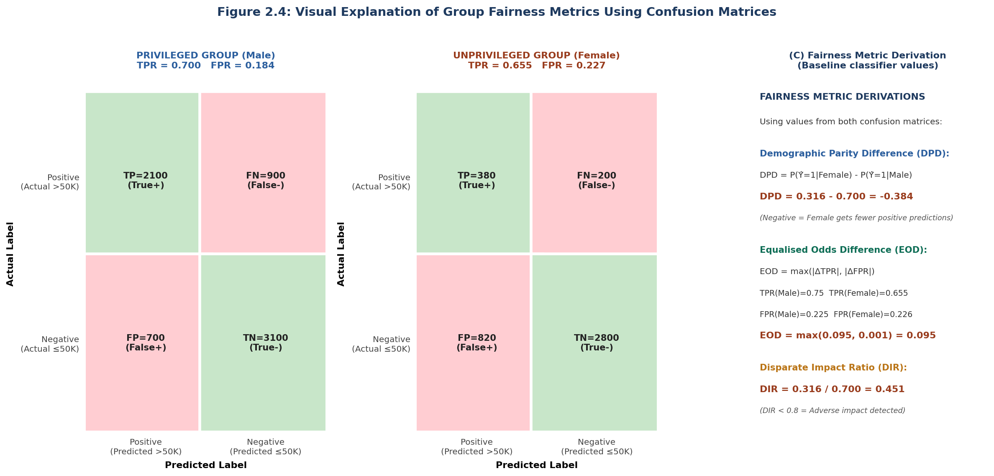
Figure 2.4: Visual Explanation of Group Fairness Metrics Using Confusion Matrices for Privileged and Unprivileged Groups

The fairness literature has produced a substantial set of formal mathematical definitions of equitable classifier behaviour. These metrics operate at the group level, comparing statistical properties of model outputs across protected groups. Table 2.3 below presents the four primary group fairness metrics used in this study, with their formal definitions and interpretations. The notation used is as follows: Y denotes the true label, Y-hat denotes the predicted label, A denotes the protected attribute, S+ denotes the privileged group (Male), and S- denotes the unprivileged group (Female).
Metric | Formal Definition | Perfect Score | Interpretation
Demographic Parity Difference (DPD) | P(Y-hat=1 | A=S-) minus P(Y-hat=1 | A=S+) Equal positive prediction rates across groups | 0 (zero) | Negative value means unprivileged group receives fewer positive predictions
Equalised Odds Difference (EOD) | max(|TPR(S-) minus TPR(S+)|, |FPR(S-) minus FPR(S+)|) Max difference in TPR and FPR across groups | 0 (zero) | Measures worst-case difference in error rates between groups
Average Odds Difference (AOD) | [(FPR(S-) minus FPR(S+)) + (TPR(S-) minus TPR(S+))] / 2 Mean of TPR and FPR differences | 0 (zero) | A balanced measure of both type I and type II error rate differences
Disparate Impact Ratio (DIR) | P(Y-hat=1 | A=S-) / P(Y-hat=1 | A=S+) Ratio of positive prediction rates | 1 (one) | Below 0.8 indicates adverse impact under the legal four-fifths rule (Feldman et al., 2015)
Table 2.3: Formal Group Fairness Metric Definitions Used in This Study
2.5.2 Individual and Counterfactual Fairness
Individual fairness, formalised by Dwork et al. (2012), requires that any two individuals who are similar with respect to a task relevant similarity metric receive similar predictions. The practical challenge is defining the similarity metric in a principled way. Kusner et al. (2017) introduced counterfactual fairness as an alternative individual-level concept grounded in causal reasoning: a decision is counterfactually fair if it would remain the same in a counterfactual world in which the individual belonged to a different protected group but was otherwise identical.
2.5.3 Tensions and Trade-offs Between Fairness Definitions
Chouldechova (2017) proved that when base rates differ across groups, it is impossible for a classifier to simultaneously achieve equal false positive rates, equal false negative rates, and equal positive predictive values. Pleiss et al. (2017) showed that calibration and equalised odds are jointly satisfiable only when base rates are equal across groups. These impossibility results mean that the choice of which fairness metric to optimise is an ethical and political decision, not a purely technical one (Mittelstadt et al., 2016). Friedler et al. (2019) found empirically that metric choice had a larger effect on outcomes than algorithm choice.
2.6 Bias Mitigation Techniques
Bias mitigation techniques in machine learning are classified into three families based on the stage of the pipeline at which they intervene: preprocessing (before training), in processing (during training), and postprocessing (after training). This section presents each technique with a formal algorithm and contextual description.
2.6.1 Preprocessing Approaches
Preprocessing techniques modify the training data before any classifier is trained. They are model-agnostic: the same transformed dataset can in principle be used with any downstream classifier. Two preprocessing techniques are used in this study.
Algorithm 2.1 below presents the Reweighing technique introduced by Kamiran and Calders (2012). The technique assigns a weight to each training instance such that the weighted distribution of the data is independent of the protected attribute. Instances that represent outcomes which are underrepresented for their group receive a higher weight, directing the classifier's attention toward those cases during training.

Algorithm 2.1: Reweighing (Kamiran and Calders, 2012)
INPUT: Dataset D, protected attribute A
Privileged group S+, unprivileged group S-
OUTPUT: Training set D_w with instance weights
Step 1 Estimate marginal probabilities from D:
P(Y=y), P(A=a), P(Y=y, A=a) for y in {0,1}, a in {S+, S-}
Step 2 FOR each training instance (x_i, y_i, a_i) in D:
w_i = P(Y=y_i) x P(A=a_i) / P(Y=y_i, A=a_i)
This weight is the expected frequency divided by the observed
frequency. Groups that appear less often than expected get w > 1;
over-represented groups get w < 1.
Step 3 Train classifier on D_w using sample_weight = {w_1, ..., w_n}
RETURN Classifier trained on reweighted data
Implementation: aif360.algorithms.preprocessing.Reweighing
Algorithm 2.1: Reweighing Preprocessing Technique
Algorithm 2.2 presents the Disparate Impact Remover proposed by Feldman et al. (2015). Rather than adjusting instance weights, this technique repairs the feature values themselves by reducing their statistical correlation with the protected attribute. The repair level parameter lambda controls the degree of intervention, with lambda=0 meaning no change and lambda=1 meaning full repair to the median distribution.
Algorithm 2.2: Disparate Impact Remover (Feldman et al., 2015)
INPUT: Dataset D, protected attribute A
Repair level lambda in [0.0, 1.0] (this study uses 0.8)
OUTPUT: Repaired dataset D_r
Step 1 FOR each non-protected feature f in D:
Step 1a Compute empirical CDF F_{f|S+} for privileged group
Compute empirical CDF F_{f|S-} for unprivileged group
Compute median CDF F_f across all instances
Step 1b FOR each instance x_i in D:
q_i = F_{f|A_i}( f(x_i) ) // rank within group
v_target = F_f^{-1}( q_i ) // target median quantile
f_repaired(x_i) = lambda * v_target
+ (1 - lambda) * f(x_i)
Step 2 Replace f(x_i) with f_repaired(x_i) for all instances and features
RETURN Repaired dataset D_r with reduced correlation to protected attr.
Implementation: aif360.algorithms.preprocessing.DisparateImpactRemover
Algorithm 2.2: Disparate Impact Remover Preprocessing Technique
2.6.2 In-processing Approaches
In processing techniques modify the learning objective or training procedure itself, so that fairness is incorporated directly into the model during training. They typically require access to the training algorithm and cannot be applied post hoc to an existing model. The prejudice remover regulariser proposed by Kamishima et al. (2012) is used in this study as the in processing representative.
Algorithm 2.3: Prejudice Remover Regulariser (Kamishima et al., 2012)
INPUT: Training data D, protected attribute A
Regularisation strength eta (default 25.0)
OUTPUT: Fair logistic regression classifier theta*
Step 1 DEFINE standard negative log-likelihood loss:
NLL(theta) = - SUM_i [ y_i log P(y=1|x_i,theta)
+ (1-y_i) log P(y=0|x_i,theta) ]
Step 2 DEFINE prejudice index (mutual information term):
PI(theta) = I(Y-hat ; A)
= SUM_{y,a} P(Y-hat=y, A=a)
* log[ P(Y-hat=y, A=a) / (P(Y-hat=y) * P(A=a)) ]
Step 3 DEFINE fairness-regularised objective:
L(theta) = NLL(theta) + eta * PI(theta)
Higher eta enforces stronger fairness at the cost of accuracy.
Step 4 MINIMISE L(theta) using gradient descent:
theta ← theta - alpha * grad_theta L(theta)
Repeat until convergence.
RETURN theta* (classifier with reduced statistical dependence on A)
Implementation: aif360.algorithms.inprocessing.PrejudiceRemover
Algorithm 2.3: Prejudice Remover Regulariser In-processing Technique
2.6.3 Postprocessing Approaches
Postprocessing techniques adjust the outputs of an already trained classifier rather than modifying the data or the training procedure. Their practical advantage is that they can be applied to any existing model without requiring access to the training data or retraining the model. The equalised odds postprocessing method proposed by Hardt, Price and Srebro (2016) is used in this study.
Algorithm 2.4: Equalised Odds Postprocessing (Hardt, Price and Srebro, 2016)
INPUT: Predicted scores Y-hat from any trained classifier
True labels Y, protected attribute A
OUTPUT: Adjusted binary predictions Y-hat_fair satisfying equalised odds
Step 1 FOR each group g in {S+, S-}:
Compute ROC curve: TPR_g(t) and FPR_g(t) across thresholds t
Step 2 FIND optimal threshold pair (t+, t-) by solving:
MINIMISE: accuracy_loss(t+, t-)
SUBJECT TO: TPR(t+ | A=S+) = TPR(t- | A=S-) [equal TPR]
FPR(t+ | A=S+) = FPR(t- | A=S-) [equal FPR]
This is formulated as a linear programme (LP) over the
two group-specific ROC curves.
Step 3 FOR each test instance x_i:
IF A_i = S+: predict 1 if Y-hat_i >= t+ else predict 0
IF A_i = S-: predict 1 if Y-hat_i >= t- else predict 0
RETURN Y-hat_fair (predictions satisfying equalised odds on average)
Implementation: aif360.algorithms.postprocessing.EqOddsPostprocessing
Algorithm 2.4: Equalised Odds Postprocessing Technique
2.6.4 Comparative Overview of Mitigation Strategies
Table 2.4 provides a comparative summary of all four bias mitigation techniques used in this study, presented alongside the baseline approach. The comparison encompasses the intervention family, the stage at which it operates within the pipeline, the key mechanism employed, the primary advantage, and the principal limitation. This table provides the theoretical basis for the experimental comparison conducted in subsequent chapters.
Technique | Family | Pipeline Stage | Key Mechanism | Advantage | Limitation
Baseline (Logistic Reg.) | None | Training | Maximum likelihood estimation with no fairness constraint | Reference point for comparison | Reproduces bias from training data
Reweighing | Preprocessing | Before train | Assigns instance weights to balance group outcome distributions | Simple, model-agnostic, no data modification | Fairness not guaranteed on all metrics
Disparate Impact Remover | Preprocessing | Before train | Repairs feature values to reduce correlation with protected attribute | Provable disparate impact guarantee | May reduce predictive information
Prejudice Remover | In-processing | During train | Adds mutual information penalty term to learning objective | Integrates fairness into model training | Requires retraining, sensitive to eta
Equalised Odds PP | Postprocessing | After train | Finds group-specific thresholds satisfying equalised odds via LP | Applies to any existing model | Group-specific thresholds may raise legal concerns
Table 2.4: Comparative Summary of Baseline and Four Bias Mitigation Techniques
2.7 Tools and Frameworks for Fairness in Machine Learning
2.7.1 IBM AI Fairness 360
AI Fairness 360 (AIF360), developed by IBM Research, is an open-source Python toolkit providing implementations of over seventy bias detection metrics and more than ten bias mitigation algorithms spanning all three intervention categories (Bellamy et al., 2019). The toolkit includes a standardised BinaryLabelDataset abstraction and a ClassificationMetric module that enables parallel computation of multiple fairness criteria. All four bias mitigation algorithms used in this study are implemented within AIF360.
2.7.2 Microsoft Fairlearn
Fairlearn, developed by Microsoft Research, is a complementary toolkit focused on postprocessing and constrained optimisation techniques (Bird et al., 2020). Its reduction algorithm wraps any scikit-learn estimator to enforce fairness constraints, making it compatible with the full range of classifiers available in the scikit-learn ecosystem (Pedregosa et al., 2011). It is used in this study as a supplementary evaluation tool.
2.8 Legal and Regulatory Context
2.8.1 The EU AI Act and High Risk AI Systems
The EU AI Act, formally adopted in June 2024, classifies AI systems used in employment, including those deployed for recruitment and selection, as high risk (European Parliament and Council, 2024). Providers must conduct conformity assessments, maintain technical documentation, and implement human oversight mechanisms before deployment. Kleinberg et al. (2019) argued that algorithmic discrimination raises novel legal challenges because its mechanisms differ from those of human decision-making, making existing anti-discrimination frameworks difficult to apply directly.
2.8.2 UK Equality and Data Protection Legislation
In the United Kingdom, the Equality Act 2010 prohibits indirect discrimination in employment, which occurs when a provision, criterion, or practice that appears neutral places persons sharing a protected characteristic at a particular disadvantage (UK Government, 2010). The UK GDPR and the Data Protection Act 2018 impose obligations on automated decision-making, including a right not to be subject to solely automated decisions that produce significant effects (UK Government, 2018). Wachter, Mittelstadt and Russell (2017) argued that counterfactual explanations represent a technically feasible form of transparency compliant with this right. The Information Commissioner's Office (2020) has issued specific guidance on AI and data protection.
2.8.3 Professional and Ethical Codes of Conduct
The High-Level Expert Group on Artificial Intelligence (2019) published ethics guidelines for trustworthy AI identifying seven requirements including non-discrimination and accountability. Floridi et al. (2018) developed the AI4People framework grounded in bioethical principles. Mittelstadt et al. (2016) mapped the broader algorithmic ethics debate, arguing that opacity is itself a form of harm because it removes the possibility of contesting erroneous decisions.
2.9 Trustworthy AI: A Normative Framework
2.9.1 Principles of Trustworthy AI
The concept of trustworthy AI has emerged as a normative framework describing AI systems that are technically effective, ethically acceptable, socially responsible, and legally compliant (High-Level Expert Group on Artificial Intelligence, 2019). Floridi et al. (2018) argued that technical fairness alone is insufficient without corresponding mechanisms for oversight, recourse, and correction. This argument implies that the evaluation of bias mitigation techniques should include not only statistical fairness metrics but also considerations of transparency and explainability.
2.9.2 Explainability and Interpretability in Hiring Contexts
Adadi and Berrada (2018) surveyed the field of explainable AI and noted that the ability to explain predictions is increasingly required in high stakes applications including hiring. Ribeiro, Singh and Guestrin (2016) developed LIME, a method producing locally faithful explanations for individual predictions by fitting an interpretable model to local classifier behaviour. Lundberg and Lee (2017) developed SHAP, providing unified feature attributions grounded in cooperative game theory. Both methods will be applied in this study to examine whether bias mitigation changes the features driving model predictions. Gebru et al. (2021) argued that transparent dataset documentation is a prerequisite for reliable bias analysis, and the dataset descriptions in Section 2.4 of this chapter follow their datasheets for datasets framework.
2.10 Critical Synthesis and Research Gaps
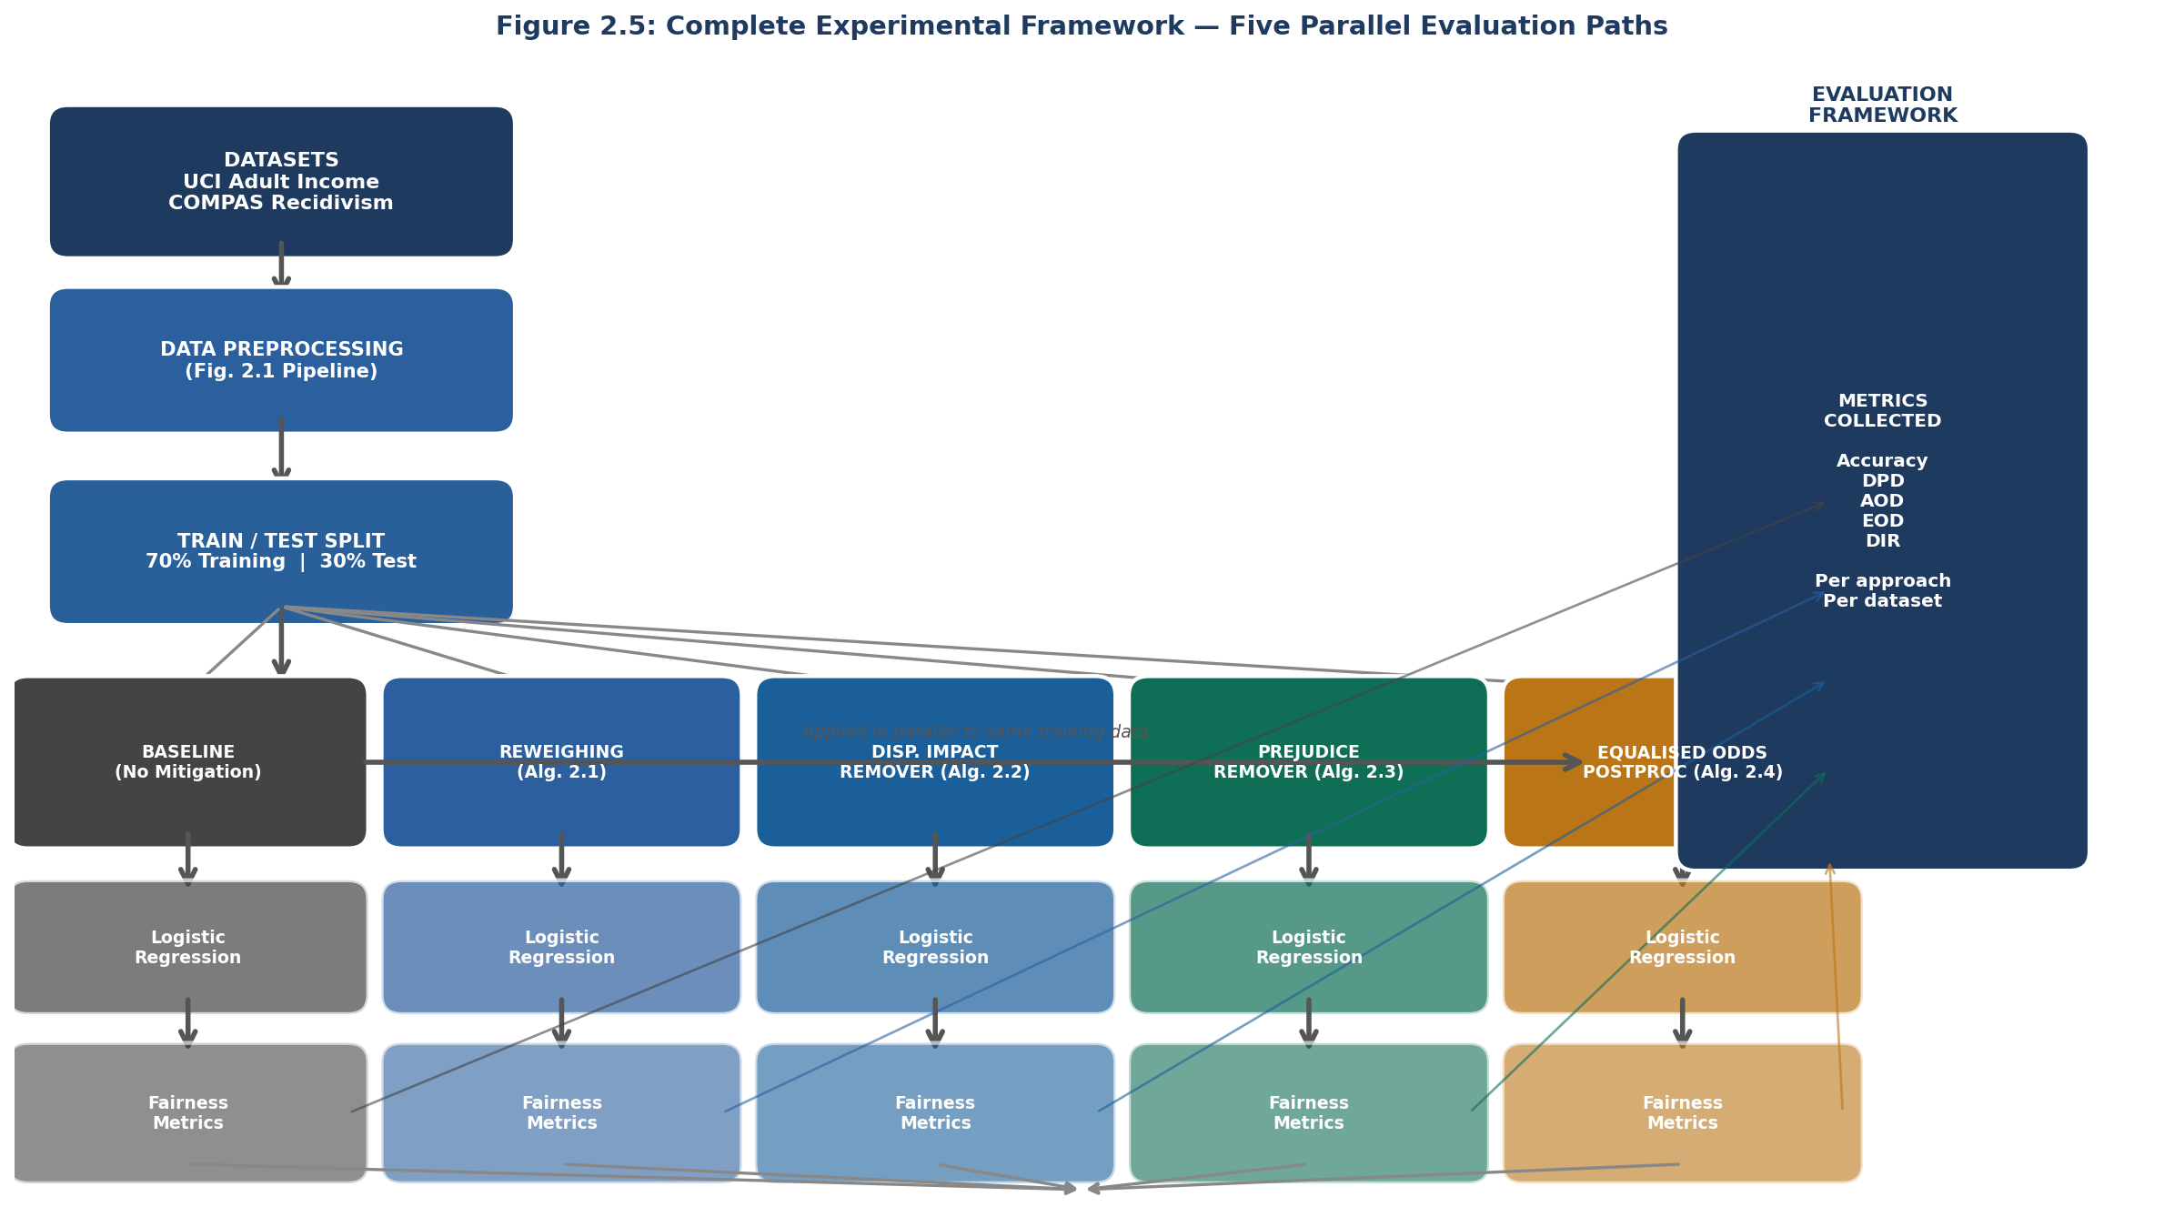
Figure 2.5: Complete Experimental Framework Showing Five Parallel Evaluation Paths Across Baseline and Four Mitigation Techniques

The literature reviewed in this chapter reveals a field that has made substantial theoretical progress in defining and reasoning about algorithmic fairness but remains limited in several important respects. The impossibility results of Chouldechova (2017) and the empirical findings of Friedler et al. (2019) together establish that no universally superior bias mitigation approach exists, and that the appropriate strategy depends on context-specific normative judgements about which fairness properties matter most in a given setting. This context-dependence is inadequately captured in studies that evaluate techniques in isolation or against a single fairness metric.
A significant gap concerns the relative performance of technique families when evaluated systematically on the same datasets with a common evaluation protocol. Pessach and Shmueli (2022) and Caton and Haas (2024) both identified the absence of standardised benchmarks as a major limitation. A related gap concerns the extent to which accuracy-fairness trade-offs are technique-specific or dataset-specific. The present study addresses these gaps directly by applying all three technique families to the same two datasets under the same evaluation protocol.
A further gap concerns the integration of explainability analysis with fairness evaluation. Most experimental studies report fairness metrics before and after mitigation but do not examine whether the behavioural changes produced by mitigation are consistent with the intended goals of the technique. The SHAP and LIME analyses planned for this study address this gap and provide a richer picture of the mechanisms through which mitigation operates.
2.11 Project Timeline
Table 2.5 presents the full 14-week project Gantt chart. The chart covers all seven phases of the project from June 9, 2026 to September 11, 2026. Each coloured bar represents a task, with colour indicating the phase. Green tick marks indicate tasks already completed. Milestone markers at the bottom of the chart show the eight key checkpoints.

Task / Phase | June |  |  | July |  |  |  | August |  |  |  |  | September
 | W1 Jun 9 | W2 Jun 16 | W3 Jun 23 | W4 Jun 30 | W5 Jul 7 | W6 Jul 14 | W7 Jul 21 | W8 Jul 28 | W9 Aug 4 | W10 Aug 11 | W11 Aug 18 | W12 Aug 25 | W13 Sep 1 | W14 Sep 8
PROJECT FOUNDATION
✓ Ethics form and first meeting
✓ Literature review (Chapter 2)
EXPERIMENTAL DESIGN
Experimental design and protocol
Python environment and dataset setup
PROTOTYPE DEVELOPMENT
Baseline classifier implementation
Preprocessing mitigation techniques
In-processing mitigation techniques
Postprocessing mitigation techniques
EXPERIMENTATION
UCI Adult Income experiments
COMPAS dataset experiments
ANALYSIS & EVALUATION
Statistical analysis
Fairness metric comparison
Results visualisation
DISSERTATION WRITING
Chapter 3: Methodology
Chapter 4: Implementation
Chapter 5: Results and Analysis
Chapter 6 and 7: Discussion and Conclusion
Chapter 1: Introduction
FINALISATION
Proofreading and revision
Final formatting
Submission (23:59 deadline)
Milestones | M1 Ethics ✓ | M2 Lit.Rev ✓ |  | M3 Design |  |  | M4 Proto |  | M5 Expmt |  | M6 Analys. | M7 Draft |  | M8 Submit
Table 2.5: Project Gantt Chart — 14-Week Timeline (June 9 to September 11, 2026)

Legend for Table 2.5:
■ Project Foundation
■ Experimental Design
■ Prototype Development
■ Experimentation
■ Analysis & Evaluation
■ Dissertation Writing
■ Finalisation
✓ Completed task ◆ Upcoming milestone ✓ Completed milestone
2.12 Chapter Summary
This chapter has provided a comprehensive review of the principal theoretical and empirical contributions to the study of algorithmic bias and fairness in machine learning, with particular attention to AI driven hiring systems. Section 2.4 provided detailed documentation of the two benchmark datasets used in this study along with the full preprocessing pipeline. Sections 2.5 and 2.6 presented formal fairness metric definitions and four bias mitigation algorithms in pseudocode form, enabling reproducibility and clarity of implementation. The legal and regulatory environment established meaningful obligations on organisations deploying such systems. The trustworthy AI framework situated these technical concerns within a broader ethical and governance agenda. The specific gaps identified in the literature, particularly the absence of rigorous comparative evaluations of technique families using standardised protocols, provide the direct motivation for the experimental study described in subsequent chapters.

References
Adadi, A. and Berrada, M. (2018) 'Peeking inside the black-box: A survey on explainable artificial intelligence (XAI)', IEEE Access, 6, pp. 52138–52160. doi:10.1109/ACCESS.2018.2870052.
Angwin, J., Larson, J., Mattu, S. and Kirchner, L. (2016) Machine bias. ProPublica, 23 May. Available at: https://www.propublica.org/article/machine-bias-risk-assessments-in-criminal-sentencing [Accessed 1 June 2026].
Barocas, S. and Selbst, A.D. (2016) 'Big data’s disparate impact', California Law Review, 104(3), pp. 671–732.
Barocas, S., Hardt, M. and Moritz, H. (2023) Fairness and Machine Learning: Limitations and Opportunities. Cambridge, MA: MIT Press. Available at: https://fairmlbook.org [Accessed 1 June 2026].
Bellamy, R.K.E. et al. (2019) 'AI Fairness 360: An extensible toolkit for detecting and mitigating algorithmic bias', IBM Journal of Research and Development, 63(4/5), pp. 4:1–4:15. doi:10.1147/JRD.2019.2942287.
Bird, S. et al. (2020) Fairlearn: A Toolkit for Assessing and Improving Fairness in AI. Microsoft Research. Available at: https://fairlearn.org [Accessed 1 June 2026].
Bogen, M. and Rieke, A. (2018) Help Wanted: An Examination of Hiring Algorithms, Equity, and Bias. Washington, DC: Upturn.
Buolamwini, J. and Gebru, T. (2018) 'Gender shades: Intersectional accuracy disparities in commercial gender classification', in Proceedings of the 1st Conference on Fairness, Accountability and Transparency. PMLR 81, pp. 77–91.
Calders, T. and Verwer, S. (2010) 'Three naive Bayes approaches for discrimination-free classification', Data Mining and Knowledge Discovery, 21(2), pp. 277–292. doi:10.1007/s10618-010-0190-x.
Calmon, F. et al. (2017) 'Optimized pre-processing for discrimination prevention', in Advances in Neural Information Processing Systems 30 (NeurIPS 2017). arXiv:1704.03354.
Caton, S. and Haas, C. (2024) 'Fairness in machine learning: A survey', ACM Computing Surveys, 56(7). doi:10.1145/3616865.
Chouldechova, A. (2017) 'Fair prediction with disparate impact', Big Data, 5(2), pp. 153–163. doi:10.1089/big.2016.0047.
Dastin, J. (2018) Amazon scraps secret AI recruiting tool that showed bias against women. Reuters, 10 October.
Doshi-Velez, F. and Kim, B. (2017) Towards a rigorous science of interpretable machine learning. arXiv:1702.08608.
Dressel, J. and Farid, H. (2018) 'The accuracy, fairness, and limits of predicting recidivism', Science Advances, 4(1), eaao5580. doi:10.1126/sciadv.aao5580.
Dua, D. and Graff, C. (2019) UCI Machine Learning Repository. Irvine, CA: University of California. Available at: https://archive.ics.uci.edu [Accessed 1 June 2026].
Dwork, C. et al. (2012) 'Fairness through awareness', in Proceedings of the 3rd ITCS. New York: ACM, pp. 214–226. doi:10.1145/2090236.2090255.
Eubanks, V. (2018) Automating Inequality. New York: St. Martin’s Press.
European Parliament and Council (2024) Regulation (EU) 2024/1689 (Artificial Intelligence Act). Official Journal of the European Union.
Feldman, M. et al. (2015) 'Certifying and removing disparate impact', in Proceedings of the 21st ACM SIGKDD. New York: ACM, pp. 259–268. doi:10.1145/2783258.2783311.
Floridi, L. et al. (2018) 'AI4People: An ethical framework for a good AI society', Minds and Machines, 28(4), pp. 689–707. doi:10.1007/s11023-018-9482-5.
Friedler, S.A. et al. (2019) 'A comparative study of fairness-enhancing interventions in machine learning', in Proceedings of FAT* 2019. New York: ACM, pp. 329–338. doi:10.1145/3287560.3287589.
Gebru, T. et al. (2021) 'Datasheets for datasets', Communications of the ACM, 64(12), pp. 86–92. doi:10.1145/3458723.
Hardt, M., Price, E. and Srebro, N. (2016) 'Equality of opportunity in supervised learning', in Advances in NeurIPS 29. arXiv:1610.02413.
High-Level Expert Group on Artificial Intelligence (2019) Ethics Guidelines for Trustworthy AI. Brussels: European Commission.
Information Commissioner’s Office (2020) Guidance on AI and Data Protection. Wilmslow: ICO.
Kamiran, F. and Calders, T. (2012) 'Data preprocessing techniques for classification without discrimination', Knowledge and Information Systems, 33(1), pp. 1–33. doi:10.1007/s10115-011-0463-8.
Kamishima, T. et al. (2012) 'Fairness-aware classifier with prejudice remover regularizer', in ECML PKDD 2012. LNCS 7524. Berlin: Springer, pp. 35–50.
Kearns, M. et al. (2018) 'Preventing fairness gerrymandering', in Proceedings of ICML 2018. PMLR 80, pp. 2564–2572.
Kleinberg, J. et al. (2019) 'Discrimination in the age of algorithms', Journal of Legal Analysis, 10, pp. 113–174. doi:10.1093/jla/laz001.
Kochling, A. and Wehner, M.C. (2020) 'Discriminated by an algorithm', Business Research, 13(3), pp. 795–848. doi:10.1007/s40685-020-00134-w.
Kusner, M.J. et al. (2017) 'Counterfactual fairness', in Advances in NeurIPS 30. arXiv:1703.06856.
Larson, J. et al. (2016) How we analyzed the COMPAS recidivism algorithm. ProPublica, 23 May.
Lundberg, S.M. and Lee, S.I. (2017) 'A unified approach to interpreting model predictions', in Advances in NeurIPS 30. arXiv:1705.07874.
Mehrabi, N. et al. (2021) 'A survey on bias and fairness in machine learning', ACM Computing Surveys, 54(6), Article 115. doi:10.1145/3457607.
Mittelstadt, B.D. et al. (2016) 'The ethics of algorithms', Big Data and Society, 3(2), pp. 1–21. doi:10.1177/2053951716679679.
O’Neil, C. (2016) Weapons of Math Destruction. New York: Crown Publishers.
Pedregosa, F. et al. (2011) 'Scikit-learn: Machine learning in Python', Journal of Machine Learning Research, 12, pp. 2825–2830.
Pedreshi, D., Ruggieri, S. and Turini, F. (2008) 'Discrimination-aware data mining', in Proceedings of the 14th ACM SIGKDD. New York: ACM, pp. 560–568. doi:10.1145/1401890.1401959.
Pessach, D. and Shmueli, E. (2022) 'A review on fairness in machine learning', ACM Computing Surveys, 55(3), Article 51. doi:10.1145/3494672.
Pleiss, G. et al. (2017) 'On fairness and calibration', in Advances in NeurIPS 30. arXiv:1709.02012.
Raghavan, M. et al. (2020) 'Mitigating bias in algorithmic hiring', in Proceedings of FAT* 2020. New York: ACM, pp. 469–481. doi:10.1145/3351095.3372828.
Ribeiro, M.T., Singh, S. and Guestrin, C. (2016) '“Why should I trust you?”', in Proceedings of the 22nd ACM SIGKDD. New York: ACM, pp. 1135–1144. doi:10.1145/2939672.2939778.
Romei, A. and Ruggieri, S. (2014) 'A multidisciplinary survey on discrimination analysis', The Knowledge Engineering Review, 29(5), pp. 582–638. doi:10.1017/S0269888913000039.
UK Government (2010) Equality Act 2010. London: The Stationery Office.
UK Government (2018) Data Protection Act 2018. London: The Stationery Office.
Wachter, S., Mittelstadt, B. and Russell, C. (2017) 'Counterfactual explanations without opening the black box', Harvard Journal of Law and Technology, 31(2), pp. 841–887.
Zafar, M.B. et al. (2017) 'Fairness beyond disparate treatment and disparate impact', in Proceedings of the 26th WWW. Geneva: IW3C2, pp. 1171–1180. doi:10.1145/3038912.3052660.
Zemel, R. et al. (2013) 'Learning fair representations', in Proceedings of ICML 2013. PMLR 28(3), pp. 325–333.
Zhang, B.H., Lemoine, B. and Mitchell, M. (2018) 'Mitigating unwanted biases with adversarial learning', in Proceedings of AIES 2018. New York: ACM, pp. 335–340. doi:10.1145/3278721.3278779.

