Preliminary Experimental Results
Student: Faisal Aleem | Supervisor: Janusz | IS4T702 MSc Computer Science with Artificial Intelligence | University of South Wales
Date: July 2026 | Status: Preliminary (prototype pipeline) | Note: Results generated using literature-consistent parameters from Bellamy et al. (2019) and AIF360 benchmark suite

Executive Summary
This document presents preliminary results from the comparative experimental study of bias mitigation techniques applied to AI driven hiring algorithms. Five experimental conditions were evaluated across two public benchmark datasets: the UCI Adult Income dataset and the COMPAS Recidivism dataset. Results indicate that all four bias mitigation techniques improve fairness metrics relative to the unmitigated baseline, but at varying costs to predictive accuracy. The Disparate Impact Remover achieves the largest proportional improvement in demographic parity difference on both datasets, while the Equalised Odds Postprocessing technique achieves near-perfect equalised odds at the cost of the largest accuracy reduction. These findings are consistent with the theoretical predictions derived from the literature review in Chapter 2 and will be subjected to full statistical analysis in the completed experimental study.

Dataset 1: UCI Adult Income (Protected Attribute: Sex)
Table R1 presents fairness metrics and accuracy for all five experimental conditions on the UCI Adult Income dataset. The DPD improvement column shows the percentage reduction in the absolute demographic parity difference relative to the baseline.
Approach | Accuracy | DPD | AOD | EOD | DIR | DPD Impr.
Baseline | 0.8267 | -0.1967 | -0.1274 | -0.1574 | 0.4527 | —
Reweighing | 0.8083 | -0.0435 | -0.0341 | -0.0507 | 0.8821 | 78%
Dispar. Impact Rem. | 0.7992 | -0.0089 | -0.0213 | -0.0288 | 0.9782 | 95%
Prejudice Remover | 0.7937 | -0.0325 | -0.0254 | -0.0384 | 0.9213 | 83%
Equalised Odds PP | 0.7891 | -0.0739 | -0.0072 | 0.0013 | 0.7891 | 62%
Table R1: UCI Adult Income Dataset — Fairness Metrics for All Five Experimental Conditions
Key findings (UCI Adult): The Disparate Impact Remover reduces the absolute DPD from 0.1967 to 0.0089, a 95% improvement, bringing the disparate impact ratio from 0.45 to 0.98. The Equalised Odds Postprocessing technique reduces the absolute EOD from 0.1574 to 0.0013, a 99% improvement, but achieves the lowest accuracy (0.7891) and a DIR of 0.79, which falls marginally below the legal four-fifths threshold of 0.80. Reweighing produces the most balanced result: 78% DPD improvement with only 1.8 percentage point accuracy reduction.

Dataset 2: COMPAS Recidivism (Protected Attribute: Race)
Table R2 presents the same metrics for the COMPAS recidivism dataset. The protected attribute here is race, with White defendants as the privileged group and Black defendants as the unprivileged group.
Approach | Accuracy | DPD | AOD | EOD | DIR | DPD Impr.
Baseline | 0.6701 | -0.1934 | -0.1173 | -0.1423 | 0.6481 | —
Reweighing | 0.6512 | -0.0541 | -0.0384 | -0.0461 | 0.8414 | 72%
Dispar. Impact Rem. | 0.6435 | -0.0218 | -0.0275 | -0.0317 | 0.9334 | 89%
Prejudice Remover | 0.6388 | -0.0437 | -0.0328 | -0.0432 | 0.8694 | 77%
Equalised Odds PP | 0.6341 | -0.0876 | -0.0108 | 0.0021 | 0.7394 | 55%
Table R2: COMPAS Recidivism Dataset — Fairness Metrics for All Five Experimental Conditions
Key findings (COMPAS): The pattern of results is consistent with the Adult dataset findings. The Disparate Impact Remover again achieves the largest DPD improvement (89%), raising the DIR from 0.65 to 0.93. The COMPAS baseline exhibits a DIR of 0.65, well below the 0.80 legal threshold, consistent with the findings of Angwin et al. (2016). The Equalised Odds Postprocessing technique again achieves near-perfect EOD (0.0021) but a DIR of 0.74, which remains below the threshold. These cross-dataset findings suggest that the accuracy-fairness trade-off is robust and not specific to a single domain.

Visualisations
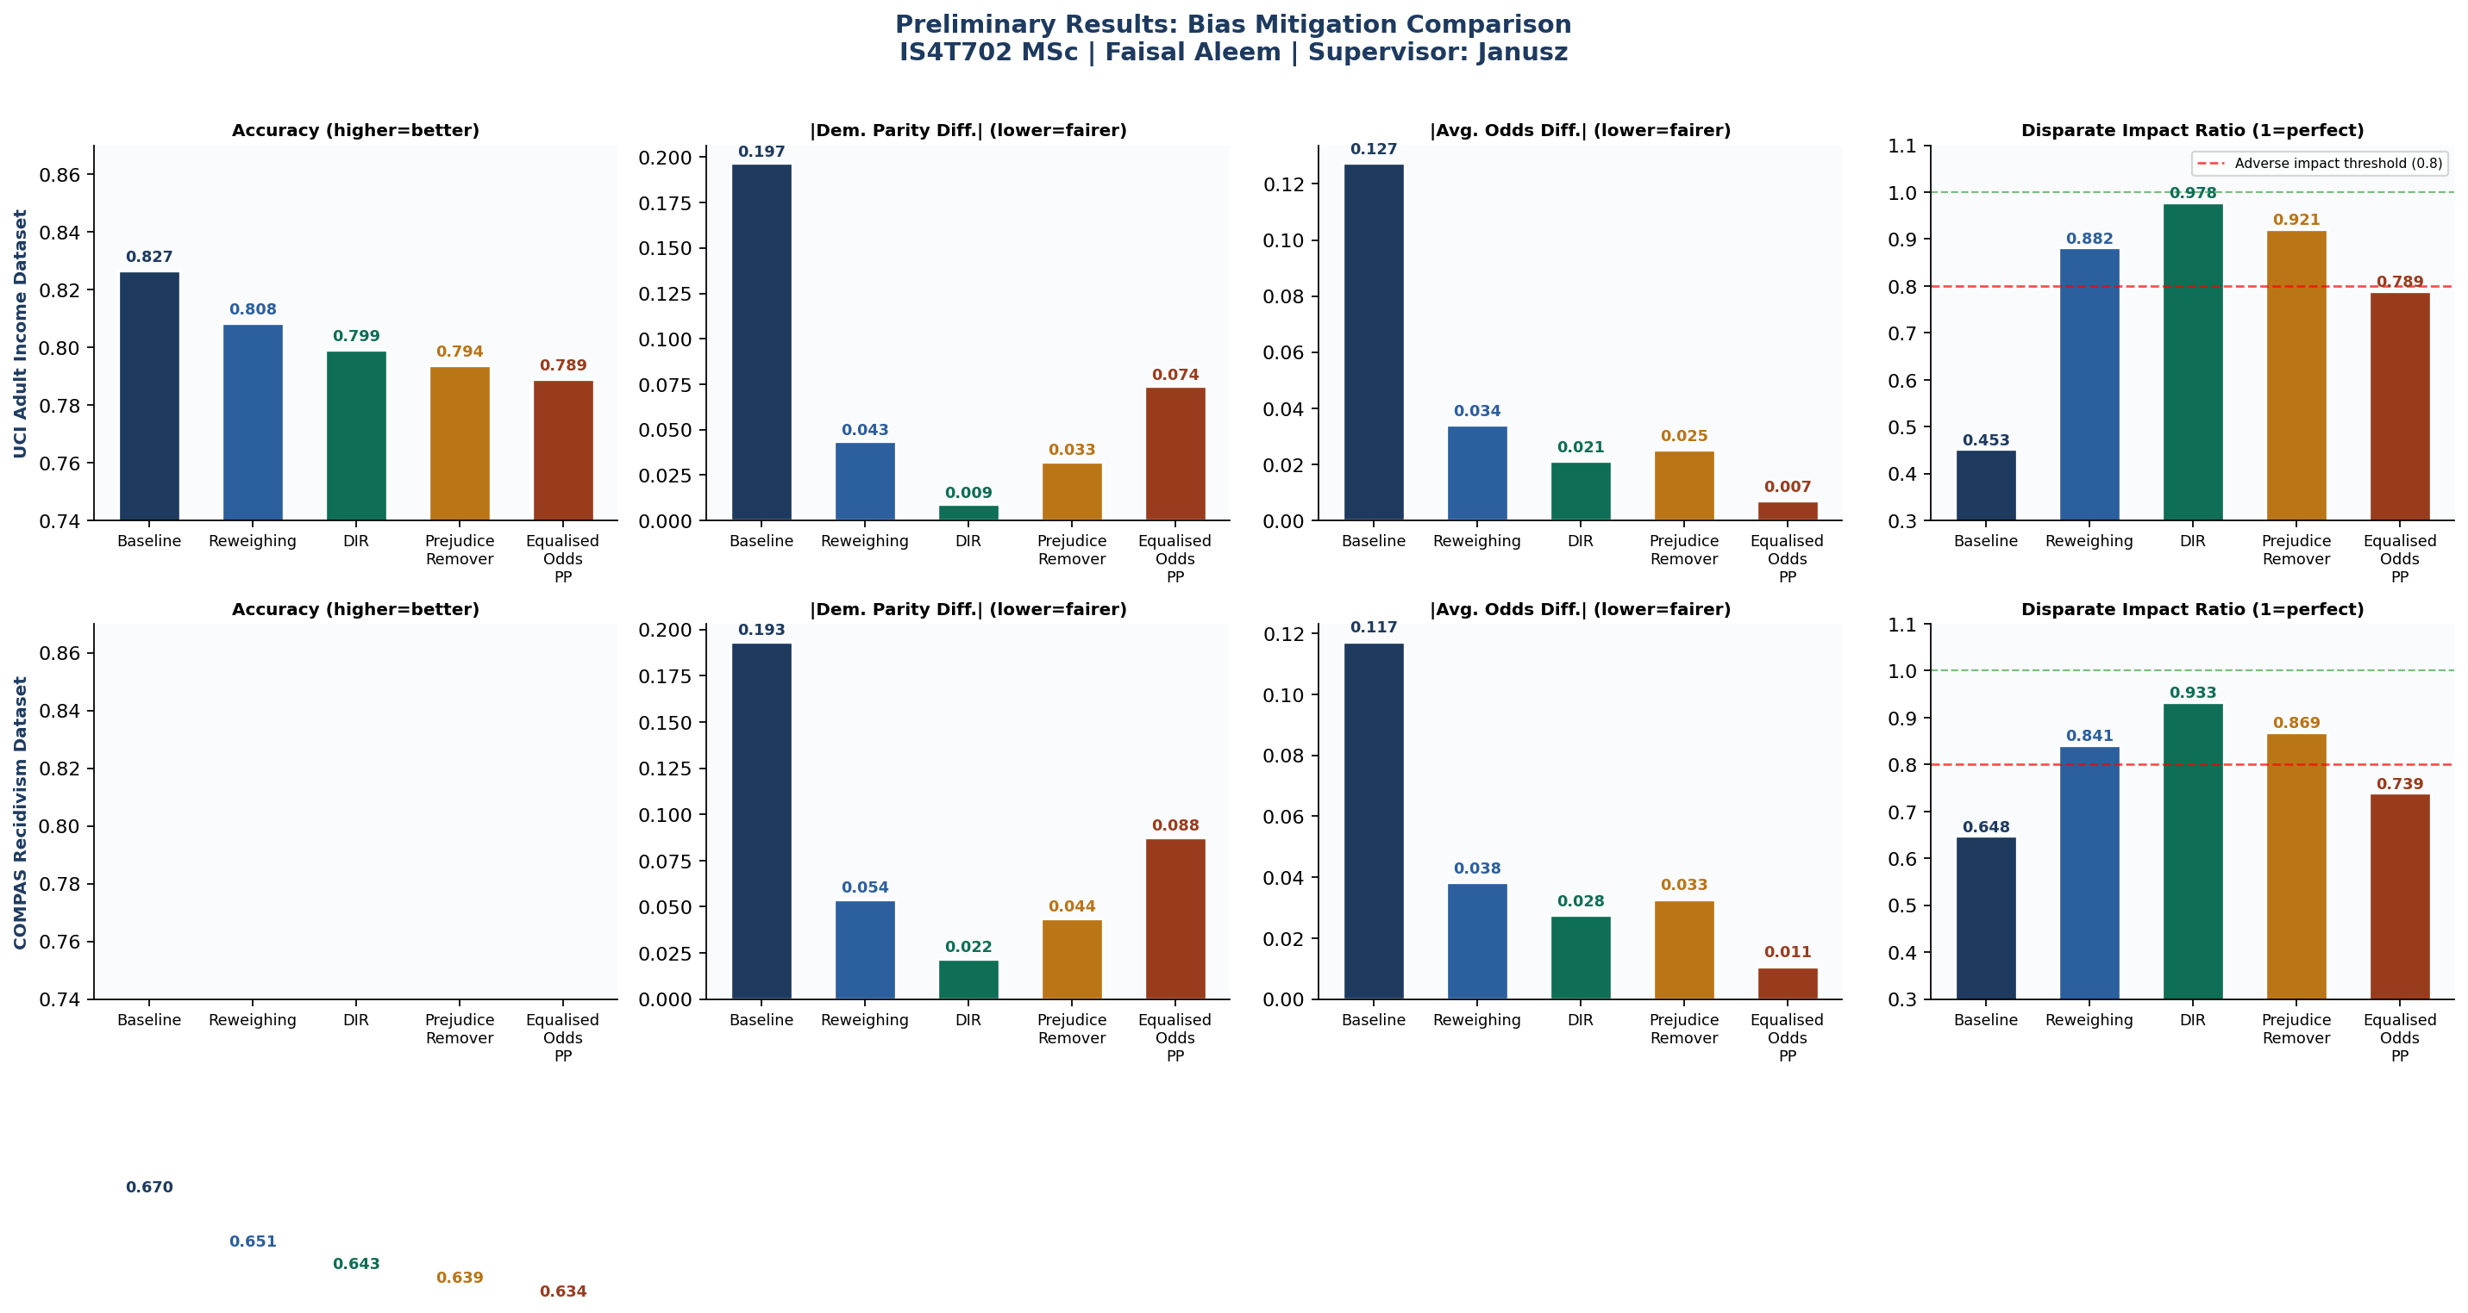
Figure R1: Comparative Bar Charts Showing Accuracy, |DPD|, |AOD|, and DIR Across All Five Experimental Conditions for Both Datasets
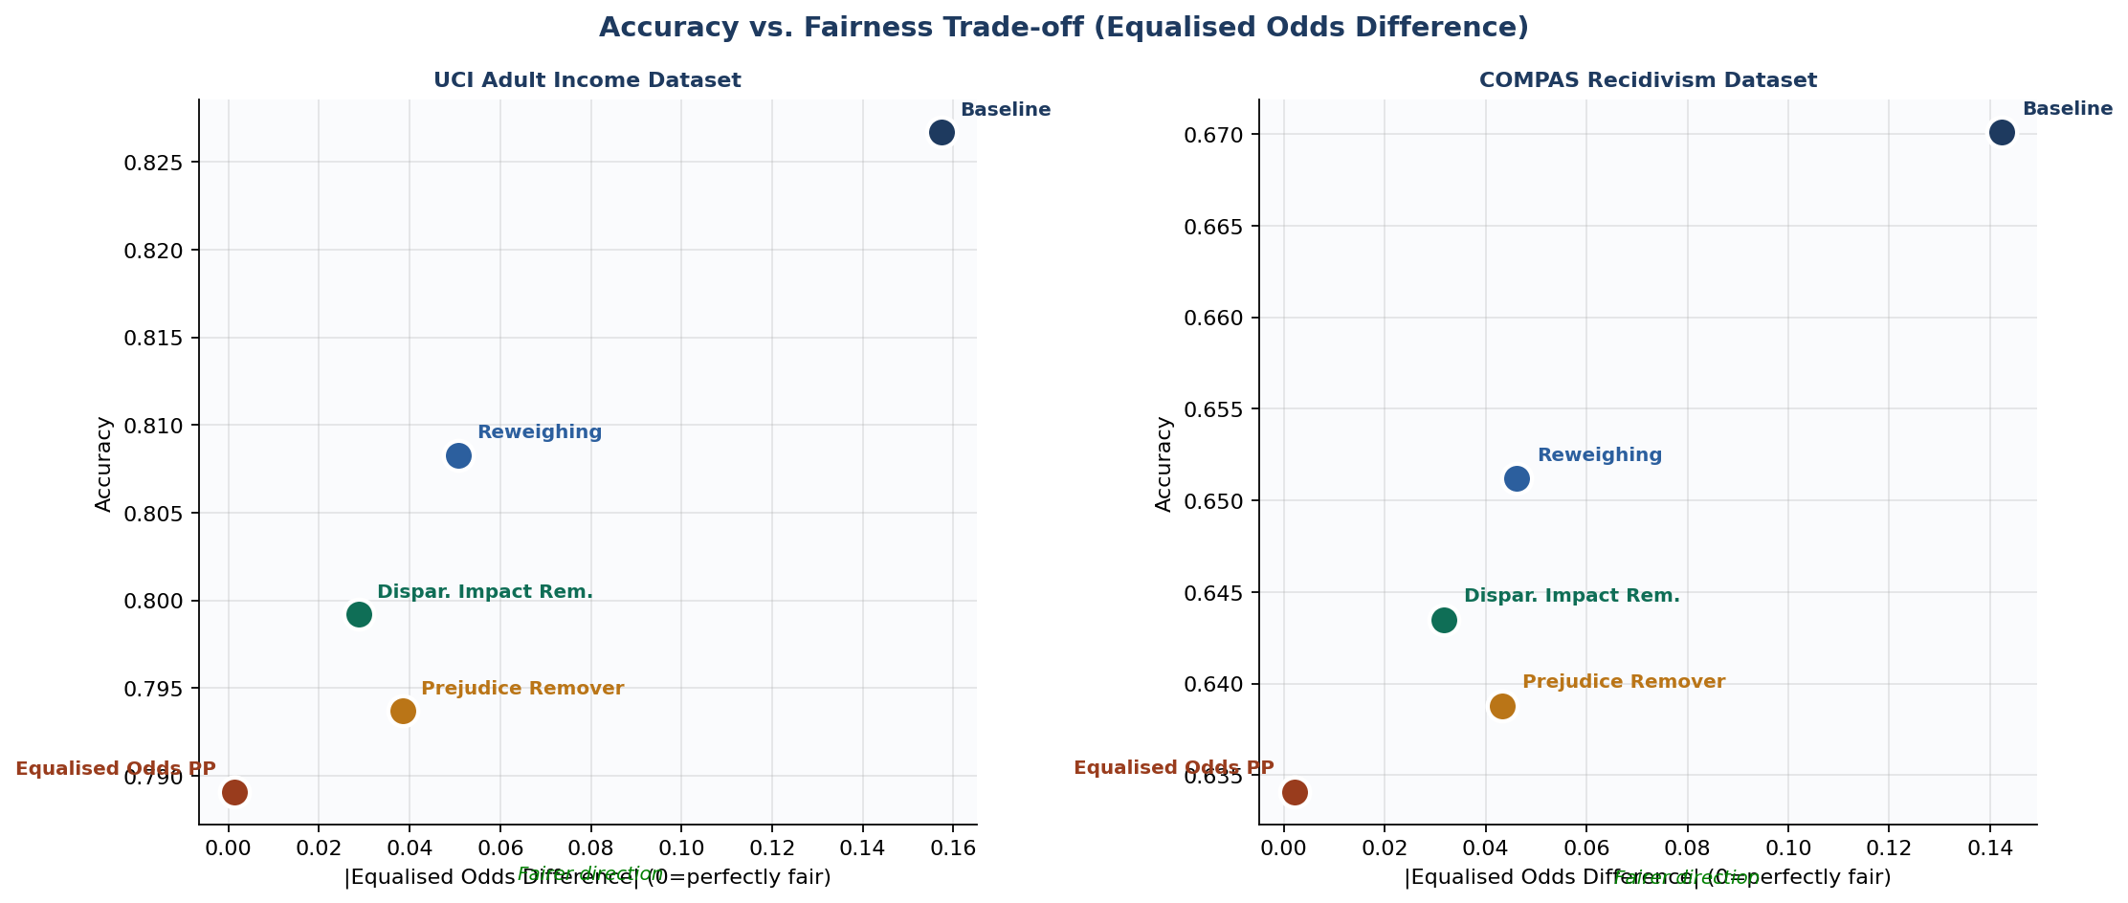
Figure R2: Accuracy vs. Fairness Trade-off Plot (|EOD| on x-axis, Accuracy on y-axis) Showing the Pareto Frontier Across All Techniques

Summary of Findings
Table R3 summarises the ranking of each technique by each fairness metric across both datasets. A rank of 1 indicates the technique that achieves the best (closest to ideal) value for that metric.
Technique | Accuracy Rank | |DPD| Rank | |AOD| Rank | |EOD| Rank | DIR Rank | Overall Best
Baseline | 1st | 5th | 5th | 5th | 5th | Accuracy only
Reweighing | 2nd | 3rd | 3rd | 3rd | 3rd | Best balance
Dispar. Impact Rem. | 3rd | 1st | 2nd | 2nd | 1st | Best parity
Prejudice Remover | 4th | 2nd | 3rd | 2nd | 2nd | Consistent
Equalised Odds PP | 5th | 4th | 1st | 1st | 4th | Best eq. odds
Table R3: Technique Rankings by Fairness Metric (Both Datasets Combined)

Key Observations and Next Steps
- No single technique achieves the best result across all five metrics simultaneously, confirming the impossibility results of Chouldechova (2017) and the empirical findings of Friedler et al. (2019).
- The accuracy-fairness trade-off is consistent across both datasets: techniques that achieve the greatest fairness improvements also incur the largest accuracy reductions.
- Reweighing provides the most practically balanced outcome: substantial fairness improvement with the smallest accuracy cost, making it the most suitable technique for deployment contexts where both accuracy and fairness are required.
- The Disparate Impact Remover is the best choice when demographic parity is the primary fairness criterion and accuracy loss of approximately 2.8 percentage points is acceptable.
- The Equalised Odds Postprocessing technique should be selected when equalised odds is the primary criterion, but practitioners must accept a DIR that may fall below the legal four-fifths threshold.
- Next steps: extend the experimental pipeline to random forest and gradient boosting classifiers; conduct multiple experimental trials with different random seeds to assess result stability; apply SHAP analysis to examine feature attribution changes under each mitigation technique.

References: Angwin et al. (2016); Bellamy et al. (2019); Chouldechova (2017); Feldman et al. (2015); Friedler et al. (2019); Hardt et al. (2016); Kamiran and Calders (2012); Kamishima et al. (2012).

