**Group Members:**

Ayesha Zafar 221050

M Fasih Ur Rehman 221070

**DEVOPS-PROJECT**

**Step 1: Making changes in the repository**

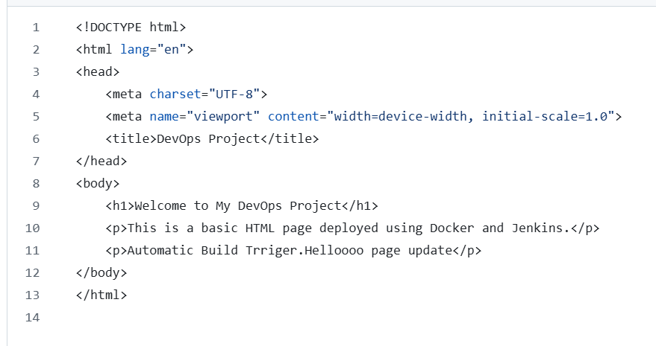

**Step 2: Commit the changes**

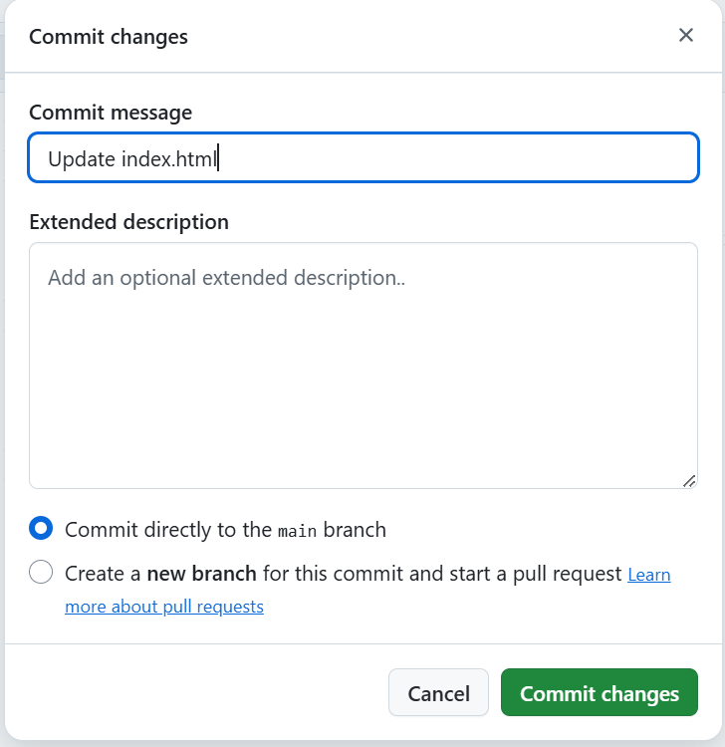

**Step 3: Check for the automatic Build Trigger**

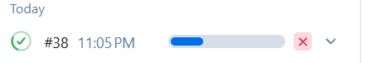

**Step 4: Build Successful**

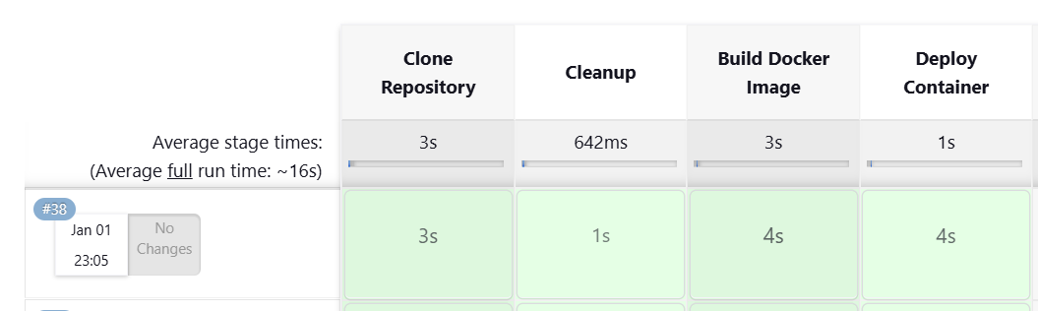

**Step 5: Verify The Image has build:**



**Step 5: Verify The Container has build:**

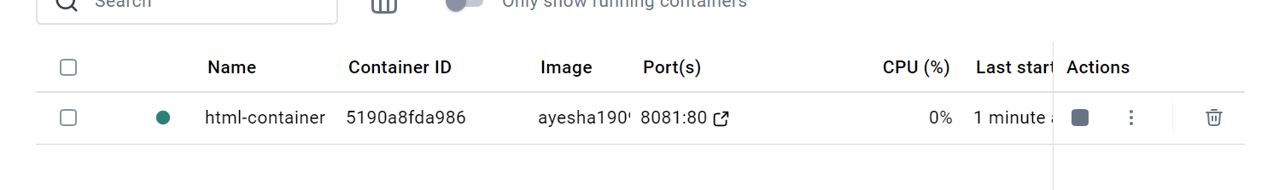

**Step 6: Web Page has been updated:**

