**Lab 06 Tasks**

**Fasiha Adnan**

**24K-0901**

**01:**

#include<iostream>

using namespace std;

class Employee {

protected:

string name;

float salary;

public:

Employee (string name, float salary) : name(name), salary(salary){}

void display(){

cout << "Employee name: " << name << endl;

cout << "Salary: " << salary << endl;

}

};

class Manager : public Employee{

protected:

float bonus;

public:

Manager (string name, float salary, float bonus) : Employee(name,salary), bonus(bonus){}

void display(){

cout << "Employee name: " << name << endl;

cout << "Salary: " << salary << endl;

cout << "Bonus: " << bonus << endl;

}

};

int main(){

Manager m1("Ali", 50000, 25000);

m1.display();

}

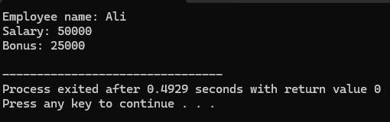

**02:**

#include <iostream>

using namespace std;

class Vehicle {

protected:

string brand;

int speed;

public:

Vehicle(string b, int s) : brand(b), speed(s) {}

virtual void display() {

cout << "Brand: " << brand << endl;

cout << "Speed: " << speed << " km/h" << endl;

}

};

class Car : public Vehicle {

protected:

int seats;

public:

Car(string b, int s, int se) : Vehicle(b, s), seats(se) {}

void display() override {

Vehicle::display();

cout << "Seats: " << seats << endl;

}

};

class ElectricCar : public Car {

private:

int batteryLife;

public:

ElectricCar(string b, int s, int se, int bl) : Car(b, s, se), batteryLife(bl) {}

void display() override {

Car::display();

cout << "Battery Life: " << batteryLife << " hours" << endl;

}

};

int main() {

ElectricCar eCar("Tesla", 200, 5, 6);

eCar.display();

return 0;

}

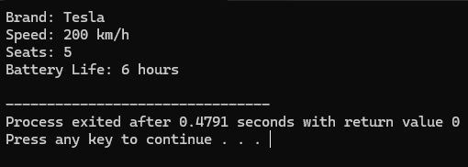

**03:**

#include <iostream>

using namespace std;

class Person{

protected:

string name;

int age;

public:

Person(string n, int a) : name(n), age(a){}

virtual void display(){

cout << "Name: " << name << endl;

cout << "Age: " << age << endl;

}

};

class Teacher : public Person{

protected:

string subject;

public:

Teacher(string n, int a, string s) : Person (n, a), subject(s){}

void display() override {

Person::display();

cout << "Subject: " << subject << endl;

}

};

class Researcher : public Teacher{

protected:

string researchArea;

public:

Researcher(string n, int a, string s, string rA) : Teacher (n, a, s), researchArea(rA){}

void display() override {

Teacher::display();

cout << "Research Area: " << researchArea << endl;

}

};

class Professor : public Researcher{

protected:

int publications;

public:

Professor(string n, int a, string s, string rA, int p) : Researcher(n, a, s, rA), publications(p){}

void display() override{

Researcher::display();

cout << "Publications: " << publications << endl;

}

};

int main(){

Professor p1("Zaroon Shah", 55, "Chemistry", "Atom Theory", 5);

p1.display();

return 0;

}

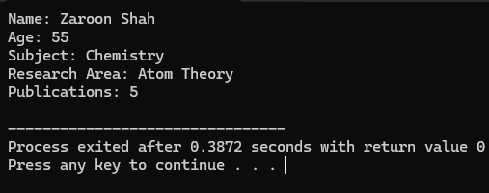

**04:**

#include <iostream>

using namespace std;

class Account {

protected:

int accountNumber;

float balance;

public:

Account(int accNum, float bal) : accountNumber(accNum), balance(bal) {}

virtual void displayDetails() {

cout << "-----------------------" << endl;

cout << "Account Number: " << accountNumber << endl;

cout << "Balance: $" << balance << endl;

}

};

class SavingsAccount : public Account {

private:

float interestRate;

public:

SavingsAccount(int accNum, float bal, float rate) : Account(accNum, bal), interestRate(rate) {}

void displayDetails() override {

Account::displayDetails();

cout << "Interest Rate: " << interestRate << "%" << endl;

}

};

class CheckingAccount : public Account {

private:

float overdraftLimit;

public:

CheckingAccount(int accNum, float bal, float limit) : Account(accNum, bal), overdraftLimit(limit) {}

void displayDetails() override {

Account::displayDetails();

cout << "Overdraft Limit: $" << overdraftLimit << endl;

}

};

int main() {

SavingsAccount savings(1002654, 2500, 5);

CheckingAccount checking(1006454, 6500, 500);

savings.displayDetails();

checking.displayDetails();

return 0;

}

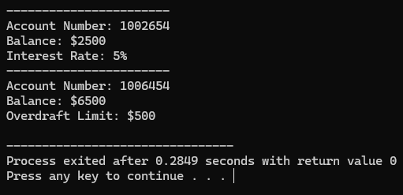

**05:**

#include <iostream>

using namespace std;

class Device {

protected:

int deviceID;

bool status;

public:

Device(int id, bool stat) : deviceID(id), status(stat) {}

virtual void displayDetails() {

cout << "Device ID: " << deviceID << endl;

cout << "Status: " << (status ? "On" : "Off") << endl;

}

};

class SmartPhone : virtual public Device {

protected:

float screenSize;

public:

SmartPhone(int id, bool stat, float screen) : Device(id, stat), screenSize(screen) {}

void displayDetails() override {

Device::displayDetails();

cout << "Screen Size: " << screenSize << " inches" << endl;

}

};

class SmartWatch : virtual public Device {

protected:

bool heartRateMonitor;

public:

SmartWatch(int id, bool stat, bool monitor) : Device(id, stat), heartRateMonitor(monitor) {}

void displayDetails() override {

cout << "Heart Rate Monitor: " << (heartRateMonitor ? "Yes" : "No") << endl;

}

};

class SmartWearable : public SmartPhone, public SmartWatch {

private:

int stepCounter;

public:

SmartWearable(int id, bool stat, float screen, bool monitor, int steps)

: Device(id, stat), SmartPhone(id, stat, screen), SmartWatch(id, stat, monitor), stepCounter(steps) {}

void displayDetails() override {

Device::displayDetails();

cout << "Screen Size: " << screenSize << " inches" << endl;

cout << "Heart Rate Monitor: " << (heartRateMonitor ? "Yes" : "No") << endl;

cout << "Step Counter: " << stepCounter << " steps" << endl;

}

};

int main() {

SmartWearable wearable(20052, 1, 6.7, 1, 5000);

wearable.displayDetails();

return 0;

}

