**Lab 04 Tasks**

**Fasiha Adnan**

**24K-0901**

**01**:

#include<iostream>

using namespace std;

class Car {

public:

string brand;

string model;

double rentalPrice;

bool availability;

Car(){

brand = "Unknown";

model = "Generic";

rentalPrice = 0.0;

availability = true;

}

Car(string b, string m, double rp, bool a){

brand = b;

model = m;

rentalPrice = rp;

availability = a;

}

void available(){

if(availability){

cout << "The car is available for rent." << endl;

}

else {

cout << "The car is not available for rent" << endl;

}

}

void display(){

cout << "-------------------------" << endl;

cout << "Brand: " << brand << endl;

cout << "Model: " << model << endl;

cout << "Rental Price: " << rentalPrice << endl;

cout << "Availability: " << (availability ? "Yes" : "No") << endl;

}

};

int main (){

Car c1;

c1.display();

Car corolla("Toyota", "2012", 5000.0, "True");

corolla.display();

}

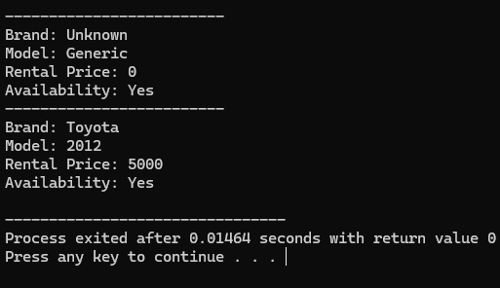

**02:**

#include<iostream>

#include<string>

using namespace std;

class Car {

private:

string brand;

string model;

double rentalPrice;

bool available;

public:

Car(string b, string m, double rp, bool a) : brand(b), model(m), rentalPrice(rp), available(a) {}

void updateDetails(string b, string m, double rp, bool a) {

brand = b;

model = m;

rentalPrice = rp;

available = a;

}

bool isAvailable() {

return available;

}

void checkAvailability() {

if (available) {

cout << "The car is available for rent." << endl;

} else {

cout << "The car is not available for rent." << endl;

}

}

void rentCar(int days) {

if (!available) {

cout << "Car is already rented." << endl;

return;

}

double finalPrice = applyDiscount(days);

cout << "Car rented successfully for " << days << " days. Total cost after discount (if applied): $" << finalPrice << endl;

available = false;

}

double applyDiscount(int days) {

double discount = 0.0;

if (days > 10) {

discount = 0.10;

} else if (days > 5) {

discount = 0.05;

}

return rentalPrice * days * (1 - discount);

}

void displayDetails() {

cout << "-------------------------" << endl;

cout << "Brand: " << brand << endl;

cout << "Model: " << model << endl;

cout << "Rental Price: $" << rentalPrice << endl;

cout << "Availability: " << (available ? "Available" : "Rented") << endl;

}

};

int main() {

Car car2("Toyota", "Corolla", 5000.0, true);

car2.displayDetails();

car2.checkAvailability();

car2.rentCar(7);

car2.displayDetails();

car2.rentCar(3);

return 0;

}

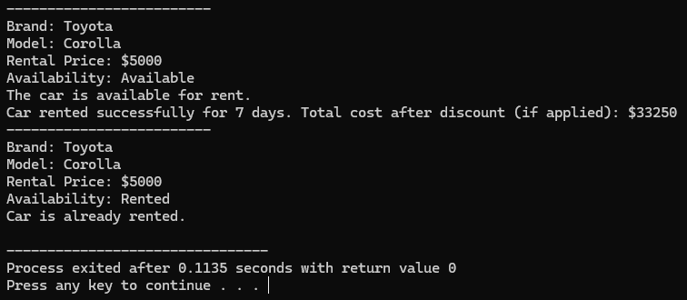

**03:**

#include<iostream>

#include<string>

using namespace std;

class Car {

private:

string brand;

string model;

double rentalPrice;

bool available;

public:

Car(string b, string m, double rp, bool a) : brand(b), model(m), rentalPrice(rp), available(a) {}

Car(const Car& other) = default;

void updateDetails(string b, string m, double rp, bool a) {

brand = b;

model = m;

rentalPrice = rp;

available = a;

}

bool isAvailable() {

return available;

}

void checkAvailability() {

if (available) {

cout << "The car is available for rent." << endl;

} else {

cout << "The car is not available for rent." << endl;

}

}

void rentCar(int days) {

if (!available) {

cout << "Car is already rented." << endl;

return;

}

double finalPrice = applyDiscount(days);

cout << "Car rented successfully for " << days << " days. Total cost: $" << finalPrice << endl;

available = false;

}

double applyDiscount(int days) {

double discount = 0.0;

if (days > 10) {

discount = 0.10;

} else if (days > 5) {

discount = 0.05;

}

return rentalPrice * days * (1 - discount);

}

void displayDetails() {

cout << "-------------------------" << endl;

cout << "Brand: " << brand << endl;

cout << "Model: " << model << endl;

cout << "Rental Price: $" << rentalPrice << endl;

cout << "Availability: " << (available ? "Available" : "Rented") << endl;

}

};

int main() {

Car car1("Toyota", "Corolla", 5000.0, true);

Car car2 = car1;

cout << "Original Car Details:" << endl;

car1.displayDetails();

cout << "Copied Car Details:" << endl;

car2.displayDetails();

car1.updateDetails("Honda", "Civic", 6000.0, false);

cout << "Modified Original Car Details:" << endl;

car1.displayDetails();

cout << "Copied Car Details (Unchanged):" << endl;

car2.displayDetails();

return 0;

}

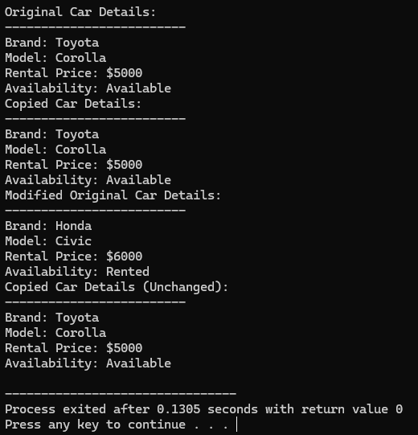

**04:**

#include<iostream>

#include<string>

using namespace std;

class Car {

private:

string brand;

string model;

double rentalPrice;

bool available;

double totalRevenue;

public:

Car(string b, string m, double rp, bool a) : brand(b), model(m), rentalPrice(rp), available(a), totalRevenue(0.0) {}

void rentCar(int days) {

if (!available) {

cout << "Car is already rented." << endl;

return;

}

double finalPrice = applyDiscount(days);

cout << "Car rented successfully for " << days << " days. Total cost: $" << finalPrice << endl;

this->totalRevenue += finalPrice;

available = false;

}

double applyDiscount(int days) {

double discount = 0.0;

if (days > 10) {

discount = 0.10;

} else if (days > 5) {

discount = 0.05;

}

return rentalPrice * days * (1 - discount);

}

void displayDetails() const {

cout << "-------------------------" << endl;

cout << "Brand: " << brand << endl;

cout << "Model: " << model << endl;

cout << "Rental Price: $" << rentalPrice << endl;

cout << "Availability: " << (available ? "Available" : "Rented") << endl;

cout << "Total Revenue: $" << totalRevenue << endl;

}

};

int main() {

Car car1("Toyota", "Corolla", 5000.0, true);

car1.displayDetails();

car1.rentCar(7);

cout << "After renting:" << endl;

car1.displayDetails();

return 0;

}

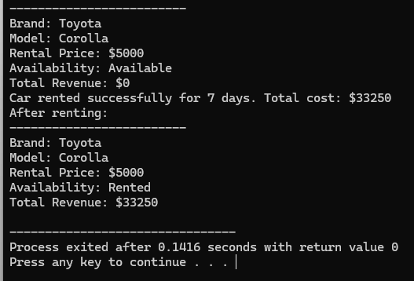

**05:**

#include<iostream>

#include<string>

using namespace std;

class Car {

private:

string brand;

string model;

double rentalPrice;

bool available;

double totalRevenue;

string carID;

public:

Car(string b, string m, double rp, bool a, string id)

: brand(b), model(m), rentalPrice(rp), available(a), totalRevenue(0.0), carID(id) {}

void rentCar(int days) {

if (!available) {

cout << "Car is already rented." << endl;

return;

}

double finalPrice = applyDiscount(days);

cout << "Car rented successfully for " << days << " days. Total cost: $" << finalPrice << endl;

this->totalRevenue += finalPrice;

available = false;

}

double applyDiscount(int days) {

double discount = 0.0;

if (days > 10) {

discount = 0.10;

} else if (days > 5) {

discount = 0.05;

}

return rentalPrice * days * (1 - discount);

}

void displayDetails() const {

cout << "-------------------------" << endl;

cout << "Car ID: " << carID << endl;

cout << "Brand: " << brand << endl;

cout << "Model: " << model << endl;

cout << "Rental Price: $" << rentalPrice << endl;

cout << "Availability: " << (available ? "Available" : "Rented") << endl;

cout << "Total Revenue: $" << totalRevenue << endl;

}

};

int main() {

Car car1("Toyota", "Corolla", 5000.0, true, "2012YP");

Car car2("Honda", "Civic", 6000.0, true, "2022LI");

car1.displayDetails();

car2.displayDetails();

car1.rentCar(7);

cout << "\nAfter renting car 1:" << endl;

car1.displayDetails();

return 0;

}

