**Task 1:**

* Clone the repository and go inside redacre-tasks/task1.
* Run command docker compose up -d –build.
* I have created 3 Dockerfile backend Dockerfile in /api.
* frontend Dockerfile in /sys-stats
* Nginx.conf file in which i will add it in my nginx image in docker-compose.yaml file.
* Created docker-compose.yaml in which i have defined the network, expose my frontend, backend, my Dockerfile path.
* Three containers will be running and the final user can access on port 80

**Task 2:**

* Go in the folder /task2/terraform.
* I have created a security group in which I have allowed specific ports opened in inbound rules.
* Setup the ami image, attach keyfile.
* Created ssh configuration.
* Copy files from my local to the server so i dont have to do it manually.
* Install docker
* Go to the specific path and run docker compose up -d – build in main.tf file.

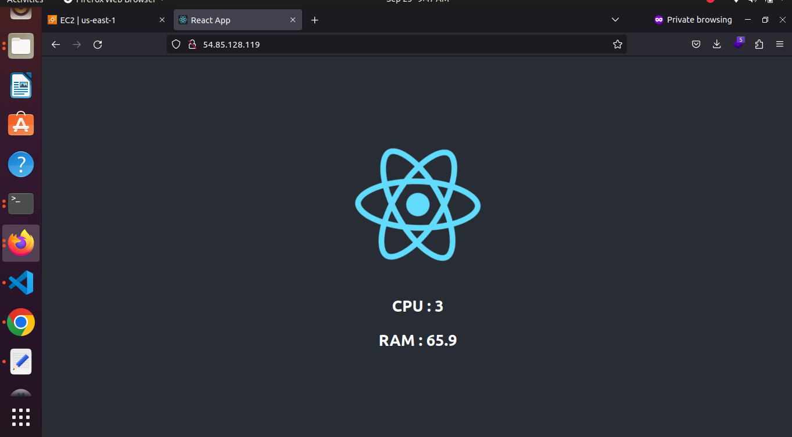

**Task3:**

* Created namespace task3.
* Created deployment and service files for my backend and frontend.
* Created ingress.yaml to expose the final app on port 80
* We will use Loadbalancer in production environment and assign static ips to our backend and frontend.
* I have given host helloworld.info on my localhost added it in my /etc/hosts file also.

