***URRICULUM ITAE***

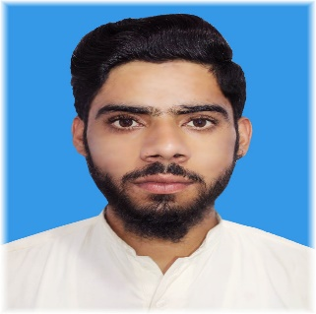

SA

Fasil Nawaz

**Address**:Paddher Maastu Distric Bagh AJK.

**Contact**#0349-5443520 **Emai:** fasilnawaz136@gmail.com

CAREEROBJECTIVES:

To achieve professional excellence by obtaining a position where my skills educationandexperiencewillbeanassettothecontinuedgrowthandprogression of the organization…

PERSONALINFORMATION:

* Father’sName : Fasil Nawaz
* Date ofBirth : 05-02-2003
* CNIC : 82102-9865401-7
* Domicile : AJK

ACADEMICQUALIFICATION

* Matric :BISEAJK(Mirpur)
* DAE :Tevta (Lahore)
* BS.CS(continue) :Abasyn University Islamabad

Experience

* ***08months*** *experience as a* ***CSR*** *in* ***Rapidsquad****.*
* ***04months*** *experience as a* ***CSR*** *in* ***SmartBrainBPO..***
* ***04months*** *experience in* ***cyclone medical billing.***
* Skills:
* *MSOfficeSuite(Documentcreation,dataanalysis)*
* *Frontend web devolping*
* *MicrosoftExcel*
* *MicrosoftWord*

Languages

* *Urdu*
* *English*
* *Punjab*