BSSE FINAL PROJECT PROPOSAL
TasteScope:AI-Powered Rewiew scraper & Analyser

Term of Registration: Fall 2025



Presented by:
Registration No: | Name:
L1F22BSSE0126 | Muhammad Ahmad
L1F22BSSE0376 | Hamza Ijaz
L1F22BSSE0396 | Muhammad Fasi Shahid

Faculty of Information Technology
University of Central Punjab
Project Title
TasteScope: AI-Powered Rewiew Scraper & Analyser

Project Advisor
Ali Haider

Particulars of the students:
S.No | Registration#  eg.L1F00BSCS0101 | Name in Full  Use Block Letters | CGPA | Signatures
1 | L1F22BSSE0126 | MUHAMMAD AHMAD | 2.59
2 | L1F22BSSE0376 | HAMZA IJAZ | 2.0
3 | L1F22BSSE0396 | MUHAMMAD FASI SHAHID | 3.25

Advisor’s Consent
I Prof./Dr./Mr./Ms. MR ALI HAIDER ARIF am willing to guide these students in all phases of above-mentioned project as advisor. I have carefully seen the Title and description of the project and believe that it is of an appropriate difficulty level for the number of students named above.

Note:  Advisor can’t be changed without prior permission of the Manager Projects and the duration for completion of the Project is 2 regular semesters (approx.) from the date of Registration of Research Project. | Signatures and Date  Advisor
EVALUATOR/REFEREE 1
I have carefully read the project proposal and feel that the proposed project is a useful one and of a sufficient difficulty level to justify 2 regular semesters workload for above mentioned students. I have made recommendations in the evaluation form to improve the scope and quality of the project.

Signatures and Date
EVALUATOR/REFEREE 2
I have carefully read the project proposal and feel that the proposed project is a useful one and of a sufficient difficulty level to justify 2 regular semesters workload for above mentioned students. I have made recommendations in the evaluation form to improve the scope and quality of the project.

Signatures and Date

Abstract / Executive Summary
TasteScope is an AI-driven web application developed to analyze and interpret public reviews from platforms such as Google Reviews and TripAdvisor. The system employs Natural Language Processing (NLP) techniques to automatically generate concise summaries that highlight key aspects, including recommended items, staff performance, and frequently reported issues. In addition to text-based analysis, the application presents visual insights through sentiment distribution charts, trend graphs, and keyword analysis.
Unlike existing platforms that only display raw reviews, TasteScope unifies fragmented feedback across multiple sources and transforms it into actionable insights. The novelty lies in its ability to aggregate scattered data, apply AI-powered sentiment analysis, and present results in the form of dashboards, graphs, and word clouds.

Introduction and Background
Online reviews significantly influence user decision-making. However, existing platforms like Google Maps and Zomato only provide raw reviews without summarization or cross-platform comparison. This results in information overload and review fatigue. TasteScope addresses this by offering an intelligent review summarization and visualization tool, providing users with a quick and comprehensive overview of sentiments and trends.

Statement of the Problem
There is no centralized system that aggregates and summarizes reviews from multiple platforms into visual insights like graphs. Users face difficulty in understanding overall sentiment due to scattered, lengthy, and unstructured reviews.

Objective(s) / Aim(s) / Target(s)
- Aggregate reviews from multiple public sources (Google, TripAdvisor, etc.).
- Apply NLP techniques to classify and summarize sentiments.
- Present visual insights through graphs, charts, and word clouds.
- Provide a web-based dashboard as the end product.
- Assist both consumers and business owners in decision-making.

Completeness Criteria

S.No. | Criteria | Weightage %
1 | Web Scraping Engine | 20
2 | Sentiment Analysis & NLP | 25
3 | Summarization & Keyword Extraction | 15
4 | Graphs & Visualization Dashboard | 20
5 | Frontend Development (React/Tailwind) | 10
6 | Backend & Database (Node/MongoDB) | 10

Challenges
- Real-time scraping from dynamic websites.
- Handling unstructured text data with NLP.
- Integrating multiple technologies (MERN + NLP + Visualization).
- Ensuring scalability and performance of the dashboard.

Knowledge Areas Required
Web Development, Software Engineering, Databases, Natural Language Processing, Data Visualization, Cloud Deployment.

Learning Outcomes
- Mastery of NLP techniques for sentiment analysis.
- Experience with web scraping using Cheerio/Puppeteer.
- Hands-on development of MERN stack applications.
- Practical knowledge of visualization libraries.
- Understanding cloud deployment strategies.

Nature of the End Product / Research Outcomes
A centralized web application that aggregates reviews from multiple sources, applies NLP for sentiment classification, and visualizes insights through graphs and dashboards. The end product will serve as a decision-support tool for users and business owners.

Related Work / Literature Survey / Literature Review
Google Maps and Zomato provide raw reviews without summarization or cross-platform integration. Existing sentiment tools like VADER are rarely used in user-facing applications. TasteScope differs by aggregating data, applying AI-driven summarization, and visualizing insights like graphs, addressing the novelty requirement.

Deliverables / Work Breakdown Structure
Deliverable | Description
Scraping Engine | Module for extracting reviews from multiple sources.
Sentiment Analysis Engine | NLP-based classification of reviews.
Summarization Engine | Rule-based NLP summarization and keyword extraction.
Visualization Dashboard | Graphs, charts, word clouds, and trend analysis.
Frontend Application | User-friendly React.js interface.
Backend + Database | Node.js API and MongoDB storage.

Project Plan / Project Schedule / Project Timetable / Project Calendar
Weeks 1-2: Requirement analysis and environment setup.
Weeks 3-4: Scraping engine development (basic functionality).
Weeks 5-6: Sentiment analysis module (initial implementation).
Weeks 7-8: Summarization and keyword extraction (prototype).
Weeks 9-10: Visualization dashboard development (basic graphs).
Weeks 11-12: Frontend-backend integration (initial integration).
Weeks 13-14: Testing and bug fixing (phase 1).
Weeks 15-16: Final deployment (phase 1) and documentation (draft).
Weeks 17-18: Improve scraping engine with dynamic websites.
Weeks 19-20: Enhance sentiment analysis with deep learning models.
Weeks 21-22: Improve summarization and keyword extraction (advanced NLP).
Weeks 23-24: Advanced visualization features (interactive charts, word clouds).
Weeks 25-26: Frontend UI/UX improvements (React + Tailwind).
Weeks 27-28: Backend optimization and database scaling (MongoDB tuning).
Weeks 29-30: Security, performance, and scalability testing.
Weeks 31-32: Final deployment, documentation, and presentation preparation.

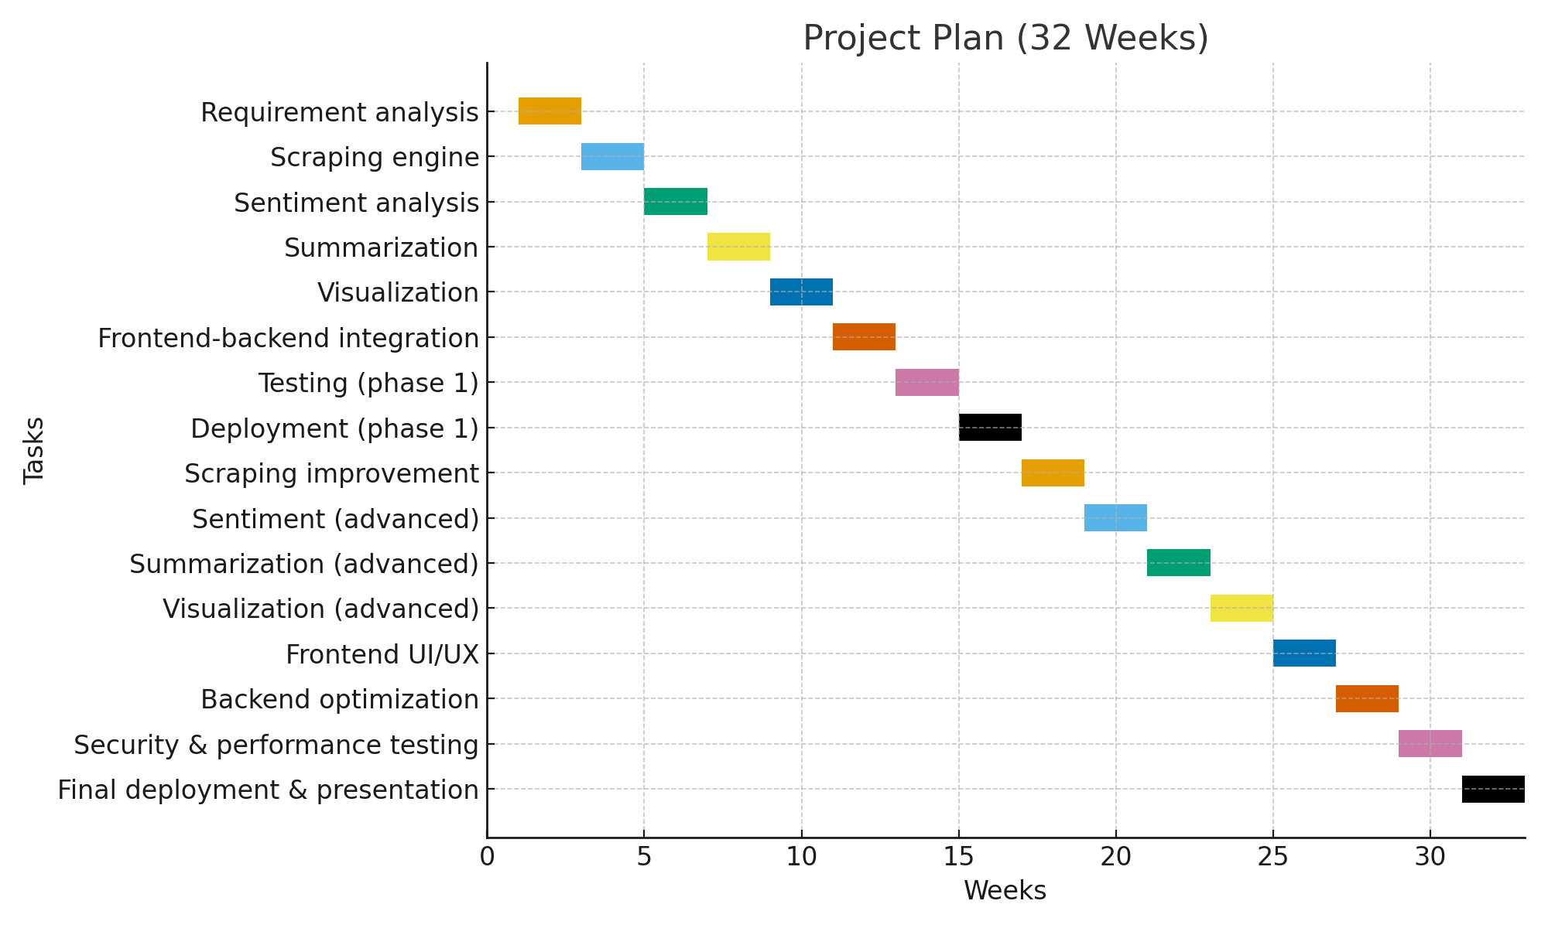

Resources Required
- Laptops with Node.js and MongoDB installed.
- Internet access for scraping and API usage.
- Libraries: Cheerio, Puppeteer, VADER, Recharts, WordCloud.js.
- Deployment: Vercel (frontend), Render/Railway (backend).
All required resources are available and open-source.

Miscellaneous
- Team members already have prior knowledge of MERN stack and basic NLP, which reduces the learning curve.
- The project scope is manageable within two semesters.
- External APIs (Google Reviews, TripAdvisor) may be explored if scraping is limited.
- The team is committed to weekly progress meetings and version control using GitHub.

Abstract Story Board and Identification of Characters (For Game-Oriented Projects Only)
This project is not game-oriented.

Sketch of Proposed Solution (For Research-based and Hardware-Oriented Projects Only)
This project is not Resarch-based and hardware-oriented.

References/Bibliography
[1] Hutto, C.J., & Gilbert, E.E. (2014). VADER: A Parsimonious Rule-based Model for Sentiment Analysis of Social Media Text.
[2] Google Maps Review Platform, https://maps.google.com
[3] TripAdvisor Review System, https://tripadvisor.com
[4] Zomato Review Aggregator, https://zomato.com
[5] Recharts Visualization Library, https://recharts.org

