BSSE FINAL PROJECT
Requirements Specification

TasteScope



Project Advisor

Ali Haider Arif

Presented by:
Group ID: F25SE019

Student Reg# Student Name
L1F22BSSE0396 Fasi Shahid
L1F22BSSE0126 Muhammad Ahmad
L1F22BSSE0376 Hamza Ijaz

Faculty of Information Technology & Computer Science

University of Central Punjab
Software Requirements Specification
Version 1

TasteScope:AI-Powered Rewiew scraper & Analyser
Advisor: Ali Hiader Arif
Group F25SE019
Member Name | Primary Responsibility
Fasi Shahid | Requirement Gathering+ Documentation
Muhammad Ahmad | Requirement Gathering+ Documentation
Hamza Ijaz | Requirement Gathering+ Documentation

Table of Contents
Table of Contents i
Revision History ii
Previous Phases Feedback ii
Abstract iii
1. Introduction and Background 1
1.1 Product (Problem Statement) 1
1.2 Background 1
1.3 Scope 1
1.4 Objective(s)/Aim(s)/Target(s) 1
1.5 Challenges 1
1.6 Learning Outcomes 1
1.7 Nature of End Product 1
1.8 Completeness Criteria 1
1.9 Business Goals 1
1.10 Related Work/ Literature Survey/ Literature Review 2
1.11 Document Conventions 2
2. Overall Description 3
2.1 Product Features 3
2.2 User Classes and Characteristics 3
2.3 Operating Environment 3
2.4 Design and Implementation Constraints 3
2.5 Assumptions and Dependencies 3
3. Functional Requirements 4
3.1 Name of Use-Case 1 4
3.2 Name of Use-Case 2 (and so on) 4
3.3 Requirements Analysis and Modeling 4
4. Nonfunctional Requirements 5
4.1 Performance Requirements 5
4.2 Safety Requirements 5
4.3 Security Requirements 5
4.4 Additional Software Quality Attributes 5
5. Other Requirements 5
6. Revised Project Plan 5
7. References 6
Appendix A: Glossary 7
Appendix B: IV & V Report 8

Revision History
Name | Date | Reason For Changes | Version

Previous Phases Feedback

Idea Defence Feedback (Screenshot)

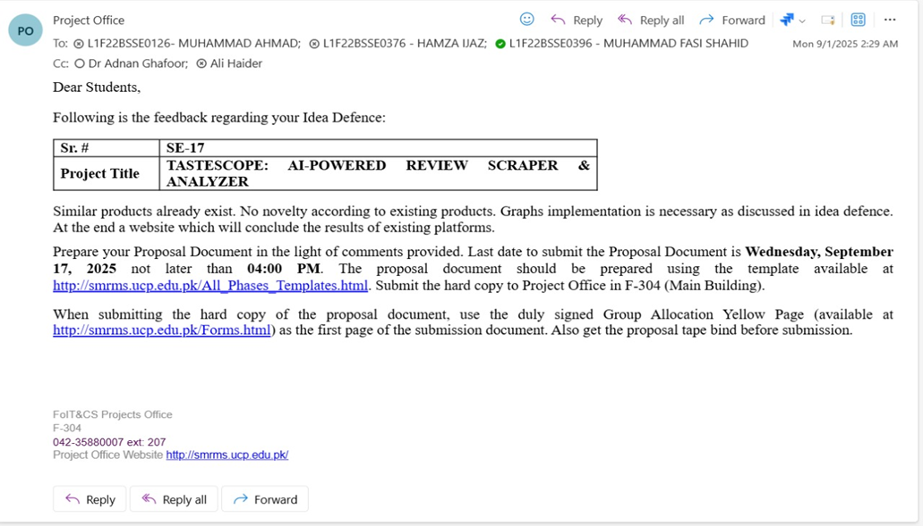

Abstract
TasteScope is an advanced AI-powered web application that helps users and business owners understand public reviews of restaurants, cafes, and other food outlets from multiple online platforms, such as Google Maps, TripAdvisor, and Zomato. Current review platforms only provide raw, unstructured reviews, which makes it challenging for users to quickly gauge the overall quality of a place or for business owners to identify actionable insights. TasteScope addresses this issue by automatically collecting, analyzing, and summarizing review data in a structured and visually appealing format.
The system performs four major functions:
- Scraping Reviews – Collects reviews from multiple sources automatically.
- Storing Data – Saves raw reviews in a structured database for processing and analysis.
- NLP Processing – Cleans text, performs sentiment analysis, extracts important keywords, and generates summaries.
- Dashboard Visualization – Presents the processed data in interactive charts, graphs, word clouds, and summary panels for easy understanding.
This project combines multiple knowledge areas including web development, database management, natural language processing, data visualization, and cloud deployment. Users can view overall sentiment trends, top pros and cons, keyword trends, and detailed review insights. Business owners can also compare competitors and identify areas for improvement.
Expected Outcomes:
- A centralized system that aggregates and analyzes review data from multiple platforms.
- Automatic sentiment classification, keyword extraction, and summary generation using AI/NLP techniques.
- Interactive dashboards with visual analytics that allow users to explore insights efficiently.
- Improved decision-making for both consumers and business owners by converting unstructured reviews into actionable information.
Knowledge Areas:
- Web Development: Creating a responsive frontend using React.js and integrating it with backend services.
- Databases: Storing and retrieving large volumes of review data using MongoDB.
- Natural Language Processing (NLP): Cleaning text data, performing sentiment analysis, extracting keywords, and generating summaries.
- Data Visualization: Presenting insights with charts, graphs, and word clouds for easy understanding.
- Cloud Deployment: Hosting frontend and backend for real-time access and scalability.
In conclusion, TasteScope is more than a review aggregator; it is a smart analytical tool that converts scattered, raw review data into structured, meaningful, and actionable insights. It saves time, reduces information overload, and enhances decision-making for all stakeholders involved.
Introduction and Background
You are required to write a brief introduction of your project and provide background. In this section you should provide the context and initial knowledge of the domain. You should also highlight the significance of problem and provide motivation behind the work being done.

Product (Problem Statement)
TasteScope is a web application designed to gather, process, and visualize reviews from multiple online platforms like Google, TripAdvisor, and Zomato.

Currently, users face two main problems:
- Scattered and unstructured data: Reviews are spread across different platforms, and it is time-consuming for users to read them all to get an overall understanding.
- Difficult analysis for business owners: Businesses cannot easily identify trends, strengths, weaknesses, or competitor comparisons because data is raw and unprocessed.

TasteScope solves this by:
- Automatically scraping reviews from multiple sources.
- Cleaning and processing the reviews using AI/NLP to extract sentiments, keywords, and summaries.
- Visualizing insights on a dashboard, making it easy to understand at a glance.

Background
The rapid growth of online review platforms has changed how people make decisions about dining experiences. Today, a majority of customers rely heavily on reviews to decide which restaurants or cafés to visit. However, the information is often dispersed across multiple platforms, each with its own structure and format, and this makes manual analysis overwhelming. Furthermore, reviews are unstructured; they contain natural language text, emoticons, abbreviations, and sometimes multiple languages, which complicates understanding. Business owners face similar challenges because they need to analyze reviews not only for their own establishments but also for competitors to understand market trends. In this domain, a tool that can automate the collection and processing of review data and present it in an understandable form is highly valuable. TasteScope fills this gap by offering an integrated solution that combines web scraping, natural language processing, and visualization, making review data accessible, interpretable, and actionable for all stakeholders.

Scope
The scope of TasteScope includes the collection, processing, and presentation of online reviews through a single web-based application. The system is capable of automatically scraping reviews from multiple sources, storing them in a structured database, and processing them using an NLP engine to extract sentiments, keywords, and summaries. Users can access the processed data through an interactive dashboard that offers visualizations such as charts, graphs, word clouds, and summarized panels. The system is designed for three types of users: normal users, who can view dashboards and insights; business owners, who can analyze both their own and competitor data; and administrators, who can manage sources, schedule scraping, view system logs, and maintain the database. While the application covers extensive review analysis and visualization, it does not extend to paid or private APIs that may restrict data access, nor does it include a native mobile application in the current version. The focus is on providing a functional, reliable, and interactive web interface that centralizes review data and delivers insights effectively.

Objective(s)/Aim(s)/Target(s)
The primary objective of TasteScope is to simplify the way users and business owners access and understand online reviews. The system aims to aggregate reviews from various platforms, clean and standardize the data, and then process it to generate actionable insights. One key target is to provide sentiment analysis that categorizes reviews as positive, neutral, or negative, along with numerical scoring to help users quantify opinions. Another important objective is to extract keywords and topics from reviews, highlighting the most commonly mentioned aspects such as food quality, service, or pricing. The system also generates concise summaries, including pros, cons, and overall insights, so users can quickly understand the general sentiment without reading every review individually. For business owners, the platform provides comparative analytics and competitor insights, supporting better decision-making. Administrators are also provided with tools to manage sources, ensure data quality, and monitor system performance. Overall, the goal is to create a seamless and intelligent system that transforms unstructured review data into meaningful, visually accessible insights for all users.

Challenges
Developing TasteScope involves several technical and practical challenges. One major challenge is web scraping because the structure of review websites is dynamic and can change frequently, which may disrupt automated data collection. Another challenge is processing unstructured text data; reviews often include spelling mistakes, abbreviations, emojis, and multiple languages, which require careful preprocessing to ensure accurate sentiment analysis and keyword extraction. Implementing a reliable NLP engine that can understand natural language nuances and generate meaningful summaries is also a complex task. Additionally, managing a large volume of data and ensuring fast dashboard performance demands efficient database design and optimized algorithms. Legal and ethical considerations for scraping publicly available data must be handled responsibly. Finally, designing a user-friendly interface that displays complex analytical results in an understandable manner presents a challenge in terms of visual design and usability.

Learning Outcomes
Through the development of TasteScope, the team will gain deep knowledge and practical experience in multiple areas. Web scraping skills will be enhanced by automating data collection from diverse platforms using modern tools. Natural language processing will be applied to real-world, unstructured textual data to perform sentiment analysis, keyword extraction, and summarization. Full-stack development experience will be gained by integrating a React frontend, Node.js backend, and MongoDB database. Additionally, data visualization techniques will be explored to create dashboards that effectively communicate insights to end-users. The project will also teach system design, including modular pipeline creation for scraping, processing, and visualization. Finally, the team will understand deployment, maintenance, and scalability concerns for web-based platforms, as well as ethical considerations around data collection.

Nature of End Product
The final product, TasteScope, will be a fully functional web application that automates the collection, processing, and visualization of online reviews. It will include a backend NLP engine capable of cleaning and analyzing text data to extract sentiments, keywords, and summaries. The system will provide dashboards to present insights through interactive charts, word clouds, and summarized information. Administrators will have a separate panel for managing review sources, scheduling scraping, and monitoring system health. Users and business owners will receive visual, actionable insights that are easy to understand and interpret. The product will serve as a comprehensive solution for centralizing review data and transforming it into meaningful intelligence, accessible to all stakeholders.

Completeness Criteria
The project will be considered complete when it achieves full functionality as described. This includes the successful scraping of review data from multiple platforms, storage of raw and processed reviews in the database, and processing through the NLP engine to produce accurate sentiment, keyword, and summary outputs. The dashboard must display interactive and correct visualizations, while the admin panel should allow effective management of sources, users, and logs. All three user types—normal users, business owners, and administrators—must be able to perform their respective tasks without errors. The system should be stable, reliable, and able to handle a reasonable volume of data efficiently.

Business Goals
TasteScope addresses several key business objectives. By aggregating reviews from multiple platforms, it saves time for both users and business owners, reducing the need to manually browse different websites. It enhances decision-making for businesses by providing clear, data-driven insights about customer feedback and competitor performance. The system improves transparency by storing processed data and presenting it in a clear visual format. Additionally, it supports business growth by enabling owners to quickly identify areas for improvement and make strategic decisions based on aggregated customer opinions. Overall, TasteScope contributes to operational efficiency, customer satisfaction, and market competitiveness.

Related Work/ Literature Survey/ Literature Review
Existing review platforms like Google Maps, TripAdvisor, and Zomato primarily provide raw review data without aggregated analysis. While some analytics tools exist, they often focus on a single platform and do not combine multi-source scraping, NLP-based processing, and interactive dashboard visualization. Research in natural language processing has shown that sentiment analysis, keyword extraction, and text summarization can significantly improve the interpretation of unstructured text data. TasteScope builds on this knowledge to provide a unified solution that integrates scraping, AI processing, and visualization in one platform, offering a level of insight that is not available in standard review platforms.

Document Conventions

This document follows specific conventions to maintain clarity and readability. Actors such as Normal User, Business Owner, Admin, and the NLP Engine are always capitalized. System modules, classes, or entities are written in CamelCase format. Database fields follow snake_case notation to ensure consistency and avoid confusion. Italicized terms denote external systems or platforms, such as Google Maps or TripAdvisor. All diagrams, including ERD, Class Diagram, Use Case Diagram, and Sequence Diagram, use arrows to indicate data or control flow direction. Diagrams are included to visually represent system structure and interactions, complementing the textual explanations in this document.
- Italicized text represents external systems or websites (e.g., Google Maps).
- Bold text highlights key modules or entities (e.g., Dashboard, NLP Engine).
- UUID is used for unique identifiers in databases.
- Diagrams follow UML notation: rectangles for classes, arrows for relationships, ovals for use cases.
- All timestamps are in ISO 8601 format.

Overall Description

Product Features
This section provides a broad understanding of TasteScope, highlighting its major capabilities, the types of users who will interact with it, the environment it will operate in, the constraints that developers need to consider, and the assumptions or dependencies that may influence the project’s success. By offering this overview, anyone reading the document can understand the purpose, boundaries, and context of the system without diving into the technical specifics yet.

User Classes and Characteristics
TasteScope is designed as a complete platform for collecting, analyzing, and visualizing restaurant and café reviews from multiple online sources. At a high level, its major features include the automated scraping of reviews from platforms like Google Maps, TripAdvisor, and Zomato. Once collected, the reviews are stored in a structured database, cleaned, and processed using an AI-powered natural language processing engine. This engine is capable of analyzing the sentiment of each review, extracting key topics and keywords, and generating summaries that capture the main pros, cons, and overall trends of customer opinions. Users are then presented with an interactive dashboard that displays visualizations such as charts, graphs, and word clouds, making the insights easy to understand at a glance. Additional features include the ability to filter reviews by sentiment, rating, or keywords, compare multiple restaurants, and view raw reviews for detailed inspection. Administrators have separate tools to manage review sources, schedule scraping, monitor logs, and ensure data quality. Overall, these features combine to create a system that is both user-friendly and capable of transforming unstructured review data into actionable insights for casual users, business owners, and administrators alike.

Operating Environment
TasteScope is a web-based application that operates in a modern cloud-friendly environment. On the client side, users interact with the system through web browsers such as Google Chrome, Mozilla Firefox, or Microsoft Edge on desktop and mobile devices. The frontend is built using React, providing a dynamic and responsive user interface. On the server side, the backend runs on Node.js, handling API requests, data processing, and communication with the database. The database is MongoDB, which stores raw reviews, processed data, sentiments, keywords, and summary information. The NLP Engine, responsible for text processing, requires Python runtime and libraries for natural language processing, sentiment analysis, and keyword extraction. The system must also handle network connections for web scraping, which may include APIs or automated browser instances. TasteScope is designed to coexist with standard security protocols, web browsers, and database environments, ensuring stability, efficiency, and compatibility across multiple platforms.

Design and Implementation Constraints
While building TasteScope, there are several design and implementation constraints that influence development decisions. First, scraping review websites must comply with the terms of service of each platform, meaning automated scraping scripts must be carefully designed to avoid rate-limiting or blocking. Memory and processing constraints are also important, as the NLP engine must process potentially large volumes of textual data efficiently. Developers must ensure the system performs adequately under peak loads, maintaining fast response times for users. The choice of technologies—React for frontend, Node.js for backend, MongoDB for database, and Python-based NLP libraries—is dictated both by technical suitability and team expertise. Additionally, the system must be secure, ensuring sensitive data like user login credentials are protected. Finally, conventions in coding standards, database schema design, and API communication protocols must be followed to maintain consistency and support future maintenance by the team or administrators.

Assumptions and Dependencies
The development and functioning of TasteScope rely on several assumptions and dependencies. It is assumed that online review platforms will continue to provide public access to reviews, either via web pages or APIs, and that scraping or data collection will not be permanently blocked. The project also assumes the availability of Python libraries and NLP frameworks for text processing, sentiment analysis, and keyword extraction. It depends on MongoDB to reliably store and retrieve large datasets and assumes network connectivity is sufficient for real-time scraping and dashboard updates. Additionally, the system assumes that users will have standard web browsers and devices capable of rendering interactive dashboards. If any of these assumptions fail—for example, if a platform changes its review structure or restricts scraping—the system may need adjustments. The project also depends on third-party tools for data visualization and web scraping, and any changes in their availability or licensing could impact functionality.

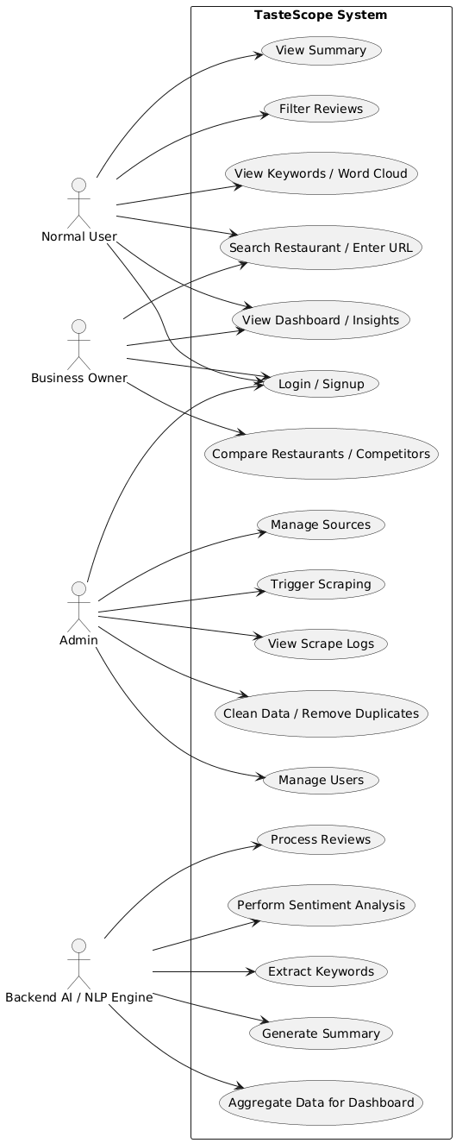
Functional Requirements

Use-Case Diagram:

Use-Case 1: Open App / Homepage
Identifier |  | UC-1
Purpose |  | To allow the user to open the TasteScope web application and view the homepage interface with navigation and featured insights.
Priority |  | High
Pre-conditions |  | User has a working web browser and internet connection.
Post-conditions |  | Homepage loads successfully; navigation options, search bar, and sample insights are displayed.
Typical Course of Action
S# | Actor Action |  | System Response
1 | User opens web browser and navigates to TasteScope URL |  | System loads the homepage interface
2
  User views navigation bar (Dashboard, Search, Compare, About, Login/Signup)
  System displays all menu items correctly
3 | User sees featured highlights and sample insights |  | System renders charts, word cloud samples, and trending restaurants section
4 | User interacts with search bar (optional) |  | System highlights the search bar and displays placeholder text
5 | User scrolls through homepage sections |  | System loads content dynamically for smooth display
6 | User clicks on Login/Signup (optional) |  | System navigates to login/signup page
Alternate Course of Action
S# | Actor Action |  | System Response
1 | User opens URL but internet is disconnected |  | System shows a “Connection Error” message
2 | User opens URL and server is down |  | System displays “Server Unavailable” notification
3 | Browser does not support certain features |  | System loads a simplified version of the homepage
Table 1: UC-1

Use-Case 2 : User Registration
Identifier |  | UC-2
Purpose |  | Allow a new user to create an account on TasteScope.
Priority |  | High
Pre-conditions |  | User is not logged in; user must have a valid email
Post-conditions |  | User account is created and stored in the system database.
Typical Course of Action
S# | Actor Action |  | System Response
1 | User clicks “Sign Up” on homepage |  | System displays registration form
2 | User enters name, email, password |  | System validates input
3 | User clicks “Create Account” |  | System stores user data and shows success message
Alternate Course of Action
S# | Actor Action |  | System Response
1 | User enters email already in use |  | System shows “Email already registered”
2 | User enters weak password |  | System displays “Password must be stronger”
3 | Server error occurs |  | System shows “Registration Failed”

Table 2: UC-2

Use-Case 3: User Login / Signup

Identifier |  | UC-3
Purpose |  | To allow a user to create an account or log in to access personalized dashboards, saved analyses, and preferences.
Priority |  | High
Pre-conditions |  | User must have valid email/password (for login) OR willingness to register.
Post-conditions |  | User is successfully authenticated and redirected to the dashboard/home.
Typical Course of Action
S# | Actor Action |  | System Response
1 | User clicks on the “Login / Signup” button |  | System loads the authentication page
2 | User enters email & password |  | System validates format
3 | User clicks “Login” |  | System checks credentials in the database
4 | User enters wrong info |  | System shows error message
5 | User enters correct info |  | System logs user in and redirects to dashboard
… | … |  | …
Alternate Course of Action
S# | Actor Action |  | System Response
1 | User forgets password |  | System shows “Forgot Password” page
2 | User enters email |  | System sends password reset link
3 | User uses Google Login option |  | System authenticates via OAuth
4 | User signup email already exists |  | System shows “Account Already Exists”

Table 3: UC-3

Use-Case 4: Access Dashboard

Identifier |  | UC-4
Purpose |  | Let the user view dashboard metrics and navigation menus.
Priority |  | High
Pre-conditions |  | User must be logged in.
Post-conditions |  | Dashboard loads successfully.
Typical Course of Action
S# | Actor Action |  | System Response
1 | User logs in |  | System loads dashboard
2 | User views analytics cards |  | System displays quick stats
3 | User navigates via side menu |  | System switches dashboard sections
Alternate Course of Action
S# | Actor Action |  | System Response
1 | User logs in but server slow |  | System shows “Loading…”
2 | User’s session expired |  | System redirects to login
3 | Dashboard modules unavailable |  | System shows partial dashboard

Table 4: UC-4

Use-Case 5: Search Restaurant / Enter URL

Identifier |  | UC-5
Purpose |  | To allow the user to search a restaurant or paste a Google/TripAdvisor URL to start scraping reviews.
Priority |  | High
Pre-conditions |  | User is on homepage or dashboard; internet connection available.
Post-conditions |  | User is taken to scraping/analysis processing screen.
Typical Course of Action
S# | Actor Action |  | System Response
1 | User types restaurant name OR pastes URL |  | System validates text/URL
2 | User clicks “Analyze” |  | System starts scraping reviews
3 | User waits for process |  | System shows loading animation
4 | Scraping completes |  | System processes data for sentiment/NLP
5 | User is redirected to dashboard |  | System displays charts, sentiment, summary
Alternate Course of Action
S# | Actor Action |  | System Response
1 | User enters invalid URL |  | System shows “Invalid URL” error
2 | Restaurant not found |  | System suggests similar restaurants
3 | Target website blocks requests |  | System shows “Scraping Failed – Try Again”
4 | No reviews available |  | System shows “No Data Found”

Table 5: UC-5

Use-Case 6: Add Review Source

Identifier |  | UC-6
Purpose |  | Let Allow users to input a restaurant name or URL for scraping.
Priority |  | High
Pre-conditions |  | User must be logged in.
Post-conditions |  | Source is saved and validated.
Typical Course of Action
S# | Actor Action |  | System Response
1 | User clicks “Add Source” |  | System opens input modal
2 | User enters restaurant name/URL |  | System validates format
3 | User clicks “Save” |  | System stores source and confirms
Alternate Course of Action
S# | Actor Action |  | System Response
1 | User enters invalid URL |  | System shows “Invalid source”
2 | Duplicate source |  | System shows “Source exists already”

Table 6: UC-6

Use-Case 7: Scrape Reviews

Identifier |  | UC-7
Purpose |  | Fetch reviews from the added platform (Google/TripAdvisor).
Priority |  | High
Pre-conditions |  | Valid source must exist.
Post-conditions |  | Reviews stored in database.
Typical Course of Action
S# | Actor Action |  | System Response
1 | User selects a source |  | System shows “Start Scraping”
2 | User clicks scrape |  | System begins data fetching
3 | System completes scraping |  | System shows number of reviews retrieved
Alternate Course of Action
S# | Actor Action |  | System Response
1 | Source unavailable |  | System shows “Failed to fetch reviews”
2 | Scraper blocked by platform |  | System displays “Rate Limit Exceeded”

Table 7: UC-7

Use-Case 8: Perform Sentiment Analysis

Identifier |  | UC-8
Purpose |  | To analyze all scraped reviews using NLP sentiment analysis (positive, negative, neutral classification).
Priority |  | High
Pre-conditions |  | Reviews must be scraped and stored.
Post-conditions |  | Sentiment scores saved and displayed to user.
Typical Course of Action
S# | Actor Action |  | System Response
1 | User selects a restaurant from dashboard |  | System loads restaurant details
2 | User clicks “Run Sentiment Analysis” |  | System begins NLP processing
3 | User waits for results |  | System displays sentiment graph and summary
Alternate Course of Action
S# | Actor Action |  | System Response
1 | User clicks without scraping reviews |  | System shows “No reviews available”
2 | NLP module fails |  | System shows “Analysis Failed — Try Again”
3 | User cancels process |  | System stops analysis

Table 8: UC-8

Use-Case 9: Generate Summary of Reviews

Identifier |  | UC-9
Purpose |  | To summarize all reviews using AI-based text summarization.
Priority |  | High
Pre-conditions |  | Sentiment analysis completed or reviews already available.
Post-conditions |  | Summary generated and displayed.
Typical Course of Action
S# | Actor Action |  | System Response
1 | User opens restaurant insights page |  | System loads existing analytics
2 | User clicks “Generate Summary” |  | System starts AI summarization
3 | User views final summary |  | System displays clear summary paragraph(s)
Alternate Course of Action
S# | Actor Action |  | System Response
1 | AI fails due to long text |  | System splits text and retries
2 | Server timeout |  | System shows “Unable to summarize”
3 | User closes tab while generating |  | System aborts process

Table 9: UC-9

Use-Case 10: View Review Analysis Dashboard

Identifier |  | UC-10
Purpose |  | To allow user to view complete sentiment analysis, charts, statistics, and summaries of scraped reviews.
Priority |  | High
Pre-conditions |  | Scraping and NLP analysis must be successfully completed.
Post-conditions |  | User sees visualized insights and detailed data.
Typical Course of Action
S# | Actor Action |  | System Response
1 | User opens dashboard after analysis |  | System loads charts and metrics
2 | User scrolls through different sections |  | System displays bar charts, pie charts, rating distribution
3 | User clicks on “View Detailed Reviews” |  | System shows full review list & sentiment tags
4 | User downloads report |  | System generates PDF summary
Alternate Course of Action
S# | Actor Action |  | System Response
1 | Charts fail to load |  | System shows fallback text version
2 | Too many reviews cause slow loading |  | System loads dashboard in paginated form
3 | Visualization library error |  | System reloads dashboard with basic graphics

Table 10: UC-10

Use-Case 11: Manage Saved Restaurants

Identifier |  | UC-11
Purpose |  | To allow users to add, edit, or delete saved restaurants in their account.
Priority |  | Medium
Pre-conditions |  | User must be logged in.
Post-conditions |  | Changes updated in user’s saved list.
Typical Course of Action
S# | Actor Action |  | System Response
1 | User opens “My Restaurants” |  | System loads list
2 | User clicks Edit/Delete |  | System opens edit/delete modal
3 | User saves changes |  | System updates and refreshes list
Alternate Course of Action
S# | Actor Action |  | System Response
1 | User deletes a restaurant used in dashboard |  | System asks confirmation
2 | Server fails during update |  | System shows “Unable to update”
3 | User enters invalid input |  | System highlights errors

Table 11: UC-11

Use-Case 12: Generate Review Report

Identifier |  | UC-12
Purpose |  | Allow the user to generate a report of reviews filtered by date, source, or sentiment.
Priority |  | High
Pre-conditions |  | User must be logged in as Analyst or Admin.
Post-conditions |  | Review report generated and downloadable in CSV/PDF format.
Typical Course of Action
S# | Actor Action |  | System Response
1 | User navigates to Reports section |  | System opens report generation interface
2 | User selects filters (date, source, sentiment) |  | System applies filters
3 | User clicks “Generate Report” |  | System generates report
4 | User downloads report |  | File downloaded successfully
Alternate Course of Action
S# | Actor Action |  | System Response
1 | No reviews match filter |  | System shows “No reviews found”
2 | System error occurs |  | System shows “Report Generation Failed”

Table 12: UC-12

Use-Case 13: Update Scraping Settings

Identifier |  | UC-13
Purpose |  | Admin can update web scraping settings (frequency, sources, etc.).
Priority |  | High
Pre-conditions |  | Admin logged in.
Post-conditions |  | Scraping settings updated successfully.
Typical Course of Action
S# | Actor Action |  | System Response
1 | Admin navigates to Scraping Settings |  | System displays current settings
2 | Admin modifies frequency or sources |  | System validates input
3 | Admin clicks “Save” |  | System updates settings and shows confirmation
Alternate Course of Action
S# | Actor Action |  | System Response
1 | Invalid input |  | System highlights errors
2 | System fails to save |  | System shows “Update Failed”

Table 13: UC-13

Use-Case 14: Manage Users

Identifier |  | UC-14
Purpose |  | Admin can add, edit, or delete users.
Priority |  | High
Pre-conditions |  | Admin logged in.
Post-conditions |  | User list updated successfully.
Typical Course of Action
S# | Actor Action |  | System Response
1 | Admin opens User Management panel |  | System shows list of users
2 | Admin clicks Add/Edit/Delete |  | System performs the selected action
3 | Admin confirms changes |  | System updates database and shows success message
Alternate Course of Action
S# | Actor Action |  | System Response
1 | User already exists |  | System shows “User exists already”
2 | Database error |  | System shows “Action Failed”

Table 14: UC-14

Use-Case 15: View Dashboard

Identifier |  | UC-15
Purpose |  | User can view visual summary of reviews and sentiment analysis.
Priority |  | High
Pre-conditions |  | User logged in.
Post-conditions |  | Dashboard loads with charts, summaries, and metrics.
Typical Course of Action
S# | Actor Action |  | System Response
1 | User navigates to Dashboard |  | System loads dashboard
2 | User views analytics cards |  | System displays stats and charts
3 | User navigates sections |  | System switches dashboard sections
Alternate Course of Action
S# | Actor Action |  | System Response
1 | Dashboard modules unavailable |  | System shows partial dashboard
2 | Session expired |  | System redirects to login

Table 15: UC-15

Use-Case 16: Search Reviews

Identifier |  | UC-16
Purpose |  | Analyst can search reviews by keywords, user, or source.
Priority |  | High
Pre-conditions |  | Analyst logged in.
Post-conditions |  | Matching reviews displayed.
Typical Course of Action
S# | Actor Action |  | System Response
1 | Analyst enters search keyword |  | System searches review database
2 | Analyst clicks “Search” |  | System displays matching reviews
Alternate Course of Action
S# | Actor Action |  | System Response
1 | No matching reviews |  | System shows “No results found”
2 | System error occurs |  | System shows “Search Failed”

Table 16: UC-16

Use-Case 17: Export Report (PDF / CSV)

Identifier |  | UC-5
Purpose |  | To allow users to export sentiment results, statistics, charts, and summaries as PDF or CSV for offline use.
Priority |  | Medium
Pre-conditions |  | User must have completed one full analysis.
Post-conditions |  | System generates downloadable file.
Typical Course of Action
S# | Actor Action |  | System Response
1 | User clicks “Download Report” |  | System prepares export modal
2 | User selects PDF or CSV |  | System processes selected format
3 | System generates file |  | User sees download button
4 | User clicks download |  | File gets downloaded successfully
Alternate Course of Action
S# | Actor Action |  | System Response
1 | User has unstable internet |  | System pauses export and prompts retry
2 | PDF engine fails |  | System shows “Generation Failed”
3 | File too large |  | System compresses and regenerates

Table 17: UC-17

Requirements Analysis and Modeling
<Include the following analysis models: use-case diagram, entity-relationship diagram, abstract class diagram, sequence diagram (at least model interactions between system and external world). Additional diagrams may be added for example state diagram, data flow diagram (model interactions between system and external world), decision table, event table etc.>

Erd Diagram:

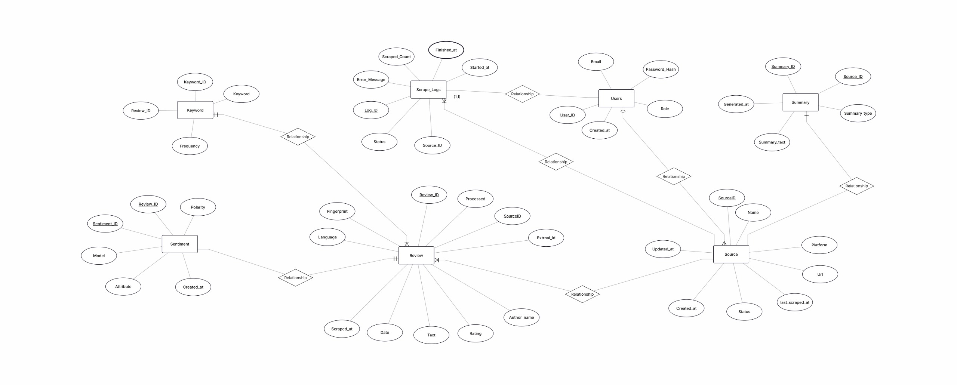

Class Diagram:

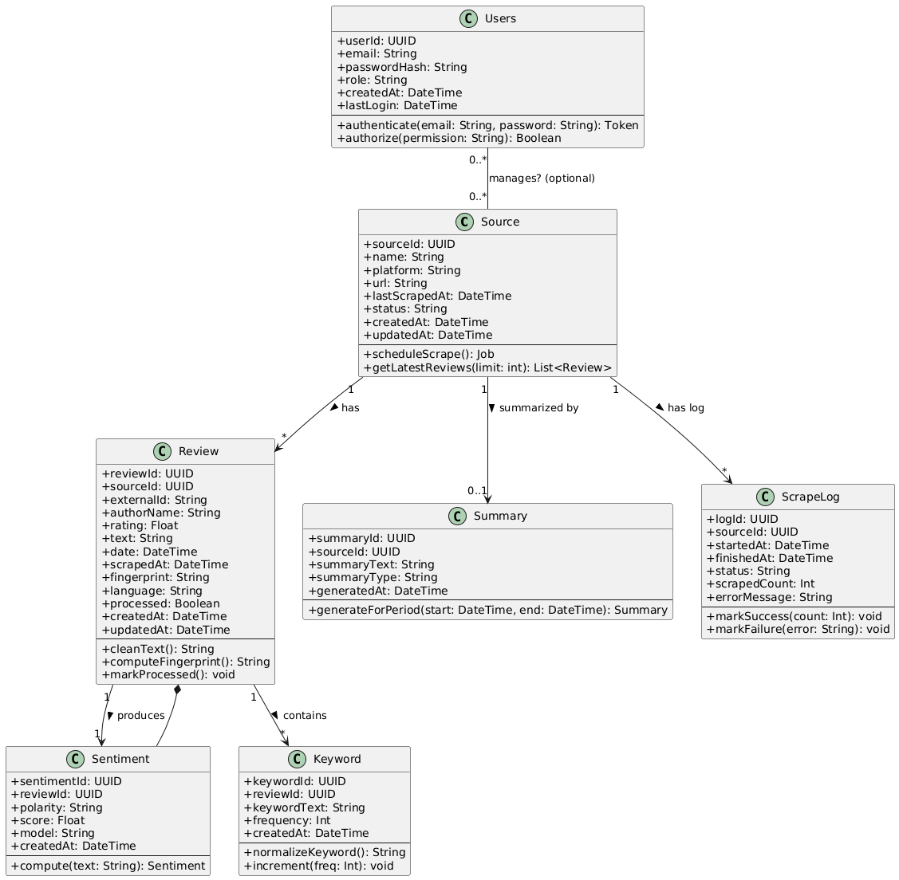

Sequence Diagram:

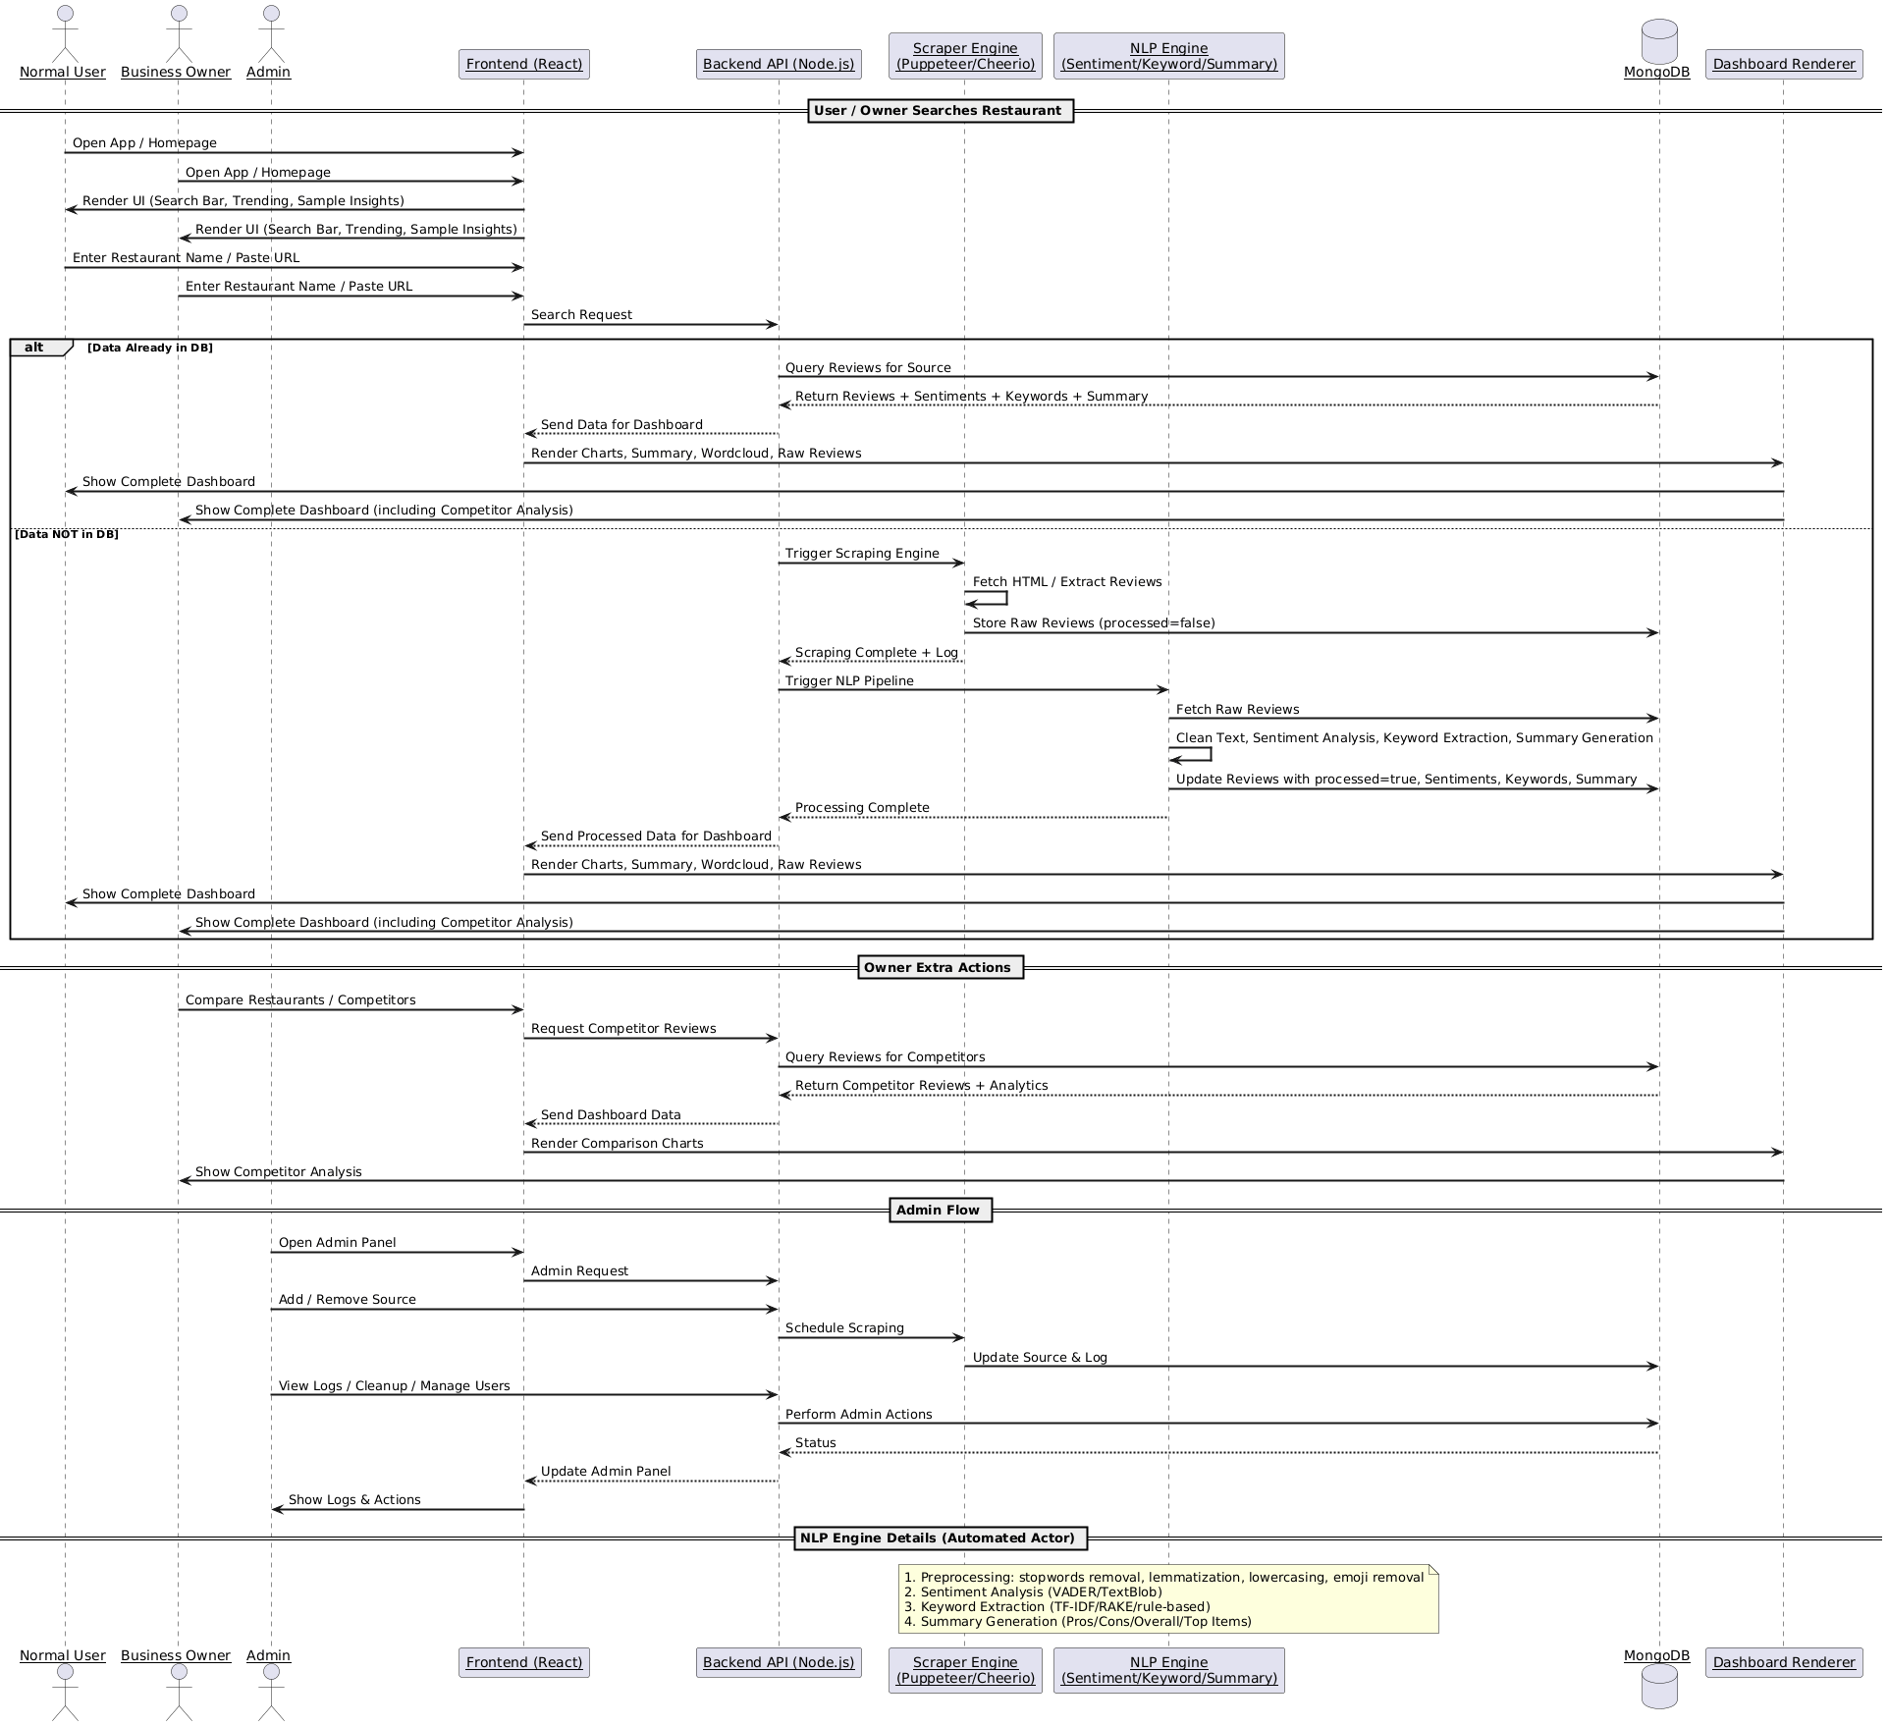

DFD Level 0:

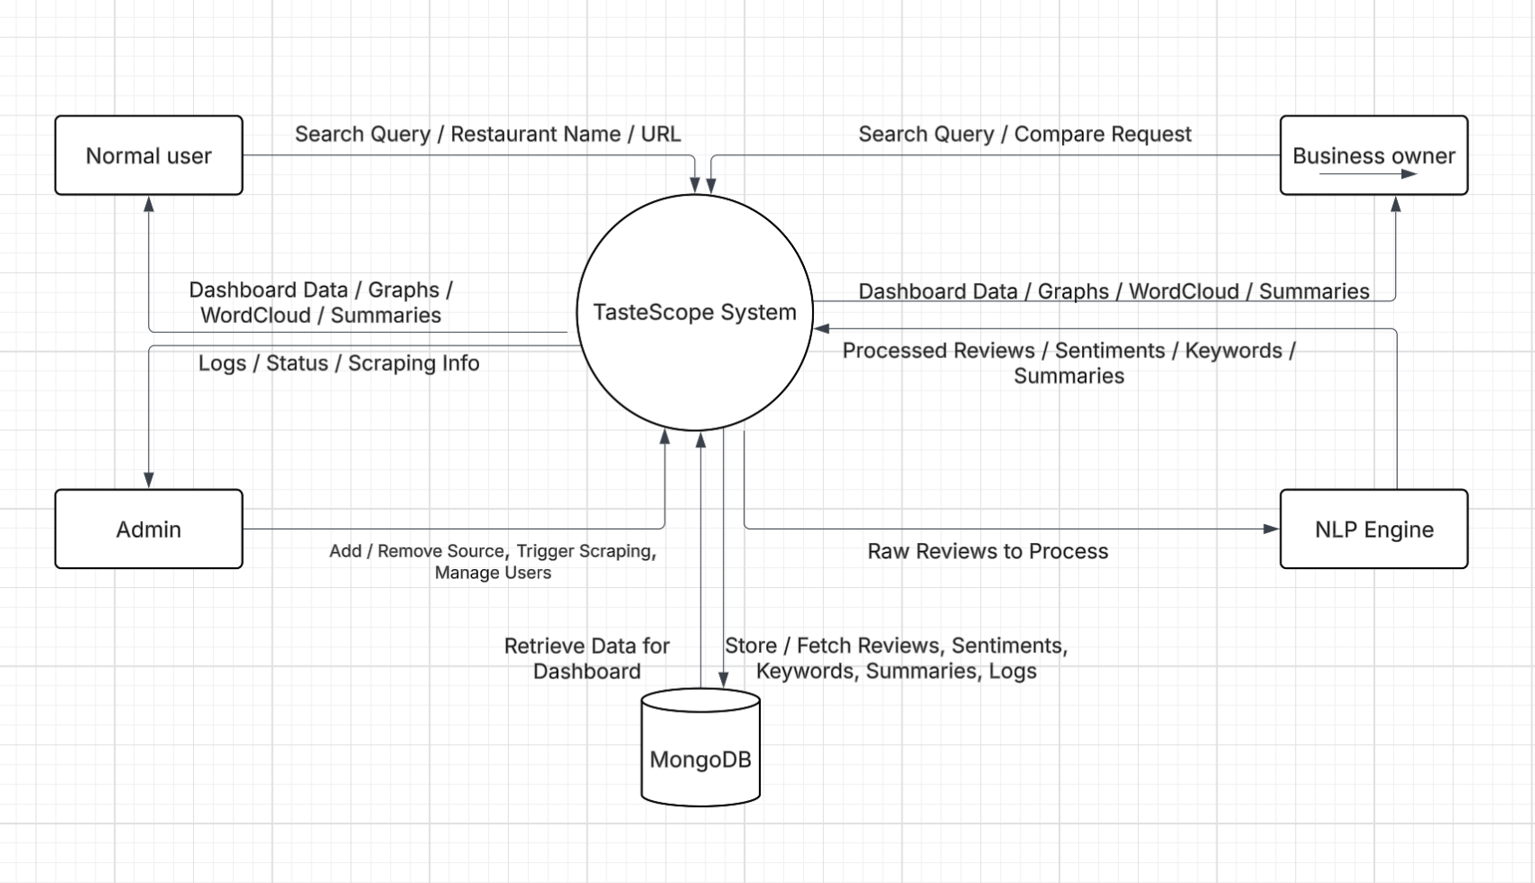

Nonfunctional Requirements
4.1 Performance Requirements
TasteScope must maintain high performance even when processing large volumes of review data. The system should be able to scrape and process up to 50,000 reviews per session without exceeding a runtime of 15 minutes per platform. Dashboard visualizations, including trend graphs, sentiment distributions, and word clouds, must render within 2 seconds for queries on datasets up to 10,000 processed reviews. API response time for fetching processed data must not exceed 1 second per request under typical load. The NLP engine should support parallel processing to efficiently handle multiple requests simultaneously. These metrics ensure a smooth, responsive user experience and prevent delays in decision-making for business users analyzing multiple datasets concurrently.

Safety Requirements
Safety requirements address potential risks of data loss, corruption, or system misuse. TasteScope must prevent accidental deletion of review or sentiment data by implementing role-based access control and operation confirmation dialogs. All database write operations must maintain transactional integrity to avoid partial failures corrupting stored data. Scraping activities must follow target platforms’ robots.txt policies to prevent unauthorized access. Automated backup and recovery mechanisms must be in place to protect against server failures, crashes, or accidental deletion. Error logging and alerts must notify administrators of critical failures for rapid corrective action.

Security Requirements
Security measures are essential to protect user data and system integrity. TasteScope must enforce secure authentication for all users using hashed passwords and encrypted session tokens. All APIs must be accessible over HTTPS to prevent data interception. Input validation must prevent injection attacks, and sensitive information must never appear in logs or error messages. Only authorized administrators may initiate scraping sessions or modify NLP configurations. All database backups and cloud storage must follow industry-standard encryption practices. The system must comply with privacy policies and applicable data protection regulations.

Additional Software Quality Attributes
TasteScope emphasizes usability, maintainability, scalability, reliability, and adaptability.
- Usability: Intuitive interface minimizing learning curve.
- Maintainability: Modular architecture with clear documentation.
- Scalability: Supports adding new review platforms and higher data volumes.
- Reliability: Consistent and accurate results from sentiment analysis and dashboard displays.
- Adaptability: Can accommodate changes in website layouts or review formats without major redesign.
Other attributes include robustness (resistant to errors and crashes), reusability (modular NLP and visualization components), and testability (supports automated unit and integration testing).

Other Requirements
• Database: MongoDB Atlas, cloud-hosted with high availability and secure access.
• External Interface: Compatible with modern web browsers (Chrome, Firefox, Edge, Safari) and adheres to web accessibility standards.
• Internationalization: UTF-8 encoding to support multilingual reviews.
• Legal Compliance: Follow scraping policies of target platforms and data privacy regulations.
• Reuse Objectives: Modular NLP engines and visualization components for other text analysis projects.
• Hardware Requirements: Cloud-hosted servers with sufficient CPU and memory to handle simultaneous scraping and NLP processing.

Revised Project Plan

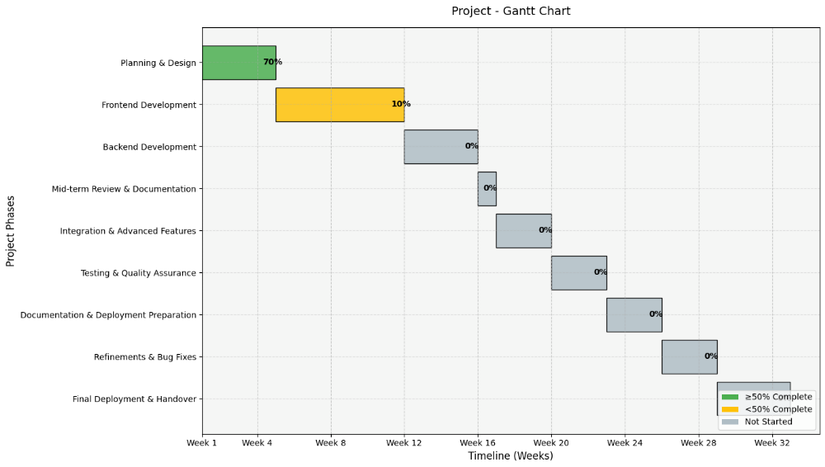
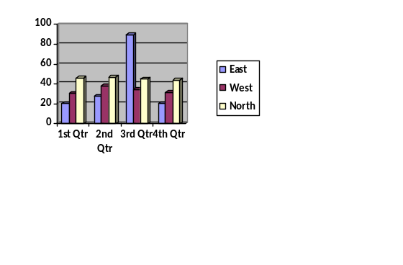
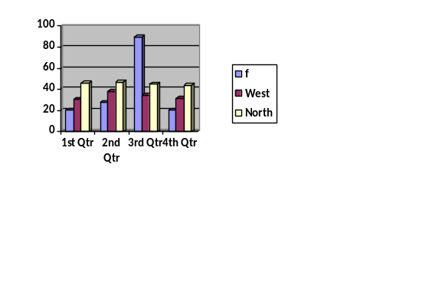

References
# | Reference Type | Details
1 | Book | Sommerville, I. Software Engineering, 10th Edition, Pearson, 2016.
2 | Book | Pressman, R.S. Software Engineering: A Practitioner’s Approach, 8th Edition, McGraw-Hill, 2014.
3 | Journal Article | Pang, B., Lee, L. "Opinion Mining and Sentiment Analysis," Foundations and Trends in Information Retrieval, Vol. 2, No. 1–2, 2008, pp. 1–135.
4 | Conference Paper | Liu, B. "Sentiment Analysis and Opinion Mining," Proceedings of the International Conference on Web Information Systems and Mining, 2012, pp. 1–10.
5 | Website | MongoDB Atlas Documentation. Available: https://www.mongodb.com/cloud/atlas
6 | Website | React Documentation. Available: https://reactjs.org/docs/getting-started.html
7 | Website | Python NLP Libraries – NLTK Documentation. Available: https://www.nltk.org/
8 | Website | TripAdvisor Scraping Guidelines. Available: https://www.tripadvisor.com/robots.txt
9 | Website | Google Maps / Reviews API Documentation. Available: https://developers.google.com/maps/documentation/places/web-service/overview

Appendix A: Glossary
Term / Acronym | Definition
API | Interface for communication between frontend and backend.
AI | Algorithms used for sentiment analysis and text summarization.
Authentication | Process of verifying user identity through email and password.
Authorization | Decides what actions a user can perform based on their role.
Dashboard | UI section displaying reviews, sentiments, keywords, and summaries.
Database (DB) | MongoDB storage for User, Review, Sentiment, Keyword, Summary tables.
Data Scraping | Automatic extraction of reviews from external sources.
Entity | A database table (User, Review, Source, Sentiment).
ERD | Diagram showing database tables and their relationships.
Frontend | React-based interface for system users.
Functional Requirements | Core features that the system must perform.
Keyword Extraction | NLP process identifying important or frequent words.
Login Session | Entry stored in Login table after successful authentication.
NLP | Text analysis used for sentiment, keywords, and summaries.
Polarity | Sentiment category: Positive, Negative, or Neutral.
Rating | Customer satisfaction score from 1 to 5.
Review | Customer feedback including text, rating, and date.
Scraper Engine | Component fetching reviews from external platforms.
Sentiment Score | Numerical emotional tone of review text.
Source | Platform from where reviews are scraped (Google, TripAdvisor).
Summary | Condensed insights generated by the NLP module.
System Scheduler | Automatically runs scraping and NLP tasks on intervals.
Use-Case Diagram | Describes actor-system interactions.
User | System participant: Visitor, Registered User, Admin.
Worker Service | Background service for scraping, NLP, and summary generation.

Appendix B: IV & V Report
(Independent verification & validation)
IV & V Resource

Name Signature

S# | Defect Description | Origin Stage | Status | Fix Time
 |  |  |  | Hours | Minutes
1
2
3
…
Table 2: List of non-trivial defects

