BSSE FINAL PROJECT
Software Design Specification

Taste Scope



Project Advisor

Ali Haider Arif

Presented by:
Group ID: F25SE019

Student Reg# Student Name
L1F22BSSE0396 Fasi Shahid
L1F22BSSE0126 Muhammad Ahmad
L1F22BSSE0376 Hamza Ijaz

Faculty of Information Technology & Computer Science

University of Central Punjab
Software Design Specification
SDP Phase II

Taste Scope: AI-Powered Review Scraper & Analyser
Advisor: Ali Haider Arif

Team F25SE019
Member Name | Primary Responsibility
Fasi Shahid | Document + Screen
Muhammad Ahmad | Document + Screen
Hamza Ijaz | Technical architecture+ screens

Table of Contents
Table of Contents i
Revision History ii
Previous Phases Feedback ii
Abstract iii
1. Introduction 1
1.1 Product 1
1.2 Background 1
1.3 Objective(s)/Aim(s)/Target(s) 2
1.4 Scope 2
1.5 Business Goals 3
1.6 Document Conventions 3
1.7 Miscellaneous 3
2. Overall Description 5
2.1 Product Features 5
2.2 Functional Description 5
2.3 User Classes and Characteristics 6
2.4 Design and Implementation Constraints 7
2.5 Assumptions and Dependencies 7
3. Technical Architecture 9
3.1 Application and Data Architecture 9
3.2 Component Interactions and Collaborations 15
3.3 Design Reuse and Design Patterns 18
3.4 Technology Architecture 19
4. Screenshots/Prototype 20
4.1 Workflow 20
4.2 Screens 22
4.3 Additional Information 29
5. Other Design Details 29
6. Revised Project Plan 29
7. References 29
Appendix A: Glossary 30
Appendix B: IV & V Report 31

Revision History
Name | Date | Reason For Changes | Version

Previous Phases Feedback

Idea Defence Feedback (Screenshot)

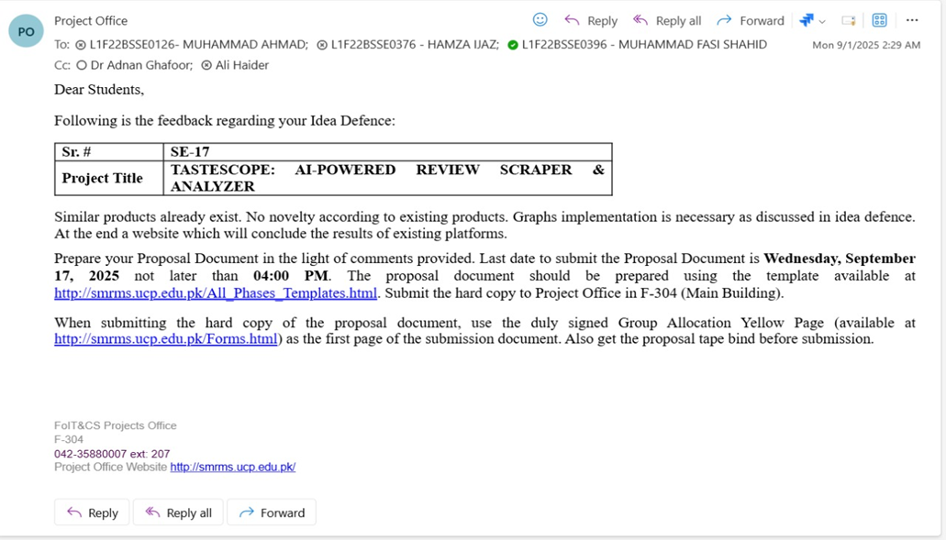

Abstract
In today’s digital age, online reviews play a crucial role in shaping customer decisions and influencing the reputation of restaurants and food businesses. However, these reviews are scattered across multiple platforms such as Google Reviews and Trip Advisor, making it difficult for users and business owners to analyze them collectively. Manually reading hundreds of reviews is time-consuming, inconsistent, and often fails to provide clear insights into customer sentiment and recurring issues. This problem becomes even more significant for business owners who need data-driven insights to improve service quality, understand customer satisfaction, and stay competitive in the market.
Taste Scope is an AI-powered web application designed to address this challenge by automatically collecting, analyzing, and presenting restaurant reviews in a structured and meaningful way. The system allows users, business owners, and administrators to search for restaurants or paste review URLs, after which the application scrapes relevant reviews from supported platforms. Using Natural Language Processing techniques, Taste Scope performs sentiment analysis, keyword extraction, and review summation to transform raw textual data into actionable insights. The processed data is then visualized through interactive dashboards, enabling users to quickly understand overall sentiment, common strengths and weaknesses, and customer trends.
The project integrates modern web technologies including the MERN stack for system development, web scraping tools for data extraction, and NLP models for text analysis. By combining these knowledge areas, Taste Scope aims to reduce manual effort, improve decision-making accuracy, and provide a unified review analysis platform. The expected outcome of this project is a reliable, scalable, and user-friendly system that helps general users make informed choices and assists business owners in enhancing their services through data-driven insights.

Introduction

Product
Taste Scope is an AI-powered web-based software system developed to simplify the process of understanding and analyzing online restaurant reviews. In the current digital environment, customers heavily rely on online reviews to decide where to eat, while restaurant owners depend on this feedback to evaluate their performance and improve services. The major problem, however, is that these reviews are scattered across multiple platforms such as Google Reviews and Trip Advisor, and they exist mostly in unstructured textual form. As a result, both users and business owners find it difficult to extract meaningful insights by manually reading large volumes of reviews.
Taste Scope addresses this problem by providing a centralized system that automatically collects reviews from multiple sources and processes them using Natural Language Processing techniques. The system applies sentiment analysis, keyword extraction, and summarization algorithms to convert raw textual reviews into structured and easy-to-understand insights. The final output is presented in the form of interactive dashboards that visually represent customer opinions, trends, and overall satisfaction levels.
The end product of this project is a complete software application that combines web scraping, artificial intelligence, and data visualization. It is not merely a research prototype or data set, but a functional web application designed to be useful for real users, including general customers, business owners, and administrators. The system aims to deliver better analytical performance and usability compared to traditional manual review analysis methods.

Background
Online review analysis has been an active area of research and development for several years, particularly with the rise of social media platforms and review-based services. Many existing systems focus on sentiment analysis of text data using predefined datasets, while others provide platform-specific analytics limited to a single source. Popular platforms such as Google and TripAdvisor allow users to view ratings and individual reviews, but they do not offer advanced insights such as keyword-based trends, summarized feedback, or cross-platform comparison in a unified manner.
Previous academic and industrial projects have explored sentiment classification, opinion mining, and text summarization using machine learning and NLP techniques. However, most of these solutions either focus only on positive and negative sentiment detection or require manual data input. Additionally, many systems are designed as research experiments rather than complete end-to-end applications that integrate scraping, processing, and visualization.
Taste Scope differentiates itself by combining multiple aspects into a single cohesive system. Unlike existing solutions, it automatically fetches live review data from supported platforms, processes it using multiple NLP techniques, and presents the results through an interactive dashboard. Compared to earlier student projects and similar review analysis tools, Taste Scope emphasizes real-world usability, multi-role access (User, Business Owner, and Admin), and a modular architecture that supports scalability and future enhancements. This integration of automated data collection, intelligent analysis, and visual presentation makes Taste Scope more comprehensive and practical than many previously developed systems.

Objective(s)/Aim(s)/Target(s)
The primary objective of the Taste Scope project is to design and develop an intelligent system that can automatically collect and analyze online restaurant reviews to provide meaningful insights. The project aims to reduce the manual effort required to read and interpret large volumes of unstructured review data by applying Natural Language Processing techniques in an automated manner.
Another key objective is to provide a centralized platform where users and business owners can view sentiment trends, common keywords, and summarized feedback through an easy-to-understand dashboard. The system also aims to support different user roles with appropriate functionalities, ensuring that general users, business owners, and administrators can interact with the system according to their needs.
From a research and academic perspective, the project aims to demonstrate the practical application of NLP algorithms such as sentiment analysis, keyword extraction, and text summarization within a real-world web application. The objectives are carefully defined to be achievable within the given time frame and academic scope, while still contributing a functional and valuable solution in the domain of intelligent review analysis systems.

Scope
The scope of the Taste Scope project covers the design, development, and implementation of a web-based intelligent system that focuses on collecting, analyzing, and visualizing online restaurant reviews. The system is intended to operate as a centralized platform where review data from selected external sources such as Google Reviews and TripAdvisor can be automatically retrieved, processed, and presented in a structured and meaningful manner. The project scope includes the complete workflow starting from user interaction on the frontend to backend processing, data storage, and insight generation.
Within the defined scope, Taste Scope supports multiple types of users, including normal users, business owners, and administrators. Normal users can search for restaurants and view analytical insights to make informed dining decisions. Business owners can access more detailed dashboards that help them understand customer feedback, identify strengths and weaknesses, and compare their restaurant’s performance with competitors. Administrators are responsible for managing data sources, monitoring scraping activities, and ensuring the overall health of the system.
The analytical capabilities of the system fall within the scope of sentiment analysis, keyword extraction, and automated review summarization using Natural Language Processing techniques. The system processes textual review data to determine customer sentiment, extract frequently discussed aspects, and generate concise summaries that reflect overall opinions. These insights are visualized through interactive dashboards that include charts, word clouds, and categorized feedback, enabling users to quickly interpret large datasets.
The scope of this project is limited to textual review analysis and does not include multimedia content such as images or videos posted in reviews. Additionally, the system focuses on analysis rather than direct interaction with review platforms, meaning it does not allow users to post, edit, or reply to reviews on external websites. The project is designed to be scalable and extensible, allowing future enhancements such as support for additional platforms, advanced machine learning models, or real-time analytics, but these features remain outside the scope of the current implementation.

Business Goals
The primary business goal of Taste Scope is to provide a smart and reliable decision-support system for both consumers and restaurant businesses by transforming unstructured online reviews into meaningful insights. In today’s digital environment, customers heavily rely on online reviews before choosing a restaurant, while business owners struggle to manually analyze large volumes of feedback scattered across multiple platforms. Taste Scope aims to bridge this gap by offering a centralized solution that saves time, reduces manual effort, and improves decision-making quality.
Another important business goal of this software is to help restaurant owners understand customer perceptions more clearly. By analyzing sentiments, identifying frequently discussed aspects, and summarizing customer opinions, the system enables businesses to recognize areas that need improvement and strengths that should be maintained. This leads to better service quality, improved customer satisfaction, and long-term brand reputation enhancement.
Taste Scope also targets scalability and sustainability as business goals. The system is designed in a modular way so that it can be extended in the future to support more platforms, advanced analytics, or enterprise-level features. From an organizational perspective, the project demonstrates how artificial intelligence and data analytics can be applied practically in the food and hospitality domain to create competitive advantages over traditional manual review analysis approaches.

Document Conventions
This Software Requirements Specification document follows standard academic and software engineering conventions to ensure clarity, consistency, and ease of understanding. The document is written in clear and formal English, avoiding unnecessary technical jargon wherever possible so that it remains understandable to both technical and non-technical stakeholders. Headings and subheadings are numbered according to the IEEE SRS structure to maintain logical flow and traceability across sections.
Uniform font style and size are used throughout the document to maintain professional presentation. Important terms such as system names, module names, and external platforms are written in a consistent format to avoid ambiguity. Diagrams such as use case diagrams, activity diagrams, class diagrams, and ER diagrams are referenced within the relevant sections to support textual explanations. The conventions used in this document ensure that future developers, supervisors, and evaluators can easily navigate, review, and validate the requirements without confusion.

Miscellaneous
This Software Requirements Specification document follows standard academic and software engineering conventions to ensure clarity, consistency, and ease of understanding. The document is written in clear and formal English, avoiding unnecessary technical jargon wherever possible so that it remains understandable to both technical and non-technical stakeholders. Headings and subheadings are numbered according to the IEEE SRS structure to maintain logical flow and traceability across sections.
Uniform font style and size are used throughout the document to maintain professional presentation. Important terms such as system names, module names, and external platforms are written in a consistent format to avoid ambiguity. Diagrams such as use case diagrams, activity diagrams, class diagrams, and ER diagrams are referenced within the relevant sections to support textual explanations. The conventions used in this document ensure that future developers, supervisors, and evaluators can easily navigate, review, and validate the requirements without confusion.

Overall Description
This section provides a high-level overview of the Taste Scope system, focusing on its main features, functional behavior, and the different types of users who interact with the system. The purpose of this section is to help the reader understand what the system does, how it generally operates, and who it is designed for, without going into deep technical details that are already covered in earlier phases.

Product Features
Taste Scope is an AI-powered web-based system designed to automatically collect, analyze, and present online restaurant reviews in a meaningful and user-friendly manner. The system allows users to search for a restaurant by name or by providing a direct review platform URL. Once a search is initiated, Taste Scope checks whether the relevant data already exists in the system; if not, it performs automated scraping from supported platforms and processes the collected reviews.
One of the core features of the product is intelligent sentiment analysis, which evaluates customer opinions and categorizes them into positive, negative, or neutral sentiments along with a confidence score. In addition to sentiment detection, the system extracts important keywords from reviews to highlight frequently discussed aspects such as food quality, service, ambiance, and pricing. Taste Scope also generates AI-based summaries that provide an overall understanding of customer feedback for a specific restaurant.
The system presents all processed information through an interactive dashboard that includes visual representations such as charts, summaries, and review listings. Business owners can additionally compare multiple restaurants to analyze competitors, while administrators are provided with tools to manage sources, control scraping activities, and monitor system logs. These features together make Taste Scope a complete review analysis and insight-generation platform.

Functional Description
The functional workflow of Taste Scope begins when a user or business owner accesses the web application through the frontend interface. The frontend communicates with the backend API to handle all requests related to searching, data retrieval, and processing. When a restaurant is searched, the backend first checks the database to determine whether previously processed data is available.
If the data exists, the system directly retrieves reviews, sentiments, keywords, and summaries from the database and prepares them for visualization. In cases where the data is not available or outdated, the backend triggers the scraping engine, which collects raw reviews from external platforms. These raw reviews are stored in the database and then passed through the NLP pipeline, where text cleaning, sentiment analysis, keyword extraction, and summary generation are performed.
After processing is completed, the backend prepares structured analytical data and sends it to the frontend. The frontend then renders the dashboard, allowing users to easily explore insights. Administrators interact with the system through a dedicated interface that allows them to manage sources, control scraping schedules, and view scraping logs. Overall, the system operates as an integrated pipeline that transforms unstructured online reviews into structured, actionable insights.

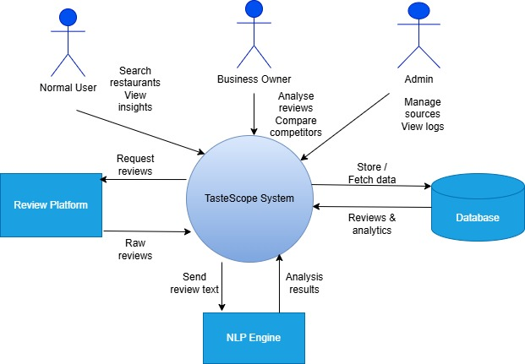

User Classes and Characteristics
Taste Scope supports multiple user classes, each with distinct roles and interaction levels within the system. The primary user class consists of normal users, who are general consumers interested in understanding public opinion about restaurants. These users typically seek quick insights, such as overall sentiment, summarized feedback, and key discussion points, without needing advanced analytical controls. Their interaction with the system is simple and read-only in nature.
The second important user class is business owners, who represent restaurant owners or managers. This user class requires more detailed insights compared to normal users. Business owners are interested in understanding customer satisfaction trends, identifying recurring complaints, and comparing their restaurant’s performance with competitors. The system prioritizes this user class by providing additional analytical views, such as comparative dashboards and deeper keyword-based insights.
The third user class is administrators, who are responsible for managing the system rather than consuming analytical results. Administrators handle tasks such as adding or removing data sources, scheduling scraping operations, monitoring scraping logs, and ensuring the smooth functioning of the system. While administrators are fewer in number, their role is critical for maintaining data quality, system reliability, and overall operational control.

Design and Implementation Constraints
The design and implementation of Taste Scope are influenced by several technical, operational, and environmental constraints that limit the range of options available during development. Since Taste Scope is a web-based analytical system, it is designed to operate within the constraints of modern web browsers and cloud-based deployment environments. The frontend is constrained to use web technologies such as React, which dictates how user interactions, visualizations, and dashboards are implemented. Similarly, the backend relies on Node.js, which affects architectural decisions related to asynchronous processing, API design, and request handling.
Another important constraint is the dependence on external review platforms such as Google Reviews and TripAdvisor. These platforms do not officially provide unrestricted public APIs for large-scale data extraction, which requires the use of scraping techniques. This introduces limitations related to scraping frequency, request throttling, IP blocking, and changes in third-party website structures. As a result, the scraping engine must be designed carefully to respect timing constraints and platform policies as much as possible.
The NLP processing pipeline also introduces implementation constraints. Sentiment analysis, keyword extraction, and summarization rely on pre-trained models and libraries that have computational and accuracy limitations. These models require sufficient processing power and memory, especially when handling large volumes of reviews. To manage this, the system processes data in batches and stores intermediate results in the database instead of performing repeated real-time analysis.
From a data perspective, MongoDB is used as the primary database, which influences how relationships are modeled, stored, and queried. Since MongoDB is a NoSQL database, certain relational constraints must be handled at the application level rather than the database level. Security is another critical constraint, requiring authentication, role-based access control, and secure handling of user credentials to ensure that admin-level operations remain restricted.
Finally, development conventions and maintainability constraints also apply. The system follows standard coding practices, modular design principles, and clear separation between frontend, backend, scraping, and NLP components. These conventions ensure that the system can be maintained or extended in the future, especially if responsibility is transferred to another development team.

Assumptions and Dependencies
The requirements and design of Taste Scope are based on several assumptions that, if changed, could affect the system’s behavior or feasibility. One key assumption is that external review platforms will continue to make publicly visible review data accessible through web pages. If these platforms significantly restrict access, introduce advanced anti-scraping mechanisms, or change their content delivery approach, the scraping component of Taste Scope may require major redesign or alternative data acquisition methods.
Another assumption is the availability and reliability of third-party NLP libraries and tools used for sentiment analysis, keyword extraction, and summarization. The system assumes that these tools will remain compatible with the chosen development environment and will provide acceptable accuracy for English-language reviews. Any major changes in library support, licensing, or performance could impact the analytical quality of the system.
TasteScope also assumes stable internet connectivity and cloud infrastructure availability, as both scraping and dashboard rendering depend on real-time communication between system components. The project further assumes that users will interact with the system using modern web browsers that support current web standards.
There are also clear dependencies on external software components and services. The backend depends on Node.js and its ecosystem, the frontend depends on React and visualization libraries, and the database layer depends on MongoDB. The NLP pipeline depends on pre-trained models and text-processing frameworks. Additionally, the system depends on deployment and hosting environments that can support concurrent scraping jobs, background processing, and secure data storage.
If any of these assumptions change or if dependent technologies become unavailable or incompatible, the project timeline, scope, or implementation approach may need to be adjusted. Therefore, these assumptions and dependencies are critical factors that must be monitored throughout the development lifecycle of TasteScope.

Technical Architecture

Application and Data Architecture
System Architecture Explanation
TasteScope is designed using a layered architecture that efficiently collects, analyzes, and visualizes online reviews. The system integrates multiple components, including frontend, backend, AI processing, and the database, to deliver a seamless user experience.

- Frontend (React.js)
Developed using React.js and runs directly in the user’s web browser.Provides an interactive dashboard that displays charts, wordclouds, summaries, and review insights.Sends user requests to the backend via secure REST APIs over HTTPS, ensuring data security and smooth communication.

- Backend (Node.js)
Built with Node.js, serving as the central controller of the system.Handles API requests and implements all business logic.Coordinates communication between the frontend, database, and worker services to ensure smooth workflow.

- Worker Service
Executes background tasks asynchronously to prevent heavy operations from blocking the main application.
Improves overall performance, scalability, and responsiveness of the system.

- Scraper Engine
Responsible for collecting raw reviews from external platforms such as Google Reviews and TripAdvisor.Extracts relevant review data including text, ratings, and timestamps for further processing.

- NLP Engine
Performs sentiment analysis to identify positive, negative, or neutral reviews.
Extracts important keywords that highlight trends and topics from review data.
Generates summarized insights to provide concise and actionable information from large datasets.

- Database (MongoDB)
Stores raw reviews, processed insights, and user-related data.
Supports flexible and unstructured data storage, ideal for handling diverse review content.

- External Data Sources
Platforms like Google Reviews and TripAdvisor act as external data providers.
Data is accessed exclusively through the scraper engine to maintain security and consistency.

- System Workflow

- The user sends a request through the frontend interface.
- The backend processes the request and triggers the worker service if needed.
- Reviews are scraped, analyzed, stored, and prepared for visualization.
- The dashboard displays charts, summaries, and insights to the user in an interactive format.

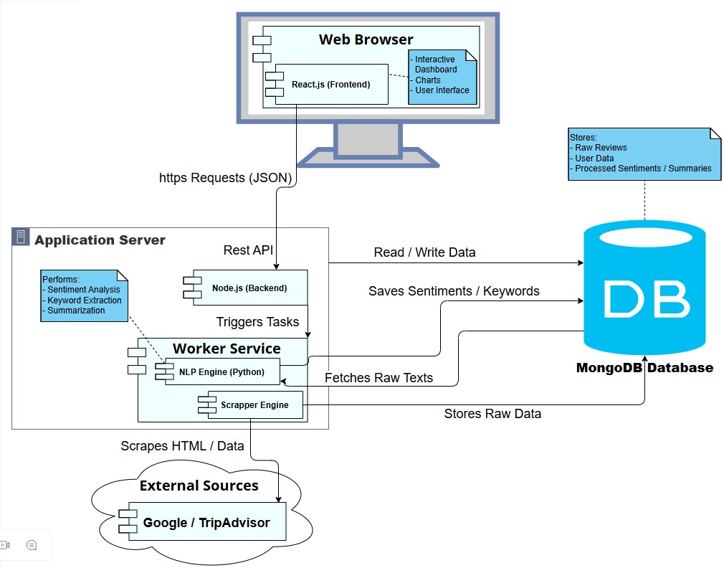

ERD (Entity-Relationship-Diagram):
TasteScope ERD shows all the major entities of the system and how they relate to each other. It is designed to organize data about reviews, sources, users, and the results of NLP processing.

- Entities:
  - Source: Represents the platform or page from which reviews are scraped, like Google Reviews or TripAdvisor. Each source has an ID, name, platform type, URL, last scrape timestamp, status, and creation/update timestamps.
  - Review: Contains the raw review details fetched from external platforms, linked to a source. Attributes include review text, author, rating, date, language, and whether it has been processed.
  - Sentiment: Each review is analyzed to detect its sentiment (positive, negative, neutral). This entity stores the polarity, score, model used, and creation time.
  - Keyword: Extracted keywords from a review with frequency. One review may have multiple keywords.
  - Summary: AI-generated summaries for a source that consolidate overall sentiment and insights from all reviews.
  - Users: Represents all system users, including normal users, business owners, and admins. Attributes include email, password hash, role, and timestamps.
  - ScrapeLogs: Tracks all scraping activities, including start and finish time, status, number of reviews scraped, and any errors.
- Relationships:
  - A Source has many Reviews, a Review has one Sentiment, a Review contains many Keywords, a Source may have a Summary , and a Source may have multiple ScrapeLogs.
  - Users are optional controllers/managers of Sources (like admins).

Why ERD is important:
It shows the data backbone of TasteScope. From this diagram, developers understand how entities are stored, how foreign keys link them, and how queries will be structured for analysis and dashboard visualization.

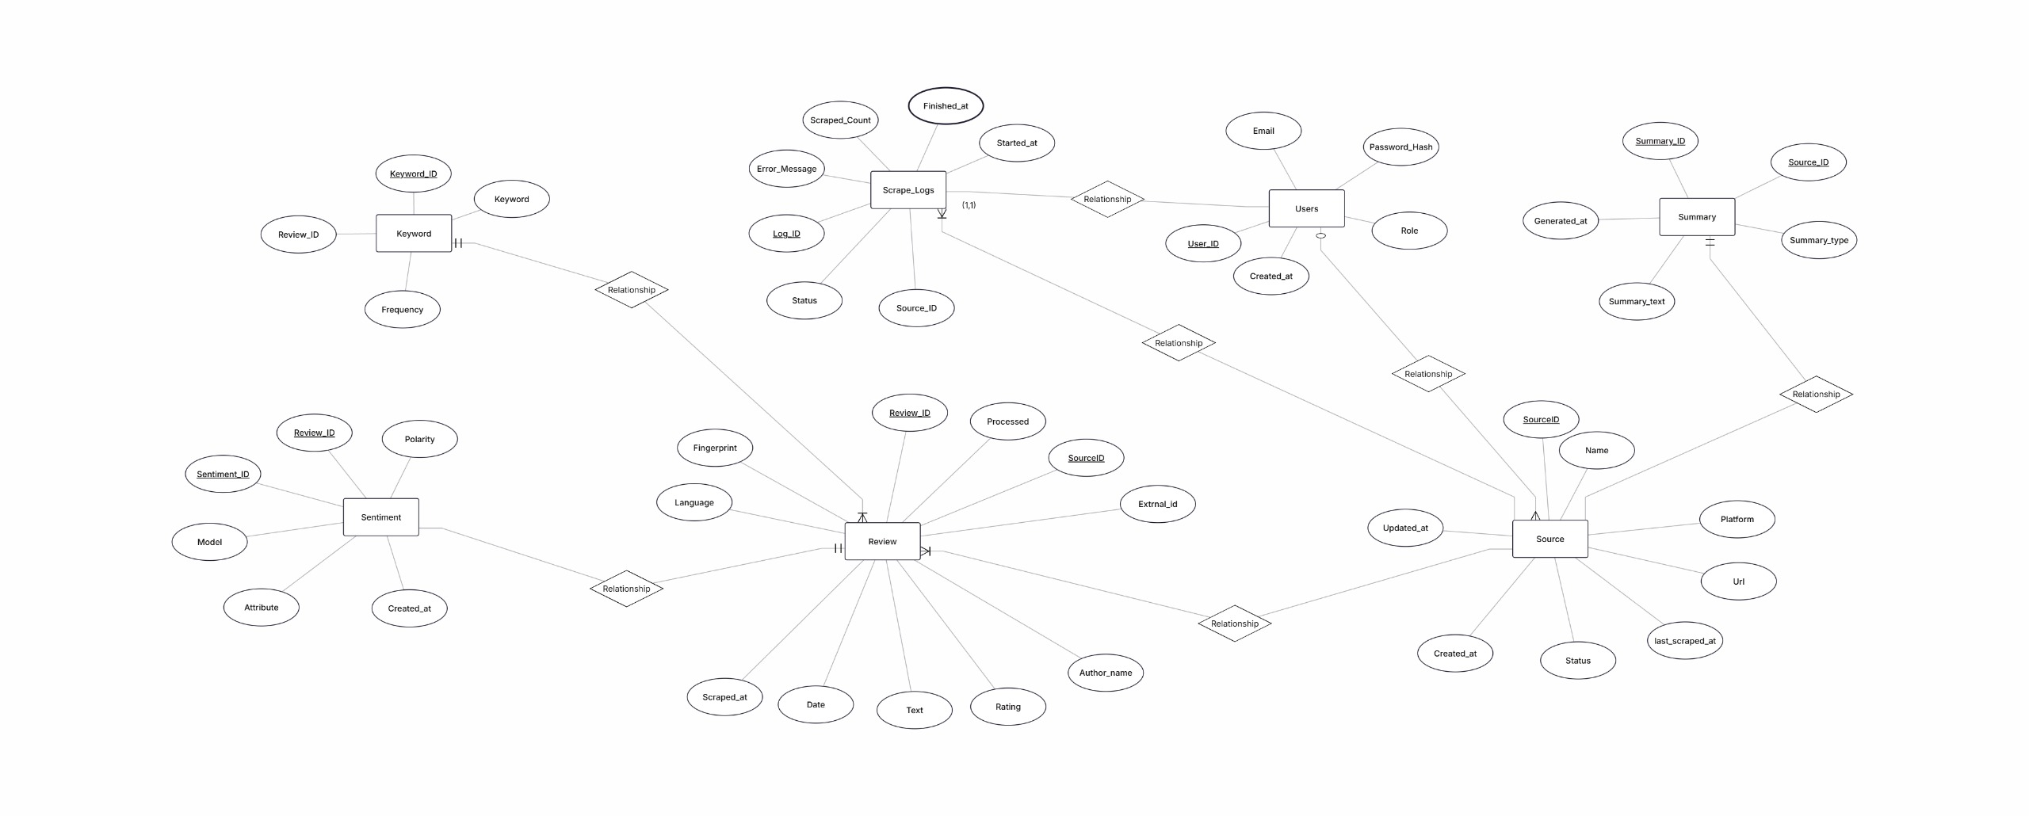

Class Diagram:
The class diagram maps system behavior and structure into software classes, showing attributes (data) and functions (operations). It extends the ERD by adding methods that each class can perform.
- Classes & Roles:
  - Source: Has functions like scheduleScrape() and getLatestReviews(limit) to manage scraping schedules and retrieve recent reviews.
  - Review: Includes functions for cleanText(), computeFingerprint(), and markProcessed() for preprocessing and validation.
  - Sentiment: Computes the sentiment of a review using compute(text).
  - Keyword: Functions normalizeKeyword() and increment(freq) help standardize and count keyword occurrences.
  - Summary: Can generate periodic summaries via generateForPeriod(start, end).
  - Users: Handles authentication (authenticate()) and permission checks (authorize()).
  - ScrapeLog: Functions for marking success or failure of a scraping job (markSuccess(count), markFailure(error)).
Why Class Diagram is important:
It bridges data structure and functional behavior. ERD shows data relationships, class diagram shows how the software acts on that data, including encapsulation, methods, and class responsibilities. It is especially useful for developers to implement code systematically, knowing what each class is responsible for.

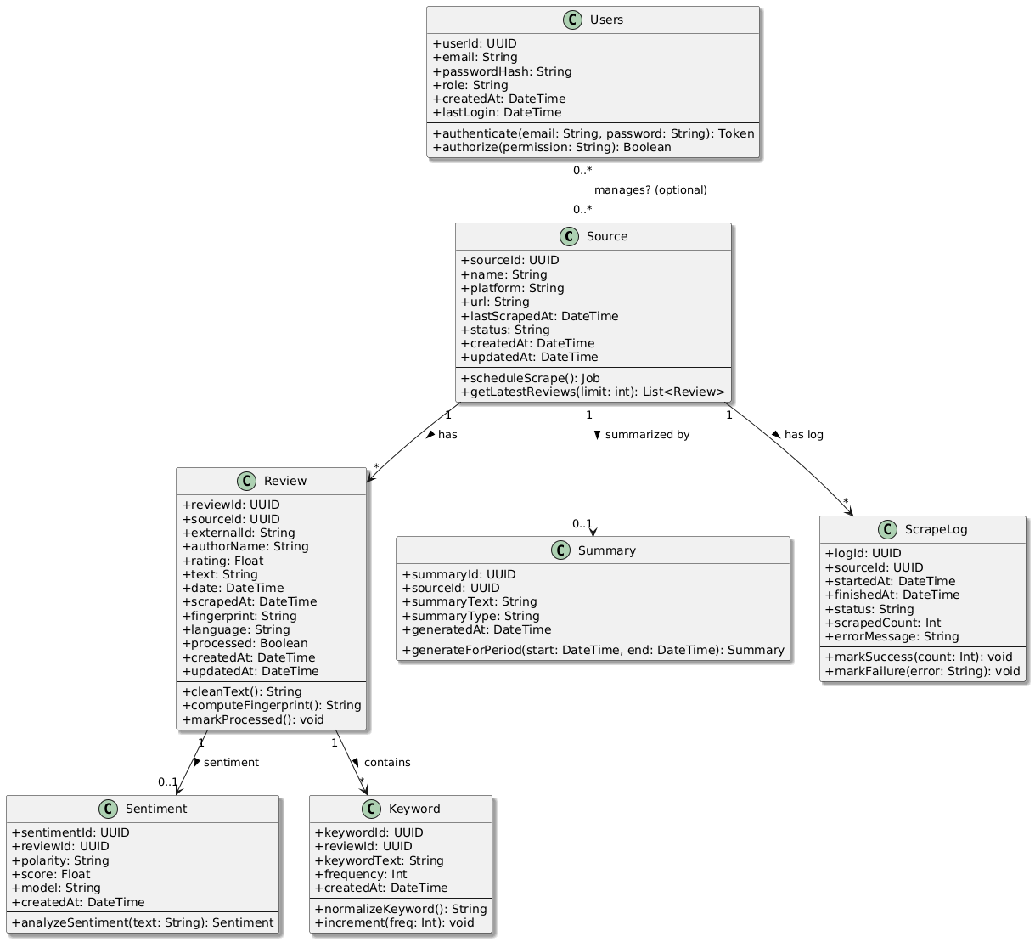

Activity Diagram (System’s Internal Workflow):
The activity diagram of TasteScope illustrates the internal workflow of the system — essentially what happens inside the system when a user or business owner searches for a restaurant or platform page. This diagram focuses purely on the internal processes rather than external interactions, giving a clear picture of how data moves through the system from start to finish.
Workflow Steps:
- Application Launch
The process begins when a user or business owner opens the TasteScope web application. This triggers the internal workflow in the system, preparing it to accept input and process requests.
- Input Entry
The user enters the name of a restaurant or pastes the URL of a specific platform page. This action serves as the starting point for data retrieval or scraping.
- Frontend Request Handling
The frontend collects the input and sends a search request to the backend API. This is where the system starts deciding how to respond based on the availability of data.
- Data Check in Database
The backend first checks if the requested data already exists in the database. There are two possible outcomes:
  - Data exists: The backend directly fetches the relevant reviews, sentiment scores, keywords, and summary from the database.
  - Data does not exist: The backend triggers the scraping engine to collect raw review data from external sources.
- Scraping Raw Reviews
If data is not available, the scraping engine fetches raw reviews from online platforms like Google or TripAdvisor. These raw reviews are stored in the database in an unprocessed format.
- NLP Processing
Once raw reviews are stored, the NLP pipeline is triggered to process them. This step includes:
  - Cleaning the text (removing stopwords, normalizing, etc.)
  - Performing sentiment analysis to determine positive, negative, or neutral opinions
  - Extracting important keywords from the reviews
  - Generating a summary of the reviews for quick insights
- Dashboard Preparation
After NLP processing, the backend prepares structured data suitable for visualization on the dashboard. This includes charts, word clouds, summaries, and raw review listings.
- Dashboard Rendering
Finally, the frontend renders the dashboard, displaying the processed insights to the user or business owner. The dashboard makes it easy to explore data, compare sources, and understand overall sentiment trends.

Why this Activity Diagram is Important:
- It visually explains the internal flow of the system, showing the step-by-step transformation of raw data into actionable insights.
- It highlights decision points (data exists or not) and parallel processing steps (scraping vs. NLP processing).
- It helps developers and stakeholders understand how the system processes information internally, separate from user-facing interactions.
- This internal workflow is crucial for planning backend processing, database design, and NLP pipeline implementation.

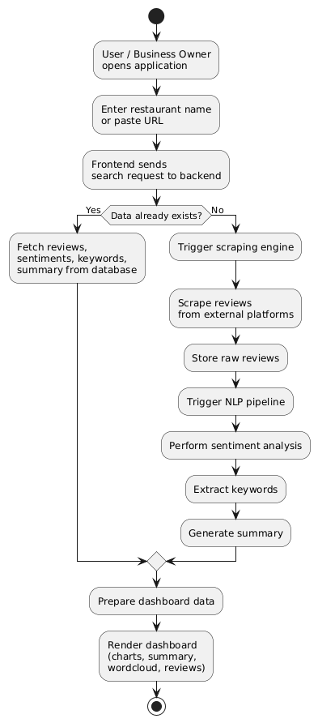

Component Interactions and Collaborations
Purpose:
This section explains how different components of TasteScope work together and collaborate to process a request, manage data, and deliver insights. Unlike the internal-focused 3.1 activity diagram, this section includes the interactions between the system and external actors, such as users, business owners, and administrators.

Sequence of Interactions (High-Level Overview):
- User / Business Owner Interaction:
  - Users or business owners initiate a request by entering a restaurant name or pasting a URL on the frontend.
  - The frontend sends this request to the backend API.
- Backend Processing:
  - The backend first checks the database for existing processed data.
  - If data exists, it retrieves reviews, sentiments, keywords, and summaries.
  - If not, it triggers the scraper engine, which collects raw reviews from external platforms.
- Scraper Engine Collaboration:
  - The scraper fetches data from sources like Google Reviews or TripAdvisor.
  - Raw reviews are stored in the database.
  - Scraper sends a completion signal back to the backend.
- NLP Engine Collaboration:
  - The backend triggers the NLP engine for text processing.
  - NLP engine performs cleaning, sentiment analysis, keyword extraction, and summary generation.
  - Processed data is updated in the database.
  - NLP notifies the backend once processing is complete.
- Dashboard Rendering:
  - The backend sends structured, processed data to the frontend.
  - The frontend uses the dashboard renderer to display charts, word clouds, summaries, and review details to the user and business owner.
  - Business owners get additional competitor analysis insights if requested.
- Admin Interactions:
  - Admins interact with the admin panel to manage sources, schedule scraping, view logs, and manage users.
  - Admin actions are processed by the backend, and status updates are stored/retrieved from the database.

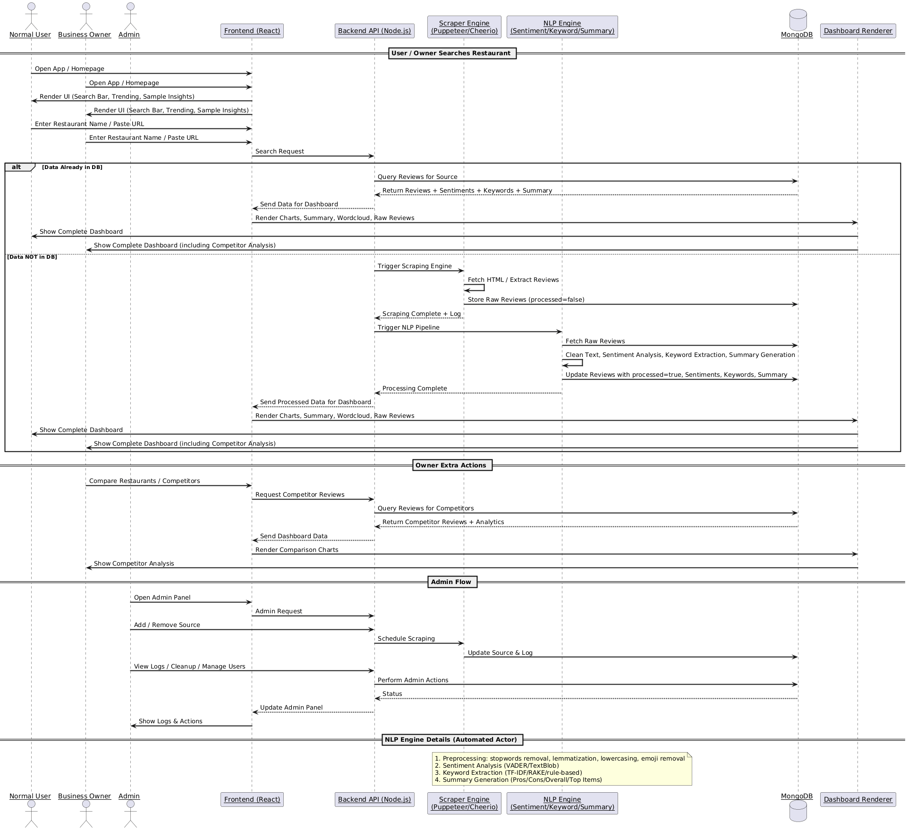

(Component Interactions & Collaborations—Activity-Diagram — External Workflow)
This activity diagram demonstrates the collaboration between TasteScope’s major components during a typical user search workflow. Unlike 3.1, which focuses on internal system processes, this diagram emphasizes how different components interact with each other to fulfill a request.
Workflow Steps:
- User Initiates Search
The process starts when a user sends a search request through the frontend interface of TasteScope. This could be entering a restaurant name or pasting a platform URL.
- Frontend Forwards Request
The frontend acts as a mediator and forwards the user’s request to the backend API. This ensures that all business logic and data processing happen on the server side.
- Backend Checks Database
Upon receiving the request, the backend first checks the database to determine if the requested data already exists.
- Decision Point — Data Availability
There are two possible outcomes:
  - Data available: The backend fetches the processed data directly from the database, which includes reviews, sentiment scores, keywords, and summary information.
  - Data not available: The backend triggers the Scraper Engine, which collects raw reviews from external sources. These raw reviews are stored in the database and then sent to the NLP Engine for processing.
- NLP Engine Processing
The NLP engine takes the raw reviews and performs multiple operations:
  - Cleans the text (normalization, stopwords removal, emoji handling)
  - Performs sentiment analysis to classify opinions
  - Extracts keywords for trend analysis
  - Generates a summary of the reviews
After processing, the NLP engine stores the results back in the database.
- Dashboard Data Delivery
Once all processing is complete (or if data was already available), the backend prepares structured dashboard data and sends it to the frontend.
- Frontend Displays Dashboard
Finally, the frontend renders the dashboard to the user, providing charts, word clouds, and summarized insights. This allows the user to visualize trends, analyze sentiment, and make informed decisions.

Why this Activity Diagram is Important:
- It highlights the collaboration between system components — frontend, backend, database, scraper engine, and NLP engine.
- It clearly shows data flow between modules and how decisions affect processing steps.
- Unlike the 3.1 diagram, which focuses internally, this diagram helps stakeholders understand component responsibilities and interactions.
- It is essential for designing robust communication protocols, API endpoints, and processing pipelines.

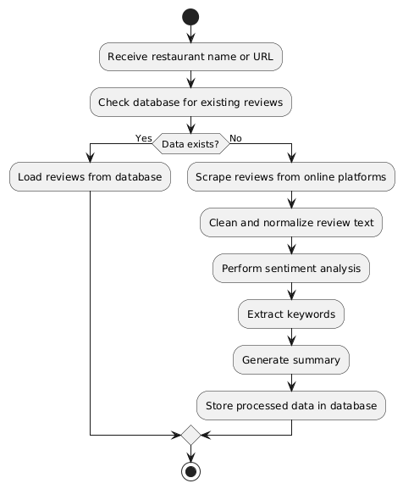

Design Reuse and Design Patterns
During the development of TasteScope, careful attention was given to leveraging existing proven solutions and established design patterns to reduce development time, improve maintainability, and ensure scalability. One of the key aspects of design reuse in this project is the modular structure of the application components. For example, the backend API, NLP processing pipeline, and scraping engine are designed as independent modules. This modularity allows individual components to be reused or replaced in future expansions without impacting the entire system.
The project also employs common software design patterns to handle recurring problems in a clean and maintainable manner. The Model-View-Controller (MVC) pattern is used in the frontend and backend, separating the user interface from business logic and data management. This ensures that any updates to the dashboard interface or data processing do not disrupt other parts of the system. For handling external service interactions, such as scraping reviews or communicating with the database, the Facade pattern is applied to provide a simplified interface, hiding the complexities of multiple underlying processes.
Additionally, pipeline design patterns are used in the NLP engine to sequentially process text for cleaning, sentiment analysis, keyword extraction, and summary generation. This ensures that each stage is reusable and can be tested independently. By combining modular design with these established patterns, TasteScope not only achieves functional efficiency but also sets a foundation for future scalability, such as integrating additional data sources or advanced analytics features.

Technology Architecture
The technology architecture of Taste Scope describes the high-level infrastructure and platforms required to support its operations. Taste Scope is designed as a web-based application, primarily hosted on cloud infrastructure to ensure scalability, high availability, and easy access by users from any location. The frontend is built using React, offering a responsive browser-based interface that can be accessed from desktops, tablets, or smartphones. This ensures that the user experience remains smooth and intuitive across multiple devices.
The backend is implemented using Node.js, providing an asynchronous, event-driven environment suitable for handling multiple concurrent requests efficiently. All application data, including raw reviews, processed NLP results, and user information, is stored in a MongoDB database, which supports flexible schema management and scalable storage for large volumes of unstructured review data.
Connectivity between frontend and backend is achieved through RESTful APIs, ensuring standardized communication and seamless integration of new components in the future. The scraping engine, built with Puppeteer/Cheerio, interacts with external review platforms to fetch data, while the NLP engine processes this data for insights using Python-based libraries.
Operational modes include both batch processing and on-demand analysis. Batch processing is used for scheduled scraping and NLP updates, while on-demand analysis allows users to fetch the latest insights in real-time. Hosting on cloud infrastructure provides flexibility to scale horizontally if the number of users or the volume of data increases. Security considerations, including encrypted communication and secure authentication mechanisms, are embedded into the architecture to protect sensitive data. Overall, this technology architecture ensures that TasteScope is robust, maintainable, and capable of handling both current and future requirements effectively.

Screenshots/Prototype

Workflow
The Swimlane Diagram illustrates how Taste Scope operates across different roles and system components, showing the interactions and responsibilities of each participant step by step. By separating activities into lanes for Normal User, Business Owner, Admin, and system components like Frontend, Backend, Scraper, NLP Engine, and Dashboard, it becomes clear who performs what action and how data flows through the system.
Workflow for Normal Users:
When a normal user opens the application, they start by entering a restaurant name or pasting a URL. This request is captured by the frontend, which then forwards it to the backend API. The backend first checks the database to see if the requested data already exists. If the data is present, it retrieves reviews, sentiment scores, extracted keywords, and summary information directly from the database. If the data is not available or outdated, the backend triggers the scraper engine, which collects raw reviews from external platforms and stores them in the database. After scraping, the NLP engine processes the reviews by cleaning text, performing sentiment analysis, extracting keywords, and generating summaries. Once processing is complete, the backend prepares structured dashboard data and sends it back to the frontend. The dashboard renderer then visualizes the data through charts, wordclouds, summaries, and review lists. Finally, the user views a complete, insightful dashboard showing all processed information.
Workflow for Business Owners:
The workflow for a business owner is similar to that of a normal user, but with additional features for competitive insights. After opening the app and entering a restaurant name or URL, the frontend and backend handle the request in the same manner as described for users. The dashboard, however, is enhanced to include competitor analysis, allowing the business owner to compare multiple restaurants or businesses and make strategic decisions based on insights from the reviews, sentiment, keywords, and AI-generated summaries.
Workflow for Administrators:
Administrators have a separate lane in the workflow because their responsibilities are more about system management than data retrieval. They start by opening the admin panel and sending requests via the frontend. The backend handles these requests, allowing admins to manage sources (add or remove platforms to scrape), schedule scraping operations, manage user accounts, and view logs or perform system cleanups. This ensures that the application operates smoothly and that all data pipelines are monitored and maintained effectively.
Importance of Swimlane Diagram:
The swimlane diagram is valuable because it visually separates roles and responsibilities, showing which component or user is responsible for each part of the workflow. Unlike a simple activity diagram, it makes clear how external actors (users, business owners, and admins) interact with system components and how tasks are distributed across the architecture. This clarity is particularly helpful when reviewing system design, on-boarding new developers, or demonstrating workflows to stakeholders.

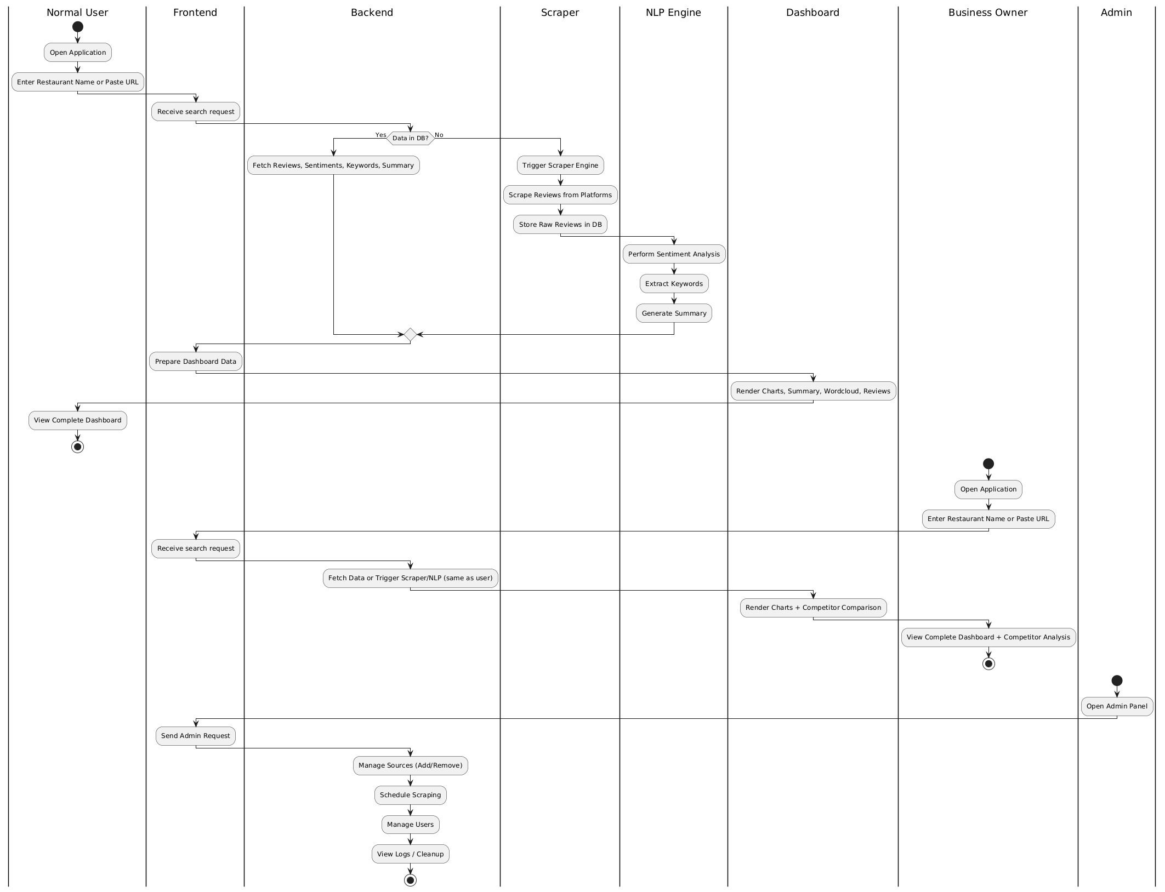

Screens
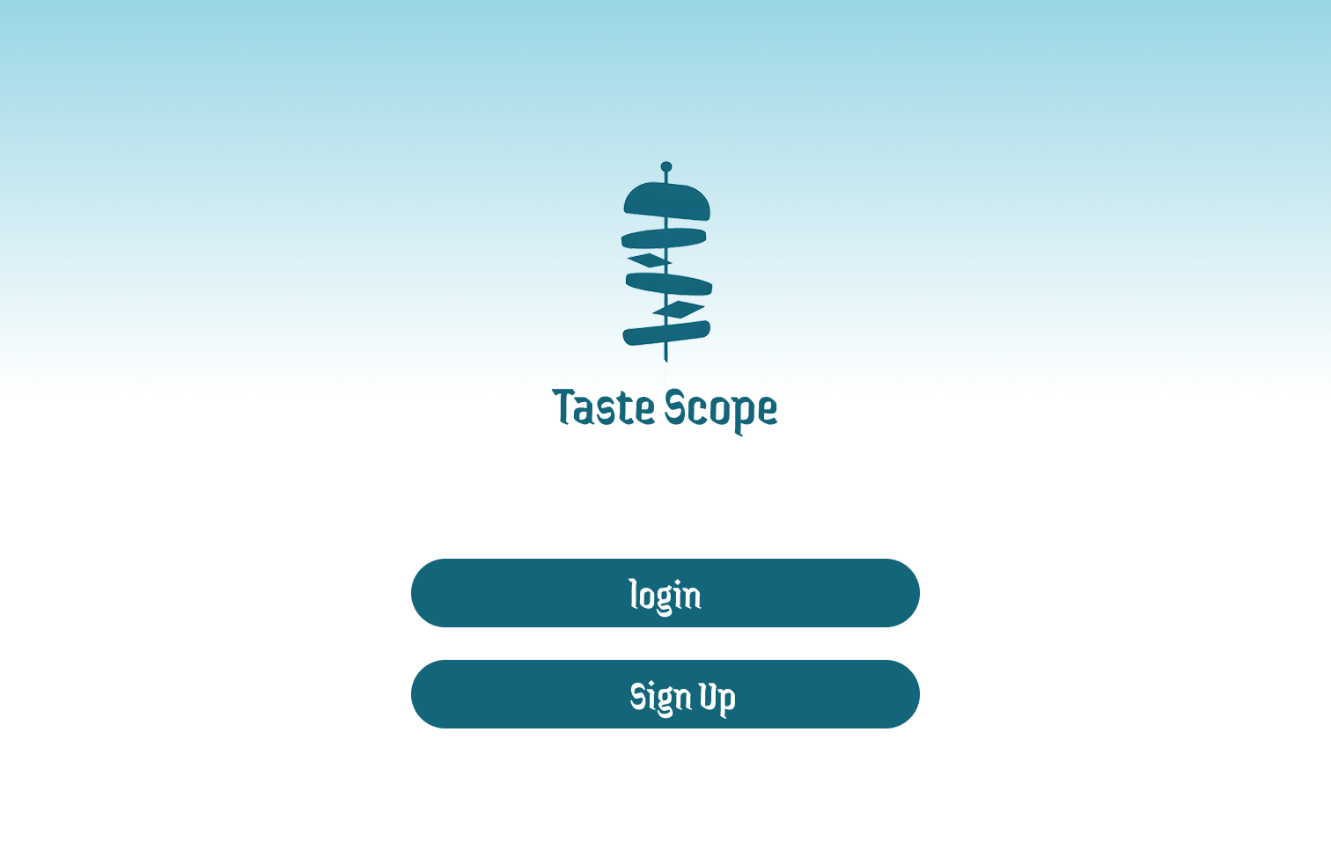

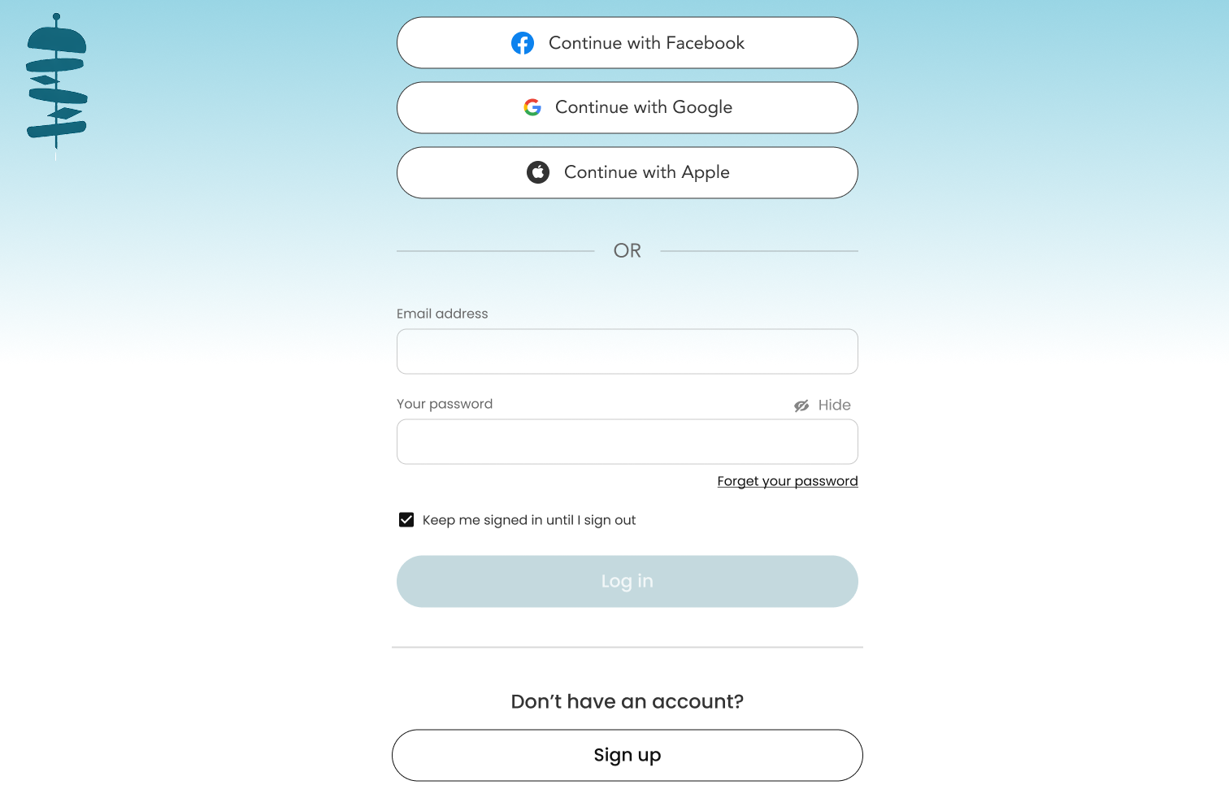

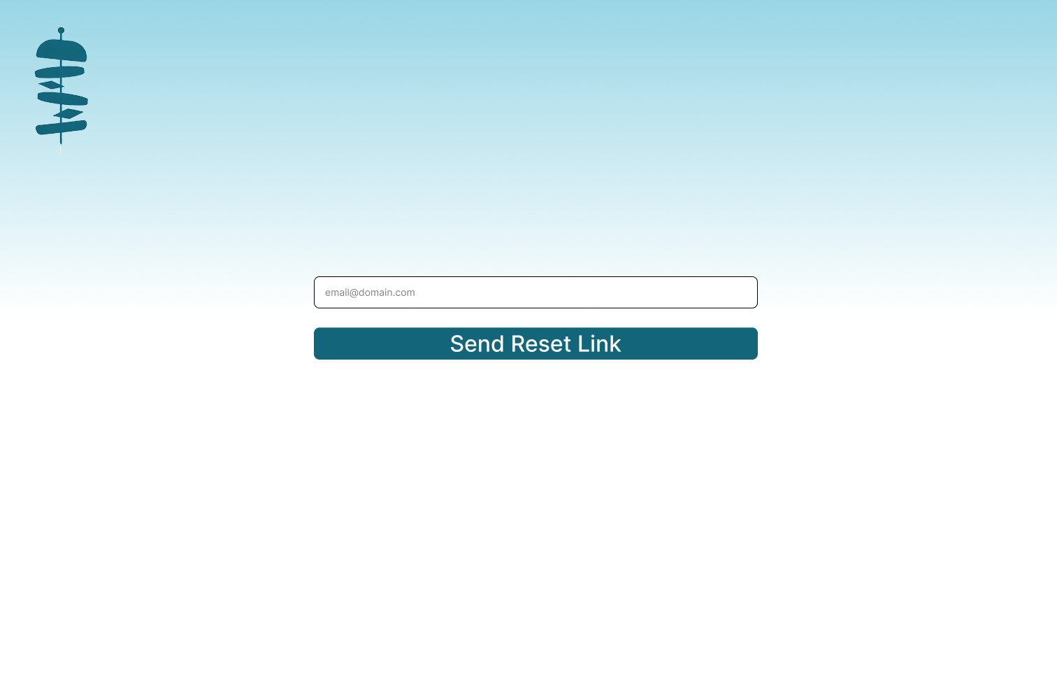

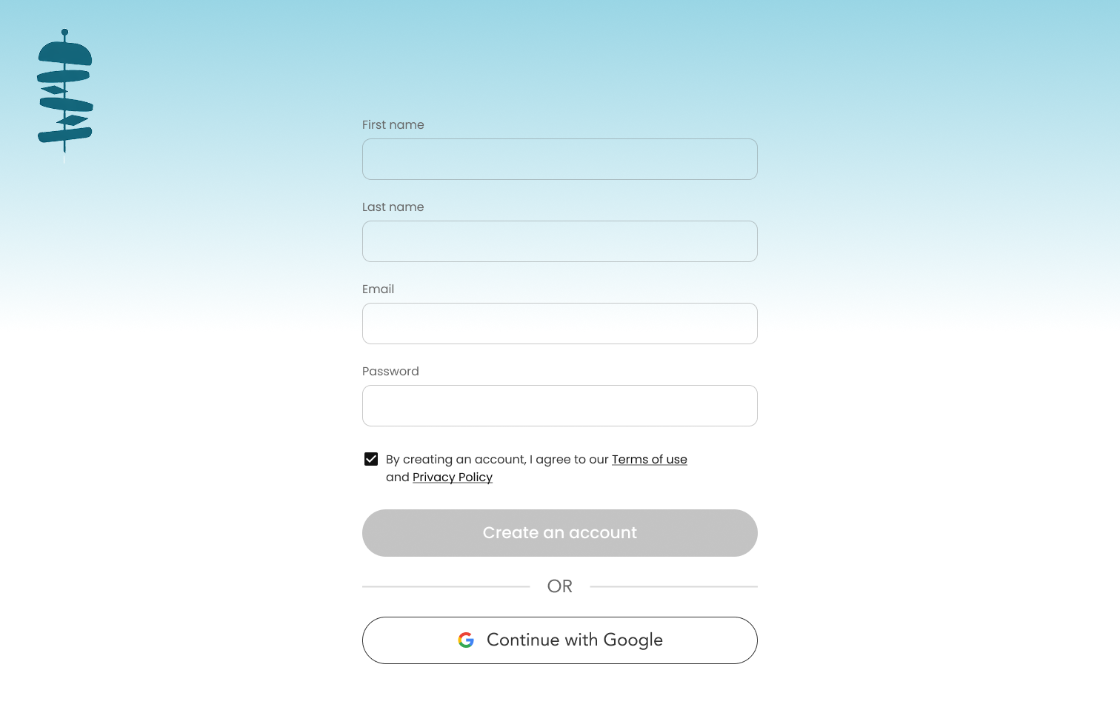
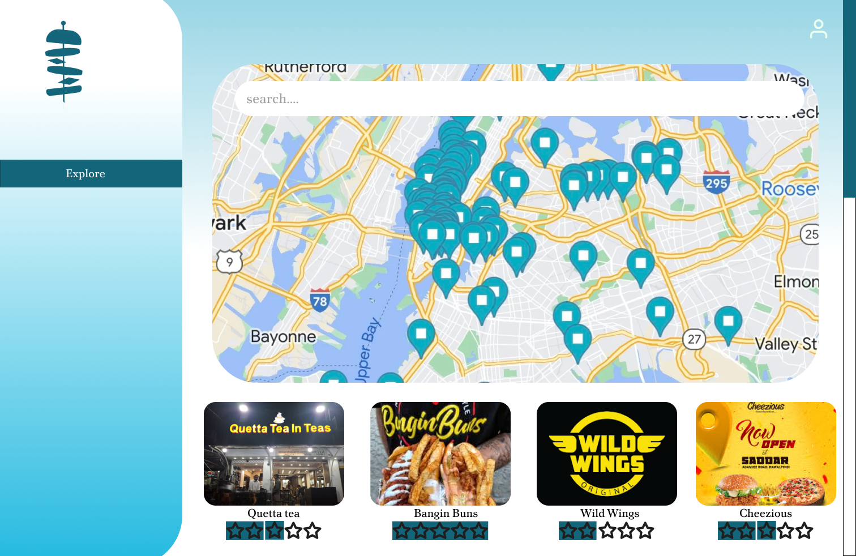

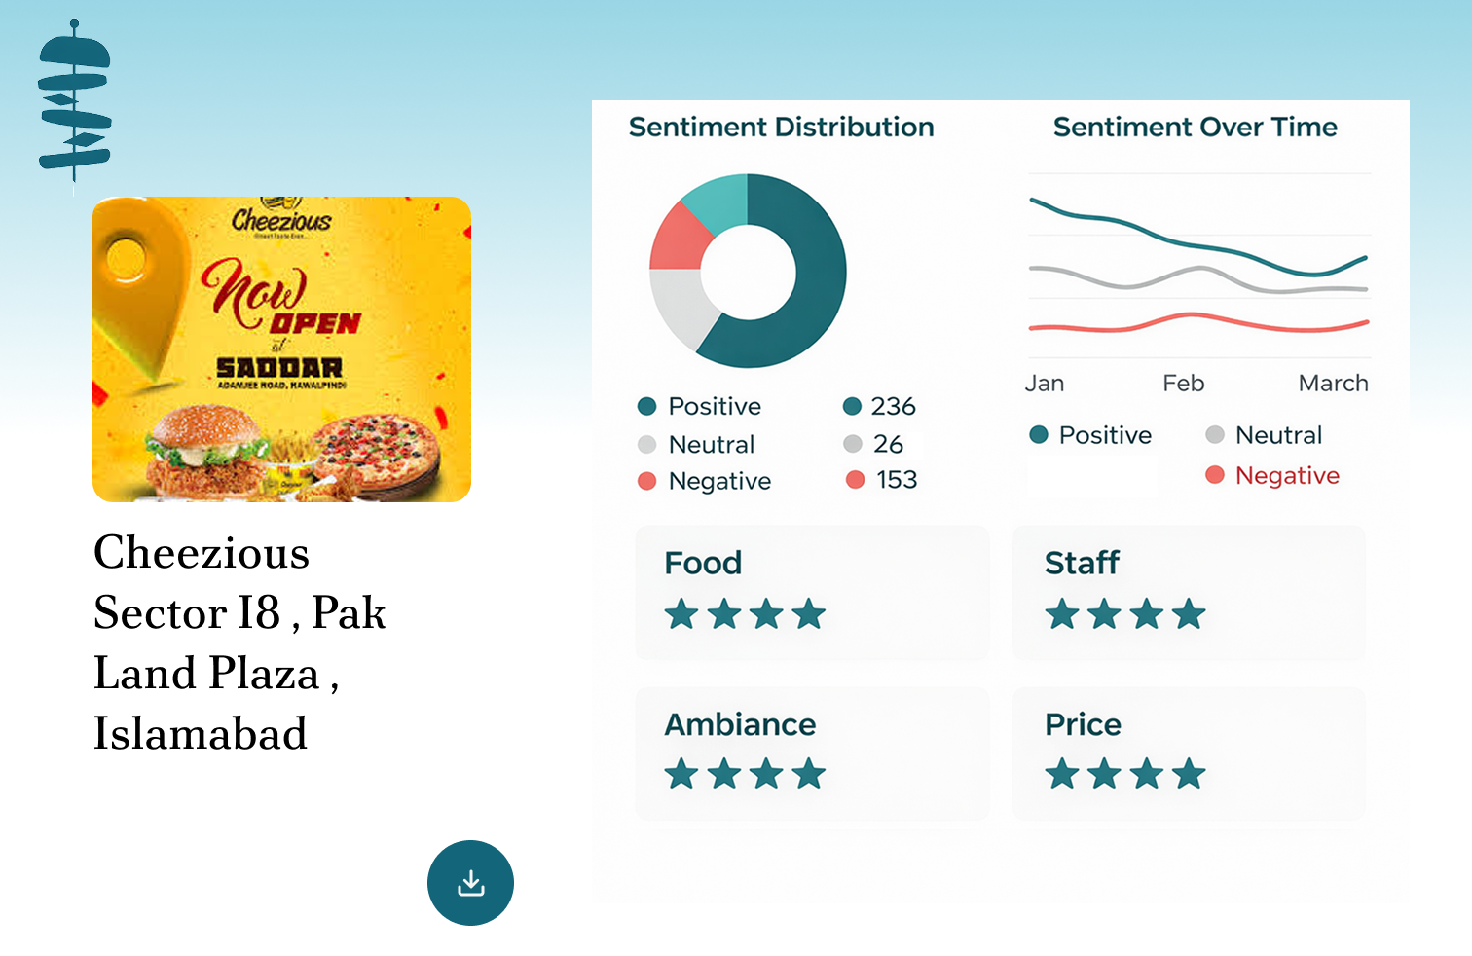

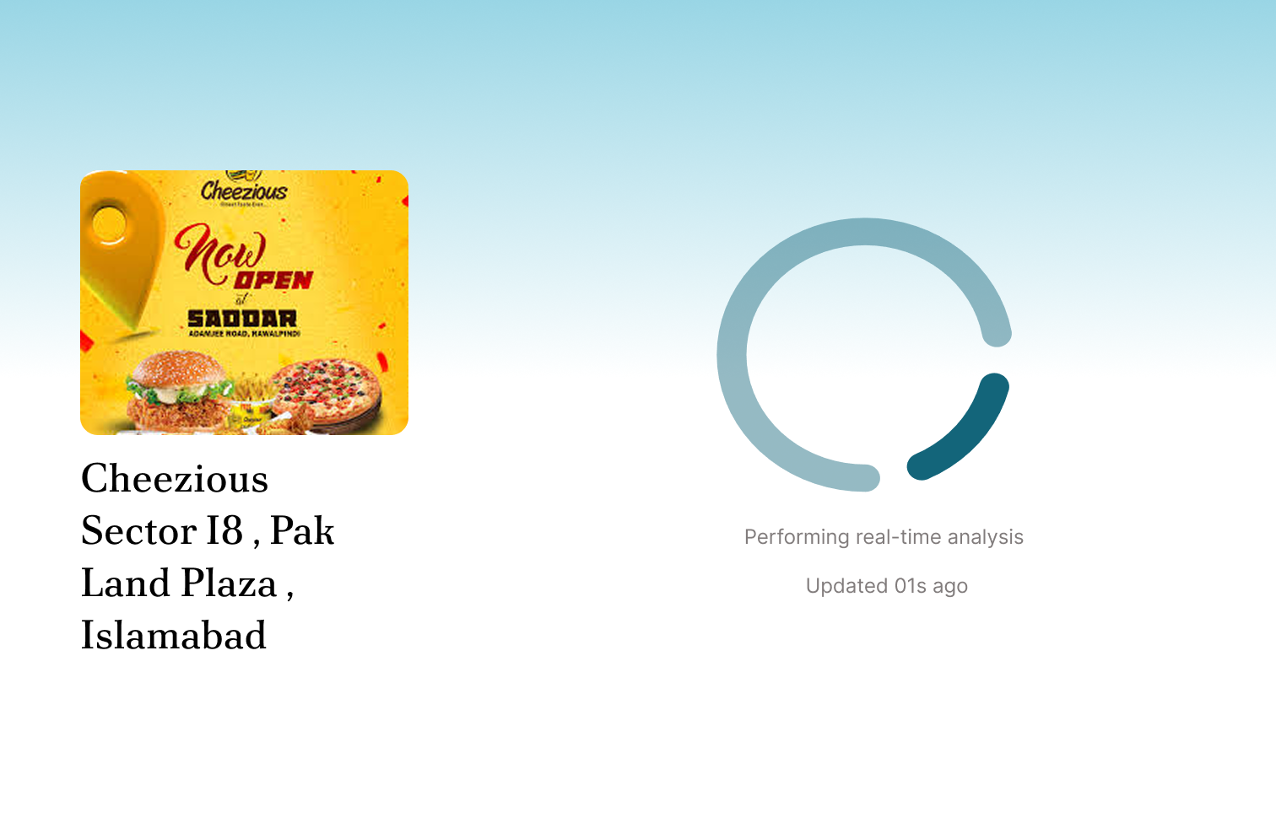

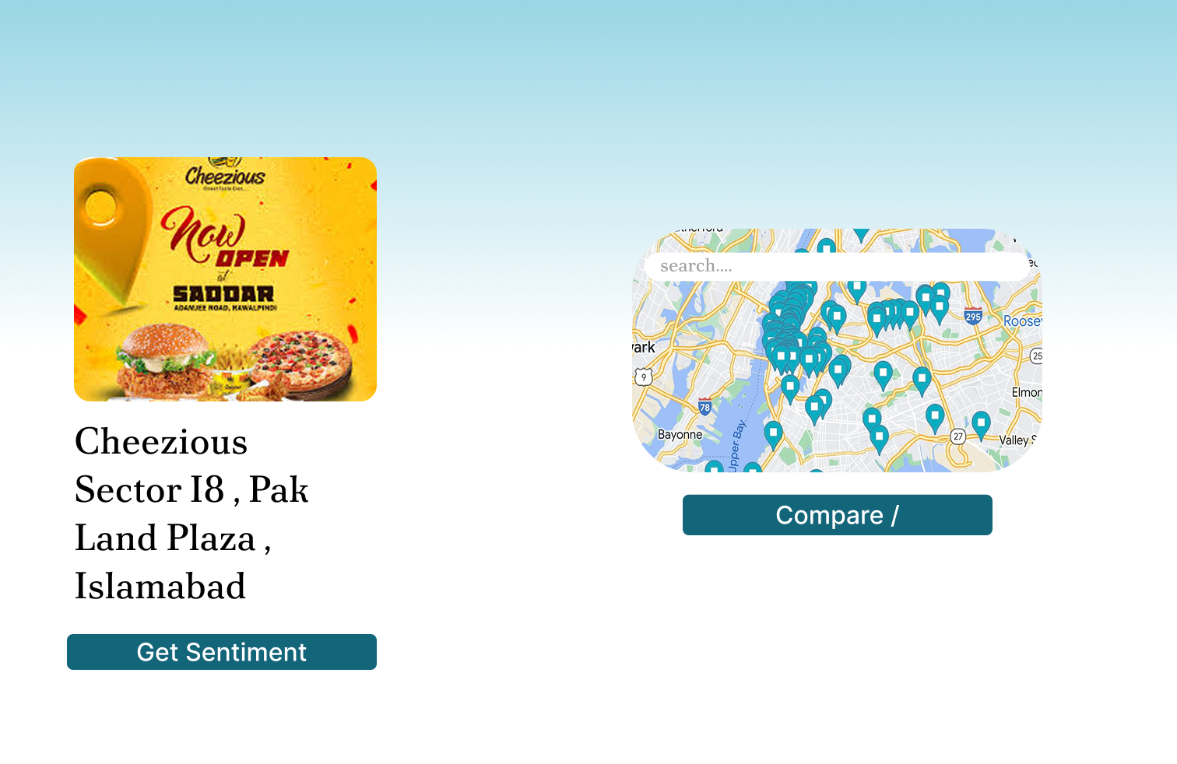

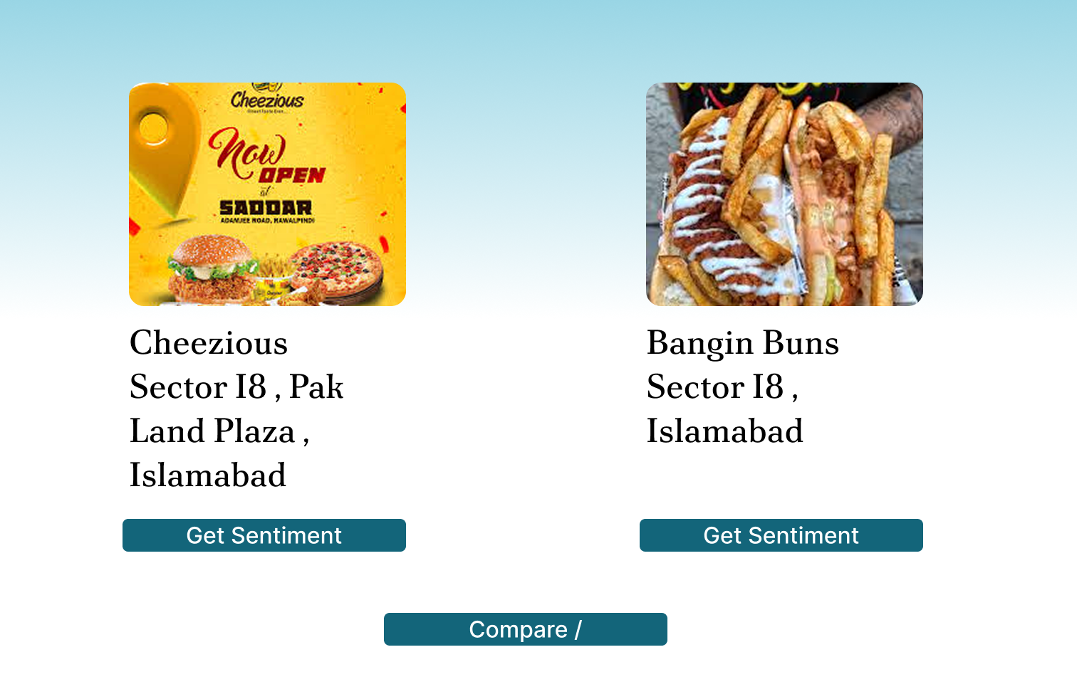
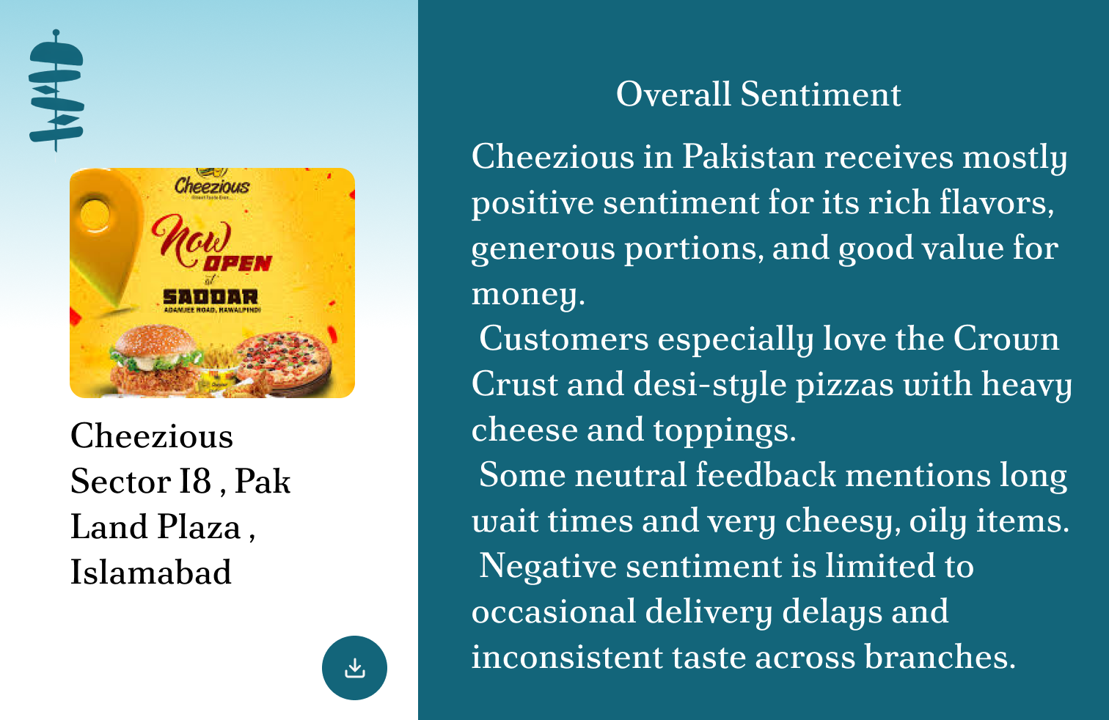

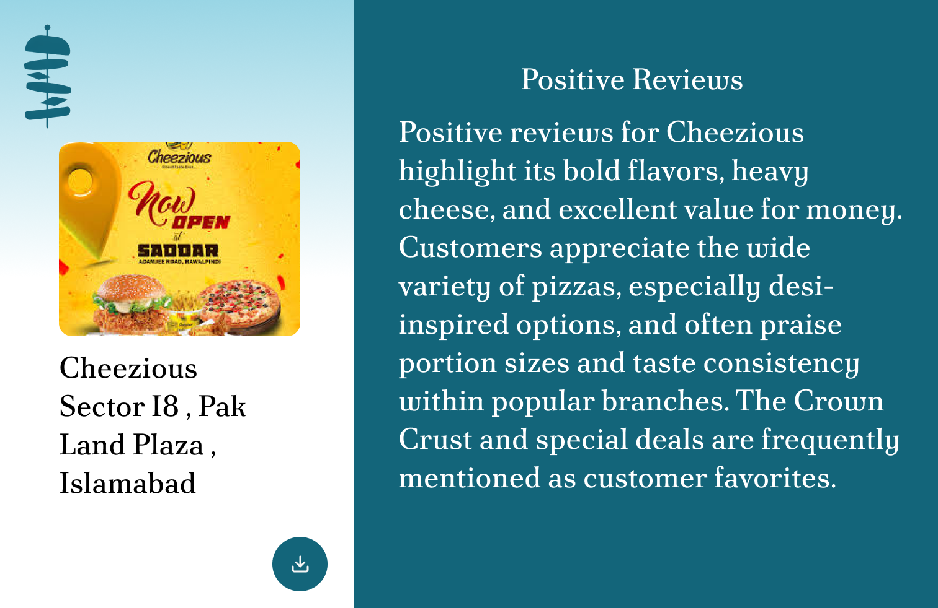
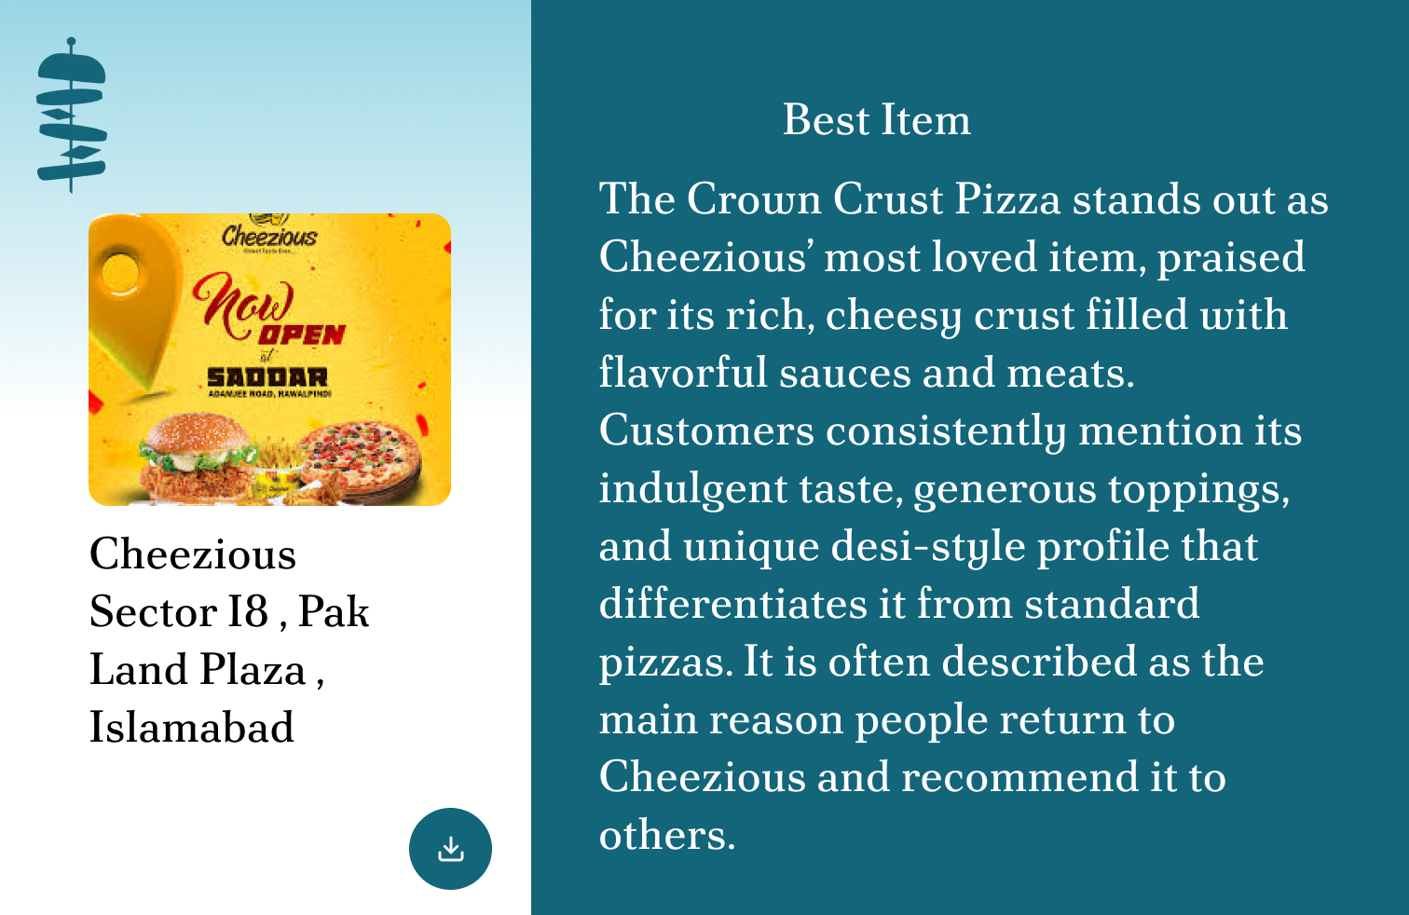

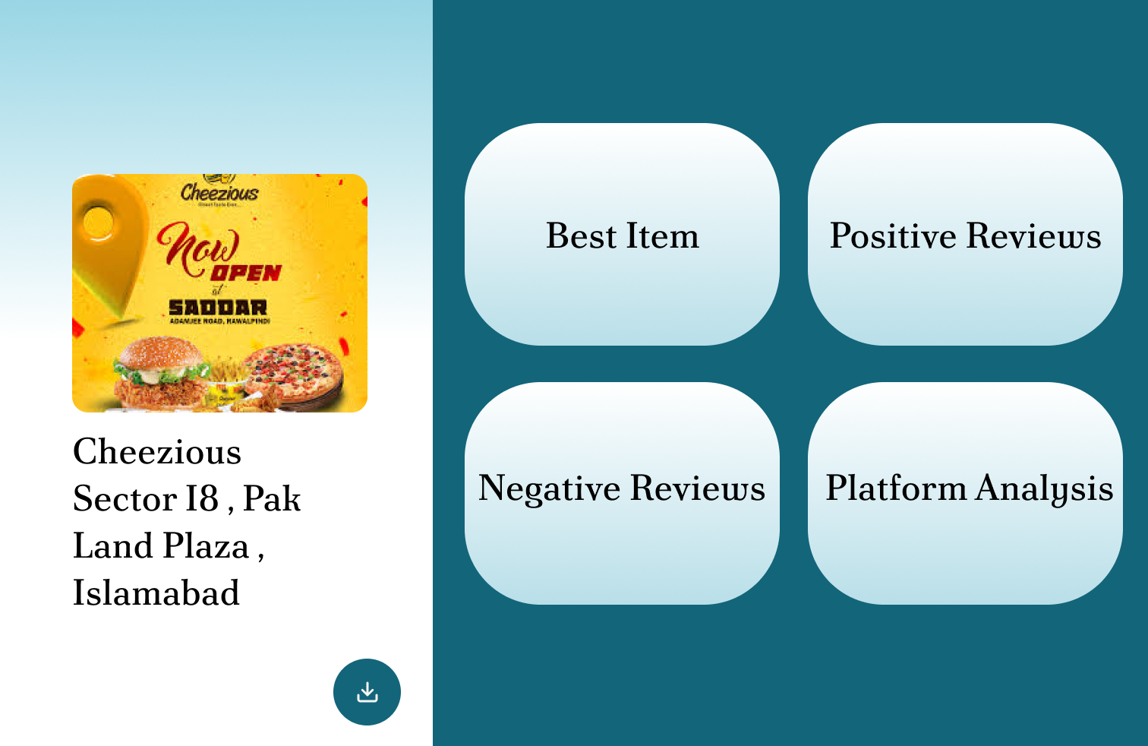

Additional Information
All the provided work and researched details about tools, and other information are based on current knowledge. There is a possibility of little changes in plan if needed.

Other Design Details
NA

Revised Project Plan
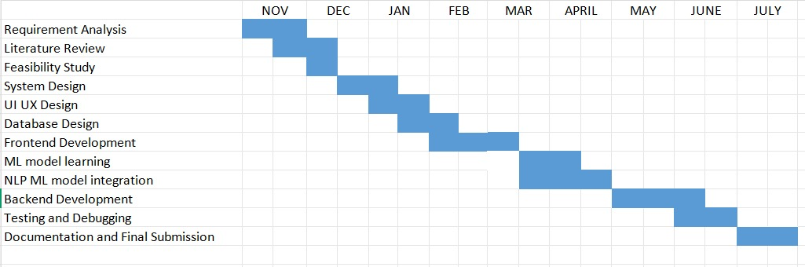

References
• Russell, S., & Norvig, P. (2021). Artificial Intelligence: A Modern Approach. 4th Edition. Pearson.
• Manning, C., Raghavan, P., & Schütze, H. (2008). Introduction to Information Retrieval. Cambridge University Press.
• Bird, S., Klein, E., & Loper, E. (2009). Natural Language Processing with Python. O’Reilly Media.
• TripAdvisor Developer Documentation. https://developer-tripadvisor.com
• Google Reviews API Documentation. https://developers.google.com/maps/documentation/places/web-service/reviews
• Fowler, M. (2004). UML Distilled: A Brief Guide to the Standard Object Modeling Language. 3rd Edition. Addison-Wesley.
• PlantUML Documentation. https://plantuml.com
Appendix A: Glossary
NLP (Natural Language Processing) | AI technology used to understand and analyze human language.
Dashboard Renderer | Component responsible for visualizing data for users and business owners.
Scraper Engine | Module that extracts raw reviews from external platforms.
Sentiment Analysis | Process of determining the positive, negative, or neutral tone of a review.
Keyword Extraction | Identifying the most relevant words or phrases from text data.
Summary Generation | AI process to produce concise summaries from raw reviews.
Frontend | User interface layer built using React.
Backend API | Server-side application built using Node.js that handles requests and processes data.
Appendix B: IV & V Report
(Independent verification & validation)
IV & V Resource

Name Signature

S# | Defect Description | Origin Stage | Status | Fix Time
 |  |  |  | Hours | Minutes
1
2
3
…
Table 1: List of non-trivial defects

This document has been adapted from the following:
- Previous project templates at UCP
- High-level Technical Design, Centers for Medicare & Medicaid Services. (www.cms.gov)

