PLATFORM Module

Organisation section

Bugs

- validation issue in GSTIN edit side and add side
No Limits and no symbols blocking

Improvments
- Status Toggle Option near Search Bar

Branch Section

Bugs

- if we deactivate a branch The Branch number is not proper

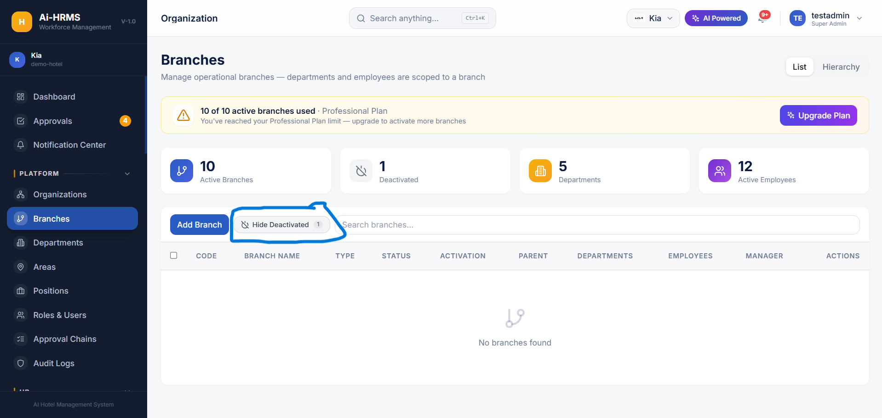

- Validations is not proper in code and branch name section
There is no limits for code and every symbols can be added

Improvment

- Success Messages can be added while edited or adding a Branch
- Status Toggle Option near Search Bar

DEPARTMENT SECTION

Bugs

- In filtering branch all the activated and deactivated branches are showing
- Validation in Code while Adding And Editing
Character Limit: 3 to 10 characters max.
Validation Rules:
Required: Cannot be left blank.
Format: Only Numbers
AREA SECTION

Bugs
- Validation issue in Code section while Adding And Editing it should only be Number
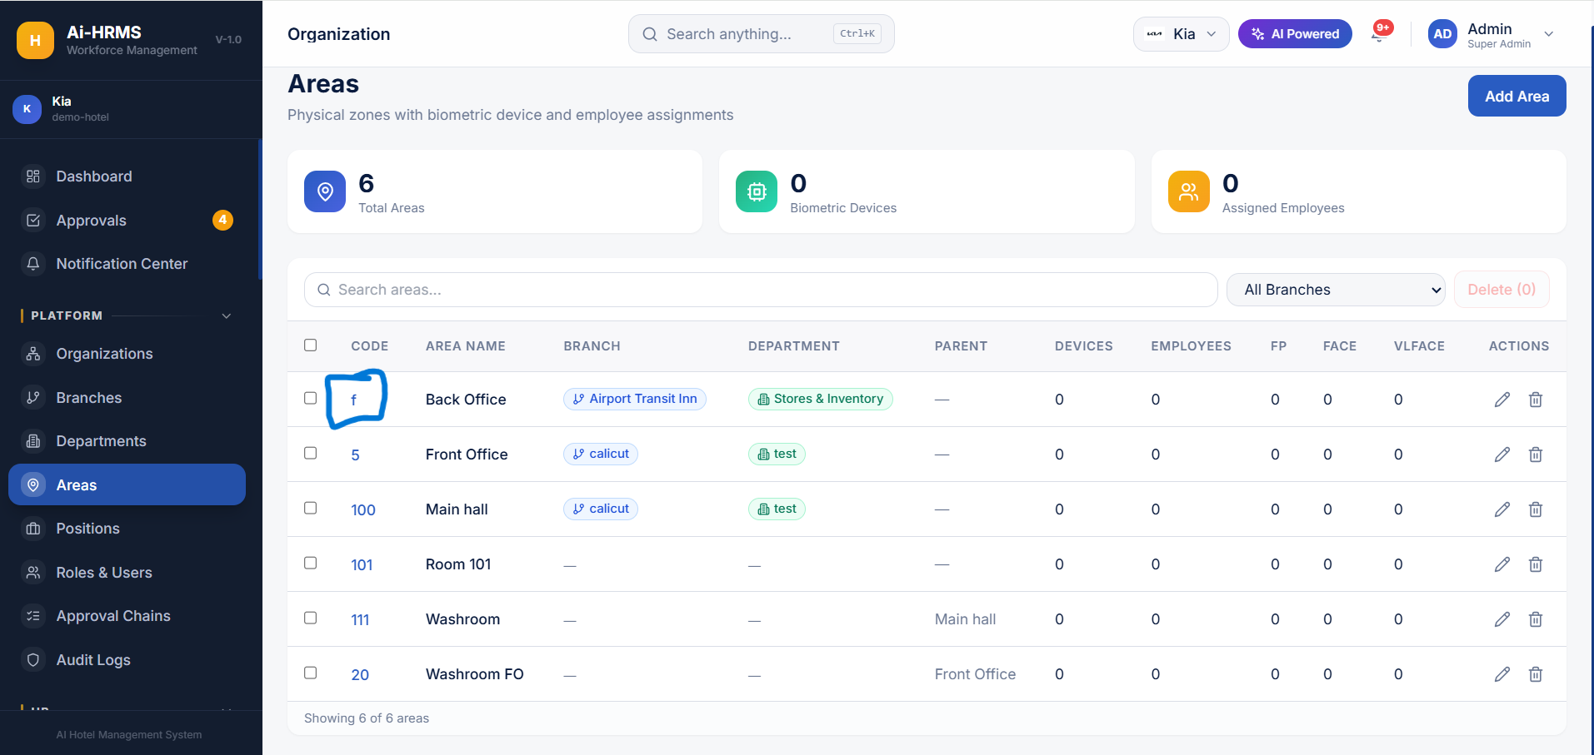
- Delete Button not working
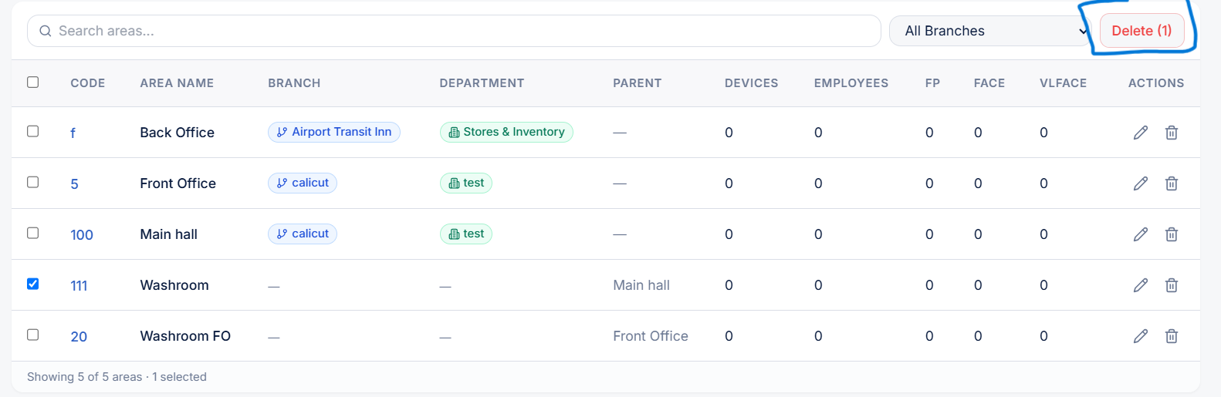

Roles And Users
Bugs

- Validation Errors while editing phone number and email of users
- Validation Error while adding a Phone number
- Newly Added Roles are not Shown while adding a User

Approval Chains

Bugs

- Sometimes Error message showing while adding new chain.Chain is Added but Error message will Pop up
- No Any Other Bugs

Audit Logs

Bugs
- No any Bugs All clear

Other Common Bugs

- Datas are empty Sometimes while refreshing or going to Another Pages
