1. 静态IP：

TYPE=Ethernet

BOOTPROTO=static

#DEFROUTE=yes

#PEERDNS=yes

#PEERROUTES=yes

#IPV4_FAILURE_FATAL=no

#IPV6INIT=yes

#IPV6_AUTOCONF=yes

#IPV6_DEFROUTE=yes

#IPV6_PEERDNS=yes

#IPV6_PEERROUTES=yes

#IPV6_FAILURE_FATAL=no

NAME=eno16777736

UUID=061c2150-410f-40fb-b27e-3202656331e3

DEVICE=eno16777736

ONBOOT=yes

IPADDR=192.168.33.168

NETMASK=255.255.255.0

GATEWAY=192.168.33.254

DNS1=192.168.33.254

DNS2=114.114.114.114

版本：

lsb_release -a

cat /etc/redhat-release

Cdh安装需求：

1. jdk: 必须是oracle，openjdk不行！
2. Centos镜像下载（修改下版本）：http://vault.centos.org/7.4.1708/isos/x86_64/
3. Ubuntu镜像：<http://mirrors.melbourne.co.uk/ubuntu-releases/16.04.2/>
4. Parcels下载：<http://archive.cloudera.com/cdh5/parcels/>
5. Cm下载： <http://archive.cloudera.com/cm5/cm/5/>
6. Mysql-connector下载：https://dev.mysql.com/downloads/connector/j/

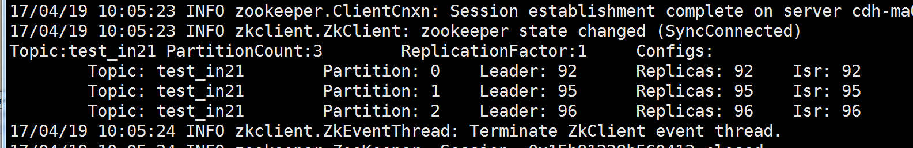

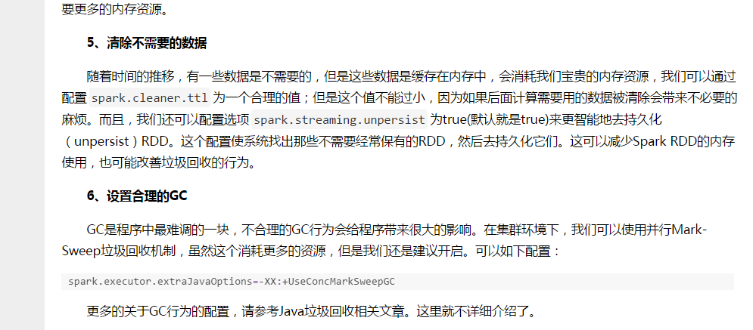

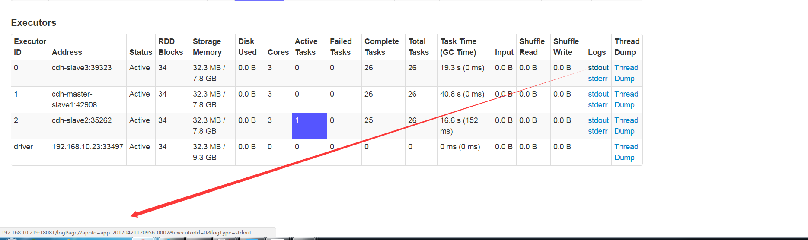

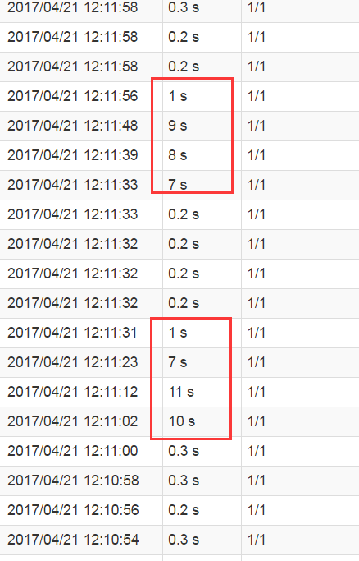

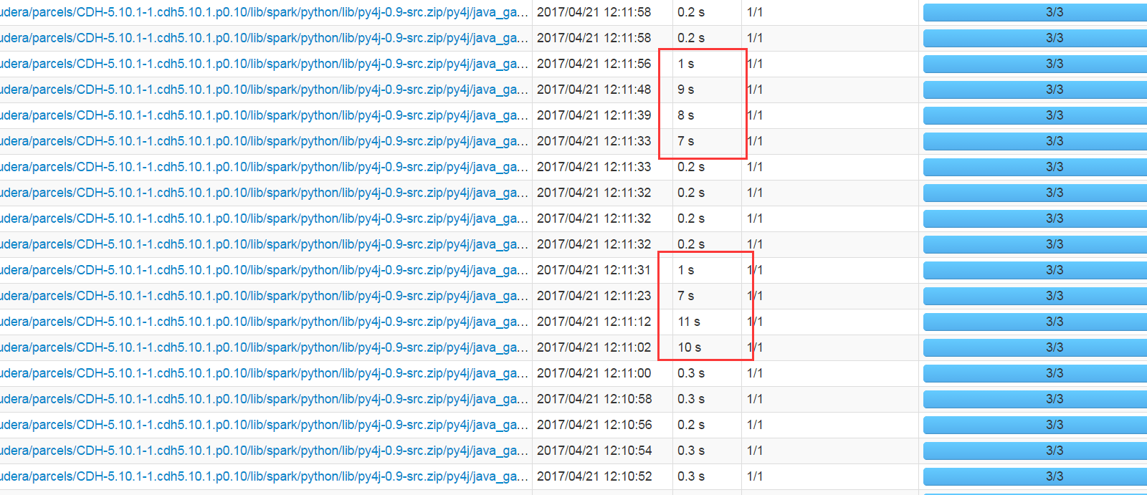

|  |  |  |  |  |  |
| --- | --- | --- | --- | --- | --- |
|  | Cores使用 | 内存 |  |  |  |
| Slave1 |  |  |  |  |  |
| Slave2 |  |  |  |  |  |
| Slave3 |  |  |  |  |  |
|  |  |  |  |  |  |
|  |  |  |  |  |  |

修改CDH: /user/spark权限:

Su hdfs

hadoop fs -chmod -R 777 /user/

在/目录下创建data: 需切换到hdfs用户，创建后，hadoop fs -chmod -R 777 /data

然后可在weiwc用户上传，可在/data下面创建data2目录，即/data/data2.

hadoop fs -chmod -R 777 /user/weiwc/.sparkStaging

|  |
| --- |
| 只能修改/etc/spark/conf/spark-defaults.conf ，所有机器都要添加如下（driver和executor），且只能在本地，且本地对应目录一致都有jar包，且权限为755,可执行，重启spark服务：  spark.driver.extraClassPath=/home/weiwc/mongo-java-driver-3.2.2.jar:/home/weiwc/mongo-spark-connector_2.10-1.0.0.jar  spark.executor.extraClassPath=/home/weiwc/mongo-java-driver-3.2.2.jar:/home/weiwc/mongo-spark-connector_2.10-1.0.0.jar |

192.168.10.23 cdh-master-slave1

192.168.10.24 cdh-slave2

192.168.10.219 cdh-slave3

CDH 访问: cdh-master-slave1:7180

Spark 访问: cdh-master-slave1:8080

Sparkstreaming一直处理，就会一直producer!但传入数据时就producer很慢！

