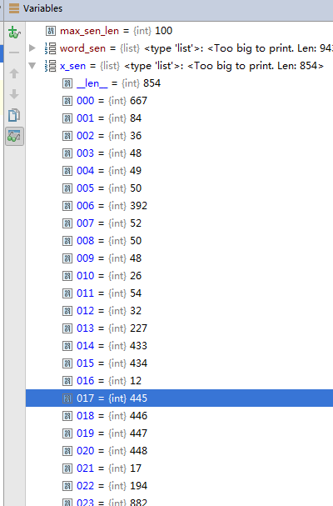

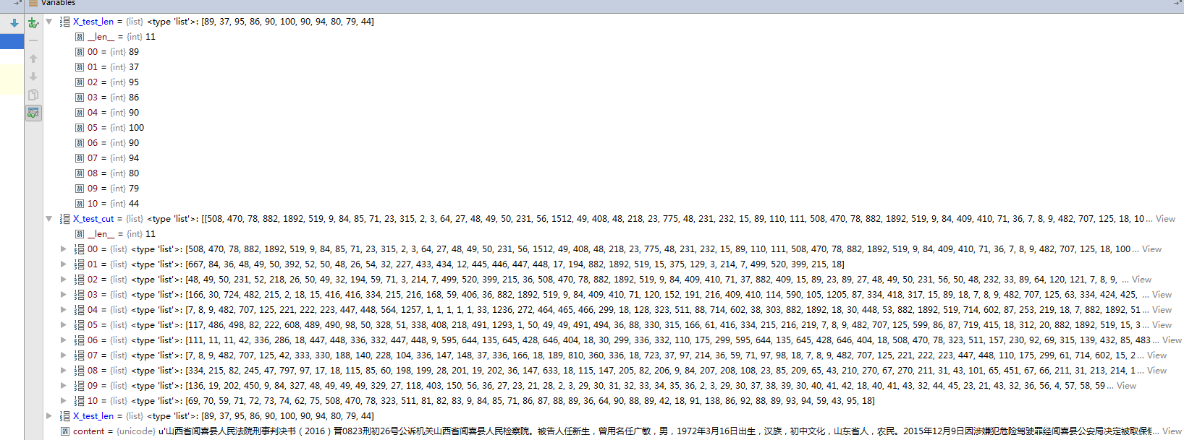

未执行X_test_cut=pad_sequences(X_test_cut,maxlen=max_sen_len,padding='post')之前：

print X_test_cut[0],X_test_cut[1],X_test_cut[2]

[508, 470, 78, 882, 1892, 519, 9, 84, 85, 71, 23, 315, 2, 3, 64, 27, 48, 49, 50, 231, 56, 1512, 49, 408, 48, 218, 23, 775, 48, 231, 232, 15, 89, 110, 111, 508, 470, 78, 882, 1892, 519, 9, 84, 409, 410, 71, 36, 7, 8, 9, 482, 707, 125, 18, 1002, 239, 122, 482, 809, 615, 18, 381, 18, 50, 54, 328, 48, 52, 218, 26, 50, 231, 32, 87, 125, 18, 512, 513, 18, 775, 82, 308, 515, 18, 508, 509, 78, 9, 18]

[667, 84, 36, 48, 49, 50, 392, 52, 50, 48, 26, 54, 32, 227, 433, 434, 12, 445, 446, 447, 448, 17, 194, 882, 1892, 519, 15, 375, 129, 3, 214, 7, 499, 520, 399, 215, 18]

[48, 49, 50, 231, 52, 218, 26, 50, 49, 32, 194, 59, 71, 3, 214, 7, 499, 520, 399, 215, 36, 508, 470, 78, 882, 1892, 519, 9, 84, 409, 410, 71, 37, 882, 409, 15, 89, 23, 89, 27, 48, 49, 50, 231, 56, 50, 48, 232, 33, 89, 64, 120, 121, 7, 8, 9, 482, 707, 125, 12, 445, 446, 447, 448, 17, 18, 412, 48, 49, 50, 231, 52, 218, 26, 408, 32, 75, 59, 71, 86, 33, 15, 89, 36, 59, 71, 115, 85, 691, 239, 692, 693, 478, 694, 18]

执行X_test_cut=pad_sequences(X_test_cut,maxlen=max_sen_len,padding='post')之后：

其中pad_sequences作用就是将X_test_cut中的每个列表大小补齐到100，不够用0填充。

print X_test_cut

X_test_cut：

[[508 470 78 ..., 0 0 0]

[667 84 36 ..., 0 0 0]

[ 48 49 50 ..., 0 0 0]

...,

[136 19 202 ..., 0 0 0]

[ 69 70 59 ..., 0 0 0]

[ 96 59 66 ..., 0 0 0]]

X_test_len：

[89, 37, 95, 86, 90, 100, 90, 94, 80, 79, 44, 59]

Y_pred = model.predict(X_test_cut)

print "Y_pred",len(Y_pred),len(Y_pred[0]),len(Y_pred[1]),Y_pred

print "X_word",len(X_word),X_word

Y_pred 12 100 100 [[[ 0. 0. 0. ..., 0. 0. 0.]

[ 0. 0. 0. ..., 1. 0. 0.]

[ 0. 0. 0. ..., 1. 0. 0.]

...,

[ 1. 0. 0. ..., 0. 0. 0.]

[ 1. 0. 0. ..., 0. 0. 0.]

[ 1. 0. 0. ..., 0. 0. 0.]]

[[ 0. 1. 0. ..., 0. 0. 0.]

[ 0. 1. 0. ..., 0. 0. 0.]

[ 0. 1. 0. ..., 0. 0. 0.]

...,

[ 1. 0. 0. ..., 0. 0. 0.]

[ 1. 0. 0. ..., 0. 0. 0.]

[ 1. 0. 0. ..., 0. 0. 0.]]

[[ 0. 0. 0. ..., 0. 0. 0.]

[ 0. 0. 0. ..., 0. 0. 0.]

[ 0. 0. 0. ..., 0. 0. 0.]

...,

[ 1. 0. 0. ..., 0. 0. 0.]

[ 1. 0. 0. ..., 0. 0. 0.]

[ 1. 0. 0. ..., 0. 0. 0.]]

...,

[[ 0. 1. 0. ..., 0. 0. 0.]

[ 0. 1. 0. ..., 0. 0. 0.]

[ 0. 1. 0. ..., 0. 0. 0.]

...,

[ 1. 0. 0. ..., 0. 0. 0.]

[ 1. 0. 0. ..., 0. 0. 0.]

[ 1. 0. 0. ..., 0. 0. 0.]]

[[ 0. 1. 0. ..., 0. 0. 0.]

[ 0. 1. 0. ..., 0. 0. 0.]

[ 0. 0. 0. ..., 0. 0. 0.]

...,

[ 1. 0. 0. ..., 0. 0. 0.]

[ 1. 0. 0. ..., 0. 0. 0.]

[ 1. 0. 0. ..., 0. 0. 0.]]

[[ 0. 1. 0. ..., 0. 0. 0.]

[ 0. 1. 0. ..., 0. 0. 0.]

[ 0. 1. 0. ..., 0. 0. 0.]

...,

[ 1. 0. 0. ..., 0. 0. 0.]

[ 1. 0. 0. ..., 0. 0. 0.]

[ 1. 0. 0. ..., 0. 0. 0.]]]

X_word 943 ['\xe5\xb1\xb1', '\xe8\xa5\xbf', '\xe7\x9c\x81', '\xe9\x97\xbb', '\xe5\x96\x9c', '\xe5\x8e\xbf', '\xe4\xba\xba', '\xe6\xb0\x91', '\xe6\xb3\x95', '\xe9\x99\xa2', '\xe5\x88\x91', '\xe4\xba\x8b', '\xe5\x88\xa4', '\xe5\x86\xb3', '\xe4\xb9\xa6', '\xef\xbc\x88', '2', '0', '1', '6',

.....

'\xe4\xb9\xa6', 'u', '3', '0', '0', '0', '\xe8\xae\xb0', 'u', '3', '0', '0', '0', '\xe5\x91\x98', 'u', '3', '0', '0', '0', 'u', '3', '0', '0', '0', '\xe6\xa8\x8a', '\xe6\xb3\xbd', '\xe6\x98\x8e']