DeepDense 128-64 params: 273,193 (InceptionV3 Non-trainable params: 21,802,784)

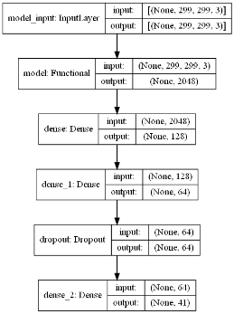

Epoch2000

test_indoor_acc=0.8032330274581909

test_outdoor_acc=0.7178344130516052

test_belt_acc=0.6450589299201965

|  |  |
| --- | --- |
|  |  |

max acc -> 0.7276532649993896 (avg indoor outdoor onconvey)

The [Epoch] of max acc -> 1960

acc=0.7215686274509804

all_avg_eachclass = 67.92980535339979%

DeepDense 256-128 params: 562,729

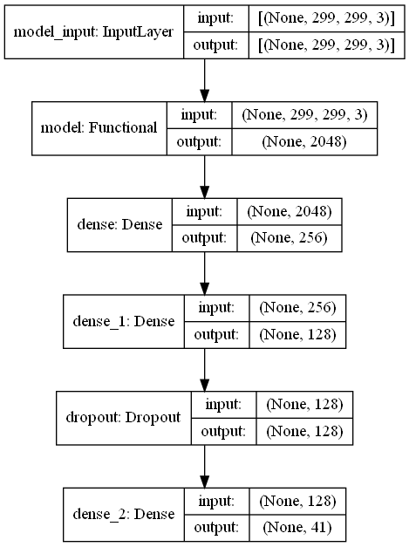

Epoch2000

test_indoor_acc=0.8232998847961426

test_outdoor_acc=0.7350318431854248

test_belt_acc=0.6872166991233826

|  |  |
| --- | --- |
|  |  |

max acc -> 0.753749152024587

The [Epoch] of max acc -> 880

acc=0.7471988795518207

all_avg_eachclass = 71.43702883033471%

DeepDense 512-256 params: 1,190,953

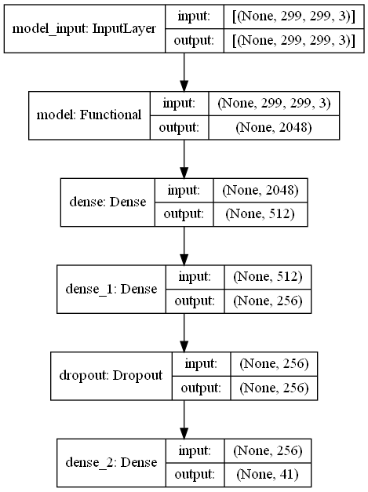

Epoch2000

test_indoor_acc=0.8333333134651184

test_outdoor_acc=0.7385350465774536

test_belt_acc=0.7089754939079285

|  |  |
| --- | --- |
|  |  |

max acc -> 0.7621145248413086

The [Epoch] of max acc -> 1320

acc=0.7551820728291316

all_avg_eachclass = 72.04922621949572%

DeepDense 1024-512 params: 2,644,009

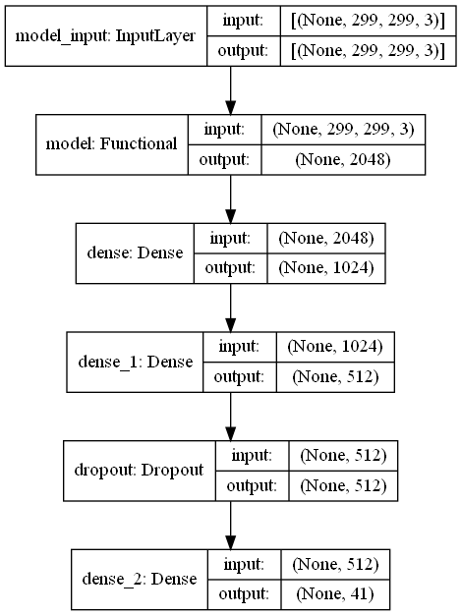

Epoch2000

test_indoor_acc=0.843366801738739

test_outdoor_acc=0.743630588054657

test_belt_acc=0.686763346195221

|  |  |
| --- | --- |
|  |  |

max acc -> 0.7598580718040466

The [Epoch] of max acc -> 920

acc=0.7529411764705882

all_avg_eachclass = 72.09885633123412%

LowDeepDense 64 params: 133,801

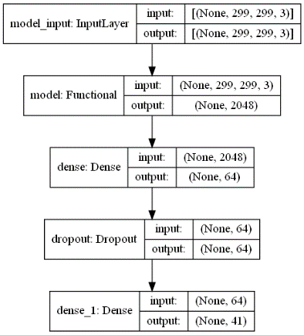

Epoch2000

test_indoor_acc=0.8210702538490295

test_outdoor_acc=0.7318471074104309

test_belt_acc=0.6786038279533386

|  |  |
| --- | --- |
|  |  |

max acc -> 0.7456002235412598

The [Epoch] of max acc -> 1400

acc=0.7397759103641457

all_avg_eachclass = 70.46599739207998%

LowDeepDense 128 params: 267,561

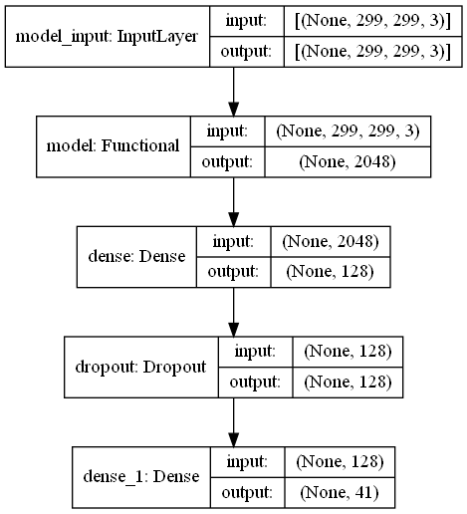

Epoch2000

test_indoor_acc=0.846711277961731

test_outdoor_acc=0.7391719818115234

test_belt_acc=0.6994560360908508

|  |  |
| --- | --- |
|  |  |

max acc -> 0.7627190152804056

The [Epoch] of max acc -> 1560

acc=0.7544817927170868

all_avg_eachclass = 72.17295915781125%

LowDeepDense 256 params: 535,081

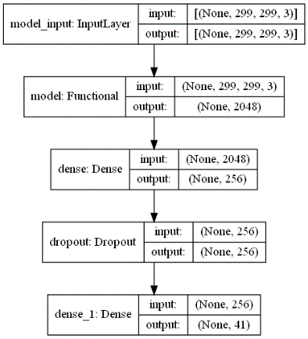

Epoch2000

test_indoor_acc=0.8561872839927673

test_outdoor_acc=0.7394904494285583

test_belt_acc=0.7026292085647583

|  |  |
| --- | --- |
|  |  |

max acc -> 0.7669739524523417

The [Epoch] of max acc -> 1320

acc=0.7584033613445378

all_avg_eachclass = 73.01831333345592%

LowDeepDense 512 params: 1,070,121

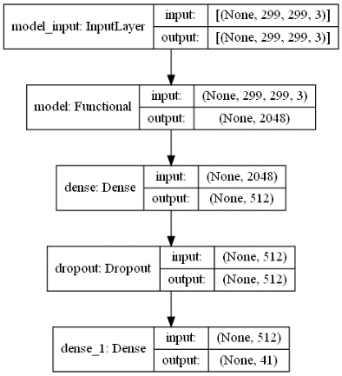

Epoch2000

test_indoor_acc=0.8428093791007996

test_outdoor_acc=0.7414012551307678

test_belt_acc=0.7103354334831238

|  |  |
| --- | --- |
|  |  |

max acc -> 0.7668473521868387

The [Epoch] of max acc -> 1120

acc=0.7595238095238095

all_avg_eachclass = 72.66142897036936%

LowDeepDense 1024 params: 2,140,201

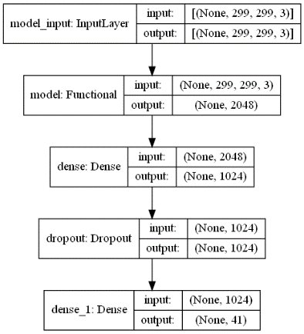

Epoch2000

test_indoor_acc=0.8517279624938965

test_outdoor_acc=0.7433121204376221

test_belt_acc=0.7048957347869873

|  |  |
| --- | --- |
|  |  |

max acc -> 0.7679847081502279

The [Epoch] of max acc -> 1920

acc=0.7599439775910364

all_avg_eachclass = 73.02583324078337%