NoDense Only OutputLayer params: 84,009

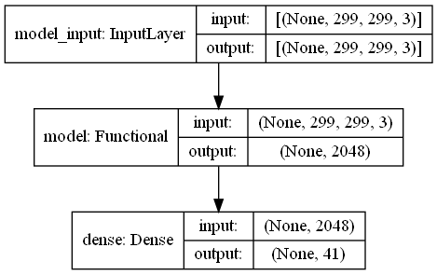

Epoch2000

test_indoor_acc=0.8522853851318359

test_outdoor_acc=0.734394907951355

test_belt_acc=0.6854034662246704

|  |  |
| --- | --- |
|  |  |

max acc -> 0.7574409047762553

The [Epoch] of max acc -> 1980

acc=0.7488795518207283

all_avg_eachclass = 71.5019571609792%

DeepDense 128-64 params: 273,193 (InceptionV3 Non-trainable params: 21,802,784)

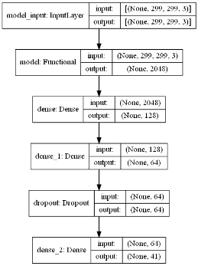

Epoch2000

test_indoor_acc=0.8032330274581909

test_outdoor_acc=0.7178344130516052

test_belt_acc=0.6450589299201965

|  |  |
| --- | --- |
|  |  |

max acc -> 0.7276532649993896 (avg indoor outdoor onconvey)

The [Epoch] of max acc -> 1960

acc=0.7215686274509804

all_avg_eachclass = 67.92980535339979%

DeepDense 256-128 params: 562,729

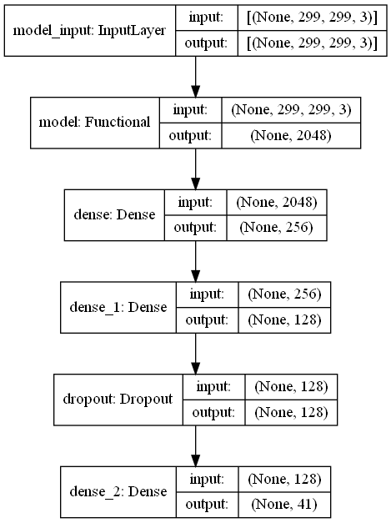

Epoch2000

test_indoor_acc=0.8232998847961426

test_outdoor_acc=0.7350318431854248

test_belt_acc=0.6872166991233826

|  |  |
| --- | --- |
|  |  |

max acc -> 0.753749152024587

The [Epoch] of max acc -> 880

acc=0.7471988795518207

all_avg_eachclass = 71.43702883033471%

DeepDense 512-256 params: 1,190,953

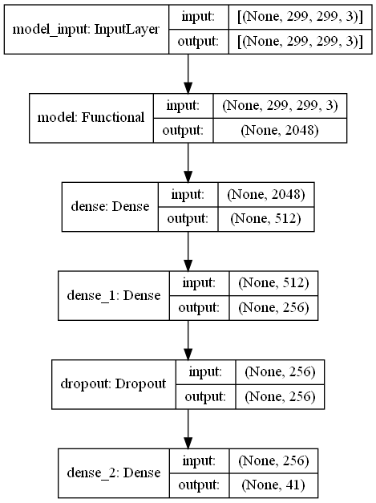

Epoch2000

test_indoor_acc=0.8333333134651184

test_outdoor_acc=0.7385350465774536

test_belt_acc=0.7089754939079285

|  |  |
| --- | --- |
|  |  |

max acc -> 0.7621145248413086

The [Epoch] of max acc -> 1320

acc=0.7551820728291316

all_avg_eachclass = 72.04922621949572%

DeepDense 1024-512 params: 2,644,009

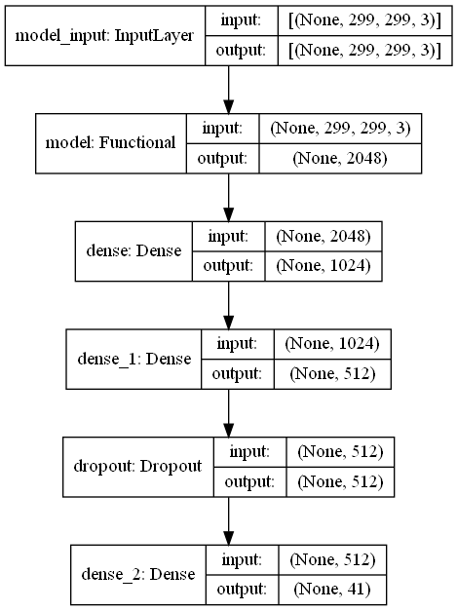

Epoch2000

test_indoor_acc=0.843366801738739

test_outdoor_acc=0.743630588054657

test_belt_acc=0.686763346195221

|  |  |
| --- | --- |
|  |  |

max acc -> 0.7598580718040466

The [Epoch] of max acc -> 920

acc=0.7529411764705882

all_avg_eachclass = 72.09885633123412%

LowDeepDense 64 params: 133,801

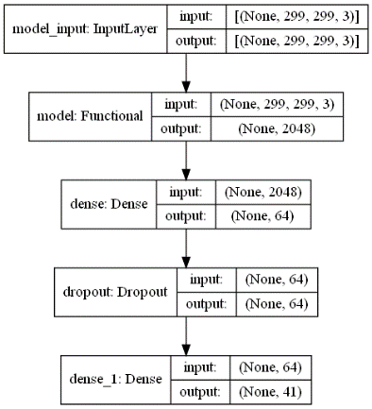

Epoch2000

test_indoor_acc=0.8210702538490295

test_outdoor_acc=0.7318471074104309

test_belt_acc=0.6786038279533386

|  |  |
| --- | --- |
|  |  |

max acc -> 0.7456002235412598

The [Epoch] of max acc -> 1400

acc=0.7397759103641457

all_avg_eachclass = 70.46599739207998%

LowDeepDense 128 params: 267,561

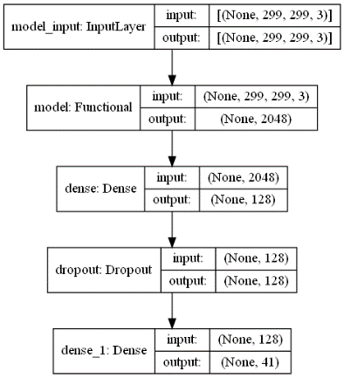

Epoch2000

test_indoor_acc=0.846711277961731

test_outdoor_acc=0.7391719818115234

test_belt_acc=0.6994560360908508

|  |  |
| --- | --- |
|  |  |

max acc -> 0.7627190152804056

The [Epoch] of max acc -> 1560

acc=0.7544817927170868

all_avg_eachclass = 72.17295915781125%

LowDeepDense 256 params: 535,081

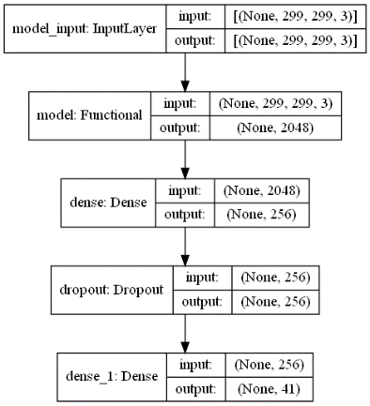

Epoch2000

test_indoor_acc=0.8561872839927673

test_outdoor_acc=0.7394904494285583

test_belt_acc=0.7026292085647583

|  |  |
| --- | --- |
|  |  |

max acc -> 0.7669739524523417

The [Epoch] of max acc -> 1320

acc=0.7584033613445378

all_avg_eachclass = 73.01831333345592%

LowDeepDense 512 params: 1,070,121

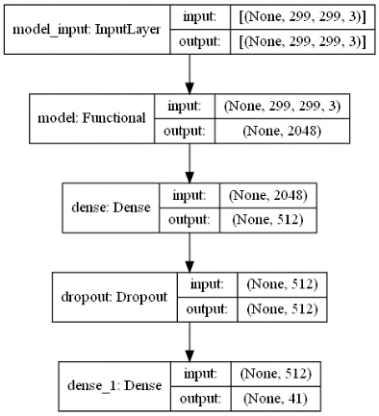

Epoch2000

test_indoor_acc=0.8428093791007996

test_outdoor_acc=0.7414012551307678

test_belt_acc=0.7103354334831238

|  |  |
| --- | --- |
|  |  |

max acc -> 0.7668473521868387

The [Epoch] of max acc -> 1120

acc=0.7595238095238095

all_avg_eachclass = 72.66142897036936%

LowDeepDense 1024 params: 2,140,201

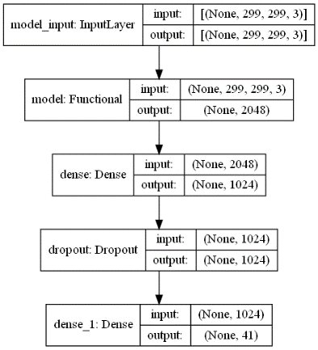

Epoch2000

test_indoor_acc=0.8517279624938965

test_outdoor_acc=0.7433121204376221

test_belt_acc=0.7048957347869873

|  |  |
| --- | --- |
|  |  |

max acc -> 0.7679847081502279

The [Epoch] of max acc -> 1920

acc=0.7599439775910364

all_avg_eachclass = 73.02583324078337%

|  |  |  |  |  |  |  |  |  |  |
| --- | --- | --- | --- | --- | --- | --- | --- | --- | --- |
| DenseType | Params | EP-2K-Acc-Indoor | EP-2K-Acc-Outdoor | EP-2K-Acc-Belt | Avg EP-2000 | Max_acc_avg | #Epoch_given_max_acc | Acc_all_sample | Avg_acc_eachclass |
| NoDense | 84,009 | 85.23 | 73.44 | 68.54 | 75.74 | 75.74 | 1980 | 74.89 | 71.50 |
| LowDeepDense 64 | 133,801 | 82.11 | 73.18 | 67.86 | 74.38 | 74.56 | 1400 | 73.97 | 70.47 |
| LowDeepDense 128 | 267,561 | 84.67 | 73.91 | 69.94 | 76.17 | 76.27 | 1560 | 75.45 | 72.17 |
| LowDeepDense 256 | 535,081 | 85.62 | 73.95 | 70.26 | 76.61 | 76.70 | 1320 | 75.84 | 73.02 |
| LowDeepDense 512 | 1,070,121 | 84.28 | 74.14 | 71.03 | 76.48 | 76.68 | 1120 | 75.95 | 72.66 |
| LowDeepDense 1024 | 2,140,201 | 85.17 | 74.33 | 70.49 | 76.66 | 76.80 | 1920 | 75.99 | 73.03 |
| DeepDense 128-64 | 273,193 | 80.32 | 71.78 | 64.50 | 72.20 | 72.77 | 1960 | 72.16 | 67.93 |
| DeepDense 256-128 | 562,729 | 82.33 | 73.50 | 68.72 | 74.85 | 75.37 | 880 | 74.72 | 71.44 |
| DeepDense 512-256 | 1,190,953 | 83.33 | 73.85 | 70.89 | 76.02 | 76.21 | 1320 | 75.52 | 72.05 |
| DeepDense 1024-512 | 2,644,009 | 84.34 | 74.36 | 68.68 | 75.79 | 75.99 | 920 | 75.29 | 72.10 |