LowDeepDense 1024 params: 2,140,201

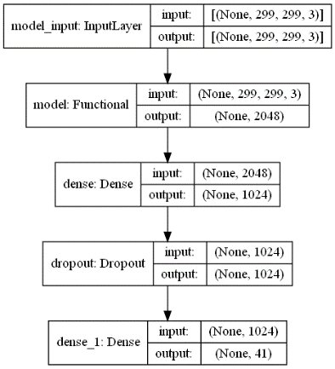

Epoch2000

test_indoor_acc=0.8517279624938965

test_outdoor_acc=0.7433121204376221

test_belt_acc=0.7048957347869873

|  |  |
| --- | --- |
|  |  |

max acc -> 0.7679847081502279

The [Epoch] of max acc -> 1920

acc=0.7619047619047619

all_avg_eachclass = 73.02583324078337%

LowDeepDense / **layers**.**RandomFlip**("horizontal")

Epoch2000

test_indoor_acc=0.8422519564628601

test_outdoor_acc=0.7356687784194946

test_belt_acc=0.7003626227378845

|  |  |
| --- | --- |
|  |  |

max acc -> 0.7615941961606344

The [Epoch] of max acc -> 1800

acc=0.753641456582633

all_avg_eachclass = 72.31663956934308%

LowDeepDense / **layers**.**RandomFlip**("vertical")

Epoch2000

test_indoor_acc=0.8628762364387512

test_outdoor_acc=0.7410827875137329

test_belt_acc=0.7139618992805481

|  |  |
| --- | --- |
|  |  |

max acc -> 0.773157020409902

The [Epoch] of max acc -> 1800

acc=0.7635854341736694

all_avg_eachclass = 73.86280246289128%

LowDeepDense / **layers**.**RandomFlip**("horizontal_and_vertical")

Epoch2000

test_indoor_acc=0.8645485043525696

test_outdoor_acc=0.7420381903648376

test_belt_acc=0.699002742767334

|  |  |
| --- | --- |
|  |  |

max acc -> 0.7696487506230673

The [Epoch] of max acc -> 1800

acc=0.7606442577030812

all_avg_eachclass = 73.58060151619476%

|  |  |  |  |  |  |  |  |  |
| --- | --- | --- | --- | --- | --- | --- | --- | --- |
| **RotationFlip** | EP-2K-Acc-Indoor | EP-2K-Acc-Outdoor | EP-2K-Acc-Belt | Avg acc EP2000 | Max_acc_avg | #Epoch_given_max_acc | Acc_all_sample | Avg_acc_eachclass |
| NoAug | 85.17 | 74.33 | 70.49 | 76.66 | 76.80 | 1920 | 75.99 | 73.03 |
| FlipHor | 84.23 | 73.56 | 70.03 | 75.94 | 76.16 | 1800 | 75.36 | 72.32 |
| FlipVer | 86.29 | 74.11 | 71.40 | 77.27 | 77.32 | 1800 | 76.36 | 73.86 |
| FlipHor&Ver | 86.45 | 74.20 | 69.90 | 76.85 | 76.96 | 1800 | 76.06 | 73.58 |

**สรุป**

**layers**.**RandomFlip**("vertical")

**layers**.**RandomRotation**(0.30)

**layers**.**RandomZoom**(height_factor=0.150,width_factor=0.150)

No #layers.RandomContrast

|  |  |  |  |  |  |  |  |  |
| --- | --- | --- | --- | --- | --- | --- | --- | --- |
| **AllBest** | EP-2K-Acc-Indoor | EP-2K-Acc-Outdoor | EP-2K-Acc-Belt | Avg acc EP2000 | Max_acc_avg | #Epoch_given_max_acc | Acc_all_sample | Avg_acc_eachclass |
| NoAug | 85.17 | 74.33 | 70.49 | 76.66 | 76.80 | 1920 | 75.99 | 73.03 |
| Ver_R30_Z15 | 82.78 | 74.04 | 72.12 | 76.31 | 76.31 | 2000 | 75.66 | 72.52 |
|  |  |  |  |  |  |  |  |  |
|  |  |  |  |  |  |  |  |  |

Epoch2000

test_indoor_acc=0.8277592062950134

test_outdoor_acc=0.7404458522796631

test_belt_acc=0.7212148904800415

|  |  |
| --- | --- |
|  |  |

max acc -> 0.7631399830182394

The [Epoch] of max acc -> 2000

acc=0.7565826330532213

all_avg_eachclass = 72.52774124513583%