Fax Server

This Documentation Is All about Sending Fax Using C# Console Application And Sql For Database Moreover using “**FAXCOMEXLib** (Library Sending Fax using Fax-modem and Telephone line).

Classes:-

Custom Exception:- Is used to open connection with database when any exception is appear at any time when project is run and save this exception at database.

Manipulation File: - Is used to create **Logs** folder and Contain Folder for every fax is sending and save steps and status at file in this folder and at folder **exception** save exception error at file.

Fax Sender Class: - This class is responsible for send fax and used pervious Class at this class.

Program Class:- This Class Declare Object From Fax Sender Class And Call Send Fax Function To Send Fax but before this is connect with database to get all fax at queue and send it using this function .

Hint :-

1) File at exception folder and Specific Folder Fax Create based on Daily and If anyone open MainServiceLog_day_month_year he/she can know what’s happened today.

2) FaxTest.exe is publish at server 10.1.1.151 at F:\fax\ITDeveloperTest\ConsoleApplication.

3) Task Scheduler is call this FaxTest.exe and run every 3 minute .

4) If anytime fax is not working Please Follow this steps

* Check fax is running By Open Logs Folder and check if any file create today if not create open Task Scheduler and disable fax task and enable again and check again.
* Restart server if you done pervious and not work.
* Open database faxApproval and check last record at logs Table is running is false not true.

5) Please install pdf at machine reference (2).

6) Install some of Features To Send fax reference (3).

7) Table Fax Configuration Is Very Important because have a lots of Important columns

Such as MaxNumberOfTries to send fax , SaveFaxAttachmentPath is path

That contains all files fax such as \\10.1.1.29\f$\ , FaxNumber is the number

That declare at machine to send fax from it .

Database Snapshots:-

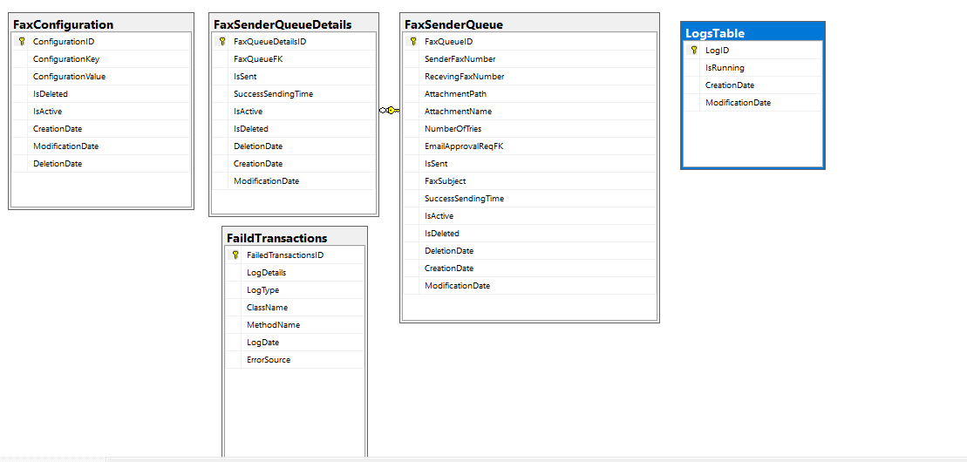

FaxConfiguration Table

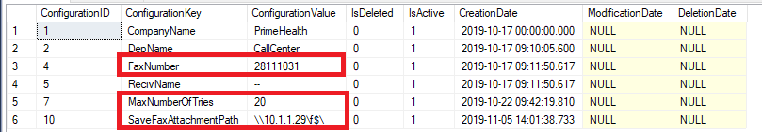

LogsTable Table



Refereces:-

1. <https://www.codeproject.com/Articles/1159834/Send-Fax-with-fax-modem-in-Csharp>
2. <https://stackoverflow.com/questions/25360404/faxcomexlib-operation-failed-when-sending-fax>
3. <https://stackoverflow.com/questions/46506932/how-can-i-send-a-fax-for-a-pdf-from-a-windows-service-using-faxcomexlib>