**Latches and Flip Flops**

**Practice Questions**

**Latches**

**Question:** A reset-dominate latch has a **set** (L) and a **reset** (M) input. It differs from a conventional SR latch in that, an attempt to simultaneously set and reset the latch (i.e., when L=1 and M=1) results in **setting** the latch so that it stores a 1. In a normal SR latch these would be forbidden inputs. SR latch is given below:

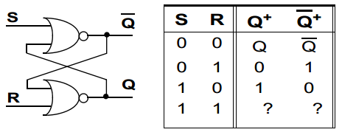

**(i)** Design an LM Latch.

**(ii)** Consider the sequence of values stored in the latch is 01100111. Give the L & M input pairs of signals for this sequence to be stored.

( , ) ( , ) ( , ) ( , ) ( , ) ( , ) ( , ) ( , )

You can safely assume that the latch was set initially before this sequence of storage.

**(Help:** You can use any concept which we have studied so far to design LM Latch).

**Question:**

**(a).** What should be the logical value of clock Pulse (CP) at the time of enabling the XY Latch whose diagram is shown below?

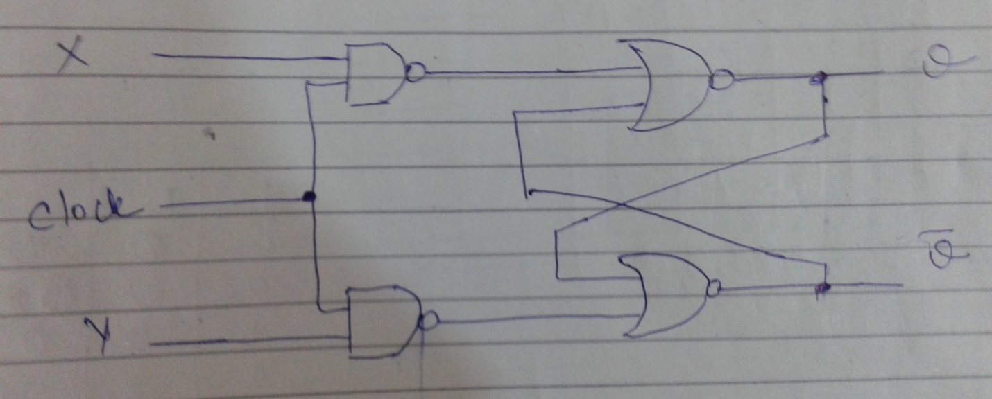

CP = _________

**(b)** Fill the function table for above latch.

|  |  |  |  |
| --- | --- | --- | --- |
| CP | X | Y | Q(t+1) |
|  |  |  |  |
|  |  |  |  |
|  |  |  |  |
|  |  |  |  |
|  |  |  |  |

**Flip-Flops**

**Question:**  Characteristic table of T (Toggle) Flip-Flop is given below, design the flip-flop and derive its characteristic equation.

|  |  |  |
| --- | --- | --- |
| **T** | **Q(t+1)** | **Operation** |
| 0 | Q(t) | No Change |
| 1 | Q’(t) | Complement |

**Question:**  Design a T-R flip-flop with following characteristic equation; also make its characteristic table:

Q(t+1) = T’Q(t)+RT

**Question:** Characteristic table of X-Y Flip-Flop is given below. Fill in the excitation table of X-Y Flip-Flip.

|  |  |  |
| --- | --- | --- |
| **X** | **Y** | **Q(t+1)** |
| 0 | 0 | 0 |
| 0 | 1 | Q(t) |
| 1 | 0 | Q(t)’ |
| 1 | 1 | 1 |

**Question:** Design of AB Flip-Flop is shown below:

Fill in the **characteristic table** given below for AB Flip-Flop.

Derive the **simplified characteristic equation** Q (t+1) as a function of Q(t), A, and B using K-map.



|  |  |  |  |
| --- | --- | --- | --- |
| Q(t) | A | B | Q(t+1) |
| 0 | 0 | 0 |  |
| 0 | 0 | 1 |  |
| 0 | 1 | 0 |  |
| 0 | 1 | 1 |  |
| 1 | 0 | 0 |  |
| 1 | 0 | 1 |  |
| 1 | 1 | 0 |  |
| 1 | 1 | 1 |  |

**Question:** A PN flip-flop has 4 operations: **clear to 0**, **no change**, **complement and set to 1**; when inputs P and N are **00, 01, 10, and 11**, respectively. **Tabulate its characteristic table and draw the circuit of the flip flop.**

|  |  |  |
| --- | --- | --- |
| P | N | Q(t+1) |
| 0 | 0 |  |
| 0 | 1 |  |
| 1 | 0 |  |
| 1 | 1 |  |