Introduction to Computer Science

**Submission: You have to submit soft copy of the assignment. Deadline for assignment submission is Wednesday, 31st October 2016:**

(Nested loops)

**Exercise 1:**

Given n and x, write a C++ program to compute the series



**Exercise 2:**

One of the most interesting Number Patterns is Pascal's Triangle. In Pascal triangle ith row contains the total number of combinations of i objects taken j at a time for all j such that . The total number of combinations of i objects taken j at a time are computed as  


Below is the Pascal triangle containing all combinations of i objects for 

1

1 1

1 2 1

1 3 3 1

1 4 6 4 1

Write a C++ program which takes an integer n from the user and output the first n+1 rows of Pascal triangle.

**Exercise 3:**

Write a program in C++ that takes two numbers (height and width of central rectangle) as input and prints the flower pattern according to the input numbers.

Example:

Say width = 7 and height = 5. Flower according to these dimensions will be as follows:

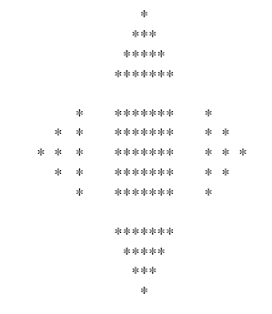

**Note: This is not a diamond. You have to make a flower pattern containing four triangles and one rectangle separated by 2 character space.**