**Introduction to Computer Science**

**Section E &F**

**PROGRAMMING PROJECT**

**IMPORTANT**

* DO NOT HARD CODE ANY NUMBER…use const type
* Your code should be properly commented
* Variable and function names should be meaningful and without abbreviations
* Your program should be user friendly
* Deduction of marks for messy and confusing code
* **Plagiarism will not be tolerated**. It will result in a straight F in the course and forwarded to DC committee, who might award 5 F’s in all courses you are taking.

You have a choice between the following projects: A game of your choice but it has to be discussed and approved by Ms. Lehmia, otherwise you have to choose one project from within the list.

**PHASE 1**

For phase 1 you have to design the system on paper. You have to submit a map of all functions that you will implement along with how data is exchanged between the different functions. Use an ellipse to denote a function and write the function name within that ellipse. Show data exchange between different functions using arrows, each arrow being labeled by the data. This should be hand written and if one A4 sheet is not enough then you can attach two or three sheets together.

**PHASE 2**

You have to submit a complete working system, along with the source code and a readme file that tells us how to use your software.

**DETAILS OF THE GAMES**

Decide which game you want to implement and read its details as given in the text that follows.

**SPACE INVADERS GAME**

Play this game at:

<http://www.spaceinvaders.de/>

You have to design and implement this game, with minimum functionality as described next.

You can omit the safety barriers if you like

To keep things simple you can make only one enemy line. Each enemy can be a simple rectangle or circle. Note that this is an array of enemies. Each enemy can have a bool variable alive or dead associated with it

You can omit the high scoring aliens if you like

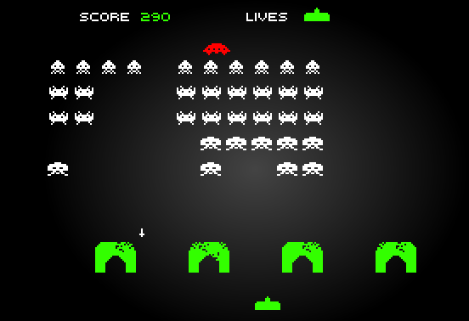

**Make as many parts of the game as you can, for extra bonus**

*Good luck and enjoy*

These scores have to be maintained

This spaceship is the same as making a shape that can move left or right as we already did in a lab.

**PAC MAN GAME**

Play this game at:

<http://www.pacmangame.org/>

You have to design and implement this game, with minimum functionality as described next.

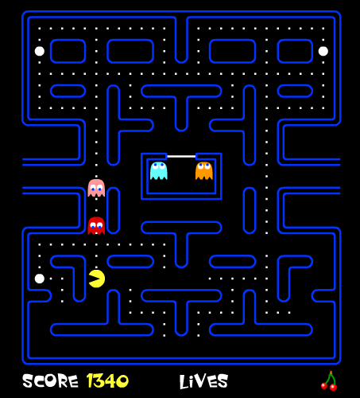

Pacman can be a circle or rectangle

You have to maintain scores and total lives left

The board can be simple made from simple dots and x characters to mark barriers. The idea is the same as for assignment 1, where you have to move up,down,left or right

You have to have a minimum of two ghosts. They can be circles or rectangles

You can have only one of these, so that when Pacman eats this, it is able to eat the ghosts

you can omit the cherry and advanced levels. One level is enough

**Make as many parts of the game as you can, for extra bonus**

*Good luck and enjoy*

**TYPING TUTOR GAME**

Play this game at:

<http://www.powertyping.com/typing_games/jibe/jibe.html>

You only need to implement only level 3, with three letter words

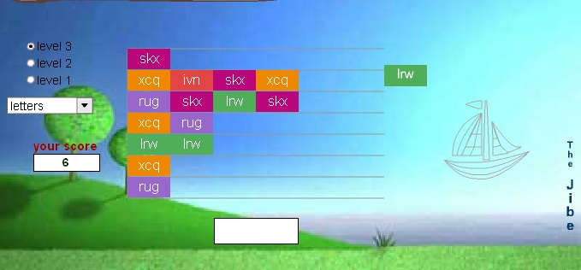

player’s typing facility should be provided and scores should be maintained

there is no need for graphics

You can make simple rectangles with words in them

As bonus you can implement this game for words of different lengths and highlight the matched part of the word

**Connect 4 game**

Read the rules of the game from:

<http://www.coolmath-games.com/0-connectfour/>

Here the user can input the column number to place his piece. This can be a grid with two symbols ‘x’ and ‘o’.

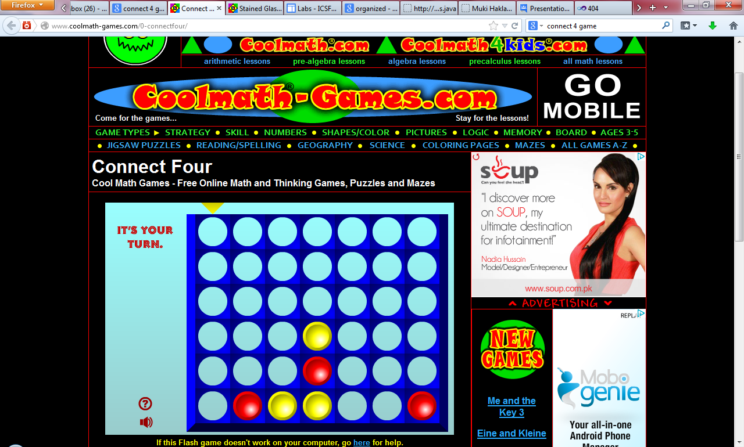

**Ball lines**

Read the rules from:

<http://www.coolmath-games.com/0-balllines/index.html>

In the grid below number the rows and columns and display the numbers also.

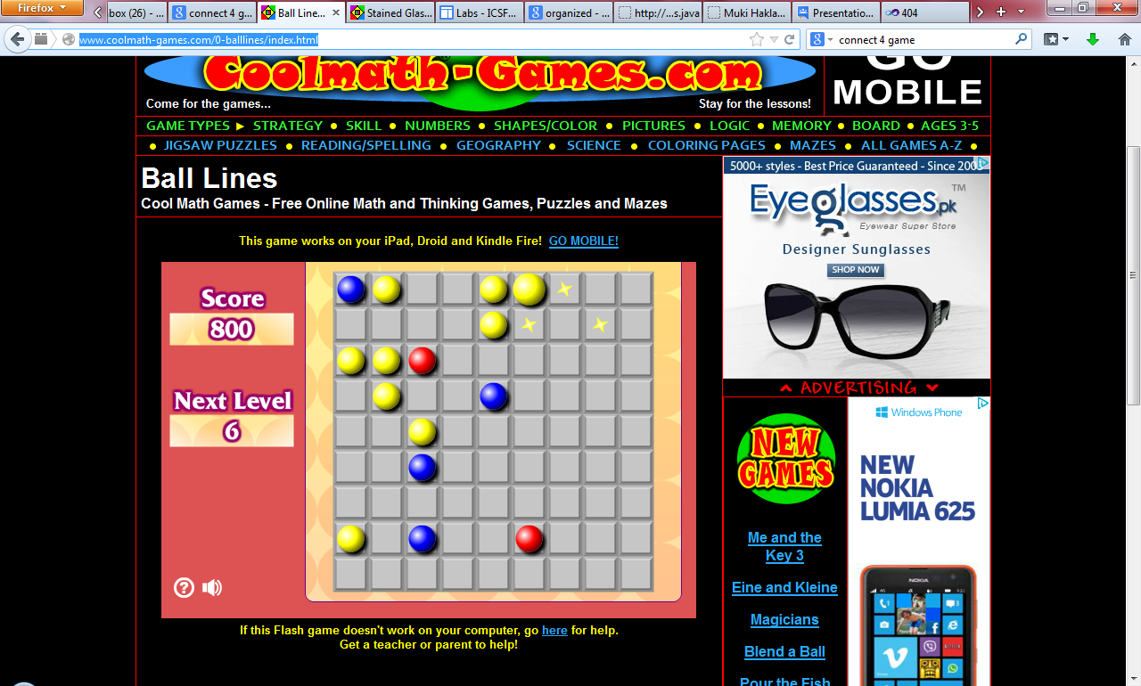

Here the user can select a ball by entering the cell number (x,y) of the source and destination cells. The rows should be numbered 1 to 9 and columns should also be numbered 1 to 9. Display the lines when moving a piece.

**2048 GAME**

**Difficulty level: easy**

Play the game on:

<http://gabrielecirulli.github.io/2048/>

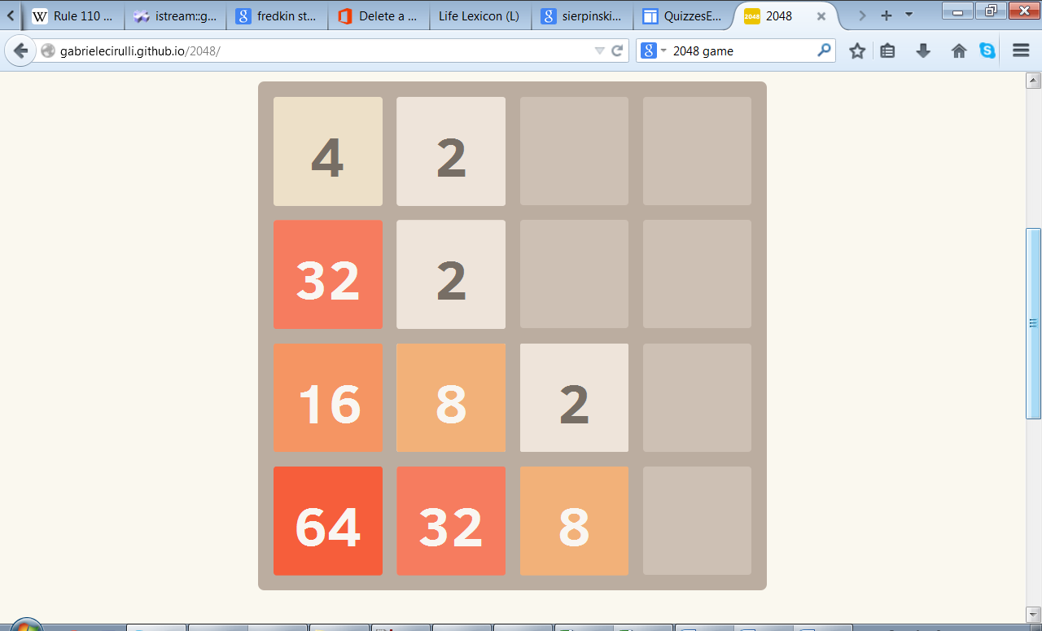

Implement all parts of the game, along with current score and best score. The ‘start new game’ option should also be there.

**OPTIONAL** for extra bonus: To add different flavor to the game you can make a bigger board with the numbers in powers of 3 instead of powers of 2. So this time three 3s will make a 9 and three 9s will make a 27 and so on.

Make the user interface as nice as possible

*Good luck*

**YOUR VERSION OF ANGRY BIRDS**

Missile fired by the shooter

**Difficulty level: intermediate**

Make a simpler version of angry birds as below:

target that will bounce up and down on the bar below

When the user fires, the missile, it follows the trajectory of a projectile to hit the target

shooter, that the player can rotate via the arrow keys

**NOTE:**

You have to implement the laws of motion to develop this game so you need to study the trajectory of a projectile. Any extra parameters should be input by the user in a creative way

Be creative and think of all the fun things you can implement here

*Good luck and enjoy*

**SIMPLIFIED VERSION OF ROBOZZLE**

**Difficulty level: challenging**

Play the game at:

<http://www.robozzle.com/>

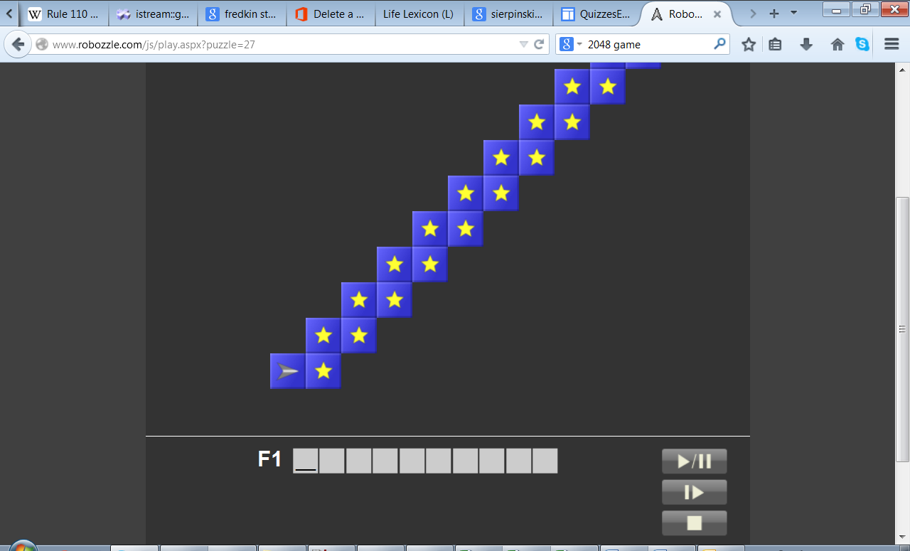

Implement a simpler rectangular grid of stars. You can read it from a file and that way it can be changed easily changed before starting the game. You can put a ‘-‘ in cells where the robot is not allowed to go

Implement only F1 and get a bonus for implementing F2.

Only implement the play button

Implementing robozzle is like implementing a small interpreter which looks at a series of commands and executes them. You can define special symbols/characters for commands. Like ‘f’ for forward, ‘r’ for rotate right, ‘l’ for rotate left, etc. Show the symbols and meaning at the bottom of the screen. Play the game online to understand how it is working.

Implementing a challenging problem is always a source of joy and satisfaction

*Good luck*

**YOUR VERSION OF ELIZA**

**Difficulty level : intermediate**

Try out Eliza at:

<http://nlp-addiction.com/eliza/>

Eliza was one of the first computer programs to demonstrate the concept of natural language processing and building a ‘chatbot’ or a ‘talking’ agent specialized for a certain task. You have to build your version of Eliza that specializes in performing mathematical calculations. For example:

User: Calculate for me 2+3

Your program: The answer is 5

User: What is 10 multiply 7

Your program: The required result is 70

This program is an example of text parsing and text processing. So given a string of characters, you will have to separate out the numbers and numeric operators and perform the calculation. The numeric operators can also occur in the text as strings. You have to do a minimum of ‘+’, ‘-‘, ‘*’,’/’, ‘%’ . Your program’s responses should also be more ‘human like’ and having minimum repetitions.

This would be your first fabulous artificial intelligence program

*Good luck*

*Good luck and enjoy*