Instructions:

* Download and install Anaconda
* Create and Activate your Anaconda Python env
* Python Exercise
* (Optional) Install and setup VS Code

**Download and install Anaconda**: <https://www.anaconda.com/products/individual>

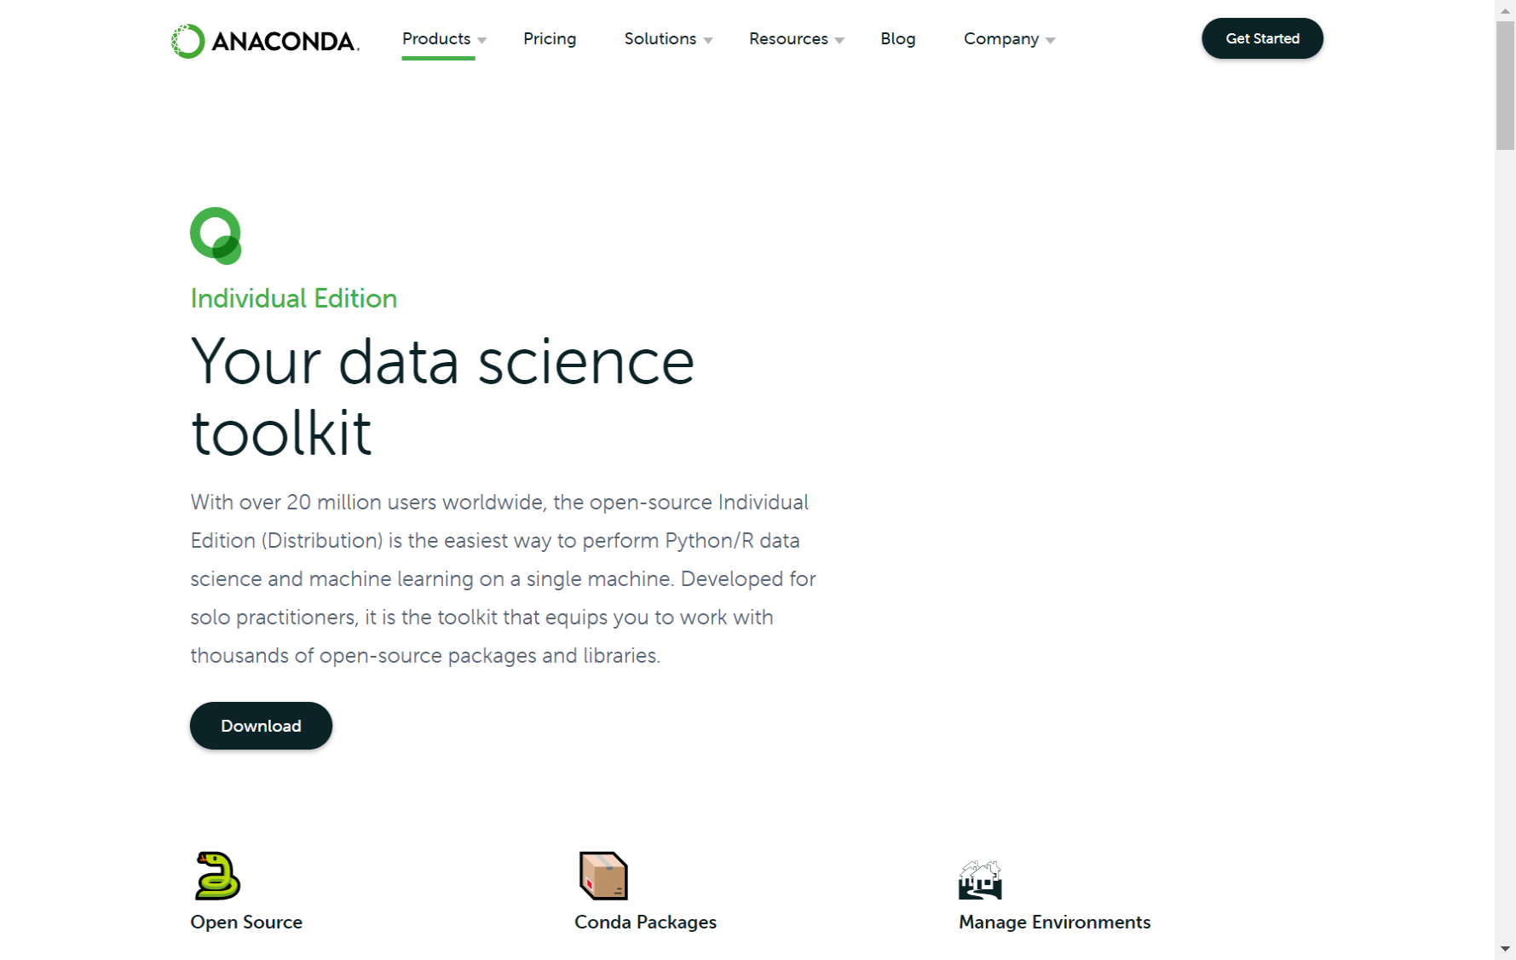

**Create and Activate your Anaconda Python env**

1. Start Anaconda Navigator
2. Launch command line

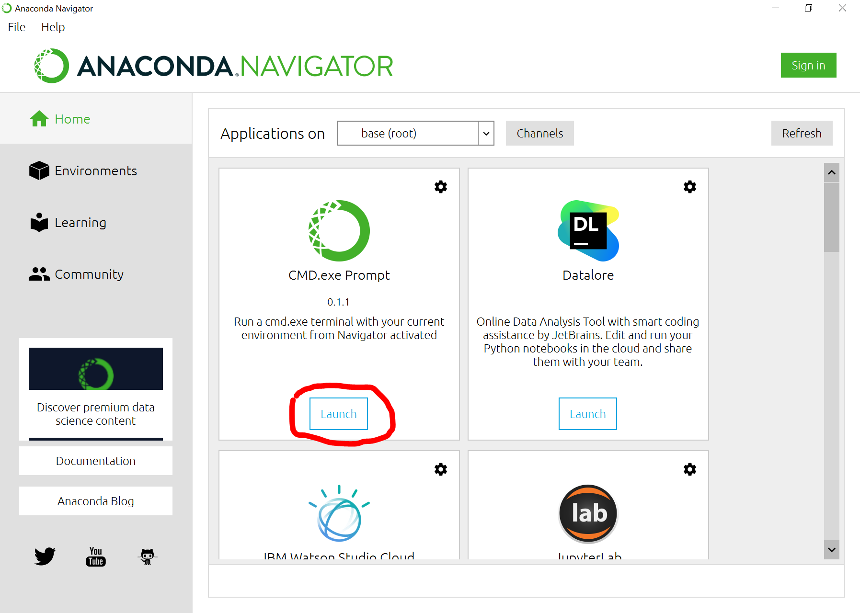

1. Create your virtual Python env (mth251) and exit once finished   
   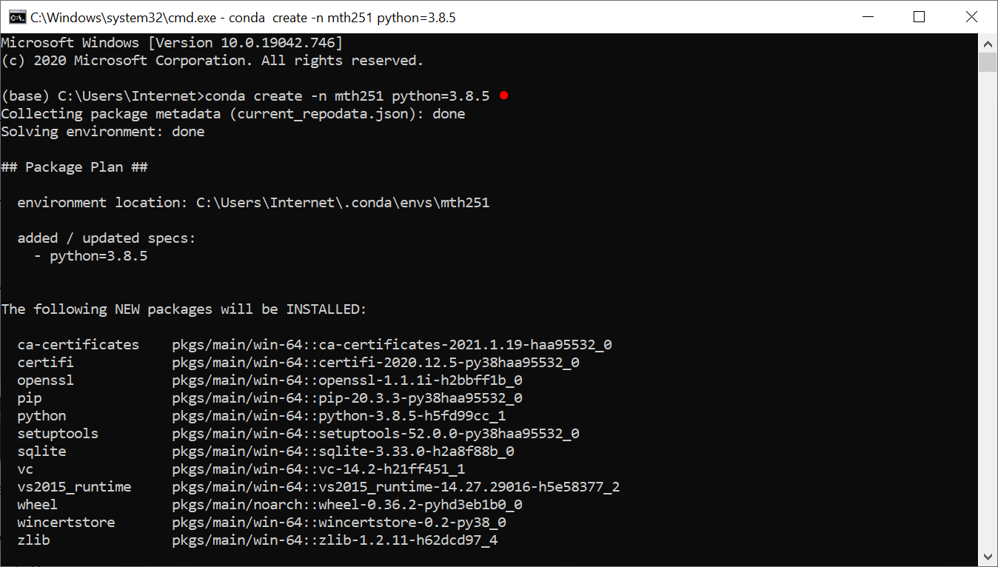
2. Back to Navigator and switch to your Python env mth251 from “Application on” dropdown and install Jupyter Notebook:  
   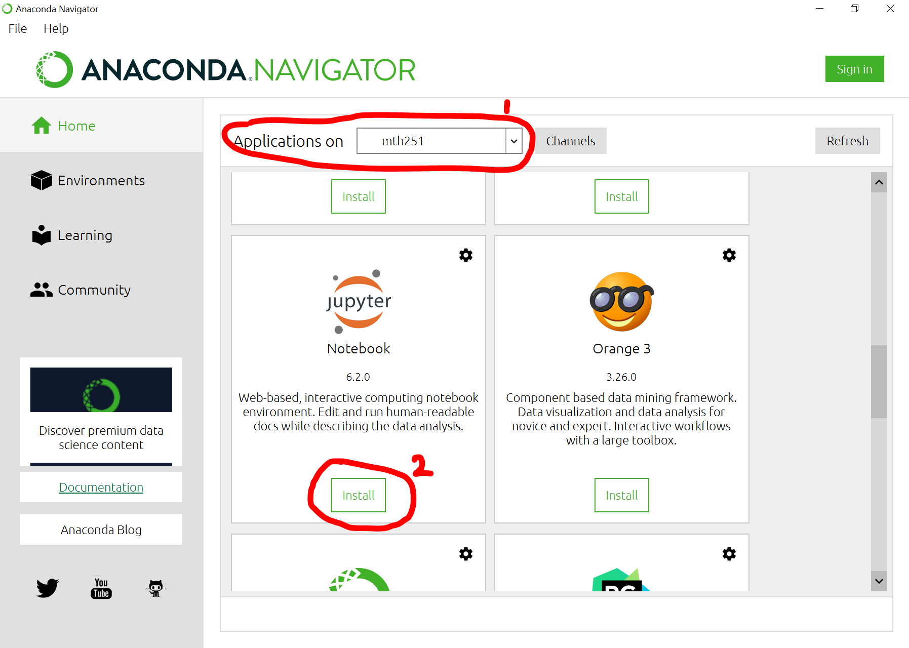
3. Launch the command line again
   1. Create and enter to your project root folder (e.g. C:\mth251)
   2. Activate your Python env for your project
   3. Launch Jupyter server

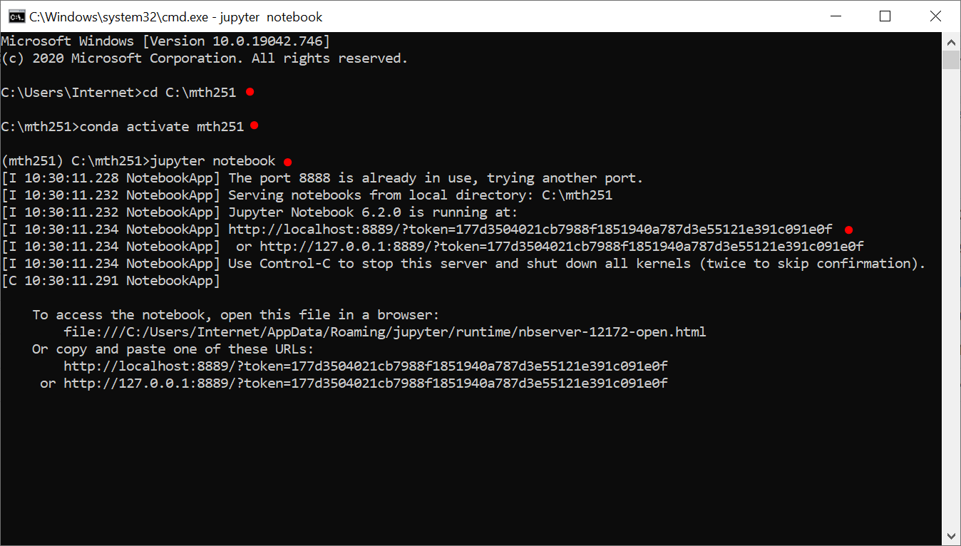

Notice the Jupyter link in the prompt, you can copy & paste it to your browser.

You can control-C to stop Jupyter from the command line.

Now You are ready to create, edit and run your Jupyter notebook (.ipynb):   
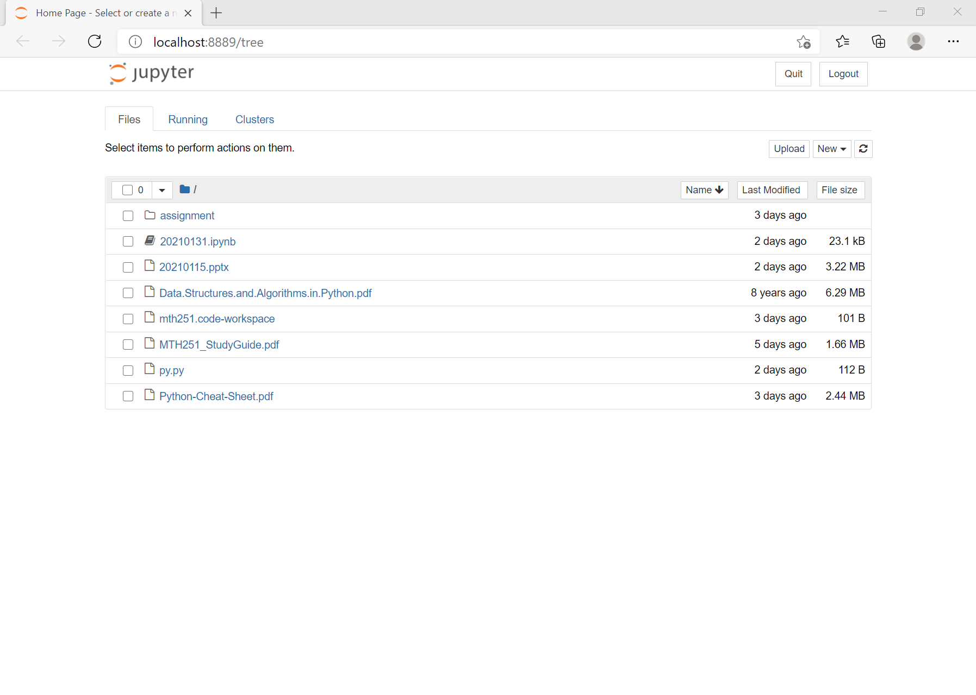

**Python Exercise**

1. Use 20210131.ipynb as reference to play with Python syntax:

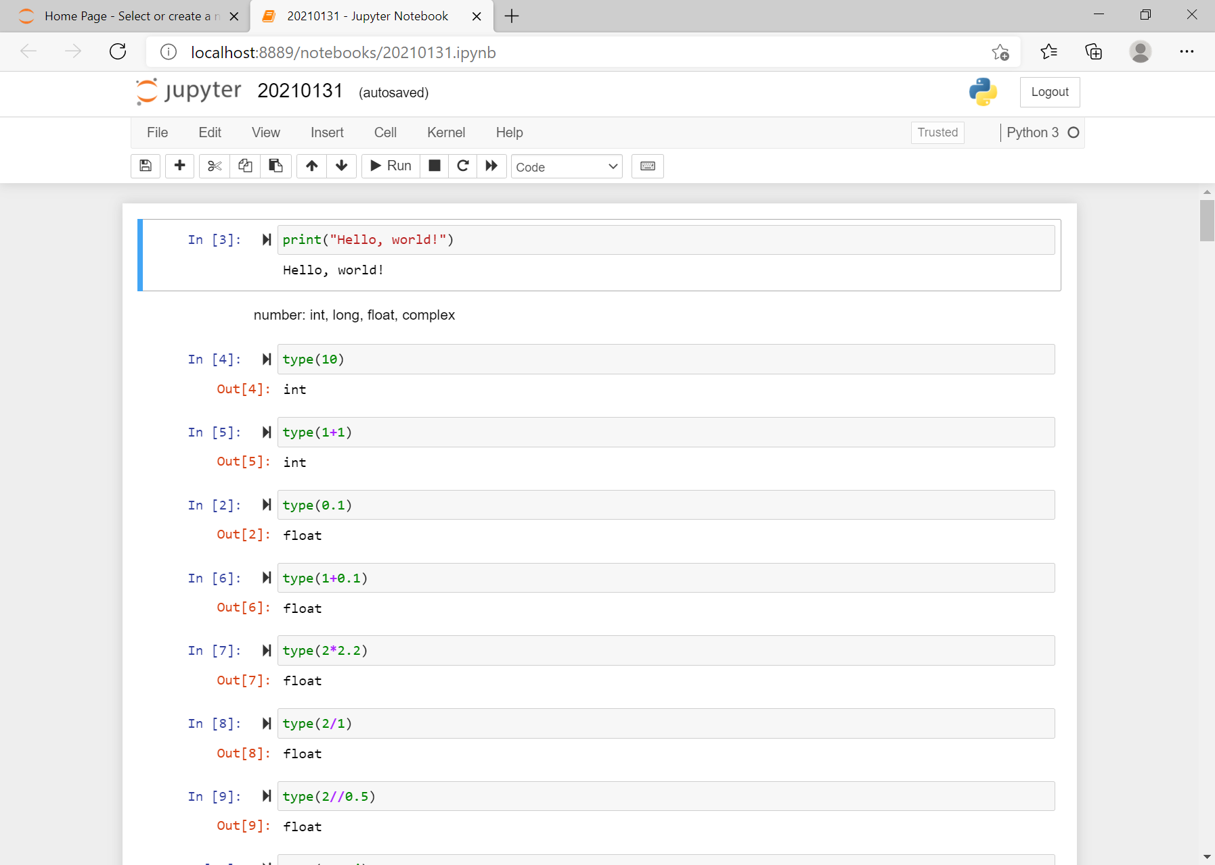

1. Go to <https://www.cs.usfca.edu/~galles/visualization/Search.html> to understand how Linear Search & Binary Search is working

1. Implement Linear Search & Binary Search in Python by yourself:
   1. Familiar with Python coding style
   2. Understand the input, output, steps and ending condition
   3. Learn and compare different approaches (time & space complexity)
   4. Test code reliability with different cases

**Install and setup VS Code**

Refer to this video “Getting Started with Python in Visual Studio Code”: <https://www.youtube.com/watch?v=7EXd4_ttIuw>