* Review binary tree and the traverse methods: **Pre-Order**, **In-Order, Post-Order, Level-Order**
* Exercise

**Exercise**:

* **Get maximum depth of binary tree**

*A binary tree's maximum depth is the number of nodes along the longest path from the root node down to the farthest leaf node.*

*For example: the maximum depth is 3*

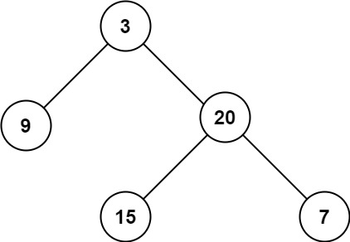

* **Check a balanced binary tree**

*A binary tree in which the left and right subtrees of every node differ in height by no more than 1.*

*balanced = true: balanced = false:*

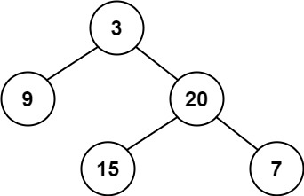 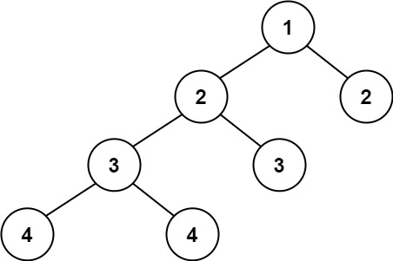

* **Check a complete binary tree**

*In a complete binary tree, every level, except possibly the last, is completely filled, and all nodes in the last level are as far left as possible. It can have between 1 and 2h nodes inclusive at the last level h.*

*complete = true: complete = false:*

