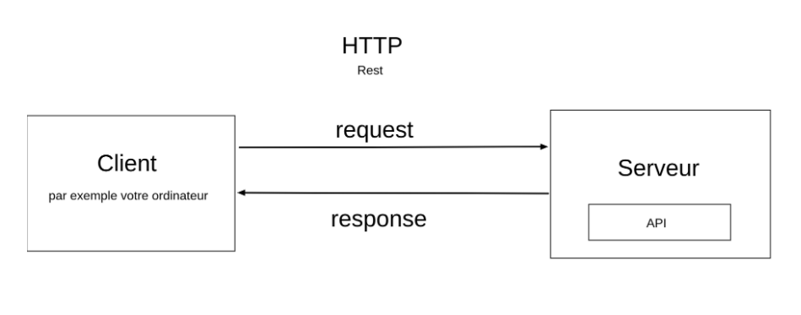
var obj = {
getWordLength: function (word) {
return word.length;
}
}

var request = require("request");

request.get("https://restcountries.eu/rest/v2/name/spain", function (err, res, body) {
console.log(err);
console.log(res.statusCode);
console.log(typeof body);
// console.log(body);

var bodyParsed = JSON.parse(body)

console.log(typeof bodyParsed);
// console.log(bodyParsed);

console.log(bodyParsed[0].capital)

var stringifyBody = JSON.stringify(bodyParsed)

console.log(stringifyBody)
console.log(typeof stringifyBody)
});

// {
// "foo": 1,
// "bar": ["buzz", "woody"]
// }
var jsonStr = '{"foo": 1, "bar": ["buzz", "woody"]}';
var json = JSON.parse(jsonStr);

console.log(json);

console.log(json.foo); // retournera 1
console.log(json.bar); // retournera ["buzz", "woody"]

var obj = { foo: 1, bar: ['buzz', 'woody'] };
var str = JSON.stringify(obj);

console.log("typeof obj:", typeof obj);
console.log("obj:", obj);

console.log(obj.length);

console.log("typeof str:", typeof str);
console.log("str:", str); // retournera '{"foo": 1, "bar": ["buzz","woody"]}'

console.log(str.length);

// {"foo":1,"bar":["buzz","woody"]}

var test = "hello";
console.log(test.length)

var str = "['Hello', 'how', 'are', 'you']"

console.log(typeof str);

console.log(str.charAt(2));

var request = require("request");

request.get("https://restcountries.eu/rest/v2/name/france", function (err, res, body) {
var firstCountry = JSON.parse(body);

var firstCurrency = firstCountry[0].currencies[0].name
console.log(firstCurrency);

request.get("https://restcountries.eu/rest/v2/name/senegal",
function (err, res, body) {
var secondCountry = JSON.parse(body);

var secondCurrency = secondCountry[0].currencies[0].name
console.log(secondCurrency);

console.log(`The currencies of ${firstCountry[0].name} and ${secondCountry[0].name} are ${firstCurrency === secondCurrency ? "the same" : "different"}`);
}
)
});

//Tester cette partie plusieurs fois pour voir que le 2 et le 3 ne s'affichent pas toujours dans le même ordre
var request = require("request");

var firstCountry = [];
var firstCurrency = "";

var secondCountry = [];
var secondCurrency = "";

console.log(1);

request.get("https://restcountries.eu/rest/v2/name/france", function (err, res, body) {
console.log(2);
firstCountry = JSON.parse(body);

firstCurrency = firstCountry[0].currencies[0].name;
console.log(firstCurrency);
});

request.get(

"https://restcountries.eu/rest/v2/name/senegal",

function (err, res, body) {
console.log(3);
secondCountry = JSON.parse(body);

secondCurrency = secondCountry[0].currencies[0].name
console.log(secondCurrency);

}
)

console.log(4);

