Smart Agriculture Robot for Crop Monitoring Using IoT Sensing, Autonomous Navigation and Edge AI
Prathamesh Fatangade¹, Tejas Kalaskar², Yash Jagdale³, Yash Hinge⁴, Dr. Sunil Mahajan^{5*}
^{1, 2, 3, 4}Student, MAEER’s MIT Arts, Commerce and Science College, Alandi (D), Pune, Maharashtra, India
⁵Associate Professor, Department of Electronics, MAEER’s MIT Arts, Commerce and Science College, Alandi (D), Pune, Maharashtra, India
*Corresponding Author: spmahajan@mitacsc.ac.in

Abstract—Smart agriculture integrates sensing, communication, automation, data analytics and decision support to improve the management of crops and agricultural inputs. This paper presents the design and analysis of a ground-based smart agriculture robot for crop monitoring that moves through field rows or protected-cultivation corridors while collecting soil, crop, weather and navigation information. The robot combines environmental and soil sensors, RGB or multispectral imaging, positioning devices, obstacle-detection sensors, edge computing and wireless communication to perform frequent, geo-referenced crop scouting. Its key functions include soil-moisture mapping, microclimate monitoring, crop-row navigation, image acquisition, disease and pest symptom screening, weed observation, water-stress assessment and alert generation, with observations reported to the farmer through a dashboard or mobile application. The paper describes the layered system architecture, component selection, working methodology, artificial-intelligence pipeline, data model, evaluation framework and performance metrics, and discusses economics, risks, sustainability and an incremental implementation roadmap. The design treats automated predictions as decision support that complements, rather than replaces, agronomic judgement. Field robustness, affordability, connectivity, interoperability and model generalization are identified as the principal barriers to adoption, and a staged development path is recommended to address them.
Index Terms—Agricultural robotics, autonomous navigation, computer vision, crop monitoring, decision support, edge AI, Internet of Things, plant disease detection, precision agriculture, smart agriculture.
I. Introduction
Crop production depends on continual observation. Farmers need to know whether plants are receiving enough water, whether a disease is spreading, whether weeds are competing with the crop, whether the soil is suitable, and whether a particular area is developing differently from the rest of the field. In conventional practice, these observations are obtained through field walks, visual inspection, sampling, communication with farm workers and periodic laboratory tests. This knowledge is valuable, but manual scouting becomes difficult when farms are large, labour is limited, crop conditions change quickly, or observations must be repeated frequently [1].
Smart agriculture attempts to make farm management more timely and location-specific. Rather than treating an entire farm as uniform, precision methods collect information from multiple locations and use that information to guide action [2]. A field may contain wet and dry zones, nutrient-rich and nutrient-poor areas, shaded and sun-exposed sections, healthy and stressed plants, and differences in pest pressure. A monitoring robot can move close to plants, collect observations at repeated locations, attach them to a map, and help farmers focus attention where it is most needed.
Ground robots are useful in this setting because they can work beneath or beside the crop canopy, obtain close-range images, carry soil probes and environmental sensors, and revisit the same routes [3], [5]. They complement other platforms such as drones, satellites, fixed sensor stations, tractors and manual inspection. A drone can rapidly cover a large area from above, whereas a ground robot can observe individual leaves, stems, fruit clusters, irrigation lines and soil conditions in detail. The choice of platform depends on crop type, row spacing, terrain, farm size, operating cost and the decisions the farmer wants to make.
This paper describes an implementable smart agriculture robot for crop monitoring. The focus is not only the mechanical vehicle but the full information chain: sensing, localization, navigation, storage, communication, analysis, visualization, recommendation and human validation. The main contributions are: (i) a modular, layered architecture for a low-cost crop-monitoring robot; (ii) a sensor-selection and data-model framework for geo-referenced field observations; (iii) an AI pipeline that reports indicators with confidence and evidence rather than unsupported diagnoses; and (iv) an evaluation framework and staged implementation roadmap suitable for field validation.
The remainder of the paper is organized as follows. Section II reviews related concepts and literature. Section III states the problem, objectives and scope. Section IV presents the system architecture and hardware design. Section V describes the methodology covering navigation, data management, AI analysis, communication and decision support. Section VI defines the evaluation framework. Section VII presents an illustrative use case, Section VIII discusses benefits, limitations, economics and ethics, Section IX outlines the implementation roadmap, and Section X concludes the paper.
II. Literature Review
A. Precision Agriculture
Precision agriculture is the management of agricultural variability using measurement, analysis and targeted action [2]. The required data may come from soil sampling, weather stations, yield monitors, crop sensors, satellites, drones, farm records or mobile robots. When these observations are geographically referenced, the farmer can identify spatial patterns rather than relying solely on field-wide averages. Important applications include irrigation scheduling, fertilizer management, weed mapping, disease surveillance, yield estimation, machinery guidance and variable-rate application. The value of the technology arises not from collecting data alone but when data changes a practical decision, such as checking a suspicious crop zone, repairing an irrigation line, changing irrigation timing, or treating only an affected part of the field [13].
B. Agricultural Robotics
Agricultural robots perceive their surroundings, move or operate in the farm environment, and perform tasks with partial or full autonomy [3], [4]. Their tasks range from harvesting and weeding to sowing, spraying, phenotyping, livestock monitoring and crop scouting [5]–[7]. For monitoring tasks, the robot carries sensors and moves them to useful observation points. The outdoor environment is nevertheless difficult: soil can be uneven, plants grow and obstruct the path, sunlight changes, dust affects sensors, and network connectivity can be weak [6], [18]. The Food and Agriculture Organization has highlighted robotics and automated equipment as enablers of sustainable crop production while noting affordability and skills as adoption constraints [1], [16].
C. Crop Monitoring and AI-Based Disease Detection
Crop monitoring is the repeated measurement of plant and field condition over time, including canopy appearance, leaf colour, lesions, plant height, flowering, fruit development, soil moisture, temperature and humidity. Monitoring does not necessarily identify the cause of a problem; yellow leaves, for example, may result from nitrogen deficiency, waterlogging, disease, root damage or natural ageing. Deep convolutional neural networks have achieved high accuracy on curated leaf-image datasets such as PlantVillage [8], [9], [11], and surveys confirm the rapid uptake of deep learning in agriculture [10]. However, performance frequently drops on field images with cluttered backgrounds and variable illumination [9], [10], which motivates field-collected datasets and confidence-aware outputs. Spectral vegetation indices provide a complementary route to stress assessment [14].
D. Internet of Things and Edge Computing
The Internet of Things (IoT) connects sensors, devices, controllers and software through communication networks [12]. In the proposed system, the robot acts as a mobile IoT node: it measures data, stores it locally, sends selected information to a server, and receives configuration or mission instructions. Edge computing performs part of the processing on the robot itself, which is useful when internet service is unreliable, when immediate obstacle avoidance is required, or when uploading every raw image would be expensive [12], [13].
E. Research Gap
Existing work tends to address individual components—navigation, disease classification or IoT sensing—in isolation, often under controlled conditions. There remains a need for an integrated, low-cost and modular monitoring platform that links mobile sensing with geo-referenced data management, uncertainty-aware AI and farmer-oriented decision support, and that is evaluated with field-relevant metrics. This paper addresses that gap at the design and evaluation-framework level.
III. Problem Statement, Objectives and Scope
A. Problem Statement
Farmers often face delayed detection of crop stress because manual observation is periodic rather than continuous. A plant disease may appear in a small portion of the field, spread before the next inspection, and become expensive to control. Similarly, irrigation may be scheduled by time rather than actual soil moisture, causing under-irrigation, water loss, nutrient leaching or unnecessary pumping costs. These problems become more serious when the farmer manages multiple plots or when seasonal labour is unavailable.
The central problem addressed by this research is the absence of a low-cost, mobile and repeatable system capable of collecting localized crop and environmental information without requiring a person to walk every row. The solution must navigate agricultural terrain, identify or avoid obstacles, capture useful images in changing light, record reliable sensor readings, communicate findings under limited connectivity, and present information in a form that a farmer can understand and act upon.
B. Research Objectives
- To design a mobile robotic platform for crop-row and field monitoring.
- To collect soil, microclimate, crop-image and positional data at repeated field locations.
- To develop an autonomous or semi-autonomous navigation method suitable for agricultural rows.
- To use image analysis to screen for visible disease symptoms, nutrient stress, pest damage, weeds and water stress.
- To create a data-management and dashboard system for maps, alerts, trends and reports.
- To support precision irrigation, targeted scouting and more efficient use of labour and inputs.
C. Scope of the Study
This work focuses on crop monitoring rather than fully autonomous farming. The robot is designed to observe, record, classify and report conditions; selective spraying, sampling, mechanical weeding and irrigation control are possible extensions outside the basic scope. The primary prototype target is row crops or protected cultivation with a navigable path. Crops such as tomato, chilli, cotton, soybean, maize, potato, leafy vegetables and greenhouse vegetables can be considered, although the sensor arrangement and navigation approach must be adapted to crop geometry.
The system is intended as a decision-support tool. It does not make a final diagnosis of every disease, prescribe pesticide products, or replace expert agronomic assessment. Instead, it prioritizes locations and plants for inspection. When an abnormal pattern is detected, the robot stores the evidence, estimates confidence, notifies the user and encourages confirmation before costly or irreversible actions are taken.
IV. Proposed System Architecture
The proposed architecture contains mechanical and power, sensing, localization and safety, edge-computing, communication, cloud and user-interface layers, as shown in Fig. 1 and summarized in Table I. Each layer has a distinct responsibility, but they work together during a monitoring mission. The robot is designed in modules so that components can be upgraded without rebuilding the entire system.
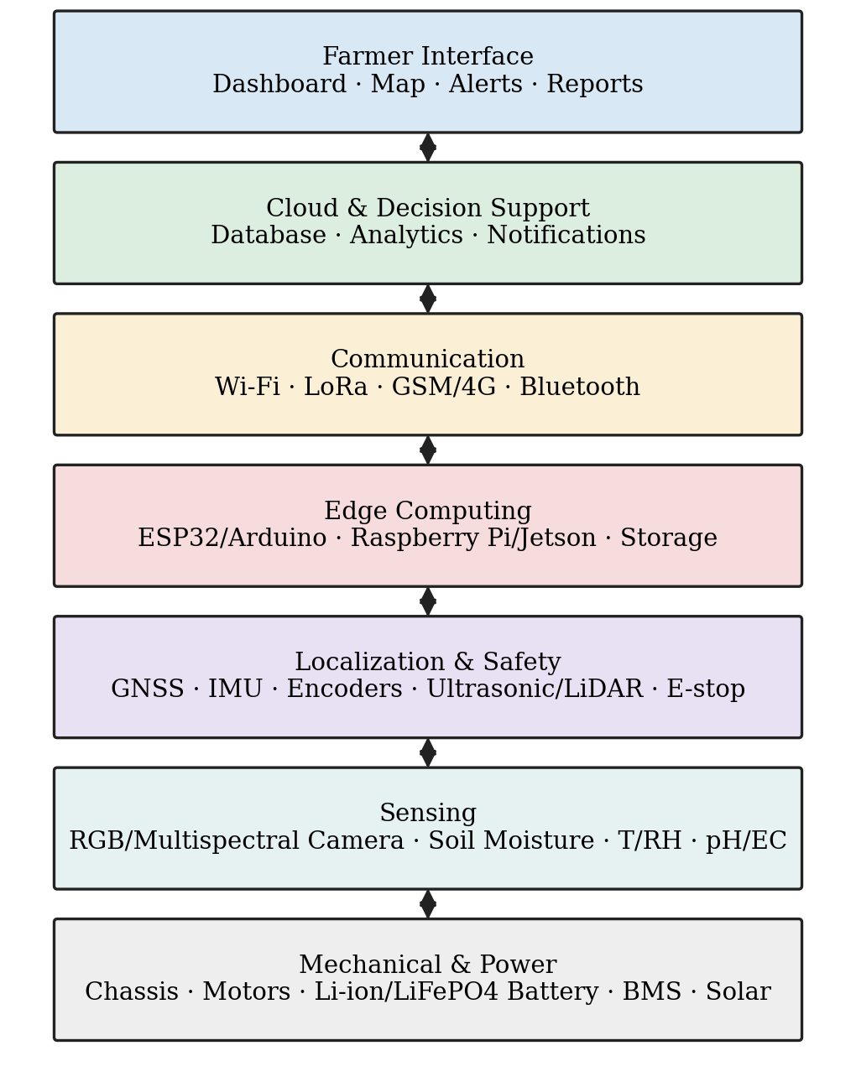
Fig. 1. Layered architecture of the proposed crop-monitoring robot.
TABLE I
Layers of the Proposed System
Layer | Typical Components | Primary Role
Mechanical and power | Chassis, wheels, motors, gearbox, battery, solar charger, weatherproof enclosure | Stable movement and electrical power
Sensing | Camera, soil-moisture, temperature–humidity, light, pH/EC and gas sensors | Observes crop, soil and local environment
Localization and safety | GPS/GNSS, IMU, wheel encoders, ultrasonic sensors, LiDAR, emergency switch | Estimates position and prevents collision
Edge computing | ESP32, Arduino, Raspberry Pi, Jetson-class board, storage | Device control and local processing
Communication | Wi-Fi, LoRa, Bluetooth, GSM/4G/5G | Transmits data, alerts and commands
Cloud and application | Database, dashboard, map interface, notification service | Stores history; presents actionable information

A practical prototype may use an ESP32 or Arduino for motor and sensor control, paired with a Raspberry Pi for imaging, higher-level navigation, local storage and dashboard communication. A computationally demanding disease-detection model may require a Jetson-class edge device or a server-side model. The correct choice depends on response-time needs, budget, power availability and network conditions.
A. Mechanical Design
The chassis must fit between crop rows without contacting plants; its width should be smaller than the narrowest navigable row spacing, leaving a safety margin on both sides. Its height should allow sensors to view the intended part of the crop: a low camera position suits leaf-level inspection, while a raised mast may be needed for canopy observation. The centre of gravity should be low to reduce tipping on uneven ground.
A four-wheel differential-drive chassis is easy to control and suitable for many prototypes. The left and right wheels are driven independently, allowing forward and reverse movement, gradual turns and in-place rotation. A tracked chassis provides better traction on soft soil but may consume more power and disturb soil during turns, whereas Ackermann steering is more efficient at higher speeds but requires a larger turning radius and more complex geometry. The mobility requirements are:
- Adequate ground clearance to avoid crop residue, small rocks and irrigation tubing.
- Wheel tread and motor torque matched to expected soil texture and slope.
- Low-speed motion for sharp images and safe obstacle avoidance.
- Wheel encoders for distance measurement and odometry.
- Protective guards that prevent crop stems and wires from entering the wheels.
- A waterproof or splash-resistant enclosure for electronics, and a physical emergency-stop switch accessible to the operator.
B. Power System
Battery selection is a major design decision because motors and computing hardware draw power continuously. Lithium-ion or lithium iron phosphate (LiFePO₄) packs are commonly used for their relatively high energy density. Capacity should be calculated from the expected current draw of motors, sensors, processor and communication module plus a safety margin; a robot expected to operate for four hours should be tested under realistic terrain and payload conditions rather than estimated only from laboratory motor ratings.
Solar panels can extend operating time, but small panels may not supply enough instantaneous power for motor acceleration; solar charging is therefore treated as a supplement to the battery. The power design includes voltage regulation, fuses, a battery-management system, reverse-polarity protection, low-voltage shutdown, and measurement of battery voltage and current for maintenance alerts.
C. Sensor Suite
1) Soil moisture: Soil moisture is one of the most useful measurements for irrigation management. Capacitive sensors are preferred over resistive sensors for low-cost prototypes because they are less affected by corrosion, but any low-cost sensor requires calibration for the particular soil type. The robot therefore records raw readings as well as calibrated estimates and periodically compares electronic readings with manual soil observations.
2) Temperature, humidity and light: Air temperature and relative humidity influence plant water demand and disease risk; high humidity and leaf wetness favour some fungal diseases, while high temperatures contribute to heat stress. Light sensors help interpret image quality and canopy conditions. Sensors placed near electronics or motors may give biased readings and should be shielded, ventilated and positioned away from heat sources.
3) Soil pH, EC and nutrients: Soil pH affects nutrient availability, and electrical conductivity (EC) can indicate salinity but is influenced by moisture and temperature. Portable NPK sensors should not be treated as laboratory-equivalent without calibration; the robot uses them mainly to identify relative variation and prioritize locations for confirmatory soil tests.
4) Imaging: An RGB camera is the most accessible choice for crop monitoring and captures leaf colour, spots, shape, canopy cover, fruit visibility and weeds. Camera placement should minimize vibration and glare; a hood, polarizing filter or controlled illumination improves consistency outdoors. Multispectral cameras support vegetation indices sensitive to plant vigour [14], and thermal cameras can indicate possible water stress when interpreted with ambient conditions, at higher cost and calibration effort.
5) Obstacle and navigation sensing: Ultrasonic sensors are inexpensive for detecting large, close obstacles but are affected by soft vegetation and angled surfaces. LiDAR offers detailed range measurements and supports mapping at higher cost. An IMU measures acceleration and rotation, wheel encoders estimate movement, and GNSS provides global position; RTK-GNSS gives much higher accuracy when a correction source is available. Combining sensors is generally more reliable than depending on any single one. Table II summarizes the sensor suite.
TABLE II
Sensor Suite and Limitations
Sensor | Measurement | Purpose | Key Limitation
Capacitive moisture probe | Relative soil water content | Irrigation-zone identification | Needs soil-specific calibration
Temperature–humidity sensor | Air temperature and RH | Microclimate and disease-risk context | Affected by placement and shielding
RGB camera | Visible image | Leaf symptoms, weeds, canopy | Sensitive to lighting and occlusion
Multispectral camera | Selected spectral bands | Vigour and early stress | Higher cost and calibration
Thermal camera | Surface temperature | Water-stress screening | Weather and emissivity effects
GNSS/GPS | Geographic position | Route and geotagging | May be inadequate in narrow rows
IMU and encoders | Motion and orientation | Local localization, motion control | Drift without correction
LiDAR / ultrasonic | Distance to objects | Obstacle avoidance | Vegetation and dust effects

V. Methodology
A. Navigation and Autonomy
1) Levels of autonomy: The robot is developed in stages. In manual mode, the operator drives the vehicle while it records measurements. In assisted mode, the robot maintains speed, avoids close obstacles and follows a row while the operator supervises. In autonomous mode, it follows a planned route, detects row ends, turns, returns to a charging point and reports exceptions. Supervised operation is recommended first because it yields realistic data before complex autonomy is introduced.
2) Localization: Localization estimates the robot’s position and orientation. Global position is needed to map observations across the farm, while local position is needed to stay inside a row. GPS may suffice on large open paths but can drift too much in narrow spaces. Fusing GNSS, wheel odometry, IMU, camera and LiDAR data with an extended Kalman filter combines these sources while accounting for their different uncertainties [17].
3) Crop-row following: A basic visual approach acquires a camera frame, segments green crop regions, soil and the navigable corridor, and estimates the path centre line. The controller compares this line with the robot’s heading and adjusts left and right wheel speeds. Advanced variants use a neural network that predicts steering commands or a semantic-segmentation model that separates crop, soil, weeds and obstacles. Because overlapping plants, weeds resembling the crop, shadows, visible irrigation lines or missing rows can confuse the system, it must be able to slow down, stop safely, request remote assistance, or switch to an alternative sensor; a safe stop is preferable to a confident but incorrect movement.
4) Obstacle avoidance: Obstacle avoidance protects people and equipment and prevents crop damage. The robot maintains a protective zone ahead of its path and decelerates or stops if a person, animal, tool, rock or irrigation component enters it. Emergency stop, proximity detection and motor shutdown operate locally and do not depend on a cloud connection.
B. Data Acquisition and Management
Every observation includes a timestamp, robot identifier, position estimate, sensor values, sensor-health status, image reference, mission identifier and crop or plot identifier, as defined in Table III. Without these fields it is difficult to compare observations over time or locate a specific alert.
TABLE III
Observation Data Model
Field | Description | Example
Mission ID | Identifier for one monitoring run | M-2026-09-29-01
Timestamp | Date and time of observation | 2026-09-29 18:30:12
Latitude, longitude | Approximate geographic position | 12.9716, 77.5946
Row / plot ID | Farm-defined location label | Tomato-R07
Sensor readings | Environmental and soil values | Moisture 24%, air temp. 31 °C
Image ID | Reference to stored image | IMG_R07_00328.jpg
Model output | Classification and confidence | Possible leaf spot, 0.82
System status | Battery, network, sensor health | Battery 68%, network weak

Raw data are preserved where feasible because improved models may later be trained on earlier images and measurements. As storage can become expensive, a practical compromise is to keep all alert images, periodic representative images, sensor summaries and a configurable subset of ordinary images. Local buffering with later synchronization is essential in rural environments with intermittent networks.
C. Artificial Intelligence for Crop Analysis
1) Image-processing pipeline: The pipeline begins with quality control, flagging blurred, over- or under-exposed and heavily occluded images before classification. Pre-processing includes resizing, colour normalization, contrast adjustment, background reduction and, during training, augmentation. Subsequent steps may include leaf detection, lesion segmentation, plant–soil segmentation or direct classification. The output comprises a label, confidence score, location, image evidence and a recommendation for human verification when confidence is low.
2) Disease detection: Convolutional neural networks are widely used because they learn image features automatically [8]–[10]. Transfer learning reduces the data needed by adapting models pre-trained on large image collections; lightweight models suit edge devices, while larger models can run on a server after upload. A major concern is the gap between laboratory and field images: a model that performs well on clean leaves against uniform backgrounds may fail when leaves overlap, soil is visible, shadows or rain reflections occur, symptoms are at an early stage, or multiple problems co-exist [9]. Field-deployable models must therefore be trained and evaluated on images captured in realistic local conditions, with attention to dataset diversity, annotation quality, class balance and testing on unseen farms.
3) Stress and nutrient indicators: Not every crop problem corresponds to a named disease. The system may identify general stress patterns such as chlorosis, wilting, low canopy density, leaf curling or abnormal colour, which are reported as indicators rather than diagnoses. For example, a yellowing pattern prompts the message “possible nutrient or water-related stress—inspect soil moisture, fertilizer history, roots and disease symptoms”, which is safer and more useful than an uncertain definitive label.
4) Weed and canopy analysis: Computer vision can distinguish crop rows from inter-row weeds when trained for the relevant crop stage, and can estimate vegetation cover, gap frequency, plant count, canopy width and row continuity. These measures reveal poor emergence, damaged sections or irrigation problems, although plant overlap and occlusion can distort counts and must be communicated as uncertainty.
5) Explainability and confidence: Each alert presents the source image, highlighted suspicious region (e.g., using class-activation maps [15]), confidence score, sensor context and comparison with previous observations. Explainability does not guarantee correctness, but it helps farmers and advisers check whether the model focused on a reasonable part of the plant.
D. Communication and Cloud Platform
Communication options are selected according to field size, infrastructure, message size and power budget. Wi-Fi is convenient near buildings and greenhouses; LoRa transmits small sensor messages over long distances at low power but is unsuitable for frequent high-resolution images; cellular networks support remote monitoring where coverage exists, with recurring data costs; and Bluetooth suits local set-up and maintenance. A hybrid strategy is adopted: the robot processes images locally, sends summaries and alerts over a low-bandwidth link, retains full images locally, and uploads detailed files on reaching Wi-Fi or stronger cellular coverage.
The cloud platform provides a map view, time-series graphs, mission history, battery status, image gallery, sensor-health page and alert log. Rather than displaying every raw measurement first, it highlights actionable questions: which zone is driest, which row needs inspection, where disease-like symptoms have increased, and whether the robot is ready for another mission.
E. Decision Support and Farmer Interface
The decision-support layer translates measurements into understandable messages. Instead of reporting only “soil moisture: 24%”, the interface compares the value with a configurable field threshold and displays “Row 7 is drier than the field median; inspect drip line and consider irrigation.” Thresholds remain configurable because acceptable moisture depends on crop, soil, growth stage, root depth and irrigation method. Alerts are prioritized: safety alerts such as motor overheating or low battery during autonomous movement require immediate action, while agronomic alerts carry a severity level, confidence, map position, supporting image and suggested verification activity. Repeated low-confidence alerts at the same location are retained, since persistent anomalies merit inspection.
F. Working Procedure
The complete mission workflow is illustrated in Fig. 2 and proceeds as follows:
- The farmer defines field boundaries, crop rows, route waypoints, crop type and alert thresholds.
- The robot performs a pre-mission self-check of battery, sensor connections, storage, motors and communication link.
- The robot starts at the mission point and begins manual, assisted or autonomous navigation.
- Localization sensors estimate position while obstacle sensors maintain a protective zone.
- Environmental and soil readings are recorded at specified distance or time intervals.
- The camera captures crop images with metadata linking each image to position and time.
- On-board software evaluates image quality and runs a lightweight screening model.
- Data are stored locally; summaries, alerts and selected images are transmitted to the dashboard.
- The dashboard converts observations into maps, trends and prioritized tasks.
- The farmer validates important alerts through inspection or expert consultation and records the action taken.
- Validated observations are used to improve model training and threshold calibration.
- The robot returns to a safe location for cleaning, charging, maintenance and data synchronization.
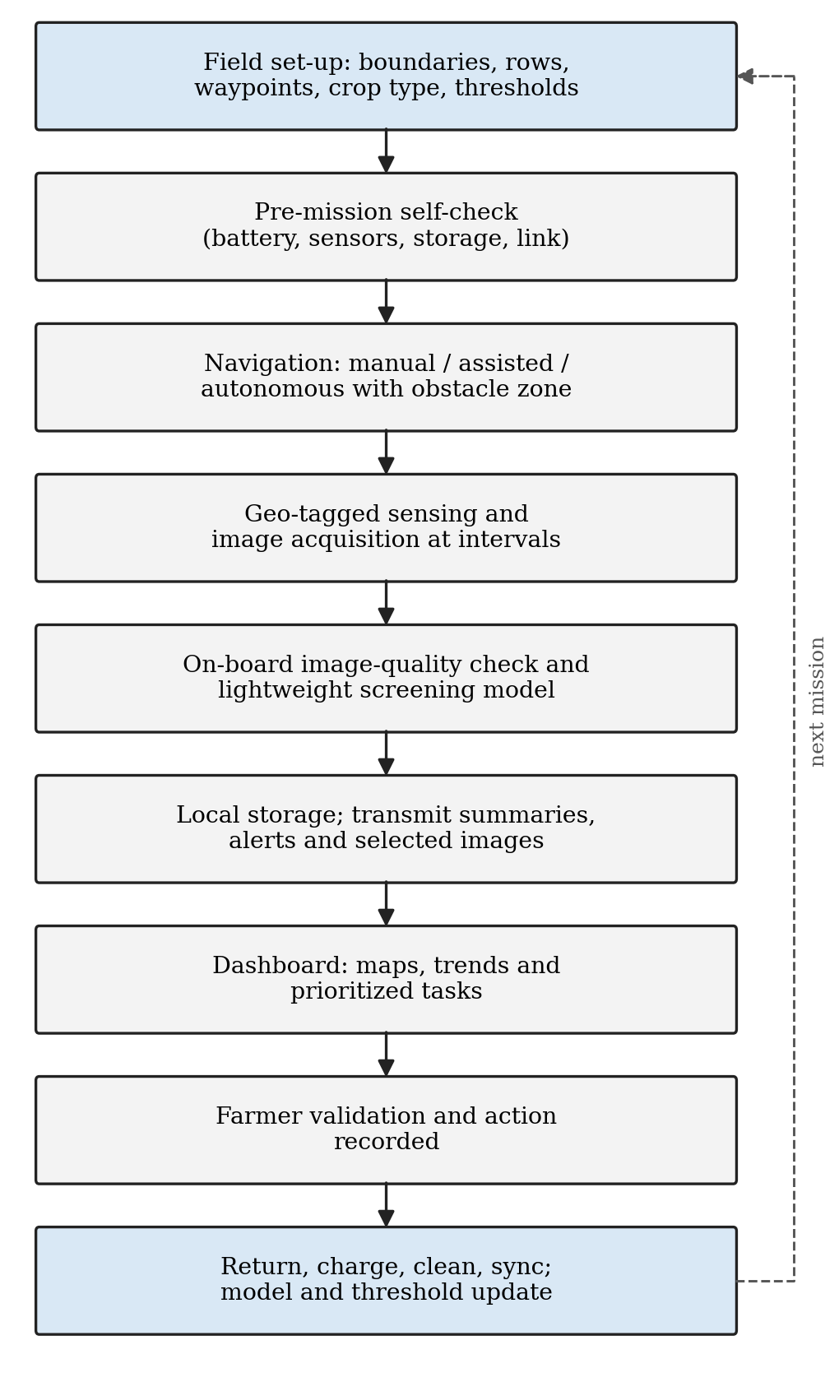
Fig. 2. Mission workflow of the crop-monitoring robot.
VI. Evaluation Framework and Performance Metrics
A. Navigation Evaluation
Navigation is assessed through repeatable field tests measuring row-following error, route completion, obstacle-detection rate, false-stop rate, average speed, turning success at row ends and number of manual interventions. Tests are repeated under different sunlight, soil, weed, moisture and crop-growth conditions, since a robot that works only on a clean, dry test track is not ready for agricultural deployment.
B. Sensor Evaluation
Sensor readings are compared with reference measurements: soil moisture with gravimetric testing or a calibrated probe, temperature and humidity with a reference instrument, and camera-based measurements with manual observations. Calibration error, drift, missing-data rate and response time are recorded. The aim is information reliable enough to improve field decisions rather than laboratory-grade accuracy for every sensor.
C. AI Evaluation
Disease and stress models are evaluated on images not used in training, using precision, recall, F1-score, confusion matrix, false-positive and false-negative rates, inference time and performance across farms and lighting conditions. In crop protection, false negatives can be serious because a missed disease may spread, while false positives waste inspection time; the acceptable balance depends on the use case. Accuracy claims must state the dataset, crop, conditions, test method and confidence threshold rather than a single headline percentage [9], [10].
D. User Evaluation
Farmer feedback assesses whether alerts are understandable, whether the robot saves time, whether the information changes farm decisions, whether maintenance is manageable and whether the cost is justified. Adoption often fails not because a model is inaccurate, but because the system is difficult to operate or repair, or poorly aligned with farm workflow. The complete set of performance metrics is listed in Table IV.
TABLE IV
Performance Metrics
Category | Metric | Interpretation
Navigation | Mean lateral row error | How well the robot stays centred in the row
Navigation | Route completion rate | Share of planned route completed without failure
Safety | Obstacle detection recall | Share of obstacles detected before collision risk
Sensing | Calibration error | Difference from reference sensor value
Vision | Precision and recall | Quality of alert classification
Vision | Inference latency | Time to analyse one image
Connectivity | Data-delivery success rate | Share of messages reaching the dashboard
Energy | Mission duration per charge | Operating time before recharge
Usability | Manual interventions per mission | Operator effort required
Agronomic value | Alerts validated in field | Usefulness of detected anomalies

VII. Illustrative Use Case
Consider a tomato farm divided into numbered rows. The robot begins a morning mission after irrigation, follows Row 1 at low speed and records soil moisture every five metres while its camera captures leaves on both sides of the path. In Row 4, the dashboard later shows a cluster of images with pale leaves and a soil-moisture reading below the field median. The model labels the images as “possible stress” rather than assigning a definite disease. The farmer visits the marked location and finds a partially blocked drip emitter; after repairing it, the farmer schedules a follow-up mission two days later. The example demonstrates the intended role of the system: it identifies and documents a localized anomaly, while a person verifies the cause and chooses the intervention.
VIII. Discussion
A. Benefits and Expected Impact
The primary benefit is improved awareness. Regular monitoring reduces the chance that a problem remains unnoticed until it becomes severe, produces consistent records even when different workers inspect the farm, and builds a historical archive of images and sensor readings that reveals seasonal patterns. Expected benefits include:
- Higher scouting frequency without repeated manual walking of every row.
- Early identification of abnormal zones for human inspection.
- Better irrigation awareness through repeated soil-moisture observations.
- Potential reduction of unnecessary field-wide input use through targeted action.
- Improved traceability of crop conditions, actions and recurring problem locations.
- Training material for farmers, students, technicians and extension workers, and integration with drones, weather data, irrigation controllers and farm-management systems.
B. Limitations and Risks
A crop-monitoring robot is not a guaranteed solution to all farm problems. It can fail mechanically, produce inaccurate data, misclassify images or be unable to traverse difficult terrain; its value depends on appropriate deployment and human oversight. The principal limitations are:
- Uneven terrain, mud, water, rocks and dense vegetation can limit mobility.
- Variable illumination, dust, rain and leaf overlap can reduce image quality.
- Low-cost sensors drift and need periodic calibration or replacement.
- AI models may not generalize across crops, seasons, cultivars, regions or disease stages [9].
- Network interruptions can delay data transfer, and battery capacity may limit coverage on large farms.
- High-end sensors and rugged components increase initial cost.
- Farm data, images and location information require secure access controls, and operators require training.
C. Economic Considerations
Economic feasibility depends on more than purchase price: a low-cost robot that fails frequently may be less economical than a slightly more expensive but maintainable one. Costs include chassis fabrication, motors, batteries, controllers, sensors, camera, communication hardware, cloud storage, repair, calibration, training and labour. Benefits may include saved scouting time, earlier detection of crop issues, reduced water or chemical waste, better record-keeping and avoided losses [1]. A modular design reduces financial risk: users may begin with a tele-operated monitoring cart carrying an RGB camera and soil-moisture sensor, and later add autonomous navigation, better cameras, cloud analytics or targeted actuation once practical value is demonstrated.
D. Sustainability and Ethics
The robot contributes to sustainability when it reduces waste of water, fertilizer, pesticides, fuel and labour. Sustainability is not automatic, however: batteries, electronics and sensors have environmental costs, and poorly designed automation creates electronic waste. The system therefore uses repairable components, replaceable batteries, durable enclosures, documented wiring and updatable software. Ethical deployment also requires attention to safety, data ownership and accessibility. Farmers should retain control over their records and understand how images and sensor data are stored or shared; recommendations should be transparent and should not pressure users into locally unvalidated actions; and systems should accommodate different farm scales, languages, literacy levels and connectivity conditions.
IX. Implementation Roadmap
An incremental five-phase plan is proposed, summarized in Table V. Phase 1 identifies the crop, row spacing, terrain, network, irrigation arrangement, intended decisions and budget, and determines which observations are most valuable. Phase 2 builds a manual or tele-operated platform with motor control, emergency stop, battery monitoring, GPS logging, RGB camera and basic environmental sensors to collect real data. Phase 3 adds assisted navigation and the dashboard. Phase 4 introduces disease-screening models, multispectral or thermal sensing where justified, and improved localization, with models trained on locally collected, expert-reviewed images and validated before automated alerts are relied upon. Phase 5 pilots the complete workflow over multiple weeks or crop stages, documenting failures, maintenance time, validated alerts, cost, user satisfaction and changes in farm decisions to decide whether the robot should be scaled, simplified or redesigned.
TABLE V
Implementation Phases
Phase | Focus | Key Output
1 | Requirements and field survey | Crop, terrain, network and decision priorities
2 | Basic prototype | Tele-operated sensing platform and real field data
3 | Assisted navigation and dashboard | Row following, obstacle stop, maps and alerts
4 | AI and advanced sensing | Validated screening models; improved localization
5 | Pilot deployment | Multi-week evaluation and scale-up decision

X. Conclusion and Future Scope
A smart agriculture robot for crop monitoring can bridge traditional field scouting and data-driven precision agriculture. By combining mobile sensing, close-range imaging, navigation, edge computing, communication and farmer-oriented dashboards, the proposed system creates detailed and repeatable observations of crop and field conditions, supporting early attention to possible disease, water stress, irrigation faults, weeds and abnormal plant growth. The robot is designed as a reliable decision-support platform rather than a replacement for farmer knowledge; its success depends on sensor calibration, safe movement, realistic image datasets, understandable alerts, secure data handling and a workflow that fits local farming practice. The recommended path is incremental: begin with a robust mobile sensing platform, validate it under real farm conditions, and add autonomy and AI only when each component demonstrates practical value.
Future work includes integration of drone imagery with close-range ground observations; RTK-GNSS and visual localization for higher-precision navigation; multispectral and thermal sensing for earlier stress screening; robotic arms for leaf sampling and fruit inspection; selective spraying or mechanical weeding after robust detection and safety validation; automated irrigation control linked to moisture maps and weather forecasts; swarms of smaller robots for large farms; federated or privacy-preserving learning; digital-twin models combining crop growth, weather, soil and sensor data; and predictive maintenance of batteries, motors and sensors.
Acknowledgment
The authors thank MAEER’s MIT Arts, Commerce and Science College, Alandi (D), Pune, for providing the facilities and support for this work.
References
[1] FAO, The State of Food and Agriculture 2022: Leveraging Automation in Agriculture for Transforming Agrifood Systems. Rome, Italy: FAO, 2022.
[2] R. Gebbers and V. I. Adamchuk, “Precision agriculture and food security,” Science, vol. 327, no. 5967, pp. 828–831, 2010.
[3] A. Bechar and C. Vigneault, “Agricultural robots for field operations: Concepts and components,” Biosystems Engineering, vol. 149, pp. 94–111, 2016.
[4] A. Bechar and C. Vigneault, “Agricultural robots for field operations. Part 2: Operations and systems,” Biosystems Engineering, vol. 153, pp. 110–128, 2017.
[5] R. R. Shamshiri et al., “Research and development in agricultural robotics: A perspective of digital farming,” Int. J. Agricultural and Biological Engineering, vol. 11, no. 4, pp. 1–14, 2018.
[6] T. Duckett et al., “Agricultural robotics: The future of robotic agriculture,” UK-RAS White Papers, UK-RAS Network, 2018, arXiv:1806.06762.
[7] L. Droukas et al., “A survey of robotic harvesting systems and enabling technologies,” J. Intelligent & Robotic Systems, vol. 107, Art. no. 21, 2023.
[8] S. P. Mohanty, D. P. Hughes, and M. Salathé, “Using deep learning for image-based plant disease detection,” Frontiers in Plant Science, vol. 7, Art. no. 1419, 2016.
[9] K. P. Ferentinos, “Deep learning models for plant disease detection and diagnosis,” Computers and Electronics in Agriculture, vol. 145, pp. 311–318, 2018.
[10] A. Kamilaris and F. X. Prenafeta-Boldú, “Deep learning in agriculture: A survey,” Computers and Electronics in Agriculture, vol. 147, pp. 70–90, 2018.
[11] D. P. Hughes and M. Salathé, “An open access repository of images on plant health to enable the development of mobile disease diagnostics,” arXiv:1511.08060, 2015.
[12] A. Tzounis, N. Katsoulas, T. Bartzanas, and C. Kittas, “Internet of Things in agriculture, recent advances and future challenges,” Biosystems Engineering, vol. 164, pp. 31–48, 2017.
[13] S. Wolfert, L. Ge, C. Verdouw, and M.-J. Bogaardt, “Big data in smart farming – A review,” Agricultural Systems, vol. 153, pp. 69–80, 2017.
[14] J. Xue and B. Su, “Significant remote sensing vegetation indices: A review of developments and applications,” J. Sensors, vol. 2017, Art. no. 1353691, 2017.
[15] R. R. Selvaraju et al., “Grad-CAM: Visual explanations from deep networks via gradient-based localization,” in Proc. IEEE Int. Conf. Computer Vision (ICCV), 2017, pp. 618–626.
[16] FAO, Agriculture 4.0 – Agricultural Robotics and Automated Equipment for Sustainable Crop Production, Integrated Crop Management, vol. 24. Rome, Italy: FAO, 2020.
[17] S. Thrun, W. Burgard, and D. Fox, Probabilistic Robotics. Cambridge, MA, USA: MIT Press, 2005.
[18] M. Bergerman, J. Billingsley, J. Reid, and E. van Henten, “Robotics in agriculture and forestry,” in Springer Handbook of Robotics, B. Siciliano and O. Khatib, Eds. Cham: Springer, 2016, pp. 1463–1492.

