**RTES-6483 Project: “The Need for Speed”**

|  |  |
| --- | --- |
| Course | RTES - 6483 |
| Course Instructor | Matthew Campisi |
| Student(s) | Rituraj Singh Gahlot (rsg8554) Aradhya Alamuru (aa9405) |
|  | Embedded Project |

**Contents**1. **Gyroscope**

* 1. Initializing Gyroscope
  2. Configuring Gyroscope
  3. Sampling rate and Calibration
  4. Reading values from gyroscope

2. **LCD and Touch Screen**

* 1. splashScreenView
  2. configScreenView
  3. mainScreenView
  4. resultScreenView

3. **Speed and Distance Calculation**

* 1. Circular Queue
  2. Calculating average velocity

4. **Assumptions**

5. **Results**

**1. Gyroscope**

* 1. Initializing Gyroscope
* Constructor:  
  Creating a gyroscope object int the main will call constructor to set the SPI frequency and format

|  |
| --- |
| Gyroscope::Gyroscope(SPI *spi_ptr, PinName ssel) {  this->spi_ptr = spi_ptr;  spi_ptr->frequency(10000000);  spi_ptr->format(8,3);  if(ssel == NC) {  _spi_ssel_ptr = NULL;  }else{  _spi_ssel_ptr = new DigitalOut(ssel, 1);  }  } |

* Read and write register API’s

|  |
| --- |
| void Gyroscope::write_register(uint8_t reg, uint8_t val) {  reg = reg & 0x7F;  if (_spi_ssel_ptr != NULL) {  _spi_ssel_ptr->write(0);  }  spi_ptr->write(reg);  spi_ptr->write(val);  if (_spi_ssel_ptr != NULL) {  _spi_ssel_ptr->write(1);  }  }  uint8_t Gyroscope::read_register(uint8_t reg) {  uint8_t val;  reg = reg | 0x80;  if (_spi_ssel_ptr != NULL) {  _spi_ssel_ptr->write(0);  }  spi_ptr->write(reg);  val = spi_ptr->write(0x00);  if (_spi_ssel_ptr != NULL) {  _spi_ssel_ptr->write(1);  }  return val;  } |

1.2 Configuring Gyroscope

* CTRL_REG1(20h): Value set to 0x0F  
  0x00 🡪 Bandwidth Selection 00

0x00 🡪 Data rate bit 00 to set output data rate to 95Hz

0x0F🡪 PD mode set to 1 : Normal mode  
 Z-axis enable to 1  
 Y-axis enable to 1  
 X-axis enable to 1

* CTRL_REG2(21h): Value set to 0x00  
  HPM1-HPM0 🡪 00 : Normal Mode  
  HPCF[3:0] 🡪 0000: Normal mode
* CTRL_REG3(22h): Value set to 0x00 (Disable interrupts)
* CTRL_REG4(23h): Value set to 0x00  
  FS1-FS0: Full scale selection set to 250dps  
  SIM: SPI serial interface mode selection mode to 4-wire
* CTRL_REG5(24h): Value set to 0x03  
  Out_Sel[1:0]: 11 : Out_Sel0 and Out_Sel1 enable  
  Hpen: 0: High-pass filter disable  
  FIFO_EN: 0: FIFO disable  
  BOOT: 0 : Normal mode

|  |
| --- |
| int Gyroscope::init() {  front = -1, rear = -1;  is_queue_full = 0;  average_angular_velocity = 0;  queue_count = 0;  zero_count = 0;  uint8_t id;  for (int i = 0; i < 3; i++) {  id = read_register(WHO_AM_I_ADDR);  if (id == Gyroscope_ID) {  break;  }  }  if(id != Gyroscope_ID){  return -1;  }  update_register(CTRL_REG4_ADDR, 0x00, 0xC0);  update_register(CTRL_REG5_ADDR, 0x03, 0x03);  update_register(CTRL_REG3_ADDR, 0x00, 0x0F); //Disable interrupts  update_register(CTRL_REG5_ADDR, 0x00, 0x40); //Disable FIFO  update_register(FIFO_CTRL_REG_ADDR, 0x00, 0xE0); // configure FIFO bypass mode  update_register(CTRL_REG4_ADDR, 0x00, 0x30); //Set Full Scale 250  update_register(CTRL_REG5_ADDR, 0, 0x10); //High Pass filter disable  update_register(CTRL_REG2_ADDR, 0, 0x0F); //Disable HPF mode config  update_register(CTRL_REG1_ADDR, 0, 0x30); //Bandwidth Selection 00  update_register(CTRL_REG1_ADDR, 0, 0xC0); //Output Data rate ODR :95hz i.e 0  update_register(CTRL_REG1_ADDR, 0x0F, 0x0F); //Enable gyroscope ; power up  return MBED_SUCCESS;  } |

1.3 Sampling Rate and Calibration

* Sampling rate is set to 100Hz
* Sensitivity factor is set to 8.75 mdps/digit
* ZERO_RATE_NOISE set to 0.28, anything below this value is discarded for average velocity calculation

|  |
| --- |
| wait_us(10000);  gyroscope.read_data_16(w_dps);    gyroX = w_dps[0] * 0.00875f;  gyroY = w_dps[1] * 0.00875f;  gyroZ = w_dps[2] * 0.00875f;  gyroX = gyroX + ZERO_RATE_NOISE;  if (gyroX < 0.30) {  gyroX = 0;  } |

1.4 Reading values from Gyroscope

* Read_data_16 will read 8-bit low value, auto increment the address and then reads the 8-bit high value
* 8-bit low value is left shifted and added with 8-bit High value to create 16-bit data each from x, y and z axis

|  |
| --- |
| void Gyroscope::read_data_16(int16_t data[3]) {  uint8_t raw_data[6];  read_registers(OUT_X_L_ADDR, raw_data, 6);  data[0] = (int16_t)(raw_data[1] << 8) + raw_data[0];  data[1] = (int16_t)(raw_data[3] << 8) + raw_data[2];  data[2] = (int16_t)(raw_data[5] << 8) + raw_data[4];  } |

**2. LCD and Touch Screen**2.1 splashScreenView  
 Main screen to display Project name with Start button

|  |
| --- |
| uint32_t splashScreenView(uint32_t screenWidth,uint32_t screenHeight) {  uint32_t activeScreen;  lcd.Clear(LCD_COLOR_WHITE);  lcd.SetBackColor(LCD_COLOR_WHITE);    wait();  lcd.SetTextColor(LCD_COLOR_RED);  lcd.SetFont(&Font24);  lcd.DisplayStringAt(0, LINE(3), (uint8_t *)"RTES", CENTER_MODE);  lcd.SetTextColor(LCD_COLOR_MAGENTA);  lcd.DisplayStringAt(0, LINE(4), (uint8_t *)"Need For Speed", CENTER_MODE);  wait();  lcd.SetTextColor(LCD_COLOR_ORANGE);  lcd.DrawLine(screenWidth / 4, 134, (screenWidth / 4) * 3, 134);  lcd.SetFont(&Font16);  lcd.SetTextColor(LCD_COLOR_BLUE);  lcd.DisplayStringAt(0, LINE(9), (uint8_t *)"Rituraj Singh", CENTER_MODE);  lcd.DisplayStringAt(0, LINE(10), (uint8_t *)"Aradhya Alamuru", CENTER_MODE);  wait();    lcd.SetTextColor(LCD_COLOR_LIGHTBLUE);  lcd.SetBackColor(LCD_COLOR_LIGHTBLUE);  lcd.FillRect(screenMargin, screenHeight - 52, screenWidth - (2 * screenMargin), 44);  lcd.SetTextColor(LCD_COLOR_WHITE);  lcd.SetFont(&Font16);  lcd.DisplayStringAt(0, screenHeight - 36, (uint8_t *)"START", CENTER_MODE);  while(1) {    ts.GetState(&TS_State);  touchX = TS_State.X;  touchY = TS_State.Y;  printf("x - %d, y - %d\n", touchX, touchY);  if ((TS_State.TouchDetected) && (touchY < 40)) {  activeScreen = CONFIG_SCREEN;  break;  }    }  return activeScreen;  } |

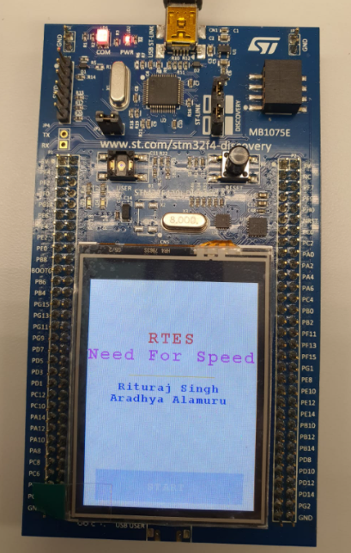

2.2 configScreenView

This screen will take input height from the user (Input height will be used in average velocity calculation)

|  |
| --- |
| **uint32_t configScreenView(uint32_t screenWidth,uint32_t screenHeight) {**  **uint32_t activeScreen;**  **userHeight = 178;**  **lcd.Clear(LCD_COLOR_WHITE);**  **lcd.SetBackColor(LCD_COLOR_WHITE);**    **wait();**  **lcd.SetTextColor(LCD_COLOR_BLACK);**  **lcd.SetFont(&Font24);**  **lcd.DisplayStringAt(0, 40, (uint8_t *)"Select Height", CENTER_MODE);**  **lcd.SetFont(&Font16);**  **lcd.SetTextColor(LCD_COLOR_GRAY);**  **lcd.DisplayStringAt(0, 60, (uint8_t *)"(centimeters)", CENTER_MODE);**    **lcd.SetFont(&Font12);**  **lcd.DisplayStringAt(0, LINE(7), (uint8_t *)"We use your height to", CENTER_MODE);**  **lcd.DisplayStringAt(0, LINE(8), (uint8_t *)"calculate speed", CENTER_MODE);**  **lcd.SetTextColor(LCD_COLOR_DARKMAGENTA);**  **lcd.SetBackColor(LCD_COLOR_DARKMAGENTA);**  **lcd.FillRect(screenMargin, screenHeight - 52, screenWidth - (2 * screenMargin), 44);**  **lcd.SetTextColor(LCD_COLOR_WHITE);**  **lcd.SetFont(&Font16);**  **lcd.DisplayStringAt(0, screenHeight - 36, (uint8_t *)"GO!", CENTER_MODE);**    **lcd.SetTextColor(LCD_COLOR_DARKRED);**  **lcd.SetBackColor(LCD_COLOR_WHITE);**  **lcd.SetFont(&Font24);**    **while(1) {**  **sprintf((char*)text1, " < %0.1f > ", userHeight);**  **lcd.DisplayStringAt(0, 170, (uint8_t *)&text1, CENTER_MODE);**  **ts.GetState(&TS_State);**  **touchX = TS_State.X;**  **touchY = TS_State.Y;**  **printf("x - %d, y - %d\n", touchX, touchY);**  **if (TS_State.TouchDetected) {**  **if (touchY < 40) {**  **activeScreen = MAIN_SCREEN;**  **break;**  **}**  **if ((touchY > 80) && (touchY < 160)) {**  **if (touchX > 160) {**  **increaseHeight();**  **// wait();**  **}**  **if (touchX < 80) {**  **decreaseHeight();**  **// wait();**  **}**  **}**  **}**  **}**  **return activeScreen;**  **}** |

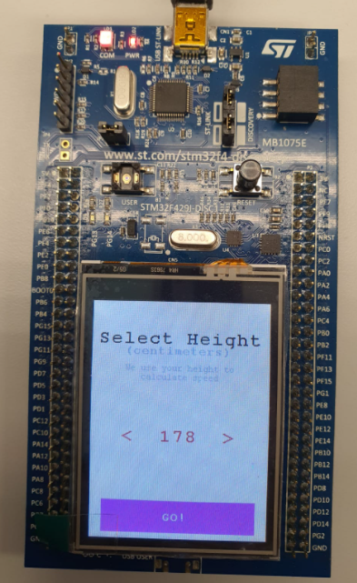

2.3 mainScreenView

* This screen will display Time elapsed, Speed and distance travelled
* Ticker is used to display speed, time and distance after every 1 second
* Gyroscope’s x, y and z-axis angular velocities is read in this API

|  |
| --- |
| **void mainScreenTickerFunc() {**  **led != led;**  **speed = avg_speed * ARC_length;**  **dist += speed;**  **lcd.SetFont(&Font24);**  **// time elapsed; seconds**  **sprintf((char*)text1, "%d", cnt);**  **lcd.DisplayStringAt(0, 26, (uint8_t *)&text1, CENTER_MODE);**  **// speed; m/s**  **sprintf((char*)text2, " %0.2f ", speed * 3.6);**  **lcd.DisplayStringAt(0, 124, (uint8_t *)&text2, CENTER_MODE);**  **// distance; meters**  **sprintf((char*)text3, "%0.2f", dist);**  **lcd.DisplayStringAt(0, 224, (uint8_t *)&text3, CENTER_MODE);**  **cnt++;**  **}**  **uint32_t mainScreenView(uint32_t screenWidth,uint32_t screenHeight) {**  **uint32_t activeScreen;**    **speed = 0;**  **dist = 0;**  **avg_speed = 0;**  **cnt = 1;**  **lcd.Clear(LCD_COLOR_WHITE);**  **lcd.SetBackColor(LCD_COLOR_WHITE);**  **lcd.SetTextColor(LCD_COLOR_RED);**  **lcd.SetFont(&Font16);**  **lcd.DisplayStringAt(0, 6, (uint8_t *)"TIME", CENTER_MODE);**  **lcd.SetFont(&Font16);**  **lcd.DisplayStringAt(0, 48, (uint8_t *)"seconds", CENTER_MODE);**    **// lcd.SetTextColor(LCD_COLOR_DARKGREEN);**  **// lcd.FillRect((screenWidth / 4) - 20, 80, (screenWidth / 2) + 40, (screenWidth / 4) + 20);**  **lcd.SetTextColor(LCD_COLOR_RED);**  **lcd.SetFont(&Font16);**  **lcd.DisplayStringAt(0, 100, (uint8_t *)"SPEED", CENTER_MODE);**  **lcd.SetFont(&Font16);**  **lcd.DisplayStringAt(0, 148, (uint8_t *)"KM / H", CENTER_MODE);**    **// lcd.SetTextColor(LCD_COLOR_DARKCYAN);**  **// lcd.FillEllipse(screenWidth / 2, 200, screenWidth / 4, screenWidth / 8);**  **lcd.SetTextColor(LCD_COLOR_RED);**  **lcd.SetFont(&Font20);**  **lcd.DisplayStringAt(0, 200, (uint8_t *)"DISTANCE", CENTER_MODE);**  **lcd.SetFont(&Font16);**  **lcd.DisplayStringAt(0, 248, (uint8_t *)"METERS", CENTER_MODE);**    **lcd.SetTextColor(LCD_COLOR_BLACK);**  **lcd.SetFont(&Font16);**  **lcd.DisplayStringAt(0, screenHeight - 32, (uint8_t *)"Tap to End", CENTER_MODE);**        **int err = gyroscope.init();**  **int16_t w_dps[3];**  **int count = 0;**    **// button.fall(&Gyro_On);**  **wait_us(1000000);**  **ARC_length = userHeight/200;**  **tick.attach(&mainScreenTickerFunc, 1.0);**    **while(1) {**  **wait_us(100000);**  **gyroscope.read_data_16(w_dps);**    **gyroX = w_dps[0] * 0.00875f;**  **gyroY = w_dps[1] * 0.00875f;**  **gyroZ = w_dps[2] * 0.00875f;**  **gyroX = gyroX + ZERO_RATE_NOISE;**  **if (gyroX < 0.30) {**  **gyroX = 0;**  **}**  **gyroX1 = gyroX * 0.0174533f;**    **avg_speed = gyroscope.average_Velocity(gyroX1); //Circular queue to calculate average velocity**  **//float x1 = x * 0.0174533f;s**    **//printf("%04d | wx1: %f, wx: %f , temp: %d\n", count, x1,x, temp);**  **printf("wx:%f wx1:%f temp:%f\n", gyroX, gyroX1, avg_speed);**  **//printf("%04d | wx: %+7.2f dps, wy: %+7.2f dps, wz: %+7.2f dps\n", count, x, y, z);**  **//led = !led;**  **count++;**  **// touchscreen stuff**  **ts.GetState(&TS_State);**  **touchX = TS_State.X;**  **touchY = TS_State.Y;**  **printf("x - %d, y - %d\n", touchX, touchY);**  **if ((TS_State.TouchDetected) && (touchY < 40)) {**  **activeScreen = RESULT_SCREEN;**  **break;**  **}**  **}**  **return activeScreen;**  **}** |

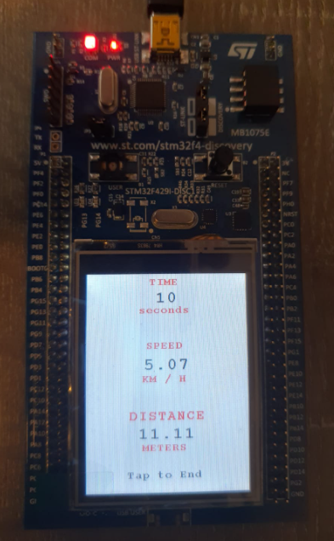

2.4 resultScreenView

* This screen will display total distance travelled and time for complete journey
* “TRY AGAIN” button will reset the LCD and gyroscope and will take you back to the first screen

|  |
| --- |
| uint32_t resultScreenView(uint32_t screenWidth,uint32_t screenHeight) {  uint32_t activeScreen;  lcd.Clear(LCD_COLOR_WHITE);  lcd.SetBackColor(LCD_COLOR_WHITE);    // wait();  lcd.SetTextColor(LCD_COLOR_DARKGREEN);  lcd.SetFont(&Font24);  lcd.DisplayStringAt(0, 40, (uint8_t *)"Done!", CENTER_MODE);  lcd.SetTextColor(LCD_COLOR_ORANGE);  lcd.DrawLine(screenWidth / 4, 72, (screenWidth / 4) * 3, 72);    wait();  lcd.SetTextColor(LCD_COLOR_BLUE);  lcd.SetFont(&Font16);  lcd.DisplayStringAt(0, 100, (uint8_t *)"Distance", CENTER_MODE);  lcd.DisplayStringAt(0, 120, (uint8_t *)"Travelled", CENTER_MODE);  wait();  lcd.SetFont(&Font24);  lcd.SetTextColor(LCD_COLOR_RED);  sprintf((char*)text1, "%0.2f meters", dist);  lcd.DisplayStringAt(0, 137, (uint8_t *)&text1, CENTER_MODE);  wait();  lcd.SetFont(&Font16);  lcd.SetTextColor(LCD_COLOR_BROWN);  lcd.DisplayStringAt(0, 190, (uint8_t *)"in", CENTER_MODE);  lcd.SetTextColor(LCD_COLOR_MAGENTA);  sprintf((char*)text2, "%d seconds", cnt);  lcd.DisplayStringAt(0, 205, (uint8_t *)&text2, CENTER_MODE);  wait();  lcd.SetTextColor(0xFF57068C);  lcd.FillRect(screenMargin, screenHeight - 52, screenWidth - (2 * screenMargin), 44);  lcd.SetBackColor(0xFF57068C);  lcd.SetTextColor(LCD_COLOR_WHITE);  lcd.SetFont(&Font16);  lcd.DisplayStringAt(0, screenHeight - 36, (uint8_t *)"TRY AGAIN", CENTER_MODE);    while(1) {  ts.GetState(&TS_State);  touchX = TS_State.X;  touchY = TS_State.Y;  printf("x - %d, y - %d\n", touchX, touchY);  if ((TS_State.TouchDetected) && (touchY < 40)) {  activeScreen = SPLASH_SCREEN;  break;  }  }  return activeScreen;  } |

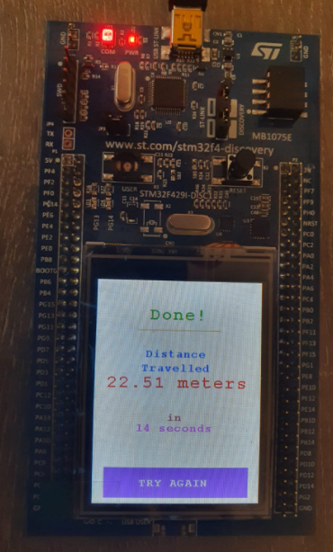

**3. Speed and Distance Calculation**3.1 Circular Queue

* Circular queue of size 50 is implemented to capture 50 samples from gyroscope at run time at a rate of 100 samples per second
* Latest samples are En-queued and old samples are De-queued if queue is full
* A moving average is calculated at run time after each sample is read from the gyroscope. This moving average is used for calculating average velocity

|  |
| --- |
| void Gyroscope::push(float angular_x)  {  if(angular_x > 0){  if(queue_count >= size && is_queue_full == 0)  {  is_queue_full = 1;  front = 0;  }  if(!is_queue_full)  {  rear = rear + 1;  queue[rear] = angular_x;  average_angular_velocity = ((average_angular_velocity * queue_count) + angular_x)/(queue_count+1);  queue_count++;  printf("1 : vel:%f qcnt:%d\n",average_angular_velocity,queue_count);  }  else{  average_angular_velocity = ((average_angular_velocity * queue_count) - queue[front])/(queue_count-1);  rear = front;  front = (front + 1) % size;  queue[rear] = angular_x;  average_angular_velocity = ((average_angular_velocity * (queue_count-1)) + angular_x)/(queue_count);  printf("2 : vel:%f qcnt:%d\n",average_angular_velocity,queue_count);  }  }  } |

3.2 Calculating average velocity and Distance

* Gyroscope values are converted to radian/second using factor 0.0174533f
* This value is stored in circular queue and moving average is calculated after each sample is read from the gyroscope
* Moving average angular velocity is multiplied with leg length of the user to calculate linear velocity
* This linear velocity is used in ticker function with timer to calculate total speed and distance

|  |
| --- |
| void mainScreenTickerFunc() {  led != led;  speed = avg_speed * ARC_length;  dist += speed;  lcd.SetFont(&Font24);  // time elapsed; seconds  sprintf((char*)text1, "%d", cnt);  lcd.DisplayStringAt(0, 26, (uint8_t *)&text1, CENTER_MODE);  // speed; m/s  sprintf((char*)text2, " %0.2f ", speed * 3.6);  lcd.DisplayStringAt(0, 124, (uint8_t *)&text2, CENTER_MODE);  // distance; meters  sprintf((char*)text3, "%0.2f", dist);  lcd.DisplayStringAt(0, 224, (uint8_t *)&text3, CENTER_MODE);  cnt++;  } |

4. Assumptions

* ZERO_RATE_NOISE is set to 0.2800, gyroscope reading below this is discarded
* Length of the leg is assumed to be half of the height of the user wearing the device
* If gyroscope reading is 0 for 30 consecutive samples, It is assumed user has stopped walking or running and moving average velocity is set to 0