Which two pins (find out the name and number) are used for the USB D+ and D- lines in the:

40 pin PDIP package
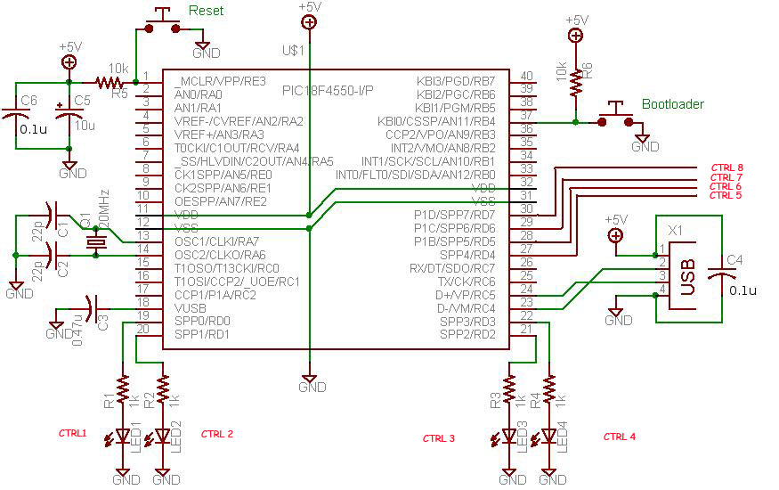
The 2 pins used for the USB D+ & D- in the PIC18F4550 40 pin PDIP package are:
- pin 23 is used for D-/VM/RC4
- pin 24 is used for D+/VP/RC5

44 pin TQFP package
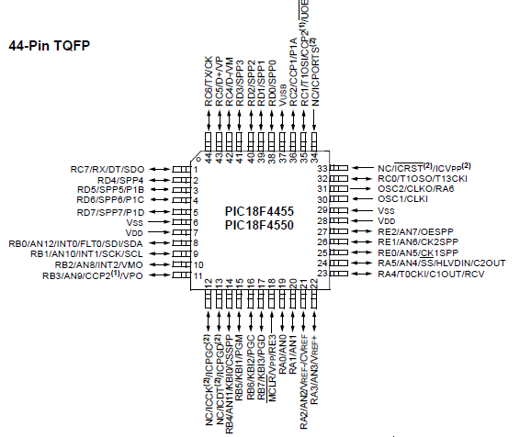
The 2 pins used for the USB D+ & D- in the PIC18F4550 44 pin PDIP package are:
- pin 42 is used for RC4/D-/VM
- pin 43 is used for RC5/D+/VP

What is the clock frequency used for full-speed operation in PIC18F4550?
- 48 MHZ

What are the two ways to configure PIC18F4550 as a full-speed device?
internal configuration
- enable the usage of internal pull-up resistor

external configuration
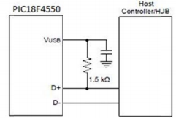
- need a external pull up resistor of 1.5K ohms
- connection is done between VUSB (pin 37) & D+ line if internal resistor is not enabled
- capacitor is connected between VUSB to GND to prevent interference

What are two ways to connect the SIE in PIC18F4550 to a transceiver?
- Serial Interface Engine
- allows data to be received or / and transmitted

Internal connection
- done by utilizing the internal transceiver
- an internal regulator of 3.3V is available to power the internal transceiver in 5V application
- directly connected to the USB

External connection (optional)
Streaming Parallel Port(SPP):
- a high speed interface to transport data to and from an external system
- operates as a master port
- used chip select and clock outputs to control movement of data
- data can be channeled to either USB SIE or a microprocessor core.
- operation of the SPP is controlled by 2 registers, SPCON and SPPCFG.

What is Microchip USB Device Firmware Framework?
microchip USB device framework
- a library that is used to create USB application
- contain necessary coding for USB operation
- provide a placeholder for user's codes

What is the Firmware Framework physical directory structure?
directory structure
- files are located in the microchip library
- these files no need any modifications
- files that require modifications are located in the <Application> folder
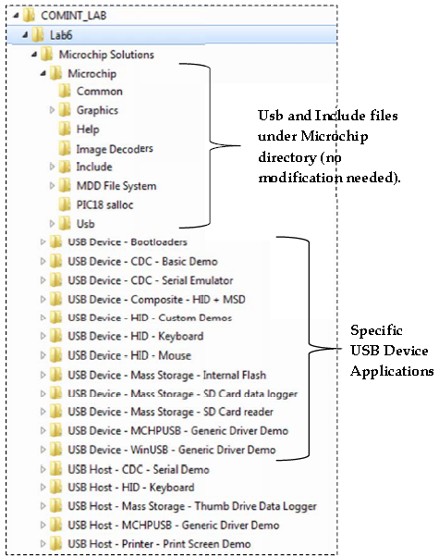

What is the Firmware Framework logical structure?
logical structure
- a set of modular framework is provided by the USB firmware framework
- firmware reference project is written in such a way that allows cooperative multitasking environment
- need not implement blocking functions

logical structure of firmware framework
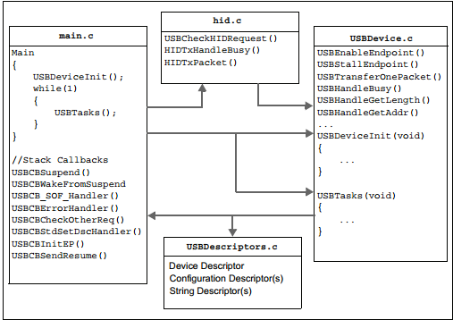

What are the steps to configure MPLAB IDE for the Firmware Framework?
- launch MPLAB IDE
- from the MPLAB IDE menu bar, select File > Open Workspace
- select workspace file. take a look at the released notes associated with stack for more information on the reference designs available.
- go to menu bar, select Project > Build Option > Project.
- select Directories tab and verify the following:
- both output and intermediary directories path is point towards the directory where the output files should be stored
- include search path directory should include the following entries: "."..\Include,..\Microchip\Include, and ..\..<Application>.
- it will allow files in the framework to look for application specific configuration files as well as application specific codes in order to reach the functions of the framework
- library search path points to the "lib" directory under suitable compliers installation directory
- linker script path points to the directory of the project's linker script file.

What is a USB descriptor?
USB descriptors
- a USB device
- provides data about itself in data structures

host obtains device from attached devices by sending data to various control requests to a default endpoint. these requests will specify the type of descriptor to be retrieved. in order to response to such requests, the device will send descriptors containing data about the device.

What are the items (and its values) contained in:
device descriptor
- represents the USB device
- can only have 1 device descriptor
- format of the device descriptor is shown on the table below
Off  set | Field | Size | Value | Description
0 | bLength | 1 | Number | Size of descriptor in bytes(18 bytes)
1 | bDescriptorType | 1 | Constant | Device descriptor (0x01)
2 | BcdUSB | 2 | BCD | USB configuration number that a device complies too  Reports the highest version of USB the device supports
4 | bDeviceClass | 1 | Class | Class code (assigned by USB Org)  If equals 0, each interface specifies its own class code  If equals 0xFF, class code is specified by the vendor  Otherwise, field is valid class code  Used by the OS to find class driver for your device  Usually set at device level
5 | bDeviceSubClass | 1 | Subclass | Sub class code (assigned by USB Org)  Used by the OS to find class driver for your device
6 | bDeviceProtocol | 1 | Protocol | Protocol code (assigned by USB Org)  Used by the OS to find class driver for your device
7 | bMaxPacketSize | 1 | Number | Max. packet size for 0 endpoint  Valid size are: 8, 16, 32, 64  All devices must support endpoint 0
8 | idVendor | 2 | ID | Vendor ID (assigned by USB Org)  Used by the OS to find a driver for your device
10 | idProduct | 2 | ID | Product ID (assigned by USB Org)  Used by the OS to find a driver for your device
12 | bcdDevice | 2 | BCD | Device release number  Same format as bcdUSB  Provide device version number
14 | iManufacturer | 1 | Index | Index of manufacturer string descriptor
15 | iProduct | 1 | Index | Index of product string descriptor
16 | iSerialNumber | 1 | Index | Index of serial number string descriptor
17 | bNumConfigurations | 1 | Integer | Number of possible configurations

configuration descriptors
- 1 USB device is allowed to have many different configurations
- specifies how the device is powered, what is the max power consumption and the number of interfaces it has
- a possibility of having dual configurations, 1 is for when device bus is powered and another when it is mains powered
- possible to have 1 configuration to use a different transfer mode
Off  set | Field | Size | Value | Description
0 | bLength | 1 | Number | Size of descriptor in bytes
1 | bDescriptorType | 1 | Constant | Configuration descriptor (0x02)
2 | wTotalLength | 2 | Number | Total length in bytes of data returned
4 | bNumInterfaces | 1 | Number | Number of interfaces
5 | bConfigurationValue | 1 | Number | Value to use as an argument to select this configuration
6 | iConfiguration | 1 | Index | Index of string descriptor that describes this configuration
7 | bmAttributes | 1 | Bitmap | D7 is reserved, set it to 1  D6 is self powered  D5 is remote wake up  D4 is 0 reserved, set it to 0
8 | bMaxPower | 1 | mA | Max power consumption in 2mA units

interface descriptor
- could be seen as a header / grouping endpoints into a functional group performing only 1 feature in the device
- the below table will show what type of format the interface descriptor conforms to
Off  set | Field | Size | Value | Description
0 | bLength | 1 | Number | Size of descriptor in bytes (9 bytes)
1 | bDescriptorType | 1 | Constant | Interface descriptor (0x04)
2 | bInterfaceNumber | 1 | Number | Number of interface  Indicates index of interface descriptor  Should be 0 based  Increment is done once for each new device descriptor
3 | bAlternateSetting | 1 | Number | Value that is used to select alternate setting  Specify alternate interfaces  Selected with set interface request
4 | bNumEndpoints | 1 | Number | Number of endpoints used for this interface  Value should exclude endpoint 0
5 | bInterfaceClass | 1 | Class | Class code (assigned by USB Org)  Used to specify supported classes  Prevents the need to write specific drivers for the device
6 | bInterfaceSubClass | 1 | Sub class | Sub class code (assigned by USB Org)  Used to specify supported classes  Prevents the need to write specific drivers for the device
7 | bInterfaceProtocol | 1 | Protocol | Protocol code (assigned by USB Org)  Used to specify supported classes  Prevents the need to write specific drivers for the device
8 | iInterface | 1 | Index | Index of string descriptor that is describing this interface

HID class specific descriptor
HID class uses class specific descriptors which are different from some of the standard USB descriptors. It requires USBlyzers to decode and display the following HID class specific descriptors:
HID descriptor | Specifies:  - number  - type and size of HID report descriptors  - physical descriptors that are associated with a HID class device
HID report descriptor | - format of data for transmission and / or reception is not define  - HID report descriptor is provided by a HID device that enumerates all the data fields a specific HID report the device can use  - in each field of the HID report, HID report descriptor must define how many bits the particular data item occupies, what usage it has and the range of values it uses

string descriptors (optional)
- provide human readable data
- any unused string descriptors must be set to the value of 0 to indicate that there is no string descriptor available
- these strings are in Unicode format
- products are made to support multiple languages
Off  set | Field | Size | Value | Description
0 | bLength | 1 | Number | Size of descriptor in bytes
1 | bDescriptorType | 1 | Constant | Interface descriptor (0x03)
2 | wLANGID[0] | 2 | Number | Support language code zero
4 | wLANGID[1] | 2 | Number | Support language code one
N | wLANGID[x] | 2 | Number | Support language code x

This above format shows string descriptor zero. if the host want to determine what languages are available, he or she should read this descriptor. if a certain language is supported, it can be referenced by sending the ID of the language in the windex field of a Get Descriptor(String) request.

all the subsequent strings will take on this format below
Off  set | Field | Size | Value | Description
0 | bLength | 1 | Number | Size of descriptor in bytes
1 | bDescriptorType | 1 | Constant | String descriptor (0x03)
2 | bString | N | Unicode | Unicode encoded string

endpoint descriptor
- used to describe endpoints other than endpoint 0
- endpoint 0 is commonly assumed as a control endpoint and is configured before any other descriptors are even requested
Off  set | Field | Size | Value | Description
0 | bLength | 1 | Number | Size of descriptor in bytes (7 bytes)
1 | bDescriptorType | 1 | Constant | Interface descriptor (0x05)
2 | bEndpointAddress | 1 | Endpoint | Endpoint address  Bits 0 to 3: endpoint number  Bits 4 to 6: reserved, set it to zero  Bits 7: direction 0 = out, 1 = in  (ignored for controlling of endpoints)
3 | bmAttributes | 2 | Bitmap | Bits 0..1 Transfer Type  00 = Control  01 = Isochronous  10 = Bulk  11 = Interrupt  Bits 2..7 are reserved. If Isochronous endpoint,  Bits 3..2 = Synchronisation Type (Iso Mode)  00 = No Synchonisation  01 = Asynchronous  10 = Adaptive  11 = Synchronous  Bits 5..4 = Usage Type (Iso Mode)  00 = Data Endpoint  01 = Feedback Endpoint  10 = Explicit Feedback Data Endpoint  11 = Reserved
4 | wMaxPacketSize | 2 | Number | Max. packet size that this endpoint is capable of sending and receiving
6 | bInterval | 1 | Number | Interval for polling endpoint data transmission  Value in frame counts  Ignored for bulk and control endpoints  Isochronous must be equals 1  Field range: 1 to 255 (for interrupt endpoints)

What are iManufacturer and iProduct and how they are related to String descriptors?
iManufacturer
- index of string descriptor describing manufacturer
- set to 0 if no string

iProduct
- index of string descriptor describing product
- set to 0 if no string

In which header files (*.h) are the following items defined in? What are their values?
- all the following items are defined in a header file by the name of "usb_config.h"

Name |  |  | Values
USB_DESCRIPTOR_DEVICE |  |  | 0x12, // Size of this descriptor in bytes
USB_DESCRIPTOR_CONFIGURATION |  |  | 0x09,//sizeof(USB_CFG_DSC), // Size of this descriptor in bytes
USB_DESCRIPTOR_INTERFACE |  |  | 0x09,//sizeof(USB_INTF_DSC), // Size of this descriptor in bytes
USB_DESCRIPTOR_ENDPOINT |  |  | 0x07,/*sizeof(USB_EP_DSC)*/
USB_DESCRIPTOR_STRING |  |  | //Language code string descriptor  ROM struct{BYTE bLength;BYTE bDscType;WORD string[1];}sd000={  sizeof(sd000),USB_DESCRIPTOR_STRING,{0x0409  }};  //Manufacturer string descriptor  ROM struct{BYTE bLength;BYTE bDscType;WORD string[19];}sd001={  sizeof(sd001),USB_DESCRIPTOR_STRING,  {'T','e','m','a','s','e','k',' ',  'P','o','l','y','t','e','c','h','n','i','c'  }};  //Product string descriptor  ROM struct{BYTE bLength;BYTE bDscType;WORD string[29];}sd002={  sizeof(sd002),USB_DESCRIPTOR_STRING,  {'T','e','m','p','e','r','a','t','u','r','e',' ',  'M','o','n','i','t','o','r','i','n','g',' ',  'S','y','s','t','e','m'  }};
EP0_BUFF_SIZE |  |  | _EP02_IN, //EndpointAddress
HID_INTF |  |  | 0x00, // Class Code  0, // Subclass code  0, // Protocol code
HID_NUM_OF_DSC |  |  | 0x09,//sizeof(USB_HID_DSC)+3, // Size of this descriptor in bytes
HID_RPT01_SIZE |  |  | HID_RPT01_SIZE,0x00,//sizeof(hid_rpt01), // Size of the report descriptor
HID_EP |  |  | HID_EP | _EP_OUT, //Endpoint Address  HID_EP | _EP_IN, //Endpoint Address
DSC_HID |  |  | 0x09,//sizeof(USB_HID_DSC)+3, // Size of this descriptor in bytes
DSC_RPT |  |  | DSC_RPT, // Report descriptor type
_DEFAULT |  | 0x09,//sizeof(USB_CFG_DSC), // Size of this descriptor in bytes
_SELF
_EP_IN | 0x07,/*sizeof(USB_EP_DSC)*/
_EP_OUT | 0x07,/*sizeof(USB_EP_DSC)*/
_INT | 0x09,//sizeof(USB_INTF_DSC), // Size of this descriptor in bytes

What is the purpose of “HardwareProfile.h”
- hardware specific definition for different firmware
- provides configuration information to the source version of the library

What are the differences between the following two applications under the Microchip Solutions directory?
USB device - HID - mouse
- designed as a self-powered device
- need means of detection when it is being powered by the host
- polling is done periodically to know if it is alright to turn on the device
- implementation is optional since it is not possible to source current on D- / D+ pins when host is inactively providing power to VBUS
- some of the features are defined in "HardwareProfile.h"

USB device - HID - custom demos
- a USB device descriptor type
- contains different types of descriptors
- supports the management of multiple strings through a look up table

Which one would you use for developing your own application?
- USB device - HID - custom demos

