Logical VS Physical address space
Some of the similarities between logical and physical address is that they share:
- same compile time
- load-time address binding scheme

but the difference between them is execution time address binding scheme
type of address | the differences between both type of addresses
Logical | - generated by CPU  - virtual address
Physical | - an address  - seen by memory unit  - MAC address (unique)  - generated by the manufacturer

Memory Management Unit (MMU)
It is a hardware device that maps virtual address to physical address. The user program will deal with the logical addresses while it will never be able to see the real address.
The user will only generate logical addresses and will be thinking that the processes are running from address number 0 to the maximum address.

The two different types of addresses involved are:
Logical | - range: 0 to max
Physical | - range: R + 0 to R + max  Where R is a base value

In this scheme, the value of relocation register is added into all the addresses generated by a user process at the time that is sent to the memory. The example below shows a dynamic relocation using a relocation register.
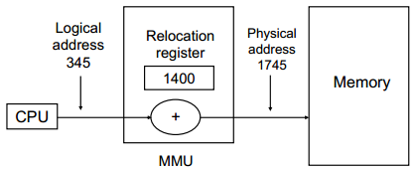

Contiguous Memory Allocation
Main memory is divided into 2 partitions for:
- resident operating system
- user processes
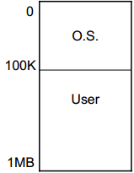

Single Partition
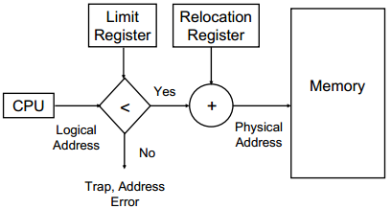
- need partition
- protect:
- OS code & data from changes by the user
- user processes from 1 another

how do users provide protection?
- use a relocation register with a limit register

relocation register | - contain values of the smallest physical address
logical register | - contain range of logical addresses

logical address must always be lesser than limit register

Multiple Partition
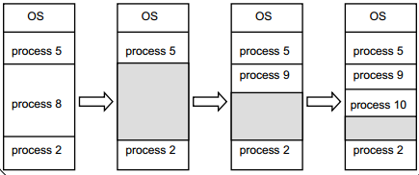
- contain several user processes in 1 memory
- divides the memory into fixed sized partitions
- 1 partition contains 1 process
- memory that are available for user processes comes together as 1 large hole
- during the arrival of each processes, users will need to search for a hole that is large enough for each processes
- allocation of space is done by allocating as much memory as it is needed while keeping the rest available so that future requests could be satisfied.

In this topic in particular, the meaning of the hole is:
- a block of available memory
- they are scattered throughout the memory
- size of each hole varies in the amount of space needed for each process

OS maintains the data about:
- allocated partition
- free partition

a process of waiting is required if there are no available block of memory that is large enough to hold a process.
Allocation Algorithms
First fit
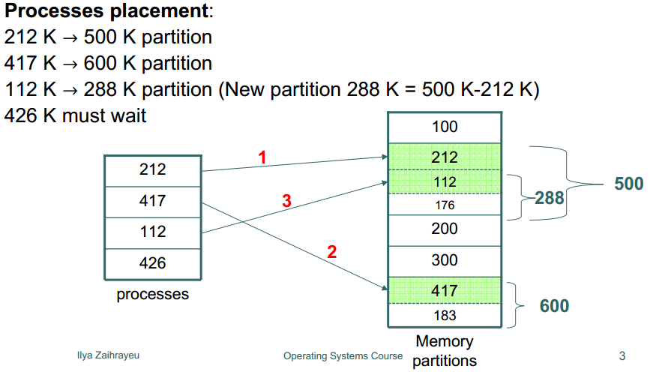
- search the list of available memory
- allocates the first block that is big enough

Best fit
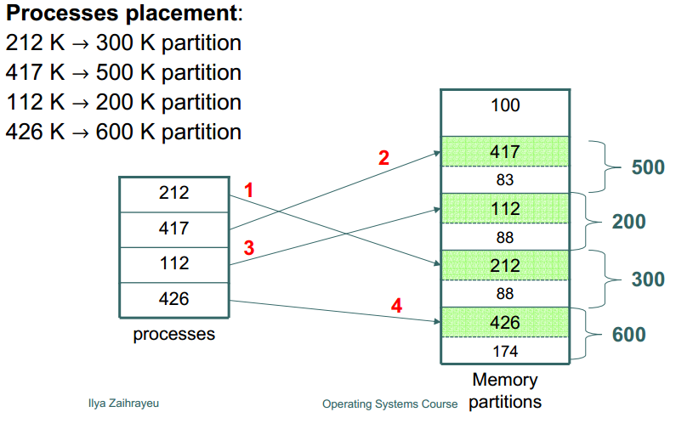
- search the entire list of available memory
- allocates the smallest block that is big enough

Worst fit
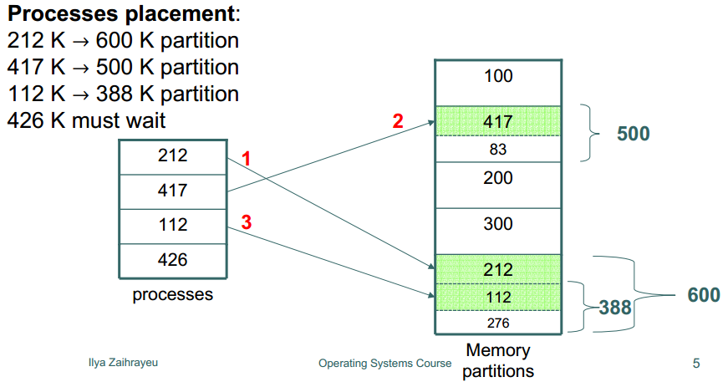
- search entire list of available memory
- allocates the largest block
- leftover block produced is larger and more useful that that produced by the best fit approach

difference between first fit, best fit and worst fit:
- both first and best fit are better in terms of speed and storage utilization

Calculation of internal & external fragmentation
difference between internal & external fragmentation:
Internal | - an unusable memory that is stored in an allocated region  - a type of excess memory that goes to waste  - such waste is known as internal fragmentation
External | - arises when free memory is separated into smaller blocks and is interspersed by allocated memory  - refers to the usable storage outside of the allocated regions

calculation of external fragmentation (formula)
external memory fragmentation = 1 - (f / t)
where f = largest block of free memory
t = total free memory

calculation of internal fragmentation (formula)
normal divisible by: 4, 8, or 16

Non contiguous memory allocation
- parts of process that can be allocated to a non contiguous chunks of memory

difference between paging and segmentation
Paging | - a memory management scheme  - allows processes physical memory to be discontinuous  - eliminates problems with fragmentation by allocation of memory that is equivalent to size blocks known as pages
Segmentation | - based upon the view of program  - programs are divided into variable size segments  - every logical address is formed of a segment name and an offset

Paging
what are the goals?
- eliminate fragmentation due to large segments
- never allow any allocation of memory that will not be in use
- enable fine grained sharing

It is a technique that needs physical memory to be divided into blocks, each with the same size called pages. each size is the power of 2, between 512 & 8192 bytes. whenever a process is in execution, correspondent pages are loaded into any available memory frames,

logical address space of a process is non contiguous process is allocated to the physical memory when there is a free memory frame available. OS will need to keep track of these n free frames as it is needed to run a program of size n pages.

these addresses that are generated by CPU is divided into:
Page number (p) | - an index into a page table
Page offset (d) | - copied into main memory
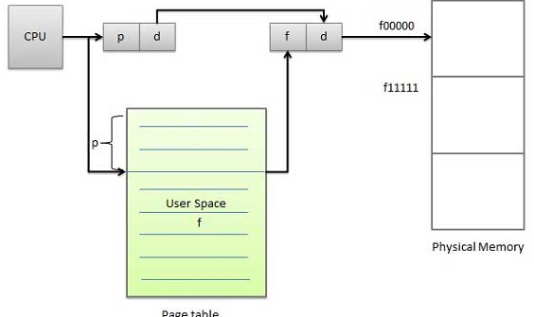
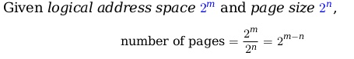

an example of addressing to 0010 0000 0000 0100 :
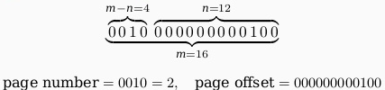
the figure below shows the paging table architecture
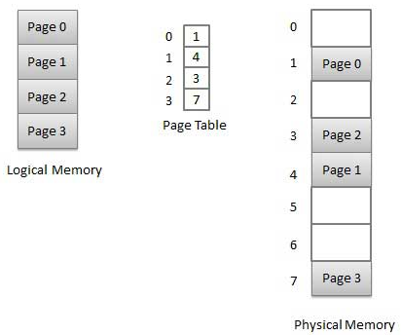

Segmentation
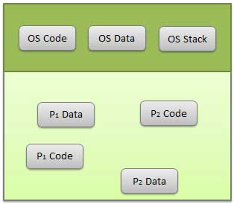
- a technique used to break memory into logical pieces
- can be implemented with or without paging

each piece is a group of related information
- data segments for the OS and each process
- code segments for each process

similar to paging, it uses virtual memory addresses and disk which allows memory to look even bigger than it actually looks

address that is generated by the CPU is divided into:
Segment number (s) | - used as an index into a segment table  - contains base address of each segment in physical memory and limit of a segment
Segment offset (o) | - first check against limit  - then combine it with base address  - used to define the physical memory address
