Processes
Definition of processes in the context of OS:
- an execution instances of a program

processes in memory
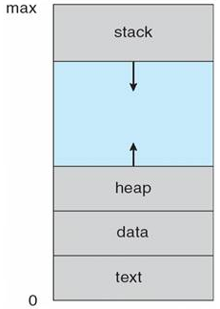
The state changes all the time as the processes are executed. The below is a diagram that illustrates about a process state.
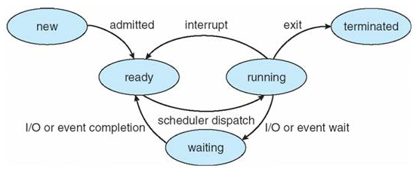
New | - a created process
Running | - instructions that are being executed
Waiting | - the process is waiting for some events to happen
Ready | - the process is waiting to be assigned to a processor
Terminated | - the process has finished its execution

Definition of context switching:
- a process of storing and restoring the execution state
- allows multiple processes to share a single processor
- it can be critical to performance
- has difficulty in dealing with multiple processes
- it is overhead hence, the system does no useful work during the switching process

CPU switch between processes
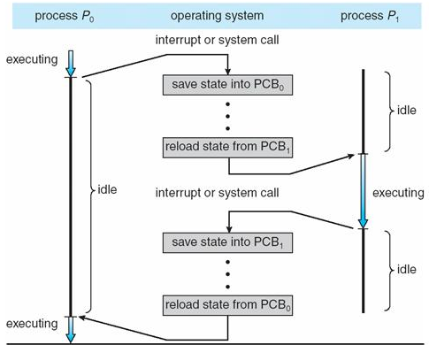
during a switching process, state of the first process must be saved so that whenever the scheduler gets back to the execution of the first process, it can be restored and continue.

state of the process includes:
- all registers that the process may be using
- any other operating system specific data

the data is usually stored in a data structure named:
- process control block (PCB)
- switch-frame

how to switch process
- first process must be created and saved

what is the difference between hardware and software context switching?
hardware context switching
- store almost all registers

software context switching
- selective
- store those registers that needs to be stored

Process scheduling queue
processes migrate among various queues
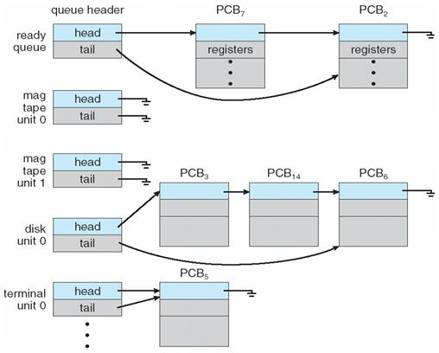
Job queue | - set of all processes in the system
Ready queue | - set of all processes residing in the main memory  - ready and waiting for execution
Device queue | - set of processes that is waiting for an I/O device

Representation of process scheduling
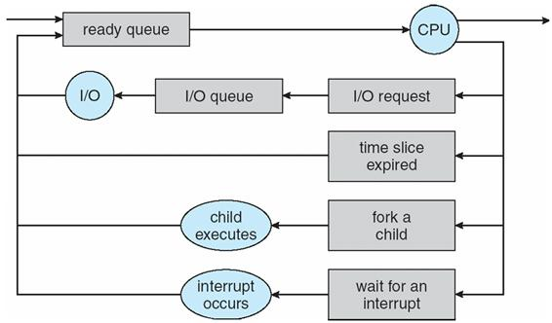

Processor scheduler
comparison between scheduler
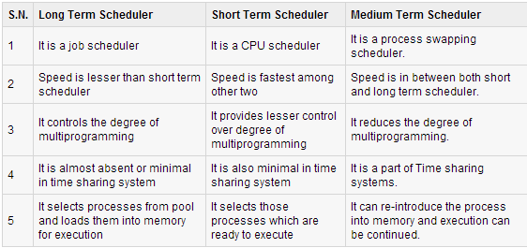
processes can be described as:
I/O bound processes | - spend more time in I/O rather than CPU computation  - many short CPU bursts
CPU bound process | - spend more time in computation  - few, very long CPU bursts

Cooperating processes
- can affect or can be affected by other processes which includes sharing of data
- need inter-process communication

Reasons for using cooperating process:
- data sharing
- convenience
- speed up computation
Inter-process communication
- process within a system can be independent or cooperating

Independent processes
- cannot affect or be affect by other processes in the system
- no sharing of data with other processes

