virtual memory
what is virtual memory?
- a memory management technique
- implemented using both hardware and software
- maps virtual addresses into physical addresses in computer memory

Reasons for using virtual memory?
- compensation for lack of random access memory to run a program / operation
- ease of programming by hiding fragmentations of physical memory

demand paging
how demand paging is implemented?
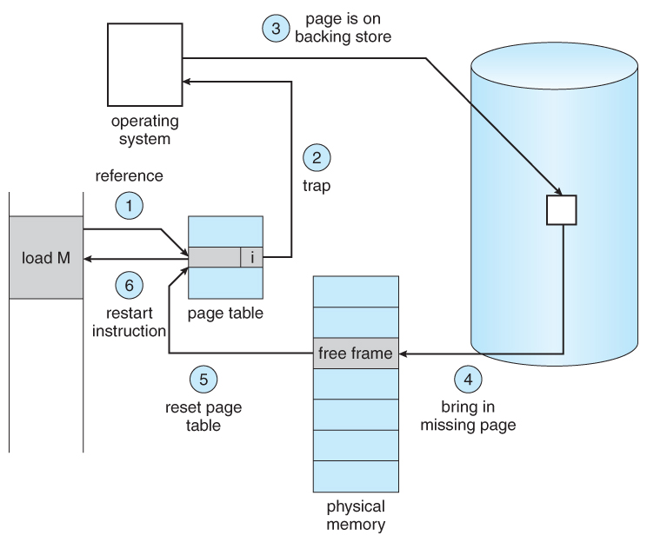
Step | Description
1 | - check internal table for the process  - determine if the reference is a valid / invalid memory address
2 | - terminates the reference if it is invalid  - if it is valid but yet the page is not brought in, page in the latter
3 | - look for a free frame
4 | - schedule a disk operation  - read the desired page into the newly allocated frame
5 | - modify the internal table kept with the process & page table as a indication that the page is in the memory
6 | - restart those instruction that was interrupted by a illegal address trap  - process can gain access to the page as if that it is always in the memory

advantages of using demand paging?
- large memory
- more efficient
- no limit on the degree of multiprogramming

disadvantages of using demand paging?
- lack of explicit constraint on a job address space size
- amount of tables / processor overhead used to handle page interrupts are greater

page fault
what is page fault?
- an interrupt
- occurs when a program request data that is currently not in the real memory
- triggers OS to fetch data virtual memory & load it on the RAM
- degrades the performance of the OS

3 types of page faults
minor page fault
- if the page is loaded into the memory during the time when the fault is generated
- not marked in the MMU as it is being loaded into the memory
- these faults involve disk latency

page fault handler in the OS will need to make an entry for that page which is in the MMU to the page which is in the memory as an indication that the page is successfully loaded into the memory for other programs.

note: the page could have also been removed from the process's working set, but yet not written / erased

advantages of using minor page faults?
- faster
- cheaper than major page faults

major page fault
- used by the OS to increase amount of memory available
- loading parts of the program is delayed by the OS from disk

page fault handler in the OS will find a free location, either:
- page in memory
- another non-free page in memory

note: once free space is located, OS will read the data for the new page into the memory, add a entry to its location in the MMU and provide an indication that the page is loaded

disadvantages of using major faults:
- more expensive than minor faults
- addition of disk latency to the interrupted program's execution

invalid page fault
- occurs for a reference to an address
- not part of virtual address space
- no page in memory can correspond to it
- results into program crash / segmentation & bus error

page fault handler in the OS will need to stop the coding that make the references / deliver an indication to the coding that the reference is invalid

how should we handle invalid page fault?
- stop the running process that causes the error condition
- notify the user that the program has malfunction

page replacement
- make decision on which memory page to page out when a page of memory needs to be allocated

why do we need page replacement?
- look at limited data about the accesses to the pages provided by the hardware
- tries to guess the pages which are required to be replace
- minimize total number of page misses
- balance the cost of the algorithm

page replacement algorithms
FIFO
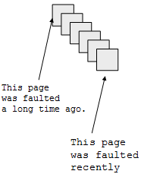
how to implement first in first out?
- maintain the list / queue of pages in an order which they were paged in memory
- on replacement, remove 1 brought in the longest time ago

why it might work?
- the one that is brought in the longest time ago is the one we are not using now

why it might not work?
- we do not have any real data to tell us if it is being used or not

what do FIFO suffer from?
- be-lady anomaly

LRU
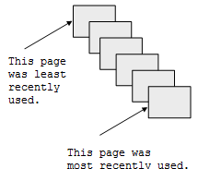
- we cannot look into the future
- take a look at past experience to make good guesses
how is replacement done in least recently used?
- remove the page that is not used for the longest time in the past

how to do a implementation least recently used?
- stamp every reference
- maintain a stack that is updated on every reference

disadvantage of using LRU?
- too costly
- no exact implementation
optimal algorithm
- also known as: be-lady anomaly
- lowest fault rate on any reference string
- replace the page that will not be used for the longest time in the future

how to implement optimal algorithm?
- compare the fault rate of any algorithm against optimal algorithm
- if the proposed algorithm is doing better than optimal, that means that the proposed algorithm is good
- if your proposed algorithm is not doing as good or better than optimal, you might as well go home

evaluation of replacement policies
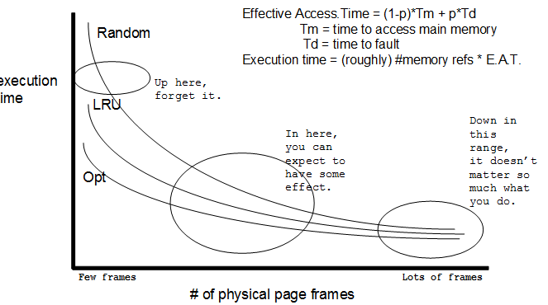

references
http://www.webopedia.com/TERM/P/page_fault.html
http://www.cs.uic.edu/~jbell/CourseNotes/OperatingSystems/9_VirtualMemory.html
http://en.wikipedia.org/wiki/Page_fault
http://en.wikipedia.org/wiki/Page_replacement_algorithm
http://lovingod.host.sk/tanenbaum/BASIC-MEMORY-MANAGEMENT.html
http://cseweb.ucsd.edu/classes/fa04/cse120/lectures/replace.pdf
http://en.wikipedia.org/wiki/Page_replacement_algorithm
http://en.wikipedia.org/wiki/Page_replacement_algorithm#First-in.2C_first-out

