Problem Statements / Objectives
Write a java program by the name of ticketing.java for Roxy Theatres, an online ticketing system. The functions of the program should enable users to:
- book tickets by clicking on the seat buttons
- key in number of refreshment packs

upon clicking the "confirm" button, messages should show the number of seats reserved with its seat numbers together with the total cost of tickets and refreshment packs.
A reset button will also be provided to allow users to reset their booking.

Project Design & Discussions
Use Case Diagram
User
online ticketing system
make bookings
reset bookings

Use Case Text (Course of events)
 | User |  | System
 |  | 1 | Prompt for option
2 | Select number of seats by clicking on the seat button
3 | Select number of refreshment packs desired
4 | Click on the confirm button to confirm booking
 |  | 5 | Display:  - number of seats reserved with seat numbers  - total cost of tickets and refreshment packs
 |  | 6 | Prompt user to pay by credit card
 |  | 7 | Prompt for option
8 | Select number of seats by clicking on the seat button
9 | Select number of refreshment packs desired
10 | Click on the reset button
 |  | 11 | System reset to allow user to redo the entire booking process

Domain model with attributes and association
User
Booking
SeatNumber
confirm
reset
NumberOfSeatsReserved
Cost
Payment
DataStorage
makes booking
contains
1
1
*
*
1
*
uses

Collaboration Diagram
:Controller
:TicketingGUI
2: getResetBooking( )
1.2: storeBooking(aBooking: Booking)
:Booking
:DataStorage
2.1: getResetBooking( )
2.2, 3.2: [ * ] getBooking( ):

Class diagram
TicketingGUI
JFrame
pOtion: JPanel
Controller

jfra
Controller
aBooking: Booking
ds: DataStorage

+createBooking(NoOfSeats, CostOfTickets, CostOfRefreshmnt, Payment:String)
+resetBooking()

jfra
DataStorage
Booking: Vector
NoOfSeats: Vector
NoOfFreshment: Vector
SeatNo: Vector
Payment: Vector

+storeBooking (bBooking: Booking)
+getBooking(NoOfSeats, SeatNo, CostOfTickets, CostOfRefreshmnt, Payment:String)

Booking
NoOfSeats: String
Booking: String
NoOfRefreshment: String
SeatNo: String
Payment: String

+Booking(NoOfSeats, Booking, NoOfRefreshment,SeatNo, Payment: String)
+getBooking: String
+resetBooking(NoOfSeats, Booking, NoOfRefreshment,SeatNo, Payment: String)
Story board
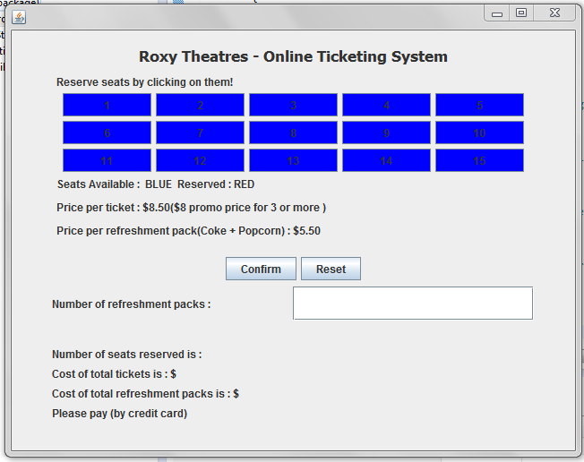

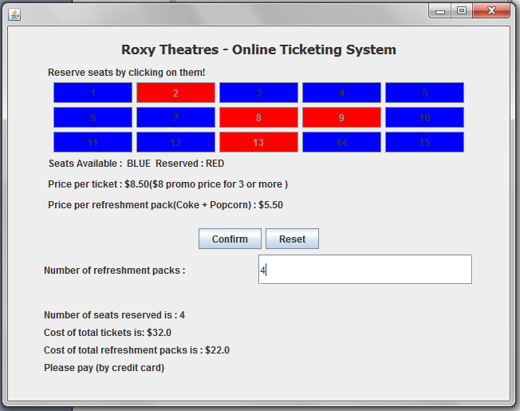

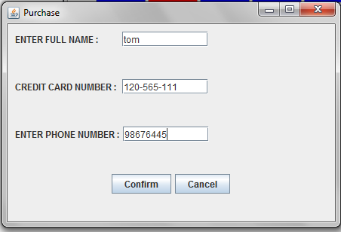

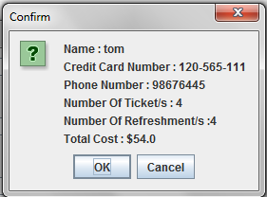
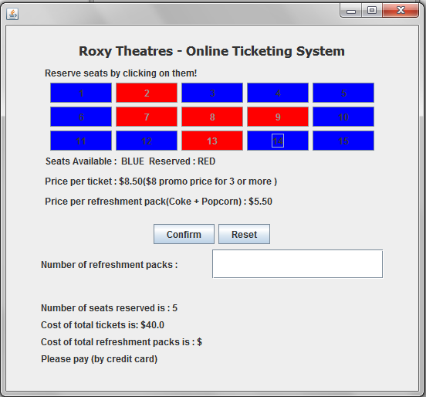

Work distribution
Adrian | - creation of the GUI interface  - report writing and submission
Habib | - coding of the project  - checking of the GUI

Conclusion
We are able to meet the objectives of the project.

There are not many limitations in this project as the designing of the GUI is simple. One of the few we have encountered is disabling of the radio buttons for the seats.

Some of the important things we have learned in this project:
- how to disable radio buttons
- implementation of the controller class and other classes which enable the program to function properly

Improvements made in the project:
- addition of new dialog box which allow users to input their particulars such as name, contact number and credit card number.
- a confirmation dialog box which shows information of user's particulars and booking information

