Defining project objectives and output deliverables
Project Scope
The primary scope of my project is to develop tester programmes for electronic components from the vehicle which will meet the minimum requirements of the quality assurances(QA) by using either national instrument's labVIEW 2012 or programmable logic controller (PLC) which will replace the old mechanical tester.

A graphical user interface on a touch screen device is also required so that it will enable technician's ease of testing and minimize the time taken. I am also responsible for re-engineering, analysis, planning, troubleshooting, unit testing and technical documentation of the electronic components.

Secondary scope of my project is to research and develop mobile applications using eclipse with android development tools which is currently under the research and development stage.

Provide assistance to the engineers, technicians when necessary and technical documentation of the test results for the quality assurance.

Concepts & Detailed Design / Generation Of Flow Chart
1. Contact List For Android Mobile Devices
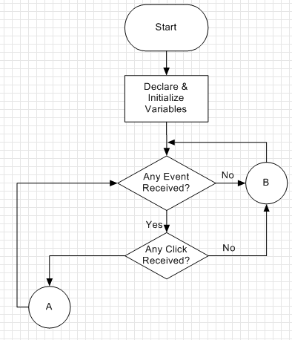

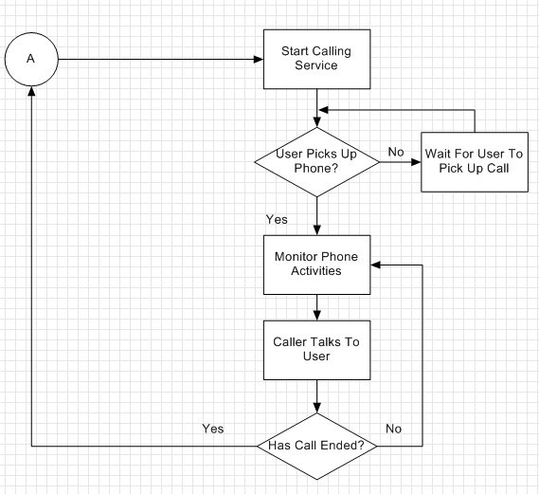
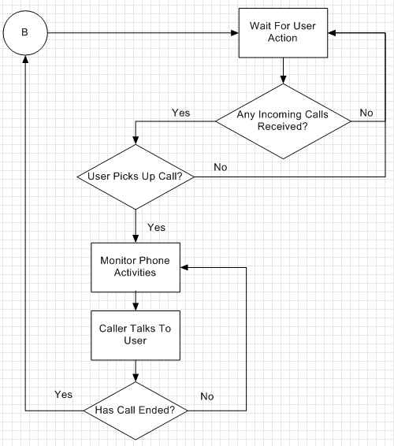

2. Android Simple Quiz For Mobile Devices
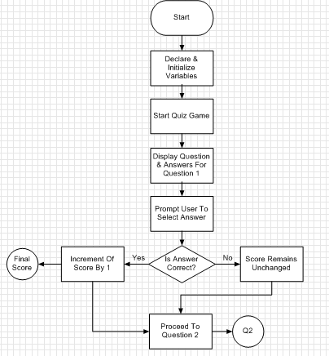

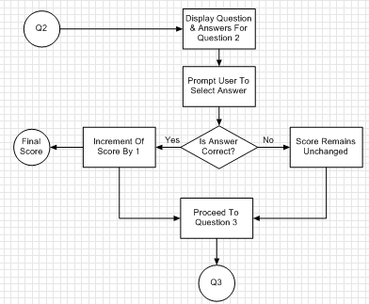
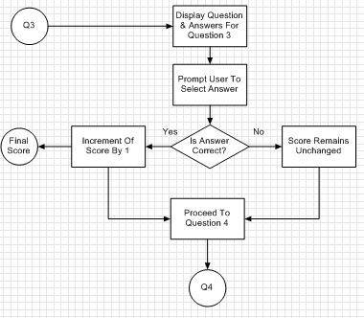

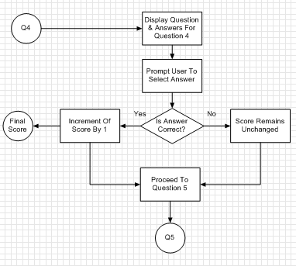

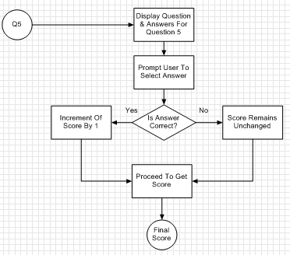

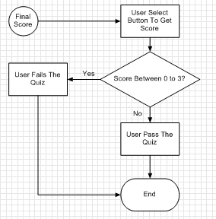

3. Programmable Logic Controller Component Continuity / Connectivity Test
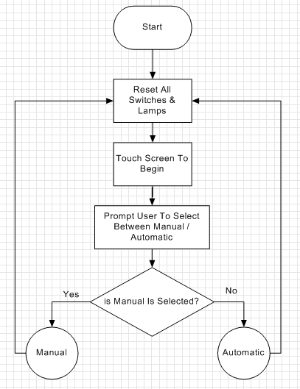

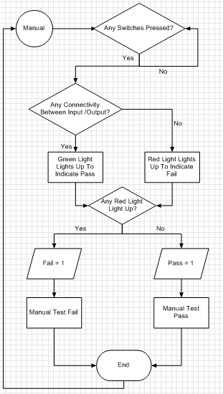
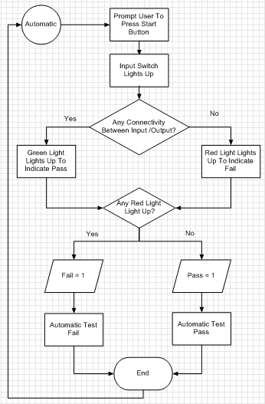
4. Programmable Logic Controller Tic Tac Toe Game
